Recovering from bushfires

Lesson: Sharing stories – 10 years on

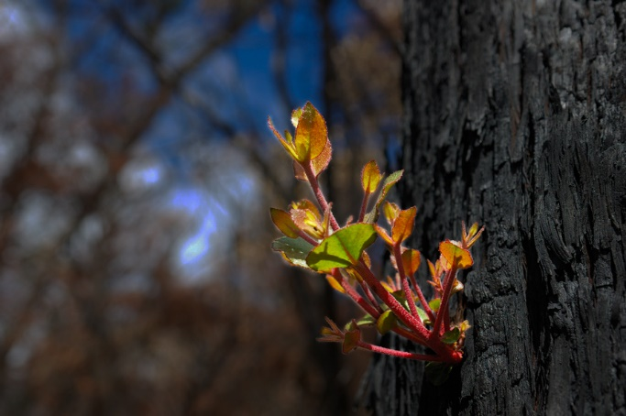
Overview
Curriculum levels: 7 and 8
Time: 50 minutes (approximately)
Links to the Victorian Curriculum F–10:
Geography, Levels 7 and 8
Geographical Concepts and Skills
Identify, analyse and explain interconnections within places and between places and identify and explain changes resulting from these interconnections (VCGGC101)
Geographical Knowledge
Factors that influence the decisions people make about where to live and their perceptions of the liveability of places (VCGGK111)
Influence of social connectedness and community identity on the liveability of places (VCGGK114)
Causes of a geomorphological hazard and its impacts on places and human responses to it to minimise harmful effects on places in the future (VCGGK121)
Personal and Social Learning, Levels 7 and 8
Self-Awareness and Management
Discuss the range of strategies that could be used to cope with difficult tasks or changing situations (VCPSCSE036)
Learning intention:
Students will hear the stories of people who have experienced bushfires and returned to their place in the bush. These people share their experiences of bushfires, resilience and recovery.
Please note: Teachers are advised that some students may find aspects of the following activities personally disturbing. Teachers ought to review all materials prior to use and carefully choose and/or adapt the activities and resources that are the most appropriate for the context, background and experience of students in their particular classroom.
Suggested resources:
- Online resources such as the linked resources listed below

Activities

Starting
Have students view the following short videos and read the accompanying articles:
- ‘“Your friends died, your home disappeared”: Black Saturday, 10 years on’, SBS News
- ‘Black Saturday fires commemoration highlights kindness and recovery’, ABC News
Ask:
- What is the purpose and significance of the Black Saturday Commemoration?
- What feelings are expressed about loss and recovery?
- In what way might such commemorations help communities recover?
- What were the thoughts/feelings of the people interviewed at Marysville about rebuilding their lives?
Explain to students that each of the communities affected by the bushfires held their own commemorations on 7 February 2019.

Exploring
For the 10-year anniversary at Kinglake, The Age interviewed people who had returned to or remained in the bush after the Black Saturday bushfires. Working in pairs, have students look at one of the following stories, ensuring that around one-third of the class looks at each story:
- ‘Reclaiming the mountain’, Part 1 (2019)
- ‘Defying Disaster’, Part 2 (2019)
- ‘We live here’, Part 3 (2019)
Have students take notes from their story under the following headings:
- Memories from before the fire
- Memories of the fire
- Recovery from the fire
- Feelings about their place in the bush

Bringing it together
Have each pair share a summary of the story and their responses with the class. When all students have shared their summaries, go on to discuss:
- Why do people return to the bush after a disaster?
- How does returning help these people to recover?
- What messages do these people give about recovery?
- What sorts of values are expressed by the people in this story?
- How did you feel reading these stories?
- Was there anything that surprised you about these stories?
- What else would you like to know about the people in these accounts?
Using the discussion and stories as a stimulus, have students write
- an account entitled ‘Recovery from Bushfire’
- a short story or short film script (with storyboard) that shows a character recovering from a traumatic experience.

Extending
The 2009 Victorian Bushfires Royal Commission investigated the circumstances leading to widespread losses of human life and property. It heard evidence from 434 expert and lay witnesses and examined more than 1200 public submissions before handing down 67 recommendations to improve bushfire management.
Using online resources, have students list the key recommendations of the Royal Commissions and explain how each of these recommendations will lead to increased safety for the inhabitants of bushfire-prone areas.
The following resources may be helpful:
- ‘Bushfires Royal Commission: the recommendations’, Sydney Morning Herald
- ‘Final report into Black Saturday released’, ABC News

