Recovering from bushfires

Lesson: The Blacksmiths Tree – remembering Black Saturday

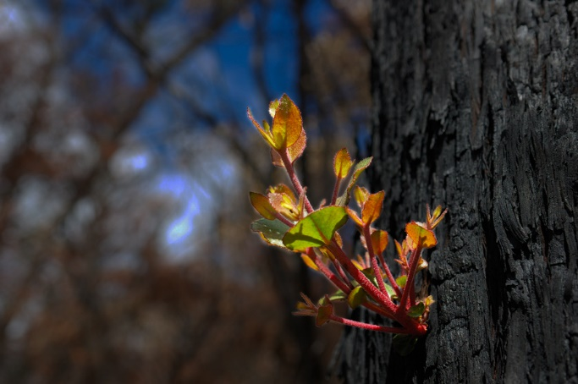
Overview
Curriculum levels: 7 and 8
Time: 50 minutes (approximately)
Links to the Victorian Curriculum F–10:
Geography, Levels 7 and 8
Geographical Concepts and Skills
Identify, analyse and explain interconnections within places and between places and identify and explain changes resulting from these interconnections (VCGGC101)
Geographical Knowledge
Influence of social connectedness and community identity on the liveability of places (VCGGK114)
English, Level 8
Writing
Create imaginative, informative and persuasive texts that raise issues, report events and advance opinions, using deliberate language and textual choices, and including digital elements as appropriate (VCELY420)
Learning intention:
Students will explore the importance of memorials to a community. They will then use this understanding when viewing examples of memorials produced after a community has been affected by bushfire.
Suggested resources:
- Online resources such as the linked resources listed below

Activities

Starting
Explain to students that as part of their recovery from bushfires, many communities have planned and built memorials of significance locally. These memorials include walls, sculptures, places of reflection, storyboards, lookout towers, roadside stops, shelters, signage, murals, plaques and seating, commemorative gardens and rotundas.
Show students The Tree Project video.
Discuss the following questions with students:
- Why do we have memorials?
- Why was this project developed?
- Why was the gum tree chosen as a memorial symbol?
- What were the benefits for blacksmiths involved in the project?
- What are the benefits for the community?
For further information, have students read:
- ‘Blacksmiths to forge Black Saturday memorial’
- The Blacksmiths Tree, Regional Development Victoria.
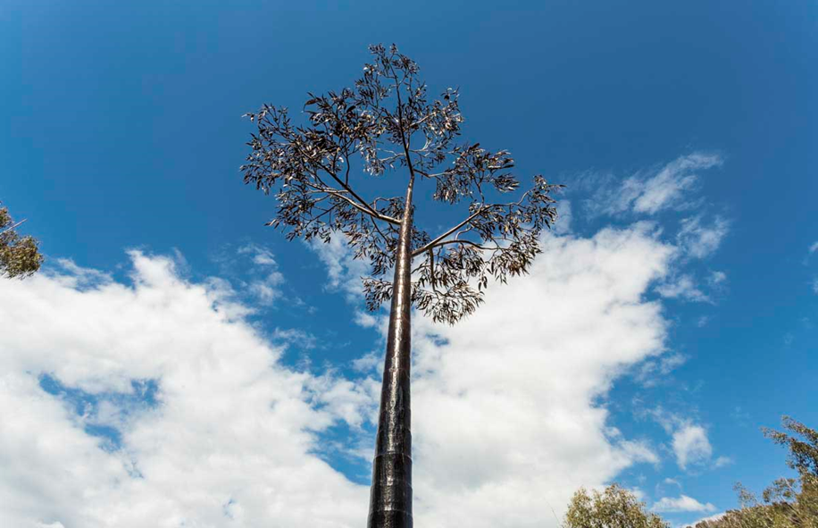
© Regional Development Victoria

Exploring
In small groups, students research examples of memorials associated with Black Saturday 2009 from the website 2009 Victorian Bushfire Memorials.

Students are to select one Black Saturday memorial and construct a brief multimedia presentation covering the following:
- where the memorial is situated
- the nature of the memorial
- how the memorial was constructed
- the values the memorial expresses
- any rituals that might take place at the memorial
- who developed the memorial and their reasons for building it
- the purpose and symbolism in this particular form of memorial
- community responses to the project and to the end result.
Students could prepare their presentations using a digital tool as a means of assembling, organising and linking images, video, audio, weblinks and text in ways that will enable students to construct a presentation.

Bringing it together
Each group delivers their presentation to the class.
Discuss with students the importance of memorials to communities and the symbols and values associated with them.

Extending
Students are to write a well-reasoned editorial for a daily newspaper, explaining how important it is to have a memorial and a commemorative ritual for Black Saturday, as a community symbol and a remembrance of those who lost their lives and as an aid to recovery.

