A Day at the Beach

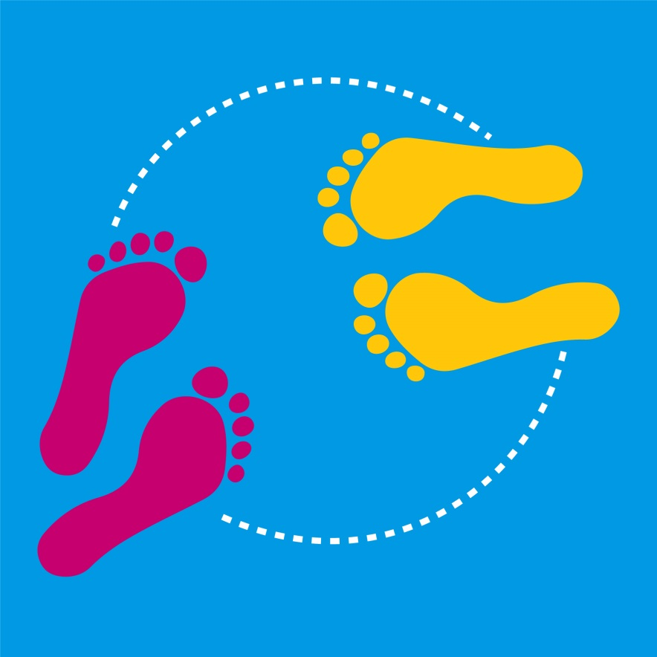
Levels 1 and 2

Authorised and published by the Victorian Curriculum and Assessment Authority
Level 7, 2 Lonsdale Street
Melbourne VIC 3000
© Victorian Curriculum and Assessment Authority [2017]

No part of this publication may be reproduced except as specified under the Copyright Act 1968 or by permission from the VCAA. Excepting third-party elements, schools may use this resource in accordance with the VCAA educational allowance. For more information go to: www.vcaa.vic.edu.au/Pages/aboutus/policies/policy-copyright.aspx.
The VCAA provides the only official, up-to-date versions of VCAA publications. Details of updates can be found on the VCAA website: www.vcaa.vic.edu.au.
This publication may contain copyright material belonging to a third party. Every effort has been made to contact all copyright owners. If you believe that material in this publication is an infringement of your copyright, please email the Copyright Officer: vcaa.copyright@edumail.vic.gov.au
Copyright in materials appearing at any sites linked to this document rests with the copyright owner/s of those materials, subject to the Copyright Act. The VCAA recommends you refer to copyright statements at linked sites before using such materials.
The VCAA logo is a registered trademark of the Victorian Curriculum and Assessment Authority.

Topic: A Day at the Beach

Level: 1 and 2

Victorian Curriculum

Health and Physical Education

Content Descriptions
Perform fundamental movement skills in different movement situations in indoor …settings (VCHPEM080)
Construct and perform imaginative and original movement sequences in response to stimuli (VCHPEM081)
Incorporate elements of effort, space, time, objects and people in performing simple movement sequences (VCHPEM084)

Achievement Standard (extract only)
By the end of Level 2, students ... demonstrate fundamental movement skills in different movement situations…. They perform movement sequences that incorporate the elements of movement.

The Arts - Dance

Content Descriptions
Use safe dance practice, fundamental locomotor and non-locomotor movements, body parts, bases and zones to explore, improvise and structure movement ideas for dance (VCADAE021)
Use choreographic devices to select and organise movement ideas and create and practise dance sequences (VCADAD022)
Use simple technical and expressive skills when presenting dance that communicates ideas about themselves and their world to an audience (VCADAP023)

Achievement Standard (extract only)
By the end of Level 2 students use the elements of dance and fundamental movement skills to make and perform safely, dance sequences that express ideas.

Teaching and learning activities
The following teaching and learning activities are designed to teach the knowledge, skills and understandings relating to Health and Physical Education and The Arts: Dance for Levels 1-2.

Activity 1: Warm up
Conduct an activity to enable students to warm up and prepare their body and mind for their dance. For example play music with a strong beat and guide students through a series of movements in time with the beat. Call out movements such as eight counts of:
- marching on the spot
- marching eight steps forward
- swinging arms backwards and forwards, while standing still followed by swinging arms while siting with legs extended
- twisting their bodies half-way round and back again while their feed remain in the same place on the floor, using a focus point to assist in maintaining balance
- marching on the spot while swinging their arms
- jumping up and down on the spot, lightly followed by jumping with more force.
Encourage students to complete the actions in time with the music; this could include assisting the students by counting the beat. The movements can be completed individually or paired, for example marching on the spot for eight counts and then marching forward eight counts.

Activity 2: Introduction to the Beach (30 minutes)
Read one of the recommended texts (See you next year, Goose at the Beach, Magic Beach- see Resources) or another age-appropriate story about a day at the beach to students.
Teacher note: Check first with students to find out how many students have experienced visiting the beach.
Have students close their eyes and imagine what fun things they might do on a day’s outing to the beach. Have students share their ideas with a partner.
Ask students to imagine that they have just arrived at the beach. Use a variety of question stems (what, how, when, why) to develop a class discussion around what might happen first before they can do any of their planned activities. For example, students might set up their spot on the beach for the day by laying out their towel, chair, beach umbrella and any play equipment they are planning to use.
Encourage responses around being safe and sunsmart, such as:
- always visit the beach with an adult
- check for warning signs
- swim between the flags
- protect yourself from the sun by putting on hats, sunscreen, sunglasses.
Use these questions and discussion as stimulus for students to create their own movement sequence to show how they set up for their day at the beach, including the placement of what they have brought with them and how they apply sunsmart procedures.
Teacher Note: It is important to remind students that the following activities are imaginary/pretend and that when actually visiting the beach that they must always be with an adult, as safety around water is always of the highest priority. This activity provides an opportunity to explore or to revise key water safety and sunsmart messages related to visiting the beach.
Frolicking on the sand
Ask students think about how they like to play on the sand when they are visiting the beach. Allow students to discuss whether they like to build things with the sand, play sports on the sand or do they like to explore different ways to move on the sand, such as galloping, jumping or hopping from foot to foot.
Encourage students to safely:
- explore how they would move on the sand during their day at the beach. They can experiment with different ways to move on the sand such as running, skipping, sliding, twirling, leaping, hopping from one foot to the other
- explore galloping from their spot on the beach, across the sand
- practice how they might perform the gallop movement so that only the balls of the feet touch the sand
- attempt a side gallop without kicking up too much sand
Have students discuss the qualities of their movements and describe how they land lightly (balls of the feet, elevation, giving with the knees and ankles when landing).
Partner frolic
Have students choose a partner and work together to create a movement sequence that includes:
- moving from their beach towels to the sand
- frolicking in the sand together
- a side gallop with a light landing.

Activity 3: Surfs Up! (30 minutes)
Using a Y chart, ask students to describe what it might be like to ride a wave.
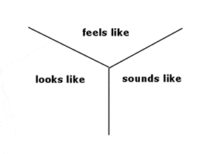

Riding a wave
Have students pretend they are having a surfing lesson on the beach.
For example ask students to:
- lay on their surfboard/boogie board or surf mat
- pretend to paddle using their arms
- explore how to push themselves into a crouch position on their pretend board/mat
- pretend to ride their board/mat.
Have students think about how their body moves to keep their balance. Discuss and explore what part or parts of the body are assisting balance such as feet, ankles, knees, torso and arms.
Ask students to imagine that a big wave has come along whilst they are riding their surfboard/mat and they crumble down into the water. Have students explore safe ways to collapse or fold their body down.
Have students improvise their own sequence of movements to the following ideas:
- laying on their beach towel
- collecting their surfboard.
- paddling out
- crouching
- riding their surfboard
- collapsing into the waves
- getting back on their board
- paddling back to shore
- returning to their beach towel.

Activity 4: A day at the beach (30 minutes)
Students work with a partner to develop a creative sequence about a day at the beach.
Their movement sequence or dance should:
- tell a story about a day at the beach
- include three activities demonstrated by movements and mime that are linked together to create a sequence. Encourage students to be imaginative with their choice of activities
- demonstrate co-operation with their partner to share ideas and make decisions.
Allow students time to prepare and practice their sequence before performing to their audience.
Encourage students to be expressive when communicating their story through movement. For example, using gestures and facial expressions, including movements with different dynamics (more or less force or speed) and movements at different levels (high, medium or low).

Activity 5: Cool down (10 minutes)
After each practical session provide an opportunity for students to cool down by focusing on slow movements and stretching followed by a period of relaxation. For example a game of follow the leader could include slow movements such as:
- walking on the spot with arms swinging
- reaching up trying to touch the sky
- slow skipping on the spot
- touching head, shoulders and toes.
Ask students to lie on the floor with their eyes closed and to breath evenly (in and out). Have students think about and move different parts of their body that they used during their dance, for example lift your right arm, shake your left leg etc.

Assessment ideas

Pre-assessment
Ask students to improvise and structure movement ideas to represent setting up at the beach and how these movements could be used to form a dance.
Refer to the assessment rubric on page 6 to identify where students are located on the Victorian Curriculum continuum.

Ongoing formative assessment
Students create imaginative movements using different locomotor and non-locomotor movements in response to storytelling, images and music. The movements should include lying, standing, side gallop, crouching and balancing. Students should show their work in progress and develop a vocabulary list of words to describe their movements.

Summative Assessment
In pairs, students create and perform an imaginative and original movement sequence in response to ‘a day at the beach’ theme.
Use the assessment rubric on page 6 to identify where students are located on the Victorian Curriculum continuum.

Resources

Texts
Andrew Larson and Todd Stewart, (2015). See you next year. Owlkids Books Inc, Toronto, ON. ISBN13: 9781926973999
Laura Wall, (2016). Goose at the Beach. Award Publications Ltd, Worksop, UK ISBN:9781782701958
Alison Lester, (2004). Magic Beach. Allen and Unwin, Melbourne, AU. ISBN:9781741144888

Music
For example, choose a selection of environmental sounds related to the beach, waves etc such as meditation music. Use a looping program such as Audacity to create a soundscape. Students could create soundscapes in a Music class.

Teacher information
Ausdance, Safe Dance factsheets contain basic information about a creating safe dance environment and strategies for minimising the risk of accident and injury.
Australian Sports Commission, Move to dance booklet provides information about teaching dance, including information about safety, equipment and strategies for conducting dance lessons.

Assessment Rubric - A Day at the Beach (Level 1-2)
 | Relevant element of the Achievement Standards
 | Foundation |  | Level 2 |  | Level 4
 | Health and Physical Education
 | By the end of Foundation Level, students… describe how their body responds to movement and they perform fundamental movement skills and solve movement challenges. |  | By the end of Level 2, students… demonstrate fundamental movement skills in different movement situations…. They perform movement sequences that incorporate the elements of movement. |  | By the end of Level 4, students…refine fundamental movement skills and apply movement concepts and strategies in different physical activities …. They create and perform movement sequences using fundamental movement skills and the elements of movement.
 | The Arts - Dance
 | By the end of Foundation Level, students make and perform dance sequences and demonstrate safe dance practice. |  | By the end of Level 2, students use the elements of dance and fundamental movement skills to make and perform safely, dance sequences that express ideas. |  | By the end of Level 4, students structure movements into dance sequences and use the elements of dance and choreographic devices to communicate their ideas and intentions. They make dances and perform safely with control, accuracy, projection and focus..

Category | At Foundation students can: | When progressing towards level 2 students can: | At level 2 students can: | When progressing towards level 4 students can: | At level 4 students can:
Performs the fundamental movement skill of the side gallop | - practise the fundamental movement skill of the side gallop | - perform the fundamental movement skill of the side gallop | - perform the fundamental movement skill of the side gallop demonstrating consistent contact of the ground with balls of the feet | - perform the fundamental movement skill of the side gallop demonstrating consistent contact of the ground with balls of the feet and elevation during flight phase | - refine fundamental movement skills of a side gallop and use a variety of movement elements such as level dynamics and spatial awareness,
Creates and performs an imaginative dance sequence including at least 3 movement ideas in response to ‘A day at the beach’ | - perform dance sequences and demonstrate safe dance practice.  - Use movement to communicate some ideas associated with ‘A day at the beach’ | - perform an imaginative dance sequence of at least 3 movement ideas  - creates and performs a dance communicating a storyline of ‘A day at the beach’ | - performs dance sequences with some technical and expressive skills  - creates and performs a dance using simple technical and expressive skills to communicate a storyline of ‘A day at the beach’ | - perform an imaginative dance  - creates and performs a dance using a variety of technical and expressive skills to communicate a storyline of ‘A day at the beach’ | - create and perform movement sequences using fundamental movement skills and the elements of movement to communicate ideas .  - creates and performs a dance with control, accuracy, projection, focus and expression.

