Where does our food
come from?
Levels 1 and 2

Home Economics

Unit of work

Disclaimer: It is the responsibility of the school to ensure that duty of care is exercised in relation to the health, hygiene and safety of all students undertaking activities where students handle or taste food. In implementing projects with a focus on food, care must be taken with regard to food safety and specific food allergies that may result in anaphylactic reactions.
Authorised and published by the Victorian Curriculum and Assessment Authority
Level 7, 2 Lonsdale Street
Melbourne VIC 3000
© Victorian Curriculum and Assessment Authority 2019.
No part of this publication may be reproduced except as specified under the Copyright Act 1968 or by permission from the VCAA. Excepting third-party elements, schools may use this resource in accordance with the VCAA educational allowance. For more information go to: https://www.vcaa.vic.edu.au/Footer/Pages/Copyright.aspx.
The VCAA provides the only official, up-to-date versions of VCAA publications. Details of updates can be found on the VCAA website: www.vcaa.vic.edu.au.
This publication may contain copyright material belonging to a third party. Every effort has been made to contact all copyright owners. If you believe that material in this publication is an infringement of your copyright, please email the Copyright Officer: vcaa.copyright@edumail.vic.gov.au
Copyright in materials appearing at any sites linked to this document rests with the copyright owner/s of those materials, subject to the Copyright Act. The VCAA recommends you refer to copyright statements at linked sites before using such materials.

The VCAA logo is a registered trademark of the Victorian Curriculum and Assessment Authority.

Contents
Introduction to the unit of work 4
Overview 4
Learning intentions 4
Victorian Curriculum correlation 5
Advice and teaching considerations 5
Learning activities, resources and tips 6
Learning activity 1: Where does our food come from? 6
Learning activity 2: Choosing healthy foods from the five food groups 7
Learning activity 3: How does food get from the paddock to us? 8
Learning activity 4: Practical session: Making butter 9
Further resources 10
Appendix 1 11
Appendix 2 15
Appendix 3 17

Introduction to the unit of work
Unit of work: Where does our food come from?
Time (approximate): 150 minutes (4 × learning activities)
Curriculum band: Levels 1 and 2
Curriculum areas: Design and Technologies
Health and Physical Education

Overview
Students explore which plants and animals are used to produce food. They match food products to their sources and place them into food groups. They explore the paddock to plate process by documenting the steps of milk production, then finish by making butter, discovering the tools and techniques that are used.

Learning intentions
- Identify plants and animals that are grown for food.
- Match common foods to their original food source and identify their food group.
- Recognise how choosing healthy foods is a part of healthy eating.
- Examine messages about dairy foods and explore the steps involved in getting milk from the farm to us.
- Explore the tools and techniques used for making butter.

Victorian Curriculum correlation
Design and Technologies strands | Health and Physical Education strand
Technologies Contexts (Food and fibre production and Food specialisations) | Personal, Social and Community Health
Achievement Standards (extract)
By the end of Level 2, students:  - identify the features and uses of some technologies for each of the prescribed technologies contexts. | By the end of Level 2, students:  - examine messages related to health decisions and describe how to help keep themselves and others healthy, safe and physically active.
Content Descriptions (extract)
Food and fibre production  - Explore how plants and animals are grown for food, clothing and shelter (VCDSTC015)  Food specialisations  - Explore how food is selected and prepared for healthy eating (VCDSTC016) | Being healthy, safe and active  - Recognise situations and opportunities to promote their own health, safety and wellbeing (VCHPEP074)

Advice and teaching considerations
- Explore local farming or food manufacturing businesses. Are there opportunities for incursions or excursions?
- Invite parents or other school community members to help set up and maintain a school garden.
- Extend on the butter-making activity by making ricotta cheese or yoghurt. Invite parents to help with these activities.
- Link the butter-making activity to the Science curriculum: Chemical sciences: everyday materials can be physically changed or combined with other materials in a variety of ways for particular purposes (VCSSU045).
- Extend this unit by having students make their own games using digital tools. For example, students could:
- Create a simple online game in PowerPoint: place images of a food product and three possible food sources into a slide, and embed an action button onto each food source image, linking to a slide that states either ‘correct’ or ‘incorrect’. (To find out more about using action buttons, see Lynda.com available through eduSTAR.)
- Use Minecraft Education Edition to build virtual crops.
- Watch a range of Virtual Reality immersive education videos around farming salmon at Primezone. (Note: mobile devices and VR goggles are required.)
- To extend Learning activity 3, have students consider other important steps in dairy production, with an emphasis on the cross-curriculum priority Learning about Sustainability. For example, consider other inputs of dairy production (grass, water, electricity, labour), transport to the store to purchase the milk, and recycling the plastic, cardboard or glass milk container.

Learning activities, resources and tips

Learning activity 1: What plants and animals are used food?
Learning intention:
Identify plants and animals that are grown for food.

- As a class, brainstorm: What plants and animals are grown for food?
- List students’ suggestions on the board. Discuss the foods that come from these plants and animals.
- Now take out some food items from a shopping bag. Ask the class to identify if each food item comes from a plant or animal.

Essential resource
- Various food items in a shopping bag

Optional resources
- Plant or animal? – Food and farming activities, at Food: A Fact of Life
- Digital tablets such as iPads

Tip
Consider starting the session with a quick online quiz using Kahoot on iPads instead of brainstorming.

Learning activity 2: Choosing healthy foods from the five food groups
Learning intentions:
Match common foods to their original food source and identify their food group.
Recognise how choosing healthy foods is a part of healthy eating.

- Give students copies of the worksheet showing foods and food sources (Appendix 1).
- Students should cut out all the pictures and paste them into their workbooks.
- Have students match each food to its source by drawing a line between them.
- Give students copies of the ‘Foods and food groups’ worksheet (Appendix 2), plus a printout of a blank Australian Guide to Healthy Eating template.
- Have students cut out the pictures on the worksheet.
- Students should then paste each food into the Australian Guide to Healthy Eating template.
- Show students the Australian Guide to Healthy Eating diagram. Discuss the different food groups, and point out the advice ‘Enjoy a wide variety of nutritious foods …’, and how each of the five food groups take up a different proportion of the circle.
- Have students write a paragraph describing how the foods we choose from the food groups can help keep us healthy.

Essential resources
- Worksheet containing images of foods and food sources (Appendix 1)
- ‘Foods and food groups’ worksheet (Appendix 2)
- Australian Guide to Healthy Eating blank template
- Australian Guide to Healthy Eating diagram

Tip
- Students can record their answers and discussions verbally using the record function in OneNote.

Learning activity 3: How does food get from the paddock to us?
Learning intention:
Examine messages about dairy foods and explore the steps involved in getting milk from the farm to us.

- As a class, watch the video ‘Milk, from the dairy to the shop’.
- Give students a copy of the ‘From paddock to plate – milk’ worksheet (Appendix 3). Have them complete the flowchart to show the journey of milk from dairy farm to supermarket.
- As a class or in small groups, discuss:
- What is the message in the video?
- What foods are made from milk?
- Why is milk good for our health?
- What could we eat if we didn’t eat dairy foods?
- If time permits, students can play the ‘Farm to fork challenge’ interactive game to explore the stages of food production.

Essential resources
- ‘Milk, from the dairy to the shop’ video
- ‘From paddock to plate – milk’ worksheet (Appendix 3)
- Farm to fork challenge – Food and farming activities, at Food: A Fact of Life

Tips
- The ‘Things to think about’ tab beneath the ‘Milk, from the dairy to the shop’ video has guiding questions and discussion prompts for use before, during and after watching the video.
- Students can complete the picture flowchart in the Word Document or create their own in PowerPoint or Google Draw.

Note
This activity is adapted from the ABC Education From paddock to plate teacher resource.

Learning activity 4: Practical session: Making butter
Learning intention:
Explore the tools and techniques used for making butter.

- As a class, discuss the importance of food safety and hygiene. (See the Department of Education’s ‘Clean Hands’ curriculum resources.)
- Show students the ‘Making butter’ video.
- Butter can be made in three different ways:
- by hand in a glass jar
- with a hand whisk
- with an electronic whisk.
- Choose a method based on the equipment available. You could also use more than one method, and compare the processes.
- Have students work in small groups to make butter.
- In their collaborative class space or workbooks, students:
- list all the tools used to make butter
- identify which tools would have been used 100 years ago
- consider which tools would be used in industry today.
- Discuss:
- What does the butter taste and smell like?
- Can it turn back into cream, or is the process irreversible?
- Why do we eat butter in small amounts only?

Essential resources
- Department of Education Clean Hands curriculum resources
- Making butter video and instructions

Background resource for teachers
- ‘Agriculture in education (a teacher’s point of view)’ – a video outlining how one teacher uses butter-making with students

Tips
- Students can photograph the different stages of butter production and make a flowchart of their process.
- Students could also add fresh or dried herbs to their butter.

Further resources
The Eat for Health website outlines the Australian Dietary Guidelines and the Australian Guide to Healthy Eating. It has a range of resources for teachers including:
- information on the five food groups
- Australian Guide to Healthy Eating poster
- food balance games
- free posters and resources available to order for display in the classroom
- other downloadable and printable resources.

Other food sources can be explored using ABC Education’s From paddock to plate teacher resource, including:
- How do apiarists farm their bees? (including a flowchart template)
- Making bread from flour
- Where does bread come from?
- How do you grow rice?
- How does rice get to the supermarket?
- Growing apples.

The Discover Dairy website has information and activities to explore milk production, including a milk cycle animation.

The PrimeZone website contains resources about primary industries, including investigating pigs and what they produce.

See FUSE: Where does my food come from resource package for more resources and ideas.

Useful resources for safety and hygiene include:
- Food allergies guidelines
- Guidelines for the prevention of anaphylaxis in schools, preschools and childcare
- Hand hygiene guidelines
- Hand hygiene teaching resources
- Safe food handling guidelines
- Food and healthy eating guidelines

Appendix 1

Foods

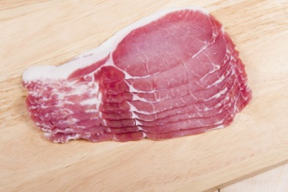 | 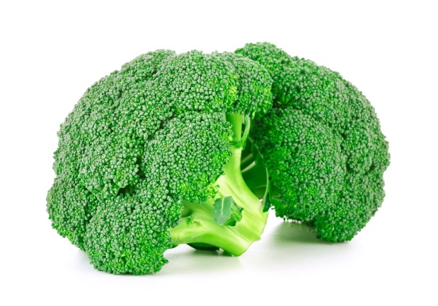 | 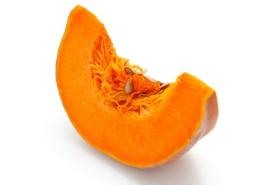
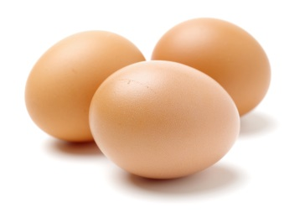 | 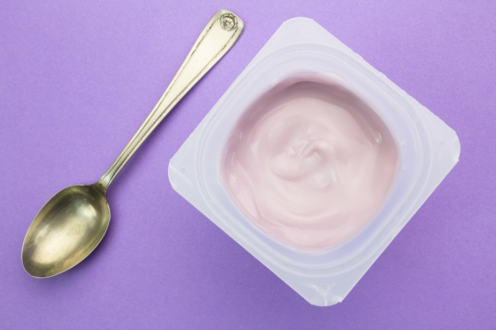 | 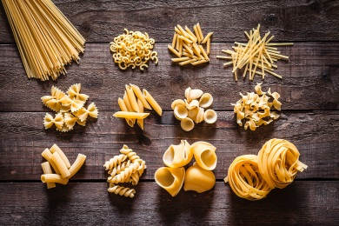
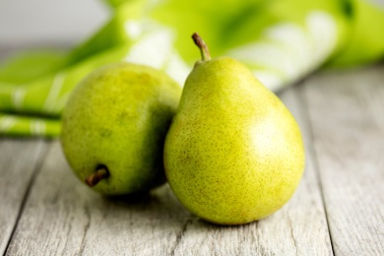 | 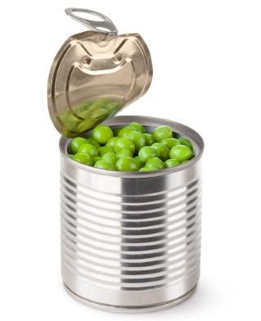 | 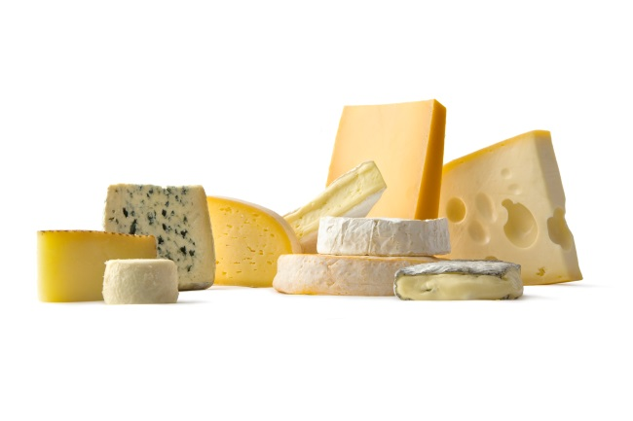
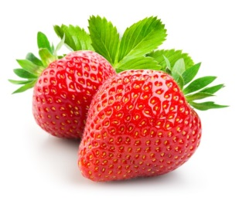 | 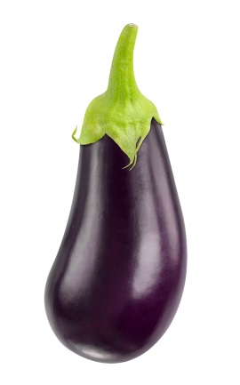 | 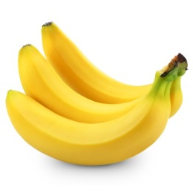
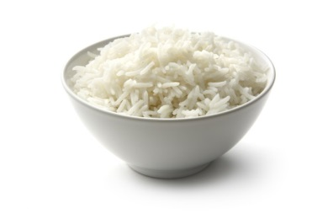 | 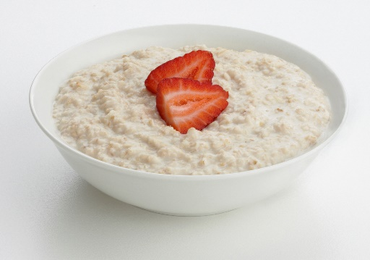 | 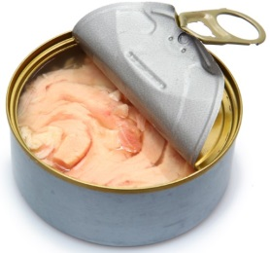

Food sources

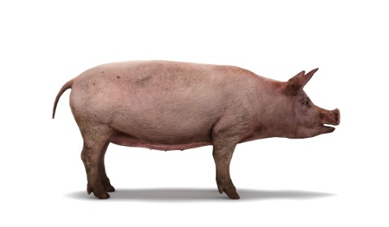 | 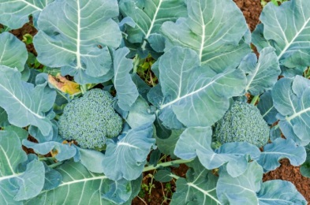 | 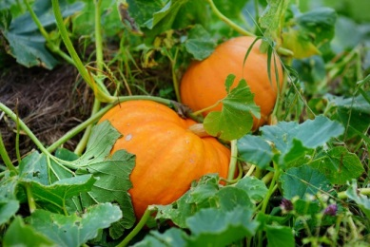
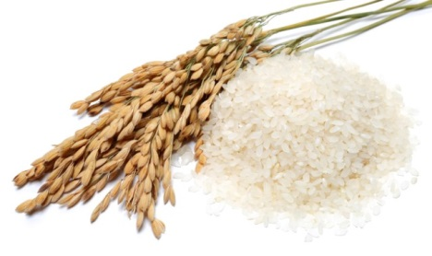 | 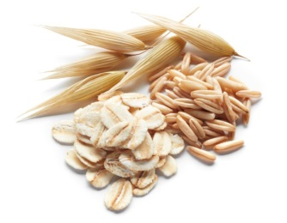 | 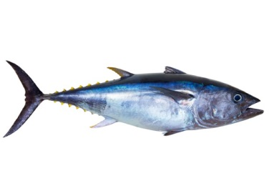
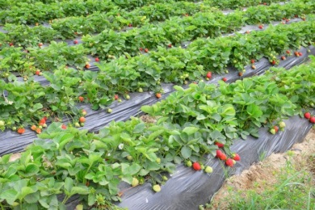 | 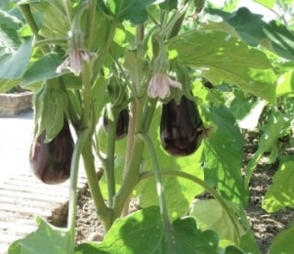 | 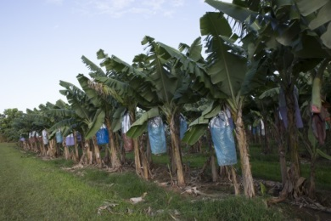
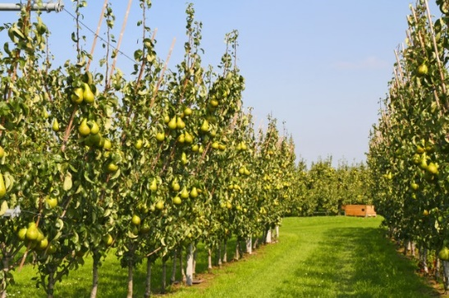 | 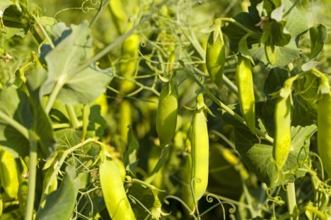 | 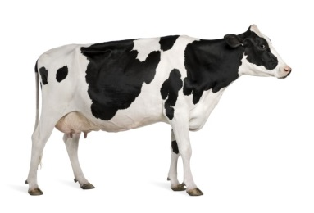
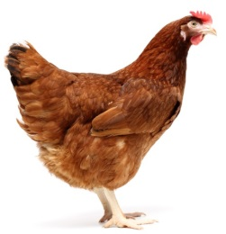 |  | 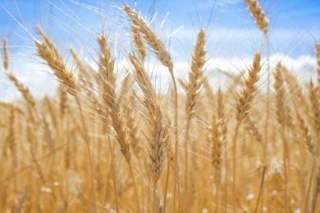

Appendix 2

Foods and food groups

Appendix 3
From paddock to plate – milk

1. Cut out the milk production steps shown below.
2. Put them in the correct order and paste them into your workbook.
3. Use numbers or arrows to show the correct order.
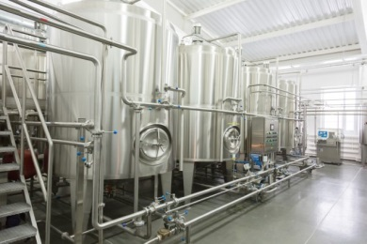 | The dairy cows are milked at the farm.
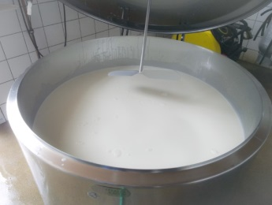 | We have milk with our lunch.
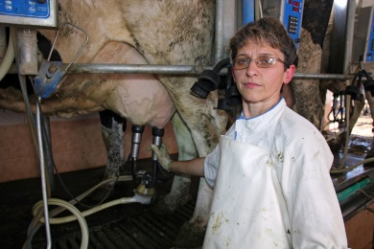 | Milk is put into bottles ready to be sold.
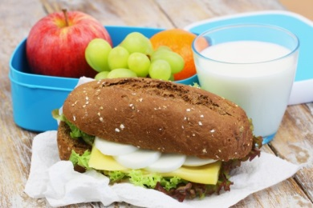 | Milk is cooled in a large vat on the farm.
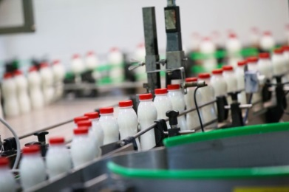 | A tanker truck collects the milk from the farm and takes it to a factory.
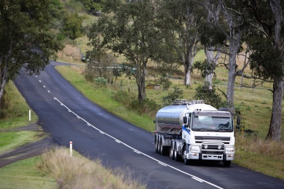 | Milk goes to the factory where it is processed.

