Profiles of EAL learners
The following descriptions of the EAL pathways and levels have been provided to assist teachers and schools to place students on the most appropriate EAL pathway and level, following analysis of the information provided in the diagnostic interview.
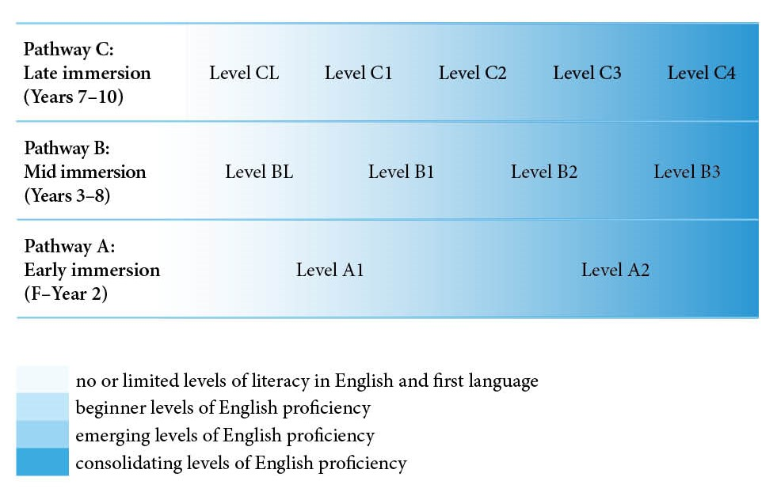

EAL Pathway A

EAL Level A1
At Level A1, students can talk about their immediate environment and experience in their first or other languages and are also beginning to use English.
They need to learn how spoken and written English can be used to communicate in their surroundings about their experiences, and develop the knowledge and skills required for understanding and producing simple English texts related to participation in the classroom.
They draw on their prior experiences as they begin to use English in classroom routines, highly contextualised interactions and learning activities, with extensive scaffolding and support.

EAL Level A2
At Level A2, students have increased familiarity with the classroom and have developed skills in using English for different interactional and instructional activities.
They need to consolidate and develop their ability to use English more creatively and expressively in the classroom, as well as in interactions outside the classroom. They need to expand the range of English texts they work with and produce, and develop a deeper understanding of the patterns and structures of spoken and written English.
They are consolidating their ability to participate in all areas of the curriculum. There may be some gaps and inconsistencies in their use of English, but their English skills are approaching what is expected across all curriculum areas in the classrooms in which they are learning.

EAL Pathway B

EAL Level BL
At Level BL, students have had a range of experiences and some informal learning prior to commencing school in Australia. They have learnt to speak their first or other languages in this context, although they are yet to develop literacy skills in any language they speak. They are beginning to learn English and are adapting to participation in Australian classrooms.
They need to learn English to communicate in the classroom and in their immediate social contexts, and become familiar with the routines and expectations of participation in classrooms. They need to engage with learning content in different curriculum areas that builds on their experiences. They need to begin to engage with and produce basic written texts and develop fundamental literacy skills of written English while still in the initial stages of learning spoken English.
They build on their experiences of highly contextualised, predictable and supported routines, interaction and learning activities to develop spoken English and basic English literacy skills that form a foundation for further learning across the curriculum areas.

EAL Level B1
At Level B1, students have developed first language skills and emerging or developed L1 literacy skills that result from their previous experience of formal schooling. They are beginning to learn English.
They need to learn how to use English for interaction and learning activities in classrooms, and develop their English language skills in highly contextualised and structured situations, with strong scaffolding, predictability and support.
They are beginning to work with basic written texts in English that relate to their personal and academic learning needs and experience. They begin to use English in highly contextualised curriculum areas to communicate about topics of which they have prior knowledge or experience.

EAL Level B2
At Level B2, students are at a stage of emergence and development of their ability to use English in social and academic contexts. Students working at this level can communicate straightforward meanings in spoken and written English about contextualised topics in familiar situations. Their knowledge of their first and other languages provides them with resources that assist development of their capacity to use spoken and written English.
They need to expand their skills in using English in different contexts, broaden the range of meanings they can communicate and use features of the language to achieve greater clarity of meaning.
They develop proficiency in a wider range of interactions and texts related to different curriculum areas, and move beyond highly contextualised or previously experienced learning areas and topics to learning that is more abstract or new to them.

EAL Level B3
At Level B3, students are able to use spoken and written English effectively in a wide range of social interactions and on a wide range of topics, and are moving to more independent, creative and expressive use of English across different types of interactions and in different curriculum areas.
They need to consolidate their skills in using English to express and work with more precise and nuanced meanings as well as their understandings of subtleties and cultural connotations that add clarity and richness to communication. They need to explore different styles of language use, and reflect on their use of English to extend their ability to use their language and remove occasional errors and inaccuracies.
They are consolidating their ability to independently participate in all areas of the curriculum. There may be some gaps and inconsistencies in their use of English, but their English skills are approaching what is expected across all curriculum areas.

EAL Pathway C

EAL Level CL
At Level CL, students have had considerable life experience and informal learning prior to commencing school in Australia. They have learnt to speak their first or other languages in that context, although they are yet to develop literacy skills in any language they speak. They are beginning to learn English and are adapting to participation in Australian classrooms.
They need to begin to learn English for communication in the classroom and in their immediate social contexts. They also need to begin to engage with learning content in different curriculum areas that goes beyond their own experiences. They need to begin to engage with and produce basic written texts and develop fundamental literacy skills of written English while still in the initial stages of learning spoken English.
They build on their experiences of highly contextualised, predictable and supported routines, interaction and learning activities to develop spoken English and basic English literacy skills that form a foundation for further learning across the curriculum areas.

EAL Level C1
At Level C1, students are building on their consolidated L1 language and literacy skills. This supports their understanding of themselves and the world, and their academic learning. They are beginning to learn English.
They need to learn how to use English for social interaction and classroom learning activities related to both concrete and abstract areas of learning. They need to use English in highly contextualised and structured situations, with a high level of scaffolding, predictability and support.
They are beginning to use basic written texts related to their personal and academic learning needs and experience, building on their existing knowledge.

EAL Level C2
At Level C2, students are at a stage of emergence beyond expression of basic and controlled meanings in English. Students working at this level can communicate straightforward meanings in spoken and written English in familiar situations and about contextualised topics. Their knowledge of L1 and other languages provides them with resources that assist development of their capacity to use spoken and written English.
They need to begin to develop their ability to use English in a wider range of situations, including different types of social interactions and tasks in different curriculum areas. They need to use the structures and features of English consistently to achieve greater clarity of meaning.
They are beginning to work with a wider range of conversations and texts, especially those that are well contextualised or relate to prior learning experiences and familiar curriculum areas.

EAL Level C3
At Level C3, students are developing their English language skills across all curriculum areas, drawing on their previous learning of English and their knowledge about language’ and often literacy, derived from proficiency in their L1 and other languages.
They need to become more adept at working with a wider range of text types, expressing more complex meanings and becoming more aware of different styles and purposes of communication. They need to work with texts of increasing complexity, dealing with more abstract meanings and developing their knowledge of how features of English are used for different purposes, topics and audiences.
They are developing some independence in their use of English, and their ability to use English is developing to include more abstract and less familiar content in all curriculum areas.

EAL Level C4
At Level C4, students are able to use spoken and written English effectively in a wide range of social interactions and topics, and they are consolidating their use of English across different types of interactions and in different curriculum areas.
They need to learn to use English to express and work with more precise and nuanced meanings, as well as develop understandings of subtleties and cultural connotations that add clarity and richness to communication. They need to explore different styles of language use, and reflect on their use of English to extend their capacity to use their language and remove occasional errors and inaccuracies.
They are consolidating their ability to independently participate in all areas of the curriculum. There may be some gaps and inconsistencies in their use of English, but their English skills are approaching what is expected across all curriculum areas in the classrooms in which they are learning.

