Differentiating existing learning sequences for English as an Additional Language students

Mathematics, Level 4, for EAL learners at Level B2
Existing learning sequences linked to particular learning areas in the Victorian Curriculum F–10 can be adapted to support differentiated teaching for English as an Additional Language (EAL) students. Teachers can adapt, remove or add to elements of their learning sequences in order to cater for all students in their classrooms.

1. Identify an existing learning sequence
Existing learning sequence: More money, more problems – Computational and algorithmic thinking in Mathematics
Curriculum area and levels: Mathematics, Level 4

2. Identify the level of language learning of your students
The EAL curriculum is a continuum structured as three EAL pathways (A, B, C). Each pathway describes a different stage of English-language learning (early, mid and late), and each pathway is divided into different levels of language learning (A1, A2, BL, B1, B2, B3, CL, C1, C2, C3, C4).
While the implementation of the EAL curriculum is the responsibility of all teachers, the EAL specialist plays a leading role in its delivery, as the expert in the field. Your EAL specialist will determine the most appropriate pathway for each EAL learner in your classroom and advise you of their current level of learning.
The differentiation suggestions provided in this document are for students working at Level B2 of the EAL curriculum.
EAL learners at Level B2 will typically be able to:
- describe a series of events or actions using some detail
- follow simple written instructions and questions
- follow simple time and logical relationships between events and ideas expressed by common cohesive devices.
Acknowledgements:
Images of Australian coins reproduced by permission, © the Royal Australian Mint; banknote images reproduced © RBA, subject to conditions. Designers of coins: Stuart Devlin and ($2) Bertram Ainslie Roberts/Horst Hahne. Australian banknote designers Bruce Stewart (1992, 1996); Max Robinson (1993); Gary Emery (1994); Brian Sadgrove (1995) and emerystudio (2016–2020).

3. Adapt the learning sequence to differentiate for EAL students
Existing learning sequence | Differentiated teaching for EAL learners at Level B2
Overview | Overview
Learning intentions:  - Students will create an algorithm for sorting coins by denomination (value) | Learning intentions:  - Students will use language effectively to create an algorithm for sorting coins by denomination (value)
Relevant content descriptions in Mathematics, Level 4:  Define a simple class of problems and solve them using an effective algorithm that involves a short sequence of steps and decisions (VCMNA164) | Additional EAL Level B2 content descriptions:  Recall and retell a simple story such as a recount, legend or fairytale (VCEALC327)  Use simple descriptive phrases (VCEALL337)  Follow simple instructions and questions in print or digital texts (VCEALC348)
Relevant achievement standard:  Students … choose appropriate strategies for calculations … for the context. | Relevant achievement standard:  At Level B2 students … describe a series of events or actions using some detail … [They] follow simple written instructions and questions … They follow simple time and logical relationships between events and ideas expressed by common cohesive devices.

Existing learning sequence | Differentiated teaching for EAL learners at Level B2
Teaching and learning activities | Teaching and learning activities  Differentiated teaching is required to support EAL learners with the following learning activities.
Activity 1: The two-coin sort  As a warm-up to this activity, first complete one of the interactive sorting algorithms from this video with the class:  - Sorting Algorithms video (mrtheta, YouTube)  Then, ask students to select any two coins (see Appendix 2) and line them up on the two-coin sorting mat (see Appendix 3). For example:  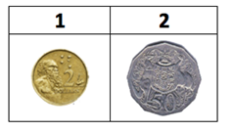  Students develop and describe a clear and logical step-by-step process (algorithm) for ordering their set from smallest to largest value in the most efficient way possible (fewest steps). They could ask one question at a time or compare two coins at a time.  Tip: This process (set of instructions) is called an algorithm. Remember that there are many ways students can solve these sorting problems using an algorithm of their own design. The key is to encourage students to revisit their algorithms and processes to improve their efficiency and accuracy.  One possible method students might find for sorting two coins is as follows.  - Compare coins 1 and 2.  - Place the largest value coin on the right.  - Coins are now sorted from smallest to largest value.  This would look like:  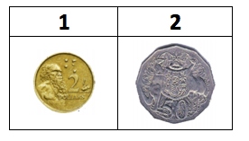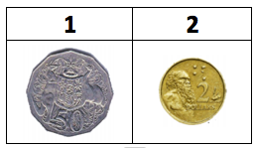  Challenge students to come up with more than one way to solve this problem.  - Is your algorithm the only way to solve this problem? How else could you have solved this problem?  - Is this the most efficient way? (Does it use the fewest moves?)  Have students record their algorithms so they can be repeated. They could do this, for example, by:  - creating a flow chart  - using pictures or diagrams  - using words or creating a story  - making a video.  At this point, encourage groups to share their algorithms with the class. Students could decide which algorithms seem to be the most efficient, or the simplest to follow. | Activity 1: The two-coin sort  Make paper signs with numbers corresponding to the number of students in the class (for example, numbers from 1 to 12 if there are 12 students in the class).  Give each student a sign with a unique number. Do the Insertion Sort (the first sorting method in the video) with the whole class (teacher does the sorting):  - Sorting Algorithms video (mrtheta, YouTube)  Once the sorting activity is complete, refer back to the activity to verbally explain the word ‘sorting’, together with ‘smallest’, ‘largest’ and ‘compare’, by using examples from the activity as follows:  - Sorting: Explain (based on the video) that this is the teacher’s act of putting the different numbers in an order.  - Compare: Explain (based on the video) that when the teacher looks at the numbers to see which one is the smallest and which one is the largest, they ‘compare’ the numbers.  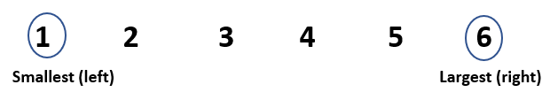  - Left/right, smallest/largest: Explain using the example below:  See Appendix 1 – Vocabulary reference table for a helpful vocabulary table that you can refer to and add to throughout the learning activities. You may need to pre-teach some of this vocabulary to students.  Tell students that they are going to learn how to sort money so that they can help adults when going shopping.  Tell them that when sorting coins, they will compare value, not size. Depending on students’ prior knowledge about coin value, you may need to explain that 50 cents is the smallest value and $2 is the largest, despite the sizes of the coins.  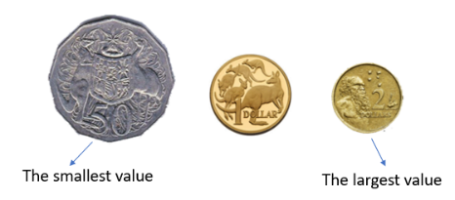  Give each student a two-coin sorting mat (Appendix 3) and one of each coin: 50 cents and 2 dollars (Appendix 2). Ask them to place the mat and the coins in front of them.  Give the following instructions, step by step, making sure the students complete each step before moving on. Refer back to the definitions above if necessary.  - Compare coin 1 and coin 2. (Ask ‘Which coin has the largest value?’)  - Place the largest value coin on the right.  - Coins are now sorted from smallest to largest value.  Check that all students follow along and sort correctly. Provide feedback where necessary. Show the result of sorting:  Explain the word ‘algorithm’ using the two-coin sort example above. The instructions can be used as an example of an algorithm that uses words:  - Compare coin 1 and coin 2.  - Place the largest value coin on the right.  - Coins are now sorted from smallest to largest value.  Visually and verbally model the following additional ways to record the above algorithm, explaining vocabulary where necessary (for example, ‘chart’, ‘diagram’, ‘video’):  - create a flow chart  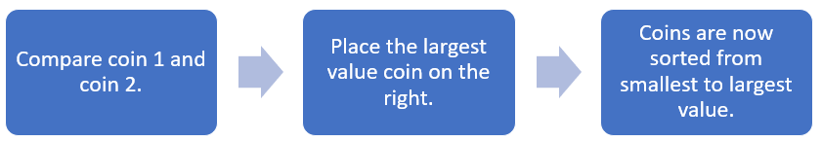  - use pictures  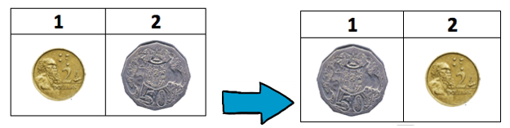  - make a video (model this method if students have access to a camera device).  Ask students:  - Is this algorithm the only way to solve this problem?  - How else could you have solved this problem?  Challenge students to come up with a different algorithm in pairs, where one student sorts and the other records the algorithm using one of the four ways above.  Ask the pairs to share their algorithms.  As a class, discuss and decide which algorithm is the easiest to follow and why. Explain the phrase ‘the most efficient algorithm’.
Activity 2: The three-coin sort  Students now select any three coins and line them up on the three-coin sorting mat (see Appendix 3). For example:  1 2 3  Students need to come up with a process (algorithm) for ordering their set from smallest to largest value in the most efficient way.  Discussion prompt:  - Can you modify your first algorithm to work here? Why or why not?  One possible method students might find for sorting three coins is as follows.  - Compare coins 1 and 2.  The largest value coin goes on the right.  - Compare coins 2 and 3.  The largest value coin goes on the right.  - Compare coins 1 and 2 again.  The largest value coin goes on the right.  Coins are now sorted from smallest to largest value.  This algorithm in practice would look like this:  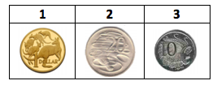  At the start  Step 1  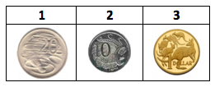  Step 2  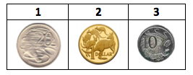  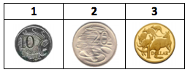  Step 3  At this point, compare strategies between small groups so students can appreciate other solution methods and corresponding algorithms.  Challenge students to come up with more than one way to solve this problem.  - Is this the most efficient way? (Does it use the fewest moves?)  - How could you use your previous algorithm here? Did it work? Why or why not?  - Test your algorithm using other starting coins on your three-coin mat. Does it still work? What needs to be fixed? | Activity 2: The three-coin sort  Preparation:  If this activity is done in a new lesson, revisit the words ‘sorting’, ‘compare’, ‘value’, ‘smallest’, ‘largest’ and ‘algorithm’, referring to the visuals in Activity 1 above.  Tell students that they are going to work in pairs to sort the coins and come up with an algorithm. Students from the same home language background should be paired where possible to allow for discussion in their home language. Where this is not possible, an EAL student should be paired with a non-EAL student or an EAL student working at a higher level of the EAL curriculum to facilitate more effective communication.  Give the following instructions in both verbal and print form. Use familiar phrases as in the instructions below and ask one student to repeat the instructions.  Instructions for pair work:  - Student A: Discuss with Student B and sort the coins from smallest to largest value.  - Student B: Discuss with Student A and record the algorithm using one of the following:  - creating a flow chart  - using pictures  - using words  - making a video.  Pair work:  Give each pair a three-coin sorting mat (Appendix 3), and one of each coin: one dollar, 20 cents and 10 cents (Appendix 2). Ask the pairs to place the resources in front of them. For example:  1 (left) 2 (middle) 3 (right)  Monitor students’ activity and provide feedback or prompts where necessary. For example, ask students:  - How could you use your previous algorithm here? Did it work? Why or why not?  - Should this coin go here or there? Why?  One possible method students might find for sorting three coins is as follows.  - Compare coins 1 and 2.  The largest value coin goes on the right.  - Compare coins 2 and 3.  The largest value coin goes on the right.  - Compare coins 1 and 2 again.  The largest value coin goes on the right.  Coins are now sorted from smallest to largest value.  Reflective discussion:  At the end of the sorting activity, ask the pairs to show their algorithms to the class. Elicit and provide feedback on students’ work.  As a class, discuss and decide which algorithm is the easiest to follow or is most efficient and why. Ask students if they can think of another way to sort the coins.  Ask students to test their algorithm using other starting coins on their three-coin mat. Ask:  - Does it still work? What needs to be fixed?
Activity 3: The four-, five- and six-coin sorts  Students now use the appropriate sorting mats (Appendix 3) to efficiently sort four, five and six random coins. For example, six coins randomly set out in the six-coin sorting mat could look like the image below.  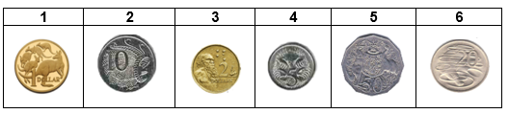  Students might like to race other small groups to see who has the most efficient sorting algorithm.  Again, prompt students to demonstrate their algorithmic thinking (logical process). Encourage students to work collaboratively and check that their algorithms work.  Tips: Encourage students to identify where they can re-use or repurpose their previous algorithms, if possible, with modifications for this new problem.  Show students the following videos and encourage them to make connections with their thinking:  - video of an animated robot using the Bubble Sort algorithm to sort coloured balls. This video also demonstrates the Quick Sort algorithm versus Bubble Sort.  Visualization of Quick sort video (uniprod, YouTube)  - video of a robot demonstrating the Merge Sort algorithm and racing another robot using the Quick Sort algorithm.  Merge Sort vs Quick Sort video (uniprod, YouTube) | Activity 3: The four-, five- and six-coin sorts  Repeat the same process as in Activity 2, this time with a four-coin sort (Appendix 3) to reinforce the process of algorithmic thinking.  Once students have become fluent with the process, get them to race with other students to develop fluency in algorithmic thinking.  Sorting competitions:  Tell students that they are going to join a whole class competition where they race each other to sort five coins, then six coins.  Show students the video of an animated robot using different sorting methods and then the video of an animated robot competing with another robot.  - Visualization of Quick sort video (uniprod, YouTube)  - Merge Sort vs Quick Sort video (uniprod, YouTube)  Discuss the main features of the races in the videos; for example, the use of different algorithms, the sequences of steps, number of steps, efficiency.  Before they start racing, remind students to keep sorting even when others have finished.  Monitor students’ sorting during the race. Keep time and record the finishes.  Discuss with students the different algorithms they used in the race and their efficiencies, similarities and differences.  Ask students what they learned from earlier sorting activities that they could use in this race.  Revisit the key concepts of ‘sorting’ and ‘algorithm’.

Additional resources
You can access the EAL curriculum on the Victorian Curriculum F–10 website.
You can access a range of resources to assist with implementing the EAL curriculum on the VCAA English as an Additional Language webpage, including profiles of EAL learners, sample progressions through the EAL pathways, a language and learning interview, FAQs, professional learning opportunities and links to external resources.

Appendices

Appendix 1 – Vocabulary reference table
Content-specific vocabulary | Linguistic-specific vocabulary  (verbs of instruction) | Language for interaction | Language for clarification
sort  compare  value  smallest  largest  steps  algorithm | Place …  Make …  Move …  Draw … | First you …  Then …  Okay, now you have to … | Can you say that again, please?  What was the step again?

Appendix 2 – Australian coins and notes
You may wish to print these on cardboard and/or laminate them. Printing the notes and coins in colour will allow students to use ‘colour’ as a sorting category.

Appendix 3 – Coin sorting mats
Students can place their sorted coins in the coin slots (empty boxes) in each mat.

Two-coin sorting mat Three-coin sorting mat
1 | 2 |  | 1 | 2 | 3

Four-coin sorting mat
1 | 2 | 3 | 4

Five-coin sorting mat
1 | 2 | 3 | 4 | 5

Six-coin sorting mat
1 | 2 | 3 | 4 | 5 | 6

