Differentiating existing learning sequences for English as an Additional Language students

Design and Technologies, Health and Physical Education, Levels 7 and 8, for EAL learners at Level C2
Existing learning sequences linked to particular learning areas in the Victorian Curriculum F–10 can be adapted to support differentiated teaching for English as an Additional Language (EAL) students. Teachers can adapt, remove or add to elements of their learning sequences in order to cater for all students in their classrooms.

1. Identify an existing learning sequence
Existing learning sequence: Food labelling practices
Curriculum area and levels: Design and Technologies, Health and Physical Education, Levels 7 and 8

2. Identify the level of language learning of your students
The EAL curriculum is a continuum structured as three EAL pathways (A, B, C). Each pathway describes a different stage of English-language learning (early, mid and late), and each pathway is divided into different levels of language learning (A1, A2, BL, B1, B2, B3, CL, C1, C2, C3, C4).
While the implementation of the EAL curriculum is the responsibility of all teachers, the EAL specialist plays a leading role in its delivery, as the expert in the field. Your EAL specialist will determine the most appropriate pathway for each EAL learner in your classroom and advise you of their current level of learning.
The differentiation suggestions provided in this document are for students working at Level C2 of the EAL curriculum.
EAL learners at Level C2 will typically be able to:
- access information in some basic academic texts with support and adequate scaffolding
- use basic text models to form their own texts using familiar and new vocabulary.

3. Adapt the learning sequence to differentiate for EAL students
Existing learning sequence | Differentiated teaching for EAL learners at Level C2
Overview | Overview
Learning intentions:  - Students will be able to read and understand the information on food labels  - Students will be able to make healthy food choices using food labels  - Students will know why food labels are required | Learning intentions:  - Students will be able to read and understand the information on food labels  - Students will be able to make healthy food choices using food labels  - Students will know why food labels are required  Language focus:  - Students will be able to make comparisons using comparatives and superlatives, such as ‘more than’, ‘less than’, ‘the most’ and ‘the least’  - Students will develop subject-specific vocabulary to discuss food products and nutrition
Relevant content description in Design and Technologies, Levels 7 and 8:  Investigate the ways in which designed solutions evolve locally, nationally, regionally and globally through the creativity, innovation and enterprise of individuals and groups (VCDSTS044)  Relevant content descriptions in Health and Physical Education, Levels 7 and 8:  Develop skills to evaluate health information and express health concerns (VCHPEP129)  Plan and use strategies and resources to enhance the health, safety and wellbeing of their communities (VCHPEP130) | Additional EAL Level C2 content descriptions:  Extract specific information from spoken or visual texts, using guide questions from the teacher (VCEALC613)  Use simple descriptive phrases (VCEALL627)  Express simple opinions and describe feelings (VCEALC615)  Locate specific information from subject-based diagrams, graphs and charts (VCEALC633)  Check and/or confirm the meaning of unfamiliar words using a bilingual dictionary (VCEALA641)  Interpret the way information is organised in texts (VCEALL643)  Use modelled subject-specific vocabulary appropriately (VCEALL669)
Relevant achievement standard:  Design and Technologies  By the end of Level 8, students … explain the contribution of design and technology innovations and enterprise to society.  Health and Physical Education  By the end of Level 8, students … gather and analyse health information.  They justify actions that promote their own and others’ health, safety and wellbeing at home, at school and in the community. | Relevant achievement standard:  At Level C2 students use simple but effective strategies … [to] communicate effectively in a range of familiar social and some basic academic contexts, experimenting with and adapting their developing English and cultural understanding. With support in academic contexts, they extract some specific information from texts …  They use headings and diagrams to assist in reading accessible texts from across the curriculum for a range of purposes … They write … some basic texts and experiment with presenting their own ideas. Their texts show varying grammatical accuracy … They use basic text models as a basis for their own texts.

Existing learning sequence | Differentiated teaching for EAL learners at Level C2
Teaching and learning activities | Teaching and learning activities  Differentiated teaching is required to support EAL learners with the following learning activities.
Activity 1: Front-of-package labelling – Y chart | Activity 1: Front-of-package labelling – Y chart  Tip: Provide relevant visuals (such as photographs, sketches, graphic organisers, diagrams, videos, 3D models and/or real objects) to set the context at the beginning of the lesson. This helps EAL learners make sense of what is being taught in the curriculum and can help them connect to previous experiences and knowledge without the limitations of language.  The Gradual Release Model (Pearson and Gallagher, 1983) is a guiding principle of EAL teaching and learning. Take note of how the activities in this sequence scaffold the learning for EAL learners, by:  - setting the context using visuals  - introducing the new vocabulary in context  - demonstrating the task, providing examples  - providing opportunity for guided practice  - providing opportunity for Independent practice.
Bring in a range of packaged food products so students can explore the front-of-package labelling. The products could be themed, such as snacks, cereals or pre-packaged meals. | Set the context:  Bring in a range of packaged food products so students can explore the front-of-package labelling.  Tip: Teachers who show cultural sensitivity and cultural awareness will help EAL learners feel they are part of an inclusive classroom. EAL learners may not have been exposed to the same kinds of food that other students have; therefore, do not assume all students will be familiar with the products on display. Allow students to see inside the food packages, and include some food products that are more commonly used in the countries of your EAL learners when selecting packaged food products for this task.  Display the packaged food products for EAL learners to understand the context of what is being discussed, prior to explaining the task and giving instructions.  If products are in categories, make sure the products are physically grouped together. Label the categories in writing for students’ reference; for example, snacks, cereals and pre-packaged meals. Vocalise the categories and point to the associated groups. This also helps to introduce key vocabulary needed for the next task.  Introduce key vocabulary in context:  Tip: EAL learners should be encouraged to develop a home language bilingual glossary within which to keep a record of new vocabulary in each subject across the curriculum. They can build on their subject-specific glossaries throughout the year.  List the content-specific vocabulary on the board, or provide a printed list to students. Allow students to use their home language (bilingual dictionary or home language peers) to access unfamiliar words on the list. Key words include ‘healthy’, ‘unhealthy’, ‘package’, ‘packaged’, ‘pre-packaged’, ‘product’, ‘snack’, ‘cereal’, ‘information’, ‘look’, ‘feel’, ‘image’, ‘mascot’, and various adjectives that can be found on the specific packaging such as ‘fun’, ‘convenient’ and ‘healthy’.  If possible, point to these words on the board when they are used in discussion during the lesson so that EAL learners can make the connection between the spoken and written words and phrases.  See Appendix 1 – Vocabulary reference table for a helpful vocabulary table that you can refer to and add to throughout the learning activities. You may need to pre-teach some of this vocabulary to students.  Tip: In addition to providing vocabulary lists, introduce students to the key words needed for the lesson by providing a matching task (students match the word to the picture) or labelling task (students are provided with the words to label a diagram, chart or image). See Appendix 2 for examples of definitions that can be provided to students at this level.
Have students work in small groups to examine one food product per group.  Each group should complete a Y chart (Appendix 3) to describe the following features of their front-of-package label:  - information and claims (for example, organic, tasty, quick)  - look (for example, colours, images, mascots)  - feel (for example, fun, convenient, healthy). | Demonstrate the task and provide examples:  Tip: Some EAL learners may have had interrupted schooling, which has limited their exposure to different kinds of learning tasks. In addition, even for EAL learners with prior schooling, some common classroom activities may not be familiar. Therefore, demonstrate each task clearly, with actions and examples.  Choose one product to demonstrate the task. Begin by asking students what the product is and if they have ever seen it or eaten it.  Use the product to model how to complete the Y chart (Appendix 3).  Make sure to use this initial discussion of the product to model simple descriptive words and phrases EAL learners can use to describe the front-of-package label. Write them on the board.  Have students add these simple descriptive words and phrases to their bilingual glossaries.  Opportunity for guided practice:  Keep the written model visible while students complete their own Y charts.  Give small mixed groups of EAL learners and their non-EAL peers a food product from the display and have them complete their Y chart together. Select an appropriate food product for groups with EAL learners. It should be a familiar item with clear and appropriately levelled vocabulary.  Opportunity for independent practice:  If time permits:  - have students independently complete a Y chart on a different product  - have EAL learners complete Appendix 4 as an additional consolidation or assessment task.  Tip: When forming small groups to complete activities, be aware of the language requirements of the task and place EAL learners where they will receive the most support. At times, EAL learners at Level C2 can be grouped with EAL learners of the same home language at Level CL or Level C1, to assist the students with the language requirements of the task. However, it is also important that students at Level C2 or above get many opportunities to practise speaking with their non-EAL peers, to hear and practise authentic expressions of English in different forms.
Activity 2: Front-of-package labelling: Short answer questions  Students can then answer the following questions:  - Who is the target market; that is, adults, teenagers, health-conscious consumers?  - How are mascots and images used to create a message?  - Why are certain colours used? Do they portray a message? What is the message?  - Which words are in the largest print? Which are in the smallest print? Why?  - Do you think any of the claims are misleading?  Have students share their findings in a class or small-group discussion. | Activity 2: Front-of-package labelling: Short answer questions  Introduce new vocabulary and demonstrate the next task.  Tip: Note how the questions for non-EAL students have been modified for EAL learners at Level C2. Each question has been simplified in way that helps to elicit definitions of new key vocabulary, such as ‘target market’, ‘message’ and ‘claim’. For example, ‘How does the mascot make you think or feel?’ serves to explain the meaning of ‘message’ in this context.  Use the same product as in Activity 1 for this task. Provide a copy of the questions below to your EAL learners and read through the questions aloud, encouraging discussion about the product to elicit some of the content-specific vocabulary.  - Would you want to buy this product? Why or why not? (This question can be used to introduce the concepts of a market and a target market.)  - Who would want to buy this product? Why? (This question can be used to reinforce the concept of a target market.)  - What do the mascot and/or images make you think or feel about this product? (This question can be used to introduce the concept of a product having a message.)  - What do the colours make you think or feel about this product? (This question can be used to reinforce the concept of a product having a message.)  - Which words are the largest? Which ones are the smallest? Why? (This question reinforces the concept of message.)  - Do you think all the information on the package is true? Why or why not? (This question can be used to introduce the concept of a claim or information being misleading.)  Write the new words on the board and elicit definitions from your students. See Appendix 5 for an example of the kinds of definitions that can be provided to students at this level.  Have students add the new words and phrases to their bilingual glossaries.  Opportunity for practice:  Give pairs of students another product to use to discuss the questions above. For this task, allow EAL learners to share their ideas in home language pairs if possible, before asking students to share their ideas with non-EAL students. This will give them the opportunity to practise the language required to discuss their ideas.  Have students share their findings in a class or small-group discussion.
Tip: Alternatives to bringing in packaging:  - Most food manufacturers include nutritional information about their products and advertising on their websites (for example, Kellogg’s Australia website).  - Packaging and nutrition panels can be found for individual food products on the Woolworths online shopping website. | Tip: Authentic and real-life materials (such as packaged food that students can hold and view) are more accessible to EAL learners than the information that can be found on websites. The familiarity of the products provides an immediate context and the information on the packaging is easier to navigate.
Activity 3: Nutritional information and ingredients – understanding food labels  Use the same food products from Activity 1, but this time have students explore the nutrition panels and ingredient lists, and compare these with the front-of-package labelling.  As a class, using the front-of-package labelling as a guide, have students rank the food products from most healthy to least healthy.  If there are debates over the appropriate ranking, ask students to justify their reasoning.  Document this ranking for comparison later in the activity.  Have students work in groups to examine one food product. Referring to Eat for Health: How to understand food labels, have them explore the following questions, documenting their findings:  - What is the main ingredient?  - How does its fat, sugar, salt and fibre content compare to Eat for Health’s guide?  - Are other names being used for fat, sugar or salt? If so, what are they?  - How many serves are in the package?  - Is this food an everyday food or a discretionary food? Why?  Students should then consider:  - Does the nutritional content match up with claims on the packaging?  - Are there any misleading terms or pieces of information?  - Are there any terms or pieces of information that you don't understand or have questions about?  Each group can then present their findings to the class.  As a class, rank the products again, from most healthy to least healthy, based on the food labels. Get students to justify where foods have been placed on this continuum.  Were there any differences from the initial ranking? If so, discuss why.  Essential resources:  - A range of packaged food products  - Eat for Health: How to understand food labels  Tip: Alternatives to bringing in packaging:  - Most food manufacturers include nutritional information about their products and advertising on their websites (for example, Kellogg’s Australia website).  - Packaging and nutrition panels can be found for individual food products on the Woolworths online shopping website | Activity 3: Nutritional information and ingredients – understanding food labels  Tip: Using the same food products from Activity 1 is helpful to EAL learners as it does not require processing of additional new information.  Set the context using visuals:  As a class, using the front-of-package labelling as a guide, line up the food products and rank them from the unhealthiest to the healthiest.  When ranking the items, physically put them in the suggested order so that it provides a visual prompt.  Having the words ‘the unhealthiest’ and ‘the healthiest’ at each end of the range, as well as images to accompany them, will also help EAL learners to understand the task.  For example:  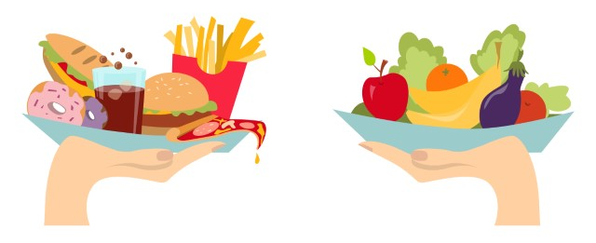  The unhealthiest The healthiest  Emphasise the words ‘least’, ‘less’, ‘more’, ‘most’ and the suffixes ‘-ier’ and ‘-iest’ when comparing the products.  Record the rankings on a cline (a scale of language terms going from one extreme to another – for example, from ‘unhealthiest’ to ‘healthiest’), as shown in the diagram below. This initial ranking will be compared to the new ranking at the end of this activity.  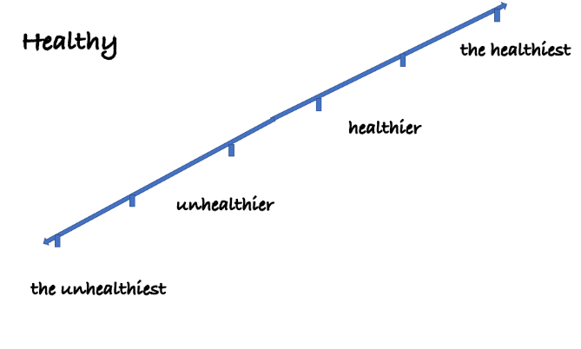  This cline also helps to consolidate the language focus for this sequence of activities, which is the use of comparatives (‘less than’, ‘more than’, ‘-ier’) and superlatives (‘the least’, ‘the most’, ‘-iest’).  Introduce new vocabulary in context:  Provide EAL learners with the ‘Language for comparison’ in the Vocabulary reference table (Appendix 1) so they can practise justifying their opinions. For example, ‘I think this has more sugar than …’ or ‘I think this has less fat than …’  Discuss the reasons students put the products in that order. During this discussion, elicit key vocabulary, such as ‘sugar’, ‘salt/sodium’, ‘fibre’, ‘vitamins’, ‘minerals’, ‘fat’, ‘saturated fat’ and ‘energy’. If appropriate, introduce other descriptive words and phrases from the packaging such as ‘no artificial flavours’.  Encourage EAL learners to use their home language (bilingual dictionary or home language peers) to access the meaning of unfamiliar words on the list. Searching Google Images can also help them with this task.  Introduce the task:  Instruct students to categorise ingredients into two groups: healthy and unhealthy. Accompany the word ‘healthy’ with a smiley emoji. Accompany the word ‘unhealthy’ with an unhappy emoji. The association of various ingredients with these emojis will be useful during this activity.  Display Eat for Health: How to understand food labels on the board. Explain the connection between the colours and the labels. Ask questions to elicit understanding, such as:  - What is a healthy amount of total fat per 100g? (less than 10g per 100g)  - What is a healthy amount of sugar per 100g? (less than 15g)  - What is a healthy amount of salt per 100g? (less than 400mg)  - What is a healthy amount of fibre per 100g? (more than 3g)  - What is a healthy amount of energy per serve? (less than 600kJ)  During the discussion of the answers, point to the relevant section of Eat for Health: How to understand food labels on the board. This will help EAL learners at Level C2 locate the relevant information when they complete the independent task.  Tip: EAL learners are not always required to complete the same tasks as non-EAL students. At this stage of the lesson, EAL learners may benefit from consolidating their understanding of Eat for Health: How to understand food labels by ranking a selection of products according to their energy content, fat content, sugar content, fibre content and salt content. This will also allow them to practise the target language of the lesson.  Have EAL learners use clines to rank an additional three products against each other in terms of their energy content, fat content, sugar content, fibre content and salt content per 100g. See Appendix 6.  Demonstrate the task:  Complete one example together as a class. Show students how to find the information by circling the relevant parts of a teacher-selected nutrition information label.  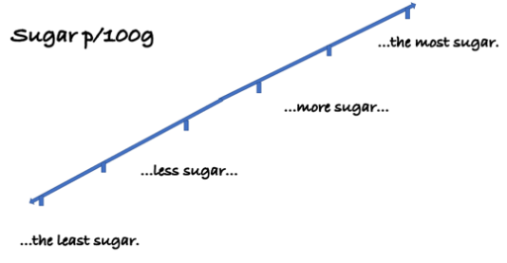  Opportunity for practice:  Have students complete the other clines independently or in pairs (Appendix 6).  Revisit the initial ranking of the food products:  Have students use the initial cline to put the food products in the same order as they were ranked at the beginning of the activity, from unhealthiest to healthiest.  Then, have them use the information gained from the food nutrition information labels to rearrange the products and line them up in the new order. Again, having the words ‘healthiest’ and ‘unhealthiest’ at each end of the range will help EAL learners to understand the task.  Present both clines on the board and compare them. One is based on the front-of-package information and the other is based on the food label information. Use the focus language for comparison in the discussion.  At the end of this task, have EAL learners write a short paragraph to explain why one product is healthier than the other. Encourage students to make comparisons using comparatives and superlatives as modelled during the lesson.  For example (key vocabulary is indicated in bold with a star [*]):  I thought that [product 2] was the healthiest(*) product because it says ‘7 vitamins’ and ‘healthy’ on the front of the package. However, I now think that [product 1] is the healthiest(*) product because it has less(*) sugar, salt and saturated fat than(*) [product 2]. A healthy amount of sugar is less than 15g per 100g. [Product 2] has more than 25g of sugar per 100g. [Product 1] also has more(*) fibre than(*) [product 2], so it is the healthiest(*).

Additional resources
You can access the EAL curriculum on the Victorian Curriculum F–10 website.
You can access a range of resources to assist with implementing the EAL curriculum on the VCAA English as an Additional Language webpage, including profiles of EAL learners, sample progressions through the EAL pathways, a language and learning interview, FAQs, professional learning opportunities and links to external resources.

Appendices

Appendix 1 – Vocabulary reference table
Content-specific vocabulary | Linguistic-specific vocabulary  (verbs of instruction) | Language for interaction | Language for clarification
healthy/unhealthy  snack  cereal  pre-packaged  label  to label  package  packaged  claim  to claim  message  image  mascot  target market  teenager  health-conscious  consumer  to consume  various descriptive words needed to describe the packed products (e.g. organic, tasty, quick, convenient)  nutrient  ingredient  fat  salt  fibre  energy  sodium  content  serves/servings  everyday food  discretionary food  gram/g  milligram/mg  per | List …  Choose …  Describe …  Answer …  Discuss…  Complete …  Match …  Share findings …  Rank …  Compare …  Read …  Write …  Add …  Search …  Categorise …  Put in order … | Asking for an opinion:  What do you think/reckon?  Expressing an opinion:  I think/reckon that …  I feel that …  Expressing polite agreement or disagreement:  Yes, I agree.  That’s what I was thinking.  I feel the same.  Mmm, maybe.  I see your point but …  I’m not so sure about that idea.  Making a suggestion:  What about …?  How about …?  Why don’t we …?  Language for comparison:  … is healthy > … is healthier than … > is the healthiest.  … is unhealthy > … is unhealthier than … > … is the unhealthiest.  … has less (fat/salt/sugar/fibre) than …  … has more (fat/salt/sugar/fibre) than …  … has the least (fat/salt/sugar/fibre)  …has the most (fat/salt/sugar/fibre)  Expressing an opinion with justification:  Personally, I think … because …  In my opinion … This is because … | Could you repeat that, please?  I didn’t get that. Could you please say it again?  Could you explain that?  What does that word mean?  Could you say that again in different words?  How do you spell that?

Appendix 2 – Vocabulary matching task
Draw a line to match each word with its correct definition or example.
Word | General definition or example
product | a group of similar things
category | something that can be sold; for example, food, clothes, furniture
package | for example, blue, red, green, yellow, pink
mascot | the box or wrapping a product is put into for sale
image | a picture
colour | a person or thing that brings good luck to a team or event
information and claims | How does it look? What words describe what you see?
look | How does it feel? What words describe what you should feel about the product?
feel | facts about something  OR  saying something is true without evidence or proof

Appendix 3 – Y chart
Describe the following features of the front-of-package label.
Feel

Who is the target market?
Look

Information and claims

Appendix 4 – Additional task
Task:
- Match each word with the correct definition.
- Then match the definition with the example from a Kellogg’s Rice Bubbles box.
Tip: Bring an example of the box if possible, to help with reading the small print
Word | General definition or example | Rice Bubbles example
product | a group of similar things | blue background with writing in different colours (red, blue, pink and green)
category | something that can be sold; for example, food, clothes, furniture | cereal
package | for example, blue, red, green, yellow, pink | Rice Bubbles
mascot | the box or wrapping a product is put into for sale | three children whose names are Snap, Crackle and Pop
image | a picture | a box with a plastic bag inside
colour | a person or thing that brings good luck to a team or event | three children with spoons looking at the rice bubbles; they are very excited
information and claims | How does it look? What words describe what you see? | exciting  fun
look | How does it feel? What words describe what you should feel about rice bubbles? | 6 vitamins and minerals  250g  3 stars  No artificial colours or flavours  Energy 1630kj  Sat fat 0.1g  Sugars 8.5g
feel | facts about something  OR  saying something is true without evidence or proof | colourful  rectangle  blue and white  colourful writing

Appendix 5 – Sample of vocabulary definitions (front-of-package questions)
Word | Definition
target | something that you aim at (it can be an object, a person, a goal)
market | a group of people who might buy a product
target market | the group of people that the product advertising is aimed at
health-conscious | to care about your health; for example, by eating healthy food and exercising
consumer | a person who buys, eats or uses something
mascot | 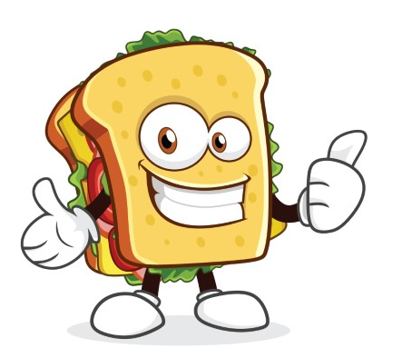  a person or animal that is linked to a product, event or team
image | a picture, sketch or photograph
message | something that is communicated in writing or images
print | printed letters and words, printed writing
claim | to say something that may or may not be true
misleading | to lead in the wrong direction; to say something is a fact when it may not be a fact (that is, misleading information)

Appendix 6 – Ranking the nutrients on food labels
Use Eat for Health: How to understand food labels to help you answer these questions. Use ‘more than’ or ‘less than' in your answers:
- What is a healthy amount of sugar per 100g? less than 15g per 100g
- What is a healthy amount of total fat per 100g? _________________________
- What is a healthy amount of saturated fat per 100g? ____________________
- What is a healthy amount of salt/sodium per 100g? ____________________
- What is a healthy amount of fibre per 100g? __________________________
- What is a healthy amount of energy per serve? _________________________

Look at the food labels of four food products. Put the products in order from unhealthiest to healthiest.

