English Level 1 map – template

**Use this curriculum area map to identify where achievement standards and content descriptions are explicitly addressed within your school’s teaching and learning units. This template will help you to both map the Victorian Curriculum F–10 Version 2.0 and audit your current teaching and learning units.**

# Instructions

1. Enter your details in the footer on page 1.
2. Look over the Curriculum Mapping tables on page 2 onwards. Read the information and important notes, below.
3. Enter the title of your teaching and learning units into each part of the mapping table. Indicate each teaching and learning unit’s connections to the curriculum by checking the box of the relevant content description(s) and writing the number(s) of the connected achievement standard extract. Refer to the VCAA ‘Connections between the achievement standards and content descriptions’ support resource if necessary.
4. Check that all content descriptions have been covered at least once.
5. Detail any comments, notes and actions.
6. Complete the Check of Achievement Standard Coverage table.
7. Complete the Assessment, Analysis of Curriculum Coverage and Next Steps sections on the final page.

**About the achievement standards in English:**

In English, achievement standards are organised via the language modes (Speaking and Listening, Reading and Viewing, and Writing). At every level there are 5 key achievement standard extracts, each beginning ‘When …’ (see the diagram, right). The 5 achievement standard extracts can be connected to content descriptions across the 3 strands of Language, Literature and Literacy. For more information about how the achievement standards and content descriptions are connected in English Version 2.0, see [Learning in English](https://f10.vcaa.vic.edu.au/learning-areas/english/english/introduction).

The VCAA has published tables that help map these connections for you; see the ‘Connections between the achievement standards and content descriptions’ support resources.

**Important notes:**

* Refer to the VCAA ‘Connections between the achievement standards and content descriptions’ support resource (see [Learning in English](https://f10.vcaa.vic.edu.au/learning-areas/english/english/introduction)) before completing the mapping table in this document.
* Some content descriptions connect to more than one language mode so, in some teaching and learning units, you might connect some content descriptions to more than one achievement standard extract.
* Make sure you use the Check of Achievement Standard Coverage table to check that you are assessing all the achievement standard extracts.

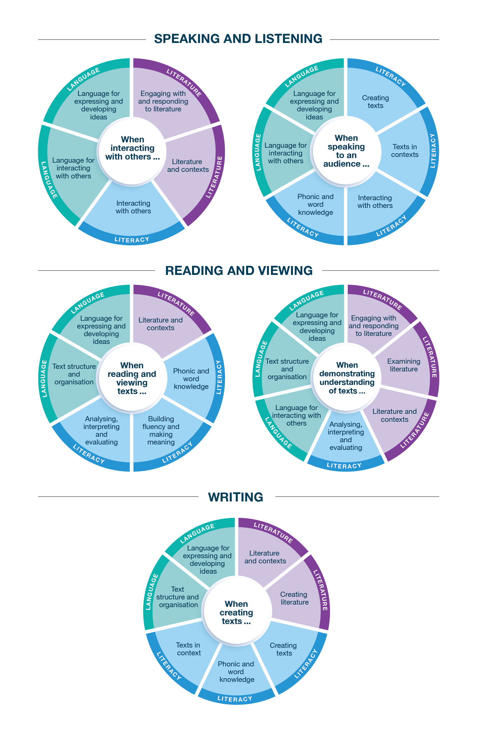

*Connecting the achievement standards and sub-strands*

# Curriculum Mapping

|  |  |  |
| --- | --- | --- |
| **Achievement standard (AS), with numbered extracts** | | |
| **Speaking and Listening** | **Reading and Viewing** | **Writing** |
| 1. When interacting with others, students understand the vocabulary of curriculum area topics and use language, facial expressions and gestures when requesting, exclaiming and commanding. They use turn-taking skills.  They explore language to express preferences and opinions. | 3. When listening, reading and viewing, students engage with a range of different types of texts, including decodable and authentic texts, using developing phonic knowledge.  They blend, segment and manipulate words with one and 2 syllables. They read an increasing number of high-frequency words and understand boundary punctuation. | 5. When creating short written and spoken texts, students use narrative and informative text structures; incorporate some detail from previously encountered texts, learnt topics or topics of interest; and include appropriate multimodal elements. They re-read their texts and complete simple edits.  They select learning area or topic-specific vocabulary.  They write words using unjoined lower-case and upper-case letters. They spell most one- and 2-syllable words with common letter patterns and common grammatical morphemes, and an increasing number of high-frequency words. They apply boundary punctuation. |
| 2. When speaking to an audience, students deliver short spoken texts, engaging with personal or learnt topics, using features of voice. | 4. When demonstrating understanding of texts, students discuss characters, settings, events and images, and make connections between texts and their personal experiences. They begin to build their understanding of literal and inferred meanings. They identify how types of texts, both print and digital, are organised for purpose and navigation. They compare how textual elements other than language, such as images and sounds, can contribute to meaning in texts. |

|  |  |  |  |  |  |  |  |  |  |  |  |  |  |  |  |
| --- | --- | --- | --- | --- | --- | --- | --- | --- | --- | --- | --- | --- | --- | --- | --- |
|  | **Strand** | **Language** | | | | | | | | | | | | | |
|  | **Sub-strand** | **Language for interacting with others** | | | | **Text structure and organisation** | | | | | | **Language for expressing and developing ideas** | | | |
|  | **Content description (CD)** | explore how language, facial expressions and gestures are used to interact with others when asking for and providing information, making offers, exclaiming, requesting and giving commands  VC2E1LA01 | | explore language to provide reasons for likes, dislikes and preferences  VC2E1LA02 | | explore how types of texts are organised according to their purpose, such as to recount, narrate, express opinion, inform, report and explain  VC2E1LA03 | | explore how repetition, rhyme and rhythm create cohesion in simple poems, chants and songs  VC2E1LA04 | | understand how concepts about print in printed and digital texts are organised using features such as page numbers, tables of contents, headings and titles, navigation buttons, swipe screens, verbal commands, links and images  VC2E1LA05 | | understand that a simple sentence consists of a single independent clause representing a single event or idea  VC2E1LA06 | | understand that words can represent people, places and things (nouns, including pronouns), happenings and states (verbs), qualities (adjectives), relationships in time and space (prepositions) and details such as when, where and how (adverbs)  VC2E1LA07 | |
| **Teaching and learning unit** | **Semester/Year** | **CD** | **AS no.** | **CD** | **AS no.** | **CD** | **AS no.** | **CD** | **AS no.** | **CD** | **AS no.** | **CD** | **AS no.** | **CD** | **AS no.** |
|  |  |  |  |  |  |  |  |  |  |  |  |  |  |  |  |
|  |  |  |  |  |  |  |  |  |  |  |  |  |  |  |  |
|  |  |  |  |  |  |  |  |  |  |  |  |  |  |  |  |
|  |  |  |  |  |  |  |  |  |  |  |  |  |  |  |  |
|  |  |  |  |  |  |  |  |  |  |  |  |  |  |  |  |
|  |  |  |  |  |  |  |  |  |  |  |  |  |  |  |  |

|  |  |  |  |  |  |  |  |
| --- | --- | --- | --- | --- | --- | --- | --- |
|  | **Strand** | **Language continued** | | | | | |
|  | **Sub-strand** | **Language for expressing and developing ideas continued** | | | | | |
|  | **Content description (CD)** | compare how images and sound in different types of texts contribute to meaning  VC2E1LA08 | | recognise and understand vocabulary across the curriculum, such as topic-specific vocabulary in other learning areas  VC2E1LA09 | | understand that written language uses punctuation such as full stops, question marks and exclamation marks, and uses capital letters for proper nouns  VC2E1LA10 | |
| **Teaching and learning unit** | **Semester/Year** | **CD** | **AS no.** | **CD** | **AS no.** | **CD** | **AS no.** |
|  |  |  |  |  |  |  |  |
|  |  |  |  |  |  |  |  |
|  |  |  |  |  |  |  |  |
|  |  |  |  |  |  |  |  |
|  |  |  |  |  |  |  |  |
|  |  |  |  |  |  |  |  |

|  |  |  |  |  |  |  |  |  |  |  |  |
| --- | --- | --- | --- | --- | --- | --- | --- | --- | --- | --- | --- |
|  | **Strand** | **Literature** | | | | | | | | | |
|  | **Sub-strand** | **Literature and contexts** | | **Engaging with and responding to literature** | | **Examining literature** | | | | **Creating literature** | |
|  | **Content description (CD)** | discuss how language and images are used to create characters, settings and events in literary texts by Aboriginal and Torres Strait Islander authors and illustrators and a wide range of Australian and world authors and illustrators  VC2E1LE01 | | discuss a range of literary texts and share responses by making connections with their own experiences  VC2E1LE02 | | discuss plots, characters and settings through a range of literary texts  VC2E1LE03 | | listen to, recite and discuss poems, chants, rhymes and songs, and imitate and invent sound patterns including alliteration and rhyme  VC2E1LE04 | | retell or adapt a range of previously encountered literary texts using plot and characters, structure, language features and vocabulary, through role-play, writing and drawing  VC2E1LE05 | |
| **Teaching and learning unit** | **Semester/Year** | **CD** | **AS no.** | **CD** | **AS no.** | **CD** | **AS no.** | **CD** | **AS no.** | **CD** | **AS no.** |
|  |  |  |  |  |  |  |  |  |  |  |  |
|  |  |  |  |  |  |  |  |  |  |  |  |
|  |  |  |  |  |  |  |  |  |  |  |  |
|  |  |  |  |  |  |  |  |  |  |  |  |
|  |  |  |  |  |  |  |  |  |  |  |  |
|  |  |  |  |  |  |  |  |  |  |  |  |

|  |  |  |  |  |  |  |  |  |  |  |  |  |  |  |  |  |  |
| --- | --- | --- | --- | --- | --- | --- | --- | --- | --- | --- | --- | --- | --- | --- | --- | --- | --- |
|  | **Strand** | **Literacy** | | | | | | | | | | | | | | | |
|  | **Sub-strand** | **Interacting with others** | | | | **Phonic and word knowledge** | | | | | | | | | | | |
|  | **Content description (CD)** | use interaction skills including turn-taking, speaking clearly, using active listening behaviours and responding to the read or spoken contributions of others, and contributing ideas and questions  VC2E1LY01 | | deliver short spoken texts to an audience using features of voice  VC2E1LY02 | | blend, segment and manipulate phonemes in words (phonemic awareness), including words with consonant blends at the beginning and end, and words with more than one syllable  VC2E1LY03 | | use knowledge of short vowels, common long vowels, consonant blends and digraphs to read and write one- and 2-syllable words  VC2E1LY04 | | understand that a letter can represent more than one sound and that a syllable must contain a vowel sound  VC2E1LY05 | | spell one- and 2-syllable words with common letter patterns  VC2E1LY06 | | read and write an increasing number of high-frequency words  VC2E1LY07 | | recognise and know how to use grammatical morphemes to create word families  VC2E1LY08 | |
| **Teaching and learning unit** | **Semester/Year** | **CD** | **AS no.** | **CD** | **AS no.** | **CD** | **AS no.** | **CD** | **AS no.** | **CD** | **AS no.** | **CD** | **AS no.** | **CD** | **AS no.** | **CD** | **AS no.** |
|  |  |  |  |  |  |  |  |  |  |  |  |  |  |  |  |  |  |
|  |  |  |  |  |  |  |  |  |  |  |  |  |  |  |  |  |  |
|  |  |  |  |  |  |  |  |  |  |  |  |  |  |  |  |  |  |
|  |  |  |  |  |  |  |  |  |  |  |  |  |  |  |  |  |  |
|  |  |  |  |  |  |  |  |  |  |  |  |  |  |  |  |  |  |
|  |  |  |  |  |  |  |  |  |  |  |  |  |  |  |  |  |  |

|  |  |  |  |  |  |  |  |  |  |  |  |  |  |  |  |
| --- | --- | --- | --- | --- | --- | --- | --- | --- | --- | --- | --- | --- | --- | --- | --- |
|  | **Strand** | **Literacy continued** | | | | | | | | | | | | | |
|  | **Sub-strand** | **Building fluency and making meaning** | | **Texts in context** | | **Analysing, interpreting and evaluating** | | | | **Creating texts** | | | | | |
|  | **Content description (CD)** | read decodable and authentic texts using developing phonic knowledge, phrasing and fluency, and make and monitor meaning using context and grammatical knowledge  VC2E1LY09 | | discuss different types of texts drawn from a range of cultures and experiences  VC2E1LY10 | | describe some similarities and differences between narrative, informative and persuasive texts  VC2E1LY11 | | use comprehension strategies, such as visualising, predicting, connecting, summarising and questioning, and draw on learnt vocabulary and growing knowledge of context and text structures to build literal and inferred meanings  VC2E1LY12 | | create short narrative and informative texts, written and spoken, on personal and learnt topics, including using some topic-specific vocabulary, appropriate multimodal elements, and a structure with an opening, middle and conclusion  VC2E1LY13 | | re-read their own texts and discuss possible changes to improve meaning, spelling and punctuation  VC2E1LY14 | | write words using unjoined lower-case and upper-case letters  VC2E1LY15 | |
| **Teaching and learning unit** | **Semester/Year** | **CD** | **AS no.** | **CD** | **AS no.** | **CD** | **AS no.** | **CD** | **AS no.** | **CD** | **AS no.** | **CD** | **AS no.** | **CD** | **AS no.** |
|  |  |  |  |  |  |  |  |  |  |  |  |  |  |  |  |
|  |  |  |  |  |  |  |  |  |  |  |  |  |  |  |  |
|  |  |  |  |  |  |  |  |  |  |  |  |  |  |  |  |
|  |  |  |  |  |  |  |  |  |  |  |  |  |  |  |  |
|  |  |  |  |  |  |  |  |  |  |  |  |  |  |  |  |
|  |  |  |  |  |  |  |  |  |  |  |  |  |  |  |  |

# Check of Achievement Standard Coverage

|  |  |  |  |  |  |
| --- | --- | --- | --- | --- | --- |
| **Achievement standard (AS), with numbered extracts** | | | | | |
| **Speaking and Listening** | **Y/N** | **Reading and Viewing** | **Y/N** | **Writing** | **Y/N** |
| When interacting with others, students understand the vocabulary of curriculum area topics and use language, facial expressions and gestures when requesting, exclaiming and commanding. They use turn-taking skills.  They explore language to express preferences and opinions. |  | When listening, reading and viewing, students engage with a range of different types of texts, including decodable and authentic texts, using developing phonic knowledge.  They blend, segment and manipulate words with one and 2 syllables. They read an increasing number of high-frequency words and understand boundary punctuation. |  | When creating short written and spoken texts, students use narrative and informative text structures; incorporate some detail from previously encountered texts, learnt topics or topics of interest; and include appropriate multimodal elements. They re-read their texts and complete simple edits.  They select learning area or topic-specific vocabulary.  They write words using unjoined lower-case and upper-case letters. They spell most one- and 2-syllable words with common letter patterns and common grammatical morphemes, and an increasing number of high-frequency words. They apply boundary punctuation. |  |
| When speaking to an audience, students deliver short spoken texts, engaging with personal or learnt topics, using features of voice. |  | When demonstrating understanding of texts, students discuss characters, settings, events and images, and make connections between texts and their personal experiences. They begin to build their understanding of literal and inferred meanings. They identify how types of texts, both print and digital, are organised for purpose and navigation. They compare how textual elements other than language, such as images and sounds, can contribute to meaning in texts. |  |

# Assessment

| **Teaching and learning unit** | **Assessment task name(s) and type(s)** | **AS no.** |
| --- | --- | --- |
|  |  |  |
|  |  |  |
|  |  |  |
|  |  |  |
|  |  |  |

# Analysis of Curriculum Coverage

|  |
| --- |
| <The following questions could be used as prompts for the analysis process:  Refer to the Curriculum Mapping table:   * Have you addressed all the achievement standard extracts? * Have you addressed all the content descriptions? * Where are there gaps in the content description coverage?   Refer to the Assessment table:   * Has each achievement standard extract been addressed appropriately? Where are there gaps in the achievement standard coverage? * Have students had the opportunity to show evidence that they are progressing towards the achievement standard?   Consider:   * Are all content descriptions equal? Do you think they all take the same amount of time to teach? * Is anything being over-taught? * Is anything being missed completely or given insufficient attention?> |

# Next Steps

|  |
| --- |
| <The following questions could be used as prompts for next steps:   * What implications would gaps in achievement standard coverage have on assessment? * What implications would gaps in content description coverage have on your teaching and learning units? * How will you address any gaps? * Use your completed curriculum area map to start populating or updating your curriculum area plan.> |