English Level 5 map – template

**Use this curriculum area map to identify where achievement standards and content descriptions are explicitly addressed within your school’s teaching and learning units. This template will help you to both map the Victorian Curriculum F–10 Version 2.0 and audit your current teaching and learning units.**

# Instructions

1. Enter your details in the footer on page 1.
2. Look over the Curriculum Mapping tables on page 2 onwards. Read the information and important notes, below.
3. Enter the title of your teaching and learning units into each part of the mapping table. Indicate each teaching and learning unit’s connections to the curriculum by checking the box of the relevant content description(s) and writing the number(s) of the connected achievement standard extract. Refer to the VCAA ‘Connections between the achievement standards and content descriptions’ support resource if necessary.
4. Check that all content descriptions have been covered at least once.
5. Detail any comments, notes and actions.
6. Complete the Check of Achievement Standard Coverage table.
7. Complete the Assessment, Analysis of Curriculum Coverage and Next Steps sections on the final page.

**About the achievement standards in English:**

In English, achievement standards are organised via the language modes (Speaking and Listening, Reading and Viewing, and Writing). At every level there are 5 key achievement standard extracts, each beginning ‘When …’ (see the diagram, right). The 5 achievement standard extracts can be connected to content descriptions across the 3 strands of Language, Literature and Literacy. For more information about how the achievement standards and content descriptions are connected in English Version 2.0, see [Learning in English](https://f10.vcaa.vic.edu.au/learning-areas/english/english/introduction).

The VCAA has published tables that help map these connections for you; see the ‘Connections between the achievement standards and content descriptions’ support resources.

**Important notes:**

* Refer to the VCAA ‘Connections between the achievement standards and content descriptions’ support resource (see [Learning in English](https://f10.vcaa.vic.edu.au/learning-areas/english/english/introduction)) before completing the mapping table in this document.
* Some content descriptions connect to more than one language mode so, in some teaching and learning units, you might connect some content descriptions to more than one achievement standard extract.
* Make sure you use the Check of Achievement Standard Coverage table to check that you are assessing all the achievement standard extracts.

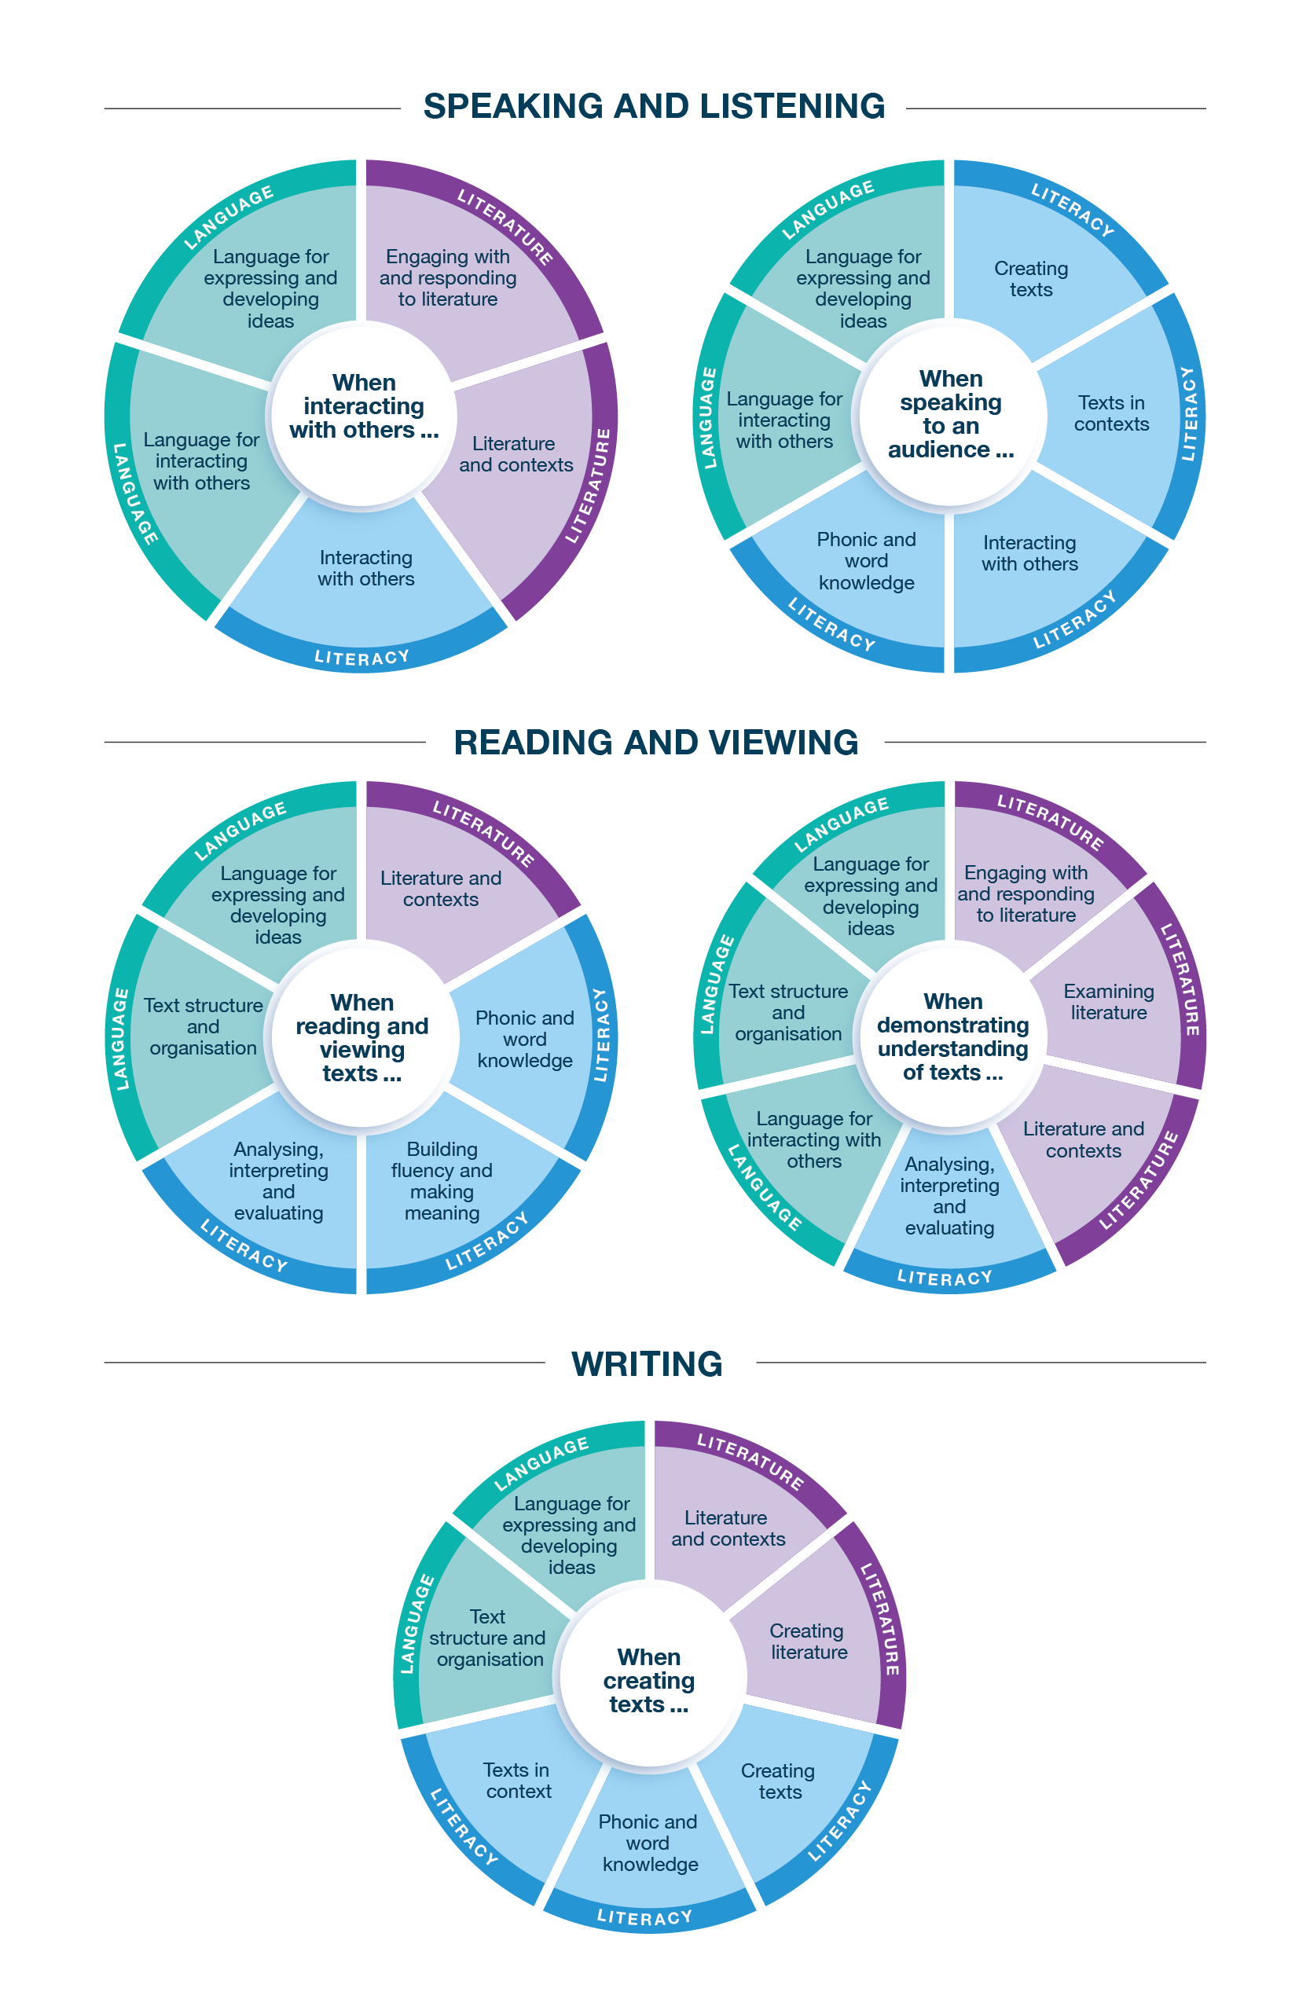

*Connecting the achievement standards and sub-strands*

# Curriculum Mapping

|  |  |  |
| --- | --- | --- |
| **Achievement standard (AS), with numbered extracts** | | |
| **Speaking and Listening** | **Reading and Viewing** | **Writing** |
| 1. When interacting with others, students use vocabulary precisely and select language for social purposes and roles, to clarify meaning and make connections.  They extend their discussion beyond bare assertions and account for differing opinions and authoritative sources. | 3. When reading and viewing, students engage with a range of different types of texts for meaning.  They read by integrating phonic, morphemic and vocabulary knowledge, and grammatical knowledge such as complex sentences and the use of clauses for effect. | 5. When creating written and spoken texts for specific purposes and audiences, students develop ideas and adapt textual details drawn from texts and include appropriate multimodal elements. They edit their texts using an agreed set of criteria.  They use text structures, including paragraphs, to create prominence and build sequence and cohesion. They use grammar and punctuation, including complex sentences to provide additional information and description.  They use precise vocabulary, such as specialist and technical terms. They experiment with language features, including figurative language.  They write legibly and fluently. They spell new and unfamiliar words using phonic, morphemic and grammatical knowledge. |
| 2. When speaking to an audience, students deliver structured spoken texts, exploring topics and text types, including multimodal or digital elements. They select language for a specific purpose and use appropriate features of voice. | 4. When demonstrating understanding of texts, students identify textual aspects that represent details about historical, cultural and social contexts. They describe how texts convey feelings, mood, actions and ideas to build literal and inferred meanings. They evaluate information and ideas in texts. They explain how different types of texts, both print and digital, are organised into characteristic stages for purpose. They discuss the effects of imagery and sound devices in texts. They explain how the sequence of still images, and moving images and sound, create or affect meaning. |

|  |  |  |  |  |  |  |  |  |  |  |  |  |  |  |  |
| --- | --- | --- | --- | --- | --- | --- | --- | --- | --- | --- | --- | --- | --- | --- | --- |
|  | **Strand** | **Language** | | | | | | | | | | | | | |
|  | **Sub-strand** | **Language for interacting with others** | | | | **Text structure and organisation** | | | | **Language for expressing and developing ideas** | | | | | |
|  | **Content description (CD)** | understand how language is selected for social contexts and that it helps to signal social roles and relationships  VC2E5LA01 | | understand how to move beyond making bare assertions by taking account of differing ideas or opinions and authoritative sources  VC2E5LA02 | | describe how different types of texts use language features and are typically organised into characteristic stages and phases, depending on purposes  VC2E5LA03 | | understand how texts are sequenced and can be made cohesive by using the starting point of a sentence or paragraph to give prominence to the message and to guide the reader through the text  VC2E5LA04 | | understand that the structure of a complex sentence includes an independent clause and at least one dependent clause, and understand how writers can use this structure for effect  VC2E5LA05 | | understand how noun groups can be expanded in a variety of ways to provide a fuller description of a person, place, thing or idea  VC2E5LA06 | | explain how the sequence of still and moving images and the use of sound in texts affect meaning  VC2E5LA07 | |
| **Teaching and learning unit** | **Semester/Year** | **CD** | **AS no.** | **CD** | **AS no.** | **CD** | **AS no.** | **CD** | **AS no.** | **CD** | **AS no.** | **CD** | **AS no.** | **CD** | **AS no.** |
|  |  |  |  |  |  |  |  |  |  |  |  |  |  |  |  |
|  |  |  |  |  |  |  |  |  |  |  |  |  |  |  |  |
|  |  |  |  |  |  |  |  |  |  |  |  |  |  |  |  |
|  |  |  |  |  |  |  |  |  |  |  |  |  |  |  |  |
|  |  |  |  |  |  |  |  |  |  |  |  |  |  |  |  |
|  |  |  |  |  |  |  |  |  |  |  |  |  |  |  |  |

|  |  |  |  |  |  |
| --- | --- | --- | --- | --- | --- |
|  | **Strand** | **Language continued** | | | |
|  | **Sub-strand** | **Language for expressing and developing ideas continued** | | | |
|  | **Content description (CD)** | understand how vocabulary is used to express greater precision of meaning, including through the use of specialist and technical terms  VC2E5LA08 | | understand how to use commas to indicate prepositional phrases, and how to use apostrophes where there is multiple possession in regular and irregular nouns  VC2E5LA09 | |
| **Teaching and learning unit** | **Semester/Year** | **CD** | **AS no.** | **CD** | **AS no.** |
|  |  |  |  |  |  |
|  |  |  |  |  |  |
|  |  |  |  |  |  |
|  |  |  |  |  |  |
|  |  |  |  |  |  |
|  |  |  |  |  |  |

|  |  |  |  |  |  |  |  |  |  |  |  |
| --- | --- | --- | --- | --- | --- | --- | --- | --- | --- | --- | --- |
|  | **Strand** | **Literature** | | | | | | | | | |
|  | **Sub-strand** | **Literature and contexts** | | **Engaging with and responding to literature** | | **Examining literature** | | | | **Creating literature** | |
|  | **Content description (CD)** | identify aspects of literary texts that represent details or information about historical, cultural and social contexts in literature by Aboriginal and Torres Strait Islander authors and a wide range of Australian and world authors  VC2E5LE01 | | form and share opinions on a literary text, using metalanguage to describe relevant literary devices, text structures and language features in a range of literary texts  VC2E5LE02 | | recognise that the point of view in a literary text influences how readers interpret and respond to plots, characters and events  VC2E5LE03 | | compare the effects of imagery, including simile, metaphor and personification, and sound devices in prose and poetry  VC2E5LE04 | | create texts, experimenting with vocabulary, figurative language, storylines, characters and settings from literary texts they have encountered  VC2E5LE05 | |
| **Teaching and learning unit** | **Semester/Year** | **CD** | **AS no.** | **CD** | **AS no.** | **CD** | **AS no.** | **CD** | **AS no.** | **CD** | **AS no.** |
|  |  |  |  |  |  |  |  |  |  |  |  |
|  |  |  |  |  |  |  |  |  |  |  |  |
|  |  |  |  |  |  |  |  |  |  |  |  |
|  |  |  |  |  |  |  |  |  |  |  |  |
|  |  |  |  |  |  |  |  |  |  |  |  |
|  |  |  |  |  |  |  |  |  |  |  |  |

|  |  |  |  |  |  |  |  |  |  |  |  |  |  |  |  |
| --- | --- | --- | --- | --- | --- | --- | --- | --- | --- | --- | --- | --- | --- | --- | --- |
|  | **Strand** | **Literacy** | | | | | | | | | | | | | |
|  | **Sub-strand** | **Interacting with others** | | | | **Phonic and word knowledge** | | | | | | **Building fluency and making meaning** | | **Texts in context** | |
|  | **Content description (CD)** | use interaction skills including paraphrasing and questioning to clarify meaning, make connections to personal experience or to a text, and present and justify an opinion or idea  VC2E5LY01 | | deliver structured spoken and multimodal texts to an audience for a specific purpose, using features of voice  VC2E5LY02 | | use phonological, morphological and vocabulary knowledge to read and spell words that share common letter patterns but have different pronunciations  VC2E5LY03 | | build and spell new words from knowledge of known words, base words, prefixes and suffixes, word origins (etymology), letter patterns and spelling generalisations  VC2E5LY04 | | explore less common plurals, and understand how a suffix changes the meaning or grammatical form of a word  VC2E5LY05 | | read different types of increasingly complex texts, integrating phonic, semantic and grammatical knowledge to read accurately and fluently for meaning, re-reading and self-correcting when needed  VC2E5LY06 | | describe the ways in which a text reflects the time and place in which it was created  VC2E5LY07 | |
| **Teaching and learning unit** | **Semester/Year** | **CD** | **AS no.** | **CD** | **AS no.** | **CD** | **AS no.** | **CD** | **AS no.** | **CD** | **AS no.** | **CD** | **AS no.** | **CD** | **AS no.** |
|  |  |  |  |  |  |  |  |  |  |  |  |  |  |  |  |
|  |  |  |  |  |  |  |  |  |  |  |  |  |  |  |  |
|  |  |  |  |  |  |  |  |  |  |  |  |  |  |  |  |
|  |  |  |  |  |  |  |  |  |  |  |  |  |  |  |  |
|  |  |  |  |  |  |  |  |  |  |  |  |  |  |  |  |
|  |  |  |  |  |  |  |  |  |  |  |  |  |  |  |  |

|  |  |  |  |  |  |  |  |  |  |  |  |
| --- | --- | --- | --- | --- | --- | --- | --- | --- | --- | --- | --- |
|  | **Strand** | **Literacy continued** | | | | | | | | | |
|  | **Sub-strand** | **Analysing, interpreting and evaluating** | | | | **Creating texts** | | | | | |
|  | **Content description (CD)** | explain characteristic features used to meet the purpose and audience in different types of texts  VC2E5LY08 | | use comprehension strategies, such as visualising, predicting, connecting, summarising, monitoring and questioning, to evaluate information and ideas to build literal and inferred meanings  VC2E5LY09 | | create different types of texts, written and spoken, with relevant, elaborated and sequenced ideas, using text structure appropriate for topic, purpose and audience, and multimodal elements as appropriate  VC2E5LY10 | | re-read and edit their own texts and the texts of others using agreed criteria for text structures and language features  VC2E5LY11 | | write legibly, fluently and automatically  VC2E5LY12 | |
| **Teaching and learning unit** | **Semester/Year** | **CD** | **AS no.** | **CD** | **AS no.** | **CD** | **AS no.** | **CD** | **AS no.** | **CD** | **AS no.** |
|  |  |  |  |  |  |  |  |  |  |  |  |
|  |  |  |  |  |  |  |  |  |  |  |  |
|  |  |  |  |  |  |  |  |  |  |  |  |
|  |  |  |  |  |  |  |  |  |  |  |  |
|  |  |  |  |  |  |  |  |  |  |  |  |
|  |  |  |  |  |  |  |  |  |  |  |  |

# Check of Achievement Standard Coverage

|  |  |  |  |  |  |
| --- | --- | --- | --- | --- | --- |
| **Achievement standard (AS), with numbered extracts** | | | | | |
| **Speaking and Listening** | **Y/N** | **Reading and Viewing** | **Y/N** | **Writing** | **Y/N** |
| 1. When interacting with others, students use vocabulary precisely and select language for social purposes and roles, to clarify meaning and make connections.  They extend their discussion beyond bare assertions and account for differing opinions and authoritative sources. |  | 3. When reading and viewing, students engage with a range of different types of texts for meaning.  They read by integrating phonic, morphemic and vocabulary knowledge, and grammatical knowledge such as complex sentences and the use of clauses for effect. |  | 5. When creating written and spoken texts for specific purposes and audiences, students develop ideas and adapt textual details drawn from texts and include appropriate multimodal elements. They edit their texts using an agreed set of criteria.  They use text structures, including paragraphs, to create prominence and build sequence and cohesion. They use grammar and punctuation, including complex sentences to provide additional information and description.  They use precise vocabulary, such as specialist and technical terms. They experiment with language features, including figurative language.  They write legibly and fluently. They spell new and unfamiliar words using phonic, morphemic and grammatical knowledge. |  |
| 2. When speaking to an audience, students deliver structured spoken texts, exploring topics and text types, including multimodal or digital elements. They select language for a specific purpose and use appropriate features of voice. |  | 4. When demonstrating understanding of texts, students identify textual aspects that represent details about historical, cultural and social contexts. They describe how texts convey feelings, mood, actions and ideas to build literal and inferred meanings. They evaluate information and ideas in texts. They explain how different types of texts, both print and digital, are organised into characteristic stages for purpose. They discuss the effects of imagery and sound devices in texts. They explain how the sequence of still images, and moving images and sound, create or affect meaning. |  |

# Assessment

| **Teaching and learning unit** | **Assessment task name(s) and type(s)** | **AS no.** |
| --- | --- | --- |
|  |  |  |
|  |  |  |
|  |  |  |
|  |  |  |
|  |  |  |

# Analysis of Curriculum Coverage

|  |
| --- |
| <The following questions could be used as prompts for the analysis process:  Refer to the Curriculum Mapping table:   * Have you addressed all the achievement standard extracts? * Have you addressed all the content descriptions? * Where are there gaps in the content description coverage?   Refer to the Assessment table:   * Has each achievement standard extract been addressed appropriately? Where are there gaps in the achievement standard coverage? * Have students had the opportunity to show evidence that they are progressing towards the achievement standard?   Consider:   * Are all content descriptions equal? Do you think they all take the same amount of time to teach? * Is anything being over-taught? * Is anything being missed completely or given insufficient attention?> |

# Next Steps

|  |
| --- |
| <The following questions could be used as prompts for next steps:   * What implications would gaps in achievement standard coverage have on assessment? * What implications would gaps in content description coverage have on your teaching and learning units? * How will you address any gaps? * Use your completed curriculum area map to start populating or updating your curriculum area plan.> |