Levels 7 and 8: Continuity and Change – Student Handout

Activity: Identifying change and continuity in western society during the medieval period (c.590 AD to c.1500 AD)
- In groups of three or four, complete one of the tasks below using one of the word clouds found on the following pages (speed of change, how much change, impact of change, or continuity).
  - Place the words from your word cloud onto a scale (e.g. from fastest to slowest, or from least impactful to most impactful).
  - As a group, present your scale to the class.
  - As a class, discuss the relevance of these words to your study of identifying change and continuity in history.

Speed of change
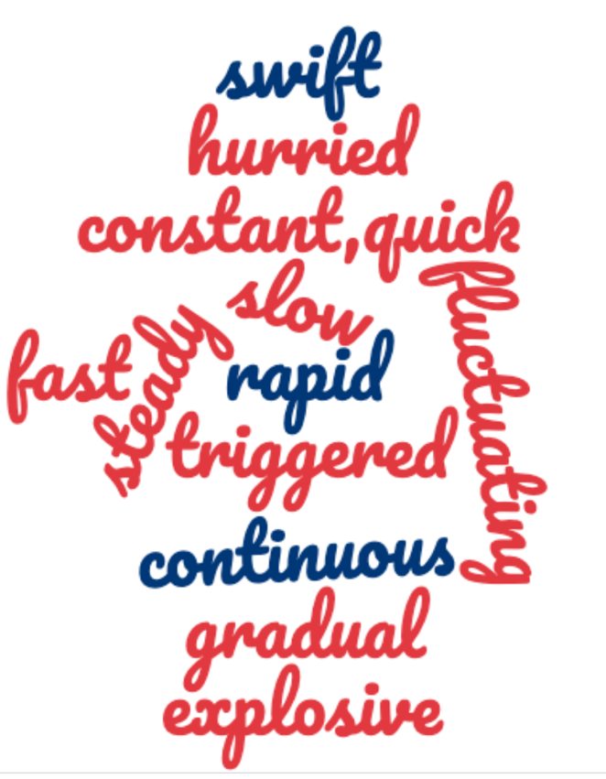

How much change
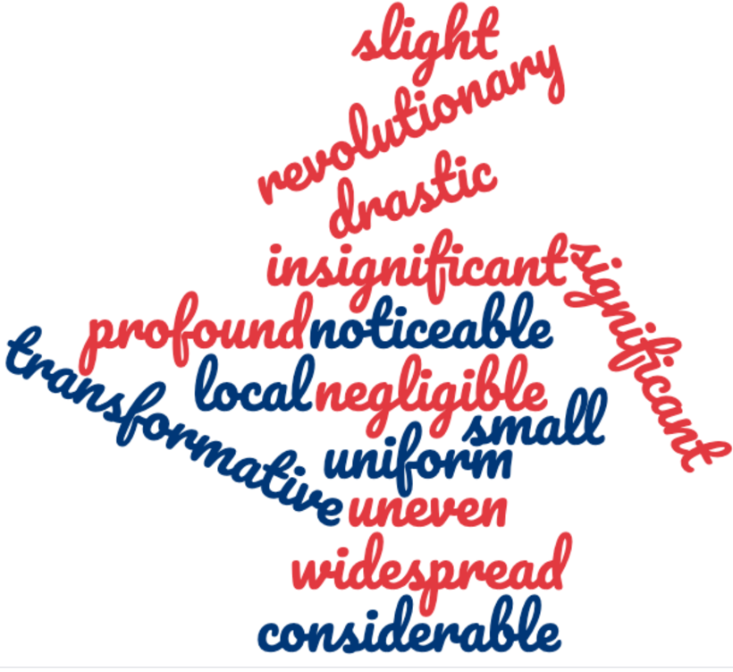

Importance of change
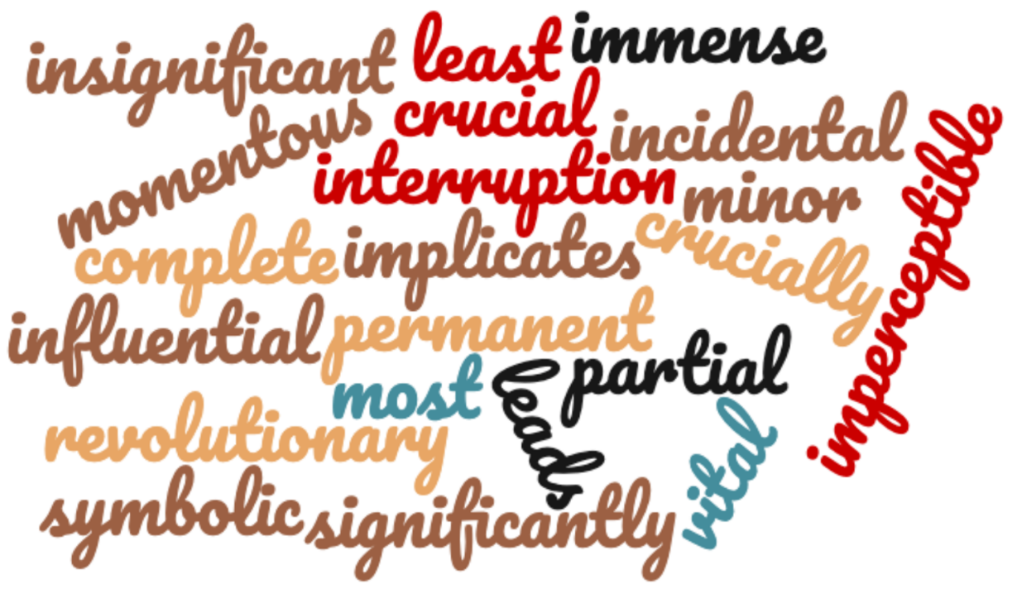

Continuity
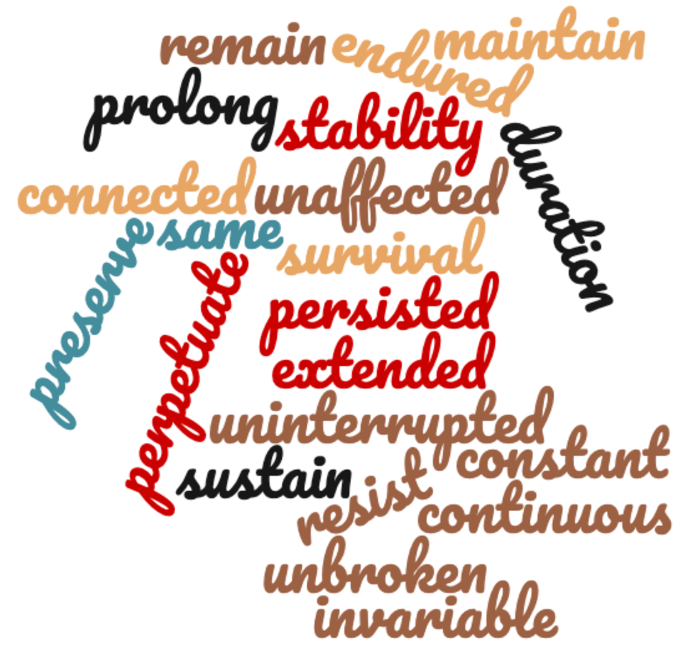

- Consider the table on the following page.
  - Using two different coloured highlighters, identify the examples of continuity and change in western society to the way of life over the medieval period.
  - Choose one of the historical events, trends or practices in the table on the following page. Use the word clouds above, as well as your answers to Question 1 and additional research on the internet, to complete one of the following:
- Write a 100 to 200-word paragraph describing this change to the way of life in western Europe during the medieval period. In describing what happened, be sure to use words like ‘sudden’, ‘gradual’, ‘widespread’, ‘violent’, ‘lasting’ and so on to describe the nature of the change.
- Write a 100 to 200-word paragraph describing this continuity to the way of life in western Europe during the medieval period. In describing what happened, be sure to use words like ‘sudden’, ‘gradual’, ‘widespread’, ‘violent’, ‘lasting’ and so on to describe the nature of the continuity.
- Write a 100 to 200-word paragraph describing the pattern of change and/or continuity to the way of life in western Europe during the medieval period. In describing what happened, be sure to use words like ‘sudden’, ‘gradual’, ‘widespread’, ‘violent’, ‘lasting’ and so on to describe the nature of the change and/or continuity.
Beginning of the medieval period | During the medieval period | By the end of the medieval period
- With the fall of the Roman empire, the population of towns and cities declines as people move to the country to escape the violence.  - Roman laws stop being upheld, and in many places, lawlessness takes over.  - The power of towns and cities declines as local nobles, lords and kings take power in the countryside.  - People seek the protection of a local lord or king who is better placed to protect them from the barbarian invaders than a far-off ruler.  - The feudal system or manorialism becomes the basis of western society.  - The Catholic Church begins to gain great political, social and religious power, seeking to destroy any heretics and opponents to become the only religion in medieval Europe. | - In 1059 AD, the Eastern (Greek) Orthodox Church spilt from the Roman Catholic Church; the latter remained powerful in western Europe.  - In 1095 AD, Pope Urban II called for all of Christendom (western Europe) to fight the Muslims to regain Jerusalem and the Holy Land; these crusades or holy wars were to continue for over two hundred years.  - Towns and cities began to rise in importance as local lords paid for their support to go on crusade.  - Crusaders brought back new ideas and new technology from the Middle East.  - In 1215 AD, King John I of England signs the Magna Carta, the first such document in English history to establish that everyone, even kings, are subject to the law of the land.  - The feudal system began to weaken, but most people still lived on the land and served their local lord.  - In the mid-14th century the Black Death pandemic swept across Europe, killing one-third of the population.  - In the late 14th century, the Schism of Avignon occurred when there were two popes simultaneously – one in Rome and one in Avignon. This weakened the religious and political power of the Church over society. | - During the 16th century the Protestant Reformation begins, creating a third Christian religion (Catholic, Orthodox and Protestantism).  - Power began to shift back towards towns and cities, though lords and nobility held most of the power.  - The Catholic Church is still a great power in western Europe.  - Religion is still very important in daily life.  - The Crusades had led to a renewed interest in trade, so towns and cities began to flourish as a new merchant class arose.  - Feudalism is still a predominant way of life for most of the population, lasting in some countries well into the 18th and 19th centuries.

