Food and you, Foundation

Annotated student work samples

Assessment task
Students were asked to design a healthy lunchbox based on food groupings of the Australian Guide to Healthy Eating. Using a template, students were required to:
- develop and describe criteria to select the foods for inclusion in the healthy lunchbox
- identify the equipment needed to prepare the foods
- identify how their designed lunchbox contributes to a healthy diet.
The template allowed students to draw, write or say their responses.
Student work was then assessed against an associated assessment rubric explicitly linked to the Design and Technologies and Health and Physical Education curriculum areas of the Victorian Curriculum F–10.
To access the sample unit of work and sample assessment task (including assessment rubric) associated with these student work samples, see the Home Economics teaching resources webpage on the VCAA website.

Student work sample 1
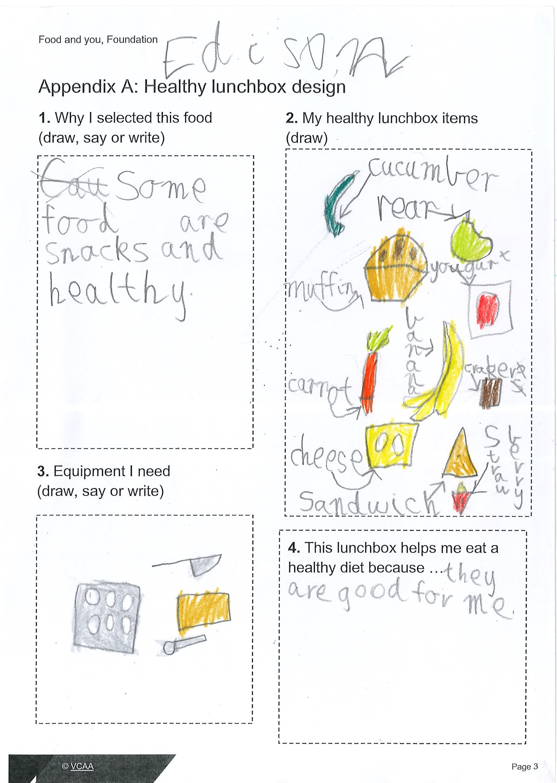

Student work sample 1 – assessment rubric
Relevant elements of the achievement standards
Design and Technologies*
By the end of Level 2, students:
- identify the features and uses of some technologies for the prescribed technologies contexts [Food specialisations]
- describe given needs or opportunities.
Health and Physical Education*
 | By the end of Foundation, students:  - identify actions that help them be healthy, safe and physically active. |  | By the end of Level 2, students:  - examine messages related to health decisions and describe how to help keep themselves and others healthy, safe and physically active.
Assessment rubric
Organising element | Performance descriptions
 | When progressing towards Foundation Level, students can: | At Foundation Level, students can: | When progressing towards Level 2, students can: | At Level 2, students can:
Equipment needed to produce a healthy lunchbox |  |  | With guidance, identify the equipment needed to produce the healthy lunchbox. | Identify the equipment needed to produce the healthy lunchbox.
Healthy lunchbox criteria |  |  | Identify the criteria used to select foods for the healthy lunchbox. | Describe the criteria used to select foods for the healthy lunchbox.
Contribution of designed lunchbox to a healthy diet. | Identify foods from the five food groups. | Refer to the notion of ‘always’ and/or ‘sometimes’ foods when explaining the basis of a healthy diet. | Identify the health benefits of eating foods classified as ‘always’ foods. | Identify key nutritional features of the designed lunchbox.

*The first achievement standard for Design and Technologies is provided at Level 2. For Health and Physical Education, the first achievement standard is provided at Foundation Level.

Student work sample 1 – evidence of learning
Edison chose to write and draw food that would be suitable for a healthy lunchbox.
Edison was able to verbally say to the teacher that the foods he chose were ‘always’ foods. He demonstrated his understanding of the contribution of a designed lunchbox to a healthy diet by drawing the ‘always’ foods, such as cucumber, pear and yoghurt, and verbally explaining to the teacher that the foods he chose for his lunchbox were ‘always’ foods and should be eaten every day. Edison recognised some foods in his lunchbox were snacks, such as muffins, and should be eaten ‘sometimes’.
Edison showed no evidence of being able to identify the criteria used to select foods for the healthy lunchbox, so there was insufficient evidence to assess Healthy lunchbox criteria.
With guidance, Edison drew equipment, including a muffin tin, chopping board and knife, to identify equipment needed to produce his heathy lunchbox.
Using the assessment rubric, Edison has been assessed as:
- progressing towards Level 2 for Equipment needed to make healthy food
- at Foundation Level for Contribution of designed lunchbox to a healthy diet.
This assessment demonstrates that Edison can:
- ‘identify actions that help them be healthy, safe and physically active’ (Health and Physical Education, Foundation Level achievement standard).

What is the student ready to learn next?
Edison is now ready to learn to:
- ‘identify the features and uses of some technologies for the prescribed technologies contexts [Food specialisations]’ (Design and Technologies, Foundation to Level 2 achievement standard)
- ‘describe given needs or opportunities’ (Design and Technologies, Foundation to Level 2 achievement standard)
- ‘examine messages related to health decisions and describe how to help keep themselves and others healthy, safe and physically active’ (Health and Physical Education, Levels 1 to 2 achievement standard).

Student work sample 2
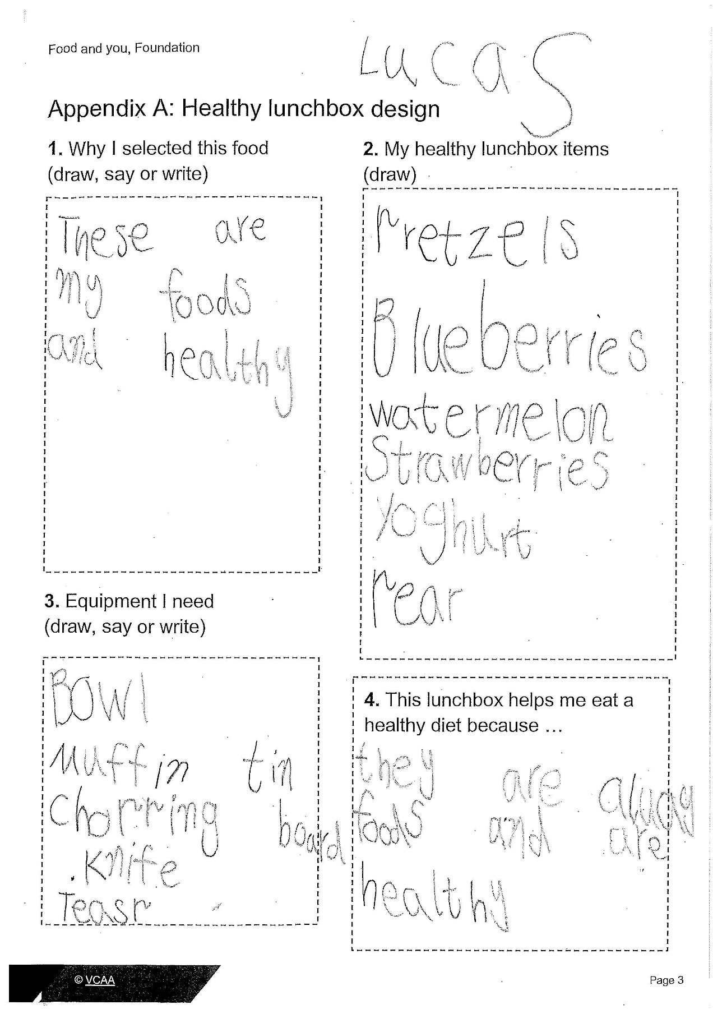
To watch a video of this student discussing his work, see the Home Economics teaching resources webpage on the VCAA website.

Student work sample 2 – assessment rubric
Relevant elements of the achievement standards
Design and Technologies*
By the end of Level 2, students:
- identify the features and uses of some technologies for the prescribed technologies contexts [Food specialisations]
- describe given needs or opportunities.
Health and Physical Education*
 | By the end of Foundation, students:  - identify actions that help them be healthy, safe and physically active. |  | By the end of Level 2, students:  - examine messages related to health decisions and describe how to help keep themselves and others healthy, safe and physically active.
Assessment rubric
Organising element | Performance descriptions
 | When progressing towards Foundation Level, students can: | At Foundation Level, students can: | When progressing towards Level 2, students can: | At Level 2, students can:
Equipment needed to produce a healthy lunchbox |  |  | With guidance, identify the equipment needed to produce the healthy lunchbox. | Identify the equipment needed to produce the healthy lunchbox.
Healthy lunchbox criteria |  |  | Identify the criteria used to select foods for the healthy lunchbox. | Describe the criteria used to select foods for the healthy lunchbox.
Contribution of designed lunchbox to a healthy diet. | Identify foods from the five food groups. | Refer to the notion of ‘always’ and/or ‘sometimes’ foods when explaining the basis of a healthy diet. | Identify the health benefits of eating foods classified as ‘always’ foods. | Identify key nutritional features of the designed lunchbox.

*The first achievement standard for Design and Technologies is provided at Level 2. For Health and Physical Education, the first achievement standard is provided at Foundation Level.

Student work sample 2 – evidence of learning
Lucas was able to write and verbally say that the foods he had chosen for his lunchbox were healthy foods. He wrote ‘always’ foods, such as blueberries, watermelon and yoghurt, and verbally stated that they were healthy food when discussing his work (see the associated video on the VCAA website). Lucas also verbally explained to the teacher that the foods he chose for his lunchbox were healthy foods and should be eaten every day. He also explained to the teacher that the foods from his lunchbox came from the food groupings of the Australian Guide to Healthy Eating and identified which food group each lunchbox item belonged to.
Independently, Lucas was able to identify equipment to produce his heathy lunchbox by writing the following terms on the handout: muffin tin, chopping board, bowl, knife, teaspoon.
Lucas was not able to identify the criteria used to select foods for the healthy lunchbox.
Using the assessment rubric, Lucas has been assessed as:
- at Level 2 for Equipment needed to make healthy food
- at Foundation Level for Contribution of designed lunchbox to a healthy diet.
This assessment demonstrates that Lucas can:
- ‘identify the features and uses of some technologies for the prescribed technologies contexts [Food specialisations]’ (Design and Technologies, Foundation to Level 2 achievement standard).
- ‘identify actions that help them be healthy, safe and physically active’ (Health and Physical Education, Foundation achievement standard).

What is the student ready to learn next?
Lucas is now ready to learn to:
- ‘describe given needs or opportunities’ (Design and Technologies, Foundation to Level 2 achievement standard)
- ‘examine messages related to health decisions and describe how to help keep themselves and others healthy, safe and physically active’ (Health and Physical Education, Levels 1 to 2 achievement standard).

Student work sample 3
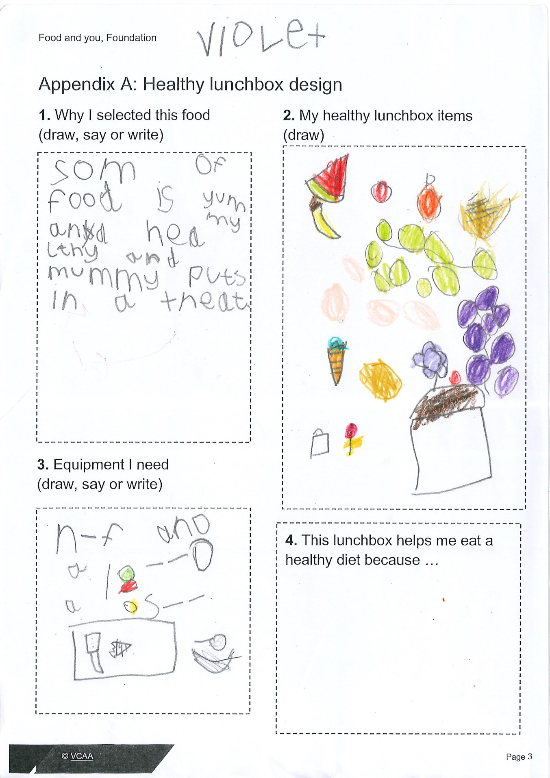
To watch a video of this student discussing her work, see the Home Economics teaching resources webpage on the VCAA website.

Student work sample 3 – assessment rubric
Relevant elements of the achievement standards
Design and Technologies*
By the end of Level 2, students:
- identify the features and uses of some technologies for the prescribed technologies contexts [Food specialisations]
- describe given needs or opportunities.
Health and Physical Education*
 | By the end of Foundation, students:  - identify actions that help them be healthy, safe and physically active. |  | By the end of Level 2, students:  - examine messages related to health decisions and describe how to help keep themselves and others healthy, safe and physically active.
Assessment rubric
Organising element | Performance descriptions
 | When progressing towards Foundation Level, students can: | At Foundation Level, students can: | When progressing towards Level 2, students can: | At Level 2, students can:
Equipment needed to produce a healthy lunchbox |  |  | With guidance, identify the equipment needed to produce the healthy lunchbox. | Identify the equipment needed to produce the healthy lunchbox.
Healthy lunchbox criteria |  |  | Identify the criteria used to select foods for the healthy lunchbox. | Describe the criteria used to select foods for the healthy lunchbox.
Contribution of designed lunchbox to a healthy diet. | Identify foods from the five food groups. | Refer to the notion of ‘always’ and/or ‘sometimes’ foods when explaining the basis of a healthy diet. | Identify the health benefits of eating foods classified as ‘always’ foods. | Identify key nutritional features of the designed lunchbox.

*The first achievement standard for Design and Technologies is provided at Level 2. For Health and Physical Education, the first achievement standard is provided at Foundation Level.

Student work sample 3 – evidence of learning
Violet was able to draw and verbally identify the foods she had chosen for her lunchbox that belonged to food groupings from the Australian Guide to Healthy Eating. She drew foods such as blueberries, watermelon, grapes, carrots and pasta. Violet said that these foods ‘were yummy and good to eat’ (see the associated video on the VCAA website). Violet also added ‘treat’ foods to her healthy lunchbox, such as ice cream and cupcakes; when prompted by the teacher she verbally stated that she could have these foods ‘in small amounts’ but did not state that these foods should only be eaten ‘sometimes’.
With guidance, Violet was able to draw and tell the teacher the equipment required to produce her healthy lunchbox.
Violet was not able to identify why foods in her lunchbox helped her eat a healthy diet nor identify criteria used to select foods for the healthy lunchbox.
Using the assessment rubric, Violet has been assessed as:
- progressing towards Level 2 Identifying equipment need to make healthy food.
- progressing towards Foundation Level Contribution of designed lunchbox to a healthy diet.
This assessment demonstrates that Violet has not yet met the relevant elements of the first achievement standards for both Design and Technologies and Health and Physical Education.

What is the student ready to learn next?
Violet is now ready to learn to:
- ‘identify the features and uses of some technologies for the prescribed technologies contexts [Food specialisations]’ (Design and Technologies, Foundation to Level 2 achievement standard)
- ‘describe given needs or opportunities’ (Design and Technologies, Foundation to Level 2 achievement standard)
- ‘identify actions that help them be healthy, safe and physically active’ (Health and Physical Education, Foundation Level achievement standard).

