Influences on food choices, Levels 9 and 10

Annotated student work samples

Assessment task
Students were asked to develop a submission to government on influences on food choices and provide recommendations that aimed to help shape a more healthy future for Australians. In the submission students:
- introduced the issue – that is, provided context around the influences on the food choices of individuals and communities
- provided evidence for how these influences affect food choices, whether positively or negatively
- provided an overview of their organisation’s vision (preferred future) in relation to these influencing factors
- identified the changes needed to adapt/modify/remove these influencing factors so as to realise this vision (preferred future) and present these as key areas/themes of action
- provided recommendations for what action the government can take to help make a positive change(s) in relation to influences on food choices and to help initiate change for better health and wellbeing.
The submission was presented as a formal report with headings, subheadings and references.
To access the sample unit of work and sample assessment task (including assessment rubric) associated with these student work samples, see the Home Economics teaching resources webpage on the VCAA website.

Student work sample 1
Food Avoidance – Influence on Food Choices
Introduction
The issue of food avoidance includes avoiding a food substance due to allergy or intolerances and avoidance due to cultural, religious or ethical reasons. Financial, personal, education, environmental, religion, and ethical are all contributing factors to the issue. Food avoidance incorporates aspects of all the factors of social, cultural and economic.
How food avoidance affects food choices
The abs.gov.au found in “2011-12, 17% of Australians aged 2 years or over (3.7million people) reported avoiding a food type due to allergy or intolerance and 7% (1.6 million) avoided particular foods for cultural, religious or ethical reasons.” In reference to figure 1 and 2 it can be seen that food avoidance due to allergy or intolerances was most prevalent among males aged 31-50 years (17%) and females aged 51-70 years (25%).
Food avoidance for cultural, religious or ethical reasons was highest among 19-30 years (10%) and 31-50 years group (9.0%). This data is affected by the previously stated factors of food avoidance. Firstly, when looking at the financial factor the example of a gluten free diet can be used. A family with two children can pay up to 17% more for a gluten free diet and a single man on welfare could spend 75% of his income on food, see figure 3. For people with low socioeconomic status this significantly impacts an individual’s ability to fulfil their dietary needs.
The financial factor also links to education because if an individual receives education, they’re more likely to be employed, in turn allowing them to have a stable income. As well as this, the education informs an individual about how to make smarter decisions when it comes to their food choices.
The factor of personal considers taste, genetics and age. In regards to taste, from birth a human is genetically programmed to have positive responses to sweet tastes and negative responses to bitter and other strong taste. Disregarding these few responses children from 2 years of age regard everything as edible. This demonstrates that individual experiences, culture and family influence the bases of a child’s likes and dislikes (food avoidance) by early adulthood.
There is thought to be a genetic link to food allergies and news-medical.net identified a study where “1,500 children from the United States and Germany, who have food allergies” where investigated to see if a genetic link can be made. “Over 5 million genetic variations were studied in the participants compared against controls. A food challenge test was done to establish a true food allergy to the reported food to rule out possible intolerance. This study was able to identify five loci that increase genetic susceptibility to food allergies. Of these five loci, four were strongly correlated for those associated with other types of allergies.” This study provides support that food allergies may have a genetic component to the development.
When focusing more on allergies the age of an individual can affect whether you develop an allergy. An allergy is the body’s immune system defensive response to a harmless substance. Anywhere from 60%-80% of children with milk and/or egg allergies outgrow their allergy.

This means the immune system no longer has a defensive response to a substance usually because it has learnt to tolerate it.
The environmental factor focuses on the access to individual food requirements and the packaging of products. Depending on if an individual lives in remote areas their access to foods can be restricted and often can be more expensive.
Food labelling on packaged products is vital in informing people with food allergies of the content of the product. The “Food Standards Code requires suppliers to declare [the following] foods on labels whenever they are present as; ingredients, components of food additives, components of processing aids.” The foods that must be declared include peanuts, tree nuts, milk, eggs, sesame seeds, fish, shellfish, soy, lupin, and wheat. “If the food isn’t in packaging or doesn’t need to have a label, the information must be displayed with the food or can be requested from the supplier.”
The final factor is religion and ethical reasons to food avoidance. With the example of the Jewish religion follows Kosher rules. These rules state “Land animals must have cloven (split) hooves and must chew the cud, meaning that they must eat grass. Seafood must have fins and scales.” Foods such as pork and shellfish cannot be consumed, and meat and dairy can’t be combined. Similar to the Christian religion with the example of Good Friday where as a recognition of Jesus sacrifice of dying on the cross they don’t eat meat. Ethical reasons to food avoidance focus on an individual’s decision to avoid certain foods because of the treatment of animals, use of chemicals and pesticides, farm management, and trade agreements. Due to individuals may change to a vegetarian, pescatarian, vegan, etc. diets.
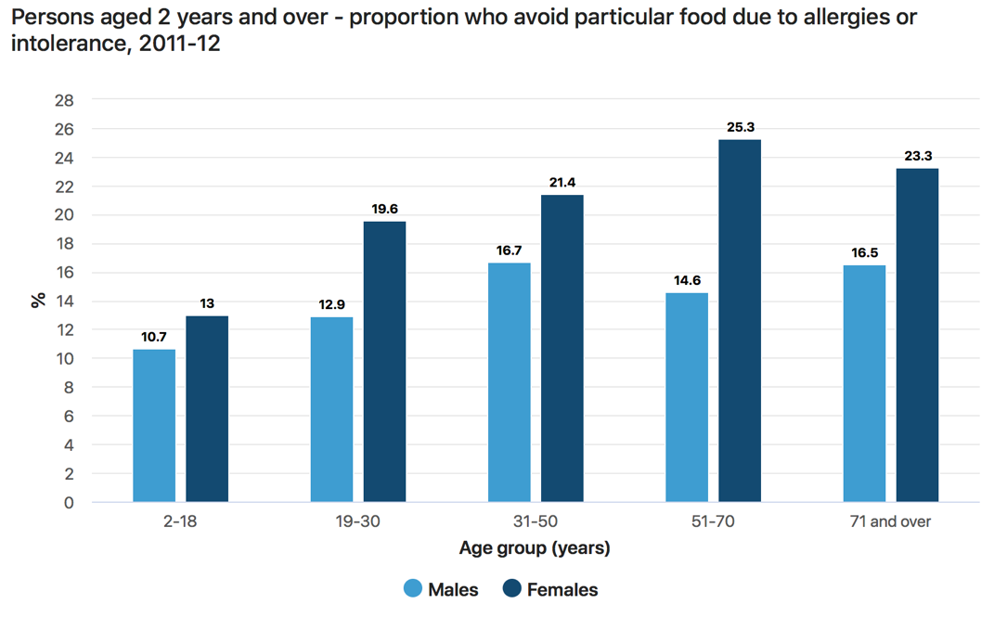
Figure 1: https://www.abs.gov.au/statistics/health/health-conditions-and-risks/australian-health-survey-nutrition-first-results-foods-and-nutrients/latest-release

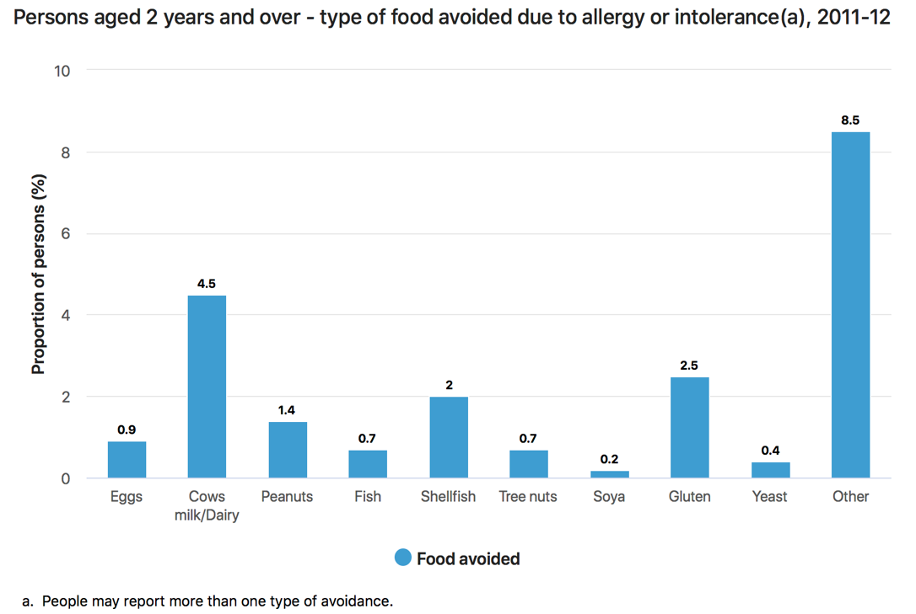
Figure 2: https://www.abs.gov.au/statistics/health/health-conditions-and-risks/australian-health-survey-nutrition-first-results-foods-and-nutrients/latest-release

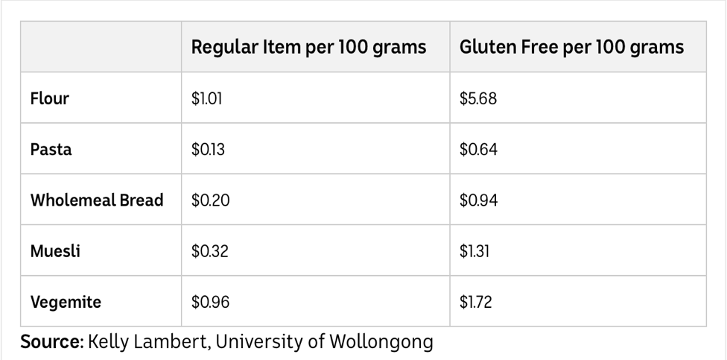
Figure 3: Kelly Lambert, University of Wollongong

Preferred Future
The major cause for accidental reactions to packaged food is because of insufficient food labelling. The preferred future for food avoidance is to see stricter food labelling regulations implemented as this is crucial in food allergy management. This future greatly impacts the factor of personal in relation to an individual’s health. The University of Melbourne conducted a “survey of 864 Allergy & Anaphylaxis Australia members found that over nine months, 58 (6.7 per cent) reported anaphylactic reactions to a packaged food where the suspected allergen was not a listed ingredient. Of the 58, five (8.6 per cent) said there was no Precautionary Allergen Label (PAL), 31 (53.5 per cent) said there was a PAL but it didn’t specify the suspected trigger food, and 22 (38 per cent) said there was a PAL that did list it.” Based on this research it can be seen the urgency to change government regulations in regards to the precautionary allergen label to ensure allergy statements are clear and easy to read on all packaged food, cautioning consumers about the high-risk allergy ingredients within packaged food.
Positive Food Allergy Marketing Strategies
One of the ways we as a nation can promote positive influence around the issue of food allergies is through the use of well-known sports players and/or celebrities. To do this well-

known people throughout Australia who have food allergies can be the main face of products promoting food allergy awareness and informing Australian’s of the severity of the issue. Another marketing strategy could be through the use of radio and television advertisement to inform the public on a following of areas surrounding the issue such as, safe food preparation, how to limit cross contamination, reading food labels etc.
Key Areas/Themes of Action and Recommended action from the government
The Australian government already have made it mandatory to declare “cereals containing gluten and their products, crustacea and their products, egg and egg products, fish and fish products, milk and milk products, peanuts and peanut products, tree nuts and tree nut products (does not include coconut), sesame seeds and sesame seed products, soybean and soybean products, added sulphites in concentrations of 10 mg/kg or more, and lupin” on all packaged food in Australia, under clause 4 of standard 1.2.3 of the Australia New Zealand Food Standards Code. As spoken before this is a crucial factor in minimising accidental reactions.
However, to bring about change for better health and wellbeing the government needs to communicate allergy awareness to schools, media and the wider community. In primary schools today students, staff and parents have a large understanding around allergies and implement strict strategies to ensure the safety of their students. Whether this be by ensuring children don’t share their food or sending messages informing parents of the requirements at home, the majority of schools in Australia are nut free although this is not compulsory.
When looking into secondary schools the number of precautionary measures drop significantly and the risk of allergy expose significantly increases. The government needs to spend more time improving allergy awareness amongst the high school age group and ensure strict precautionary practices are put in place such as having a ban on all nut products coming into the school. As well as this, the government could have allergy awareness programs that go to schools to teach children and even adults the issue of food allergies.
The media influence our opinions and perspective of topics and issues going on in the world every day, whether this be positively or negatively. Food allergies in particular have been portrayed by the media as comedic and not serious which in turns manipulates the audience to feel the same. This is proven by a study conducted in 2015 states foodallergy.org “two groups of participants were shown two different sets of clips; one set contained negative or comedic depictions of food allergies in movies and tv shows, the other set showed serious and positive portrayals of food allergies.
The study concluded that participants exposed to more humorous portrayals of food allergies were expected to have more negative attitudes towards those with food allergies, perceptions of food allergies in general, and be less likely to take lifesaving measures in an emergency” they write. If the government is able to change the way the media portray food allergies to positive and realistic information, awareness of the severity of the issue will be improved.

References
https://www.abs.gov.au/statistics/health/health-conditions-and-risks/australian-health-survey-nutrition-first-results-foods-and-nutrients/latest-release
https://www.abc.net.au/news/2016-04-19/new-study-reveals-hidden-costs-of-gluten-free-diet/7336374
https://www.ncbi.nlm.nih.gov/books/NBK217511/
https://www.4cornerspc.com/blog/do-children-grow-out-of-allergies
https://www.news-medical.net/health/Can-Food-Allergies-Be-Genetic.aspx
https://www.foodstandards.gov.au/consumer/labelling/Pages/allergen-labelling.aspx
https://about.unimelb.edu.au/newsroom/news/2018/october/better-food-labels-could-reduce-food-allergy-related-anaphylaxis
https://www2.health.vic.gov.au/public-health/food-safety/food-allergen-awareness
https://www.foodallergy.org/resources/how-media-portrays-food-allergies

Student work sample 1 – assessment rubric

Relevant elements of the achievement standards
Design and Technologies
By the end of Level 8, students:  - explain the contribution of design and technology innovations and enterprise to society |  | By the end of Level 10, students:  - identify the changes necessary to designed solutions to realise preferred futures they have described.
Health and Physical Education
By the end of Level 8, students:  - investigate strategies and resources to manage changes and transitions and their impact on identities  - gather and analyse health information  - investigate strategies that enhance their own and others’ health, safety and wellbeing  - justify actions that promote their own and others’ health, safety and wellbeing at home, at school and in the community. |  | By the end of Level 10, students:  - critically analyse contextual factors that influence their identities, relationships, decisions and behaviours  - access, synthesise and apply health information from credible sources to propose and justify responses to situations in the home, in the school and the community  - compare and contrast a range of actions that could be undertaken to enhance their own and others’ health, safety and wellbeing.

Assessment rubric
Organising element | Performance descriptions
 | At Level 8 students can: | When progressing towards Level 10, students can: | At Level 10 students can: | Beyond Level 10, students can:
Influences on food choices | Examine a range of influences on food choices. | Analyse the influence of personal, social, cultural and environmental factors on food choices. | Critically evaluate a range of influences on food choices. | Compare and contrast the influences on food choices across different population groups.
Changes needed to adapt/modify/remove influencing factors on food choices | Identify marketing/promotional strategies that may influence food choices. | Identify changes that are needed to make a positive influence on food choices. | Describe the changes needed to make a positive influence on food choices. | Promote positive influences on food choices through marketing strategies.
Key areas/themes of action | Present the identified changes needed to make a positive influence on food choices according to the broad categories of influences. | Present the identified changes needed to make a positive influence on food choices according to the broad categories of influences, and provide commentary on their similarities and differences. | Describe the similarities and differences in the identified changes needed to make a positive influence on food choices according to the broad categories of influences. | Analyse the key areas/themes of action in terms of their similarities and differences.
Recommended actions | Identify recommended actions to help bring about change for better health and wellbeing. | Describe recommended actions to help bring about change for better health and wellbeing. | Justify the recommended actions to help bring about change for better health and wellbeing. | Critique the recommended actions to help bring about change for better health and wellbeing.

Student work sample 1 – evidence of learning
Jemma created a Word document entitled ‘Food avoidance – Influence on food choices’ that highlighted a range of factors that influence food choice, including allergies or intolerances, religion, and financial and ethical reasons. Jemma was able to use data from the Australian Bureau of Statistics to critically evaluate these influences on food choices across different population groups and provide reasons for food avoidance. Jemma also described the similarities and differences between some factors such as financial, personal, education, environmental, religious and ethical reasons.
Jemma was able to highlight changes that would have a positive influence on food choices and provided a critique of her recommendations. She discussed the need for food labels to be easy to read to ensure individuals were provided with accurate information about food allergens. She also discussed the importance of teaching both primary and second students to understand food labelling to improve their understanding of food allergies. In addition, Jemma emphasised the critical role of media in influencing opinions and providing information about issues such as food allergies.
Using the assessment rubric, Jemma has been assessed as:
- at Level 10 for Influence on food choices
- at Level 10 for Changes needed to adapt/modify/remove influencing factors on food choices
- at Level 10 for Key areas/themes of action
- progressing beyond Level 10 for Recommended actions.
This assessment demonstrates that Jemma can:
- ‘identify the changes necessary to designed solutions to realise preferred futures they have described’ (Design and Technologies, Levels 9 to 10 achievement standard)
- ‘critically analyse contextual factors that influence their identities, relationships, decisions and behaviours’ (Health and Physical Education, Levels 9 to 10 achievement standard)
- ‘access, synthesise and apply health information from credible sources to propose and justify responses to situations in the home, in the school and the community’ (Health and Physical Education, Levels 9 to 10 achievement standard)
- ‘compare and contrast a range of actions that could be undertaken to enhance their own and others’ health, safety and wellbeing’ (Health and Physical Education, Levels 9 to 10 achievement standard).

What is the student ready to learn next?
Jemma is progressing beyond Level 10.

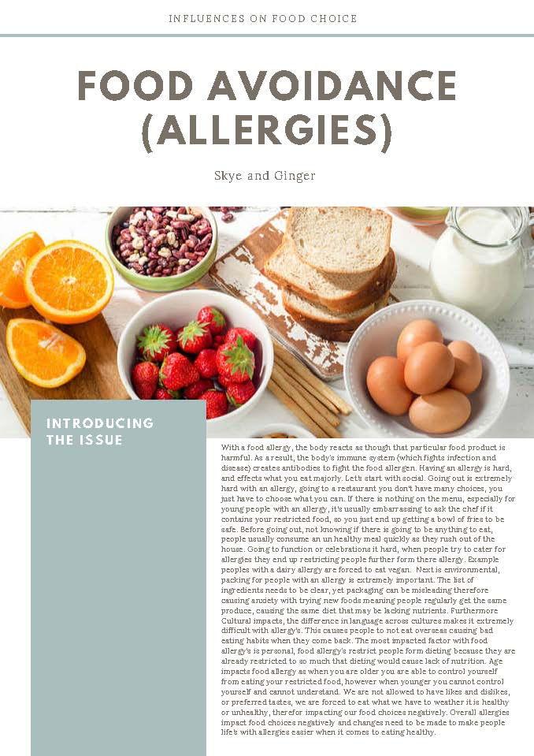
Student work sample 2

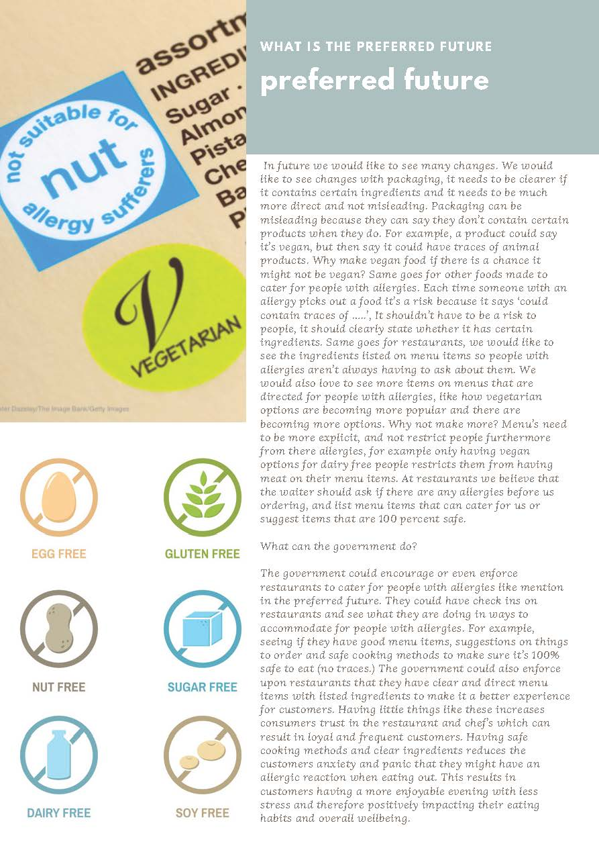
To watch the video presentation prepared by this student, see the Home Economics teaching resources webpage on the VCAA website.

Student work sample 2 – assessment rubric

Relevant elements of the achievement standards
Design and Technologies
By the end of Level 8, students:  - explain the contribution of design and technology innovations and enterprise to society  . |  | By the end of Level 10, students:  - identify the changes necessary to designed solutions to realise preferred futures they have described
Health and Physical Education
By the end of Level 8, students:  - investigate strategies and resources to manage changes and transitions and their impact on identities  - gather and analyse health information  - investigate strategies that enhance their own and others’ health, safety and wellbeing  - justify actions that promote their own and others’ health, safety and wellbeing at home, at school and in the community. |  | By the end of Level 10, students:  - critically analyse contextual factors that influence their identities, relationships, decisions and behaviours  - access, synthesise and apply health information from credible sources to propose and justify responses to situations in the home, in the school and the community  - compare and contrast a range of actions that could be undertaken to enhance their own and others’ health, safety and wellbeing.

Assessment rubric
Organising element | Performance descriptions
 | At Level 8 students can: | When progressing towards Level 10, students can: | At Level 10 students can: | Beyond Level 10, students can:
Influences on food choices | Examine a range of influences on food choices. | Analyse the influence of personal, social, cultural and environmental factors on food choices. | Critically evaluate a range of influences on food choices. | Compare and contrast the influences on food choices across different population groups.
Changes needed to adapt/modify/remove influencing factors on food choices | Identify marketing/promotional strategies that may influence food choices. | Identify changes that are needed to make a positive influence on food choices. | Describe the changes needed to make a positive influence on food choices. | Promote positive influences on food choices through marketing strategies.
Key areas/themes of action | Present the identified changes needed to make a positive influence on food choices according to the broad categories of influences. | Present the identified changes needed to make a positive influence on food choices according to the broad categories of influences, and provide commentary on their similarities and differences. | Describe the similarities and differences in the identified changes needed to make a positive influence on food choices according to the broad categories of influences. | Analyse the key areas/themes of action in terms of their similarities and differences.
Recommended actions | Identify recommended actions to help bring about change for better health and wellbeing. | Describe recommended actions to help bring about change for better health and wellbeing. | Justify the recommended actions to help bring about change for better health and wellbeing. | Critique the recommended actions to help bring about change for better health and wellbeing.

Student work sample 2 – evidence of learning
Skye analysed the influence of personal, social, cultural and environmental factors on food choices by creating a Ted Talk on social factors influencing food choices as well as writing about food allergies and their influence on food choices with a focus on personal, cultural and environmental factors.
Skye was able to analyse the influence of social factors on food choices in the Ted Talk she created with classmate Ginger. She described changes that would have a positive influence on food choices with reference to social influences such as the availability of money. Skye justified her recommended actions to help bring about change for better health and wellbeing, focusing on preparing your own meals, which could be consumed as part of a healthy diet.
Skye analysed the influence of personal, cultural and environmental factors by focusing on the impact of a food allergy on everyday life and ways it may influence dining experiences of adolescents. She analysed how customers with food allergies may be limited with food choices, and often likes and dislikes (personal factors) were not taken into consideration when ordering menu items because of lack of availability of suitable foods to address their food allergy. She went on to describe how restaurant menus needed to improve by providing ingredient lists for menu items, and that restaurant staff could assist those with allergies by using knowledge about ingredients in the menu items to offer safe food to these customers. Skye also analysed how cultural factors may influence food choices, stating that language may be a barrier to understanding food labelling and highlighting that individuals from diverse cultural backgrounds may not have suitable food choices in their new country. Skye was able to justify the role of government in enforcing strict guidelines to support the safety of those with allergies when they dine out, identifying the impact on the customer and society.
Using the assessment rubric, Skye has been assessed as:
- progressing towards Level 10 for Influence on food choices
- at Level 10 for Changes needed to adapt/modify/remove influencing factors on food choices
- at Level 8 for Key areas/themes of action
- progressing towards Level 10 for Recommended actions.
This assessment demonstrates that Skye can:
- ‘explain the contribution of design and technology innovations and enterprise to society’ (Design and Technologies, Levels 7 and 8 achievement standard)
- ‘critically analyse contextual factors that influence their identities, relationships, decisions and behaviours’ (Health and Physical Education, Levels 9 and 10 achievement standard)
- ‘gather and analyse health information’ (Health and Physical Education, Levels 7 and 8 achievement standard)
- ‘investigate strategies that enhance their own and others’ health, safety and wellbeing’ (Health and Physical Education, Levels 7 and 8 achievement standard).

What is the student ready to learn next?
Skye is now ready to learn to:
- ‘identify the changes necessary to designed solutions to realise preferred futures they have described’ (Design and Technologies, Levels 9 and 10 achievement standard)
- ‘access, synthesise and apply health information from credible sources to propose and justify responses to situations in the home, in the school and the community’ (Health and Physical Education, Levels 9 and 10 achievement standard)
- ‘compare and contrast a range of actions that could be undertaken to enhance their own and others’ health, safety and wellbeing’ (Health and Physical Education, Levels 9 and 10 achievement standard).

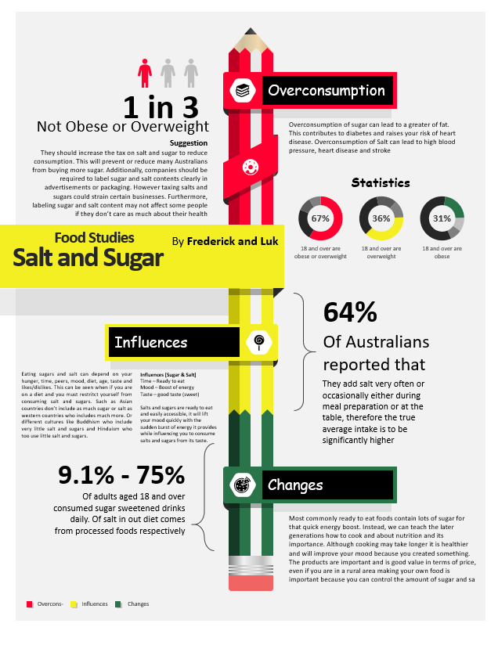
Student work sample 3

Student work sample 3 – assessment rubric

Relevant elements of the achievement standards Relevant elements of the achievement standards
Design and Technologies
By the end of Level 8, students:  - explain the contribution of design and technology innovations and enterprise to society |  | By the end of Level 10, students:  - identify the changes necessary to designed solutions to realise preferred futures they have described
Health and Physical Education
By the end of Level 8, students:  - investigate strategies and resources to manage changes and transitions and their impact on identities  - gather and analyse health information  - investigate strategies that enhance their own and others’ health, safety and wellbeing  - justify actions that promote their own and others’ health, safety and wellbeing at home, at school and in the community. |  | By the end of Level 10, students:  - critically analyse contextual factors that influence their identities, relationships, decisions and behaviours  - access, synthesise and apply health information from credible sources to propose and justify responses to situations in the home, in the school and the community  - compare and contrast a range of actions that could be undertaken to enhance their own and others’ health, safety and wellbeing.

Assessment rubric
Organising element | Performance descriptions
 | At Level 8 students can: | When progressing towards Level 10, students can: | At Level 10 students can: | Beyond Level 10, students can:
Influences on food choices | Examine a range of influences on food choices. | Analyse the influence of personal, social, cultural and environmental factors on food choices. | Critically evaluate a range of influences on food choices. | Compare and contrast the influences on food choices across different population groups.
Changes needed to adapt/modify/remove influencing factors on food choices | Identify marketing/promotional strategies that may influence food choices. | Identify changes that are needed to make a positive influence on food choices. | Describe the changes needed to make a positive influence on food choices. | Promote positive influences on food choices through marketing strategies.
Key areas/themes of action | Present the identified changes needed to make a positive influence on food choices according to the broad categories of influences. | Present the identified changes needed to make a positive influence on food choices according to the broad categories of influences, and provide commentary on their similarities and differences. | Describe the similarities and differences in the identified changes needed to make a positive influence on food choices according to the broad categories of influences. | Analyse the key areas/themes of action in terms of their similarities and differences.
Recommended actions | Identify recommended actions to help bring about change for better health and wellbeing. | Describe recommended actions to help bring about change for better health and wellbeing. | Justify the recommended actions to help bring about change for better health and wellbeing. | Critique the recommended actions to help bring about change for better health and wellbeing.

Student work sample 3 – evidence of learning
Frederick created a poster on ‘Salt and sugar’ that highlighted how increasing sugar and salt consumption are linked to overweight and obesity. He used headings in his poster that included statistics to support his comments, but there was no citing of references. He was also able to identify individual influences on consumption of foods high in salt and sugar, including hunger, time, peers, mood, diet, age, taste and likes/dislikes. Frederick described how people who subscribe to particular religions such as Buddhism and Hinduism do not eat a lot of sugar and salt, and how social factors such as lack of time can influence high-salt and high-sugar food choices.
Frederick was able to present changes needed to make a positive influence on salt and sugar consumption, and provide general commentary on these influences. He identified that an increase in salt and sugar taxes could reduce consumption of foods high in salt and sugar. He also identified that this change could be harmful to some businesses but did not provide any other commentary about this suggested change. Frederick was able to describe that educating people about the importance of nutrition and improving cooking skills could contribute to making good food choices by decreasing consumption of food high in salt and sugar.
Using the assessment rubric, Frederick has been assessed as:
- at Level 8 Influences on food choices
- progressing towards Level 10 for Changes needed to adapt/modify/remove influencing factors on food choice
- at Level 8 for Key areas/these of action
- progressing towards Level 10 for Justify recommended actions to help bring about change for better health and wellbeing.
This assessment demonstrates that Frederick can:
- ‘explain the contribution of design and technology innovations and enterprise to society’ (Design and Technologies, Levels 7 and 8 achievement standard)
- ‘investigate strategies and resources to manage changes and transitions and their impact on identities’ (Health and Physical Education, Levels 7 and 8 achievement standard)
- ‘gather and analyse health information’ (Health and Physical Education, Levels 7 and 8 achievement standard)
- ‘investigate strategies that enhance their own and others’ health, safety and wellbeing’ (Health and Physical Education, Levels 7 and 8 achievement standard)
- ‘justify actions that promote their own and others’ health, safety and wellbeing at home, at school and in the community’ (Health and Physical Education, Levels 7 and 8 achievement standard).

What is the student ready to learn next?
Frederick is now ready to learn to:
- ‘identify the changes necessary to designed solutions to realise preferred futures they have described’ (Design and Technologies, Levels 9 and 10 achievement standard)
- ‘critically analyse contextual factors that influence their identities, relationships, decisions and behaviours’ (Health and Physical Education, Levels 9 and 10 achievement standard)
- ‘access, synthesise and apply health information from credible sources to propose and justify responses to situations in the home, in the school and the community’ (Health and Physical Education, Levels 9 and 10 achievement standard)
- ‘compare and contrast a range of actions that could be undertaken to enhance their own and others’ health, safety and wellbeing’ (Health and Physical Education, Levels 9 and 10 achievement standard).

