Computational and   
algorithmic thinking   
in Mathematics

Unpacking the content descriptions

Level 6



Authorised and published by the Victorian Curriculum and Assessment Authority  
Level 7, 2 Lonsdale Street  
Melbourne VIC 3000

© Victorian Curriculum and Assessment Authority 2019

No part of this publication may be reproduced except as specified under the *Copyright Act 1968* or by permission from the VCAA. Excepting third-party elements, schools may use this resource in accordance with the [VCAA educational allowance](http://victoriancurriculum.vcaa.vic.edu.au/Curriculum/ContentDescription/VCCCTQ003#schools). For more information go to: <https://www.vcaa.vic.edu.au/Footer/Pages/Copyright.aspx>.

The VCAA provides the only official, up-to-date versions of VCAA publications. Details of updates can be found on the VCAA website: [www.vcaa.vic.edu.au](https://www.mathplayground.com/grade_1_games.html).

This publication may contain copyright material belonging to a third party. Every effort has been made to contact all copyright owners. If you believe that material in this publication is an infringement of your copyright, please email the Copyright Officer: [vcaa.copyright@edumail.vic.gov.au](mailto:vcaa.copyright@edumail.vic.gov.au)

Copyright in materials appearing at any sites linked to this document rests with the copyright owner/s of those materials, subject to the Copyright Act. The VCAA recommends you refer to copyright statements at linked sites before using such materials.

The VCAA logo is a registered trademark of the Victorian Curriculum and Assessment Authority.

Contents

Explicitly teaching computational and algorithmic thinking 4

Overview of the resource 5

Fraction flowcharts 6

Additional teaching resources 13

Appendix 1 14

Appendix 2 15

Appendix 3 17

Appendix 4 19

Explicitly teaching computational and   
algorithmic thinking

The *Computational and algorithmic thinking – Unpacking the content descriptions* resources unpack the Victorian Curriculum F–10 Mathematics content descriptions that address computational thinking and algorithms at each level in the Patterns and algebra sub-strand of the Number and Algebra strand.

Each resource provides teachers with links between one Mathematics content description and extract from the achievement standard related to computational and algorithmic thinking and a teaching and learning activity that is designed to develop computational thinking and problem-solving skills and produce corresponding algorithms in a mathematical context. Teachers can also find excerpts from the Victorian Curriculum Mathematics and Digital Technologies glossaries in Appendix 3.

The resources have been developed with respect to teaching in the Mathematics learning area of the Victorian Curriculum and they also include suggestions how these activities could be extended to the Critical and Creating Thinking and Digital Technologies curriculums.

Teachers will find detailed ideas about how to integrate Mathematics with one or both of Digital Technologies and Critical and Creating Thinking in Appendix 1 and Appendix 2 respectively.

Overview of the resource

**Curriculum area and level:** Mathematics, Level 6

**Strand and sub-strand:** Number and Algebra, Patterns and algebra

**Content description:** Design algorithms involving branching and iteration to solve specific classes of mathematical problems ([VCMNA221](http://victoriancurriculum.vcaa.vic.edu.au/Curriculum/ContentDescription/VCMNA221))

**Achievement standard (extract):** Students … solve problems involving the addition and subtraction of related fractions.

**Title:** Fraction flowcharts

**Timing:** 2 or 3 lessons (approx. 100–150 minutes)

**Description:** Students explore the creation of flowcharts for a process that involves branching and iteration (an algorithm).

The focus for these lessons is to work with fractions; however, the concept could be used in similar investigations.

**Learning objectives:** Students can:

add and subtract fractions with the same or different denominators using an algorithm

describe the purpose of an algorithm for solving problems

design algorithms involving branching and iteration to mathematical problems

create flowcharts to represent these algorithms

transfer this skill by creating a flowchart for a similar problem (extension).

**Resources:** Provide the following resources to each group of students:

fraction wall or fraction strips (see Appendix 4)

fraction question sheet (see Appendix 4)

butchers’ paper or poster paper

colour markers/pencils.

Fraction flowcharts

In groups of two or three, students explore the creation of flowcharts to assist in adding fractions, such as the flowchart [here](https://creately.com/diagram/example/ho8w0b9u/Flow%20Chart%20for%20Adding%20Fractions%20and%20Mixed%20Numbers). Background material on flowcharts can be found [here](https://www.geeksforgeeks.org/an-introduction-to-flowcharts/).

Provide each group of students with the materials listed in the Overview of the resource. You may wish to print the resources on cardboard and/or laminate them.

Activity 1: Adding fractions with the same denominator

In groups of two or three, students explore the concept of showing the steps involved in adding fractions with the same denominator using a flowchart.

**Tip**: A fraction wall would be a great accompaniment to this task. Students could be provided with a physical fraction wall or fraction strips (see Appendix 4) or an [online interactive fraction wall](https://www.visnos.com/demos/fraction-wall).

Begin by asking students to experiment with the solutions they find when adding two unit fractions(fractions with a numerator of 1) that have the same denominator together.

**Tip:** Reinforce the idea of fractions being parts of a whole. Also try to use various ways of describing fractions. For example, you could talk about 1/6 as being one part of one whole divided into six equal parts, or as one-sixth.

Have students use the fraction question sheet, Section 1 (seeAppendix 4) to explore this idea. For example:

$$\frac{1}{2}+\frac{1}{2}= ?$$

$$\frac{1}{3}+\frac{1}{3}= ?$$

$$\frac{1}{6}+\frac{1}{6}= ?$$

**Tip:** The fraction question sheet is provided as a starting point. Students should experiment with their own questions. Students should use technology (calculators) to check their answers and determine whether their flowchart and proposed algorithms are consistent.

What do students notice when solving the question? Two things could be discussed here:

* The numerator is 2, for example:

$\frac{1}{3}+\frac{1}{3}= \frac{2}{3}$ (when not simplified).

* The denominator remains unchanged.

What happens when $\frac{1}{2}+\frac{1}{2}= ?$ Does it follow this rule? Yes, because $\frac{1}{2}+\frac{1}{2}=\frac{2}{2}$, and two parts of two parts is one whole.

Challenge and extend

Students may also be able to identify simplification using their fraction strip or wall.

For example, they may realise: $\frac{1}{6}+\frac{1}{6}= \frac{2}{6}=\frac{1}{3}$

These students could create a separate flowchart for ‘simplifying’ and then add this step to their original flowchart.

Next, have students start to draw their flowchart on butchers’ paper, poster paper or in their books.

In a flowchart, questions requiring a decision are contained in a diamond, while branches – identified as true (Yes) or false (No) – lead to the next action (in a rectangle) or outcome (in a parallelogram).

Provide the class with the first question of the flowchart: ‘Do the fractions being added have the same denominator?’

If this is true (Yes), then what should happen next in this branch of the flowchart?

Students have already looked at unit fractions, so they know what to do if the fractions are unit fractions. Ask them to add a question about whether the fractions are unit fractions and then add two branches from this. Get them to write the action or outcome for true (Yes).

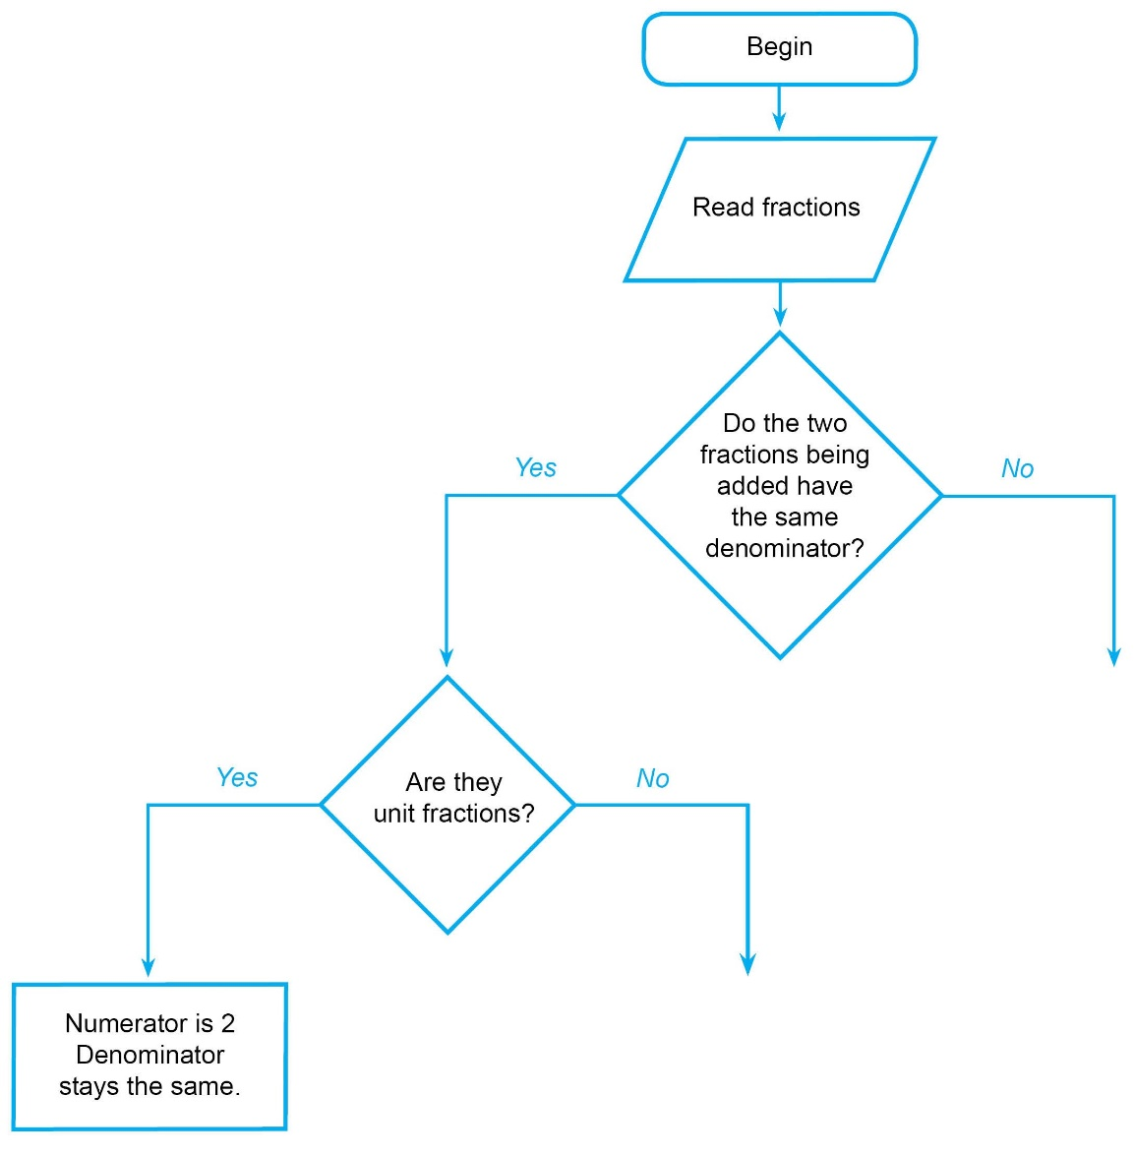

Discuss what happens if the two fractions with the same denominator are not unit fractions. Have students try Section 2 of the fraction question sheet (see Appendix 4)

For example: $\frac{1}{3}+\frac{2}{3}= \frac{3}{3}$

**Discussion prompts**

Where would the problems in Section 2 of the Fraction question sheet be considered in your flowchart?

(Answer: After the ‘no’ arrow, under ‘Are they unit fractions?’)

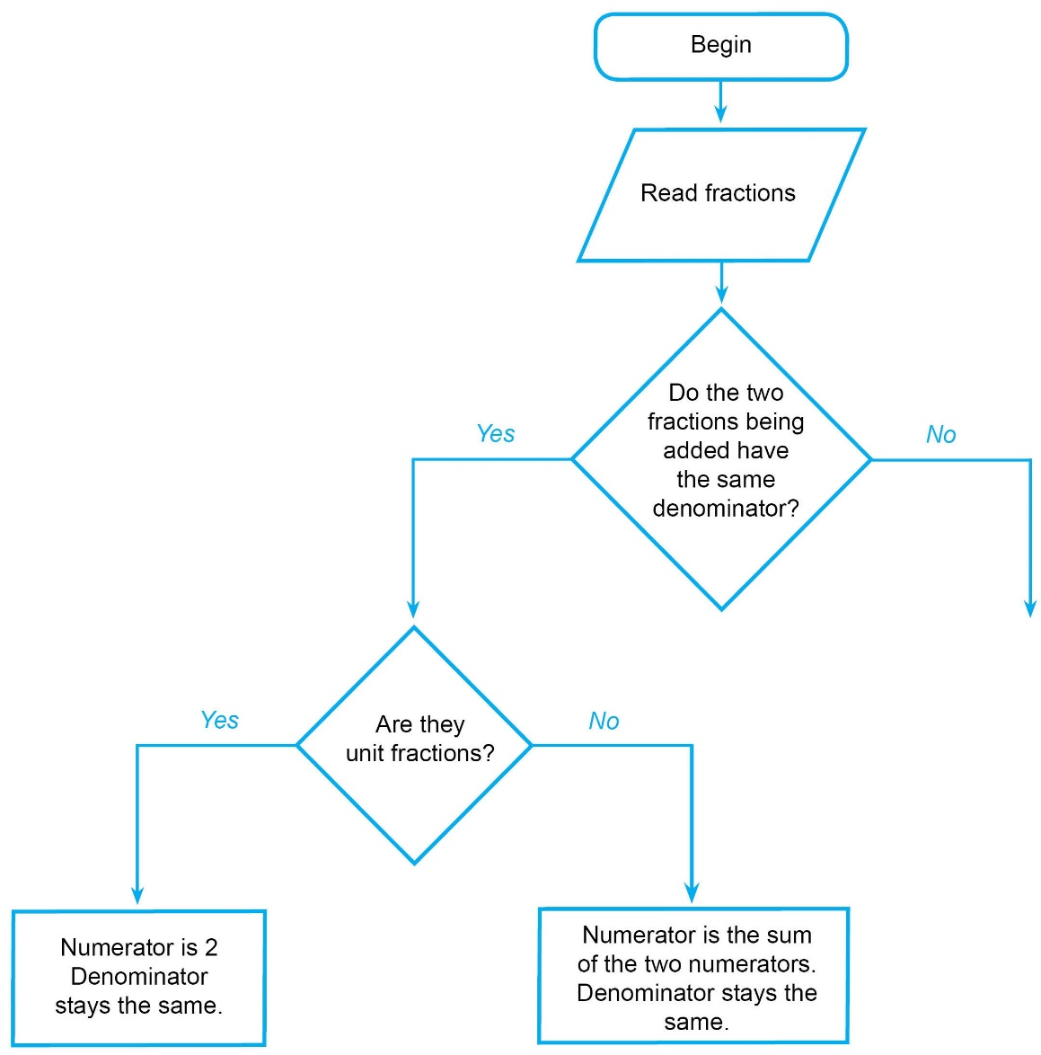

► **Cross-curricular links**

See Appendix 1 and Appendix 2 for ways to link this activity to the explicit teaching of Digital Technologies and/or Critical and Creative Thinking.

Activity 2: Equivalent fractions and simplifying

Encourage students to consider equivalent fractions to help with simplifying.

For example, using the fraction strips, we can see that $\frac{2}{6}=\frac{1}{3}$. These two fractions are said to be equivalent.

**Tip:** One way of simplifying fractions is to identify equivalent fractions using the fraction wall or strips. The equivalent fraction with the smallest possible denominator is the simplest form of the fraction.

For example, $\frac{4}{12}$ = $\frac{2}{6}$ = $\frac{1}{3}$ shows that $\frac{4}{12}$ in simplest form is $\frac{1}{3}$. This is because there is no equivalent fraction with a smaller denominator.

Can students find equivalent fractions for all their answers with the smallest possible number as a denominator? This step of simplifying could be added to their flowcharts as an additional branch, leading to the final answer.

Some preparatory work on simplifying may be required.

Some students may identify that they are dividing the numerator and denominator of the fraction by the same number when finding equivalent fractions. They might like to include this on their own flowchart.

► **Cross-curricular links**

See Appendix 1 and Appendix 2 for ways to link this activity to the explicit teaching of Digital Technologies and/or Critical and Creative Thinking.

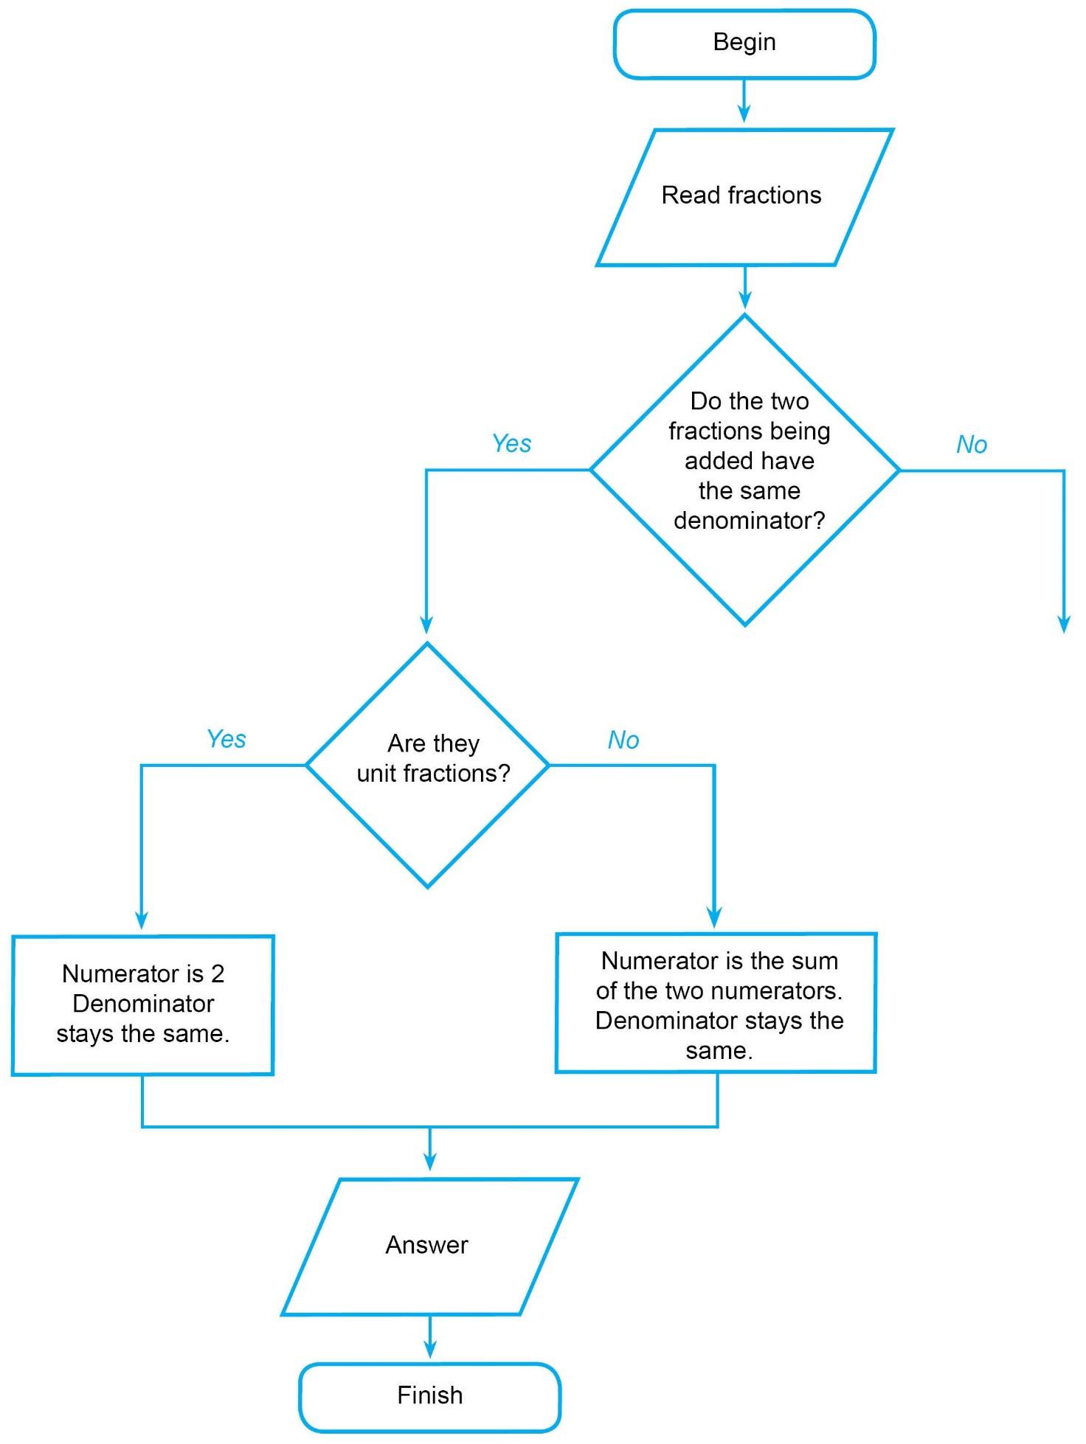

Activity 3: Adding fractions with different denominators

Now, students will be filling in the section on the right of the flowchart. This is the time for students to explore their solutions using fraction strips, walls and other ideas.

There could be differences in the way students divide their flowcharts up, and the methods they find that work.

For example, students might find, using the fraction strips, that:

$\frac{1}{3}+\frac{1}{4}= \frac{7}{12}$.

Students should be encouraged to discover how this happened using the steps below.

**Discussion prompts**

What do you think is the pattern/process here?

Students could consider the fractions in different equivalent forms to try to find the patterns when adding fractions with different denominators.

Encourage them to consider equivalentfractions at this point (as in Activity 2).

Using the fraction strips, we know: $\frac{1}{3}= \frac{2}{6}=\frac{4}{12}$ and $\frac{1}{4}= \frac{3}{12}$.

We now know that the problem could be expressed using fractions with the same denominator! This leads to:

$\frac{1}{3}+\frac{1}{4}=\frac{4}{12}+\frac{3}{12}= \frac{7}{12}$ as seen above.

**Discussion prompts**

* Does using equivalent fractions help solve the problem?
* Can you then use another part of your flowchart for solving the problem?

(Answer: Once the denominators are the same for both fractions, students can draw an arrow back to their ‘same denominators’ side and follow the flowchart to the answer.)

At this point, students will be developing different flowcharts according to the findings in their group. Encourage students to:

* try different ideas (think creatively)
* share ideas (work collaboratively)
* use technology to check their solutions and check whether their algorithm/pattern works (verify)
* test their algorithm/flowchart using other examples (try some problems not on the question sheet)
* extend their algorithm if they finish early.

Ask students: ‘What if you are adding more than two fractions? Can you add to your simplification algorithm?’

Allow students to explore patterns and results on their own but also provide assistance and guidance if groups are getting off track.

► **Cross-curricular links**

See Appendix 1 and Appendix 2 for ways to link this activity to the explicit teaching of Digital Technologies and/or Critical and Creative Thinking.

Challenge and extend

Subtraction of fractions using a flowchart

Now that students have developed a flowchart describing their algorithm for adding fractions, can they add on to, or create an entirely new algorithm (and flowchart), for *subtracting* fractions?

Students can use a teacher-generated subtraction question sheet to help guide this exploration in their small groups.

You might like to mix up fast-finishing groups to encourage sharing of new ideas and strategies.

Reflection

Students share their algorithms with other groups or with the whole class so students can see there are many ways to approach a problem using an algorithm.

With the class, in small groups or individually, ask students to reflect on their algorithmic thinking. Ask:

* How does your algorithm work in each activity?
* What is the purpose of the flowcharts you have created?
* What does your algorithm do well? Why?
* What doesn’t it do so well? Why?
* What do you think was the purpose of this investigation?

Explore the problem-solving aspect of this task. Ask:

* What were some challenges you faced in this task? How did you overcome these (what were some strategies)?
* What were some skills you learnt to help in a similar situation?
* Can you think of other problems where a flowchart might be used to help solve a complicated problem?

**Tip:** Reflection is an important aspect of any computational-thinking focused activity because it encourages students to consider the different aspects of the task, such as defining the problem and breaking the task down, selecting tools and processes, problem-solving, teamwork and verifying their solution. This helps students reflect on the process of their own learning (meta-learning) and how the skills they have used might transfer to other contexts.

Additional teaching resources

This is a different activity and context for which a flowchart could also be used to develop and represent an algorithm.

Diagram showing Tower of Hanoi problem. Three stands that are identical. On the left stand, there are three rings, with the smallest on the bottom. Stands are labelled A, B, CThe Tower of Hanoi is a well-known iterative problem that involves moving a stack of discs or rings from one ‘tower’ on the far left (A) to another on the far right (C) or equivalent, with the discs/rings stacked from largest to smallest in diameter.

This is done by following two simple rules:

* You can only move one disc/ring at a time
* You cannot place a disc/ring on top of a disc/ring that is *smaller.*

Students can watch a [video of the solution](https://youtu.be/GxYQCQB4CDM) for the three-ring puzzle (this channel also has solutions for the problem with more rings).

Students could explore this problem by creating algorithms for a simpler case (starting with two or three discs) and exploring branching and iteration for more complex cases, such as:

* more discs are added
* more towers are added (more than three)
* when the starting position of the discs changes.

Students can work with the problem with various numbers of layers at the following sites:

* [Tower of Hanoi](http://www.primarygames.com/puzzles/strategy/hanoi/), Primary Games (requires Flash)
* [Tower of Hanoi](https://www.mathsisfun.com/games/towerofhanoi.html), Math is fun.

Appendix 1

Suggestions for explicitly teaching Digital Technologies (stimulus only)

**Curriculum area:** Digital Technologies

**Strand:** Creating Digital Solutions

**Band:** Levels 5 and 6

**Content description:** Design, modify and follow simple algorithms represented diagrammatically and in English, involving sequences of steps, branching and iteration [(VCDTCD032)](https://victoriancurriculum.vcaa.vic.edu.au/Curriculum/ContentDescription/VCDTCD032)

**Achievement standard (extract):** Students … developing algorithms … they incorporate decision-making, repetition …

**Suggestions that extend Activities 1–3:**

* following, modifying and describing the design of a game involving simple algorithms represented diagrammatically or in English, for example creating a flowchart with software that uses symbols to show decisions, processes, and inputs and outputs
* experimenting with different ways of representing an instruction to make a choice, for example branches in a tree diagram or using an ‘IF’ statement to indicate making a choice between two different circumstances, using a spreadsheet or a visual program
* experimenting with different ways of representing an instruction to make a repetition, for example loops in a flowchart diagram or using a ‘REPEAT’ statement
* using different design tools to record ways in which digital solutions will be developed, for example creating storyboards or flowcharts to record relationships or instructions about content or processes

See also [Unpacking Digital Technologies Content Descriptions](https://www.vcaa.vic.edu.au/Documents/viccurric/digitech/Unpacking_the_Content_Descriptions/Unpacking_Digital_Technologies_Content_Descriptions-5-6.docx) for Levels 5 and 6.

Appendix 2

Suggestions for explicitly teaching Critical and Creative Thinking (stimulus only)

**Curriculum area:** Critical and Creative Thinking

**Strand:** Questions and possibilities

**Band:** Levels 5 and 6

**Content description:** Examine how different kinds of questions can be used to identify and clarify information, ideas and possibilities ([VCCCTQ021](http://victoriancurriculum.vcaa.vic.edu.au/Curriculum/ContentDescription/VCCCTQ021))

**Achievement standard (extract):** [S]tudents apply questioning as a tool to focus or expand thinking.

**Suggestions that link to Activity 2**

* Exploring the kinds of questions that can assist in finding equivalent fractions and simplifying and discussing whether any could be added to the flowchart
* Comparing questions across different flowcharts and discussing their effect on thinking

**Curriculum area:** Critical and Creative Thinking

**Strand:** Reasoning

**Band:** Levels 5 and 6

**Content description:** Consider the importance of giving reasons and evidence and how the strength of these can be evaluated [(VCCCTR025)](http://victoriancurriculum.vcaa.vic.edu.au/Curriculum/ContentDescription/VCCCTR025)

**Achievement standard (extract):** [Students] explain how reasons and evidence can be evaluated.

**Suggestions that link to Activities 1–3:**

* Discussing to what extent the fraction wall provides evidence to check the algorithm

**Curriculum area:** Critical and Creative Thinking

**Strand:** Meta-Cognition

**Band:** Levels 5 and 6

**Content description:** Investigate thinking processes using visual models and language strategies [(VCCCTM029)](http://victoriancurriculum.vcaa.vic.edu.au/Curriculum/ContentDescription/VCCCTM029)

**Achievement standard (extract):** Students represent thinking processes using visual models and language.

**Suggestions that link to Activities 1–3:**

* Drawing mind maps and flowcharts for different purposes, such as classifications of fractions (unit fraction, same denominator, simplified form) or to identify connections between different branches of their solutions algorithm (the flowchart may branch off then come back together when a familiar problem type is reached)
* Swapping flowcharts and mind maps and then reflecting on whether mind maps and flowcharts made the task easier or harder and when they could be used again

**Curriculum area:** Critical and Creative Thinking

**Strand:** Meta-Cognition

**Band:** Levels 5 and 6

**Content description:** Investigate how ideas and problems can be disaggregated into smaller elements or ideas, how criteria can be used to identify gaps in existing knowledge, and assess and test ideas and proposals [(VCCCTM031)](http://victoriancurriculum.vcaa.vic.edu.au/Curriculum/ContentDescription/VCCCTM031)

**Achievement standard (extract):** Students disaggregate ideas and problems into smaller elements or ideas … as required.

**Suggestions that link to Activity 1:**

* Discussing the identification of smaller elements within a problem of ‘adding fractions’ (such as type of fraction, numbers involved) as a strategy for a flowchart that is not working because the steps are too big, and constructing a plan for each element using a flowchart or developing strategies to identify mistakes within an existing solution flowchart

Appendix 3

Excerpts from the Victorian Curriculum Mathematics and Digital Technologies glossaries

There are some commonalities in the terms used when explicitly teaching computational and algorithmic thinking in Mathematics and Digital Technologies; however, there are also some subtle but important differences in the definitions of terms. Some of these common terms and their definitions are listed below, under the two different curriculum areas.

If you are going to explicitly teach Mathematics, please refer to the [Victorian Curriculum Mathematics Glossary](https://victoriancurriculum.vcaa.vic.edu.au/LearningArea/LoadFile?learningArea=mathematics&subject=mathematics&name=Mathematics%20Glossary.docx&storage=Glossary). If you are also going to explicitly teach Digital Technologies, refer to the [Victorian Curriculum Digital Technologies Glossary](https://victoriancurriculum.vcaa.vic.edu.au/LearningArea/LoadFile?learningArea=technologies&subject=digital-technologies&name=Digital%20Technologies%20Glossary.docx&storage=Glossary).

Mathematics

Algorithm

An **algorithm** is a process that can be carried out mechanically, using a well-defined set of instructions, to perform a particular task or solve a type of problem. Examples of mathematical algorithms include processes for tasks such as ordering a set of numbers from smallest to largest, multiplying many-digit decimal numbers, factorising linear expressions, determining which of two fractions is larger, bisecting an angle, or calculating the mean of a set of numbers.

Algorithmic thinking

**Algorithmic thinking** is the type of thinking required to design, test and evaluate problem-solving processes in a systematic way, using algorithms.

Coding

A process by which algorithms are represented for implementation. For computers, this is done using a coding language such as block coding, C++, JavaScript, Python, Wolfram Language.

Computational thinking

In this context, computational thinking is considered to be linked to algorithmic thinking. This type of thinking is usually considered specific to computers which involves solving problems, designing systems and implementation.

Sequence (number)

A **sequence** is an ordered set of elements such as numbers, instructions or objects. From an algorithmic point of view, a sequence is an ordered set of instructions or actions.

Unplugged

A commonly used term for computational thinking activities carried out without digital technology. “Unplugged” representations of algorithms may include structured mathematical processes, English representations (steps) or flowcharts.

Digital Technologies

Algorithm

A description of the steps and decisions required to solve a problem. For example, to find the largest number in a list of positive numbers:

1. Note the first number as the largest
2. Look through the remaining numbers, in turn, and if a number is larger than the number found in 1, note it as the largest.
3. Repeat this process until complete. The last noted number is the largest in the list.

Flowcharts are often useful in visualising an algorithm.

Computational thinking

A problem-solving method that involves various techniques and strategies in order to solve problems that can be implemented by digital systems, such as organising data logically, breaking down problems into components, and the design and use of algorithms, patterns and models.

Appendix 4

Fraction strips

~~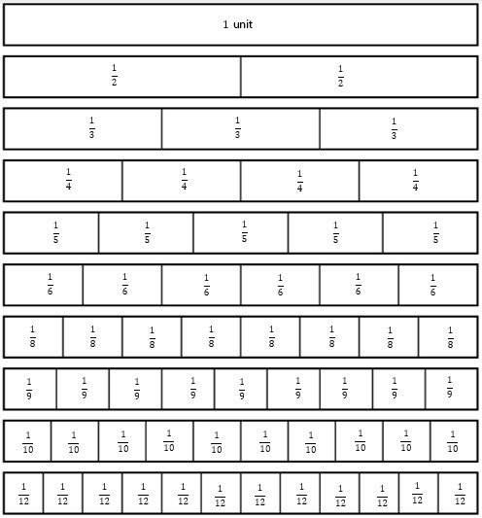~~

Fraction question sheet

Section 1

Adding fractions with the same denominators

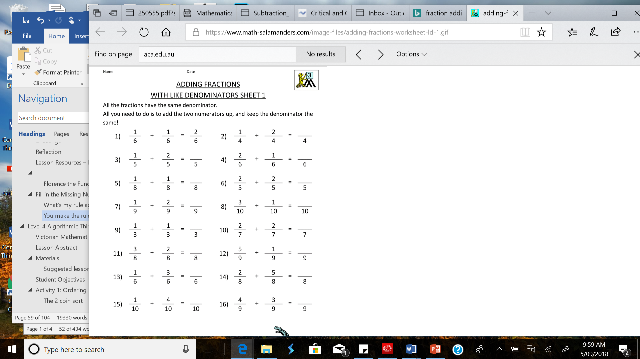   

Section 2

Adding fractions with different denominators

**Hint:** Find equivalent fractions to help with this.

