Over- and under-estimates
This task involves making estimates for the total price of the purchase of several items, to identify a range within which the total would lie, and an estimate of this total. The percentage error of the estimate from the actual value is also found as a measure of accuracy.
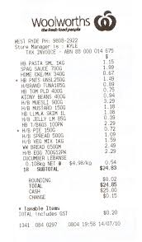

Part 1
- Form an under-estimate for the total price of the items shown below. Show how you obtained this under-estimate.
Item A $ 1.17
Item B $ 8.93
Item C $ 5.36
Item D $ 2.19
Item E $ 12.68
Item F $ 0.95
Item G $ 10.11

- Form an over-estimate for the total price of the items. Show how you obtained this over-estimate.

- Form an estimate for the total price of the items that lies between the estimates in a. and b. above. Show how you obtained this estimate.

- Calculate the actual total price of the items

The percentage error of an estimate is found by comparing the difference between the estimate and the actual value to the actual value and representing this as a percentage. The algorithm for this is given below:
Step 1: calculate the difference: estimate – actual value
Step 2: divide this difference by the actual value
Step 3: multiply the answer to Step 2 by 100

- Calculate the percentage error using the estimate from c. and round this correct to one decimal place.

Part 2
Consider the docket for a weekend grocery shopping trip (shown below).
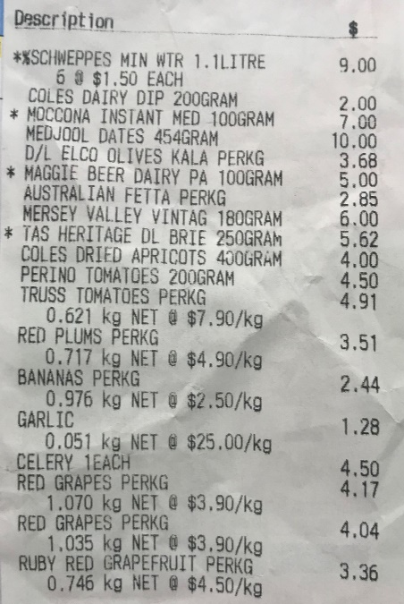
Carry out a. to e. from Part 1 for this list. Briefly discuss the accuracy of the estimate for Part 2.

