Level 9 – Measurement and geometry

Overview
Task name When three sides work
Learning intention To explore Pythagoras’s theorem and the relationship between the sides of triangles and their lengths
Duration 30 minutes

Links to the Victorian Curriculum
These work samples are linked to Level 9 of the Mathematics curriculum.

Extract from achievement standard
Apply Pythagoras’s theorem … to solve problems involving … lengths in right-angled triangles.

Relevant content description
- Investigate Pythagoras’ Theorem and its application to solving simple problems involving right-angled triangles (VCMMG318)

Links to NAPLAN

Minimum standards – numeracy
Year 9: Classification and properties of shapes
Students can classify 2D shapes … according to common properties including … sides, perimeters, areas …

Student work samples − Constructing triangles
These work samples were created by students working at
Level 9. Evidence of student achievement has been annotated.
Victorian Curriculum link
Investigate Pythagoras’ Theorem and its application to solving simple problems involving right-angled triangles (VCMMG318)

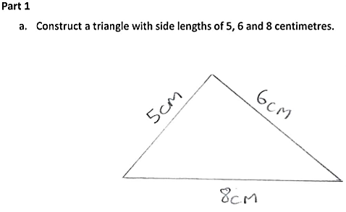

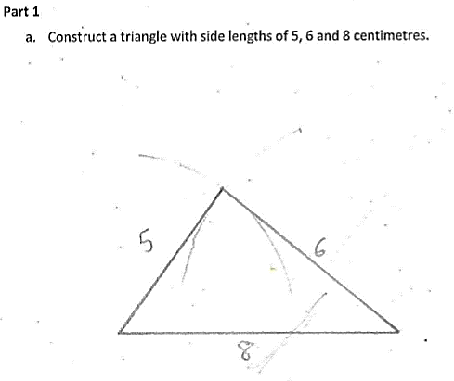

Uses a ruler to draw a triangle with required side lengths

Labels sides with correct measurements, including units

Uses a ruler and compass to construct a triangle with required side lengths

Labels sides with correct measurements but without units

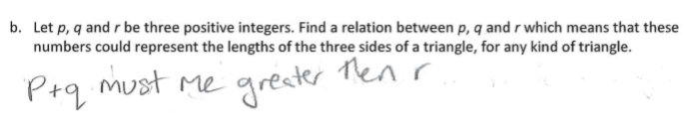

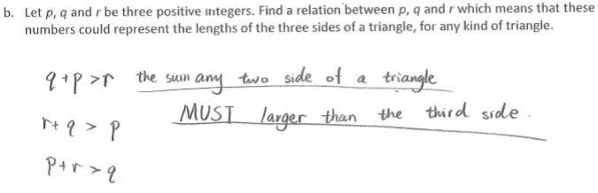

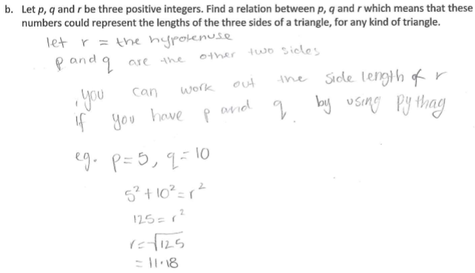

Uses symbols and words to specify the relation, assuming r corresponds to the longest side

Uses symbolic expressions including inequality to write a set of relations independent of the relative magnitudes

Provides a specific example of the Pythagorean relation for right-angled triangles

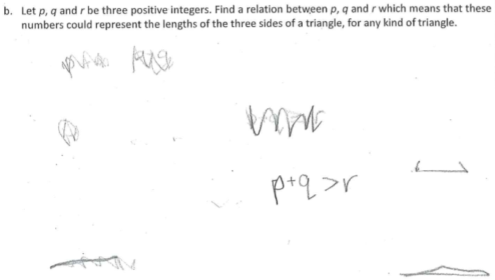

Sketches a case for which the corresponding values would not form the side lengths of a triangle

Initially writes a relation using ≥ then changes this to > assuming r corresponds to the longest side

Sketches a case corresponding to a
collapsed triangle

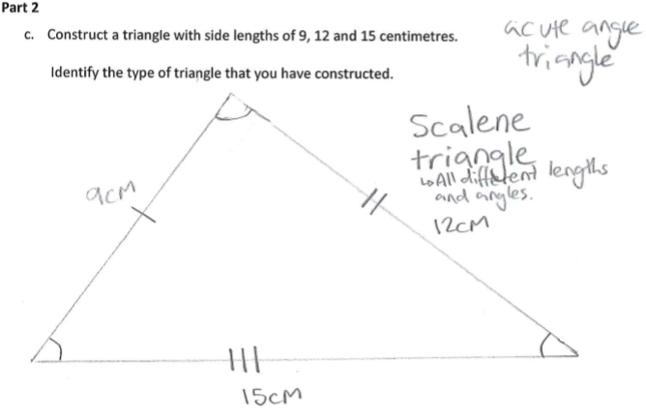

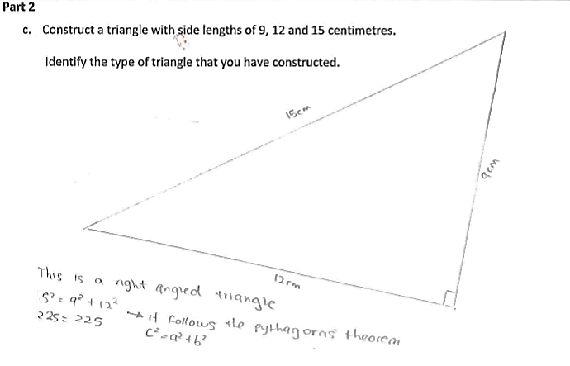

Identifies the triangle as scalene with acute angles

Uses geometric conventions to indicate angles and sides

Identifies a right-
angled triangle

Uses Pythagoras’s theorem to verify the triangle is right-angled

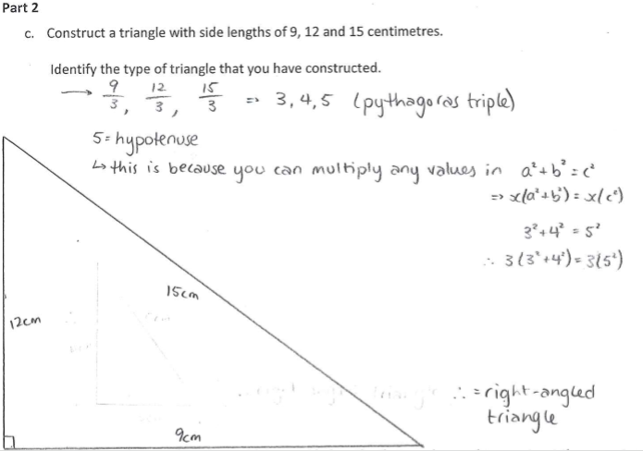

Identifies and verifies
the triangle as a
scaling of the 3, 4, 5
Pythagorean triple

Labels side lengths on reverse sides, including units

Identifies the
triangle as a
right-angled triangle

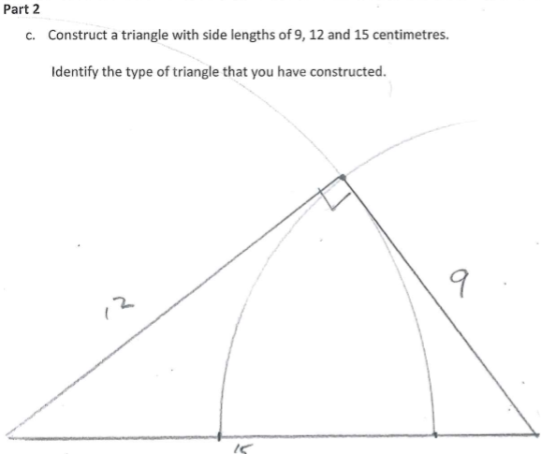

Uses a compass and ruler to construct a right-angled triangle with right angle at the apex and hypotenuse at the base

Labels side lengths with correct measurements

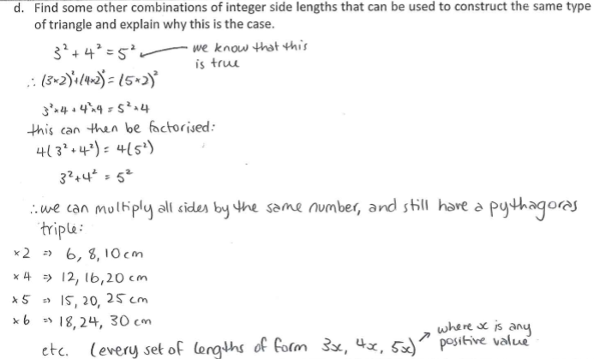

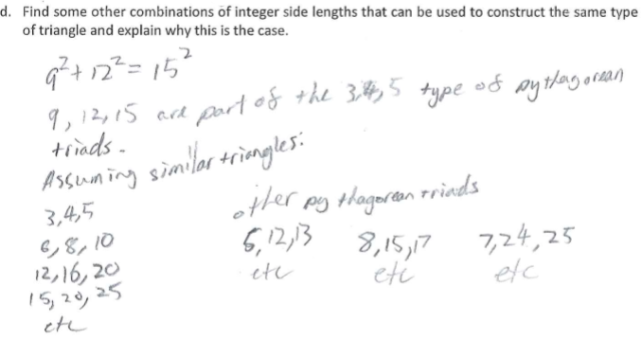

Uses a particular example to show the original relation is true with scaling

Lists a set of triangles based on scaling from a 3, 4, 5 triangle

Provides a general form

Identifies a set of similar right-angled triangles based on scaling from a 3, 4, 5 triangle

Identifies other combinations (Pythagorean triads) that can similarly generate other related triangles

Where to next for the teacher?
When the task on which these annotated student work samples is based has been used as a classroom activity, there is opportunity to gather data on student achievement to help inform further teaching.
An analysis of student responses, on an individual, group or whole class basis, can be used to develop and direct student learning with respect to the following content.

For students needing to review underpinning knowledge and skills at Level 8
- Develop the conditions for congruence of triangles (VCMMG292)
- Establish properties of quadrilaterals using congruent triangles and angle properties, and solve related numerical problems using reasoning (VCMMG293)

For students consolidating knowledge and skills at Level 9
- Apply trigonometry to solve right-angled triangle problems (VCMMG320)
- Use similarity to investigate the constancy of the sine, cosine and tangent ratios for a given angle in right-angled triangles (VCMMG319)

For students moving on to new knowledge and skills at Level 10
- Solve right-angled triangle problems including those involving direction and angles of elevation and depression (VCMMG346)

Resources
- Numeracy Learning Progressions, Victorian Curriculum and Assessment Authority (VCAA) –The Numeracy Learning Progressions amplify, extend and build on the numeracy skills in the Victorian Curriculum F–10: Mathematics and support the application of numeracy learning within other learning areas.
- FUSE, Victorian Department of Education and Training (DET) – The FUSE website provides access to digital resources that support the implementation of the Victorian Curriculum F–10, including an extensive range of activities and other resources for Primary Mathematics and Secondary Mathematics.
- Mathematics Curriculum Companion, Victorian Department of Education and Training (DET)
- Aligned Australian Curriculum Resources (Mathematics), Australian Curriculum, Assessment and Reporting Authority (ACARA)

