Shape up!
1. Describe the geometric properties of the following objects.

2. Match the three-dimensional objects with their net by matching them up.

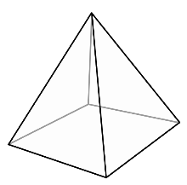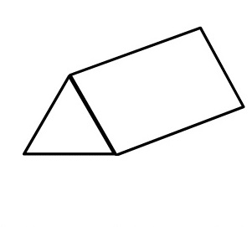

3. Draw the net of the objects below.

4. What two-dimensional shapes are used to form these three-dimensional objects?

_________________________________________________

_____________________________________________________________

______________________________________________________

_________________________________________________

