What are the chances?
Please refer to the spinner below.
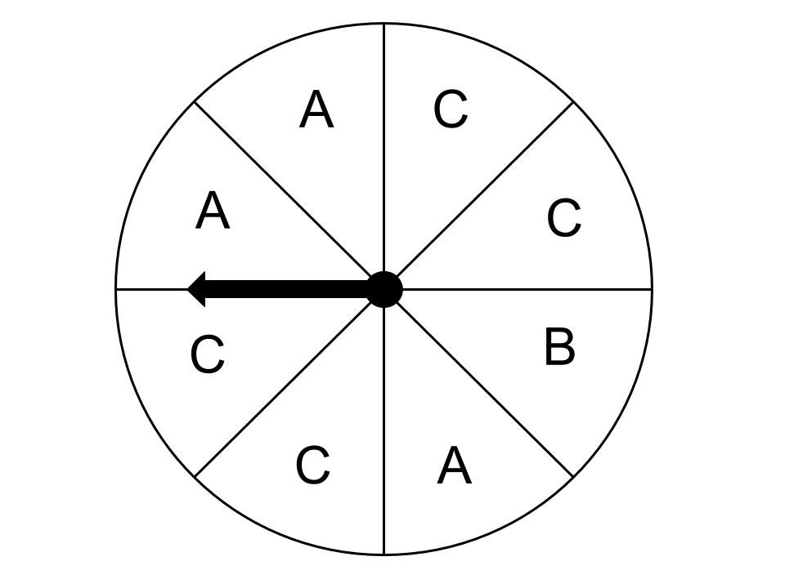

As a fraction, what is the probability (chance) of the spinner landing on each of the following?
A | B | C
A or B | B or C | C or A

On a six-sided dice, what is the probability of the rolling the following?

A 4 | An odd number | A number greater than 2 | A 1, 3 or 4

This is the weather forecast over a six-day period.
M | T
W | Th
F | S

Using the letters for each of the days in the table shown above, locate them according to likelihood of rain on the scale below.

On what days would you take an umbrella? Why?

On what days would you NOT take an umbrella? Why?

Weather forecasts reproduced by permission of Bureau of Meteorology, © 2019 Commonwealth of Australia

