STEM
Design a robot chariot
Levels 3–4

Authorised and published by the Victorian Curriculum and Assessment Authority
Level 7, 2 Lonsdale Street
Melbourne VIC 3000
© Victorian Curriculum and Assessment Authority 2018
No part of this publication may be reproduced except as specified under the Copyright Act 1968 or by permission from the VCAA. Excepting third-party elements, schools may use this resource in accordance with the VCAA educational allowance. For more information go to: www.vcaa.vic.edu.au/Pages/aboutus/policies/policy-copyright.aspx.
The VCAA provides the only official, up-to-date versions of VCAA publications. Details of updates can be found on the VCAA website: www.vcaa.vic.edu.au.
This publication may contain copyright material belonging to a third party. Every effort has been made to contact all copyright owners. If you believe that material in this publication is an infringement of your copyright, please email the Copyright Officer: vcaa.copyright@edumail.vic.gov.au
Copyright in materials appearing at any sites linked to this document rests with the copyright owner/s of those materials, subject to the Copyright Act. The VCAA recommends you refer to copyright statements at linked sites before using such materials.
The VCAA logo is a registered trademark of the Victorian Curriculum and Assessment Authority.

Overview
sTEM: Design a Robot Chariot
What is the challenge/design brief?  The challenge is for students to design and produce a robot racing chariot and program a Sphero robot to compete in a robot race over a certain distance. | Levels: Levels 3-4
 | Duration/time: Approximately 10 hours
What makes this unit have a STEM focus?
Design and Technologies:
- Technologies Contexts: Materials and technologies specialisations
- Creating Designed Solutions: Investigating, Generating, Planning and managing, Producing, Evaluating
Digital Technologies: Creating Digital Solutions
Mathematics: Measurement and Geometry: Using units of measurement.

Content Descriptions
Technologies |  |  | Mathematics
Design and Technologies |  | Digital Technologies
Technologies Contexts | Creating Designed Solutions | Creating Digital Solutions | Measurement and Geometry
Levels 3-4 |  | Levels 3-4 | Level 3 | Level 4
Materials and technologies specialisations  Investigate the suitability of materials, systems, components, tools and equipment for a range of purposes (VCDSTC027) | Investigating  Critique needs or opportunities for designing and explore and test a variety of materials, components, tools and equipment and the techniques needed to create designed solutions (VCDSCD028)  Generating  Generate, develop, and communicate design ideas and decisions using appropriate technical terms and graphical representation techniques (VCDSCD029)  Evaluating  Evaluate design ideas, processes and solutions based on criteria for success developed with guidance and including care for the environment and communities (VCDSCD031)  Planning and managing  Plan a sequence of production steps when making designed solutions (VCDSCD032) | Define simple problems, and describe and follow a sequence of steps and decisions involving branching and user input (algorithms) needed to solve them (VCDTCD023) | Using units of measurement Measure, order and compare objects using familiar metric units of length, area, mass and capacity (VCMMG140) | Using units of measurement  Use scaled instruments to measure and compare lengths, masses, capacities and temperatures (VCMMG165)

Achievement Standards
Design and Technologies | Digital Technologies | Mathematics
By the end of Level 4 students explain needs or opportunities and evaluate ideas and designed solutions against identified criteria for success, including sustainability considerations. They develop and expand design ideas and communicate these using models and drawings including annotations and symbols. Students plan and sequence major steps in design and production. | By the end of Level 4, students define simple problems, and design and develop digital solutions using algorithms that involve decision-making and user input. | Level 3: Measurement and Geometry  Students use metric units for length...  Level 4: Measurement and Geometry  Students use scaled instruments to measure length…of…objects.
Learning activities
Equipment | Resources
- construction building blocks such as K-nex and Lego  - iPad with Sphero Edu app (https://itunes.apple.com/au/app/sphero-edu-coding-for-sphero-robots/id1017847674?mt=8  - masking tape or chalk to mark start and finish for the challenge  - materials and joining proforma (Appendix 3)  - materials such as plastic cups, icy pole sticks, paper, cardboard, tape, hot glue gun and sticks, straws, pipe cleaners, match sticks, CDs, cotton spools  - robotic ball such as Sphero  - scaled instruments: measuring tapes or rulers to measure the distance for the challenge. | - collage of chariots handout (Appendix 5)  - design brief (Appendix 1)  - floor space to conduct the challenge  - FreeMind (Mind Mapping tool) http://fuse.education.vic.gov.au/?LM8889  - Generating design options proforma (Appendix 4) – print as A3  - Padlet (online noticeboard):  - www.padlet.com  - http://fuse.education.vic.gov.au/?V6YFM7  - production plan proforma (Appendix 2)
Occupational health and safety (OH&S)
Teachers should be familiar with the Victorian Department of Education and Training’s Risk Management policy and references that provide tools and links to resources that assist in identifying and mitigating against risk in schools. The Risk Management policy can be accessed at: www.education.vic.gov.au/school/principals/spag/governance/pages/risk.aspx
In this particular activity, consideration should be given to the following:
- Students may need to be supervised with the use of a hot glue gun.
Key concepts and vocabulary
- Algorithm: a description of the steps and decisions required to solve a problem; e.g written instructions
- Bluetooth: a wireless technology that connects the Sphero to the iPad
- Code: enter the algorithm; e.g. into the app
- Chariot: a two or four wheeled vehicle drawn by horses, used in ancient racing
- Commands: instructions provided to the robot to make it move
- Computational thinking: thought processes involved in problem-solving and expressing a solution
- Scaled instrument: measuring device such as a ruler or tape measurement that has uniform and consistent measurements such as centimetres
- Sphero: a robotic ball that can be controlled by using certain apps and programming language
- Systems thinking: understanding the linkages and interactions between parts of a system
- Testing and troubleshooting: establishing why the algorithm is not working correctly; this is part of computational thinking
- Visual programming: a programming language where the program is represented and created visually rather than as text. A common visual metaphor represents statements and control structures as blocks that can be composed to form programs, allowing programming without having to deal with syntax errors
Teacher instructions
- Prior to the learning sequence, install Sphero Edu app onto iPad and ensure Sphero is fully charged.
Session 1 (one hour)
Learning intention and success indictors for students
- I can identify the characteristics that make a chariot and identify possible materials to be used in the production of a unique and innovative design that meets the design brief.
  - Introduce what a chariot is and explain how they have been used in society. Explore what characteristics make a chariot (i.e. two or four wheels, pulled by a horse) by asking students to investigate different types of chariots. Use the ‘samples of chariots’ handout (Appendix 5) and the specific websites listed in the ‘Additional resources/references’ and/or books from the library, to gather knowledge for the design of their own unique and innovative designed solution. Consider possible material use with this knowledge to be drawn on and utilised in session two. Provide the following questions to stimulate their research (Investigating sub-strand):
    - What materials were used to produce a chariot in the past?
    - Why do you think certain materials were chosen?
    - What were chariots used for?
    - What structural features does a chariot require?
    - What allows the wheels to move?
    - Do you think a chariot would be able to change direction?
- Introduce the challenge by providing the design brief to the students (Appendix 1).
- Prompt students with the following questions to get them thinking about how they will be successful in creating a designed solution that fits the design brief:
    - How far should the chariot travel in the race?
    - What materials should be available to produce the chariot?
    - How will the chariot move?
    - Should any sized chariot be allowed to compete in the race?
- Tell the students these questions will be used as the success criteria; i.e. how to measure the success of the challenge. Following the discussion, ask students to identify three to four success criteria for the challenge such as:
  - must travel one metre (or distance determined by the teacher)
  - must be produced from craft materials
  - must have a surface area no larger than an A4 piece of paper
  - must have two or four wheels
  - must be pulled or pushed by the robot (Sphero).
- Provide the students with the assessment rubric for them to refer to throughout the challenge and outline what each component is. Discuss the language used throughout and how the students will document their learning by taking photos at different stages (i.e. different sub-strands) of the ‘Creating Designed Solutions’ process (which will be familiar to them already from F-2 curriculum) such as design options, during production, completion of production, testing with Sphero robot and during the running of the robot chariot race.

Session 2 (one hour)
Learning intention and success indictors for students
- I can generate a design that meets the design brief using thinking techniques.
- I can test different joining techniques and evaluate how effective they are.
- Begin with explicit instruction of how to generate and document design ideas. Discuss the importance of the design process and what makes a good design. Prompt students with questions and discussion points such as:
  - What is a design?
  - Why are the ‘investigate’ and ‘generate’ sub-strands of the design process important?
  - Where do you get your ideas from?
  - What should a design look like?
  - What materials are the wheels going to be made of and will the chosen material allow the wheels to turn/move?
  - How can materials be best joined, connected or assembled to ensure the chariot is able to move the required distance?
- Introduce strategies to assist students to think creatively such as using elements from the SCAMPER thinking technique (refer to Additional resources/references) or use post it notes, butchers paper or digital tools, such as Padlet or FreeMind, to allow students to build on each other’s ideas to support them to develop original and innovative ideas.
- Demonstrate to students how they can use the ‘substitute’ thinking technique from SCAMPER. Use the knowledge of the features of a chariot and how it was used in the past and adapt it to meet the design brief. Model how to adapt the chariot from being pulled by a horse to how it could either be pushed or pulled with a Sphero and what features of the chariot structure may need adapting.
- Brainstorm different ways to generate a unique and innovative design to meet the requirements of the design brief including drawings with labels, lists of materials, etc. Provide students with a specific time allocation (to be determined by the teacher - approximately 20 minutes) to work with a partner to begin generating three designs that have different materials used for the wheels. Provide students with a copy of Appendix 4 (printed A3) for them to generate their designs. Students need to draw on knowledge from Session 1 of the functions and features of a chariot, how it has been used throughout history, design constraints and materials. Ensure students complete annotations on their design, detailing materials used, methods of attachment/joining, clear measurements, how it will work with the Sphero robot and how it will move. Annotations need to include:
  - all materials required
  - size / measurement of materials required
  - methods of attachment/joining; i.e. hot glue gun, masking tape, cable tie.
- Provide students with opportunities to experiment with how materials can be best joined, connected and assembled to ensure students are able to successfully produce their chariot. Allow time as a whole class to explore and experiment with different attachment methods and their functionality, such as using a hot glue gun, testing the movement of wheels using skewers and trialling the durability of materials such as paper and cardboard when moved by a Sphero. Provide the materials and joining proforma (Appendix 3) to each student to document how well the types of joins worked, evaluating why certain joins were more successful than others.
- Provide opportunity for critique of designs with students presenting their preferred design option to the whole class at the conclusion of the session. Discuss how elements of the design meet the brief; for example: Does the design have two or four wheels? Is the design produced using craft materials?
- Use the following questions as prompts for discussion:
  - What technical language can be used during the design process? Use the specific vocabulary of the Creating Designed Solutions process (investigating, generating, producing, evaluating, planning and managing) and brainstorm what is required of students at each different stage in the process.
  - How does this design help you to think about appropriate material choices?
  - How will the Sphero move the chariot?
  - Are there any limitations to your chariot design?
Session 3 (one hour)
Learning intention and success indictors for students
- I can justify how my preferred design option meets the design brief and explain the materials and joining techniques that will be used in production.
- Following the critique of the designs in the previous session, provide students with time to finalise their selected design with a clear list of required materials and to make any modification based on feedback they received.
- Conclude the session with students communicating their final design and required materials to their peers, detailing how and why they have chosen the design and how it will be produced. Discuss the importance of communicating the design process with peers and what can be learnt from this process. Students to verbally communicate their designed solution to their peers using their annotated design to outline material use and methods of attachment/joining.
Session 4 and 5 (two hours)
Learning intention and success indictors for students
- I can write a production plan to produce my designed solution.
- I can use the materials and joining techniques specified in my production plan to produce my chariot.
- Begin with explicit instruction about how to develop a production plan. Discuss the importance of following a plan like a procedural text; i.e. gathering all materials first, referring back to the design throughout production process. Explain how a production plan is linked to systems thinking – following a sequence of steps similar to those that they will determine for the controlling of the robot. Discuss interactions and relationships; e.g. What must happen first? What is the sequence? Provide students with a scaffold to develop the production plan proforma (refer to Appendix 2).
- Provide students with time to develop their production plan.
- Share/communicate the different approaches students have to their production plan – what is similar and different between plans? What are necessary features of a useful production plan?
- Provide at least one 60 minute session for production of the chariot. If possible, encourage students to document the production process with written or photographic evidence to allow for prompts throughout the evaluation phase (which has occurred throughout the process already) and to reflect on the execution of the design and production plan. Have students take one photo (if they do not have access to a camera, the teacher should take the photos) at the following stages of the design process: final design, during the production process, conclusion of the production process (final product) and during the testing process with the Sphero. The photos will support the evaluation of the final product.
- Allow students the opportunity to test their chariot with the Sphero and make modifications, as necessary, to meet the success criteria identified in the design brief to get the Sphero to move in the race. Explain how making adjustments links to computational thinking; i.e. problem-solving, such as, examining the design, development and evaluating the algorithm. Emphasise the importance of reflecting and documenting any changes made to the design and production plan.
Session 6, 7 and 8 (three hours)
Learning intentions and success indictors for students
- I can use a scaled instrument to correctly measure the required distance.
- I can develop an algorithm that moves the Sphero in a straight line for the required distance.
- Begin this session with explicit instruction on length/distance and how to correctly use scaled instruments such as tape measures and metre rulers to measure the length/distance. Explore strategies to problem-solve how to measure a distance that is longer than the provided scaled instrument. Outline to students the required length for the robot race as determined by the design brief in the success criteria.
- Provide pairs of students with either masking tape or chalk, to demonstrate how to correctly use a scaled instrument to measure the required length for the robot race.
- Explicitly teach how to use both systems and computational thinking to develop a digital solution using an algorithm in the Sphero EDU app. Begin by discussing the commands in which you would need to instruct the robot to follow to make it move. Use a flow chart to show a visual process; i.e.
  - set the ‘aim’ button to 0 to travel in a straight line
  - set the time the Sphero will need to travel for
  - set the speed for the Sphero to move at
  - command the Sphero to stop at the completion of the race on the finish line.
- Allow students to build their algorithm and code (enter the algorithm) in the Sphero EDU app and test the commands with the chariot, using the measured line from earlier in the session. Based on trials, ask students to troubleshoot the algorithm with modifications to time and speed commands to have the chariot finish the race at the end of the measured distance. Assist students with troubleshooting by asking the following questions:
  - What is it doing?
  - Why is it doing that?
  - What will happen if I make this change?
- Provide opportunities for students to communicate and discuss how they are approaching the development of an algorithm to meet the design brief, such as:
  - What will need to be the first step in the algorithm?
  - What direction does the Sphero need to travel in?
  - What commands will be needed to control the speed and direction?
  - How can you ensure the robot stops exactly on the finish line?
- Use this as an opportunity to extend students in developing concise algorithms with steps and decisions that efficiently meet the design brief.
- Students to have finalised their algorithm at the conclusion of this session, ready to participate in the whole class robot racing chariot event in the next session. Discuss the importance of trial and error when testing and troubleshooting.
Session 9 (one hour)
Learning intention and success indictors for students
I can develop a designed solution that can successfully compete in the robot race.
- As a whole class, conduct the running of the robot chariot event over the pre-determined distance.
- Discuss the outcome of the chariot event and how successful the different chariots were. Discussion questions could include:
  - Did the chariot that moved the quickest complete the race first?
  - Did the speed in which the Sphero moved impact on how the chariot moved?
  - What made for a successful chariot in the race?
  - What features of the robot chariots worked well?
  - Did successful chariots have anything in common?
  - Were all the chariots successful?
  - What testing and troubleshooting did you do if your chariot was not successful?
- Ensure students have taken photos of their completed chariot and its participation in the robot racing chariot event.
Session 10 (one hour)
Learning intention and success indictors for students
I can evaluate the success of my designed solution against the design brief and success criteria statements.
- Discuss why it is important to evaluate the ‘Creating Designed Solutions’ process and how this can be completed.
- Begin with explicit instruction on how to evaluate the finished product against the success criteria identified from design brief provided at the commencement of the challenge.
- Refer back to the success criteria statements and discuss the following questions either as whole class, small groups or with partner:
  - What worked and what didn’t and why?
  - Did you meet the design brief? How?
  - What is one feature you would change about your chariot design?
  - What materials worked best? Why?
  - What was the most challenging part of the activity? Why?
  - How did the size of the wheels or other design characteristics impact the results?
  - What worked well within your team? Why?
Assessment strategies for students
 | Elements from the Achievement Standards | Indicators
Design and Technologies | Explain needs or opportunities and evaluate ideas…against identified criteria for success, including sustainability. | Generates criteria for success. | Insufficient evidence | Selects ideas for chariot design using identified criteria for success, including sustainability. | Uses criteria for success that meet requirements of the design brief for the chariot, including sustainability. | Evaluates ideas for chariot design using identified criteria for success, including sustainability.
 | Develop and expand design ideas and communicate these using models and drawings including annotations and symbols. | Develops design ideas to meet the design brief and uses models and drawing including annotations and symbols. | Insufficient evidence | Identifies options that meet the design brief for a chariot. | Identifies options that meet the design brief for a chariot and labels components of the design options. | Generates options that meet the design brief for a chariot and uses technical language to label components of the design options.
 |  |  | Insufficient evidence | Identifies materials, based on their characteristics and properties, used in design options. | Identifies materials, based on their characteristics and properties, used in design options and identifies how tools will be used with these materials. | Explains materials, based on their characteristics and properties, used in design options, and explain how tools will be used to make the design options.
 | Evaluate…ideas and designed solutions against identified criteria for success, including sustainability considerations. | Evaluates design options for the chariot against the design brief. | Insufficient evidence | Identifies that features of the design options for the chariot meet the requirements of the design brief, including sustainability considerations. | Explains how the features of the design options for the chariot meets the requirements of the design brief, including sustainability considerations. | Analyses the features of the design options for the chariot against the requirements of the design brief including sustainability considerations, and discusses why the preferred options was selected for the design of the chariot.
 | Plan and sequence major steps in design and production. | Follows a sequence of steps to create a solution to the design brief. | Insufficient evidence | Identifies the steps for the creation of the chariot, and follows this sequence of steps to create the chariot, using safe work practices. | Lists the sequence of steps for the creation of the chariot and follows this sequence to create the chariot, using safe work practices. | Manages the sequence of steps to create the chariot, using safe work practices.
Digital Technologies | Define simple problems, and design and develop digital solutions using algorithms that involve decision-making and user input. | Uses visual programming to successfully move the chariot in a straight line. | Insufficient evidence | Uses visual programming to move the chariot in a straight line. | Uses visual programming to move the chariot in a straight line in a specified direction. | Uses visual programming to move chariot in a straight line in a specified direction and enables the chariot to stop after a given distance or time.
Mathematics | Use metric units for length…. | Reads scales. | Insufficient evidence | Identifies nearest centimetre. | Improves accuracy by taking measurements to nearest millimetre. | Acknowledges uncertainties using scales.
 |  | Selects measurement tool. | Insufficient evidence | Selects a tool to measure length. | Selects a tool taking into consideration length to be measured; e.g. metre rule. | Selects a tool with precision of measurement required; e.g. tape measure with graduated scale.
 | Use scaled instruments to measure length…of …objects. | Uses a graduated scale marking to measure the distance to be travelled by the chariot. | Insufficient evidence | Uses a 30 cm ruler to measure length of chariot race. | Uses a meter ruler to measure length of chariot race. | Uses a tape measure to measure length of chariot race.

Additional resources/references
This YouTube clip shows an example of how you may set up your chariot horse races and different examples of chariot designs.
- Chariot example video: www.youtube.com/watch?v=rOWBDdxw1wY
This website provides information on what a chariot is and how it has been used in the past.
- Chariot research website: www.ancient.eu/chariot/
This website provides information on what a chariot is and how it has been used in the past.
- Chariot research website: www.britannica.com/technology/chariot
SCAMPER technique
- This PDF provide information about the SCAMPER thinking technique.
www.phf.org/resourcestools/Documents/The_SCAMPER_Technique_Tool.pdf
Sphero
- This website (American-based) provides information about the Sphero robot and accessories you can purchase. It does include some information and links of how it can be used in educational settings.
www.sphero.com/
Sphero Edu app
- This website provides information about the app that can be used to program the Sphero robot.
https://itunes.apple.com/au/app/sphero-edu-coding-for-sphero-robots/id1017847674?mt=8

Appendix 1
Design brief
With a partner, design and produce a chariot in a 60 minute session to compete in a race against other chariots. Program a robot (Sphero) that successfully moves the chariot over the distance of one metre. (The distance determined can be based on the amount of appropriate space you have but a minimum of 1 metre is recommended). The chariot must have a surface area no larger than an A4 piece of paper and be produced with basic craft materials.

Appendix 2
Production plan
Team members

Materials required |  | Methods of joining materials
Task sequence | Time required |  | To be completed by
1.

2.

3.

4.

5.

6.

Safety considerations during production:

Appendix 3
Joining materials – testing and evaluating

Material and joining technique
1.

2.

3.

4.

Which material and joining technique was the most successful and why do you think this?

Which material and joining technique was the least successful and why do you think this?

Appendix 4
Generating design options
Sketch three design options that are possible solutions for the challenge. Ensure you annotate each design and identify the different materials that will be used as a substitution for the wheels of the chariot.
For each design option, identify one plus, one minus and one interesting point.
Remember each design option must meet the design brief.
Design option 1 |  |  | Design option 2 |  |  | Design option 3
Plus | Minus | Interesting | Plus | Minus | Interesting | Plus | Minus | Interesting

Which design option are you going to select and why?

Appendix 5
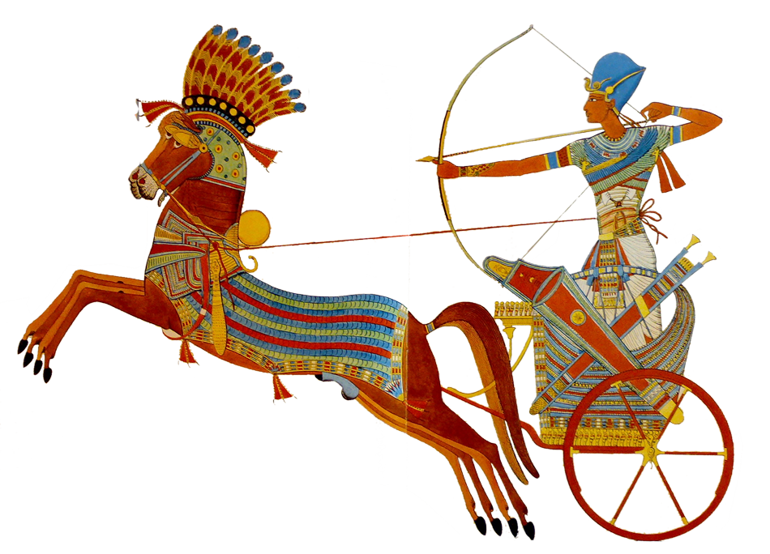
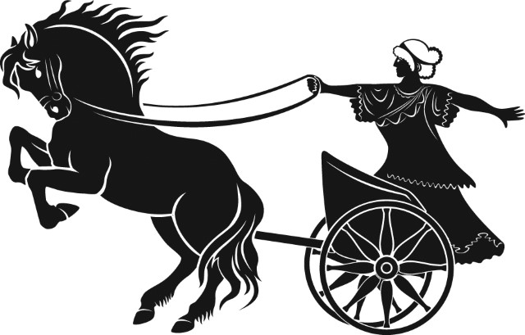
Samples of chariots

