2024 VCE Product Design and Technology external assessment report

General comments
The 2024 VCE Product Design and Technology examination was based on the VCE Product Design and Technology Study Design 2024–2028.
Areas of strength in this year’s responses included:
- identifying an end-user profile
- identifying constraints
- knowing the difference between primary and secondary research
- understanding the benefits of mycelium-based products
- referring to the stimulus material given in the examination
- attempting to answer all questions
Areas for improvement included:
- understanding the circular economy and its role in supporting sustainability
- understanding the importance of research and development
- understanding flexible and responsive manufacturing
- knowing both critical and creative thinking techniques, and relating them to the Double Diamond design process
- knowing the names of specific materials, their characteristics and properties
- understanding the command terms used in the questions
- avoiding unnecessary rewriting of questions, which uses up space and time
- writing legibility.
In 2024, 65 examinations were potentially impacted by the early publication of the examination material. After extensive analysis, only 5 exams were found to have been impacted. The Product Design and Technology examination was one of those 5 examinations.
The independent Expert Advisory Panel led by Professor John Firth:
- reviewed student marks in the affected exams and identified any anomalies in how students have responded to the affected questions, including how the affected question related to the rest of the exam.
- analysed if any discrepancies were identified. If so, the panel conducted further analysis
The statistical analysis revealed anomalies in the data where a small number of students performed significantly better on the impacted questions compared to their performance in the rest of the paper.
To avoid any consequent disadvantage for other students, the Panel recommended that those students were removed from the standard study score, including the distribution of study scores. The scores of impacted students were then inserted into the overall distribution at a matched point after the study scores had been distributed.
This has ensured that no student lost a mark through this process and no student was disadvantaged as a result of this process.

Specific information
This report provides sample answers, or an indication of what answers may have included. Unless otherwise stated, these are not intended to be exemplary or complete responses.
The statistics in this report may be subject to rounding, resulting in a total more or less than 100 per cent.

Question 1a.
Marks | 0 | 1 | 2 | Average
% | 8 | 16 | 76 | 1.7
Students were asked to formulate one profile of an end user for the mycelium-grown bricks.
There was no need to develop personal details such as names etc; however, some students did so. The question stated ‘an end user’ and, as such, a broad interpretation of the end user was acceptable.
High-scoring responses provided a profile of an end user that included the context. Lower-scoring responses identified an end user but did not provide a profile.
The following is an example of a high-scoring response:
One end user for the mycelium-grown bricks could be builders, who are seeking alternative materials with similar properties to traditional bricks but [that are] instead more environmentally friendly.

Question 1b.
Marks | 0 | 1 | 2 | Average
% | 15 | 16 | 79 | 1.6
Students were asked to identify two constraints the end user could have encountered in the Ecovative bricks, and most responses did this well.
High-scoring responses referred directly to the information provided.
The following is an example of a high-scoring response:
the end user may require the bricks to be lightweight and easier to handle
the end user may have required the bricks to be eco-friendly and biodegradable.

Question 2
Marks | 0 | 1 | 2 | 3 | 4 | Average
% | 22 | 7 | 20 | 16 | 35 | 2.4
Students were asked to evaluate the Ecovative Design bricks using the constraints they had identified in the previous question.
Most responses did this well, referring to the information provided. High-scoring responses referred to the specific information and evaluated how this had been addressed in the bricks’ design. Lower-scoring responses developed evaluation criteria instead of evaluating the brick.
The following is an example of a high-scoring response:
Mycelium-grown bricks by Ecovative Design are insulating, offering the ability to maintain a comfortable inside temperature as well as reduce noise. They are suitable in this aspect. However, their ability to withstand different weather such as rain is called into question. The bricks are resistant to moisture, which while helpful does not equal waterproof. They are, however, resistant to mould and can be treated to resist fire. Overall, while the bricks may fit Constraint 1, they fall short on Constraint 2 as they are not proven to be weatherproof.

Question 3a.
Marks | 0 | 1 | 2 | 3 | 4 | Average
% | 25 | 13 | 24 | 16 | 35 | 2.0
Students were asked to discuss two features of the circular economy.
Many responses made general reference to sustainability and being eco-friendly but were not specific to the circular economy. High-scoring responses clearly identified two concepts related to the circular economy, and presented a balanced discussion.
The following is an example of a high-scoring response:
The circular economy means keeping the product or the product’s material alive as long as possible using recycling and other methods. The two features of [the] circular economy are technical, which is recycling materials such as plastic or metal to be able to be used again, and biological, which includes organic materials such as cotton and involves returning it to the Earth.

Question 3b.
Marks | 0 | 1 | 2 | 3 | Average
% | 22 | 16 | 27 | 35 | 1.8
This question asked students to analyse how the Ecovative Design bricks utilised the circular economy.
To achieve full marks for this question, responses needed to refer to the brick specifically and analyse it contributed to the circular economy. Responses addressed this well and referred to the biodegradable nature of the bricks or the renewable resource of mycelium.
The following is an example of a high-scoring response:
The Ecovative bricks use a circular economy as when they are no longer used they will break down and biodegrade, which feeds nutrients back to the Earth. From this, this will enable more mushrooms to grow so that at the vegetative state they can be made into new bricks, leaving little to no wastage after end of life.

Question 4
Marks | 0 | 1 | 2 | 3 | 4 | Average
% | 39 | 11 | 25 | 8 | 16 | 1.5
This question asked students to identify and describe one creative and one critical thinking technique that would be used in the first diamond of the double diamond design approach. Responses also needed to make a connection between the thinking technique and the development of the Ecovative Design bricks.
High-scoring responses referenced creative and critical thinking techniques that were relevant to the second diamond, such as generating ideas through graphical product concepts.
The following is an example of a high-scoring response:
Creative thinking technique
Mind mapping – the designer can create a chart to link and expand ideas to determine how the product concept could look and be made.
Critical thinking technique
Review past trends on the demands and requirements for bricks in the market to see how they can meet end users’ needs but also improve upon after waste products on the market.

Question 5
Marks | 0 | 1 | 2 | 3 | 4 | Average
% | 19 | 5 | 19 | 12 | 45 | 2.6
This question asked students to describe an example of primary and secondary research that Ecovative Design may have conducted.
Lower-scoring responses identified different areas of research but did not demonstrate understanding of primary or secondary research. Primary research is completed by the designer in person, whereas secondary research is information the designer finds from other sources. Responses needed to describe this and relate it to the Ecovative Design brick.
The following is an example of a high-scoring response:
Primary
Ecovative Design may have conducted research themselves into how mould resistant the bricks are by keeping some in a moist, humid room and some in a dry and non-humid room to evaluate the difference.
Secondary
Evocative Design may have conducted secondary research by reading reports and discoveries of how mycelium can bind with other organic materials like straw to create a strong brick perhaps discovered by scientists.

Question 6
Marks | 0 | 1 | 2 | 3 | 4 | 5 | 6 | 7 | 8 | Average
% | 18 | 9 | 17 | 18 | 19 | 9 | 7 | 1.7 | 0.8 | 2.8
This question asked students to critique the Ecovative Design bricks in relation to the triple bottom line’s economic and social sustainability. However, many responses referenced all three dimensions or only discussed the environmental dimension. While they were not penalised for this, these responses were not allocated marks for references to the environmental dimension. Lower-scoring responses discussed the positive aspects of the economic and social dimensions of the brick but did not critique them.
High-scoring responses provided a critique of both the economic and social sustainability dimensions by analysing and assessing their strengths and weaknesses, considering variable aspects and offering an informed and thoughtful examination.

Question 7
Marks | 0 | 1 | 2 | 3 | 4 | Average
% | 5 | 8 | 26 | 22 | 40 | 2.9
Students were asked to discuss one positive and one negative aspect of consumers growing mycelium to make products in their own homes or local communities.
Many responses identified a positive aspect and discussed this well. Several responses referred to negative impacts on the manufacturer, for example that they would not make as much profit. However, the question asked for the impact on consumers, not the manufacturer. High-scoring responses discussed both a positive and a negative for the consumer.
The following is an example of a high-scoring response:
Positive
Consumers can grow their own materials to make products, which would be cheaper than buying them commercially.
Negative
If consumers don’t carefully follow standards, the product might not adhere to Australian standards for the product they are making, making it dangerous to use.

Question 8
Marks | 0 | 1 | 2 | 3 | Average
% | 22 | 28 | 29 | 21 | 1.5
This question asked students to discuss how an information campaign about the sourcing, production and life cycle of mycelium-based products may encourage entrepreneurial activities within the design industry.
High-scoring responses presented a clear, considered and balanced discussion of entrepreneurial activity/activities related to mycelium-based products and included reference to the information campaign and how this encourages the entrepreneurial activity/activities.
The following is an example of a high-scoring response:
An information campaign could incentivise potential designers to consider the usage of mycelium in a broad range of fields of design, once seeing the benefits of the material. This could thus encourage entrepreneurial activities, as designers take risks involving manufacturing with mycelium and create unique and innovative concepts in order to gain support from potential end users and investors.

Question 9
Marks | 0 | 1 | 2 | 3 | Average
% | 8 | 22 | 34 | 36 | 2.0
Students were asked to provide one reason why mycelium-based products may be considered ethical.
Generally, responses addressed this appropriately, however many responses included more than one reason. While they were not penalised for this, these additional reasons were not allocated marks.
The following is an example of a high-scoring response:
Mycelium-based products are to be considered ethical as [they are] environmentally friendly and [are] produced utilising repurposed recycled materials. Through key environmental considerations, this product has benefits to the planet [in that it] is further promoting respect to future human generations and non-humans.

Question 10a.
Marks | 0 | 1 | 2 | Average
% | 41 | 31 | 28 | 0.9
This question asked students to refer to the information provided about the census and describe one method of investigating market needs or opportunities.
The command term was to ‘describe’, however several responses explained how the information would be used and did not describe the method of investigating, for example a questionnaire.
The following is an example of a high-scoring response:
This could be gathering, analysing and creating online questionnaires directed towards the end user population. This could gain information such as the number of occupied apartments, and after analysis, realise that is increasing.

Question 10b.
Marks | 0 | 1 | 2 | Average
% | 30 | 23 | 47 | 1.2
This question asked students to outline two ethical considerations when gathering research.
High-scoring responses outlined two different ethical considerations that were relevant to gathering research. However, lower-scoring responses outlined ethical considerations related to the information provided, not to gathering the research.
The following is an example of a high-scoring response:
Privacy: researchers must keep personal information about participants safe and private.
Informed consent: researchers need to explain the study clearly so participants know what it is about.

Question 11a.
Marks | 0 | 1 | 2 | 3 | 4 | 5 | 6 | Average
% | 5 | 1 | 8 | 7 | 11 | 11 | 57 | 4.8
This question asked students to address the concerns of end users living in smaller spaces by describing two multi-functional and space-saving product concepts for apartment living. Responses needed to also identify two different functions for each of the product concepts.
Most responses answered this question in sufficient detail, however lower-scoring responses named the product concept but didn’t identify its function.
The following is an example of a high-scoring response:
Product concept 1
Description
A compact minimalist couch that folds out into [a] bed
Function one provides comfortable seating while taking up minimal space for movement.
Function two folds out into a space to sleep at night, eliminating the need for a large bed.

Question 11b.
 | Marks | 0 | 1 | 2 | 3 | 4 | Average
11b (i) | % | 5 | 30 | 44 | 13 | 8 | 1.9
11b (ii) | % | 9 | 26 | 42 | 11 | 12 | 1.9
11b (iii) | % | 11 | 40 | 37 | 9 | 3 | 1.5
This question asked students to select one of the product concepts they identified in Question 11a., and draw and annotate two different visualisations that addressed the concerns of apartment living.
Many responses contained drawings of the same product concept showing a second function, however some responses revealed some misunderstanding of the question and contained drawings of two different product concepts.
Several responses contained drawings of whole apartments or floor plans, also misunderstanding the question. Some responses contained annotations in reference to the end-user needs, however many of these annotations did not directly address the end-user concerns and instead only explained the product concept.

The following are examples of high-scoring responses:
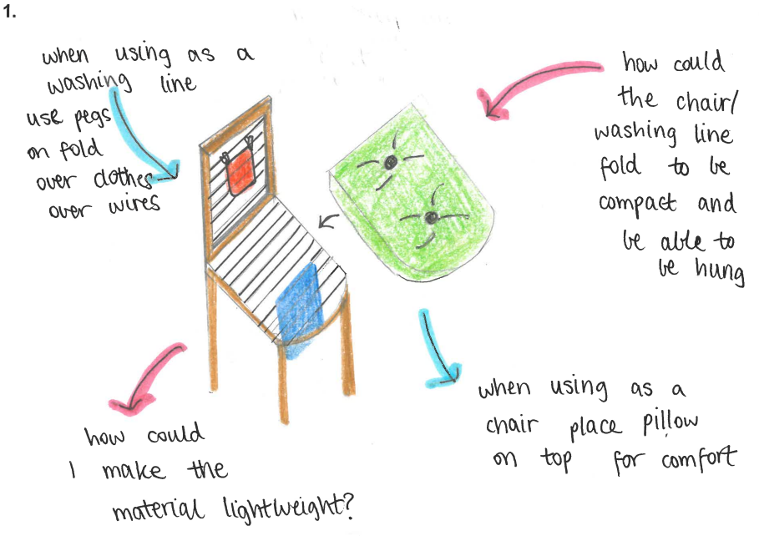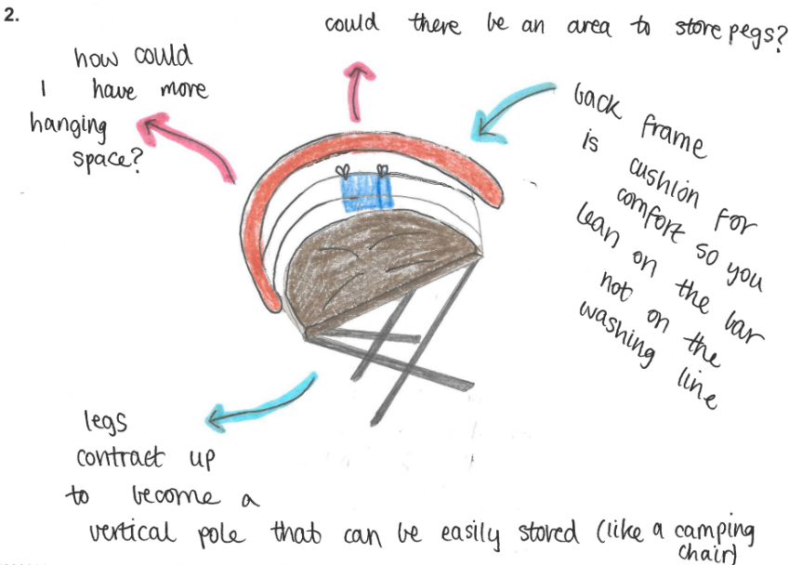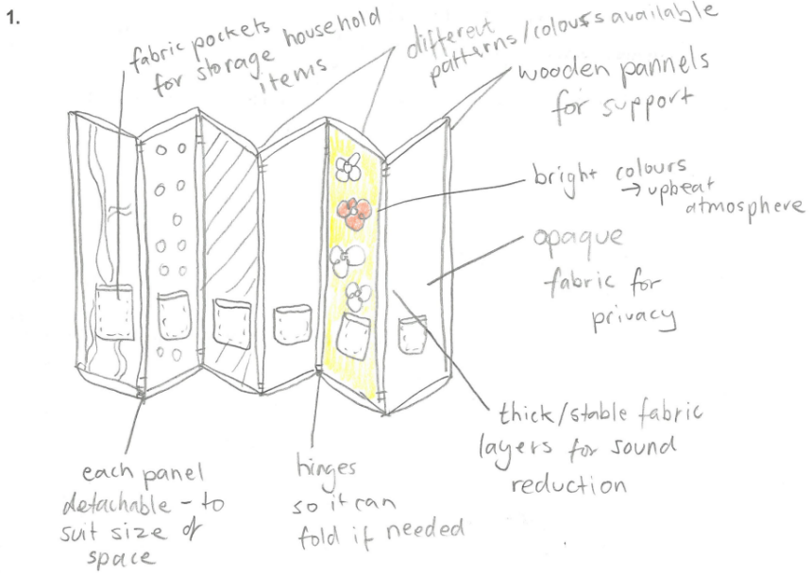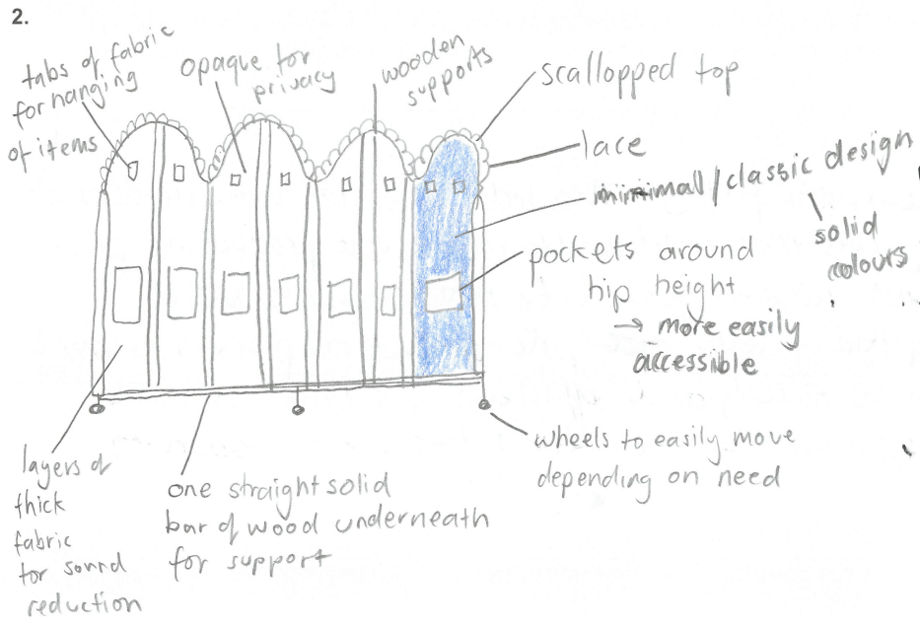
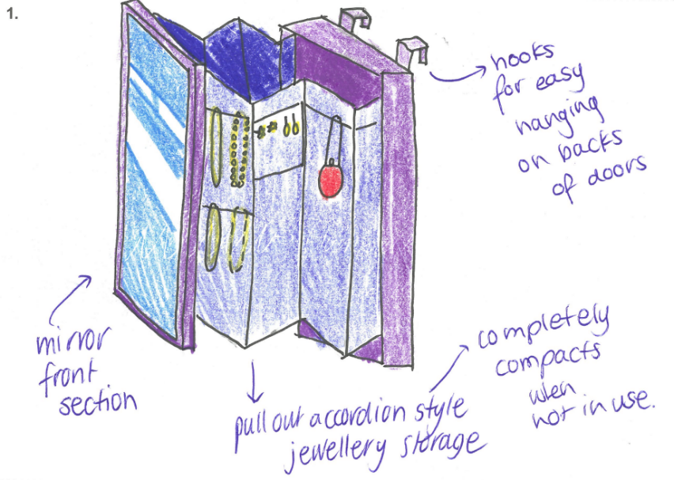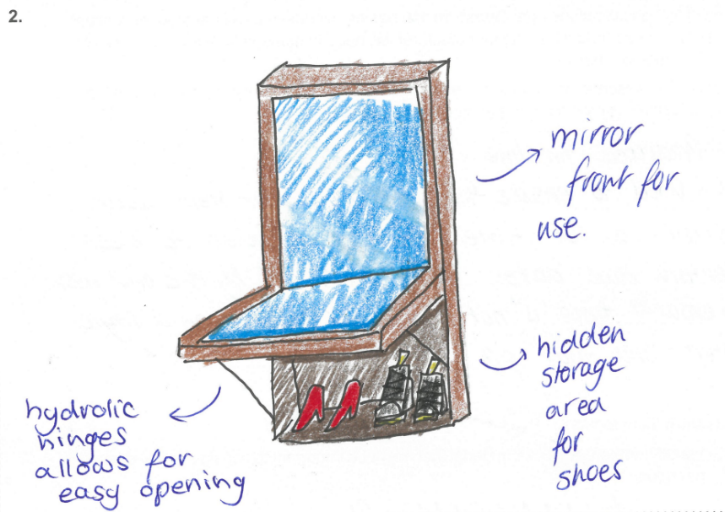

Question 11c.
Marks | 0 | 1 | 2 | 3 | 4 | Average
% | 7 | 5 | 19 | 25 | 44 | 3.0
Students were asked to select one of the visualisations from Question 11b. and critique how it met the end-user needs in reference to being space-saving and multi-functional.
This question was consistently answered competently, with most responses critiquing how their visualisation had met the end-user needs.
The following is an example of a high-scoring response:
Multifunctional
The design is multi-functional because it can be lowered or lifted to fit the needs of the end user as a low side table or high dining table.
Compact / space-saving
The design is compact and space-saving because it removes a necessary piece of furniture from the apartment, combining multiple [functions] together [in one piece of furniture].

Question 12
Marks | 0 | 1 | 2 | 3 | Average
% | 32 | 14 | 22 | 32 | 1.6
Students were asked to identify and describe one method used to manage time and/or resources to ensure that a quality product is produced efficiently and effectively if one of the visualisations from Question 11b. was chosen to be the final proof of concept.
Some responses referred to implementing a scheduled production plan, while others referred to implementing new and emerging technologies or lean manufacturing. Both answers were acceptable.
Lower-scoring response did not address the command term correctly, or they identified a method without describing it.
The following is an example of a high-scoring response:
A production schedule can be used as it plans out the exact tasks that must be completed at a certain date, also taking into account the materials, technologies and processes required to produce a quality product efficiently and effectively.
The following is an example of a high-scoring response:
Manufacturers could use lean manufacturing. Lean manufacturing involves coordinating delivery of products from suppliers so that resources are directed exactly when they are needed, and products are directed to distributors or end users as soon as finished to reduce wait times.

Question 13a.
Marks | 0 | 1 | Average
% | 29 | 71 | 0.7
This question asked students to identify one property of a material that might be important to consider when designing a product.
Responses were consistently of a high standard, with most responses identifying an appropriate property.
The following is an example of a high-scoring response:
Durability, as it is important that the materials of a product can withstand knocks.

Question 13b.
Marks | 0 | 1 | 2 | Average
% | 32 | 27 | 41 | 1.1
Students were asked to describe an experiment, test or trial that could be used to test the property they identified in Question 13a.
Some responses did this effectively, however some explained instead of described the experiment. High-scoring responses described the test in detail.
Some responses did this effectively, however some stated what the test/experiment was instead of describing the test/experiment. High-scoring responses described the test in detail.
The following is an example of a high-scoring response:
Weights could be used to test the durability of a material as they can be placed on top of the material until the desired weight can be held by the material without breaking.

Question 13c.
Marks | 0 | 1 | 2 | Average
% | 30 | 32 | 38 | 1.1
Students were asked to explain how the findings of the experiment from Question 13b. may help to justify a chosen product concept.
Most responses explained the findings of the experiment appropriately, however a number did not explain how this may justify a product concept. High-scoring responses were able to do both.
The following is an example of a high-scoring response:
This may help decide and justify a chosen product concept as it will show the designers what material is the strongest, most suited for the design and design problem and how the product is best suited to be used by the end user.

Question 14
Marks | 0 | 1 | 2 | 3 | Average
% | 41 | 28 | 19 | 12 | 1.1
Students were asked to discuss one way that research and development (R&D) in relation to polyamide 11 could contribute to innovation.
Lower-scoring responses referred to market research instead of research and development. Other responses referred to materials testing of the product.
High-scoring responses referred to research and development being scientific and technical to discover new materials and processes. These responses then explained how this contributes to innovation.
The following is an example of a high-scoring response:
R&D in relation to polyamide 11 could contribute to innovation as the plant-based materials is rather unknown. Through R&D, the properties of polyamide 11 could be explored such as weight, stretch and durability. Using this information, innovation around how it could be used and how the design of a helmet could be reimagined would come about.

Question 15a.
Marks | 0 | 1 | 2 | Average
% | 7 | 24 | 69 | 1.6
This question asked students to describe the purpose of prototyping.
Most responses did this appropriately, referring to aspects of prototyping such as testing ideas, gathering feedback, and identifying faults before production.
The following is an example of a high-scoring response:
The purpose of prototyping is to help find issues or faults for a product before it is mass produced, allowing products such as the HEXR helmet to meet end-user needs or wants.

Question 15b.
Marks | 0 | 1 | 2 | Average
% | 17 | 36 | 47 | 1.3
Students were asked to describe how prototyping is used to justify a chosen product concept.
Lower-scoring responses described the general purpose of prototyping but did not describe how prototyping can be used to justify a chosen product concept. High-scoring responses provided a clear and detailed description of how prototyping is used to justify a chosen product concept.
The following is an example of a high-scoring response:
Prototyping can be used to justify a chosen product concept as it can help identify what the advantages and disadvantages of each product concept [are] and help identify the most viable product concept.

Question 16
Marks | 0 | 1 | 2 | 3 | 4 | 5 | 6 | Average
% | 10 | 5 | 19 | 20 | 28 | 11 | 6 | 3.1
Students were asked to critique the impact of the smartphone app for both the consumers and producers of the HEXR smartphone app.
Most responses adequately identified positives of the app for both consumers and producers, however many didn’t provide a critique. High-scoring responses analysed and assessed strengths and weaknesses, considered variable aspects and offered an informed, balanced and thoughtful examination of the app.
The following is an example of a high-scoring response:
Consumers
Consumers are able to send their measurements and information easier and faster however may feel nervous or concerned about the process because there is no direct human contact. Despite this, the app may be more effective [at] leaving the consumers satisfied.
Producers
Producers will be able to easily convert the information gathered from the app into the 3D printing software and will be able to produce the helmets quicker and easier. However, if the information is not clear producers cannot easily fix it.

Question 17
Marks | 0 | 1 | 2 | Average
% | 38 | 28 | 34 | 1.0
This question asked students to describe how the manufacturing process of the HEXR helmet could be considered an example of flexible and responsive manufacturing.
Lower-scoring responses referred to lean manufacturing and did not demonstrate an understanding of flexible or responsive manufacturing. High-scoring responses described how the manufacturing of the HEXR helmet was an example of flexible or responsive manufacturing.
The following is an example of a high-scoring response:
As the HEXR helmet is manufactured in small batches of six with a relatively short turnaround time, changes can be made between batches in CAD software and implemented in the next batch, and in this [way] the HEXR helmet manufacturing process can be considered as flexible and responsive. Furthermore, the number of helmets produced can be easily adjusted through the use of multiple 3D-printers to match the demand of the helmet.

