2024 VCE Visual Communication Design external assessment report

General comments
In 2024, the Victorian Curriculum and Assessment Authority produced an examination aligned with the new VCE Visual Communication Design Study Design From 2024 that incorporated significant changes to course structure and content. This year's examination format gave students greater flexibility by allowing them to select from a range of fields of design practice in Sections A and B, including messages, environments, objects and interactive experiences. With the inclusion of new concepts such as human-centred research methods, the double-diamond design process, Gestalt principles, circular design and conceptions of good design, the examination tested students' ability to apply both theoretical knowledge and practical design skills across a variety of questions.
A key strength observed among the cohort was students' ability to manage the time constraints of the examination effectively, with most students completing the 80-mark examination within the 90-minute limit. A majority of students selected the most appropriate examples from the resource book to apply their knowledge of the field of design practice to respond to specific questions. For example, students who paired the Nightingale Apartments design with Question 2 (focused on factors affecting design), or who selected messages designs for Questions 3 and 4 (focused on design elements and principles, and Gestalt principles, respectively), were able to respond more effectively and in greater detail. Similarly, students who chose the Hup Hup Chair for Question 5 (focused on conceptions of good design) provided stronger, more analytical responses. Additionally, students demonstrated their knowledge of aspects of the VCD design process in many of the practical responses in Section B, with students showcasing their thoughtful application of visual language.
However, the examination did highlight particular areas where students could have improved their responses. Notably, there was a lack of clarity and depth in students’ understanding of the legal factors related to their selected field of design practice, with many using vague or inaccurate terminology. This area therefore requires further attention and clearer articulation in future study and practice. Additionally, the responses continued to reflect some uncertainty among students around key terminology, such as design elements, principles, and Gestalt principles and factors, as well as confusion between stakeholder needs and design constraints. These terms are clearly outlined in the Study specifications and Terms used in the study on pages 12–20 of the study design and in the published Frequently asked questions under Support materials on the study design page. The ability to accurately use and integrate these terms in responses is essential and will require more focused attention in future.
Another area for improvement concerns students' reading comprehension and ability to carefully interpret examination questions. Misunderstanding or misinterpreting questions, particularly with regard to the specific focus of a given task, led some students to provide formulaic or off-target responses.
Lastly, while many students displayed strong drawing skills in their practical work, there remains room for improvement in the refinement of presentation drawings with regard to conventions, particularly under timed conditions. Specific information about the conventions of development, documentation and presentation drawings is provided in the Study specifications on page 15 of the study design and in the published Frequently asked questions. Practising their skills in quick and precise sketching, as well as honing the drawing method most aligned with their strengths in a selected field of design practice, will help students perform better in Section B in future.
In future examinations, it is essential that students take full advantage of the flexibility offered in the examination across the fields of design practice to apply their knowledge of and strengths in a particular field of design practice to respond to the questions. Practising with the range of fields of design practice in the School-assessed Coursework and the School-assessed Task, and engaging with past examination questions, will help students become more comfortable with the expectations of the external examination and the time constraints. Additionally, students would benefit from refining their drawing techniques and ensuring that they understand all key terminology and design concepts, which will improve their performance in the examination. It is important to remember that each year’s examination is unique, with subtle differences in structure and content. Therefore, students should not rely solely on sample or past examinations; a broad understanding of both theoretical knowledge and practical design skills is crucial for success. Careful preparation and thoughtful engagement with all the key knowledge and skills of the outcomes in Units 3 and 4 and the Study specifications and Terms used in the study will ensure that students are well prepared for the examination.
In 2024, 65 examinations were potentially impacted by the early publication of the examination material. After extensive analysis, only 5 exams were found to have been impacted. The Visual Communication Design examination was one of those 5 examinations.
The independent Expert Advisory Panel led by Professor John Firth:
- reviewed student marks in the affected exams and identified any anomalies in how students have responded to the affected questions, including how the affected question related to the rest of the exam
- analysed if any discrepancies were identified. If so, the panel conducted further analysis.
The statistical analysis revealed anomalies in the data where a small number of students performed significantly better on the impacted questions compared to their performance in the rest of the paper.
To avoid any consequent disadvantage for other students, the Panel recommended that those students were removed from the standard study score, including the distribution of study scores. The scores of impacted students were then inserted into the overall distribution at a matched point after the study scores had been distributed.
This has ensured that no student lost a mark through this process and no student was disadvantaged as a result of this process.

Specific information
Note: Student responses reproduced in this report have not been corrected for grammar, spelling or factual information.
This report provides sample answers, or an indication of what answers may have included. Unless otherwise stated, these are not intended to be exemplary or complete responses.
The statistics in this report may be subject to rounding resulting in a total more or less than 100 per cent.

Section A

Question 1
Marks | 0 | 1 | 2 | 3 | 4 | 5 | 6 | Average
% | 11 | 10 | 26 | 19 | 20 | 8 | 5 | 2.7
For this question, students needed to choose a field of design practice – messages, objects, environments or interactive experiences – and discuss two human-centred research methods that could be used to develop design criteria within that field.
Common human-based research methods included (but were not limited to):
- surveys
- interviews
- ethnographic research
- focus groups
- audience or user personas
- focus groups.
High-scoring responses:
- discussed the selected human-based research method with specific relevance to their chosen field of design practice, avoiding generic descriptions
- explained how the selected human-centred research method directly informed the development of design criteria, showing an understanding of the Discover and Define phases.
Most students were able to identify a human-centred research method and provide a relevant discussion around how it might be used. However, the most common shortcoming was an inability to fully explain how those research methods would be used to inform the design criteria in the selected field of design practice.
Many students provided responses that were too broad, with descriptions of research methods that could apply to any field of design practice, without linking them specifically to their chosen area. This limited their ability to demonstrate an understanding of the selected field of design practice. A common error involved misunderstanding the phrase ‘development of their design criteria’, as some students focused on the Develop stage rather than the criteria development, discussing feedback and iteration of an existing design instead of initial research to shape design requirements. This often led to examples that focused on the use of prototypes and gathering feedback on design solutions, which is more relevant to the development or testing of concepts.
A few students referenced specific examples from the resource book, sometimes focusing on the examples themselves rather than discussing how human-centred research methods could generally inform criteria for a broader range of design contexts. Although this was not necessary, these examples added relevance when used well; however, some students did not incorporate a broader perspective. While surveys and interviews were popular choices and often effective, some students leaned on these methods without differentiating their unique contributions or explaining how they specifically supported criteria development in their chosen field of design practice, leading to repetitive discussions.
The following are examples of high-scoring responses:
Environments – Surveys may have been conducted from the designer towards potential users about certain issues or problems they find within the community’s infrastructure or landscapes. This allows for the designer to actively receive specific feedback from potential users who the design will impact, so the design criteria can focus [on] and stem from the information from the surveys.
Focus groups can also be conducted by the designer allowing for many potential users to all come together and collaboratively discuss issues of problems they find with their current landscapes and infrastructure. Allowing for a more engaging and direct discussion between the designer and potential users in order to create design criteria suited for the audience/users.
Objects – A designer may have interviewed a member of the specific target audience, asking them specific questions regarding the design criteria. This can allow them to obtain rich, detailed insight on what the object they want to redesign does well, lacks or other ideas to enhance it, allowing them to form the communication need, constraints and considerations and purpose based on the specific needs of the target audience.
A designer may conduct a survey where they interview hundreds of members from the specific target audience. This can allow the designer to gather a more realistic, representative spread of results due to the larger sample size, providing insight on what the general target audience believes the object that they want to redesign does well, lacks or other ideas, thus enabling the design criteria to be formed that addresses a majority of the target audience’s needs.

Question 2
Marks | 0 | 1 | 2 | 3 | 4 | 5 | 6 | Average
% | 18 | 5 | 15 | 17 | 25 | 13 | 7 | 2.9
In this question, students were asked to discuss, with evidence, how two factors influenced the design decisions in the selected design example.
Commonly selected factors and corresponding examples included:
- economic, environmental and social – Nightingale Apartments
- cultural and social – Nando’s Restaurant
- environmental and economic – Hup Hup Chair
- technological, social and cultural – NAIDOC Week campaign
- environmental, technological and social – Scienceworks Museum.
High-scoring responses:
- demonstrated a close link between the selected factors and design decisions, grounding their discussion in specific examples from their chosen field of design practice by using evidence
- successfully justified the relevance of the factors to the chosen design example, demonstrating a thoughtful selection process that strengthened their argument.
Most students were able to identify relevant factors using the correct terminology, such as cultural, technological, environmental, social and economic. However, there were some instances of students not using the correct terminology, for example, by discussing ‘financial’ or ‘sustainability’ factors in place of ‘economic’ and ‘environmental’. It is important for future students to ensure that the terminology they use is correct, only selecting from the five key factors – technological, economic, cultural, environmental and social – specified on page 33 of the study design and the additional information in the published Frequently asked questions on the study design page. In addition, only a few students effectively used direct evidence from their chosen example to illustrate the influence of these factors. This led to some responses seeming generic and rehearsed.
In lower-scoring responses, students either did not identify any factors, making their discussions less relevant, or chose factors that did not align well with their chosen design example. For example, pairing Seaside Growers with a social factor, or the University of NSW setting with cultural influences, tended to result in forced connections that detracted from the coherence of the response.
The following are examples of high-scoring responses:
NAIDOC Week Application
One factor influencing this design would be cultural factors. Due to the significance of Indigenous culture in this design, display of culture would be important. This would influence the NAIDOC Week design as symbols such as hands and tokens, as well as motifs, would have to be included to ensure the design is culturally appropriate. Secondly, another factor influencing the design would be social factors that would require the design of the Instagram campaign to be easily readable as well as easy to follow. This would influence the design in terms of layout and colour choice, in order to effectively convey the information of NAIDOC Week existing in this communication.
Nightingale Apartments
Environmental: The inclusion of green spaces within the Nightingale Apartments reflects a consideration of the impact of carbon emissions on the environment. The plants help to sequester carbon, as well as insulate the building and provide shade, drastically reducing energy needs for heating and cooling.
Social: From the image, the Nightingale Apartments include an open space that can be used by the residents to interact together. By including benches and balconies it allows the residents such as adults, children, parents and senior citizens to stay comfortable and enjoy a sunny day outside with their fellow neighbours or enjoying a beautiful view of the sunrise/sunset. By considering social factors the audience's social needs have been met by allowing face-to-face interaction.

Question 3
Marks | 0 | 1 | 2 | 3 | 4 | 5 | 6 | Average
% | 3 | 2 | 14 | 15 | 35 | 23 | 8 | 3.8
For this question, students were required to describe the functions of one design element and one design principle within their chosen design example, selecting from the four fields of design practice in the resource book.
Commonly selected elements and principles and corresponding examples included:
- colour, type, contrast and figure-ground – Seaside Growers
- type, shape, contrast and hierarchy – University of NSW
- line, texture, scale and proportion – Nightingale Apartments
- form, texture and contrast – Nido Bath
- colour, type, shape, contrast and hierarchy – NAIDOC Week campaign.
High-scoring responses:
- clearly identified one design element and one design principle that were relevant to the selected design example
- were able to describe how the element and principle were used, with a clear link to their functions.
Generally, students demonstrated a solid understanding of the design elements and principles listed in the Study specifications on page 16 of the study design, with only a few exceptions where students incorrectly analysed two elements or confused categories. Commonly discussed elements included colour, shape, type and form, while the most frequently referenced principles were contrast, hierarchy, figure-ground and balance. The most popular choices of fields of design practice for this question were both examples from messages, along with the NAIDOC Week application from interactive experiences. These selections often led to the strongest responses.
Many students provided thorough descriptions of how the element and principle were applied and linked these to function, although some responses did not describe this relationship fully. Many students used phrases such as ‘to stand out’ or ‘to pop’ to describe the function of their element and/or principle, which were somewhat vague and generic expressions.
Lower-scoring responses often included elements or principles that were not suitable for their selected design examples. A typical error involved discussing ‘shape’ for a three-dimensional object, such as a bath, when the term ‘form’ would have been more appropriate. Pattern remains a principle that is not well understood, as some students mistakenly discussed it in relation to Seaside Growers or the University of NSW, despite there being no evidence of pattern in those examples. Occasionally students began their discussion by identifying one design element but then veered off topic to discuss a different element. This led to confusion and a lack of clarity in student responses. In future examination responses, students are encouraged to be intentional in their selection of elements and principles, to align their discussion with their chosen design example, and to ensure that their responses focus solely on these selected elements and principles.
The following are examples of high-scoring responses:
NAIDOC Week Application
The element of colour has been utilised in this design to support the idea of inclusivity that the campaign promotes. The inclusion of a large variety of bright colours, not limited to one, makes the design look welcoming and enthusiastic, compared to if darker tones were used instead. The colourful palette being used as a recurring background for the user interface design’s pages reinforces the idea of a welcoming space, with the different colours showing harmony in their arrangement despite the contrasting tones, mirroring the campaign’s purpose of bringing awareness to a harmonious community. The principle of hierarchy has been used in this design to arrange certain elements of the user interface to be easily readable and make navigation across the app easy to navigate for users. By arranging larger, bolder type at the top of the page and certain page elements, the design is able to clearly communicate to users the purpose of each page, and thus hierarchy is an essential principle within the design’s functionality.
Seaside Growers
A prominent design element is colour where a natural, earthy colour scheme has been used, consisting of calming, vivid greens, yellows, blues and pinks. This functions in portraying ‘Seaside Growers’ as a natural, real produce brand that is free from artificial means as the earthy tones aim to illustrate how the brand embraces the earth's fresh produce and maintains its vibrancy in the produce it sells. A prominent design principle is contrast as the white cursive type of ‘Seaside Growers’ opposes the vibrant tones behind it. This functions in immediately drawing one’s eye into the brand's name since the contrast makes it stand out and serve as the focal point, therefore strengthening its brand identity and recognition.

Question 4
Marks | 0 | 1 | 2 | 3 | 4 | Average
% | 22 | 9 | 28 | 30 | 12 | 2.0
In this question, students needed to describe how a Gestalt principle was used to organise visual information within their chosen design example from one of the four fields of design practice: messages, objects, environments or interactive experiences.
Commonly selected Gestalt principles and corresponding examples included:
- continuity – Nando’s Restaurant
- focal point and figure-ground – Seaside Growers
- closure – University of NSW
- similarity and proximity – NAIDOC Week campaign.
High-scoring responses:
- correctly identified a relevant Gestalt principle in relation to the selected design example
- described how the Gestalt principle was used to organise visual information in the selected example.
Most students were able to correctly identify a Gestalt principle from those listed on page 16 of the study design, with ‘figure-ground’ being a popular and well-executed choice in the discussion of the Seaside Growers design. Other successful selections included ‘continuity’ in the Nando’s interior design and ‘proximity’ or ‘similarity’ in the NAIDOC Week application example. While many students effectively described the application of the Gestalt principle, some who chose examples from the objects field of practice, such as the Nido Bath, found it challenging to accurately identify and describe how a Gestalt principle was used to organise visual information.
Lower-scoring responses did not identify a relevant Gestalt principle, occasionally identifying a regular design principle such as hierarchy instead, or an irrelevant term such as ‘consistency’. Some responses lacked sufficient depth in their description of how the visual information was organised according to the principle in their chosen example, merely defining what the principle is and providing no reference to the selected design example.
A few responses demonstrated a misunderstanding of specific Gestalt principles, particularly ‘continuity’, which was mistakenly discussed as a consistent aspect across products rather than as a means to interpret movement or direction within a composition. Given that the Gestalt principles are new to the study design, future students are encouraged to ensure that they learn these terms, including how to analyse their use and apply them in their own work.
The following are examples of high-scoring responses:
NAIDOC Week Application
The Gestalt principle of similarity is used on each of the pages of the interactive experience. Similarity refers to grouping elements that look alike to suggest they share a common feature. The black squares with the same green coloured type work to organise visual information into different categories, because the similarity of the colour and shape suggests that they all fall under the same heading of information ‘My NAIDOC 10’ to keep it organised.
Seaside Growers
The Gestalt principle of focal point has been used within the brand’s branding, consequently isolating the brand name ‘Seaside Growers’ and drawing emphasis to the product. This focal point is achieved through the vast colour contrast through the bright, dynamic, organic shapes in the background contrasting upon the white minimalistic cursive type that drawing emphasis to the brand name. Focal point is also achieved as the name is always located in the centre of the design, further reinforcing its presence, thus attracting people to read the branding.
Nando’s
Proximity has been used specifically in the text within this design, in which lines of text have been designed to be close to one another to create the appearance of a thick curved/wavy line across the wall. The designer has made lines of text in close proximity (similar distance to each other) in order for this wavy design to these successful, making an appealing design that matches the curved vine motifs that are also present in the design, while also displaying information for customers to read when seated in the store.

Question 5
Marks | 0 | 1 | 2 | 3 | 4 | 5 | 6 | 7 | 8 | Average
% | 7 | 7 | 10 | 13 | 22 | 17 | 15 | 7 | 3 | 4.0
In this question, students were required to evaluate how the designer had drawn on conceptions of good design to meet audience or user needs in a selected design example.
Common conceptions of good design included that the selected example was:
- environmentally friendly
- unobtrusive
- aesthetic
- based on as little design as possible
- innovative
- long-lasting
- useful.
High-scoring responses:
- referenced multiple appropriate conceptions of good design to the selected design example
- evaluated how the designer was able to use the identified conceptions of good design to meet audience or user needs.
Most students effectively referenced Dieter Rams's Ten Principles of Good Design; however, this was not the only source of good design principles students could have referenced, as there were others such as the Good Design Australia awards and the Good Design series, as stated on page 19 of the study design.
The strongest responses typically selected two or three principles of good design, which allowed for a deeper analysis and avoided the pitfalls of overly broad, list-like responses. Popular examples chosen for analysis were the Hup Hup Chair, Nido Bath, Nightingale Apartments and Seaside Growers, which provided a clear basis for discussing good design in terms of practical application and relevance to user needs.
However, many students could improve by carefully reading the question prompt to ensure that they address not only the conceptions of good design, but also their relevance to the audience or user and the selected example. Lower-scoring responses often did not identify a connection to the needs of the end user or audience, with some responses omitting reference to the user entirely. While students were able to identify and discuss concepts such as Rams's principles well, their responses often remained descriptive rather than evaluative, with limited examination of how these principles met audience or user needs.
The following are examples of high-scoring responses:
Nightingale Apartments
The designers of the Nightingale Apartments have successfully drawn upon the concepts of good design to ensure that residents and visitors feel connected to the community, and safe in their residence. Good design is long-lasting, and through the use of material such as brick, concrete and metal, the design is durable in its nature. This provides safety for residents as it will be able to withstand extreme weather conditions and decades of use, thus ensuring the space will be able to continuously be used by residents well into the future. Good design is also thorough, and through the attention to detail, and attention to the residents’ needs, the apartments have successfully provided a wonderful space which will create community. This thorough design would have been because of the extremely detailed research of potential end-users, therefore resulting in the understanding that apartment design should bring people together, rather than disconnect. The attention to detail of the communal rooftop garden makes these apartments inhabitable by families, people with pets, and individuals or couples. Therefore, the concepts of good design have been applied extremely successfully to create a thriving communal environment, rooted in safety.
Hup Hup Chair
The designer here has achieved a Dieter Rams principle of good design through using ‘as little design as possible’ in the construction of a minimalist and simple chair, usable in solving its sole purpose as a seat for users to rest on, whilst not containing any unnecessary flourishes or additions, it's minimal use of space and ability to be folded up against the wall making it ‘unobtrusive’ to any small space/area, this meets users and audience needs, leaving in small quarters that require minimal and functional furniture that won't detract from their spaces. The design is also clearly understandable and intuitive in its purpose; it does not require instruction or a complex mechanism but can simply be folded to reduce to a flat piece. The environmental aspects achieved design’s sustainable material selection of timber opt for an audience with an interest in sustainability and creative/innovative environment substitutions.

Question 6
Marks | 0 | 1 | 2 | 3 | 4 | 5 | 6 | Average
% | 11 | 5 | 12 | 28 | 26 | 14 | 6 | 3.2
In this question, students were required to compare the design practices of two designers they had studied, focusing on the contexts in which the designers worked and the design decisions they made.
High-scoring responses:
- clearly identified the names of the designers or design studios studied
- compared the practices of the two designers, with particular emphasis on the contexts in which they worked, as well as the design decisions that they made
- often referenced a particular project the designers worked on.
Most students were well prepared for this question and demonstrated their familiarity with a range of designers, indicating that they had undertaken thorough study in Unit 3, Area of Study 1 and 2. High-scoring responses demonstrated a strong understanding of context by examining specific projects involving the selected designers, which enabled students to provide insight into the decisions the designers made and the influences or conditions shaping those decisions. These responses effectively compared the designers’ approaches by highlighting similarities and differences in their work.
Some students, however, relied on pre-prepared comparisons and discussed the designers’ practices in too much depth, rather than providing concise responses that addressed the specific requirements of the question. While it is important for students to have an in-depth knowledge of all aspects of the designers they study throughout the year, it is crucial that students carefully read and understand the examination questions and the published VCAA command terms for VCE and tailor their responses accordingly. Additionally, a number of students did not provide an adequate comparison, often describing each designer’s work separately without directly analysing similarities and differences in the designers’ practices. There was also a tendency to omit context altogether or to misunderstand it, leading to less focused responses. Further information regarding context is provided in the published Frequently asked questions on study design page. Context is influenced by the field of design practice in which the designer is working. It can be the location and time where the visual communication design is created, located or viewed. Context can also refer to the location and place where designers work, such as client and studio-based practices that are local and/or international.
In some cases, students discussed design types rather than identifying specific designers or studios. For example, some compared an interior designer with a graphic designer, and the ways in which they typically work. This approach did not meet the question requirements, as it prevented students from making clear comparisons between the practices of individual designers. Furthermore, some students chose to select artists such as painters, photographers and sculptors, which meant that their responses did not properly address the question and were outside the scope of the subject.
The following are examples of high-scoring responses:
Wood Marsh architecture is a business that specialises in building houses and commercial buildings, whereas Carolyn Hawkins is a freelance designer, primarily creating posters and advertisements. Both designers in their practices work with their clients and regularly seek their feedback and advice on the design throughout the entirety of its development. They also both utilise digital-based software programs to generate mock-ups of their design to transfer for client approval. However, Wood Marsh designs are presented in the context of being on residential property and land, whereas Carolyn Hawkins’ work is found online or on billboards/posters is to advertise. Wood Marsh makes design decisions surrounding safety, functionality and sustainability of the building, whereas Carolyn Hawkins makes decisions around ensuring appropriateness and copyright requirements.
Mark Newson is a London-based designer of objects mainly known for his work in home furnishings. Kerstin Thompson is a Melbourne-based architect best known for her architectural designs and landscape works. Both Newson and Thompson operate their own businesses: Mark Newson Limited and Kerstin Thompson Architects. Mark Newson has said he prefers to work all over the world as he cannot ‘fathom creating something for any one region and not another’. Similar to Newson, Thompson prefers to operate internationally but mainly works within urban and metropolitan Australia. Mark Newson’s designs are distributed globally to buyers who source his designs and value his work to be long-lasting and not generate wastage, thus sustainable. For Newson he prefers ‘to create very high-quality’ designs users wouldn't want to get rid of, as seen in his fibreglass encased in riveted aluminium Lockhead Lounge. Kerstin makes creative decisions which best fit her clients such as her clients for Albury House, Jane and Vic Carrol in rural NSW and thus dictates her designs to follow their uses such as creating a sloping roof on Albury House to align with its environment.

Question 7
Marks | 0 | 1 | 2 | 3 | 4 | Average
% | 18 | 16 | 40 | 18 | 8 | 1.8
For this question, students were asked to discuss the legal obligations relevant to their selected field of design practice.
Common responses centred around:
- Messages – copyright, trademark, use of style guides and creative commons
- Objects – patents, design registration and safety standards
- Environments – safety standards, building code, council regulations and accessibility
- Interactive experiences – copyright, data privacy and accessibility.
High-scoring responses:
- identified the legal obligations relevant to their selected field of design practice
- discussed these obligations in depth and with accuracy
- often provided examples to support their discussion.
Overall, students performed well on this question, with many discussing legal obligations such as copyright, trademarks, patents and safety standards. Teachers should note that there is no definitive list of legal obligations in the study design and that they depend on the context and the characteristics of the field of design practice. Intellectual property and copyright are defined in the Study specifications on page 18 of the study design. Further information regarding legal obligations is provided in the Frequently asked questions.
Students who chose messages tended to respond more effectively, often discussing legal requirements like trademarking and copyright, which are directly relevant to this field of practice. They also often specified that logos, for example, automatically have copyright protection, but that further protection can be obtained through a registered trademark. However, some students confused trademark and copyright or misinterpreted these concepts, with discussions of trademark occasionally describing copyright instead. Only a few responses referenced the importance of style guides, which was an oversight given the need for brand consistency in this field of practice.
In other fields of design practice, responses were generally less precise. For objects, a significant number of students mentioned patents, although not all demonstrated a clear understanding of what patenting involves or recognised the importance of design registration. Those who chose environments often discussed safety regulations, and few mentioned the need for planning permits, compliance with local council regulations, and building codes. Students who chose interactive experiences wrote responses that were more varied, with some students discussing obligations that overlapped with other areas, particularly messages and environments. These led to discussions about typeface licences and photography use in digital applications, as well as discussion of building codes and safety regulations for physical experiences.
While many students were able to identify a type of legal obligation relevant to their selected field of design practice, some merely defined the intellectual property (IP) generally, and their response lacked specificity. Additionally, IP was at times misinterpreted as a single obligation rather than an umbrella term encompassing multiple legal protections. Students occasionally made factually incorrect statements, for example, stating that trademarks are used to protect objects from being copied. To improve, students should focus on accurately identifying the legal obligations pertinent to each field of design practice and avoid conflating the requirements across fields of design practice.
The following are examples of high-scoring responses:
One design field is environments. Legal obligations in this area of design relate to safety and accessibility. Designers in this field such as architects must ensure that the space is operational and can be used by the audience without injury or exclude a specific type of individual. For example, ramps may need to be considered in the design if the building is used by those who have a wheelchair, ensuring they are not prevented from using the building. Other legal obligations relate to the height of the building, size, and emergency exits and distance from fences or roads. Consideration of these features will ensure that the construction process can go ahead and the designer will avoid fines or being prevented from the building being made.
Objects: One legal obligation in the design of objects is the use of patents to protect the function of a particular design and how it works. This use of patents creates a legal form of intellectual property, so that the function of the design and how it works is protected from others attempting to steal or recreate the design’s function. Another legal obligation is design registration, to protect the aesthetics of the design and how looks. This is needed for the designer as another legal form of intellectual property or protection. The designer will have needed to pay a fee for this design registration and go to the registration office/department of registration to gain this legal protection, within a specific timeframe.
The messages design field is automatically protected by copyright when any intellectual property is created (a physical manifestation of an idea), meaning the creator has the right to reuse/reproduce their work. However, if the designer requires greater legal protection in the professional industry they can register for a trademark, which serves to protect unique symbols, branding, slogans, colours etc. for exclusive use for up to 10 years with renewal capabilities. When a design is registered it will show the ® symbol beside you to indicate this.

Section B

Question 1
Marks | 0 | 1 | 2 | 3 | 4 | 5 | 6 | Average
% | 1 | 2 | 9 | 30 | 33 | 18 | 7 | 3.8
In this question, students were required to describe the distinct needs of three stakeholders in a kindergarten context: parents, staff and children.
Common responses centred around:
- parent needs – safety, clear communication, convenience and accessibility
- staff needs – functional and efficient work environment, resources and easy surveillance
- child needs – engaging and stimulating environment, social interaction, comfort and care.
High-scoring responses:
- described the specific needs of each stakeholder group
- avoided repetitive answers about the common needs of stakeholders.
Generally, this question was handled well, with students referring to multiple relevant needs for each type of stakeholder. Students described needs that were unique to each group, such as ‘parents need assurance of a safe and engaging environment’, ‘staff require effective spaces to manage activities and ensure student safety’, and ‘children need stimulating, age-appropriate spaces to support growth and learning’.
However, some students did not differentiate between the unique needs of each stakeholder group, often repeating similar needs for all three. For example, a safe environment was frequently cited as a need for parents, staff and children without delving into the specific, differentiated needs of each group. Additionally, several responses focused on constraints or specific design features rather than the broad, underlying needs expected in the discovery stage.
Some students described the same or similar needs for parents or staff and children, which diluted the specificity required for this question. For example, statements like ‘parents want an interactive environment for their children’ conflated the child’s developmental needs with the parents’ needs, rather than directly addressing what parents in particular require, such as ‘clear communication from staff about their child’s progress and wellbeing’.
A common shortfall was over-emphasising the needs of parents, leaving less space to discuss the needs of staff and children. Some responses also mistook staff responsibilities for staff needs, such as the statement that ‘staff need to ensure all students are safe’, rather than identifying what staff require to fulfill those responsibilities, like ‘sufficient resources and a well-structured layout to supervise children effectively’. In future, students should focus on articulating distinct and relevant needs for each stakeholder group, while avoiding the repetition and blending of needs across groups. They also need to avoid simply restating aspects of the question in their responses.
The following is an example of a high-scoring response:
Parents’ needs: Safety and education for their kids. Parents are concerned for their kids’ wellbeing and education [and] therefore need the design to be safe to use for the kids and also productive.
Staff needs: A design that engages kids and is useful. Staff will be caring for and supervising the kids, so they need a design that keeps them occupied and is useful, while promoting good behaviour. They also want the design to promote sustainability and nature.
Children’s needs: A fun design that encourages them to learn. The children will need something that is fun to use and learn from, that will therefore encourage them to keep using the design.

Question 2
Marks | 0 | 1 | 2 | 3 | 4 | 5 | 6 | Average
% | 1 | 3 | 10 | 25 | 35 | 21 | 6 | 3.8
In this question, students were required to generate at least three ideas from one or more fields of design practice using the design criteria provided.
High-scoring responses:
- clearly communicated at least three ideas
- typically used drawings to generate and explore their design ideas, with supportive words/annotations to explain them
- had clear links to the natural environment, addressed circular and sustainable design practices, and were engaging for 3–4-year-old children
- often explored ideas across more than one field of design practice, which allowed for a broader and more innovative range of solutions.
Many students were able to generate ideas that were age appropriate for the audience of 3- and 4-year-old children and included clear links to the natural environment. It was quite common for responses to involve fruit and vegetable imagery, as well as references to trees, flowers and animals. Many students generated clear ideas linked to the design criteria.
Students who were able to effectively consider circular design practices usually did so by representing the materials they might hypothetically use, through drawing and supportive explanations/annotations. These students selected materials that were recycled or ethically sourced and/or that could be recycled or repurposed in future.
Responses using only words, such as a brainstorm, were accepted. However, these responses were often unable to specify distinct ideas, leading to general responses that lacked clarity or depth. Some students did not address the design criteria directly, especially in terms of sustainable design practices. Students frequently misinterpreted ‘circular design’ as a reference to circular shapes rather than sustainable design practices. Students must develop their understanding of this concept as outlined in the Terms used in the study on page 20 of the study design as it is integral to the key knowledge and skills of the outcomes in Units 3 and 4.
While students were not assessed on the quality of their drawing or their drawing skills in this question, it is important that students ensure that their drawings communicate their ideas and messages, as would be expected in the Develop phase of the VCD design process in Unit 3, Outcome 3.

The following are examples of high-scoring responses:
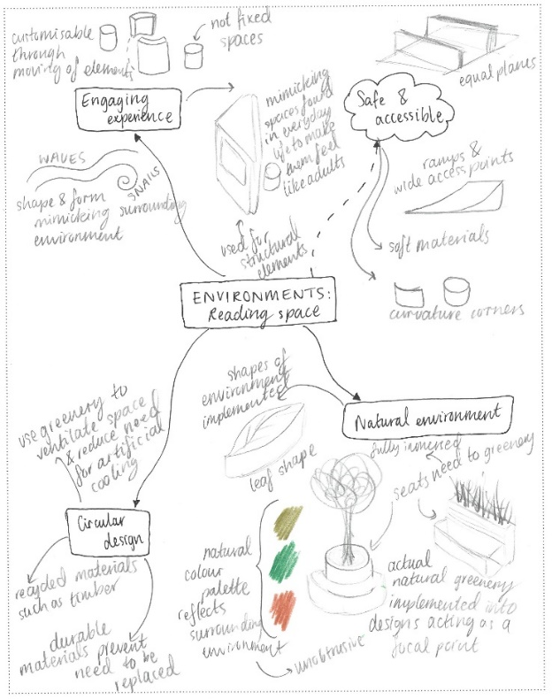
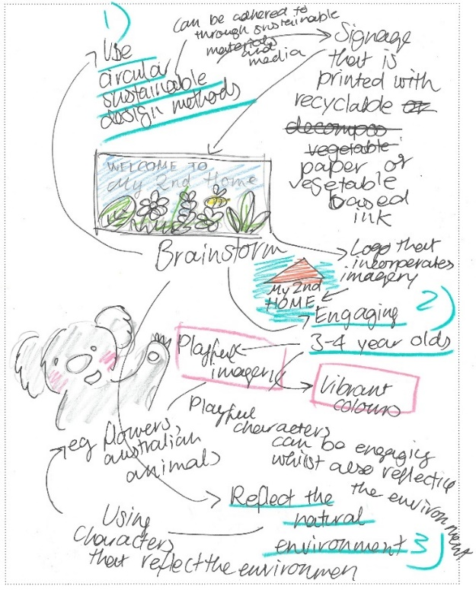

Question 3
Marks | 0 | 1 | 2 | 3 | 4 | 5 | 6 | 7 | 8 | 9 | 10 | 11 | 12 | Average
% | 2 | 1 | 5 | 11 | 18 | 20 | 19 | 12 | 7 | 3 | 1 | 0.5 | 0.1 | 5.2
In this question, students were expected to take one idea from Question 2 and develop two concepts relevant to the field of design practice, with detailed annotations evaluating and explaining their choice of methods, materials and media used in the development drawings.
The question implied that students were to focus on the same field of design practice to develop two concepts. Messages was the most commonly selected option, followed by environments and then objects. Those who opted for interactive experiences often chose to design a digital interface with educational games to enhance learning, as well as physical spaces with interactive elements such as sounds and lights.
High-scoring responses:
- used drawings to effectively develop two clear variations of a single idea, allowing for a nuanced exploration within the chosen field of design practice
- used annotations effectively to evaluate and explain the specific methods, materials and media used in the developmental drawings for each concept.
Most students developed two concepts from an idea in Question 2, and certain themes were common, such as flora and fauna, and highly engaging designs for children. Those students who scored highly often demonstrated a connection between their concepts and sustainable practices, either in the material choices or the functionality of the design. This went beyond simply labelling something as ‘sustainable’, instead establishing a direct link between materials and methods and sustainability. Additionally, most students developed their concepts in line with the expectations set in the design criteria relevant to the selected field of design practice (for example, a quiet reading area).
While almost all students who completed this question annotated their drawings, many included general critical thinking models such as a PMI (Plus, Minus, Interesting) as opposed to focusing on the core requirements of the question – the methods, materials and media selected. Additionally, many students provided simple labels (such as ‘media used is pencil’) rather than detailed annotations explaining and evaluating the use of methods, materials and media. In terms of their annotations, students explained either the methods, materials and media they used in their response (for example, using greylead or fineliner as a medium, or paper as a material) or what they hypothetically planned to use in the production of the design (for example, vector-based application for the signage using the method of laser cutting). It is important for students to carefully read the question, as it required them to evaluate and explain their use of materials, methods and media relevant to their use in the developmental drawings and the design criteria, rather than merely listing them.
The question required students to select a single idea to develop from Question 2, a component that some students overlooked. Some students attempted to generate new ideas or develop two separate ideas instead of refining a single concept. Additionally, some students either developed just one concept, or the two concepts they developed were almost identical, reducing the effectiveness of their development process. Students are reminded that they should not develop more concepts than is required by a question, as the additional concepts will be deemed irrelevant and therefore not assessed.
Below is specific feedback for students responding to the design criteria in each field of design practice:
- Messages – Students needed to develop a logo for ‘My 2nd Home’ and then a separate sign that used the same branding elements (such as colour, type and shape), or, for example, develop a clear sign with a specific purpose and place the logo in the corner. Some students misunderstood the prompt and designed signage only (such as wayfinding signs), without including branding such as a logo/visual identity relevant to ‘My 2nd Home’. Other students designed only a logo and simply placed a box around it to indicate signage, which was not a highly effective approach.
- Objects – Students needed to develop an educational toy. The responses to this question were highly varied, with some students successfully creating engaging toy concepts that would lead to age-appropriate learning, for example, designs that featured tactile components, music and lights. Other designs, however, lacked clear relevance to the design criteria, as they were either not toys or had no educational benefit to the child (such as educating them about nature or the environment).
- Environments – Students needed to design a quiet reading space for the children. Typically, designs included spaces for seating, shelving for books and lighting considerations. Some students misinterpreted the prompt and designed furniture pieces for a room (such as a chair or shelf for a reading room, reflecting the object field of design practice) rather than designing the environment or space itself.
- Interactive experiences – Students needed to design an interactive experience, either in the physical space or online, to enhance student learning. Successful designs often opted for digital applications appropriate for a tablet, which included educational games. While physical spaces were not nearly as common, those students who did explore this option considered the children’s movement in the space, the lighting, materials and how they might interact with tactile features that aim to educate and engage. Several students limited their exploration to a single screen without considering the full interactive experience, missing out on the depth expected in this field of design practice. While there was no specified number of screens required, students who opt for a digital interactive experience should provide enough screens to explain their concept clearly.
The following are examples of high-scoring responses:
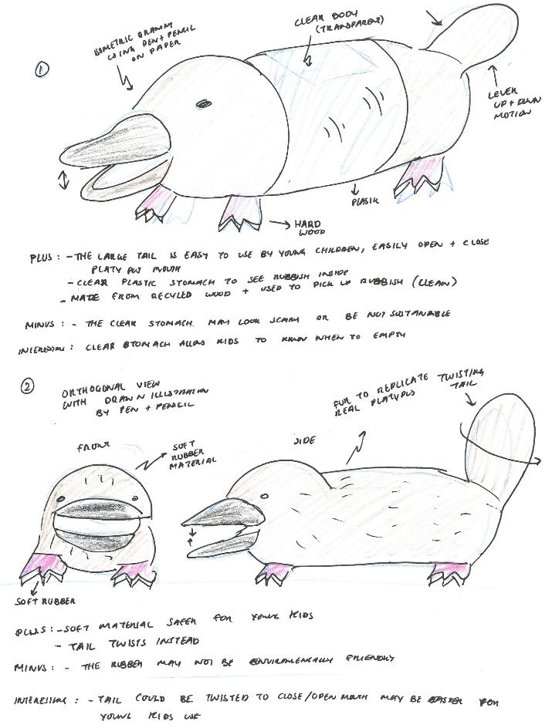
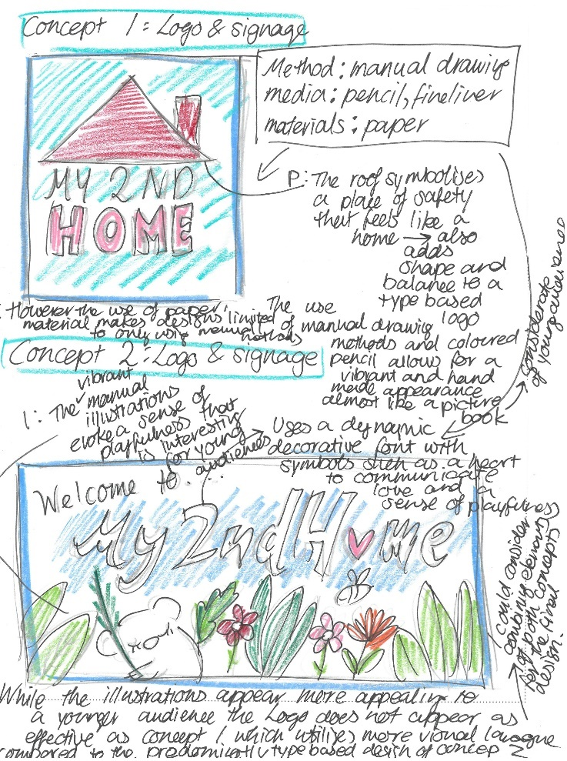

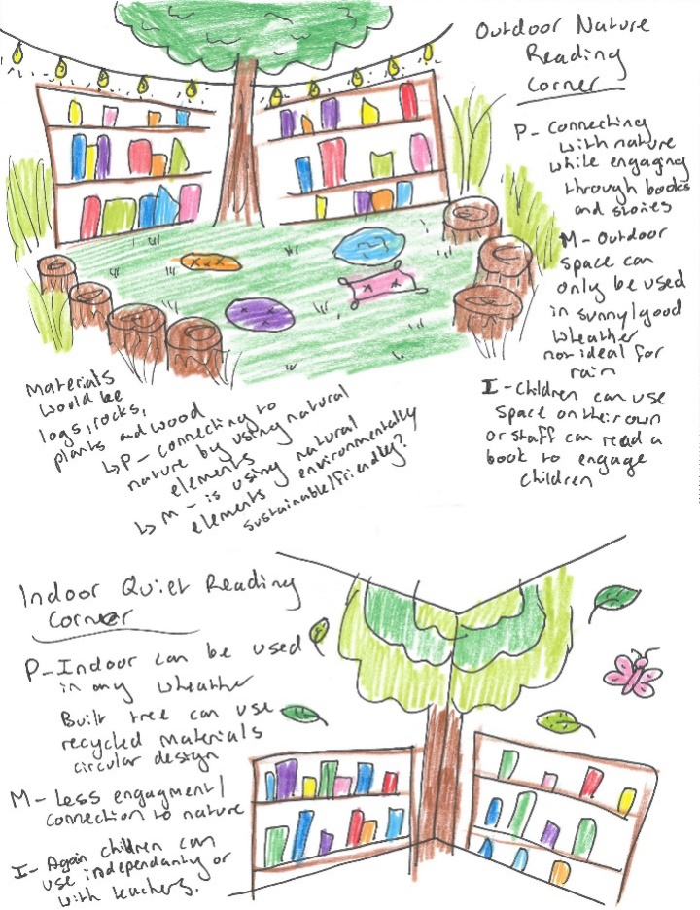
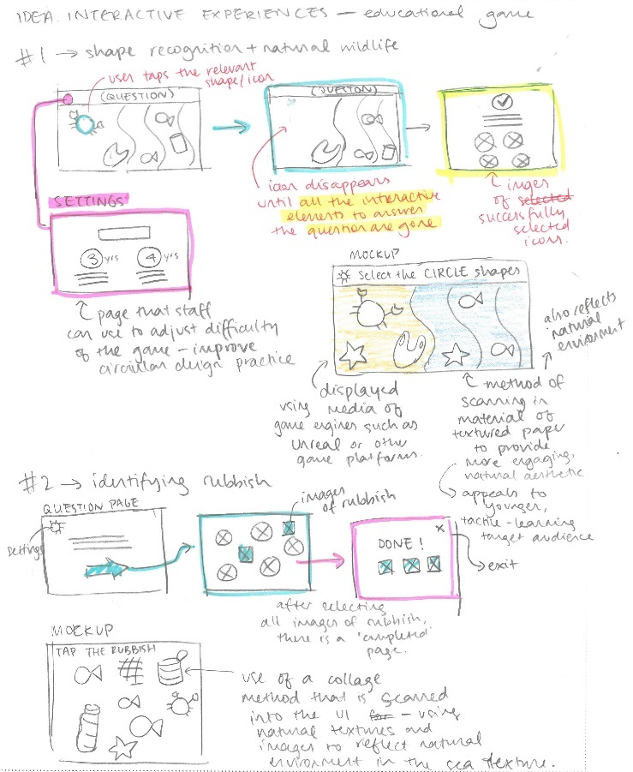

Question 4
Marks | 0 | 1 | 2 | 3 | 4 | 5 | 6 | 7 | 8 | 9 | 10 | 11 | 12 | Average
% | 6 | 1 | 3 | 7 | 12 | 16 | 21 | 16 | 10 | 5 | 2 | 1 | 0.2 | 5.6
In this question, students were expected to select and refine one of their concepts from Question 3 to create a presentation to the client that adhered to the design criteria and the conventions relevant to the selected field of design practice.
High-scoring responses:
- demonstrated a well-developed progression from Question 3, with thoughtful adjustments based on the design criteria to refine their concept
- incorporated conventions relevant to their chosen field of design practice
- considered how the client might view and interpret the concept, therefore providing clarity around how the design looks and functions.
Most students attempted this question and were able to produce a final concept that addressed the design criteria and was related to their selected field of design practice. Although most students displayed some level of refinement, there were varying levels of success in fully addressing the requirements of the question for a refined concept that addressed the design criteria and applied the conventions of the field of design practice. Some responses included skilled drawing techniques, met the communication need relevant to the field of design practice and applied accurate and considered design conventions relevant to the selected field of design practice. The drawings were informed by the design criteria visually and/or through annotations. While annotations were not expected in this question, considered explanations that outlined the features of the concept were often helpful to explain the student’s concept and how they had met the design criteria.
Students should ensure that they fully understand the conventions that are unique to each field of design practice. These are addressed in the key knowledge and skills for Unit 4, Outcome 1. Further information on the conventions of each field is published in the Support materials under Planning and in the Frequently asked questions for Visual Communication Design on the study design page.
Below is specific feedback for students responding to the design criteria in each field of design practice:
- Messages – Strong responses included both a logo and signage that demonstrated careful consideration of logo simplicity and legibility. Signage needed to be relevant to a kindergarten (such as for the purposes of wayfinding or room identification) and not just the logo with a box around it. Students were required to ensure that they spelt the name ‘My 2nd Home’ correctly, as some students changed ‘Home’ to ‘House’ or ‘2nd’ to ‘Second’, which could lead to misidentification of the kindergarten. Others ignored the name altogether, simply having ‘Kinder’ as their identity, which was not in line with the design criteria. Many responses lacked clarity on what constitutes a logo, often resulting in overly complex illustrations that would not be suitable for branding. More attention to typography and simple, scalable logo designs would have improved responses. Finally, students often misinterpreted signage for posters, uniforms and banners – again, not addressing the requirements in the design criteria.
- Objects and environments – The best responses for objects selected a drawing method that represented the children’s toy most effectively, such as a rendered isometric drawing. Similarly, for environments, students who selected one- or two-point perspective or planometric drawings often provided the stronger responses.
More technical approaches were taken by some students. For example, some opted to draw the toy using third-angle orthogonal, including basic dimensions, a scale and labelled views, whereas some of those students completing the quiet reading space used floor plans and/or elevations. However, students did not always execute these technical drawings effectively, often lacking precision and accuracy. Some students used more traditional technical drawing methods, such as strict line drawings, while others rendered their floor plans and elevations – either option was acceptable.
In addition, students who did multiple drawings for their refined concepts (such as a perspective and a floor plan) were often able to convey their concept with greater effectiveness, given the advantage of having both a two- and three-dimensional view.
- Interactive experiences – Refined concepts for interactive experiences were often drawn representing digital screens, with the highest-scoring responses demonstrating multiple screens such as a home screen and then two or three from the educational experience in action. Students typically drew these screens with mobile or tablet proportions. Most students opted for a coloured version of the screen, as opposed to a wireframe option; however, either option would have been appropriate. For the physical interactive spaces, some students embedded screens into their environments/context, along with other tactile/engaging features that served educational benefits. Students commonly drew their designs as perspectives; however, other two- and three-dimensional drawing methods could be appropriate.
General shortcomings included students only adding colour or increasing the scale without making significant adjustments to refine the concept. These additions alone, without deeper consideration and explanation, resulted in only minimal improvement.
The following are examples of high-scoring responses:
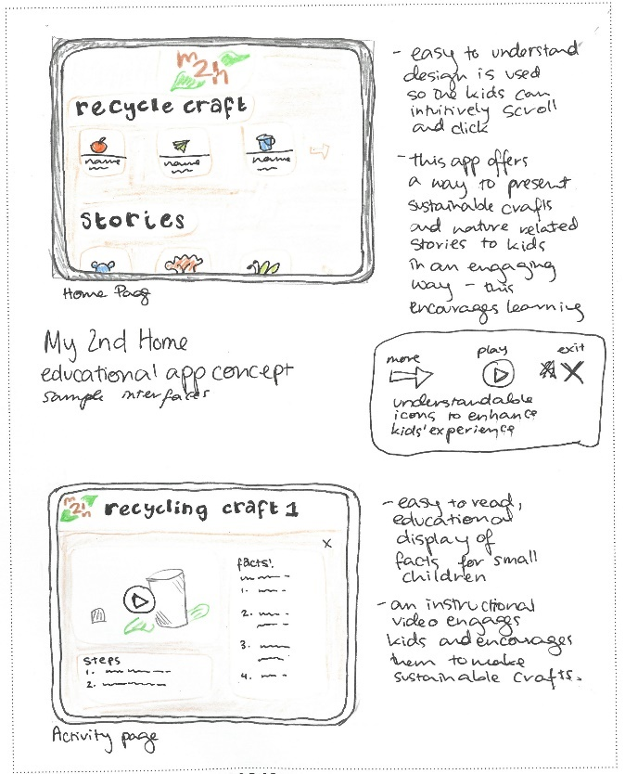
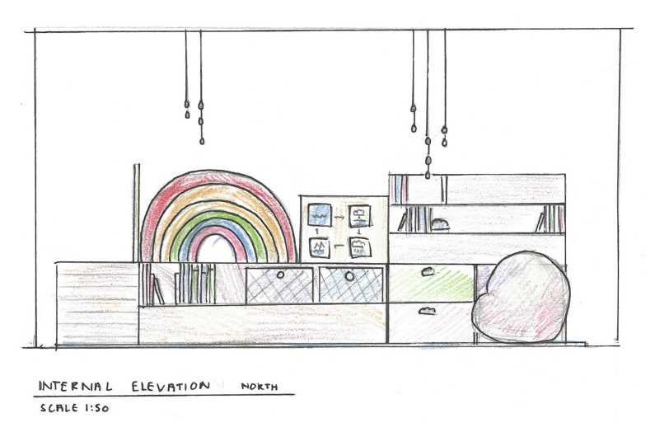

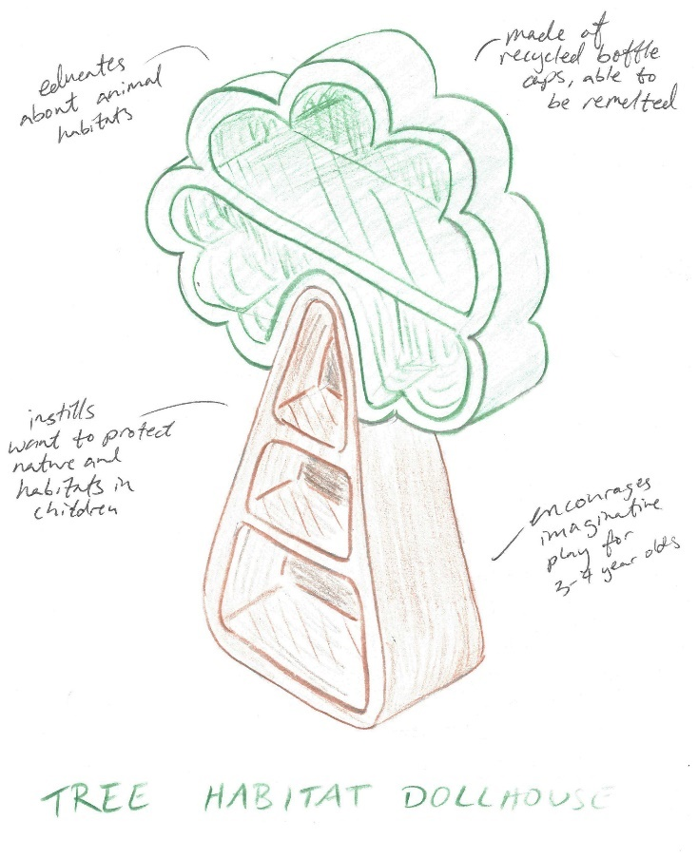

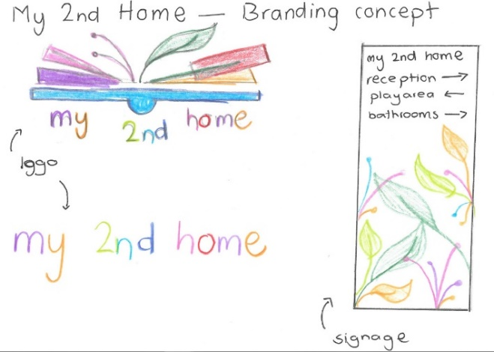

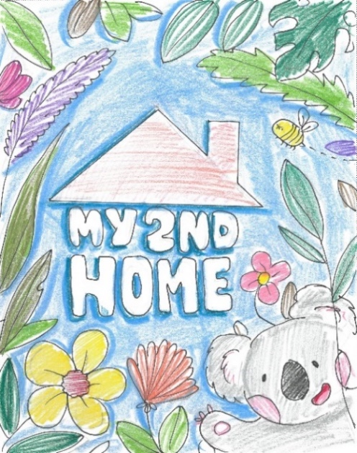
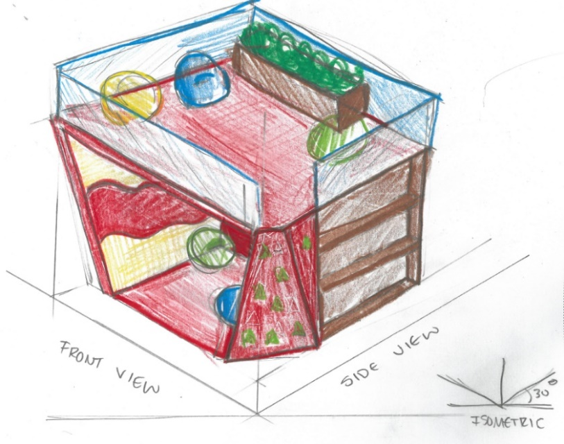

Question 5
Marks | 0 | 1 | 2 | 3 | 4 | Average
% | 20 | 20 | 33 | 20 | 7 | 1.8
In this question, students were required to discuss how they applied visual language in their design solution in Question 4, and how this met the needs of one of the stakeholder groups – parents, staff or children.
High-scoring responses:
- provided a fluent and clear explanation of how they used visual language in their design solution
- discussed aspects relevant to the field of design practice chosen, such as design elements and principles, symbolic, pictorial or typographic elements
- clearly identified one stakeholder group.
Generally, students demonstrated a sound understanding of visual language, with most choosing to discuss design elements and principles. Students who scored highly often went beyond this, making mention of specific aspects that related to their design, such as the material used for their reading space, the reflectiveness of their toy to engage children or the cartoon-like aesthetic of the logo to relate to the kindergarten. Most students were able to link their response to the needs of one chosen stakeholder group.
However, some responses lost focus by addressing the design criteria instead of specifically discussing the impact of the visual language on the chosen stakeholder group. For example, it was not uncommon for a student to discuss the ways in which they had created a sustainable concept that considered circular design practices, or how it reflected the natural environment. Yet students needed to centre their discussion around how their application of visual language directly meets stakeholder needs, rather than discussing broader design goals or criteria.
Occasionally students discussed multiple stakeholders when the question specified only one. It is important for students to identify the specific requirements of the question, as discussing multiple stakeholders often diluted the effectiveness of their response.
The following is an example of a high-scoring response:
The stakeholders of children wanted a fun and interactive space. Through green colours, in the fake grass combined with potential illustrated flowers, the space creates a sustainable and ‘garden’ aesthetic. Furthermore, the movable ‘lily pad’ seat provides flexible and comfortable seating for small children, who will be encouraged to move and interact with the space, getting creative with their seating arrangements. The simple space is visually appealing and interactive, encouraging kids to learn, ensuring it meets the needs of young children.

