VCE Physical Education - Unit 4 Area of Study 3

Sample approach to assessment
Outcome statement
On completion of this unit, the student should be able to integrate theory and practice that enables them to analyse the interrelationships between skill acquisition, biomechanics, energy production and training, and the impacts these have on performance.

Key points regarding implementation
- See the Assessment section of the VCE Physical Education study page for guidance on implementing Unit 4 Area of Study 3.

Designing and delivering the SAC task
The SAC task has two parts the students need to complete which are both assessable.
- Completion of the planning tool
- Completion of the extended response task
Both components occur within the same lesson.
Students should be provided with approximately 20 minutes to complete the planning tool. They use their reflective folio notes for Unit 4 Area of Study 3 (specifically, the theoretical notes for each discipline area) to address the inquiry question.
The purpose is for students to show their understanding of the connections that exist between discipline areas, relevant to the practical activity context.

Once the time for the planning tool has ended, students are given the extended response question, which includes the specific SAC question and the relevant factors for consideration from each discipline area.Students should be given approximately 25-30 minutes to complete the question. They should refer to the planning tool and the appropriate U4 AOS 3 reflective folio notes while working on the extended response.

Assessing the SAC task
The Assessment section of the VCE Physical Education study page contains a sample performance descriptor which could be adapted to assess this task.
An example of how assessment could be implemented is provided below.
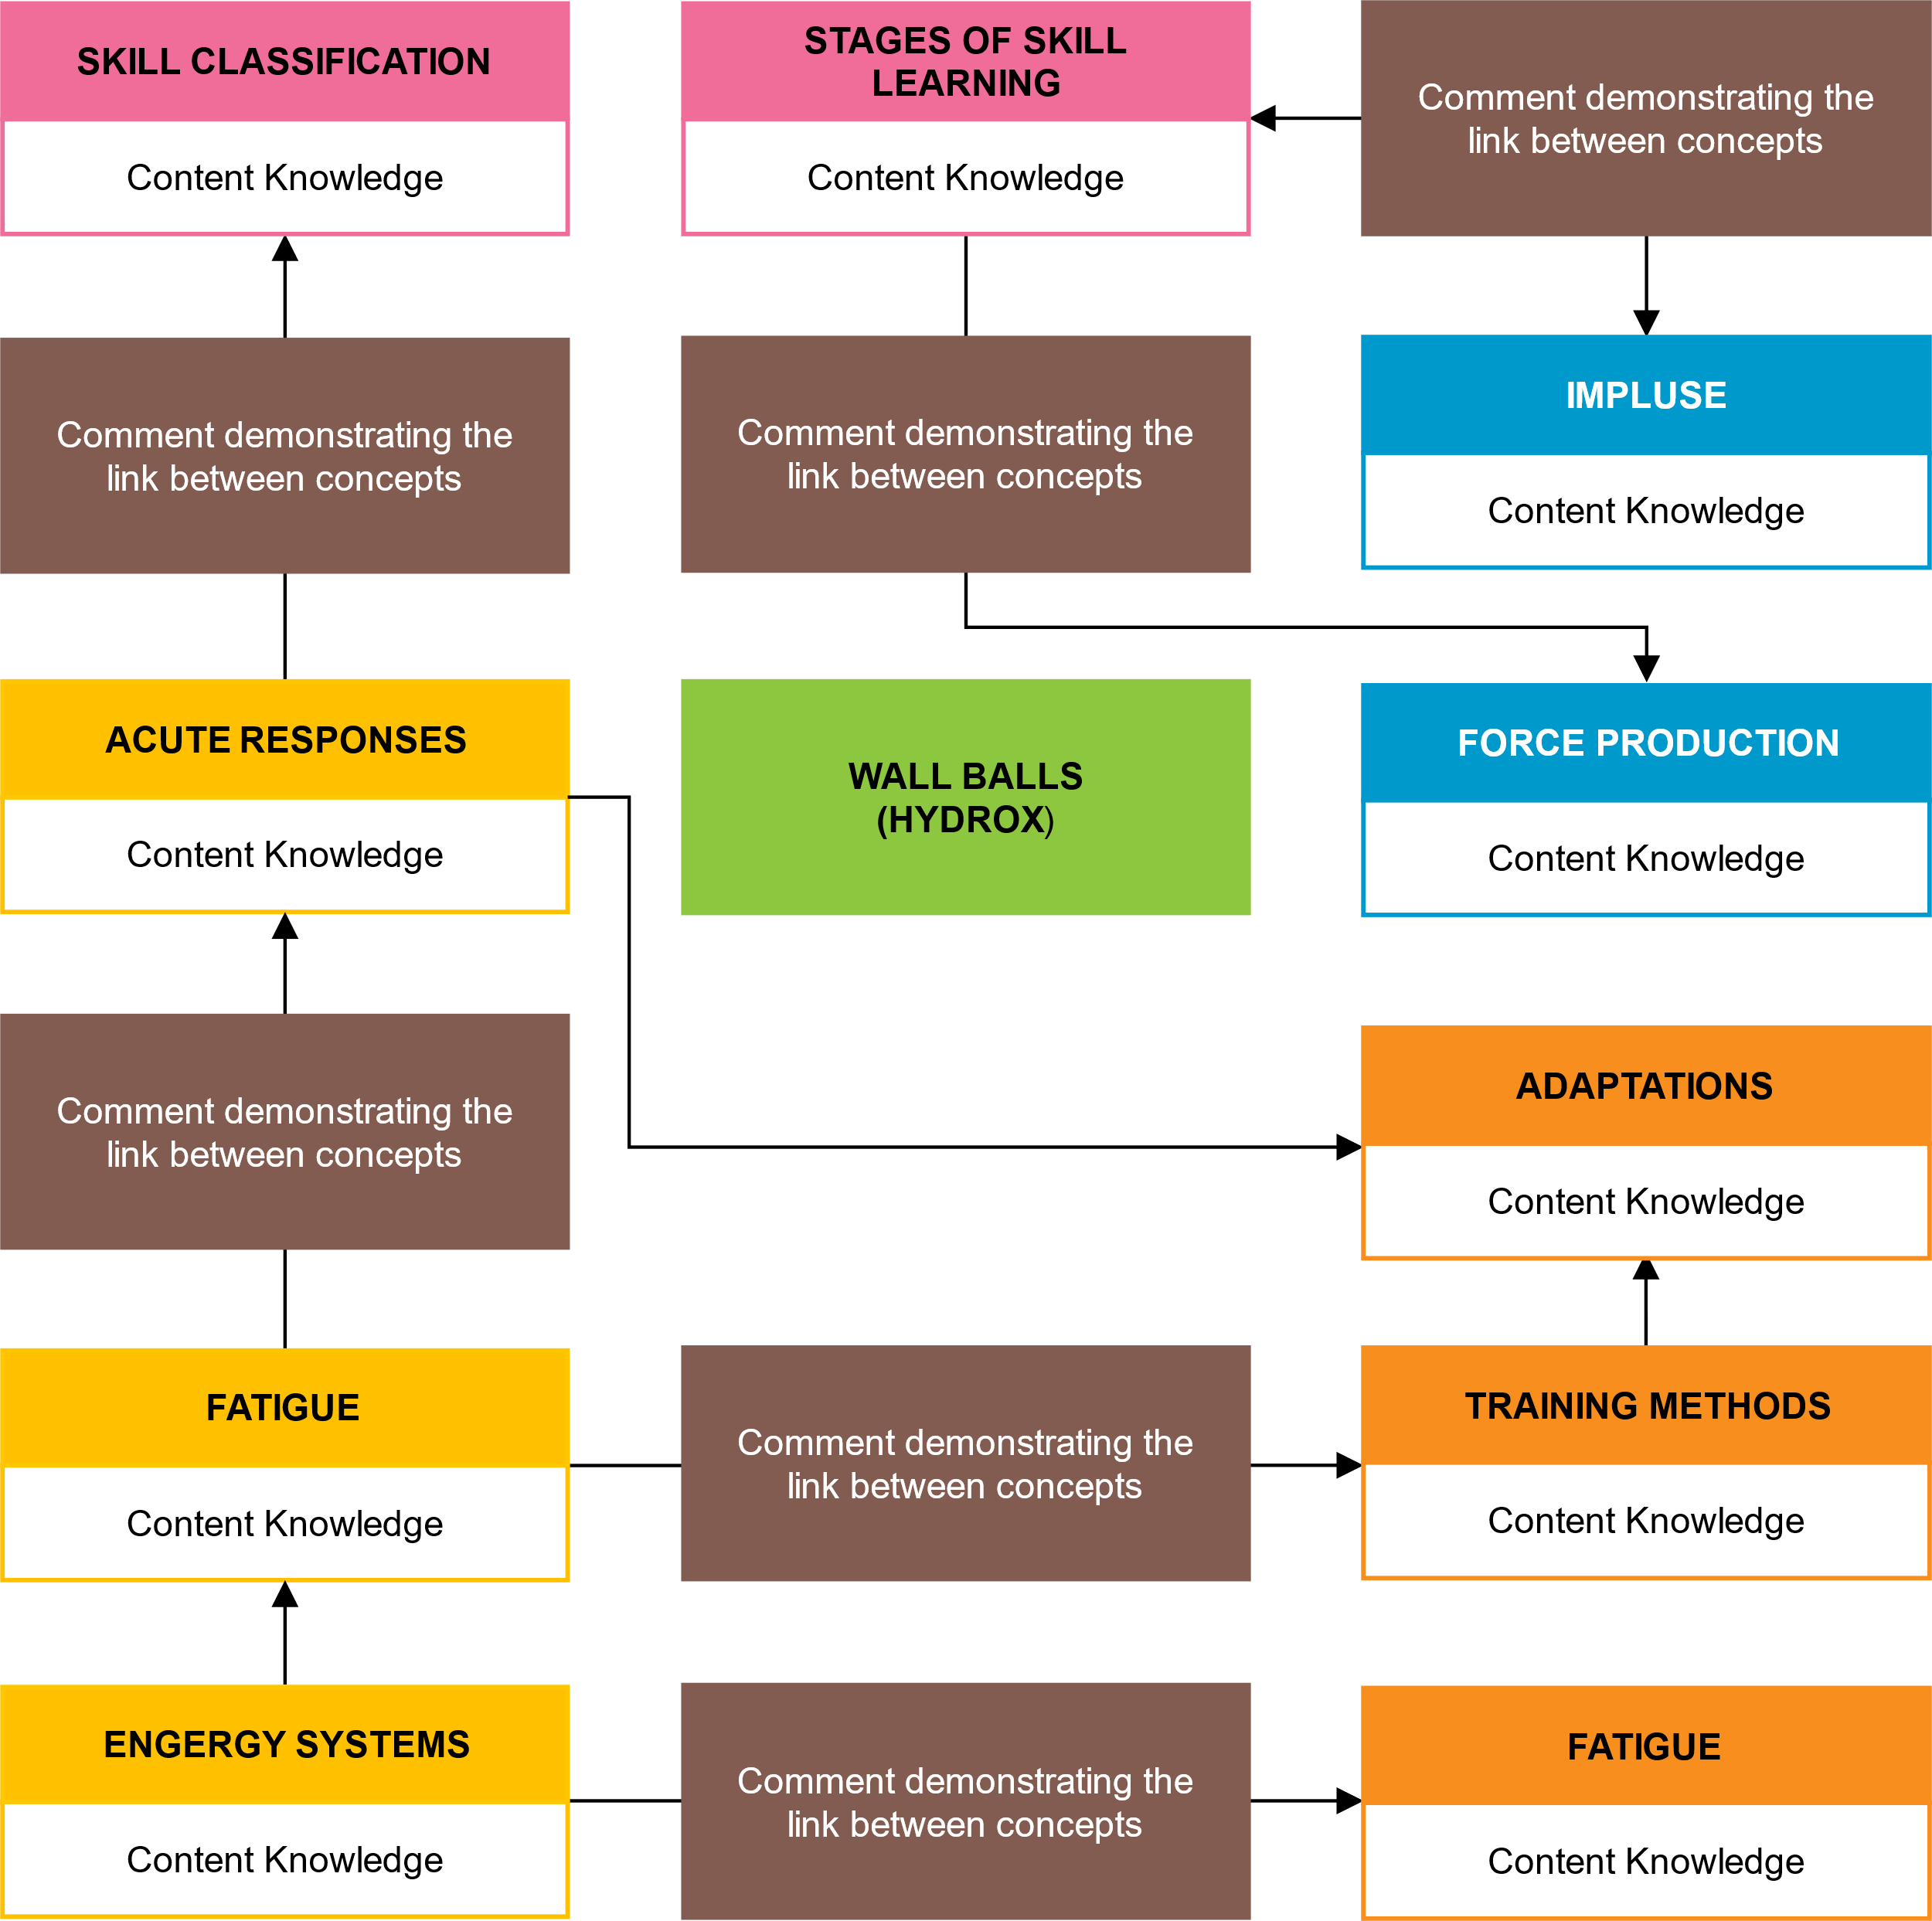
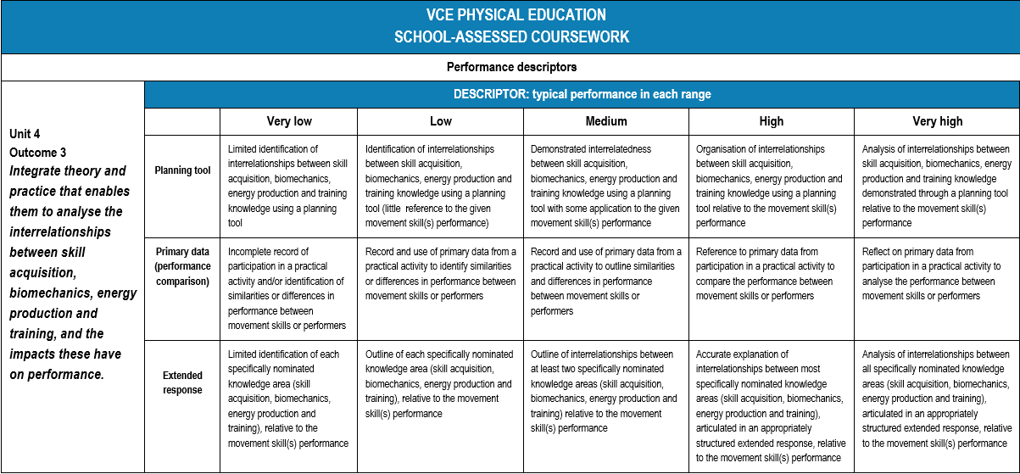

Assessment of the planning tool
A very high performing planning tool would exhibit the following qualities:
- Understanding of each concept (i.e. skill classification) within the discipline area (i.e. skill acquisition shown in pink) relative to the practical activity (performing 75 wallball’s) and the comparison between performers
- Multiple connections (shown as lines) between concepts and across discipline areas
- A note that demonstrates how the concepts are linked (brown)

- \

Assessment of the planning tool
A very high performing planning tool would exhibit the following qualities:
- Understanding of each concept (i.e. skill classification) within the discipline area (i.e. skill acquisition shown in pink) relative to the practical activity (performing 75 wallball’s) and the comparison between performers
- Multiple connections (shown as lines) between concepts and across discipline areas
- A note that demonstrates how the concepts are linked (brown)

- \

Assessing the extended response
SAMPLE SAC QUESTION
Explain how the interelationship between the following factors contributes to differences in performance of 75 wall balls between you and an elite athlete:
- Classification of movement skills (skill acquisition)
- Impulse (biomechanics)
- Energy system contribution (energy production)
- Chronic adaptations required to enhance performance (training)

In your response, ensure you have drawn on data and reflections from your your performance of the skill.

SAMPLE ANSWER (excerpt only)
The elite athlete was able to complete the wall balls (using the full 4kg ball) with more efficiency and with fewer (if any) breaks between repetitions. Whereas I was only able to complete 2-3 reps at a time.
This made the skill continuous in nature for the elite athlete given that there was no distinct start and finish, as each rep flowed to the next, whereas the repeated breaks for me as the student meant each rep was more identifiable and made the skill discrete. To produce these unbroken repetitions, the elite athlete efficiently manipulated the impulse equation, by increasing the time the force was absorbed by dropping immediately into the next squat as the ball was caught. To sustain these repeated reps, the elite athlete relied upon a higher level of muscular endurance which is an outcome of a higher lactate tolerance and more efficient use of the anaerobic glycolysis system contribution.

USING THE PERFORMANCE DESCRIPTOR
- The first row is allocated to assessing the planning tool
- The second row is allocated to the use of primary data. Teachers should be looking for specific references from the logbook entries that referenced students’ performance of the skill.
- The third row can be used to assess the extended response. Teachers should look for multiple connections across discipline areas when making a point. The colours used to highlight the response above provide an example of a high performing response which applies an interdisciplinary approach.
- The rows are not intended to communicate that each row is equal in weighting. Performance descriptors are meant to be adapted to suit the assessment context for a school.
- One example of how the weighting of the criteria could be applied for a task scored out of 25, could be the planning tool (8) use of primary data (5) and the extended response (12).

VCE PHYSICAL EDUCATION
SCHOOL-ASSESSED COURSEWORK
Performance descriptors
Unit 4  Outcome 3  Integrate theory and practice that enables them to analyse the interrelationships between skill acquisition, biomechanics, energy production and training, and the impacts these have on performance. | DESCRIPTOR: typical performance in each range
 |  | Very low | Low | Medium | High | Very high
 | Planning tool | Limited identification of interrelationships between skill acquisition, biomechanics, energy production and training knowledge using a planning tool | Identification of interrelationships between skill acquisition, biomechanics, energy production and training knowledge using a planning tool (little reference to the given movement skill(s) performance) | Demonstrated interrelatedness between skill acquisition, biomechanics, energy production and training knowledge using a planning tool with some application to the given movement skill(s) performance | Organisation of interrelationships between skill acquisition, biomechanics, energy production and training knowledge using a planning tool relative to the movement skill(s) performance | Analysis of interrelationships between skill acquisition, biomechanics, energy production and training knowledge demonstrated through a planning tool relative to the movement skill(s) performance
 | Primary data (performance comparison) | Incomplete record of participation in a practical activity and/or identification of similarities or differences in performance between movement skills or performers | Record and use of primary data from a practical activity to identify similarities or differences in performance between movement skills or performers | Record and use of primary data from a practical activity to outline similarities and differences in performance between movement skills or performers | Reference to primary data from participation in a practical activity to compare the performance between movement skills or performers | Reflect on primary data from participation in a practical activity to analyse the performance between movement skills or performers
 | Extended response | Limited identification of each specifically nominated knowledge area (skill acquisition, biomechanics, energy production and training), relative to the movement skill(s) performance | Outline of each specifically nominated knowledge area (skill acquisition, biomechanics, energy production and training), relative to the movement skill(s) performance | Outline of interrelationships between at least two specifically nominated knowledge areas (skill acquisition, biomechanics, energy production and training) relative to the movement skill(s) performance | Accurate explanation of interrelationships between most specifically nominated knowledge areas (skill acquisition, biomechanics, energy production and training), articulated in an appropriately structured extended response, relative to the movement skill(s) performance | Analysis of interrelationships between all specifically nominated knowledge areas (skill acquisition, biomechanics, energy production and training), articulated in an appropriately structured extended response, relative to the movement skill(s) performance

Very Low 1–4 | Low 5–9 | Medium 10–15 | High 16–20 | Very High 21–25

