2024 VCAA Special Provision Report

Authorised and published by the Victorian Curriculum and Assessment Authority  
200 Victoria Parade East Melbourne VIC 3002

ISBN: 978-1-xxxxxx-xx-x [email [vcaa.media.publications@edumail.vic.gov.au](mailto:vcaa.media.publications@edumail.vic.gov.au) for ISBN requests]

© Victorian Curriculum and Assessment Authority [year]

No part of this publication may be reproduced except as specified under the *Copyright Act 1968* or by permission from the VCAA. Excepting third-party elements, schools may use this resource in accordance with the [VCAA educational allowance](https://www.vcaa.vic.edu.au/Footer/Pages/Copyright.aspx). For more information go to <https://www.vcaa.vic.edu.au/Footer/Pages/Copyright.aspx>.

The VCAA provides the only official, up-to-date versions of VCAA publications. Details of updates can be found on the VCAA website at [www.vcaa.vic.edu.au](https://www.vcaa.vic.edu.au/Pages/HomePage.aspx).

This publication may contain copyright material belonging to a third party. Every effort has been made to contact all copyright owners. If you believe that material in this publication is an infringement of your copyright, please email the Copyright Officer [vcaa.copyright@edumail.vic.gov.au](mailto:vcaa.copyright@edumail.vic.gov.au)

Copyright in materials appearing at any sites linked to this document rests with the copyright owner/s of those materials, subject to the Copyright Act. The VCAA recommends you refer to copyright statements at linked sites before using such materials.

The VCAA logo is a registered trademark of the Victorian Curriculum and Assessment Authority.

|  |
| --- |
| Contact us if you need this information in an accessible format - for example, large print or audio.  Telephone (03) 9032 1635 or email [vcaa.media.publications@edumail.vic.gov.au](mailto:vcaa.media.publications@edumail.vic.gov.au) |

Contents

Introduction 2

Executive Summary 3

Special Examination Arrangements (SEA) 4

Student applications and approvals 4

SEA categories 7

Derived Examination Scores (DES) 12

Number of students with DES applications and approvals 12

DES categories 15

Appendix 1 – Eligibility for SEA 17

Appendix 2 – Types of SEA 18

Appendix 3 – Eligibility for a DES 19

Appendix 4 – How DES are calculated 20

Introduction

This report provides a statistical overview of VCAA Special Provision for VCE external assessments in 2024. It includes comparable data from 2020 to 2024 to show recent trends, as well as data from 2015 to show longer-term trends.

Two types of special provisions are available to students completing VCE external assessments:

* Special Examination Arrangements (SEA)
* Derived Examination Scores (DES)

The VCAA Special Provision policy provides students with disabilities, illnesses or other circumstances that affect their ability to access a VCE external assessment, the opportunity to participate and complete their secondary level studies. The principles of the policy are to ensure that the most appropriate, fair and reasonable arrangements are available for students to access and communicate responses in high stakes assessment.

In addition to the Special Examination Arrangements, schools may approve special provision strategies for both classroom learning and school-based assessments to enable students with a disability, illness, impairment or other circumstances to demonstrate what they know and participate in classroom learning and School-based Assessments.

This report focuses on the VCE external assessments provisioned by the VCAA, including written, performance, and oral examinations as well as the Extended Investigation Critical Thinking Test and the General Achievement Test (GAT).

Executive Summary

The number of students applying for Special Examination Arrangements (SEA) has increased over the past five years. Applications for a Derived Examination Score (DES) spiked in 2021 due to COVID and increased again in 2022 due to floods, while declining in the past two years.

A high proportion of students who apply for SEA or a DES continue to have their applications approved.

**2024 Special Examination Arrangements (SEA)**

* 11,487 students applied for SEA, an increase of 12.2% from 2023 and an increase of 77.4% from 2020.
* 98.4% of students had at least one SEA provision approved. This is a decrease of 0.8% from 2023 and an increase of 2.0% compared to 2020.
* Mental Health Condition (42.9%) followed by Health Impairment (21.8%) were the most common categories for approved SEAs.

The increase in the number of SEA applications is predominantly due to the streamlining of evidence requirements implemented in 2023, which places greater emphasis on school judgement and the history of provisions a student already has in place.

**2024 Derived Examination Scores (DES)**

* 1,705 students had one or more DES applications, which is a 15.8% decrease compared to 2023 (2,026). This is the second consecutive year that the number of students applying for a DES has decreased.
* The rate of students with approved DES applications was 95.8%, which is a 1.9% increase from 2023.
* Acute illness/circumstances (48.7%) and Chronic illness/circumstances (21.0%) accounted for most of the DES applications.

Special Examination Arrangements (SEA)

The VCAA recognises that some students with a disability, as defined in the *Disability Discrimination Act 1992 (Cwlth)*, or illness, may require Special Examination Arrangements (SEA) to access examination material and to communicate their responses in a timed external assessment. Appendix 1 details SEA eligibility categories, and Appendix 2 details the types of arrangements that may be provided to a student with a successful application.

The following section provides information on the number of students who applied for SEA and the number of approved provisions. Statistics on SEA[1] categories and sectors are also included.

Student applications and approvals

The number of students applying for SEA has steadily increased by around 12% each year since 2015, with a particularly sharp increase of 22.4% in 2023 (Table 1). In 2024, 11,487 students applied for SEA, an increase of 12.2% from 2023 (11,487), and an increase of 77.4% from 2020 (6,477). The increase in 2023 is primarily a result of changes made to evidence requirements which placed a greater focus on school-based evidence (outlining conditions, history of provisions approved and evidence used to make decisions) with an emphasis on confirming existing arrangements a student already has in place at their school.

The percentage of SEA applications approved remained high for 2024 at 98.4%. There has been an increase of 2.0% in the rate of SEA approvals since 2020 (96.4%).

Students with approved SEA applications have grown relatively consistently across government, Catholic and independent sectors over the past 10 years (Figure 1).

Table 1 Special Examination Arrangements by sector, 2015 and 2020 – 2024

|  |  |  |  |  |  |  |  |  |  |  |  |  |  |  |  |  |  |  |  |  |  |
| --- | --- | --- | --- | --- | --- | --- | --- | --- | --- | --- | --- | --- | --- | --- | --- | --- | --- | --- | --- | --- | --- |
|  | **Number of students with applications** | | | | | | | **Number of students with approvals** | | | | | | | **Percentage of students approved** | | | | | | |
| **Sector** | **2015** | **2020** | **2021** | **2022** | **2023** | **2024** | **2015** | | **2020** | **2021** | **2022** | **2023** | **2024** | **2015** | | **2020** | **2021** | **2022** | **2023** | **2024** |
| Adult | 74 | 59 | 61 | 28 | 48 | 31 | 74 | | 59 | 61 | 28 | 47 | 31 | 100 | | 100 | 100 | 100 | 97.9 | 100 |
| Catholic | 1,046 | 1,512 | 1,733 | 2,093 | 2,508 | 2,912 | 1,032 | | 1,470 | 1,712 | 2,064 | 2,486 | 2,874 | 98.7 | | 97.2 | 98.8 | 98.6 | 99.1 | 98.7 |
| Government | 1,640 | 2,747 | 2,812 | 3,162 | 4,056 | 4,356 | 1,593 | | 2,661 | 2,793 | 3,123 | 4,027 | 4,274 | 97.1 | | 96.9 | 99.3 | 98.8 | 99.3 | 98.1 |
| Independent | 1,326 | 2,158 | 2,568 | 3,084 | 3,626 | 4,185 | 1,258 | | 2,054 | 2,517 | 3,018 | 3,596 | 4,124 | 94.9 | | 95.2 | 98 | 97.9 | 99.2 | 98.5 |
| Other Providers | 0 | 1 | 3 | 2 | 4 | 3 | 0 | | 1 | 3 | 2 | 4 | 2 | N/A | | 100 | N/A | 100 | 100 | 66.7 |
| **Total** | **4,086** | **6,477** | **7,177** | **8,369** | **10,242** | **11,487** | **3,957** | | **6,245** | **7,086** | **8,235** | **10,160** | **11,305** | **96.8** | | **96.4** | **98.7** | **98.4** | **99.2** | **98.4** |

[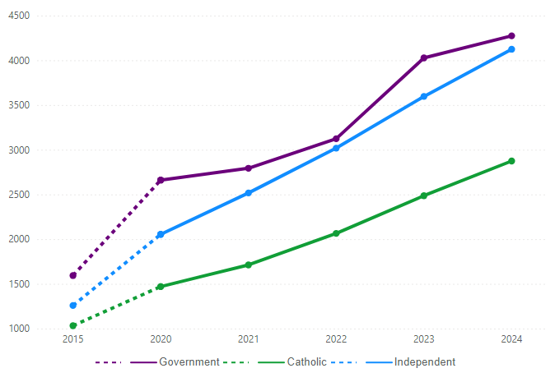](https://app.powerbi.com/MobileRedirect.html?action=OpenReport&reportObjectId=adf7530a-ce68-41b6-8945-d54e89bd3e69&ctid=d96cb337-1a87-44cf-b69b-3cec334a4c1f&reportPage=ReportSection&pbi_source=copyvisualimage)Figure 1 Number of approved Special Examination Applications by sector, 2015 and 2020 – 2024

[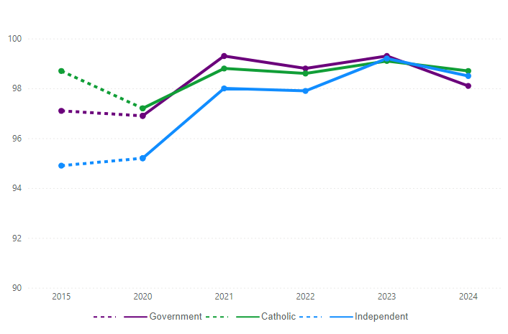](https://app.powerbi.com/MobileRedirect.html?action=OpenReport&reportObjectId=adf7530a-ce68-41b6-8945-d54e89bd3e69&ctid=d96cb337-1a87-44cf-b69b-3cec334a4c1f&reportPage=ReportSection&pbi_source=copyvisualimage)Figure 2 Percentage of approved Special Examination Arrangements by sector, 2015 and 2020 – 2024

SEA categories

In 2024, Mental Health Condition (42.9%) was the most common approved SEA category, followed by Health Impairment (21.8%) (Table 2).

Mental Health Condition and Health Impairment have accounted for the majority of approved SEA applications over the past five years[2]. The combined total of approved SEA applications for reasons of Mental Health Condition and Health Impairment has remained relatively stable over the past 10 years at an average of 63.0%, varying between 61.4% to 64.8%.

Table 2 Special Examination Arrangements by category, 2015 and 2020 – 2024

|  |  |  |  |  |  |  |
| --- | --- | --- | --- | --- | --- | --- |
|  | **Percentage distribution** | | | | | |
| **Category** | **2015[3]** | **2020** | **2021** | **2022** | **2023** | **2024** |
| Deaf and Hard of Hearing | 1.3 | 1.3 | 0.9 | 0.8 | 0.9 | 1.1 |
| Emergency Application | 15.7 | 17.5 | 17.9 | 18.7 | 13.1 | 11.9 |
| Health Impairment | 64.6 | 23.7 | 21.8 | 20.3 | 21.0 | 21.8 |
| Language Disorder | 0.5 | 1.1 | 1.2 | 1.4 | 2.4 | 2.8 |
| Learning Disability | 14.0 | 10.2 | 10.8 | 11.0 | 12.6 | 13.1 |
| Mental Health Condition | - | 38.8 | 40.8 | 41.8 | 43.8 | 42.9 |
| Motor Disorder | - | 3.2 | 3.3 | 3.0 | 3.0 | 2.6 |
| Physical Disability | 2.0 | 3.0 | 2.3 | 1.8 | 2.2 | 2.7 |
| Vision Impairment | 1.8 | 1.2 | 1.1 | 1.2 | 1.2 | 1.0 |
| **Total** | **100** | **100** | **100** | **100** | **100** | **100** |

Emergency Applications[4] accounted for 11.9% of all approved applications in 2024, which is a decrease from 2023 (13.1%) and from 2015 (15.7%).

Table 3 shows that overall, 98.6% of applications for SEA were approved in 2024. The highest rate of approvals was for Emergencies (99.7%) and the lowest was for Language Disorder (96.0%). While the rate of approvals across categories has been relatively stable in recent years, over a 10-year period, the rate of approvals for Language Disorder applications has increased by 36.0% from 2015, and by 16.4% for Learning Disability since 2015.

Figure 3 presents the percentage of approvals within each category. There has been an overall increase in the percentage of approvals over the last 10 years. In 2024, the overall percentage of approvals was 98.6%, an increase of 1.8 percentage points from 2015.

Table 3 Number of approved SEA by category and percentage distribution across categories, 2015 and 2020 – 2024[5]

|  |  |  |  |  |  |  |  |  |  |  |  |  |  |  |  |  |  |  |
| --- | --- | --- | --- | --- | --- | --- | --- | --- | --- | --- | --- | --- | --- | --- | --- | --- | --- | --- |
|  | **Number of applications** | | | | | | **Number of approvals** | | | | | | **Percentage approved** | | | | | |
| **Category** | **2015** | **2020** | **2021** | **2022** | **2023** | **2024** | **2015** | **2020** | **2021** | **2022** | **2023** | **2024** | **2015** | **2020** | **2021** | **2022** | **2023** | **2024** |
| Deaf and Hard of Hearing | 53 | 92 | 70 | 80 | 118 | 157 | 52 | 89 | 70 | 78 | 118 | 155 | 98.1 | 96.7 | 100 | 97.5 | 100 | 98.7 |
| Emergency Application | 641 | 1,241 | 1,474 | 1,833 | 1,670 | 1,774 | 641 | 1,240 | 1,474 | 1,830 | 1,666 | 1,769 | 100 | 99.9 | 100 | 99.8 | 99.8 | 99.7 |
| Health Impairment | 2,641 | 1,730 | 1,793 | 1,997 | 2,685 | 3,263 | 2,636 | 1,683 | 1,790 | 1,988 | 2,675 | 3,224 | 99.8 | 97.3 | 99.8 | 99.5 | 99.6 | 98.8 |
| Language Disorder | 20 | 94 | 112 | 143 | 311 | 421 | 12 | 81 | 98 | 136 | 301 | 404 | 60.0 | 86.2 | 87.5 | 95.1 | 96.8 | 96.0 |
| Learning Disability | 572 | 877 | 954 | 1,180 | 1,638 | 1,962 | 457 | 726 | 888 | 1,082 | 1,603 | 1,890 | 79.9 | 82.8 | 93.1 | 91.7 | 97.9 | 96.3 |
| Mental Health Condition | - | 2,774 | 3,357 | 4,109 | 5,603 | 6,415 | - | 2,750 | 3,351 | 4,092 | 5,582 | 6,349 | - | 99.1 | 99.8 | 99.6 | 99.6 | 99.0 |
| Motor Disorder | - | 226 | 273 | 294 | 381 | 394 | - | 225 | 272 | 291 | 378 | 392 | - | 99.6 | 99.6 | 99 | 99.2 | 99.5 |
| Physical Disability | 83 | 217 | 190 | 177 | 282 | 404 | 83 | 213 | 189 | 175 | 280 | 397 | 100 | 98.2 | 99.5 | 98.9 | 99.3 | 98.3 |
| Vision Impaired | 75 | 82 | 92 | 121 | 153 | 154 | 75 | 82 | 90 | 121 | 151 | 152 | 100 | 100 | 97.8 | 100 | 98.7 | 98.7 |
| **Total** | **4,085** | **7,333** | **8,315** | **9,934** | **12,841** | **14,944** | **3,956** | **7,089** | **8,222** | **9,793** | **12,754** | **14,732** | **96.8** | **96.7** | **98.9** | **98.6** | **99.3** | **98.6** |

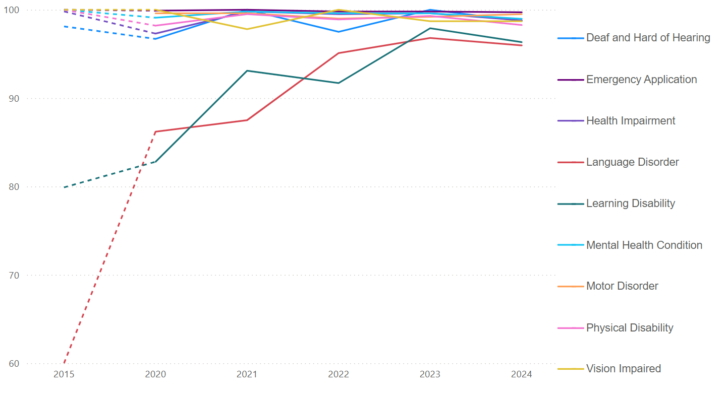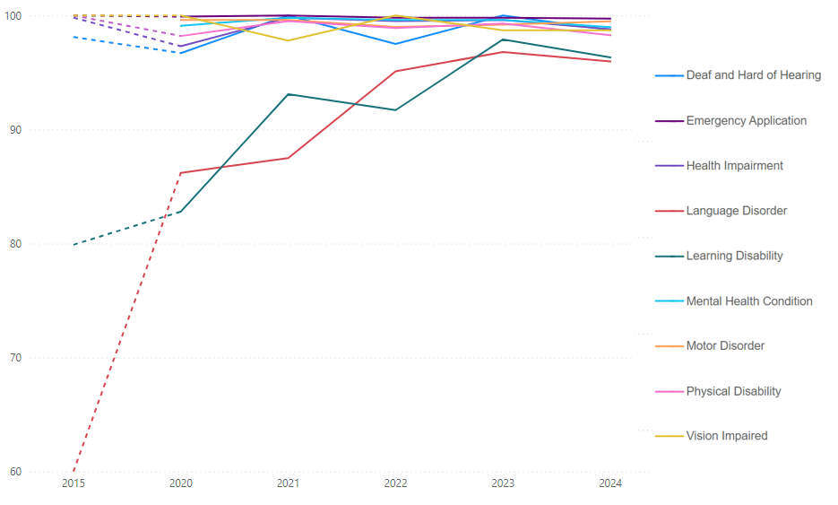Figure 3 Percentage of approved Special Examination Arrangements by category, 2015 and 2020 – 2024

Table 4 Number of applications by SEA category and sector, 2015 and 2020 – 2024

|  |  |  |  |  |  |  |  |
| --- | --- | --- | --- | --- | --- | --- | --- |
|  |  | **Year** | | | | | |
| **Category** | **Sector** | **2015** | **2020** | **2021** | **2022** | **2023** | **2024** |
| **Deaf and Hard of Hearing** | Government | 27 | 49 | 38 | 35 | 51 | 68 |
| Catholic | 11 | 20 | 19 | 28 | 32 | 44 |
| Independent | 14 | 22 | 13 | 17 | 33 | 45 |
| Adult | 1 | 0 | 0 | 0 | 1 | 0 |
| Other Providers | 0 | 1 | 0 | 0 | 1 | 0 |
| **Total** | **53** | **92** | **70** | **80** | **118** | **157** |
| **Emergency Application** | Government | 248 | 577 | 599 | 710 | 692 | 697 |
| Catholic | 200 | 322 | 382 | 465 | 402 | 468 |
| Independent | 191 | 337 | 481 | 650 | 572 | 604 |
| Adult | 2 | 5 | 12 | 6 | 4 | 4 |
| Other Providers | 0 | 0 | 0 | 2 | 0 | 1 |
| **Total** | **641** | **1,241** | **1,474** | **1,833** | **1,670** | **1,774** |
| **Health Impairment** | Government | 1,056 | 781 | 747 | 844 | 1,157 | 1,390 |
| Catholic | 710 | 419 | 471 | 524 | 688 | 880 |
| Independent | 812 | 519 | 559 | 621 | 826 | 978 |
| Adult | 63 | 11 | 14 | 8 | 14 | 14 |
| Other Providers | 0 | 0 | 2 | 0 | 0 | 1 |
| **Total** | **2,641** | **1,730** | **1,793** | **1,997** | **2,685** | **3,263** |
| **Language Disorder** | Government | 4 | 33 | 18 | 27 | 70 | 103 |
| Catholic | 9 | 30 | 40 | 85 | 122 | 151 |
| Independent | 7 | 31 | 54 | 31 | 119 | 167 |
| Adult | 0 | 0 | 0 | 0 | 0 | 0 |
| Other Providers | 0 | 0 | 0 | 0 | 0 | 0 |
| **Total** | **20** | **94** | **112** | **143** | **311** | **421** |
| **Learning Disability** | Government | 227 | 284 | 272 | 371 | 538 | 589 |
| Catholic | 82 | 136 | 170 | 236 | 363 | 498 |
| Independent | 256 | 454 | 509 | 573 | 733 | 873 |
| Adult | 7 | 3 | 3 | 0 | 3 | 1 |
| Other Providers | 0 | 0 | 0 | 0 | 1 | 1 |
| **Total** | **572** | **877** | **954** | **1,180** | **1,638** | **1,962** |
| **Mental Health Condition** | Government | - | 1,152 | 1,347 | 1,563 | 2,265 | 2,497 |
| Catholic | - | 648 | 805 | 974 | 1,314 | 1,489 |
| Independent | - | 933 | 1,169 | 1,557 | 1,986 | 2,405 |
| Adult | - | 41 | 35 | 15 | 36 | 24 |
| Other Providers | - | 0 | 1 | 0 | 2 | 0 |
| **Total** | **-** | **2,774** | **3,357** | **4,109** | **5,603** | **6,415** |
| **Motor Disorder** | Government | - | 72 | 79 | 78 | 103 | 86 |
| Catholic | - | 58 | 72 | 74 | 106 | 104 |
| Independent | - | 94 | 121 | 142 | 172 | 204 |
| Adult | - | 2 | 1 | 0 | 0 | 0 |
| Other Providers | - | 0 | 0 | 0 | 0 | 0 |
| **Total** | **-** | **226** | **273** | **294** | **381** | **394** |
| **Physical Disability** | Government | 38 | 90 | 85 | 72 | 126 | 158 |
| Catholic | 19 | 47 | 42 | 44 | 66 | 88 |
| Independent | 25 | 77 | 61 | 58 | 89 | 157 |
| Adult | 1 | 3 | 2 | 3 | 1 | 1 |
| Other Providers | 0 | 0 | 0 | 0 | 0 | 0 |
| **Total** | **83** | **217** | **190** | **177** | **282** | **404** |
| **Vision Impaired** | Government | 39 | 34 | 26 | 37 | 57 | 62 |
| Catholic | 15 | 20 | 29 | 31 | 47 | 45 |
| Independent | 21 | 27 | 35 | 52 | 49 | 47 |
| Adult | 0 | 1 | 2 | 1 | 0 | 0 |
| Other Providers | 0 | 0 | 0 | 0 | 0 | 0 |
| **Total** | **75** | **82** | **92** | **121** | **153** | **154** |
| **Grand Total** |  | **4,086** | **7,333** | **8,315** | **9,934** | **12,841** | **14,944** |

Derived Examination Scores (DES)

Students who are ill or affected by other personal circumstances at the time of a VCE external assessment and whose result is unlikely to be a fair or accurate indication of their learning or achievement in a study may apply for a Derived Examination Score (DES)[6]. Appendix 3 details the eligibility criteria for a DES.

Number of students with DES applications and approvals

There was a 15.8% decrease in the number of students applying for a DES in 2024 compared to 2023[7]. This follows large increases in applications in 2021 and 2022, driven primarily by COVIDand flood events. While the number of applications has decreased over the past two years, the number of applications is still higher than 2020 when the VCAA first implemented it’s Consideration of Educational Disadvantage (CED) process to address the impact of COVID on students across the state. , 95.8% of DES applications were approved, which is a 1.9% increase from 2023.

[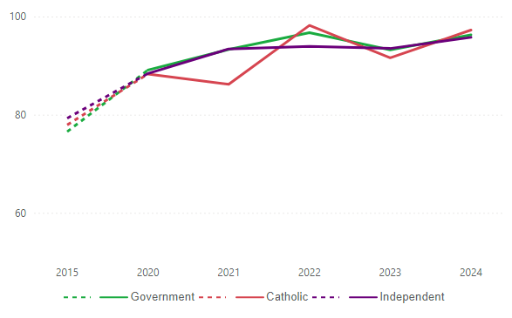](https://app.powerbi.com/MobileRedirect.html?action=OpenReport&reportObjectId=adf7530a-ce68-41b6-8945-d54e89bd3e69&ctid=d96cb337-1a87-44cf-b69b-3cec334a4c1f&reportPage=ReportSectionab5dbd52dc5a0704cd5a&pbi_source=copyvisualimage)Figure 4 Percentage of approvals by sector, 2015 and 2020 – 2024

Table 5 Number of examinations where a DES was requested, number of approvals and percentage of DES approvals by sector, 2015 and 2020 – 2024

|  |  |  |  |  |  |  |  |  |  |  |  |  |  |  |  |  |  |  |
| --- | --- | --- | --- | --- | --- | --- | --- | --- | --- | --- | --- | --- | --- | --- | --- | --- | --- | --- |
|  | **Number of examinations where a DES was requested** | | | | | | **Number of examinations where a DES request was approved** | | | | | | **Percentage of DES approved** | | | | | |
| **Sector** | **2015** | **2020** | **2021** | **2022** | **2023** | **2024** | **2015** | **2020** | **2021** | **2022** | **2023** | **2024** | **2015** | **2020** | **2021** | **2022** | **2023** | **2024** |
| Adult | 38 | 33 | 58 | 16 | 16 | 16 | 29 | 31 | 53 | 15 | 14 | 16 | 76.3 | 93.9 | 91.4 | 93.8 | 87.5 | 100 |
| Catholic | 933 | 571 | 1,008 | 3,000 | 1,021 | 908 | 727 | 504 | 869 | 2,945 | 935 | 883 | 77.9 | 88.3 | 86.2 | 98.2 | 91.6 | 97.2 |
| Government | 1,616 | 1,120 | 2,032 | 3,440 | 2,089 | 1,536 | 1,237 | 998 | 1,896 | 3,326 | 1,946 | 1,479 | 76.5 | 89.1 | 93.3 | 96.7 | 93.2 | 96.3 |
| Independent | 811 | 683 | 1,042 | 1,803 | 1,088 | 1,038 | 643 | 604 | 973 | 1,693 | 1,017 | 994 | 79.3 | 88.4 | 93.4 | 93.9 | 93.5 | 95.8 |
| Other Providers | 1 | 0 | 9 | 14 | 32 | 6 | 1 | 0 | 9 | 13 | 31 | 6 | 100.0 | - | 100 | 92.9 | 96.9 | 100.0 |
| **Total** | **3,399** | **2,407** | **4,149** | **8,273** | **4,246** | **3,504** | **2,637** | **2,137** | **3,800** | **7,992** | **3,943** | **3,378** | **78** | **88.8** | **91.6** | **96.6** | **92.9** | **96.4** |

Table 6 Number of students with DES applications and approvals by sector, 2015 and 2020 – 2024

|  |  |  |  |  |  |  |  |  |  |  |  |  |  |  |  |  |  |  |
| --- | --- | --- | --- | --- | --- | --- | --- | --- | --- | --- | --- | --- | --- | --- | --- | --- | --- | --- |
|  | **Number of students with DES application** | | | | | | **Number of students with approval** | | | | | | **Percentage of approvals** | | | | | |
| **Sector** | **2015** | **2020** | **2021** | **2022** | **2023** | **2024** | **2015** | **2020** | **2021** | **2022** | **2023** | **2024** | **2015** | **2020** | **2021** | **2022** | **2023** | **2024** |
| Adult | 19 | 16 | 24 | 8 | 7 | 6 | 16 | 15 | 23 | 7 | 7 | 6 | 84.2 | 93.8 | 95.8 | 87.5 | 100.0 | 100.0 |
| Catholic | 327 | 264 | 460 | 969 | 481 | 445 | 288 | 232 | 416 | 944 | 455 | 432 | 88.1 | 87.9 | 90.4 | 97.4 | 94.6 | 97.1 |
| Government | 612 | 569 | 1,019 | 1,292 | 995 | 737 | 508 | 506 | 956 | 1,247 | 929 | 709 | 83.0 | 88.9 | 93.8 | 96.5 | 93.4 | 96.2 |
| Independent | 331 | 308 | 490 | 690 | 536 | 516 | 274 | 265 | 461 | 645 | 505 | 486 | 82.8 | 86.0 | 94.1 | 93.5 | 94.2 | 94.2 |
| Other Providers | 1 | 0 | 2 | 7 | 7 | 1 | 1 | 0 | 2 | 6 | 6 | 1 | 100.0 | - | 100.0 | 85.7 | 85.7 | 100.0 |
| **Total** | **1,290** | **1,157** | **1,995** | **2,966** | **2,026** | **1,705** | **1,087** | **1,018** | **1,858** | **2,849** | **1,902** | **1,634** | **84.3** | **88.0** | **93.1** | **96.1** | **93.9** | **95.8** |

DES categories

The most common categories of applications for a DES are Acute illness/circumstances which accounted for 48.7% of all applications in 2024 followed by Chronic illness/circumstances which accounted for 21.0% of all applications.

There was a notable decrease in approved DES requests in the Other category from 85 in 2023 to 22 in 2024. This came after a sharp increase in the Other category resulting from students being affected by international developments during 2023. Applications in the COVID-19 category also declined from 549 in 2023 to 250 in 2024.

In 2024, the highest proportion of approvals where a DES was requested was in the Death (99.4%) and Family (99.1%) categories (Table 7).

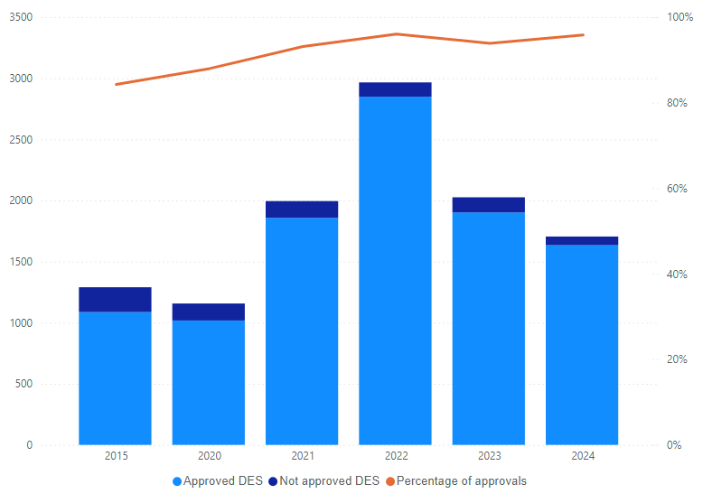

Figure 5 Number of students with DES applications with approved and not approved, 2015 and 2020 – 2024

Table 7 Number of examinations where DES was requested and number of examinations where DES was approved by category, 2015 and 2020 – 2024

|  |  |  |  |  |  |  |  |  |  |  |  |  |  |  |  |  |  |  |
| --- | --- | --- | --- | --- | --- | --- | --- | --- | --- | --- | --- | --- | --- | --- | --- | --- | --- | --- |
|  | **Number of examinations where a DES was requested** | | | | | | **Number of examinations where DES requested was approved** | | | | | | **Percentage of examinations where DES requested was approved** | | | | | |
| **Category** | **2015** | **2020** | **2021** | **2022** | **2023** | **2024** | **2015** | **2020** | **2021** | **2022** | **2023** | **2024** | **2015** | **2020** | **2021** | **2022** | **2023** | **2024** |
| Acute illness/circumstances | 1,733 | 1,063 | 1,203 | 1,541 | 1,905 | 1,708 | 1,372 | 919 | 1,075 | 1,422 | 1,751 | 1,633 | 79.2 | 86.5 | 89.4 | 91.9 | 91.9 | 95.6 |
| Chronic illness/circumstances | 748 | 345 | 558 | 488 | 790 | 736 | 476 | 286 | 482 | 423 | 725 | 700 | 63.6 | 82.9 | 86.4 | 91.8 | 91.8 | 95.1 |
| COVID-19 |  | 173 | 1,607 | 568 | 591 | 254 |  | 169 | 1,513 | 544 | 549 | 250 |  | 97.7 | 94.2 | 92.9 | 92.9 | 98.4 |
| Death | 536 | 416 | 451 | 492 | 420 | 490 | 476 | 395 | 430 | 452 | 402 | 487 | 88.8 | 95 | 95.3 | 95.7 | 95.7 | 99.4 |
| Family | 270 | 249 | 205 | 259 | 287 | 231 | 234 | 237 | 191 | 242 | 265 | 229 | 86.7 | 95.2 | 93.2 | 92.3 | 92.3 | 99.1 |
| Flood |  | - | - | 4,835 | 119 |  |  | - | - | 4,835 | 119 |  |  | - | - | 100 | 100 |  |
| Psychological | 93 | 147 | 96 | 64 | 49 | 61 | 63 | 119 | 83 | 52 | 47 | 57 | 67.7 | 81 | 86.5 | 81.3 | 95.9 | 93.4 |
| Other | 19 | 14 | 29 | 26 | 85 | 24 | 16 | 12 | 26 | 22 | 85 | 22 | 84.2 | 85.7 | 89.7 | 100 | 100 | 91.7 |
| **Total** | **3,399** | **2,407** | **4,149** | **8,273** | **4,246** | **3,504** | **2,637** | **2,137** | **3,800** | **7,992** | **3,943** | **3,378** | **77.6** | **88.8** | **91.6** | **96.6** | **92.9** | **96.4** |

Appendix 1 – Eligibility for SEA

Students are eligible for SEA if they can demonstrate that their capacity to access a VCE external assessment is impaired due to:

* Mental Health condition (e.g., anxiety disorders, depression)
* Health Impairment (e.g., diabetes, chronic fatigue syndrome)
* Physical disability
* Learning disability
* Language disorder
* Deaf and hard of hearing
* Vision Impairment
* Motor Disorders

Schools can submit an Emergency Application to the VCAA on behalf of students if they are impacted by illness or other circumstance immediately before or during an assessment period.

Appendix 2 – Types of SEA

SEA can include the following.

* **Rest breaks**. Rest breaks are typically approved at a rate of 10 minutes per hour of the ‘total examination writing time’. Rest breaks are in addition to the writing time. In specific circumstances, the VCAA may approve ‘unlimited rest breaks’ to facilitate the management of a significant medical or physical condition.
* **Extra working time**. Extra working time is typically approved at a rate of 10 minutes per hour of the ‘total examination writing time’. In specific circumstances, the VCAA may approve ‘extra working time’ in excess of 10 minutes per hour.
* **Separate rooms**. If approval has been granted for the use of a reader (or electronic reader), scribe (or electronic scribe), a clarifier, an Auslan interpreter and/or assistive technology, a student must complete their external assessment in a separate examination room and a separate supervisor must be present.
* **Use of computers, tablets or other assistive technologies**.
* **Small group settings**. Where a school has two or more students undertaking an examination in the same session, that have the same or similar approved Special Examination Arrangements, the school can at their discretion choose to seat these students in the same room with appropriate supervision.
* **Readers**. The function of a reader is to read the examination/test paper and/or the student’s responses as often as requested by the student.
* **Electronic readers**. If a student is approved for the use of an electronic reader or reader software, they must be supervised in a separate room.
* **Scribes**. The function of a scribe is to record, on the appropriate response material, the verbal responses and directions made by the student in the process of answering the question/s.
* **Electronic scribes**. If a student is approved for the use of scribing software, they must be supervised in a separate room.
* **Clarifiers**. The function of a clarifier is to clarify words contained within examination/test material. The appointed clarifier may work with the student during any practice examinations.
* **Auslan interpreters**. The role of an Auslan interpreter is to facilitate communication between the student, the supervisor, the reader, the scribe or the clarifier. The Auslan interpreter signs everything that is spoken and voice everything that is signed by the student.
* **Alternative format examination papers**. Alternative format examination papers and materials can include enlarged print, electronic text and Braille.
* **Alternative examination centre**. In exceptional circumstances, the VCAA will approve for a student to sit an external assessment at an alternative centre, for example, at home or in hospital. Such circumstances include serious physical or psychological incapacity.

Appendix 3 – Eligibility for DES

Students are eligible for a DES if they meet all of the following criteria:

* They have completed the course of study leading to the external assessment and have a result for at least one other graded assessment in the same study.
* They experience the onset of an illness or the occurrence of an injury, personal trauma or serious intervening event in the period before or during a VCE external assessment, that has either prevented them from attending the external assessment or significantly affected their performance during the external assessment.
* They provide evidence that demonstrates the illness, injury, personal trauma or serious intervening event has affected their performance in the external assessment or has prevented them from attending the external assessment.

A ‘personal trauma’ may include, but is not limited to, the death or serious illness or an accident involving a family member, or family break-up.

A ‘serious intervening event’ may include, but is not limited to, an accident on the way to or at an examination, attendance at a funeral of a family member or other person of close relationship, or the required attendance at a court proceeding.

Appendix 4 – How DES are calculated

For each approved application, the VCAA calculates a DES for a specific external assessment. The VCAA calculates a range of possible DES scores from the student’s other assessments, including:

* moderated School-based Assessments
* GAT component scores
* other external assessment scores if applicable
* indicative grades provided by the school.

The contribution made by the GAT component scores, the graded assessments and the indicative grades is determined by analysis of the comparison of this data with the final score for external assessment for all students who have not applied for a DES.

If a student is eligible for a DES for a specific external assessment and the highest of the predictors is greater than the achieved external assessment score, the highest predictor is chosen as the final score for the student for that external assessment.

1. Students provided with SEA due to having three examinations scheduled on one day are not included in these statistics
2. Prior to 2018, SEA applications submitted on the basis of a mental health condition were included under the category of Health Impairment. Since 2018, mental health conditions have been reported as a separate category.
3. From 2020, students could be recorded against multiple categories. Prior to this, students were only recorded against one category.
4. Schools can submit an Emergency Application on behalf of students if they are impacted by illness or other circumstance immediately before or during an assessment period.
5. The difference between the total number of student applications and approvals shown in Table 1 and total number of applications and approvals by category in Table 3 is due to students being able to be recorded against multiple categories.
6. A DES is not available for the GAT, Music Composition Externally-assessed Task, Music Inquiry Externally-assessed Task or Extended Investigation Externally-assessed Task written report
7. The statistics for DES are based on individual applications and exclude cases where a DES was approved due to either three examinations timetabled on one day or other irregularities outside of a student’s control and which adversely affect a student's performance immediately before, or during, a VCE external assessment.