VCE Visual Communication Design – School-assessed Task Professional learning

Annotated Folio pages
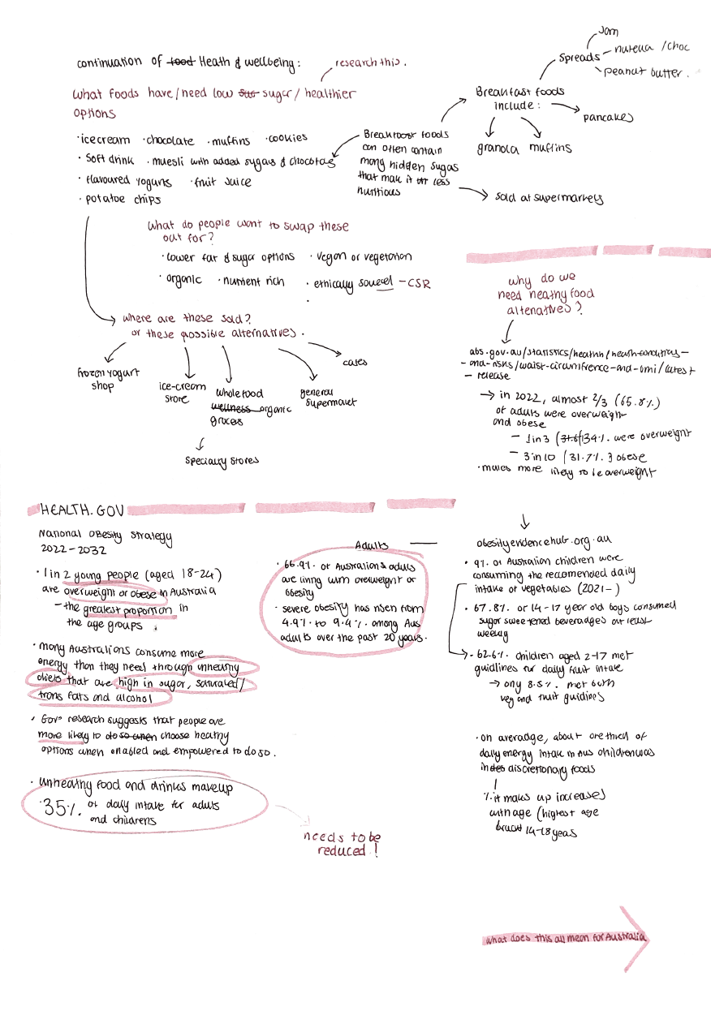
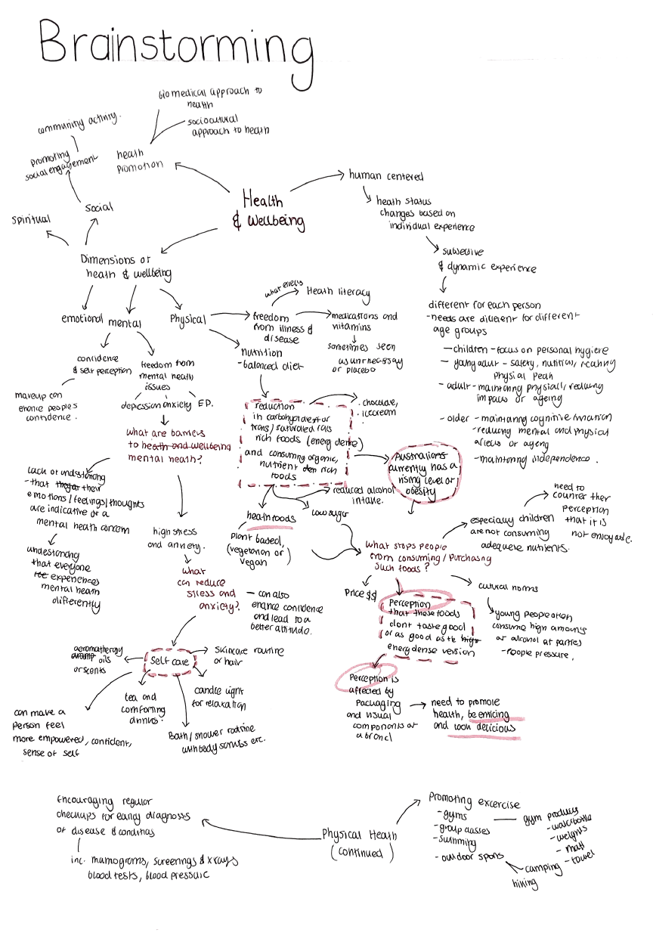
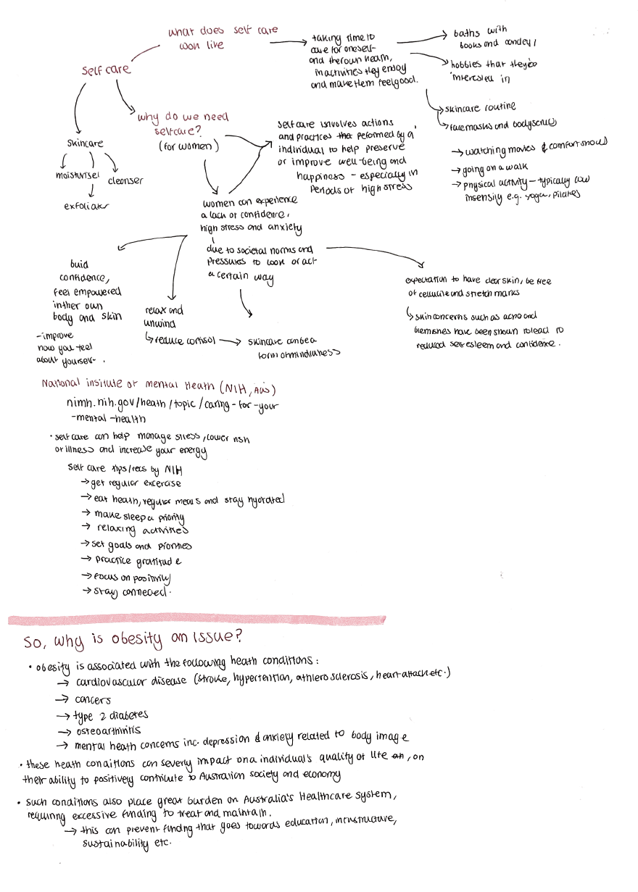

Source: Ruby Vincent

Unit 3 Outcome 3 Criterion 1 – Design research methods to define communication problems.
The student has explored the design problem through divergent thinking, gathering insights using multiple approaches. They have created a brainstorm map with guiding questions and topics centered on well-being, which has informed further research into health statistics (as seen on page 2). Their exploration also includes reflection on obesity as a contributing factor, demonstrating a broad and thoughtful approach to understanding the design challenge.

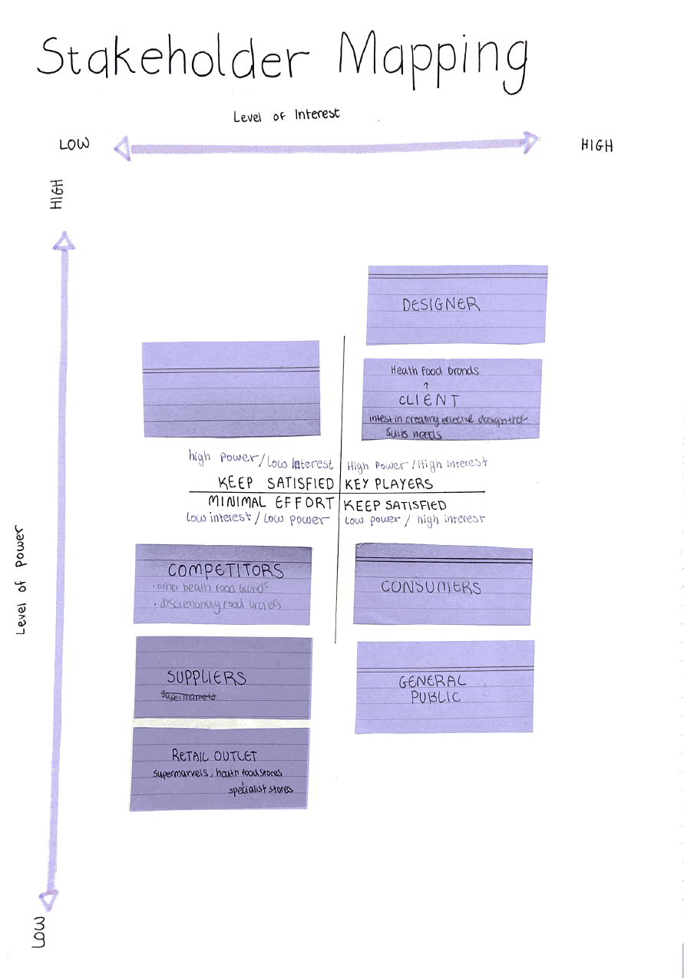
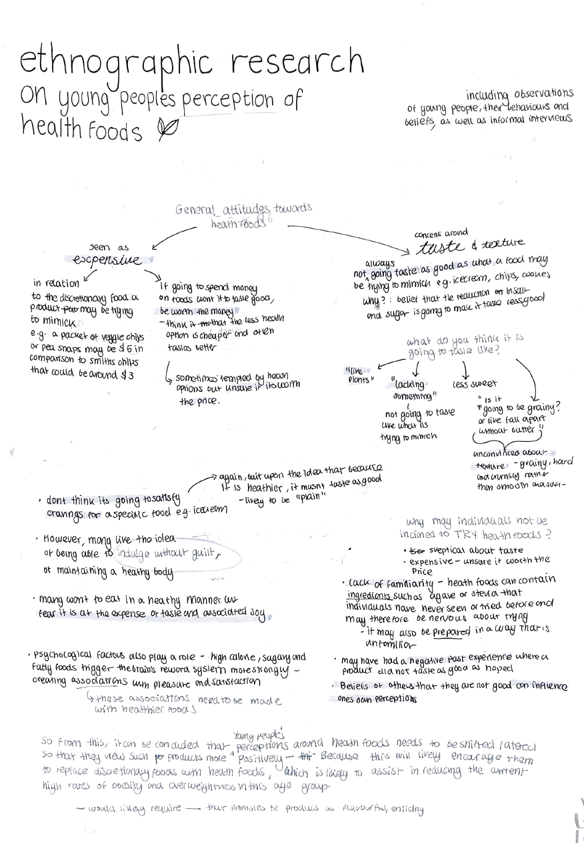
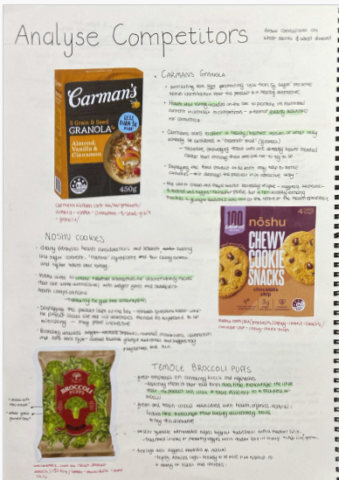
Source: Ruby Vincent

Unit 3 Outcome 3 Criterion 1 – Design research methods to define communication problems.
Research strategies to gather insights. Understanding of legal and ethical obligations. Understanding of good design. Here the student has researched a range of types of health foods and their packaging. They have analysed the use of visual language to convey information about the product. They also discuss the dietary features of each. The student has written the source of the image under each. In their annotations they consider how each example conveys the health information thus addressing the legal obligations of designers.
Research strategies to gather insights: Stakeholder analysis. The student has used a graphic organiser to analyse the designer, audience and context of the design. There are headings that identify the interest of the stakeholders, and they are described and what investment they may have in the design.
Research strategies to gather insights: Ethnographic research. This is another form of research that the student has used to gather insights on the users of health food products. They have analysed the attitudes of a specific audience group to gain further insights.
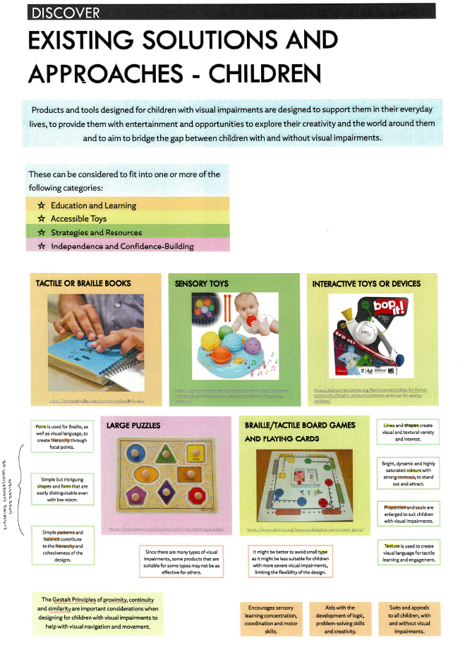
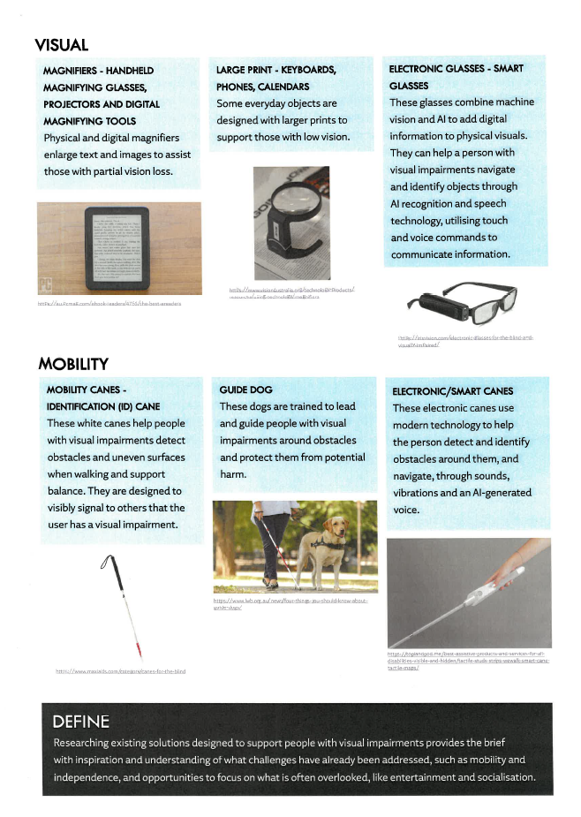
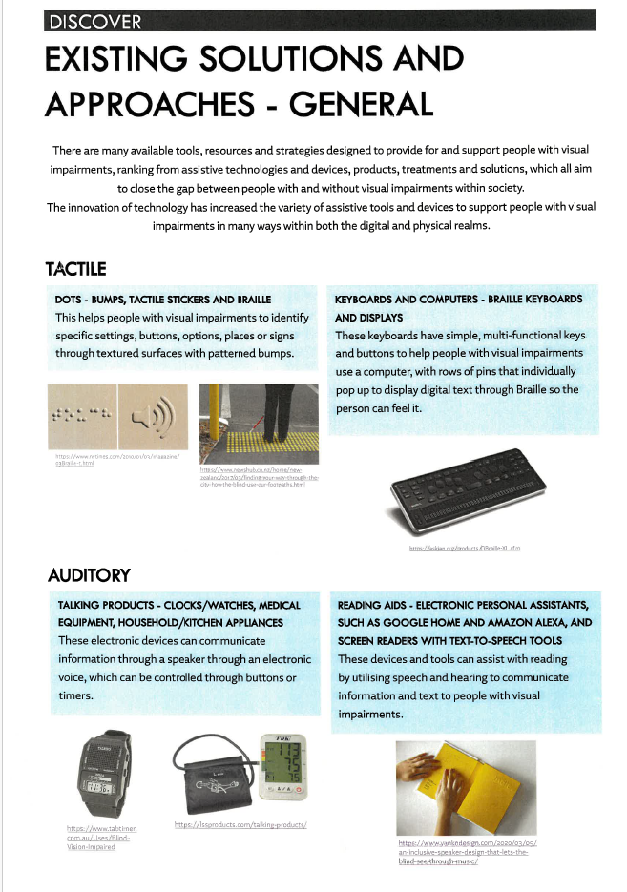

Unit 3 Outcome 3 Criterion 2: Documentation of a design brief defining two distinct communication needs and the presentation of design criteria (GOOD DESIGN – CONVERGENT THINKING)
The student has established a design problem, and they are using convergent thinking to further research and define the design problem. They have researched existing solutions such as vision impaired devices and how they provide access and mobility for users. They discuss the features of each device and how it is used (Images 1 and 2). They also research existing designs (Image 3) using the Gestalt Principles of Visual perception. They have annotated the design elements and principles in each example. This research assists the student to explain the design problem.

Source: Andrea Ong

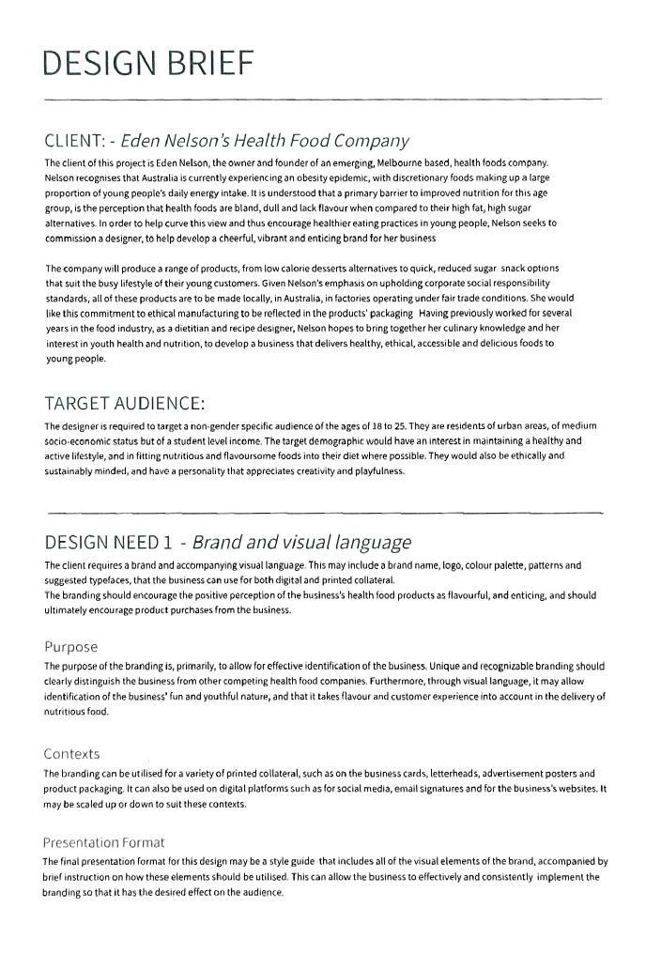
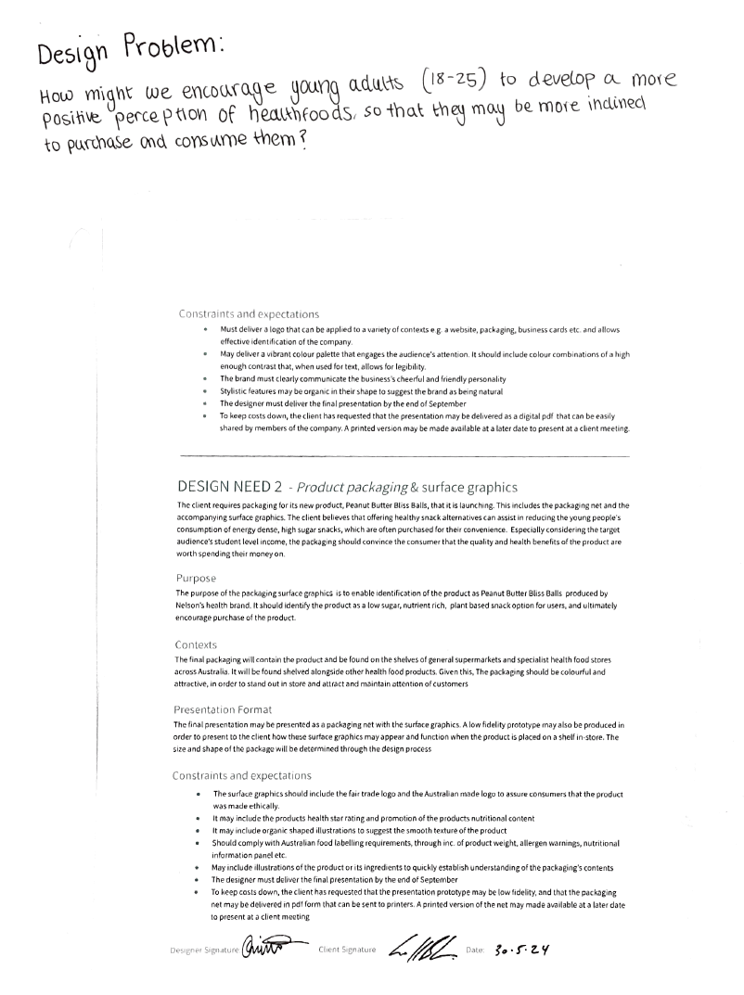

Source: Ruby Vincent

Unit 3 Outcome 3 Criterion 2 – Documentation of a design brief defining two distinct communication needs and the presentation of design criteria (Design brief and design criteria).
At the top of the brief the student has written the design problem. The client and audience are explained by providing detail of the location and characteristics of each. These have been developed from the different forms of research where the student investigated the audience, the context, and existing solutions to the problem. Each need is described referring to the design field of messages and its conventions. (Eg: logo, colour palette, pattern and type face). The need is related to the design problem. Then the purpose is described and how visual language will communicate the need. The context explains what the visual communication design is, where the design solution will be located (branding on printed collateral, business cards, letter heads, posters and product packaging) and how it will be viewed. The presentation format is explained and the student discusses how the communication need will be presented to the client. For example, the style guide with instructions of how to use it. The student has also outlined the constraints and expectations for both communication needs. They highlight aspects such as specific client constraints regarding style, conventions relating to the field, and ethical and legal obligations (inclusion of the Australian food guidelines). Finally, the brief is signed and dated by the teacher and the student.

Hint: Students use the information under each heading in the brief to have a clear idea of their design criteria.
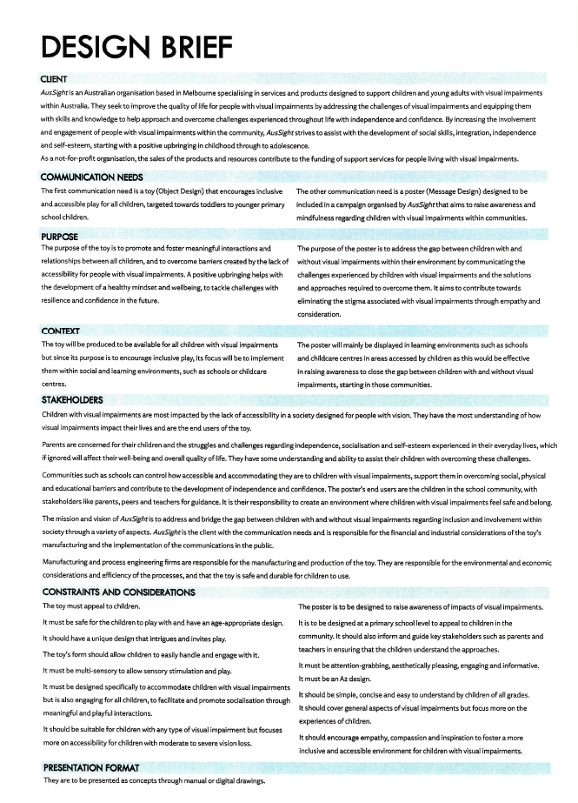

Unit 3 Outcome 3 Criterion 2 – Design brief and design criteria.
This Design brief has been developed from the specific research on children and young adults who are vision impaired. From the research into organisations who provide access to vision impaired people, the student can discuss the client in detail. Two different communication needs are explained, and the fields of Messages and Objects. The purpose has developed from the specific research into each design field so the design problem is fully explained. The contexts explain what the design solution is relevant to the field (eg: Object design: a toy) and where it will be used (social environments and learning)
There are several stakeholders (or users) for the design solution (parents, children and communities). These are explained referring to how they would use the design solutions. As there are specifications for the toy, the student has also described how the manufacturer is a user of the design solution.
Each design solution has constraints and considerations. The student has drawn on the client, users and conventions of both design solutions. They have considered ethical and legal obligations referring to accessibility regulations and also constraints from manufacturers and printers.
The presentation format is identified and could have further explanation that related to purpose, context and conventions of the identified field. However, most of this information is covered in other areas of the brief.

Hint: Students use the information under each heading in the brief to have a clear idea of their design criteria.

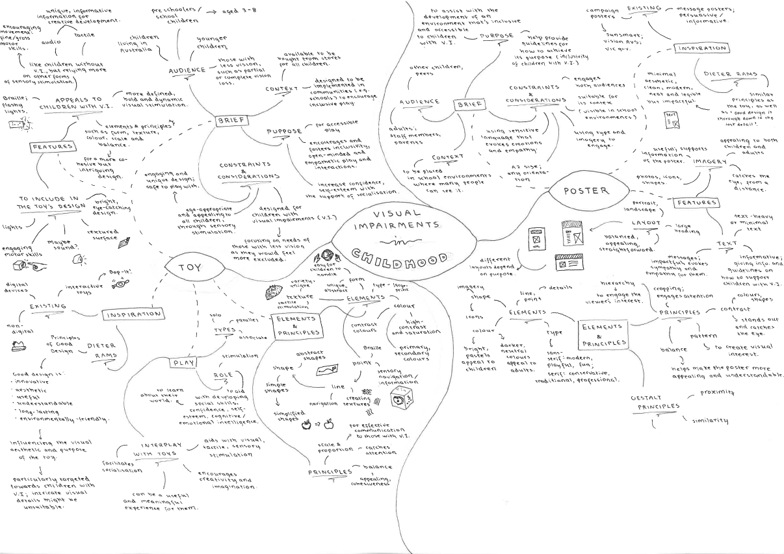

Source: Andrea Ong
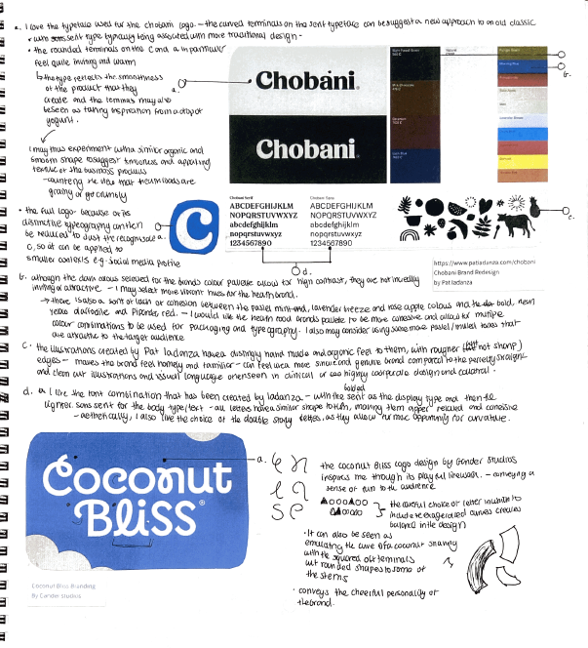
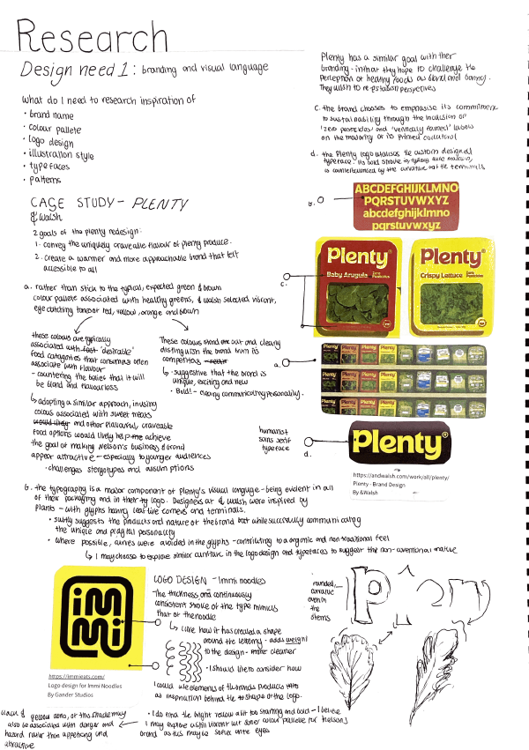
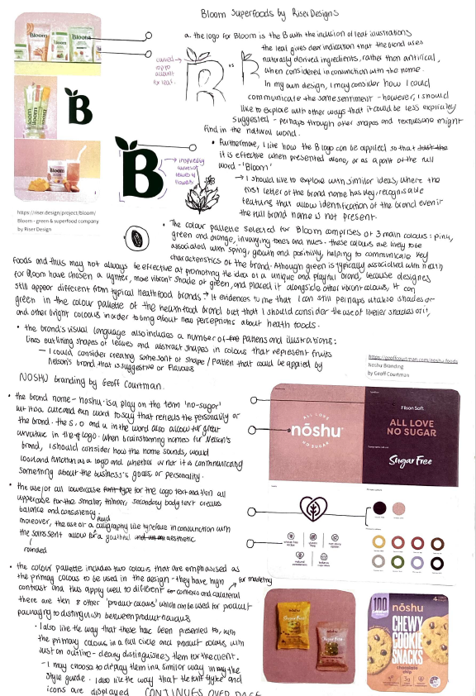

Source: Ruby Vincent

Unit 3 Outcome 3 Criterion 3 – Generate and develop a range of design ideas drawing on the design criteria (design idea generation)
At the start of their generation of design ideas, the student has drawn on the design criteria (Image 1: top left) by writing a list. They then complete a series of case studies on logos. In these case studies the student focuses on the effective use of design elements and principles and generates some small thumbnail sketches next to the examples. They also reflect on why they are examples of good design, particularly on how they address the audience and the communication need. They also consider the conventions of the Messages field by discussing features such as typefaces. The annotations are presented in a concise list of bullet points. The student has also referenced the source of the image next to it. The student has also considered legal and ethical obligations by considering regulations for the use of found typefaces and the information that must be conveyed on packaging.

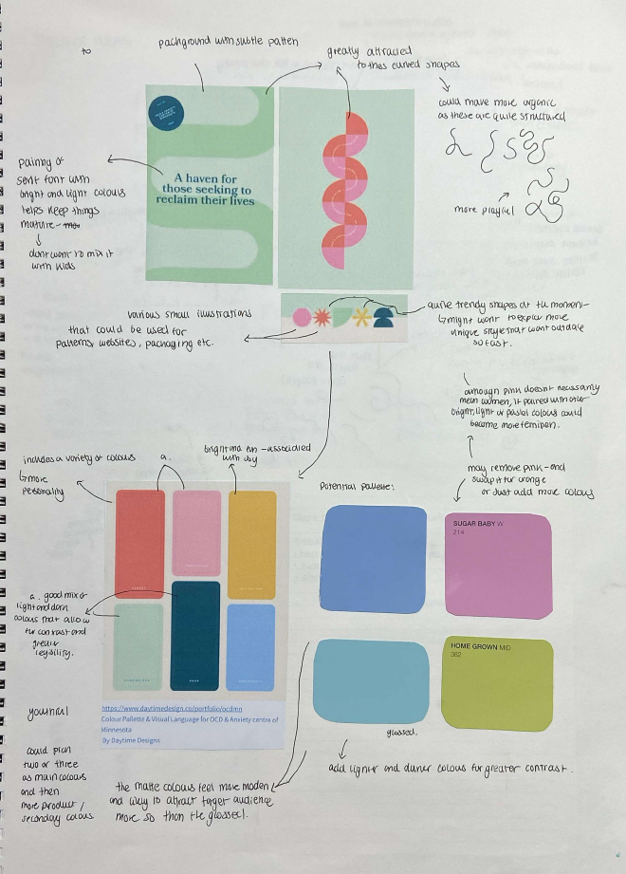
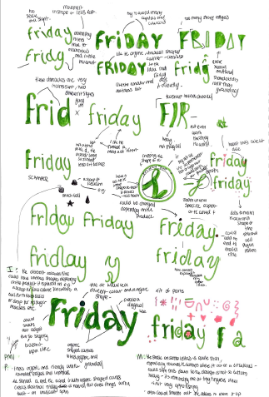
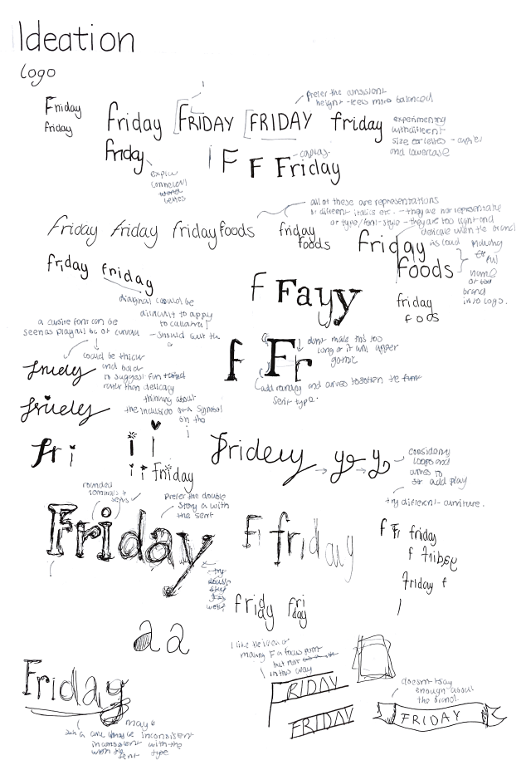

Unit 3 Outcome 3 Criterion 3 – Generate and develop a range of design ideas drawing on the design criteria
These examples show the student exploring and expanding on the design criteria. They have started to explore their logo using different methods, materials and media. The type for the logo is explored in different ways and the use of the ink and brush demonstrates the expansion on the fineliner. Digital methods are used to explore the shapes of the logo and the colour for the background. Throughout the exploration the annotations explain the use of the design elements and principles and how they effectively communicate the ideas to the audience.

Hint: It is a good idea to keep a list of the design criteria to help with organising the generation and development of design ideas.
Source: Ruby Vincent
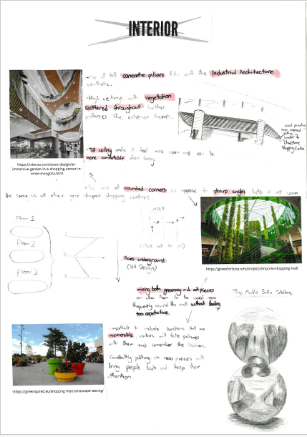
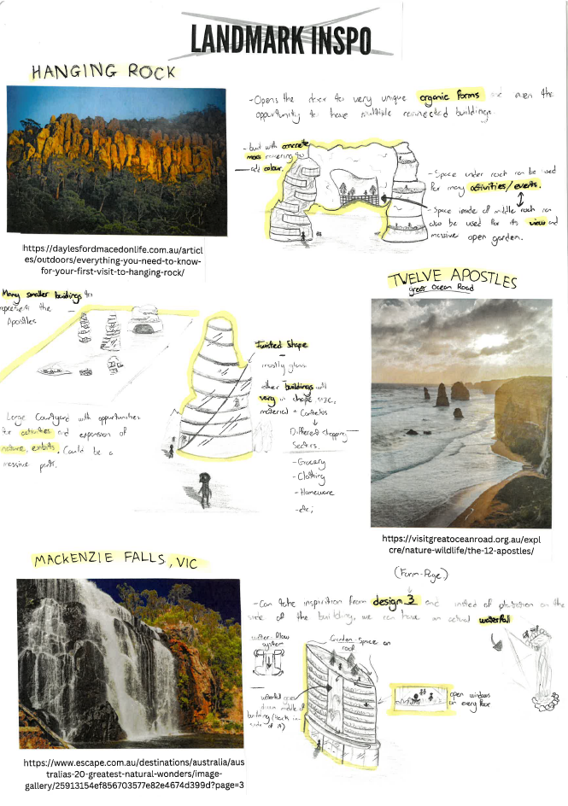
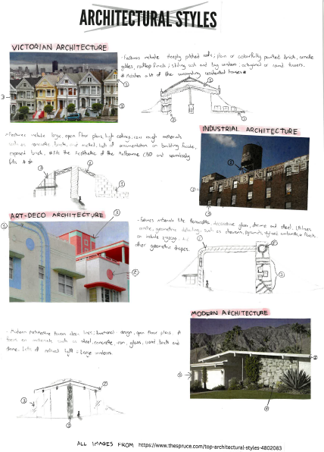

Unit 3 Outcome 3 Criterion 3 – Generate and develop a range of design ideas drawing on the design criteria
In developing design ideas for a shopping centre, this student has drawn inspiration from natural forms, architectural styles, and interior designs. These themes were developed from a brainstorm of the design criteria. The student has highlighted words that are relevant to the design criteria for each example. There are small drawings using a range of materials and media next to each exploration, including a rendered manual drawing of a sculpture thus demonstrating the student considering form. The student discusses how they would develop these ideas further by referring to the design criteria.

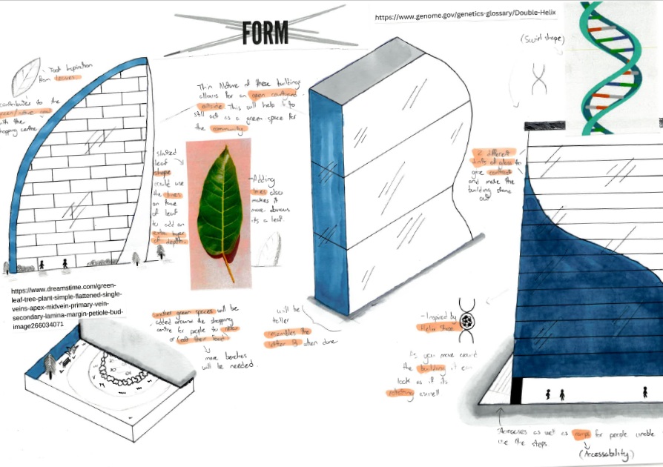
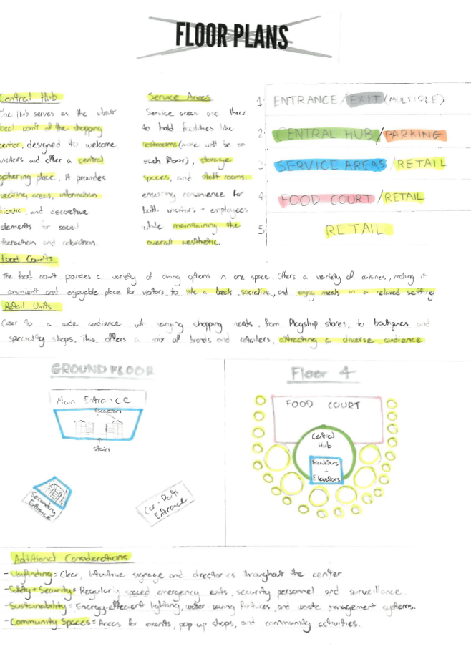

Unit 3 Outcome 3 Criterion 3 – Generate and develop a range of design ideas drawing on the design criteria
In these pages the student has developed their design ideas. They have focused on a specific design element to explore and based their exploration on natural forms. They have generated ideas for a floor plan for the shopping centre and they are now considering other factors such as sustainability, safety and security and a sense of community. These are all ethical considerations in the development of the design. The design criteria in both examples are highlighted in the student annotations. Often the annotations are added to with small thumbnail sketches demonstrating convergent thinking.

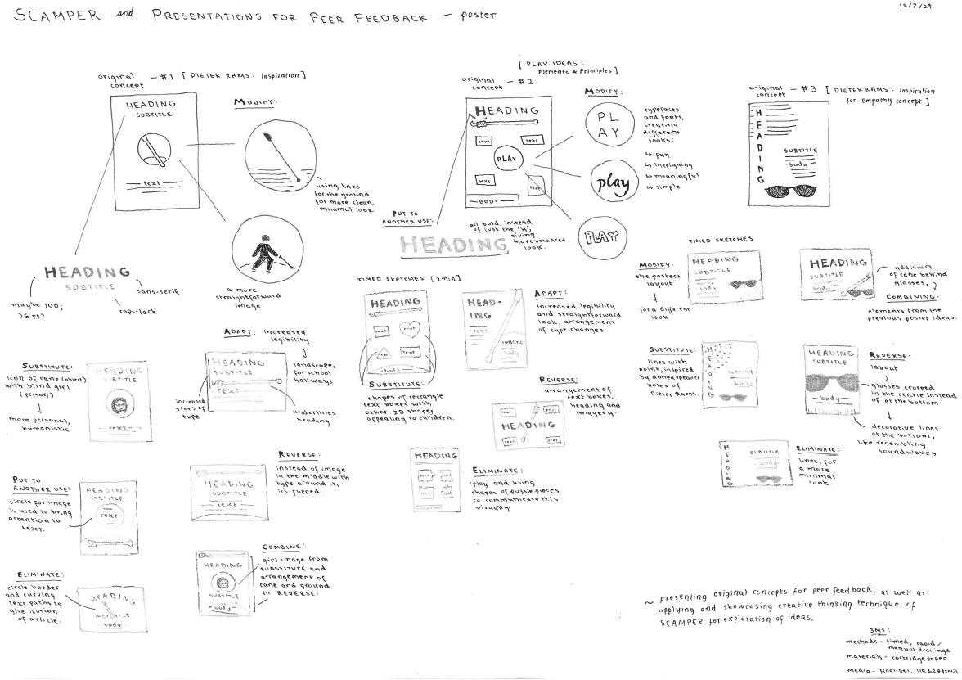
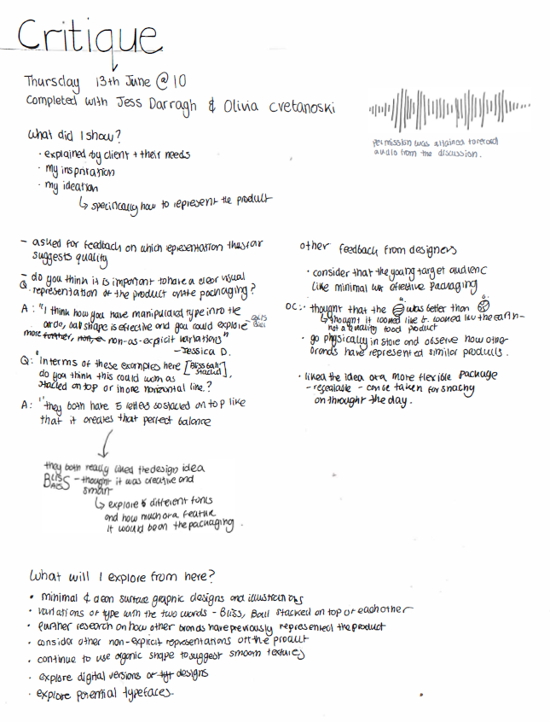

\
Source: Andrea Ong

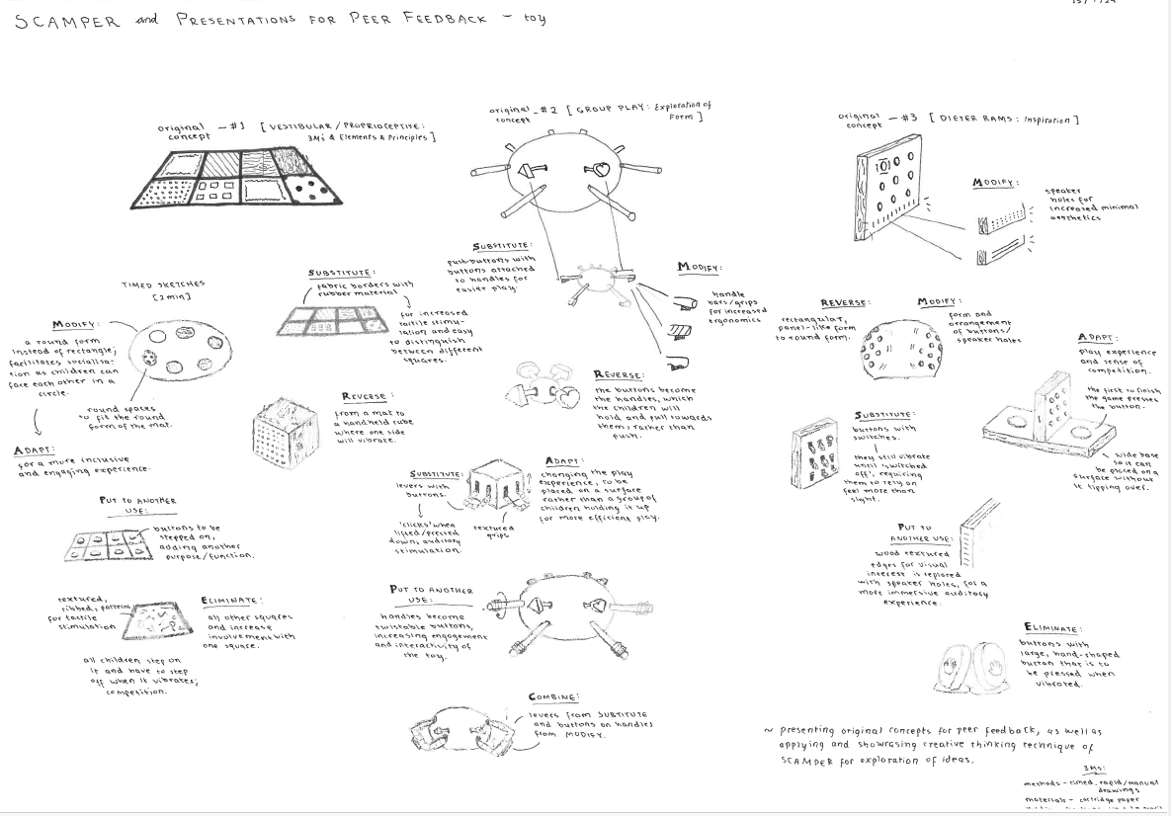

Source: Ruby Vincent

Unit 3 Outcome 3 Criterion 4 – Present a range of design ideas drawing on the design criteria (planning for the critique)
These examples demonstrate how the students have planned for the presentation of their design ideas. They are planning the presentation by drawing diagrams of the design ideas using divergent thinking strategies (SCAMPER: Image 2 and 3) and developing questions. These questions for feedback focus on the design criteria and the student’s understanding of good design. In image 1 the student has written a list of factors to develop further including research, specific examples of their design ideas and the design elements and principles.

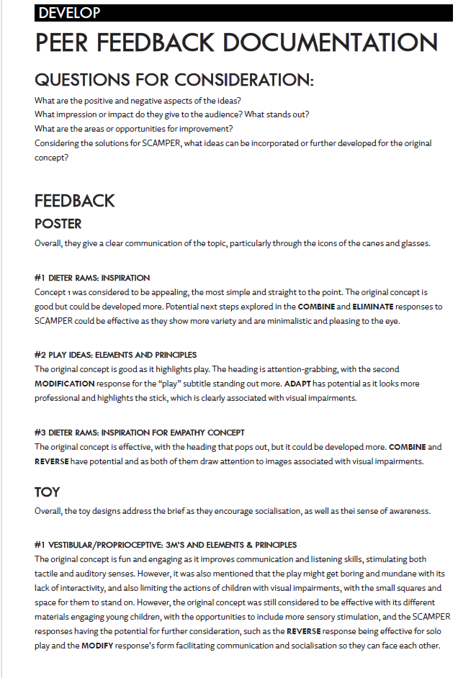
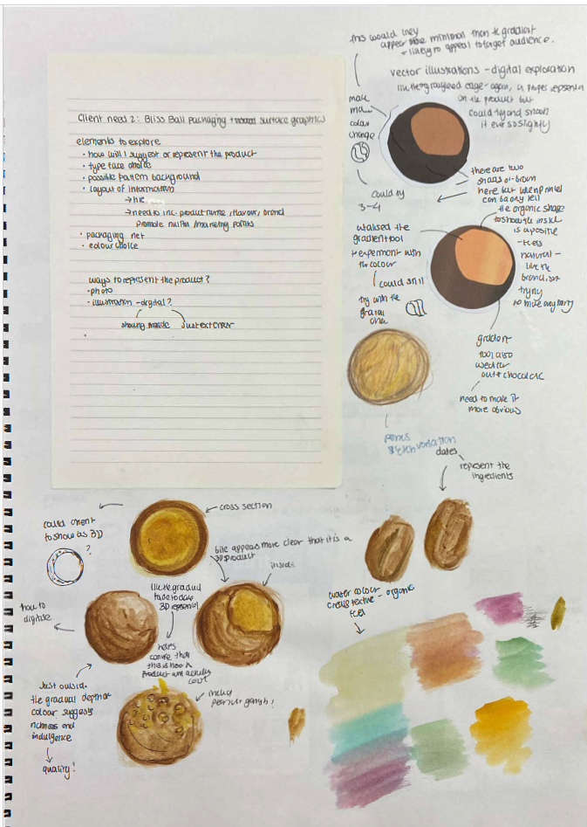

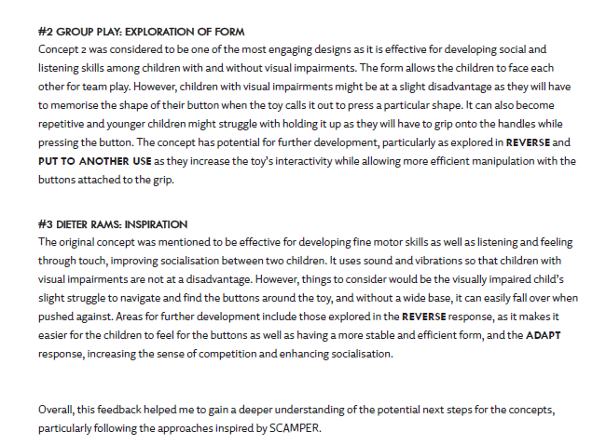
Source: Andrea Ong

Source: Ruby Vincent

Unit 3 Outcome 3 Criterion 4 – Present a range of design ideas drawing on the design criteria (feedback and response)
These examples showcase students articulating their questions and feedback while planning the further development of their design concepts in Unit 4. The feedback is structured around the design criteria, with students reviewing these criteria and summarizing their insights. They demonstrate critical and reflective evaluations, incorporating strategies for critical and reflective thinking, design elements and principles, as well as methods, media, and materials. Additionally, students have created specific diagrams to visually illustrate their thinking.

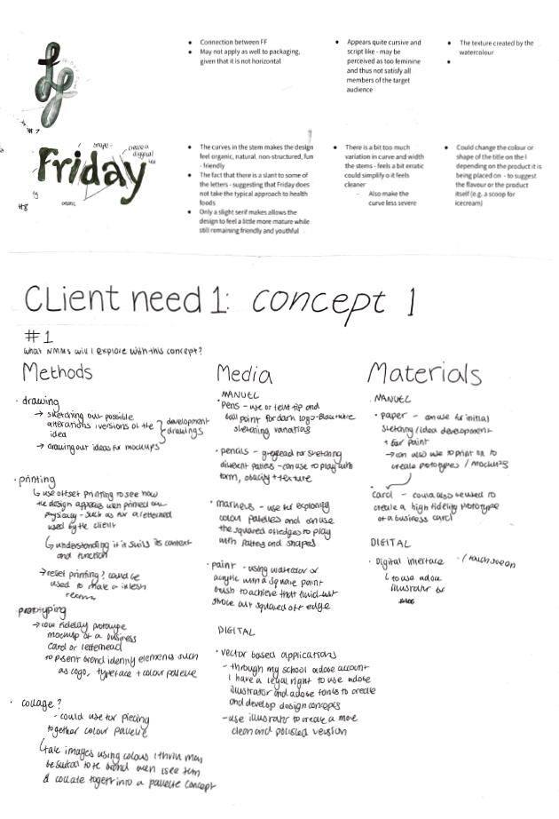
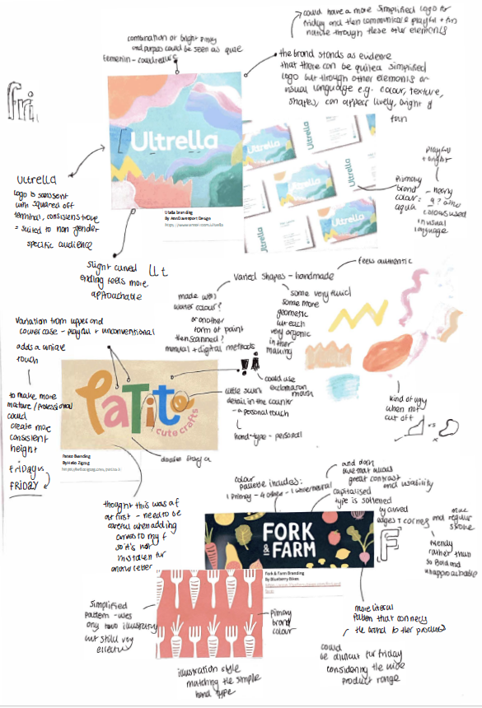
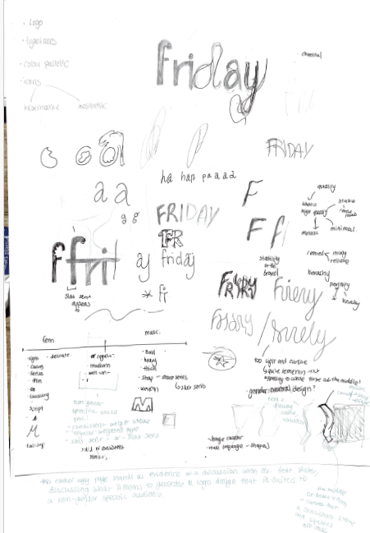
Source: Ruby Vincent

Unit 4 Outcome 1 Criterion 5 – Refinement and resolution of design concepts for two communication needs
The student has developed a plan based on the feedback from the Unit 3 critique of the design concepts from the design ideas that they will refine further. Here the student has identified one design idea and undertaken further analysis by researching other logos and packaging surfaces. The student evaluates and compares the use of the design elements and principles and refers to the design criteria. They also discuss to how they can use methods, media and materials by discussing watercolour effects and also digital type created in Illustrator. They then synthesise the use of methods, media and materials and discuss what they will explore to refine one concept.

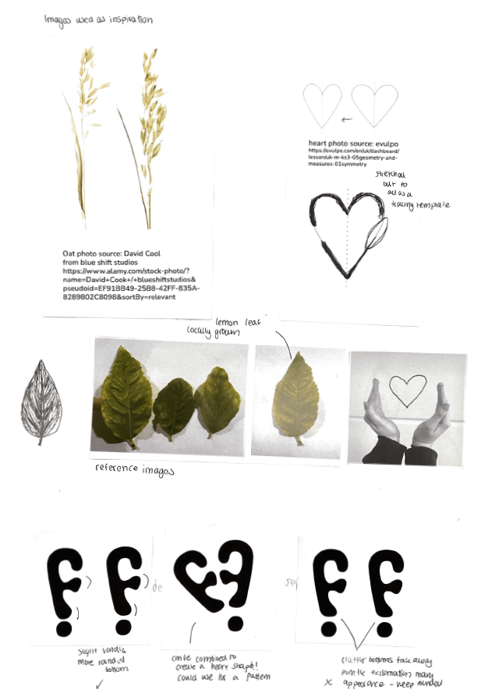
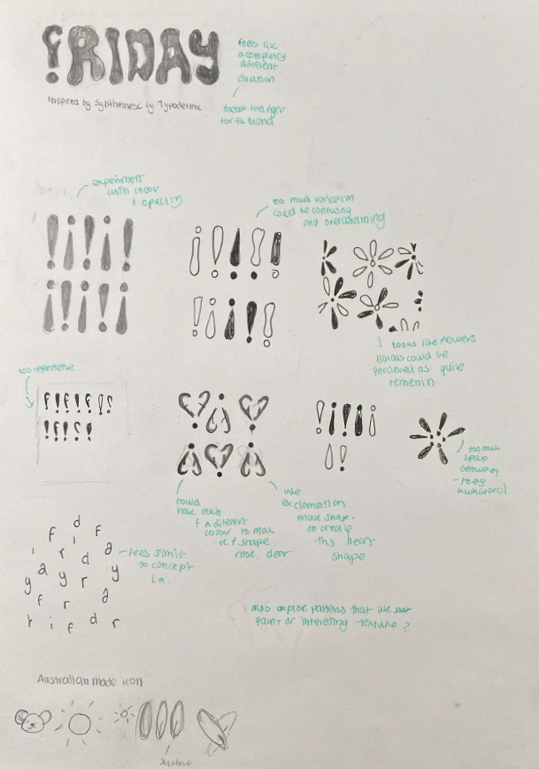
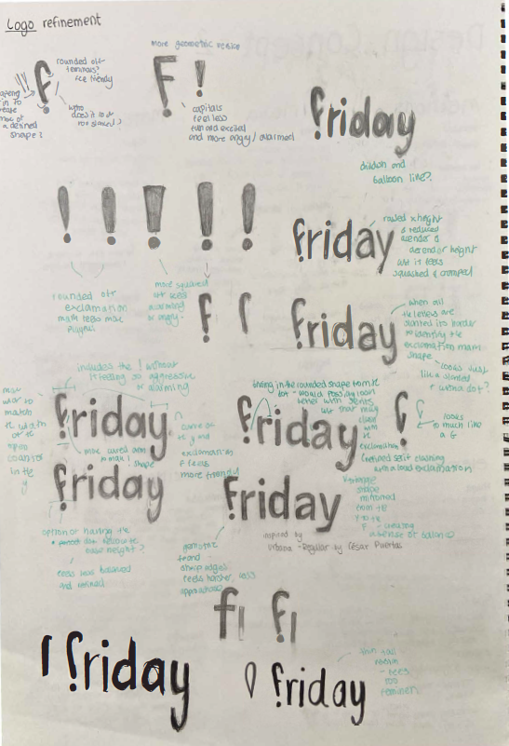

Unit 4 Outcome 1 Criterion 5 – Refinement and resolution of design concepts for two communication needs
The student has developed a plan based on feedback from the Unit 3 critique, refining their design concepts further. Focusing on the logo concept, the student delves deeper into the conventions of the Messages field, emphasizing typography. They also explore design elements and principles to create effective visual language. The annotations provide specific insights into each iteration of the concept. Additionally, the student draws inspiration from photography and natural imagery that align with the design criteria, considering the client’s role as a health food producer. Resource images are included alongside their respective source links. The student also accounts for ethical and legal obligations by examining the required packaging symbols for health food in Australia.

Source: Ruby Vincent

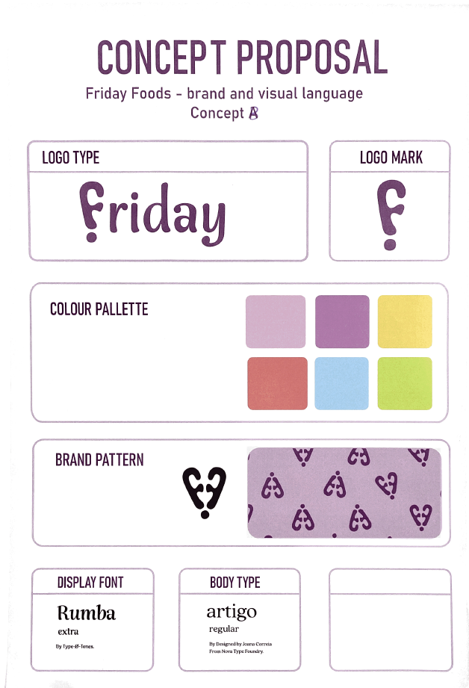
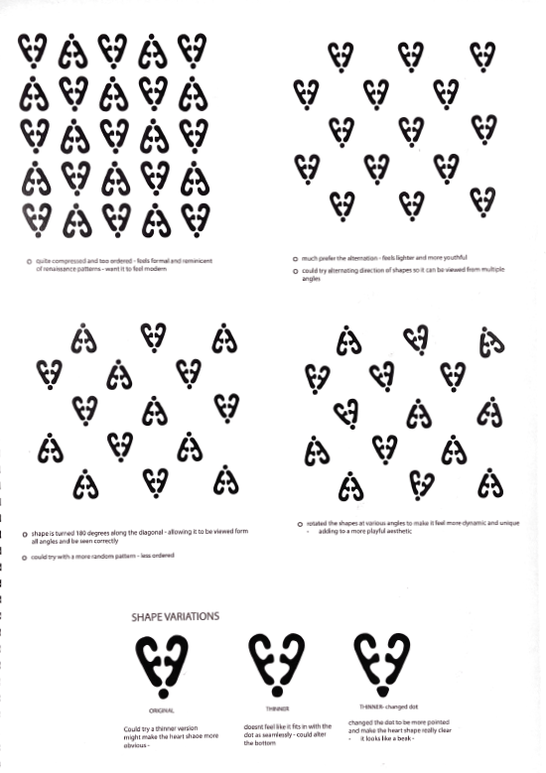
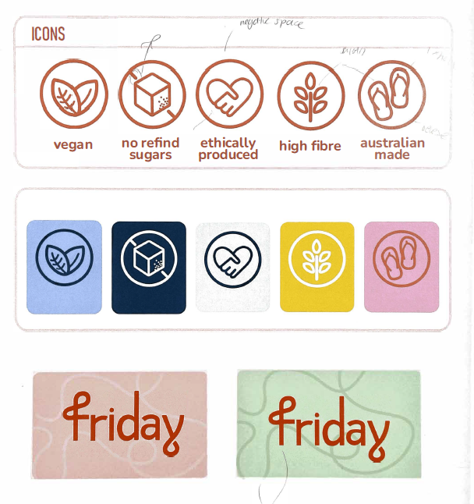
Source: Ruby Vincent

Unit 4 Outcome 1

Criterion 5 – Refinement and resolution of design concepts for two communication needs. Criterion 6 – Evaluation and presentation of design concepts drawing on the requirements of the brief.
These examples illustrate the focused refinement of a pattern for the brand identity. The student has used digital methods to explore pattern and shape in packaging, papers, and cards.
The final concept is presented in a pitch, demonstrating how the design solutions align with the criteria outlined in the brief. The student reviews their summary of design criteria, explaining how they refined their design ideas. They also address legal and ethical obligations, particularly the use of symbols required by the Australian government. They clarify how these elements were incorporated into the design concepts, any adjustments made, and how the final designs comply with Australian packaging regulations—for example, the use of the ‘Made in Australia’ symbol.

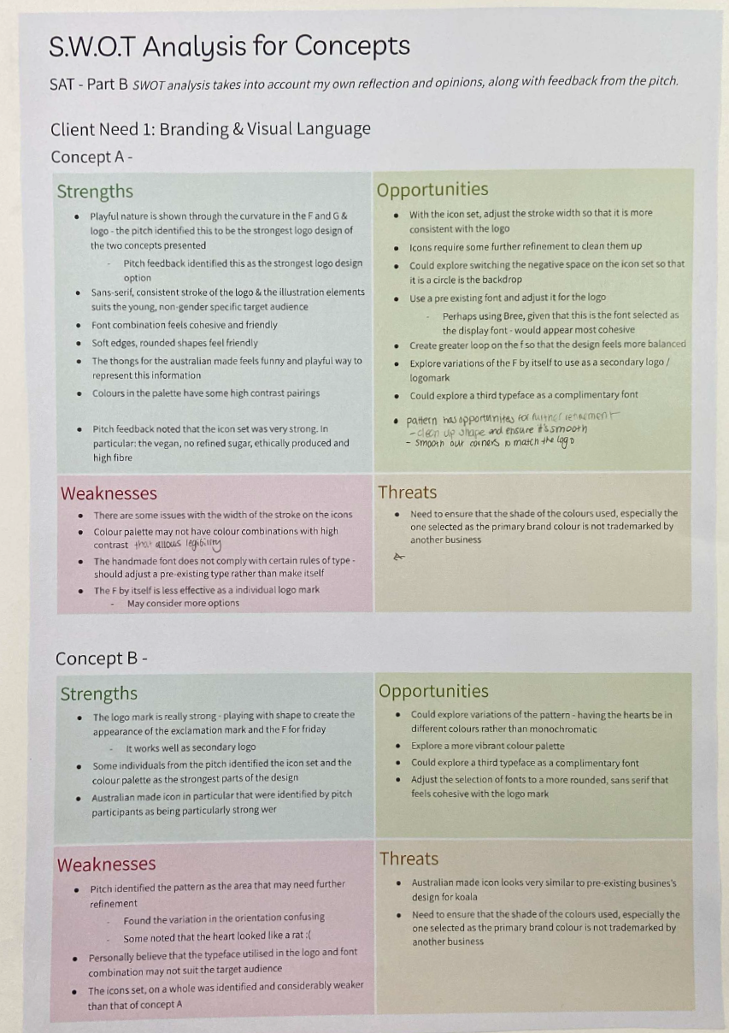
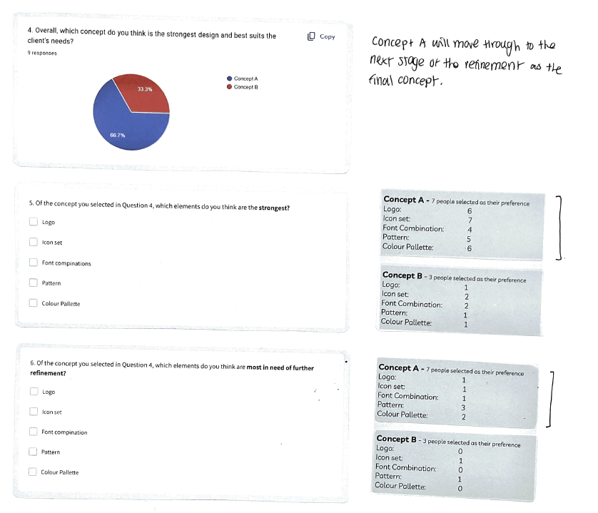
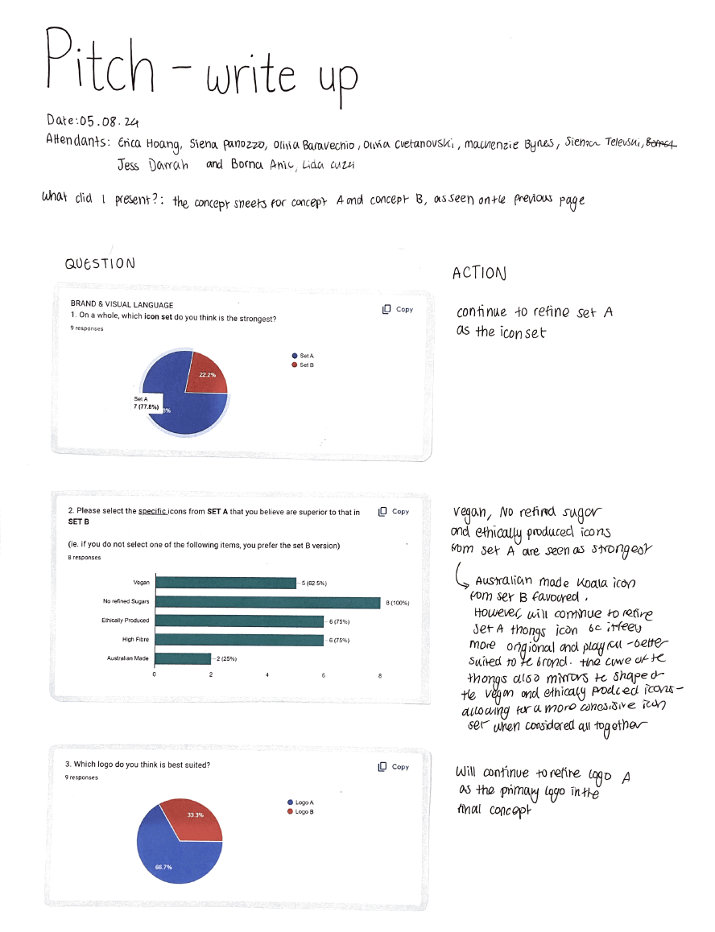

Source: Ruby Vincent

Unit 4 Outcome Criterion 6 – Evaluation and presentation of design concepts drawing on the requirements of the brief.
The student has applied convergent thinking from their pitch to refine their design concepts further. They documented the questions posed to other students along with the feedback received. Using a software program, they created a survey to gather insights, focusing on specific branding elements such as icons and the logo for targeted refinement. Following the feedback process, the student conducted a SWOT analysis to evaluate and refine their concepts. They incorporated key aspects essential to the solution, including visual language and ethical and legal obligations.

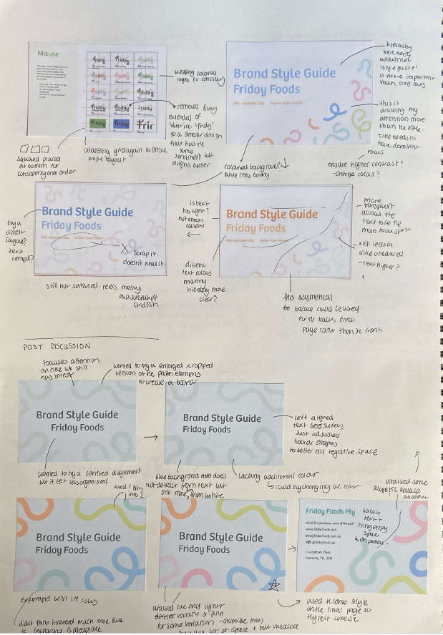
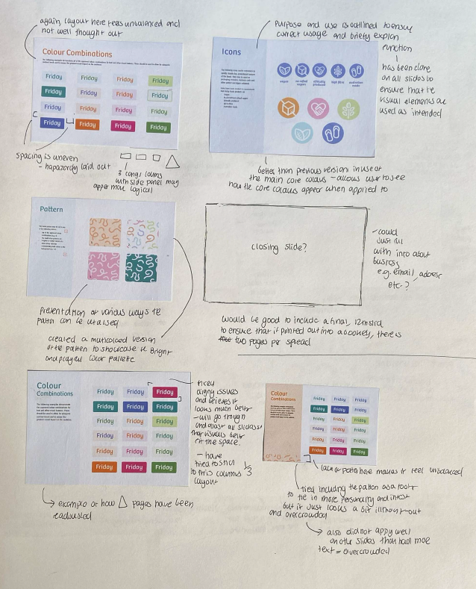
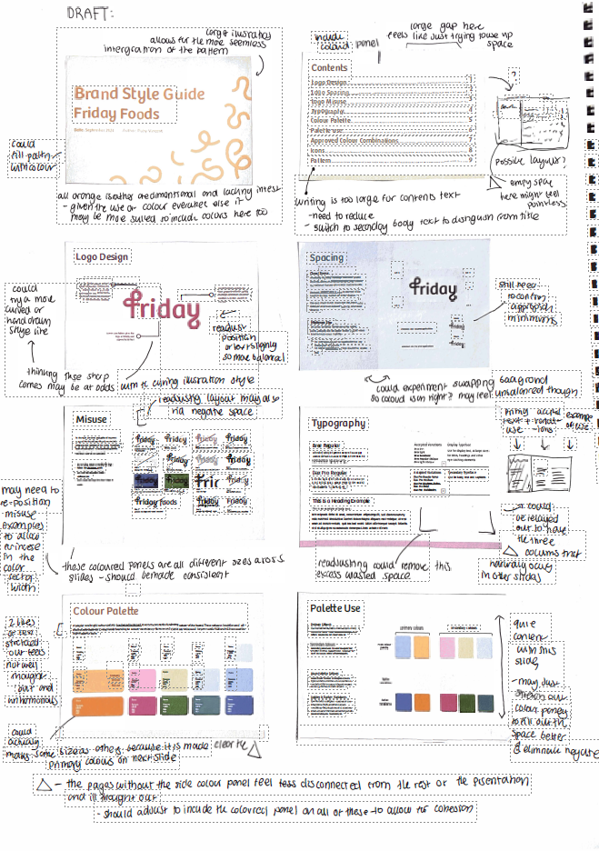

Unit 4 Outcome Criterion 7 – Presentation of design solutions to address the communication needs specified in the brief.
The student has applied their analysis to refine the concept for the style guide. They first created a draft of the guide’s pages and then enhanced each one digitally. The annotations on the draft communicate insights into page layout using Gestalt principles. Two examples showcase digital refinements across the eight pages. The student has provided commentary on layout, including the placement of the previously refined logo and icons. Additionally, they have incorporated conventions from the Messages field, refining typographic conventions and layout.
Source: Ruby Vincent

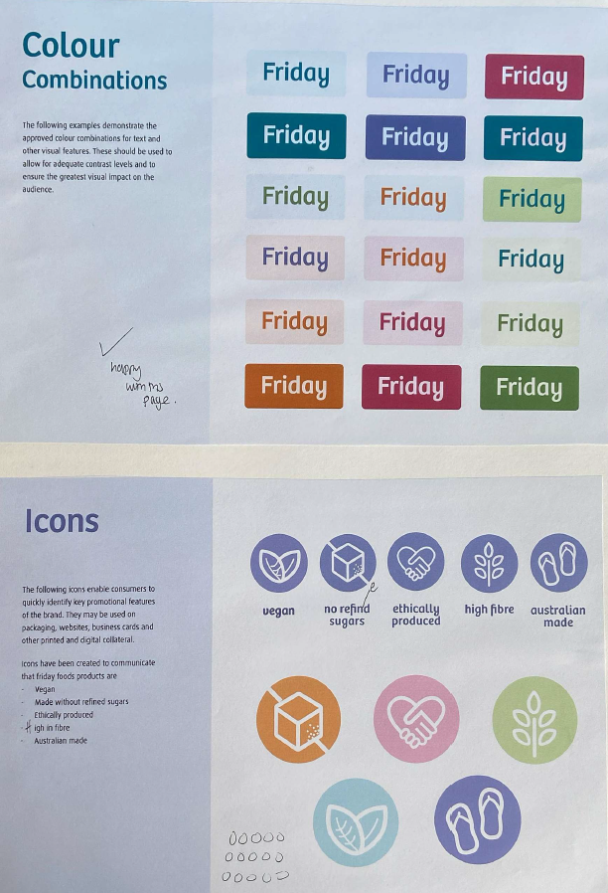
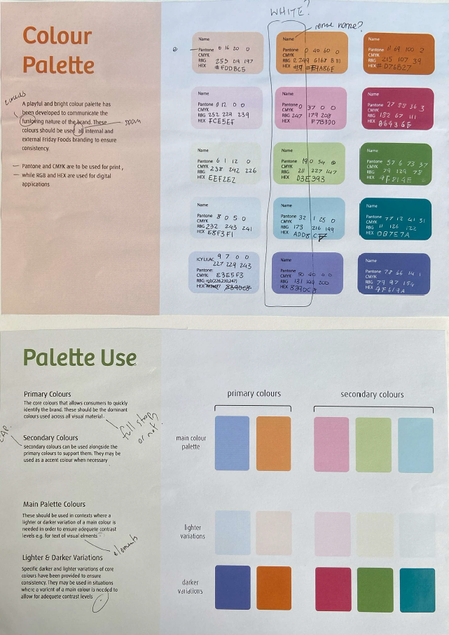

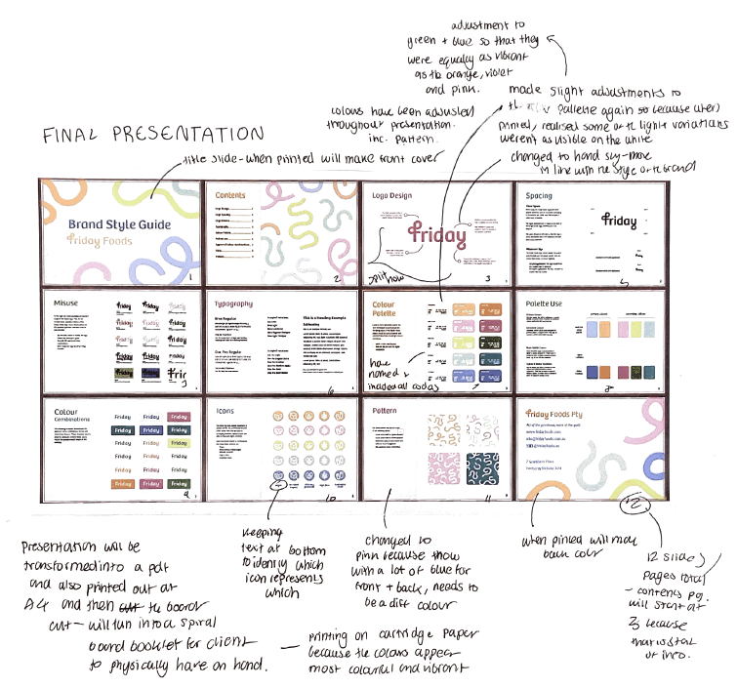
Source: Ruby Vincent

Unit 4 Outcome Criterion 7 – Presentation of design solutions to address the communication needs specified in the brief.
The student is resolving the layout of the presentation of their design solution. They have used digital methods for each aspect of the brand and style guide, and then considered the layout for the client as specified in the brief under Presentation format. By viewing the pages in a map the student is able to refine specific aspects of the visual language before moving to refine the presentation digitally.

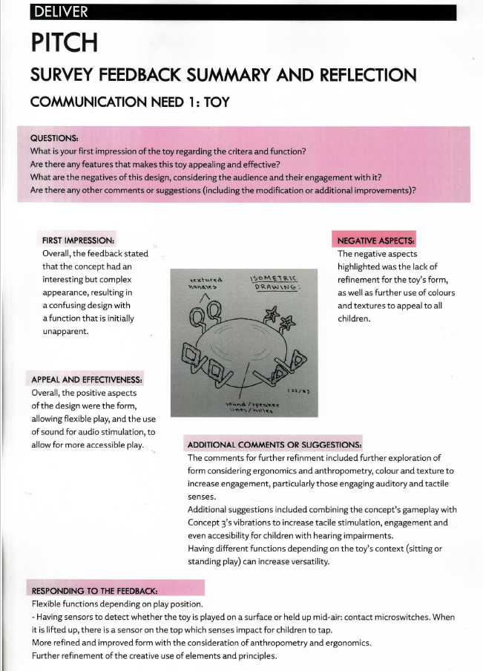
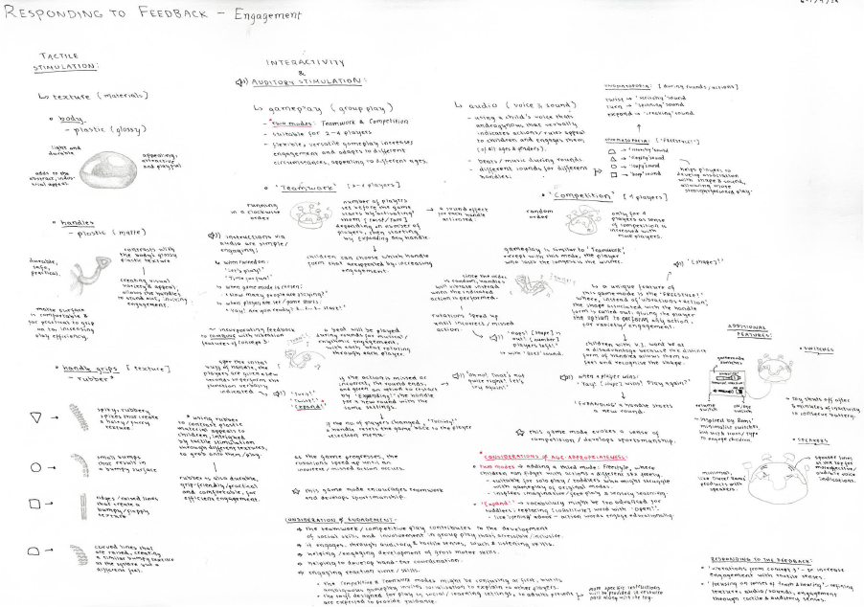

Source: Andrea Ong

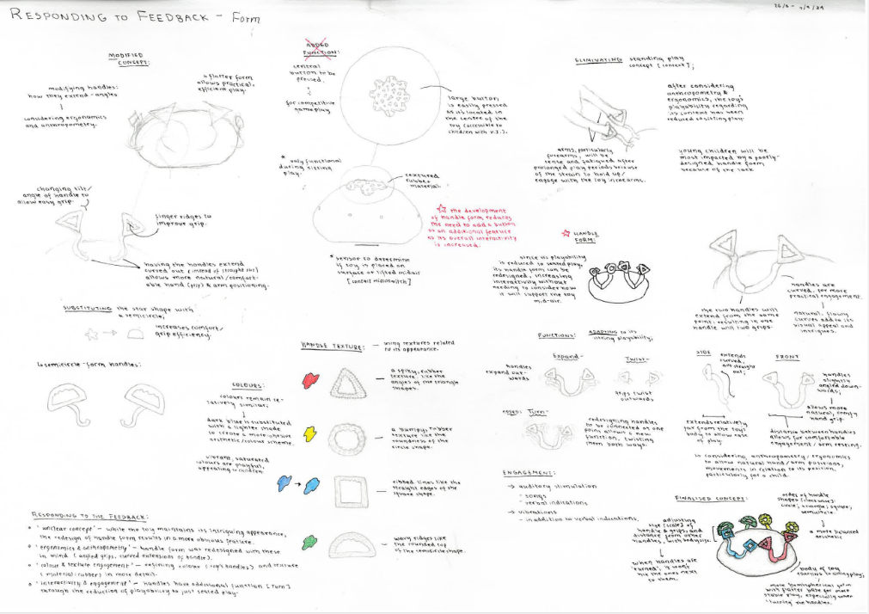

Unit 4 Outcome Criterion 7 – Presentation of design solutions to address the communication needs specified in the brief.
In these examples, the student has summarized feedback from the brief, highlighting both the positive and negative aspects of the toy design. The feedback addresses the effective use of visual language, the intended purpose of the design, and how it serves the user. To refine their work, the student has incorporated small illustrations and brainstorming sessions, responding to the feedback with further improvements. These illustrations and annotations align with the design criteria outlined in the brief and demonstrate convergent thinking.
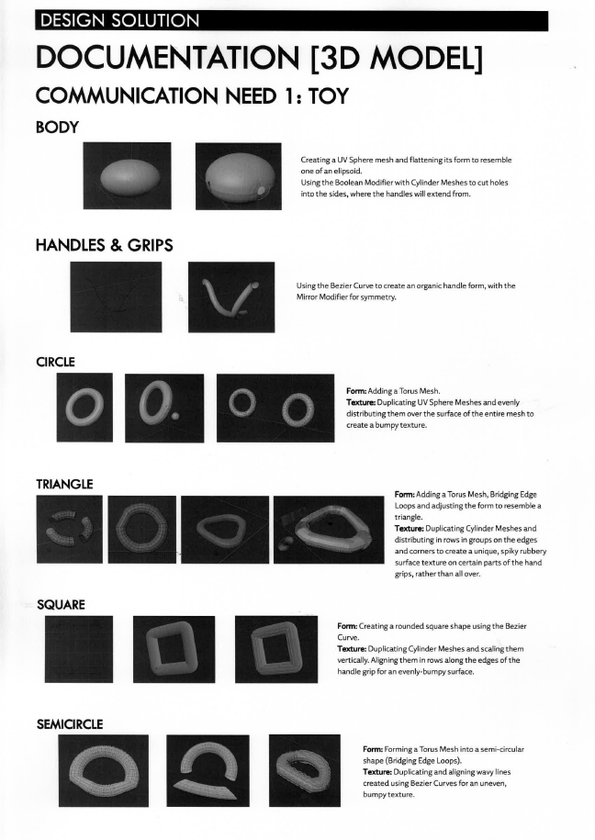
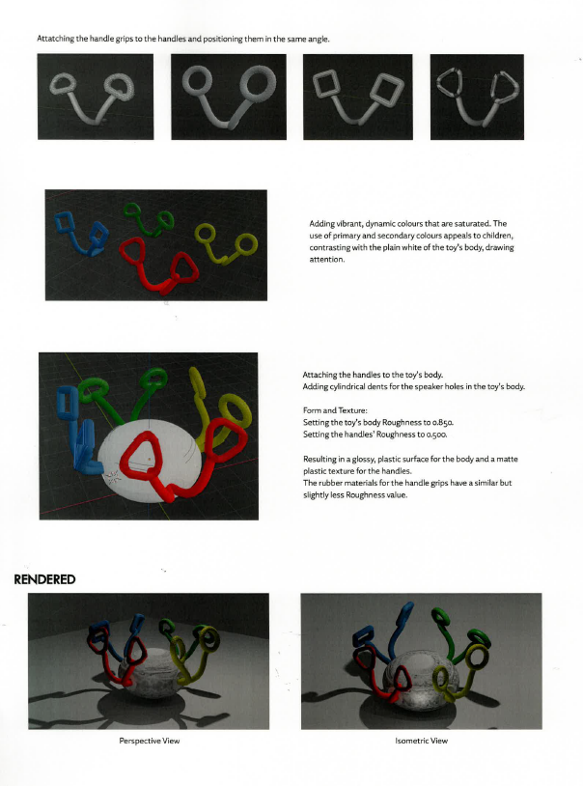

Source: Andrea Ong

Unit 4 Outcome Criterion 7 – Presentation of design solutions to address the communication needs specified in the brief.
The student has further refined a design solution, incorporating feedback from the brief. Their focus has been on enhancing the form and handle of the toy design. Using digital tools, such as design software, they have explored handle variations and examined design elements and principles. The accompanying annotations highlight these design aspects while aligning with the established design criteria.

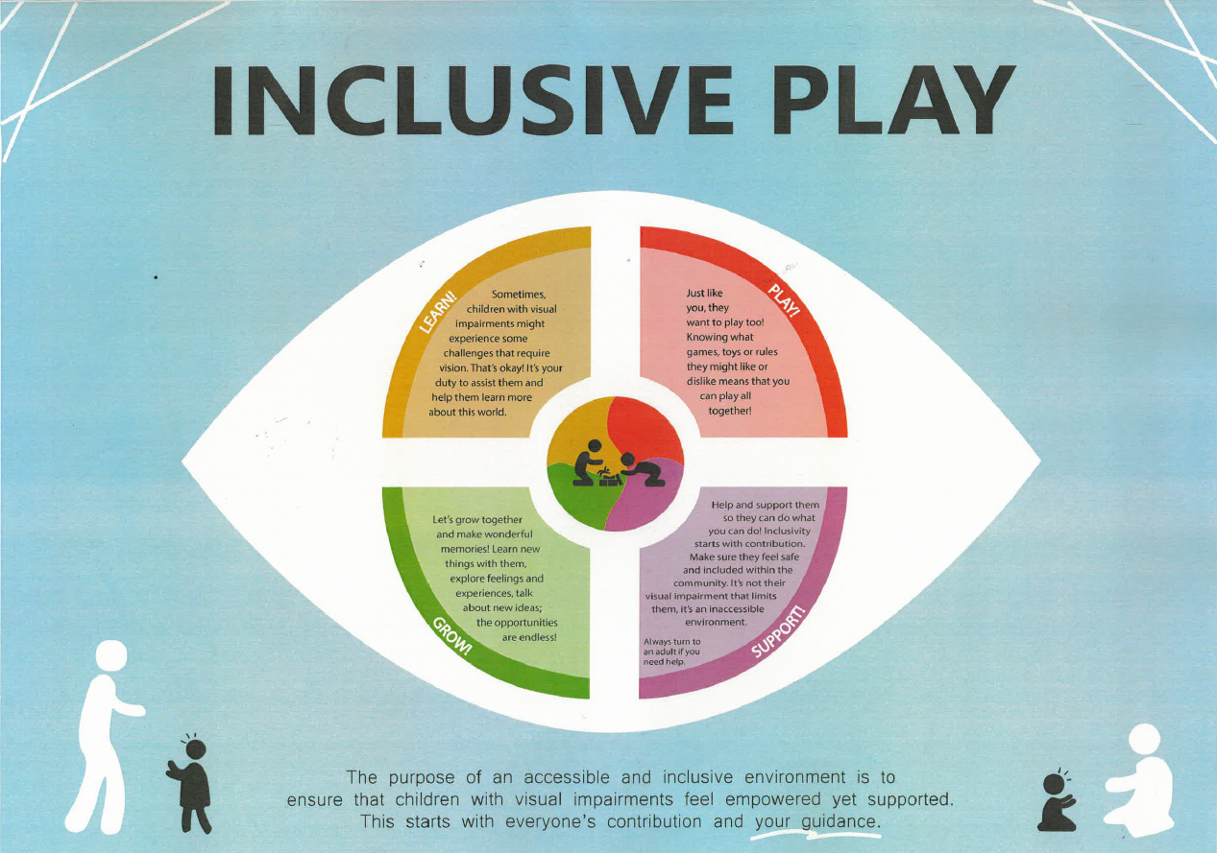
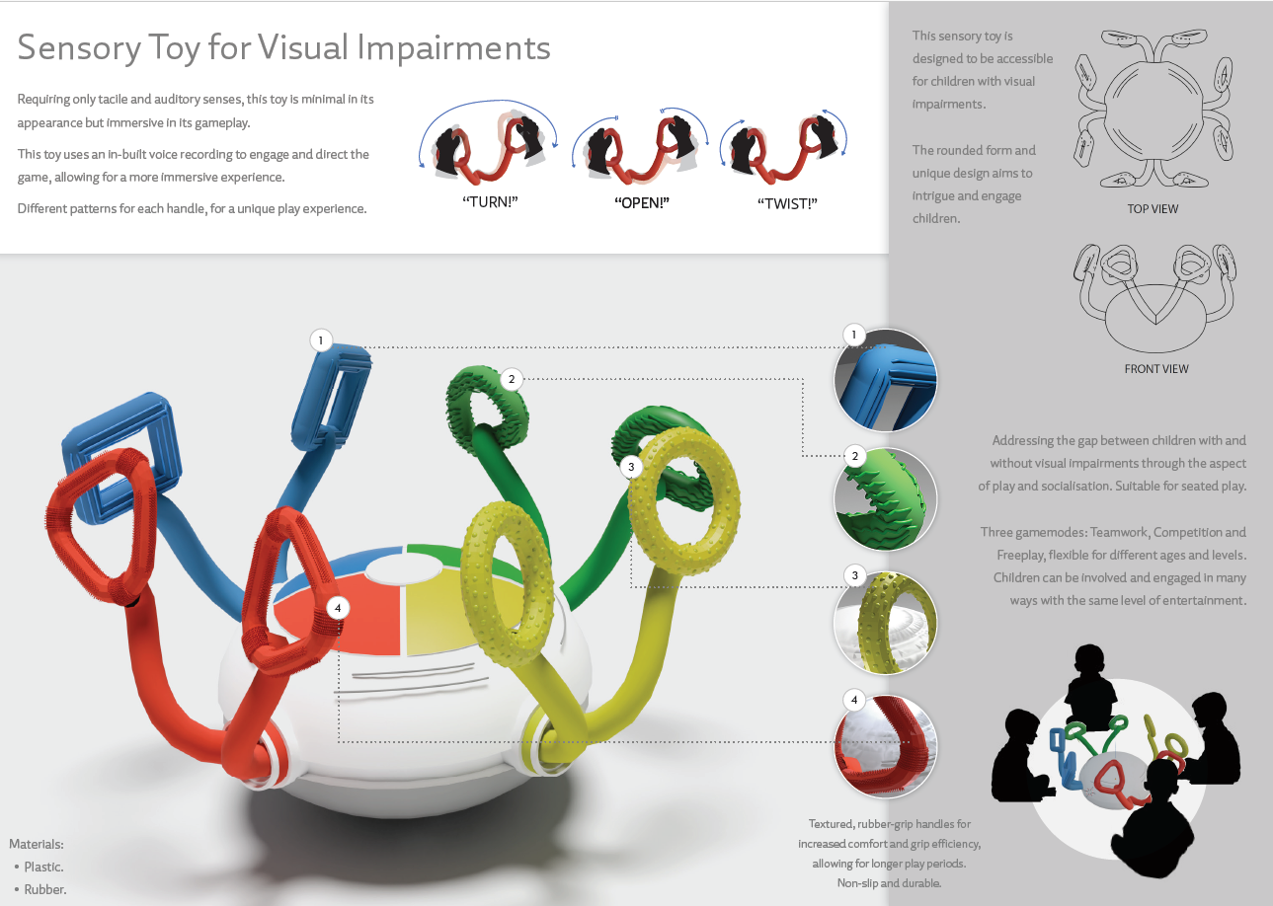

Source: Andrea Ong

Unit 4 Outcome Criterion 8 – Use of visual language to address the distinct communication needs specified in the brief.
The student has further refined a design solution, incorporating feedback from the brief. Their focus has been on enhancing the form and handle of the toy design. Using digital tools, such as design software, they have explored handle variations and examined design elements and principles. The accompanying annotations highlight these design aspects while aligning with the established design criteria.
The student has developed two different design solutions—a sensory toy and a poster about inclusive play—each in separate design solution presentation formats. By referring to the brief, one can identify the design criteria and examine how the student has refined their visual language. The folio work leading up to the presentations highlights this refinement, as the annotations demonstrate the deliberate application of design elements and principles.
Within the presentations, the concepts have been further refined to suit their respective formats. Additionally, ethical and legal obligations, such as the use of icons, scientific information on vision impairment, and accessibility regulations, are demonstrated. The student would have addressed these aspects during the refinement process leading up to the production of these final presentation formats.

