VCE Romanian Units 1 and 2: 2024–2028; Units 3 and 4: 2025–2028

VCE Romanian Planning Tool – SAMPLE

This sample illustrates one way of developing a program for VCE Romanian. Please refer to the study design for further information.
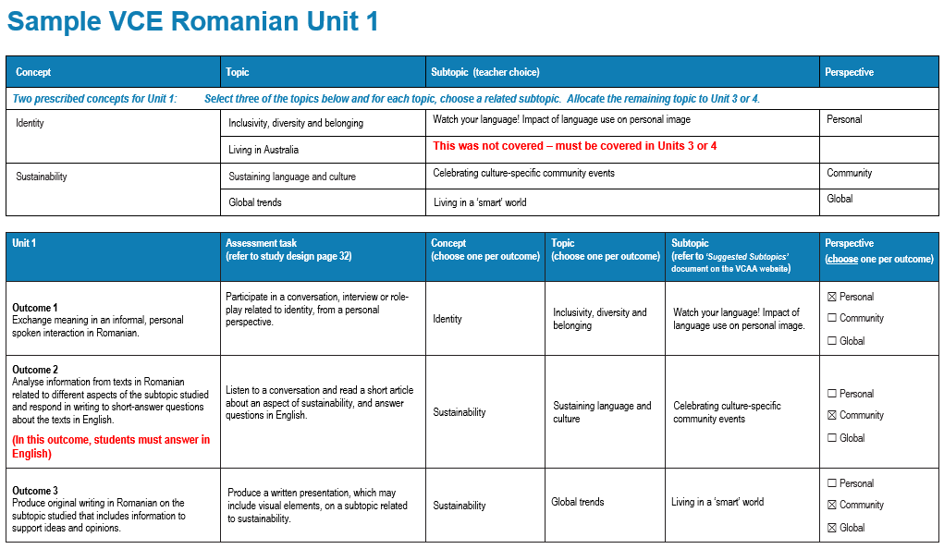

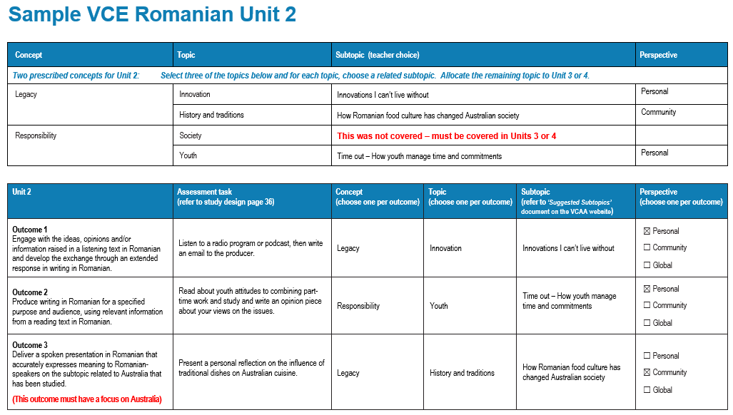
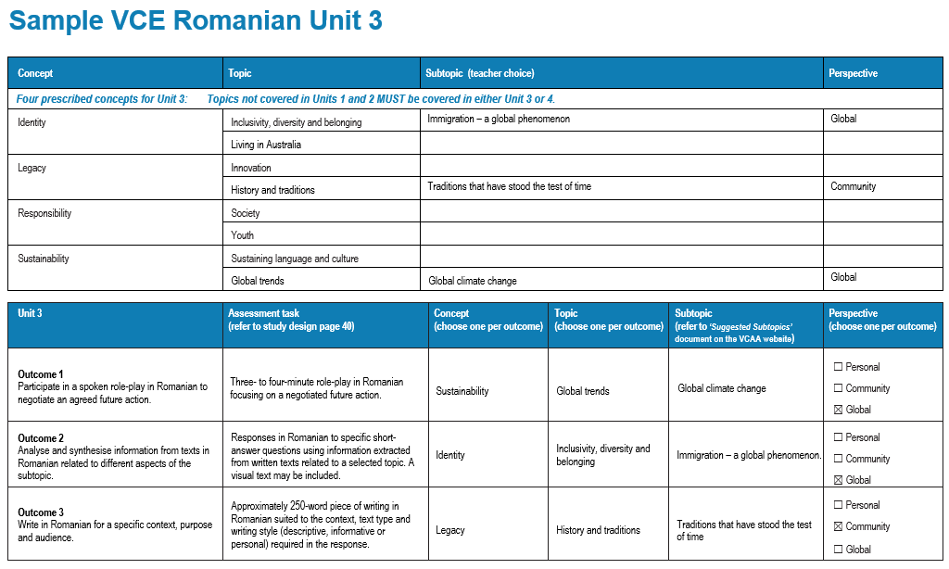
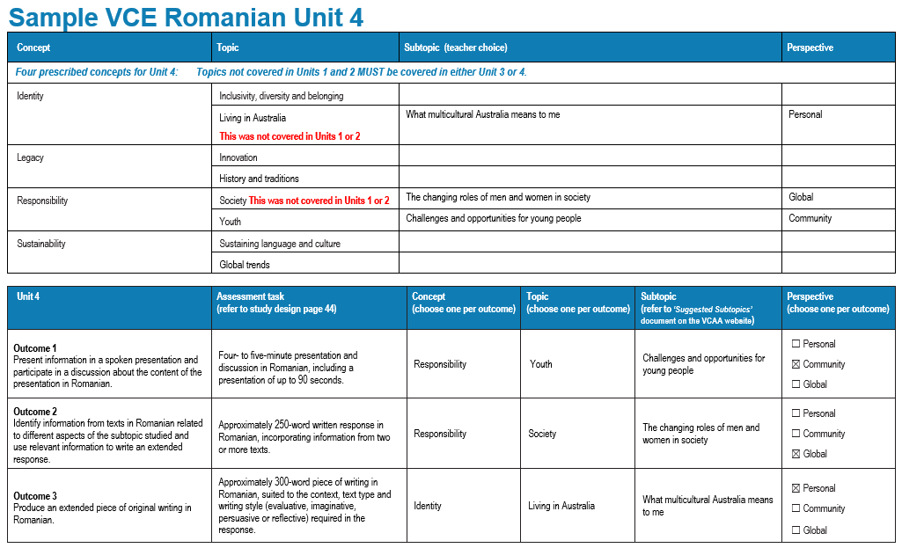

For further support, please refer to the VCE Romanian study page on the VCAA website.

VCE Romanian Unit 1 VCE Romanian Units 1 and 2: 2024–2028; Units 3 and 4: 2025–2028
Concepts and topics not covered in Units 1 and 2 must be covered in Units 3 or 4. Each of the concepts and topics must be covered at least once by the end of Unit 4.
All perspectives must be addressed over the two years of the study.
Concept | Topic | Subtopic (Suggested subtopics on the study design page) | Perspective
Two prescribed concepts for Unit 1: Select three of the topics below and for each topic, choose a related subtopic. Allocate the remaining topic to Unit 3 or 4.
Identity | Inclusivity, diversity and belonging
Identity | Living in Australia
Sustainability | Sustaining language and culture
Sustainability | Global trends

Unit 1 | Assessment task  (refer to study design page 32) | Concept  (choose one per outcome) | Topic  (choose one per outcome) | Subtopic  (refer to ‘Suggested Subtopics’ document on the VCAA website) | Perspective  (choose one per outcome)
Outcome 1  Exchange meaning in an informal, personal spoken interaction in Romanian. |  |  |  |  | - Personal  - Community  - Global
Outcome 2  Analyse information from texts in Romanian related to different aspects of the subtopic studied and respond in writing to short-answer questions about the texts in English. |  |  |  |  | - Personal  - Community  - Global
Outcome 3  Produce original writing in Romanian on the subtopic studied that includes information to support ideas and opinions. |  |  |  |  | - Personal  - Community  - Global

VCE Romanian Unit 2 VCE Romanian Units 1 and 2: 2024–2028; Units 3 and 4: 2025–2028
Concepts and topics not covered in Units 1 and 2 must be covered in Units 3 or 4. Each of the concepts and topics must be covered at least once by the end of Unit 4.
All perspectives must be addressed over the two years of the study.
Concept | Topic | Subtopic (Suggested subtopics on the study design page) | Perspective
Two prescribed concepts for Unit 2: Select three of the topics below and for each topic, choose a related subtopic. Allocate the remaining topic to Unit 3 or 4.
Legacy | Innovation
Legacy | History and traditions
Responsibility | Society
Responsibility | Youth

Unit 2 | Assessment task  (refer to study design page 36) | Concept  (choose one per outcome) | Topic  (choose one per outcome) | Subtopic  (refer to ‘Suggested Subtopics’ document on the VCAA website) | Perspective  (choose one per outcome)
Outcome 1  Engage with the ideas, opinions and/or information raised in a listening text in Romanian and develop the exchange through an extended response in writing in Romanian. |  |  |  |  | - Personal  - Community  - Global
Outcome 2  Produce writing in Romanian for a specified purpose and audience, using relevant information from a reading text in Romanian. |  |  |  |  | - Personal  - Community  - Global
Outcome 3  Deliver a spoken presentation in Romanian that accurately expresses meaning to Romanian-speakers on the subtopic related to Australia that has been studied. |  |  |  |  | - Personal  - Community  - Global

VCE Romanian Unit 3 VCE Romanian Units 1 and 2: 2024–2028; Units 3 and 4: 2025–2028
Concepts and topics not covered in Units 1 and 2 must be covered in Units 3 or 4. Each of the concepts and topics must be covered at least once by the end of Unit 4.
All perspectives must be addressed over the two years of the study.
Concept | Topic | Subtopic (Suggested subtopics on the study design page) | Perspective
Four prescribed concepts for Unit 3: Topics not covered in Units 1 and 2 MUST be covered in either Unit 3 or 4.
Identity | Inclusivity, diversity and belonging
Identity | Living in Australia
Legacy | Innovation
Legacy | History and traditions
Responsibility | Society
Responsibility | Youth
Sustainability | Sustaining language and culture
Sustainability | Global trends

Unit 3 | Assessment task  (refer to study design page 40) | Concept  (choose one per outcome) | Topic  (choose one per outcome) | Subtopic  (refer to ‘Suggested Subtopics’ document on the VCAA website) | Perspective
Outcome 1  Participate in a spoken role-play in Romanian to negotiate an agreed future action. | Three- to four-minute role-play in Romanian focusing on a negotiated future action. |  |  |  | - Personal  - Community  - Global
Outcome 2  Analyse and synthesise information from texts in Romanian related to different aspects of the subtopic. | Responses in Romanian to specific short-answer questions using information extracted from written texts related to a selected topic. A visual text may be included. |  |  |  | - Personal  - Community  - Global
Outcome 3  Write in Romanian for a specific context, purpose and audience. | Approximately 250-word piece of writing in Romanian suited to the context, text type and writing style (descriptive, informative or personal) required in the response. |  |  |  | - Personal  - Community  - Global

VCE Romanian Unit 4 VCE Romanian Units 1 and 2: 2024–2028; Units 3 and 4: 2025–2028
Concepts and topics not covered in Units 1 and 2 must be covered in Units 3 or 4. Each of the concepts and topics must be covered at least once by the end of Unit 4.
All perspectives must be addressed over the two years of the study.
Concept | Topic | Subtopic (Suggested subtopics on the study design page) | Perspective
Four prescribed concepts for Unit 4: Topics not covered in Units 1 and 2 MUST be covered in either Unit 3 or 4.
Identity | Inclusivity, diversity and belonging
Identity | Living in Australia
Legacy | Innovation
Legacy | History and traditions
Responsibility | Society
Responsibility | Youth
Sustainability | Sustaining language and culture
Sustainability | Global trends

Unit 4 | Assessment task  (refer to study design page 44) | Concept  (choose one per outcome) | Topic  (choose one per outcome) | Subtopic  (refer to ‘Suggested Subtopics’ document on the VCAA website) | Perspective  (choose one per outcome)
Outcome 1  Present information in a spoken presentation and participate in a discussion about the content of the presentation in Romanian. | Four- to five-minute presentation and discussion in Romanian, including a presentation of up to 90 seconds. |  |  |  | - Personal  - Community  - Global
Outcome 2  Identify information from texts in Romanian related to different aspects of the subtopic studied and use relevant information to write an extended response. | Approximately 250-word written response in Romanian, incorporating information from two or more texts. |  |  |  | - Personal  - Community  - Global
Outcome 3  Produce an extended piece of original writing in Romanian. | Approximately 300-word piece of writing in Romanian, suited to the context, text type and writing style (evaluative, imaginative, persuasive or reflective) required in the response. |  |  |  | - Personal  - Community  - Global

VCE Romanian Planning Tool - Checklist

Concepts and topics not covered in Units 1 and 2 must be covered in Units 3 or 4. Each of the concepts and topics must be covered at least once by the end of Unit 4.
All perspectives must be addressed over the two years of the study.

Unit 1 | Concept | Topic | Perspective |  | Unit 3 | Concept | Topic | Perspective
Unit 1 | ☐ Identity | ☐ Inclusivity, diversity and belonging | ☐ Personal  ☐ Community  ☐ Global |  | Unit 3 | ☐ Identity | ☐ Inclusivity, diversity and belonging | ☐ Personal  ☐ Community  ☐ Global
 |  |  |  |  |  |  | ☐ Living in Australia | ☐ Personal  ☐ Community  ☐ Global
Unit 1 | ☐ Identity | ☐ Living in Australia | ☐ Personal  ☐ Community  ☐ Global |  | Unit 3 | ☐ Legacy | ☐ Innovation | ☐ Personal  ☐ Community  ☐ Global
 |  |  |  |  |  |  | ☐ History and traditions | ☐ Personal  ☐ Community  ☐ Global
Unit 1 | ☐ Sustainability | ☐ Sustaining language and culture | ☐ Personal  ☐ Community  ☐ Global |  | Unit 3 | ☐ Responsibility | ☐ Society | ☐ Personal  ☐ Community  ☐ Global
 |  |  |  |  |  |  | ☐ Youth | ☐ Personal  ☐ Community  ☐ Global
Unit 1 | ☐ Sustainability | ☐ Global trends | ☐ Personal  ☐ Community  ☐ Global |  | Unit 3 | ☐ Sustainability | ☐ Sustaining language and culture | ☐ Personal  ☐ Community  ☐ Global
 |  |  |  |  |  |  | ☐ Global trends | ☐ Personal  ☐ Community  ☐ Global
Unit 2 | Concept | Topic | Perspective |  | Unit 4 | Concept | Topic | Perspective
Unit 2 | ☐ Legacy | ☐ Innovation | ☐ Personal  ☐ Community  ☐ Global |  | Unit 4 | ☐ Identity | ☐ Inclusivity, diversity and belonging | ☐ Personal  ☐ Community  ☐ Global
 |  |  |  |  |  |  | ☐ Living in Australia | ☐ Personal  ☐ Community  ☐ Global
Unit 2 | ☐ Legacy | ☐ History and traditions | ☐ Personal  ☐ Community  ☐ Global |  | Unit 4 | ☐ Legacy | ☐ Innovation | ☐ Personal  ☐ Community  ☐ Global
 |  |  |  |  |  |  | ☐ History and traditions | ☐ Personal  ☐ Community  ☐ Global
Unit 2 | ☐ Responsibility | ☐ Society | ☐ Personal  ☐ Community  ☐ Global |  | Unit 4 | ☐ Responsibility | ☐ Society | ☐ Personal  ☐ Community  ☐ Global
 |  |  |  |  |  |  | ☐ Youth | ☐ Personal  ☐ Community  ☐ Global
Unit 2 | ☐ Responsibility | ☐ Youth | ☐ Personal  ☐ Community  ☐ Global |  | Unit 4 | ☐ Sustainability | ☐ Sustaining language and culture | ☐ Personal  ☐ Community  ☐ Global
 |  |  |  |  |  |  | ☐ Global trends | ☐ Personal  ☐ Community  ☐ Global

