Instructions to request a Student Achievement Profile

Eligibility
The Student Achievement Profile summary is designed for students enrolled in a VCE (including the VCE Vocational Major) or Victorian Pathways Certificate program, who are exiting their senior secondary education without satisfactorily completing their program and:
- where VCE students have satisfactorily completed at least eight units
- where VPC students have satisfactorily completed at least one unit.
Students who have not completed the minimum number of units, or who are not exiting their senior secondary schooling, are not eligible for the Student Achievement Profile.
Students receiving a VCE, VCE-VM, VCE BAC, or VPC certificate cannot also receive a Student Achievement Profile.
Because the Student Achievement Profile is only generated for students exiting their senior secondary schooling, it is anticipated that students will not be able to receive more than one summary.

User Groups who can request a Student Achievement Profile
The following User Groups within VASS can request a Student Achievement Profile summary:
- CL – Clerical Admin
- VA – VASS Administrator
- PRIN – Principal’s Statistics group (can view requests)

Requesting a Student Achievement Profile

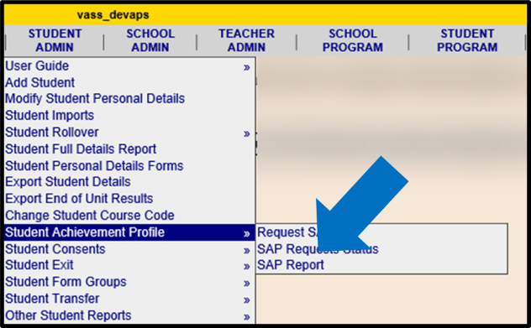
To request a Student Achievement Profile (SAP) summary, in VASS go to STUDENT ADMIN > Student Achievement Profile > Request SAP.

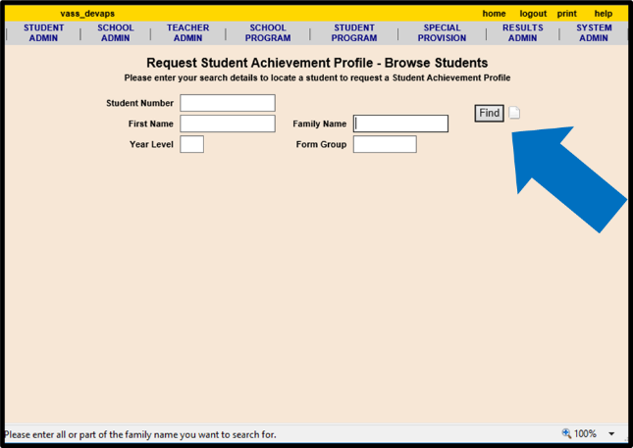
Search for a particular student using the search fields or retrieve a list of all students enrolled in the relevant certificates by clicking “Find”.

Select the relevant student and click “Request Student Achievement Profile” at the bottom of the screen.
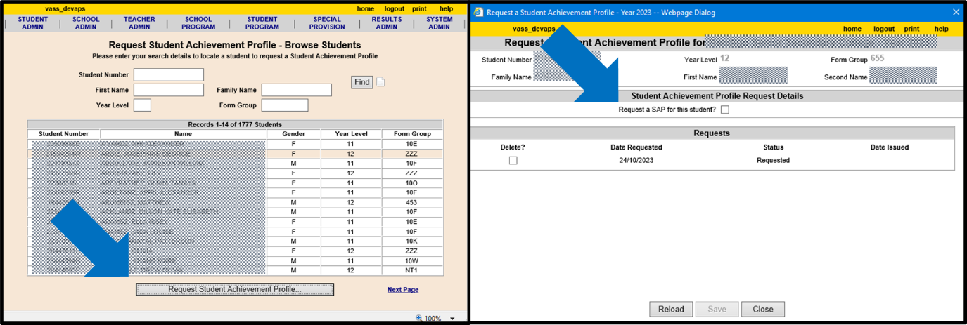
Click the selection button in the middle of the screen next to “Request a SAP for this student?” and click SAVE. The screen will show the date and status (Requested, Issued) of the request, and the date when it is issued.
You will not be able to request a SAP for a student who is not eligible for one.

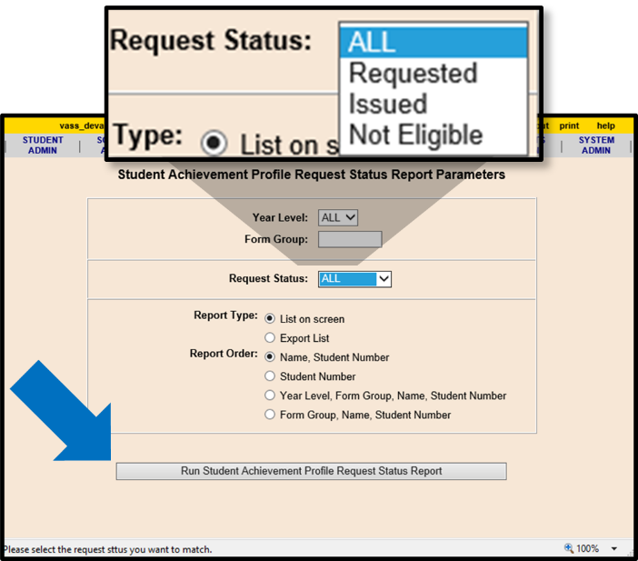
You are also able to see the status for all your requests by going to STUDENT ADMIN > Student Achievement Profile > SAP Requests Status.

From this screen you can view all requests, or filter according to their status.

