VCE Vocational Major


Unit 2: Uniting Communities
Numeracy curriculum support materials
Acknowledgement
The Victorian Curriculum and Assessment Authority proudly acknowledges and pays respect to Victoria’s Aboriginal and Torres Strait Islander communities and their rich and enduring cultures.
We acknowledge Aboriginal and Torres Strait Islander people as Australia’s first peoples and as the Traditional Owners and custodians of the lands and waters on which we rely. We pay respect to Elders past and present of the lands where we conduct our work and recognise their ongoing contributions as the first educators on the land now known as Victoria.
Authorised and published by the Victorian Curriculum and Assessment Authority
Level 7, 200 Victoria Parade
East Melbourne VIC 3002
ISBN: 978-1-923204-68-3
© Victorian Curriculum and Assessment Authority 2025
No part of this publication may be reproduced except as specified under the Copyright Act 1968 or by permission from the VCAA. Excepting third-party elements, schools may use this resource in accordance with the VCAA educational allowance. For more information go to vcaa.vic.edu.au/footer/copyright
The VCAA provides the only official, up-to-date versions of VCAA publications. Details of updates can be found on the VCAA website at vcaa.vic.edu.au
This publication may contain copyright material belonging to a third party. If you believe that material in this publication is an infringement of your copyright, please email the Copyright Officer vcaa.copyright@education.vic.gov.au
Copyright in materials appearing at any sites linked to this document rests with the copyright owner/s of those materials, and is subject to the Copyright Act. The VCAA recommends you refer to copyright statements at linked sites before using such materials.
The VCAA logo is a registered trademark of the Victorian Curriculum and Assessment Authority.

Contact us if you need this information in an accessible format, for example, large print or audio.
Telephone (03) 9032 1629 or email vcaa.publications@education.vic.gov.au

Contents
Using this resource 1
Student and teacher actions 2
Numeracy activities 3
Task 1: Maps 3
Activity 1.1 What numeracy skills do I need for road trip planning? 3
Activity 1.2 Map key symbols and grid locations 4
Activity 1.3 Compass directions 5
Activity 1.4 Planning a road trip 6
Activity 1.5 Feedback 8
Activity 1.6 Report table 9
Task 1: Feedback and assessment 9
Task 2: Shadow drawings 11
Activity 2.1 Identify the mathematics 11
Activity 2.2 Angles 12
Activity 2.3 Back-to-back drawing 13
Task 2: Feedback and assessment 15
Task 3: Mean, median and mode 17
Activity 3.1 What is mean, median and mode? 17
Activity 3.2 Ordering numbers 18
Activity 3.3 House prices 19
Activity 3.4 Report table 22
Task 3: Feedback and assessment 22
Task 4: Inflation 23
Activity 4.1 What is inflation? 24
Activity 4.2 Collecting and analysing data 24
Activity 4.3 Report table 30
Task 4: Feedback and assessment 30
Task 5: Probability 32
Activity 5.1 Brainstorm 32
Activity 5.2 Likelihood 33
Activity 5.3 Driving 35
Task 5: Feedback and assessment 38
Task 6: Sample space and outcomes 40
Activity 6.1 What is sample space? 40
Activity 6.2 Sample space 41
Activity 6.3 First down the mountain 43
Task 6: Feedback and assessment 45
Task 7: The ultimate trip planner 45
Activity 7.1 Where do I want to go? 46
Activity 7.2 Travel arrangements 49
Activity 7.3 Activities planning 55
Activity 7.4 Travel budgets 57
Activity 7.5 Currency conversion 61
Task 7: Feedback and assessment 63

Using this resource
- This curriculum resource is an example and shows one way a school could deliver the Victorian Pathways Certificate (VPC) and VCE Vocational Major (VCE VM) through an integrated approach to teaching and learning.
- You will need to make changes to the curriculum resource to best suit your cohort’s needs and abilities by adding or removing scaffolds, and to tailor resources to your school's context. When modifying this curriculum resource, please review the relevant VCAA VCE VM study design and check that the relevant area of study, key skills and key knowledge, and overall learning outcome statement are still being addressed.
- This document is a companion to the suite of curriculum support materials for VCE VM Unit 2: Uniting Communities. Read over the ‘Advice for teacher delivery and assessment summary’ in detail before delivery. Applied learning requires proactive planning and preparation prior to delivery. The curriculum resource does not function like a traditional text or workbook. Pre-work and modifications are required to use this curriculum resource effectively.
- Unit preparation checklists in the ‘Advice for teacher delivery and assessment summary’ highlight key actions to be completed by the teacher prior to the overall unit delivery. It is essential for teachers to review and use the unit checklists prior to implementing or using this curriculum resource.
- This curriculum resource is designed to support your teaching and does not replace you as the teacher. How you deliver the resource and run applied learning activities to support your program is a teacher and school-based decision. Explicit instruction, teacher support and monitoring of student progress is still required.
- In accordance with the Pillars of Applied Learning (POAL) all assessment tasks are flexible and open to negotiation. To support individual students to successfully achieve learning outcomes, modification in collaboration is encouraged.
- This curriculum resource includes links to third party materials as examples for teacher reference only. It is not mandatory to use any of these materials or third party services. Inclusion of links to these materials does not constitute VCAA endorsement of the views or content contained in or linked from these sites. Teachers are advised to use their own judgement in determining what is appropriate for their students and school community. Teachers should ensure that any information or activity complies with their school or organisation’s policies.

Student and teacher actions
Within the student task activities, the following icons indicate these actions:
 | For teacher awareness, advice and information. Should be deleted before providing to students.
 | To be adapted or changed to the relevant educational context.
 | The teacher needs to hyperlink or add in their own documents or links to resources for their students to access the correct information from their own school-based documents.
 | Indicates ‘how to’ IT, document support or general guidance for students. Teachers can decide to leave this in or remove it.
 | Indicates to students which activities can be completed and submitted for assessment as a group.
 | Indicates to students which activities need to be completed and submitted for assessment individually.
 | Indicates to students which activities will be completed with a peer.

Numeracy activities

Task 1: Maps
Numeracy Context: Personal (a)
Area of Study (AoS) 5 Dimension and direction

Key knowledge and key skills
AoS 5 KS 1 Find and locate places of interest on maps and describe location in relation to other objects and landmarks using appropriate maps or technology.
AoS 5 KS 2 Determine and give or follow everyday straightforward instructions to move between familiar locations.
AoS 5 KS 3 Identify everyday compass directions such as N, S, W, E, NE, SE.

Task checklist
Students will complete the following for Task 1: Numeracy Context: Personal (a)
☐ Activity 1.1 What numeracy skills do I need for road trip planning?
☐ Activity 1.2 Map key symbols and grid locations
☐ Activity 1.3 Compass directions
☐ Activity 1.4 Planning a road trip
☐ Activity 1.5 Feedback
☐ Activity 1.6 Report table

In this task, you will locate places on maps and describe locations and landmarks. You will plan a road trip by giving detailed directions and instructions. You will be able to identify symbols from a key on a map, follow grid coordinates and give detailed instructions to travel between locations.
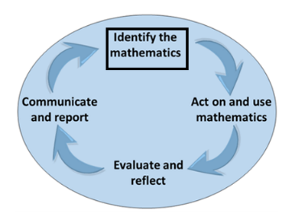
Identify the mathematics: Recognise, select and interpret the mathematical information embedded in a real-world context and decide what mathematics to use.

Activity 1.1 What numeracy skills do I need for road trip planning?
Part 1: You are going to plan a short road trip. You will need to pre-plan your route, including specific stops and detailed directions for your journey. What mathematical concepts or numeracy skills do you think you will need to create and follow your travel plan? List your ideas in the space below.
Things to consider:
- What technology can you use to plan your trip?
- If you are out of phone service range, what can you use instead of relying on technology?
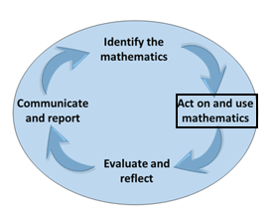
Act on and use mathematics: Perform mathematical actions and processes to complete a task – including the use and application of a range of mathematical processes.

Activity 1.2 Map key symbols and grid locations
Part 1: From the linked map of Torquay below, identify the key map symbols and describe them in the table below.
Map source: Surf Coast Shire, Torquay map
Location | Symbol description
Post office
Playground
Camping grounds
Scenic view lookout
Shopping precinct
Shipwreck site
Part 2: Use the grid co-ordinates listed in the table below to find the landmarks.
Grid reference | Landmark
C9 | RACV golf course
A10 | Reserve
D8 | Reserve
F5 | Beach
H2 | Resort

Activity 1.3 Compass directions
Part 1: Compass directions – Answer the following questions.
- You're on a hike and your compass shows you're facing North. The trail map says the waterfall is to the Northeast. Which direction should you walk to reach the waterfall?
- While driving, you notice the sun setting on your left. If the sun sets in the West, what direction are you heading?
- Your school is directly East of your home. If you need to visit a friend who lives directly South of your school, which direction should you travel from your home to reach your friend's place?
- You're using a compass in your backyard. If the garden is located to the Southeast of your house, which direction will you walk to get to the garden from the back door?
- A map shows that the grocery store is North of the park and the library is East of the grocery store. If you're standing in the park, which direction do you need to travel to reach the library?

Activity 1.4 Planning a road trip
Part 1: Planning a three-day road trip – You need to organise a three-day road trip in Victoria that starts from where you live. Your caregivers require the following information:
- Starting point
- 3 towns/places your will pass through.
- 2 towns/places you will stay.
- End point.
Worked example
My Robinvale trip
- Starting Point: Torquay
- 3 Towns/Places of Interest: I will pass through Bendigo, Wycheproof, Manangatang
- 2 Towns/Places: I will stay on this trip in Bendigo & Manangatang
- End Point: Robinvale

Add your trip details here.
Part 2: Create written instructions of your travel plans. You need to provide written instructions for your chosen route that will include appropriate location language (direction, street names, landmarks), distance and time estimations.
Consider:
- what time you leave.
- stops along the way
- distance and driving times
You can use Google Maps to consider travel routes, distances and travel times.
Worked example
- Meet at Torquay McDonalds at 7 am to depart at 7.15 am.
- From the McDonald's car park, turn left onto the Surf Coast Hwy travelling north towards Geelong.
- Stay on this Hwy for approximately 7min or 10km until you reach the Mt Duneed Roundabout - take the first exit on the right.
- At the next roundabout (approx. 2km) take the 3rd exit towards the Ring Rd Geelong and Follow signs towards Melbourne.
- Stay on the Ring Rd for approx. 15min or 20km, bypassing Geelong and looking for the Exit to Bacchus Marsh.
- Once exited towards Bacchus Marsh stay on this road passing the Barwon Prison on your Right, with You Yangs Mountain Range in the background.
- Pass through Bacchus Marsh and travel approx. 45km to Gisborne as the next landmark.
- Gisborne is ... etc.
- Continue North …etc.
- Bendigo ... etc.
Part 3: Route Map – Please include a screenshot of your chosen journey using Google maps.
Worked example: Google Maps.
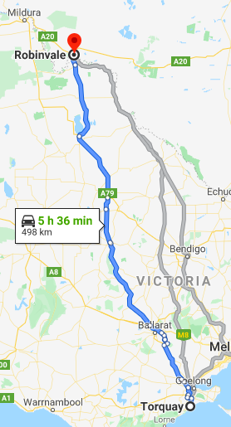

Add a screen shot of your travel route here.
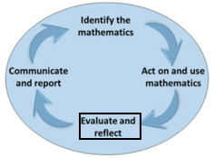
Evaluate and reflect: Check and reflect on the mathematical problem-solving processes and outcomes in relation to the real-world context.

Activity 1.5 Feedback
Part 1: Ask a peer and a teacher to check your instructions. Use the checklist of location language below when assessing your instructions.

Peer feedback
Name of peer & date
Location language used
Location language

Teacher feedback
Teacher name & date
Location language used
Location language
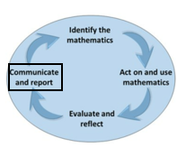
Communicate and report: Use a combination of informal and formal mathematical representations to document and report outcomes and results.

Activity 1.6 Report table
Part 1: Complete the table below and add in additional tools you used throughout your road trip planning.

Tool used | What is it? | How/when is this tool needed/used? | Accuracy level? | How likely are you to use this tool again  (Rate 1-5) | Do I need to add this to my numeracy toolkit?
Google maps |  |  |  | Choose a rating | ☐
Map symbols (KEY) |  |  |  | Choose a rating | ☐
Grid coordinates  (A7, C5) |  |  |  | Choose a rating | ☐
Compass coordinates  (N,S,E,W) |  |  |  | Choose a rating | ☐
Calculator |  |  |  | Choose a rating | ☐

Task 1: Feedback and assessment
Peer feedback
Activity 1.1 | Identify the mathematics for planning a road trip | Choose an item.
Activity 1.2 | Key symbols and grid coordinates | Choose an item.
Activity 1.3 | Compass directions | Choose an item.
Activity 1.4 | Planning a road trip | Choose an item.
Activity 1.5 | Peer feedback | Choose an item.
Activity 1.6 | Report table | Choose an item.
Peer comment:
Name of peer:

AoS 5 KS 1 Find and locate places of interest on maps and describe location in relation to other objects and landmarks using appropriate maps or technology.
Student reflection: How well did you go with this step? (Please tick the box below)
☐Not Submitted | ☐Beginning | ☐Consolidating | ☐Achieving | ☐Excelling
Student comment (optional):
Teacher feedback
☐Not Submitted | ☐Beginning | ☐Consolidating | ☐Achieving | ☐Excelling
Not Submitted: No work has been submitted or attempted for this outcome. | Beginning: You have attempted to identify locations on maps. To bump it up, you need to complete all parts of the activity and show that you can find and locate places on a map, as well as describe locations using other objects and/or landmarks. | Consolidating: You have identified some locations on maps and have described basic information for locations. To bump it up, you need to complete all parts of the activity and show that you can find and locate places on a map, as well as describe locations using other objects and/or landmarks. | Achieving: You have shown you can find and locate places on a map, as well as describe locations using other objects and/or landmarks. To bump it up, check over your answers to make sure they are all correct and include the required information. | Excelling: You have shown that you can consistently find and locate places on maps. You have demonstrated the ability to provide detailed location descriptions that refer to other locations, objects or landmarks. The information you have provided is accurate. Great work!
Teacher comment:

AoS 5 KS 2 Determine and give or follow everyday straight forward instructions to move between familiar locations.
AoS 5 KS 3 Identify everyday compass directions such as N, S, W, E, NE, SE.
Student reflection: How well did you go with this step? (Please tick the box below)
☐Not Submitted | ☐Beginning | ☐Consolidating | ☐Achieving | ☐Excelling
Student comment (optional):
Teacher feedback
☐Not Submitted | ☐Beginning | ☐Consolidating | ☐Achieving | ☐Excelling
Not Submitted: No work has been submitted or attempted for this outcome. | Beginning: You have attempted to identify some locations using compass directions. You have made some attempts to create instructions and use directional language. To bump it up, you need to re-read the activity and complete all required parts of this task. | Consolidating: You have identified some locations using compass directions. You have included basic instructions to move between familiar locations with some evidence of directional language. To bump it up, you need to re-check your answers and complete all required parts of the activity. Try to include more directional language. | Achieving: You have identified locations using compass directions. You have included basic instructions to move between familiar locations with evidence of directional language. To bump it up, you need to re-check your answers and try to include more detailed directional language. | Excelling: You have identified locations using compass directions. You have included detailed instructions to move between familiar locations with evidence of directional language. Great work!
Teacher comment:

Task 2: Shadow drawings
Numeracy Context: Personal (a)
Area of Study (AoS) 5: Dimension and Direction
Key knowledge and key skills
AoS 5 KS 4 Identify and demonstrate an understanding of everyday angles such as 45, 90, 180 and 360 degrees.
AoS 5 KS 5 Understand where an object is in space using one-, two- and three-dimensions and everyday familiar language such as up, down, left, right, in front, behind to describe position and location in space.

Task checklist
Students will complete the following for Task 2: Numeracy Context: Personal (a)
☐ Activity 2.1 Identify the mathematics
☐ Activity 2.2 Angles
☐ Activity 2.3 Back-to-back drawing
In this task, you will develop an understanding of angles and how to identify them in an everyday context. You will describe where an object is in space using instructional language.
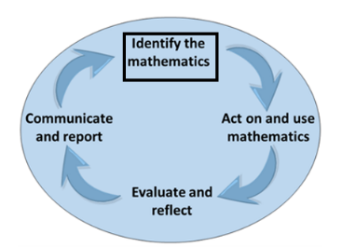
Identify the mathematics: Recognise, select and interpret the mathematical information embedded in a real-world context and decide what mathematics to use.

Activity 2.1 Identify the mathematics
Part 1: In the box below, brainstorm the mathematical concepts, numeracy skills and everyday language you need to understand. Apply the following:
- Identify common angles like 45⁰, 90⁰, 180⁰ and 360⁰.
- Accurately describe the position and of objects in one, two and three-dimensional spaces.
Things to consider:
- What tools or instruments can you use to measure angles accurately?
- When describing the location of an object, what directional language can you use to communicate its position clearly?
- How does understanding angles help in determining directions and navigating spaces? Can you think of situations where knowing specific angles is crucial?
- Formulas/concepts?
- Can technology be used to support this concept?

Activity 2.2 Angles
Act on and use mathematics: Perform mathematical actions and processes to complete a task – including the use and application of a range of mathematical processes.
Part 1: Everyday angles – Take photos of everyday objects from different angles. Label the angles and annotate the photos for the degrees listed in the table below.
Worked example
45 degrees

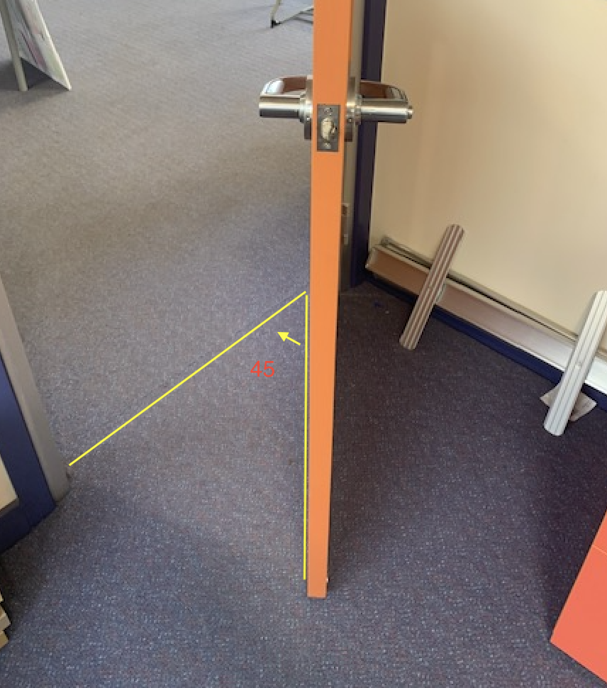
When the door is exactly halfway open, 45 degrees ↓↓on each side.
90 degrees

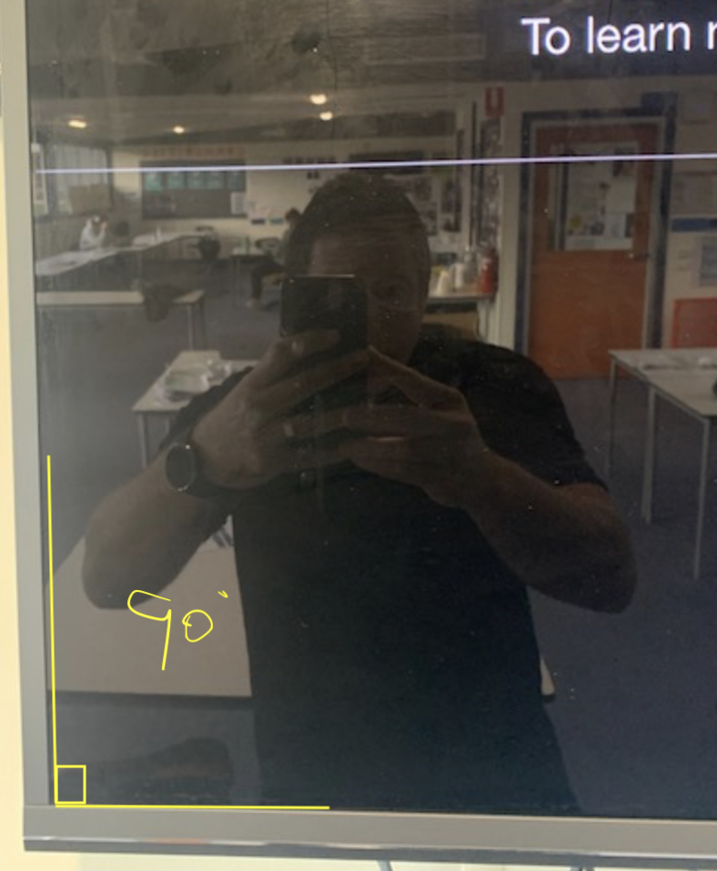
Corner of our rectangular TVs.

45 degrees
90 degrees
180 degrees
360 degrees
Part 2: Where else in the world would you find these everyday angles? Fill in the table below with three to four examples for each angle.
Angle | Objects/life
Example:  90⁰ | Wall-to-floor in most houses.  Basketball court corners.  Corner of rectangle table.
90⁰
45⁰
180⁰
360⁰

Activity 2.3 Back-to-back drawing
Part 1: Select an image from your teacher, do not show this to your partner who will try and draw this image through your directional instructions, sitting ‘Back-to-Back’. The drawer may ask questions for clarification. When complete, compare the two images and record observations.
Worked example

*This is the image the communicator is explaining to the drawer.
Person 1 (Communicator):
- In the centre of the page draw a round circle, the size of a standard cup.
- Directly above that but with a 2cm gap, draw a square of similar size.
- Directly below the circle but with a 2cm gap, draw a triangle of similar size.
- To the right of the centre circle, approximately halfway between the circle and the end of the page, draw a small circle the size of a 10-cent piece.
- To the left of the centre circle, approximately halfway between the circle and the end of the page, draw a small circle, the same size as the previous instruction and again halfway between the centre circle and the page end.
Person 2 (Drawer):
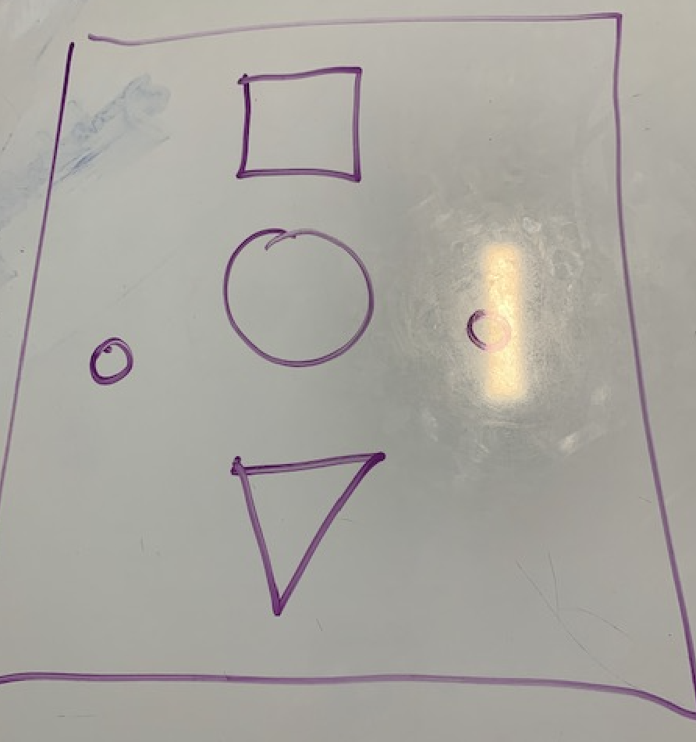

Insert/Add image selected:
Drawer name:
Communicator name:
Add final drawing for comparison:

Part 2: In the box below, list examples of directional language that you can use to instruct the drawer. You should describe position and location in space, for example: up, down, left, right, in front of, and behind.
Part 3: Reverse roles for the back-to-back drawing activity.
Insert/Add image selected:
Drawer name:
Communicator name:
Add final drawing for comparison:

Evaluate and reflect: Check and reflect on the mathematical problem-solving processes and outcomes in relation to the real-world context.
Part 4: Get peer feedback related to the effectiveness of the directional language you used for your ‘Back-to-back’ drawing partner.
Peer feedback
Name of peer:
Feedback on directional language used.
Communicate and report: Use a combination of informal and formal mathematical representations to document and report outcomes and results.
Part 5: Write a short paragraph about the activity. Include ’what went well’ and ’even better if’ for next time.

Task 2: Feedback and assessment

Peer feedback
Activity 2.1 | Identify the mathematics | Choose an item.
Activity 2.2 | Angles | Choose an item.
Activity 2.3 | Back-to-back drawing | Choose an item.
Peer comment:
Name of peer:

AoS 5 KS 4 Identify and demonstrate an understanding of everyday angles such as 45, 90, 180 and 360 degrees
Student reflection: How well did you go with this step? (Please tick the box below)
☐Not Submitted | ☐Beginning | ☐Consolidating | ☐Achieving | ☐Excelling
Student comment (optional):
Teacher feedback
☐Not Submitted | ☐Beginning | ☐Consolidating | ☐Achieving | ☐Excelling
Not Submitted: No work has been submitted or attempted for this outcome. | Beginning: You have attempted to identify some angles. To bump it up, you need to re-read the activity and complete all required parts of this task. | Consolidating: You have identified some examples of angles within everyday objects. To bump it up, to re-read the activity and complete all required parts of this task. | Achieving: You have provided examples for most angles and included details about where the angles are found and used in everyday objects and settings. To bump it up, you need to re-check your activities and make sure you have completed all parts. | Excelling: You have provided a range of examples for all angles and included details about where the angles are found and used in everyday objects and settings. Great work!
Teacher comment:

AoS 5 KS 5 Understand where an object is in space using one-, two- and three-dimensions and everyday familiar language such as up, down, left, right, in front, behind to describe position and location in space.
Student reflection: How well did you go with this step? (Please tick the box below)
☐Not Submitted | ☐Beginning | ☐Consolidating | ☐Achieving | ☐Excelling
Student comment (optional):
Teacher feedback
☐Not Submitted | ☐Beginning | ☐Consolidating | ☐Achieving | ☐Excelling
Not Submitted: No work has been submitted or attempted for this outcome. | Beginning: You have attempted to provide instructions using language to describe position and location in a space. To bump it up, you need to re-read the activity and complete all required parts of this task. | Consolidating: You have provided some basic instructions using language to describe position and location in a space. To bump it up, you need to try to include more directional language to describe position and location in space. | Achieving: You have provided basic instructions using language to describe position and location in a space. To bump it up, you need to try to include more directional language to describe position and location in space. | Excelling: You have provided detailed instructions using language to describe position and location in a space. Great work!
Teacher comment:

Task 3: Mean, median and mode
Numeracy Context: Civics (b)
Area of Study (AoS) 6: Data

Key knowledge and key skills
AoS 6 KS 2 Choose and find simple common measures of spread for contextual data sets, for example mean, and range of data.

Task checklist
Students will complete the following for Task 3: Numeracy Context: civics (b)
☐ Activity 3.1 What is mean, median and mode?
☐ Activity 3.2 Ordering numbers
☐ Activity 3.3 House prices
☐ Activity 3.4 Report table
In this task, you will learn the differences between mean, median and mode, as well as the range of a data set. You will apply this knowledge to a real-life data set and use your information to make informed data judgements.
Identify the mathematics: Recognise, select and interpret the mathematical information embedded in a real-world context and decide what mathematics to use.

Activity 3.1 What is mean, median and mode?
Part 1: Watch the video by clicking on the hyperlink below.

Video source: 2 Minute Classroom, An Average Video | Mean, Media, Mode, and Range
Part 2: Once you have watched the video in Part 1, write a definition of each term in your own words and describe how to find them in a data set.
Mean:
Median:
Mode:
Range:

Activity 3.2 Ordering numbers
Part 1: Now use the data set below to calculate the mean, median, mode and range. Make sure you use the worked example below to help. Show all your working out.
Act on and use mathematics: Perform mathematical actions and processes to complete a task – this includes the use and application of a range of technologies.
Worked example
Data set: Ages of staff at our school.
22, 45, 65, 40, 35, 25, 56, 38, 39, 26, 23, 26, 40
Put numbers in order = 22, 23, 25, 26, 26, 35, 38, 39, 40, 40 45, 56, 65
Mean: Sum of all numbers divided by the number of data
= 22 + 23 + 25 + 26 + 26 + 35 + 38 + 39 + 40 + 40 + 45 + 56 + 65 = 480
= 13 numbers = 480/13
= 36.92
Median: The middle number
22, 23, 25, 26, 26, 35, 38, 39, 40, 40 45, 56, 65
= 38
Mode: The number that occurs the most
22, 23, 25, 26, 26, 35, 38, 39, 40, 40 45, 56, 65
= 26 and 40 both occur twice
Range: The difference between the highest and lowest value
22, 23, 25, 26, 26, 35, 38, 39, 40, 40 45, 56, 65
= 65 - 22
= 43
Data set: Goal tallies of Coleman medal winners.
64, 58, 42, 67, 65, 69, 80, 75, 67, 68, 65, 71, 78, 86, 102
Hint: Make sure you show all your working out and don’t forget to re-order the numbers.
Mean:
Median:
Mode:
Range:

Activity 3.3 House prices
Part 1: House prices – Use Realestate.com.au to find at least 10 different house prices from two different places in Australia. Refer to ’Task 3: mean, median and mode Activity 3.2 Ordering numbers’ for a reminder on how to find the mean, median, mode and range.
Worked example
Place 1: Robinvale
$400,000, $460,000, $434,500, $250,000, $700,000, $440,000, $315,000, $400,000, $100,000, $346,000
Put numbers in order =
$100,000, $250,000, $315,000, $346,000, $400,000, $400,000, $434,500, $440,000, $460,000, $700,000
Mean: Sum of all numbers divided by the number of data
= $100,000 + $250,000 + $315,000 + $346,000 + $400,000 + $400,000 + $434,500 + $440,00+, $460,000 + $700,000 = $3,845,500
= 10 numbers = $3,845,500/10
= $384,550
Median: The middle number
$100,000, $250,000, $315,000, $346,000, $400,000, $400,000, $434,500, $440,000, $460,000, $700,000
= Two numbers are in the middle, find the average = $400,000 + $400,000 = $800,000/2
= $400,000
Mode: The number that occurs most
$100,000, $250,000, $315,000, $346,000, $400,000, $400,000, $434,500, $440,000, $460,000, $700,000
= $400,000 occurs twice.
Range: The difference between the highest and lowest number
$100,000, $250,000, $315,000, $346,000, $400,000, $400,000, $434,500, $440,000, $460,000, $700,000
= $700,000 - $100,000
= $600,000
Place 2: Koroit
$540,000, $930,000, $599,900, $385,000, $895,000, $525,000, $599,900, $380,000, $670,000, $600,000
Put numbers in order =
$380,000, $385,000, $525,000, $540,000, $599,900, $599,900, $600,000, $670,000, $895,000, $930,000
Mean: Sum of all numbers divided by the number of data
= $380,000 + $385,000 + $525,000 + $540,000 + $599,900 + $599,900 + $600,000 + $670,000 + $895,000 + $930,000 = $6,124,800
= 10 numbers - $6,124,800/10
= $612,480
Median: The middle number
$380,000, $385,000, $525,000, $540,000, $599,900, $599,900, $600,000, $670,000, $895,000, $930,000
= Two numbers are in the middle, find the average = $599,900 + $599,900 = $1,199,800/2
= $599,900
Mode: The number that occurs most
$380,000, $385,000, $525,000, $540,000, $599,900, $599,900, $600,000, $670,000, $895,000, $930,000
= $599,900 occurs twice.
Range: The difference between the highest and lowest number
$380,000, $385,000, $525,000, $540,000, $599,900, $599,900, $600,000, $670,000, $895,000, $930,000
= $930,000 - $380,000
= $550,000

Hint: Make sure you show all your working out and don’t forget to re-order the numbers.
Place 1:
Data Set:
Mean:
Median:
Mode:
Range:

Hint: Make sure you show all your working out and don’t forget to re-order the numbers.
Place 1:
Data Set:
Mean:
Median:
Mode:
Range:
Evaluate and reflect: Check and reflect on the mathematical problem-solving processes and outcomes in relation to the real-world context.
Part 2: Use this data from the two places you have chosen to write a comparative analysis. You need to refer to the calculations you have completed in your analysis. You can also use other research to support your analysis. Please write in full sentences! Don’t forget to do a spelling and grammar check.
Analysis Prompts
Which is the more expensive place to live? Why?
What is the cheapest place to live? Why?
Which town has the most variety in prices?
If you wanted to buy a really nice house in each town, how much money would you need?
If you were a first home buyer, which place would you recommend buying a house in?

Write your analysis in this section. Please use full sentences. Refer to your data and any other relevant information to support your opinion.

Activity 3.4 Report table
Communicate and report: Use a combination of informal and formal mathematical representations to document and report outcomes and results.
Part 1: Complete the table below.
Tool/formula used | What is it? | How/when is this tool or formula needed/used? | Accuracy level? | How likely are you to use this tool again (Rate 1-5)? | Do I need to add this to my numeracy toolkit?
Mean |  |  |  | Choose a rating | ☐
Median |  |  |  | Choose a rating | ☐
Mode |  |  |  | Choose a rating | ☐
Range |  |  |  | Choose a rating | ☐
 |  |  |  | Choose a rating | ☐

Task 3: Feedback and assessment

Peer feedback
Activity 3.1 | What is a mean, median and mode? | Choose an item.
Activity 3.2 | Ordering numbers | Choose an item.
Activity 3.3 | House prices | Choose an item.
Activity 3.4 | Report table | Choose an item.
Peer comment:
Name of peer:

AoS 6 KS 2 Choose and find simple common measures of spread for contextual data sets, for example mean, and range of data.
Student reflection: How well did you go with this step? (Please tick the box below)
☐Not Submitted | ☐Beginning | ☐Consolidating | ☐Achieving | ☐Excelling
Student comment (optional):
Teacher feedback
☐Not Submitted | ☐Beginning | ☐Consolidating | ☐Achieving | ☐Excelling
Not Submitted: No work has been submitted or attempted for this outcome. | Beginning: You have attempted to calculate mean, median, mode and range. To bump it up, you need to complete all parts of the activity. | Consolidating: You have shown a basic understanding of how to calculate mean, median, mode and range. You have shown some working out. To bump it up, check over your answers to see if they are correct and include more details of your working out. | Achieving: You have shown an understanding of how to calculate mean, median, mode and range. You have shown your workings. To bump it up, recheck your answers to make sure your answers are all correct. | Excelling: You have shown a high level of understanding of how to calculate mean, median, mode and range. You have shown all your workings out and all your answers are correct. Great work!
Teacher comment:

Task 4: Inflation
Numeracy Context: Civics (b)
Area of Study (AoS) 6: Data

Key knowledge and key skills
AoS 6 KS 1 Collect, collate and organise familiar and simple data sets, and display these choosing and using the most appropriate format, including axes and simple scales.
AoS 6 KS 3 Identify key facts from tables and graphs.
AoS 6 KS 4 Read and interpret results from familiar and simple data presented in both graph and table form, including describing general patterns and trends.

Task checklist
Students will complete the following for Task 4: Numeracy Context: Civics (b)
☐ Activity 4.1 What is inflation?
☐ Activity 4.2 Collecting and analysing data
☐ Activity 4.3 Report table
In this task, you will learn how to collect, organise and graph a data set. You will also learn to describe patterns and interpret results. You will apply this knowledge to inflation data and use your information to describe patterns and trends related to inflation.

Activity 4.1 What is inflation?
Identify the mathematics: Recognise, select and interpret the mathematical information embedded in a real-world context and decide what mathematics to use.
Part 1: What is inflation? Complete the questions below.
- Working with a partner, brainstorm and discuss what you already know about inflation.
- Research a definition of inflation, then rephrase the definition into your own words.
- Brainstorm which mathematical terms, tools or concepts could be applied to understand and analyse inflation.

Activity 4.2 Collecting and analysing data
Act on and use mathematics: Perform mathematical actions and processes to complete a task – this includes the use and application of a range of technologies.
Part 1: Use The Inflation Explorer to research how prices of individual goods and services have changed over time. Follow the instructions below to help you find the information you need.
Instructions:
- Select three items to include in your shopping basket.
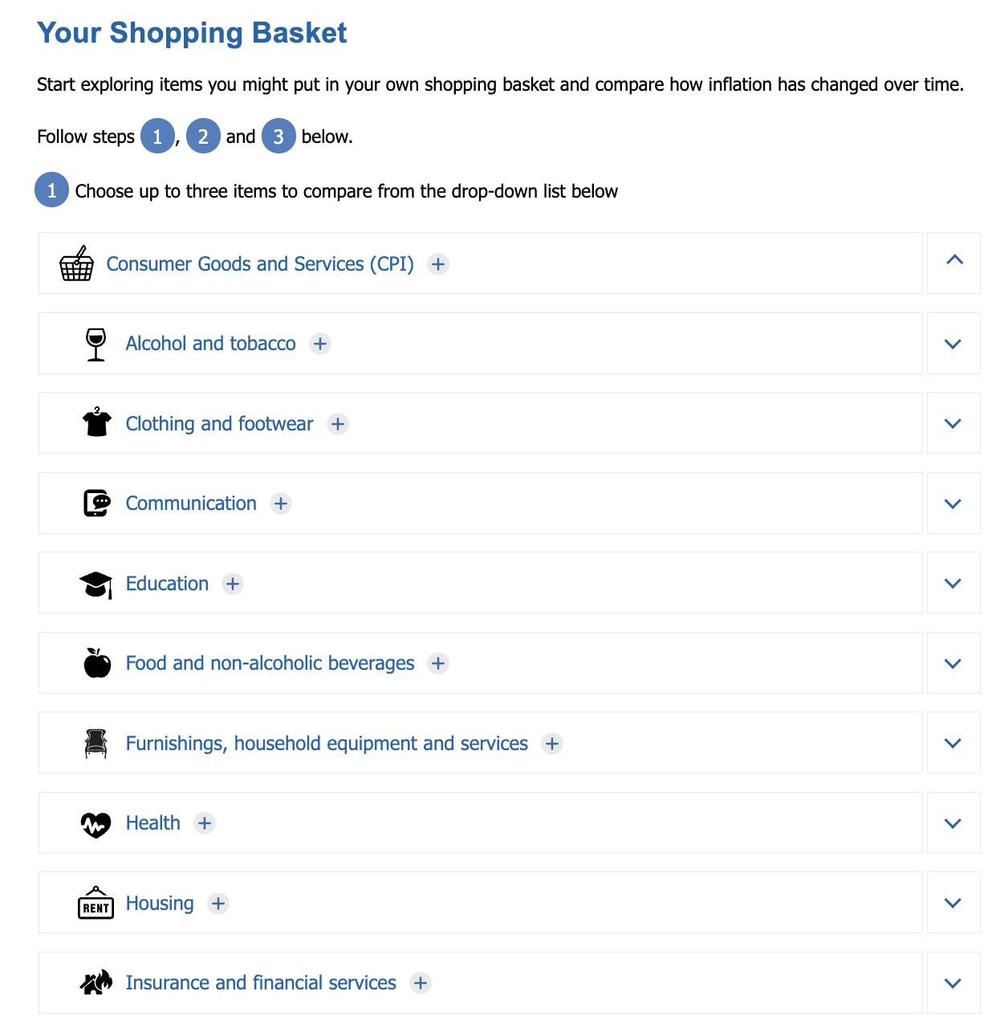
Image source: Inflation Explorer | Education | RBA; licensed CC-BY 4.0
- In the ‘from year’ enter 1975 and ‘to year’ insert 1985.
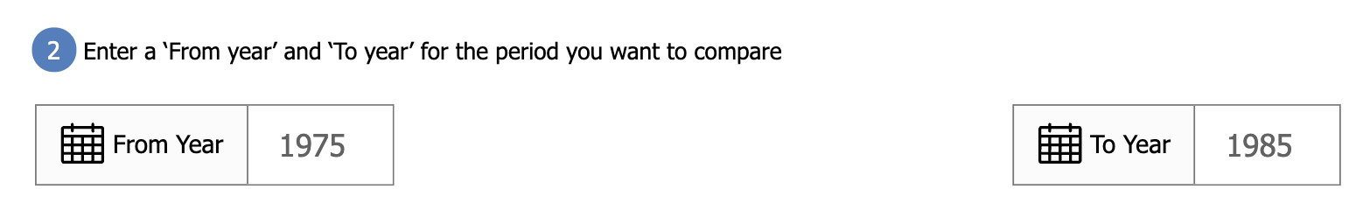
Image source: Inflation Explorer | Education | RBA; licensed CC-BY 4.0
- Enter an amount in the first ‘amount’ box. Use the same amount for each category.
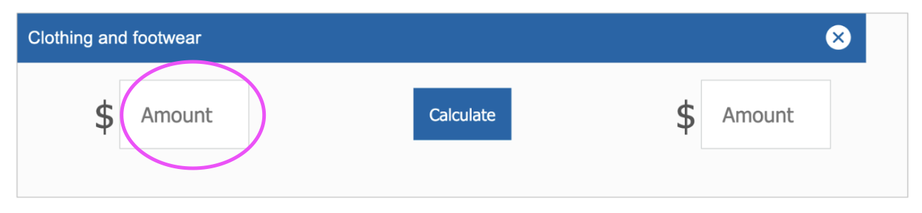 Image source: Inflation Explorer | Education | RBA; licensed CC-BY 4.0
- Press ‘calculate’.
- Take a screenshot of your items and add them to the table below.
Worked example
1975 - 1985

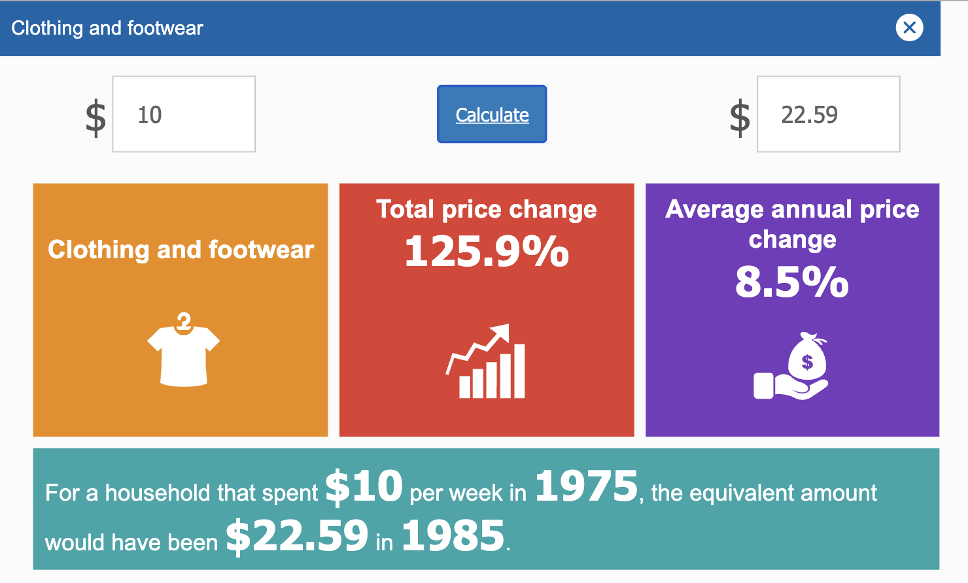
Image source: Inflation Explorer | Education | RBA; licensed CC-BY 4.0

1975 - 1985
Item 1 –
Item 2 –
Item 3 –

- Complete the same steps as above, with the same items and the same first ‘amount’ as above. Change the dates to be as follows: ‘from year’ - 1985 and ‘to year’ - 1995.
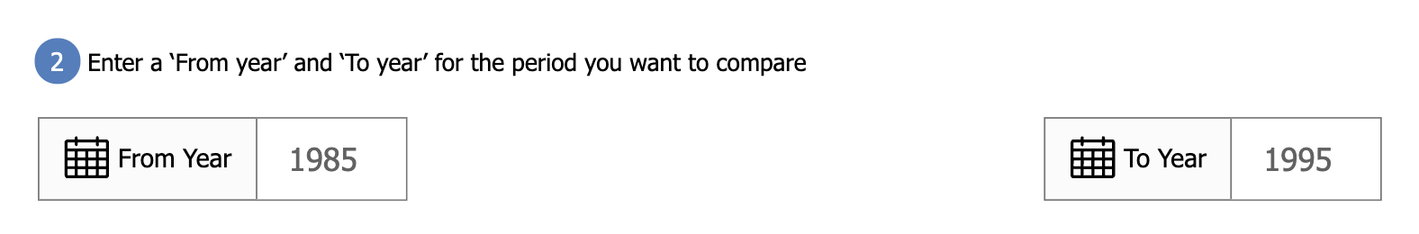 Image source: Inflation Explorer | Education | RBA; licensed CC-BY 4.0
- Take a screenshot of your items and add them to the table below.
1985 – 1995
Item 1 –
Item 2 –
Item 3 –
- Complete the same steps as above, with the same items and the same first ‘amount’ as above. Change the dates to be as follows: ‘from year’ - 1995 and ‘To year’ - 2005.
- Take a screenshot of your items and add them to the table below.
1995 – 2005
Item 1 –
Item 2 –
Item 3 –
- Complete the same steps as above, with the same items and the same first ‘amount’ as above. Change the dates to be as follows: ‘from year’ - 2005 and ‘To year’ - 2015.
- Take a screenshot of your items and add them to the table below.
2005 – 2015
Item 1 –
Item 2 –
Item 3 –

Part 2: Organising and graphing the data. Fill in the table below using the data you have collected.
Inflation item | 1975 | 1985 | 1995 | 2005 | 2015
Item 1 –
Item 2 –
Item 3 –
Part 3: Use a data program like Google Sheets or Excel to create a graph that represents the data you collected and put into a table for Part 2.
Worked example (created using Excel spreadsheet)
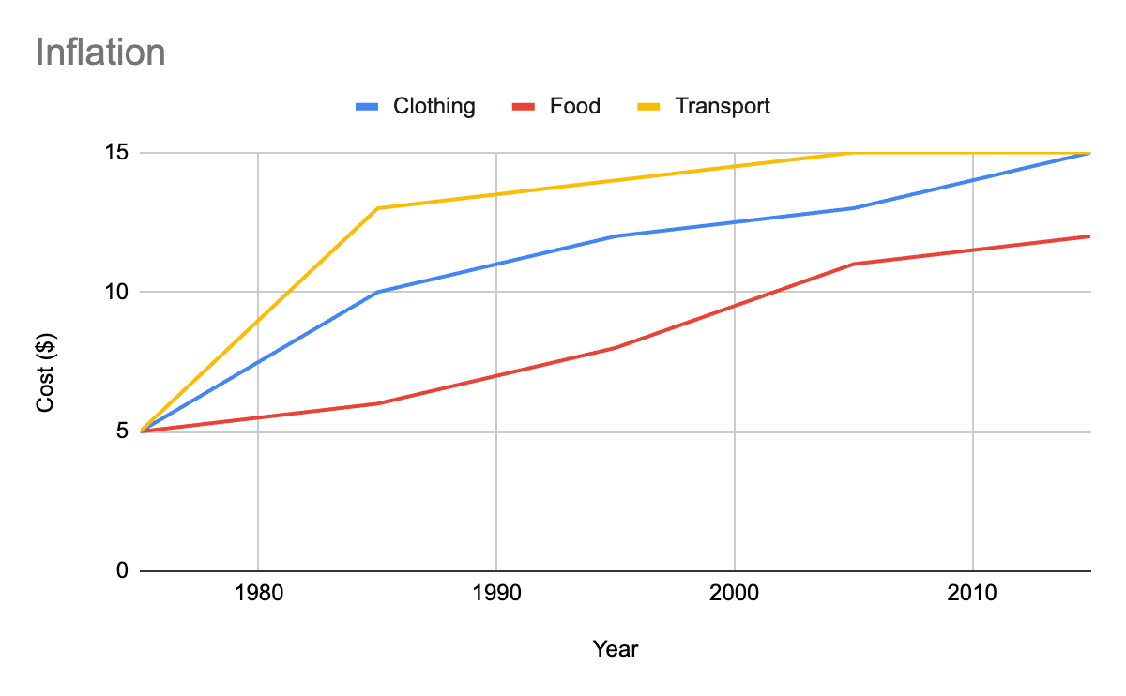

Add your graph here.

Evaluate and reflect: Check and reflect on the mathematical problem-solving processes and outcomes in relation to the real-world context.
Part 4: Self-assessment – Make sure that you have included all the following in your graph:
☐The graph has a title.
☐Both axes are labelled.
☐The graph effectively shows the inflation over time of all three of your categories.
☐A legend
If any of the above features are missing from your graph, please go back to Part 3 and add them in.
Part 5: Conclusions and patterns – Complete the questions below.
- Write at least three sentences describing general patterns and trends that can be seen from your graph in Part 3.
- Using the patterns and trends you have identified above, in the next 10 years what do you predict will happen to the prices of your selected items? Explain your answer by referring to the patterns and trends from the graph.

Activity 4.3 Report table
Communicate and report: Use a combination of informal and formal mathematical representations to document and report outcomes and results.
Part 1: Complete the table below.
Tool/formula used | What is it? | How/when is this tool or formula needed/used? | Accuracy level? | How likely are you to use this tool again  (Rate 1-5)? | Do I need to add this to my numeracy toolkit?
Excel/Google sheets |  |  |  | Choose a rating | ☐
Inflation calculator |  |  |  | Choose a rating | ☐
Tables |  |  |  | Choose a rating | ☐
Graphs |  |  |  | Choose a rating | ☐
 |  |  |  | Choose a rating | ☐

Task 4: Feedback and assessment

Peer feedback
Activity 4.1 | What is inflation? | Choose an item.
Activity 4.2 | Collecting and analysing data | Choose an item.
Activity 4.3 | Report table | Choose an item.
Peer comment:
Name of peer:

AoS 6 KS 1 Collect, collate and organise familiar and simple data sets, and display these choosing and using the most appropriate format, including axes and simple scales.
Student reflection: How well did you go with this step? (Please tick the box below)
☐Not Submitted | ☐Beginning | ☐Consolidating | ☐Achieving | ☐Excelling
Student comment (optional):
Teacher feedback
☐Not Submitted | ☐Beginning | ☐Consolidating | ☐Achieving | ☐Excelling
Not Submitted: No work has been submitted or attempted for this outcome. | Beginning: You have shown some attempts to collect, collate and organise familiar and simple data sets. To bump it up, you need to re-read the task requirements and provide basic responses for all sections. | Consolidating: You have shown a basic ability to collect, collate and organise familiar and simple data sets and display these. You have provided a response for most parts of this activity. To bump it up, check over your answers to see if they are correct and make sure you have provided a basic response for all parts of this activity. | Achieving: You have shown an ability to collect, collate and organise familiar and simple data sets and display these. You have provided a response for all parts of this activity. To bump it up, recheck your answers to make sure your answers are correct. | Excelling: You have shown an ability to collect, collate and organise familiar and simple data sets and display these. You have provided detailed responses for all parts of this activity. Great work!
Teacher comment:

AoS 6 KS 3 Identify key facts from tables and graphs
AoS 6 KS 4 Read and interpret results from familiar and simple data presented in both graph and table form, including describing general patterns and trends.
Student reflection: How well did you go with this step? (Please tick the box below)
☐Not Submitted | ☐Beginning | ☐Consolidating | ☐Achieving | ☐Excelling
Student comment (optional):
Teacher feedback
☐Not Submitted | ☐Beginning | ☐Consolidating | ☐Achieving | ☐Excelling
Not Submitted: No work has been submitted or attempted for this outcome. | Beginning: You have attempted to identify key facts from tables and graphs. To bump it up, you re-read the activity and provide a basic response to all the required parts. | Consolidating: You have shown a basic understanding of how to identify key facts from tables and graphs. You have made comments on simple patterns and trends. To bump it up, check over your answers to see if they are correct and make sure all parts of each question are answered. | Achieving: You have shown how to identify key facts from tables and graphs. You have provided a basic explanation for simple patterns and trends. To bump it up, you need to add more details to your explanation of patterns and trends. | Excelling: You have shown how to identify key facts from tables and graphs. You have provided a detailed analysis of simple patterns and trends. Great work!
Teacher comment:

Task 5: Probability
Numeracy Context: Personal (a)
Area of Study (AoS) 7: Uncertainty

Key knowledge and key skills
AoS 7 KS 1 Estimate and identify likelihood of common and familiar events occurring using simple fractions, decimals or percentages such as $\frac{1}{2}$, $\frac{1}{3}$, $\frac{1}{5}$, 0.5, 50%
AoS 7 KS 3 Recognise that the likelihood of events occurring can differ and develop an understanding of how to reduce or increase the likelihood of an event occurring.

Task checklist
Students will complete the following for Task 5: Numeracy Context: Personal (a)
☐ Activity 5.1 Brainstorm
☐ Activity 5.2 Likelihood
☐ Activity 5.3 Driving

In this task, you will need to identify the likelihood of familiar events occurring using simple fractions, decimals or percentages such as 0.5, 50%. You will use simple fractions, decimals and percentages to explain the likelihood of common events and identify how to reduce or increase the likelihood of an event occurring.

Activity 5.1 Brainstorm
Identify the mathematics: Recognise, select and interpret the mathematical information embedded in a real-world context and decide what mathematics to use.
Part 1: Uncertainty (probability) happens in our everyday lives. For example, there is a 70% chance of rain occurring today. Brainstorm where probability occurs in your daily life. Provide at least four examples.
Add a photo of your hand drawn brainstorm below or use Canva and upload.
www.canva.com
Part 2: Why is understanding probability important? Explain in your own words by giving an example. Your example should be two to three sentences minimum.
For example, if you know the odds or chance you are likely to win on the pokie machines, you may be less likely to bet your money.

Activity 5.2 Likelihood
Act on and use mathematics: Perform mathematical actions and processes to complete a task – this includes the use and application of a range of technologies.
Part 1: Understanding the terminology and numbers of probability – Probability can be represented through numbers and words. Below is a scale of probability. Fill in the blanks with the list of words provided below.

0.0
0.5
1.0
%

Certain | 100% | 80%
20% | Likely | Impossible
Even chance | 0% | 50%
Part 2: Review the formulas below and then fill in the table by looking up the likelihood of the following events happening.
Worked example
Percentage to decimal
Formula Percentage / 100
Working out 42.22% / 100 = 0.42
Percentage to fraction
Formula put the percentage over 100 (after removing the % sign) and simplify if necessary.
Working out 42% to fraction
42/100

Event | Chance of winning (likelihood of occurrence) | Fraction | Decimal conversion
Example – Blackjack | 42.22% | 42/100 | 0.42
Pokies
‘The truth is, with gaming machines you only have around a 1 in 7,000,000 chance of winning the top prize (playing maximum lines, ways or patterns).’
Source: Gaming machines and gambling odds refresher course | Business Queensland; licensed CC-BY 4.0
Powerball – Division One
‘Powerball draws are conducted on a Thursday night. Powerball is drawn from two drawing machines. Seven numbers are drawn from the first drawing machine, numbered 1 to 35, and one Powerball number is drawn from the second drawing machine, numbered 1 to 20. A minimum of four games must be played. The chance of winning a Division One prize (based on 1 standard game) is 1 in 134,490,400.’
Source: GambleAware, NSW Office of Responsible Gambling; Hotel gaming signage home print; licensed CC-BY 4.0
Melbourne Cup
Rolling a 6 on die
Chance of rain tomorrow

Activity 5.3 Driving
Part 1: Research suggests that young drivers and riders, aged 16 to 24 years, are 60% more likely to be involved in a serious crash than licensed mature adult drivers and riders, aged 25 to 59 years. Use the link below and look at the graph to answer the following questions.
Link
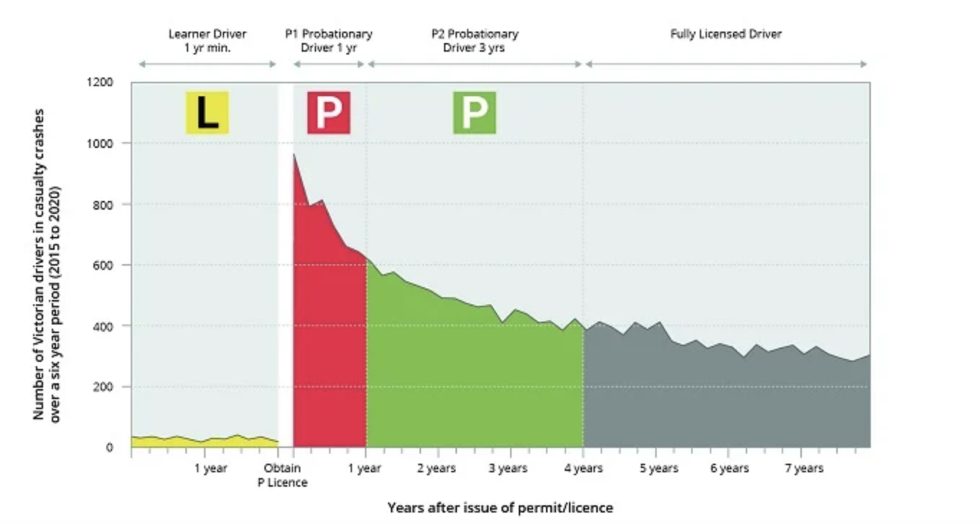
Image source: Learner and probationary driver road rules - Transport Victoria; licensed CC-BY 4.0
- Which plate driver is the least likely to be involved in a car accident?
- Which plate driver is the most likely to be involved in a car accident?
- Which plate driver is the second most likely to be involved in a car accident?

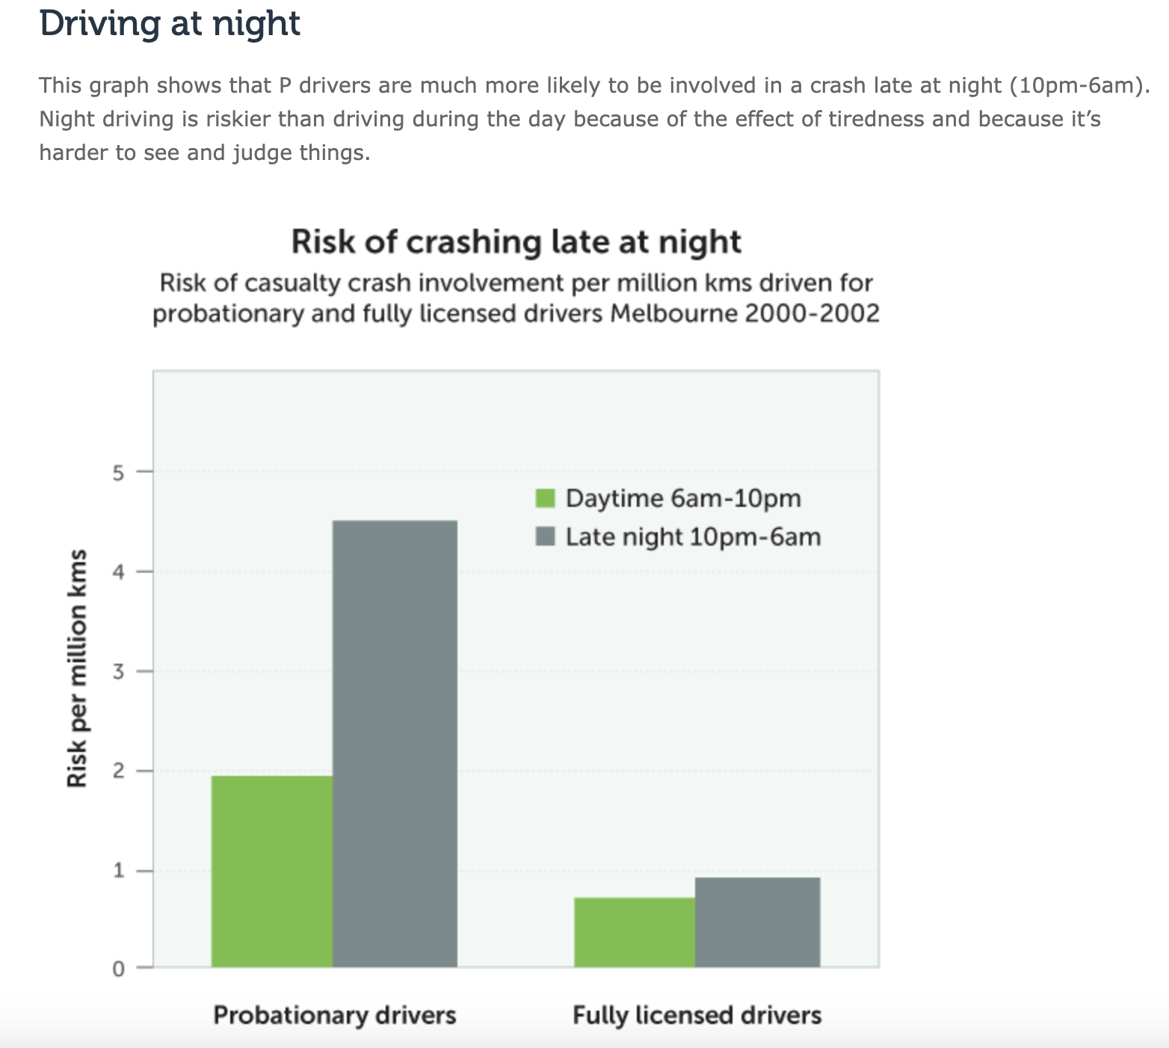
Image source: Learner and probationary driver road rules - Transport Victoria; licensed CC-BY 4.0
Hint: Use estimates of percentage to answer the following questions (e.g. 10% more likely).
- How much more likely are P plate drivers to be involved in a crash at night than during the day?
- How much more likely are fully licensed drivers to be involved in a crash at night than during the day?
Part 2: Now that you are aware that young drivers have a higher risk of crashing, you will use this information in the context of car insurance. Use the RACV insurance quote estimate to find out what premium insurance will cost when you first get your licence.
You can choose whatever car you want, but please select your age as 18. Complete the following questions.
- What was the estimated quote for your insurance?
Now, go back to the ‘about you’ section and change your age (e.g. 53). Complete the quote the same way as you did the first time.

Image source: RACV, Car insurance quote estimate
- What was the cost of the second quote?
- What is the difference between the two quotes? Show your working out.
Evaluate and reflect: Check and reflect on the mathematical problem-solving processes and outcomes in relation to the real-world context.
Part 3: Using the information from Part 2, explain why you think the price is different.
Hint: Think about the driver's age and risk. Make sure that you use data and evidence to support your explanation.
Extension: Complete the quote again but change whatever details you want. Is the final quote higher or lower than your first quote? What are the factors considered in calculating insurance premiums? What did you change and why do you think the price changed?

Communicate and report: Use a combination of informal and formal mathematical representations to document and report outcomes and results.
Part 4: After completing the above tasks, explain why understanding probability is important. Provide two more examples to support your explanation. These examples need to be different from what you provided in ’Task 5: Probability Activity 5.1 Brainstorm Part 2’.
Importance:
Example 1:
Example 2:

Task 5: Feedback and assessment

Peer feedback
Activity 5.1 | Brainstorm | Choose an item.
Activity 5.2 | Likelihood | Choose an item.
Activity 5.3 | Driving | Choose an item.
Peer comment:
Name of peer:

AoS 7 KS 1 Estimate and identify likelihood of common and familiar events occurring using simple fractions, decimals or percentages such as $\frac{1}{2}$, $\frac{1}{3}$, $\frac{1}{5}$, 0.5, 50%.
Student reflection: How well did you go with this step? (Please tick the box below)
☐Not Submitted | ☐Beginning | ☐Consolidating | ☐Achieving | ☐Excelling
Student comment (optional):
Teacher feedback
☐Not Submitted | ☐Beginning | ☐Consolidating | ☐Achieving | ☐Excelling
Not Submitted: No work has been submitted or attempted for this outcome. | Beginning: You have attempted to answer some questions using percentages, decimals and fractions. To bump it up, you need to re-read the activity and provide a basic response for all parts. | Consolidating: You have shown a basic understanding of solving problems using percentages, decimals and fractions. You have responded to most parts of this activity. To bump it up, check over your answers to see if they are correct and include more details of your working out. | Achieving: You have shown an understanding of solving problems using percentages, decimals and fractions. You have responded to all parts of this activity. You have shown your workings. To bump it up, recheck your answers to make sure your answers are all correct. | Excelling: You have demonstrated an understanding of solving problems using percentages, decimals and fractions. You have shown your detailed workings out and all your answers are correct. Great work!
Teacher comment:

AoS 7 KS 3 Recognise that the likelihood of events occurring can differ and develop an understanding of how to reduce or increase the likelihood of an event occurring.
Student reflection: How well did you go with this step? (Please tick the box below)
☐Not Submitted | ☐Beginning | ☐Consolidating | ☐Achieving | ☐Excelling
Student comment (optional):
Teacher feedback
☐Not Submitted | ☐Beginning | ☐Consolidating | ☐Achieving | ☐Excelling
Not Submitted: No work has been submitted or attempted for this outcome. | Beginning: You have attempted to answer some of the questions. To bump it up, you need to complete all parts of the activity and show that you understand how to reduce or increase the likelihood of an event occurring. | Consolidating: You have shown a basic understanding of how to reduce or increase the likelihood of an event occurring, with some explanation. To bump it up, check over your answers to see if they are correct and add more details to your responses. | Achieving: You have demonstrated an understanding of how to reduce or increase the likelihood of an event occurring with explanations and suggestions. You have shown your workings. To bump it up, recheck your answers to make sure your answers are all correct. | Excelling: You have demonstrated an excellent understanding of how to reduce or increase the likelihood of an event occurring with detailed explanations and suggestions. You have shown your workings. Great work!
Teacher Comment:

Task 6: Sample space and outcomes
Numeracy Context: Personal (a)
Area of Study (AoS) 7: Uncertainty

Key knowledge and key skills
AoS 7 KS 2 Identify sample spaces or options for common and familiar events or occurrences.

Task checklist
Students will complete the following for Task 6: Numeracy Context: Personal (a)
☐ Activity 6.1 What is sample space?
☐ Activity 6.2 Sample space
☐ Activity 6.3 First down the mountain
In this task, you will need to identify the sample space of events or occurrences and mathematically describe the chances of outcomes. You will be able to identify and calculate the sample space of common and familiar events/occurrences.

Activity 6.1 What is sample space?
Identify the mathematics: Recognise, select and interpret the mathematical information embedded in a real-world context and decide what mathematics to use.
Part 1: Understanding terminology – There are many unfamiliar words that are used in probability/uncertainty. Watch the video below to gain an understanding of what space is, then complete the questions below.
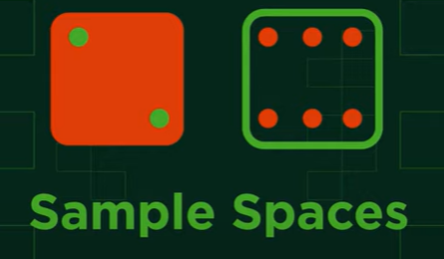
Video source: FuseSchool – Global Education, Sample Spaces | Statistics & Probability | Maths | FuseSchool
- Write down the definition of sample space in your own words.
- The video explained three different ways to calculate sample space. Give a summary of these terms below.
Lists:
Tables:
Tree diagrams:

Review the worked example of a tree diagram below.
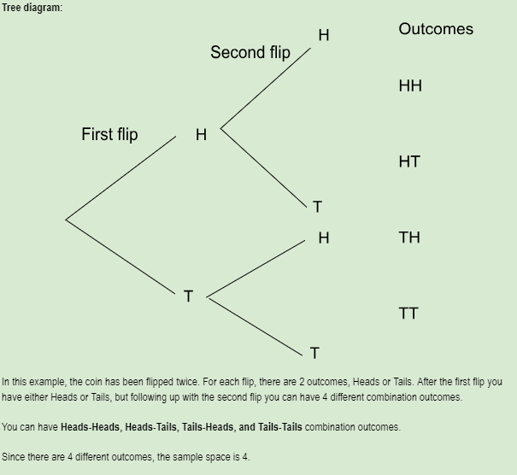

Activity 6.2 Sample space
Act on and use mathematics: Perform mathematical actions and processes to complete a task – this includes the use and application of a range of technologies.
Part 1: You will use a table to show the sample space of flipping 2 coins. Fill out the blank sections in the tables below.
 | Heads | Tails
Heads | Heads-Heads
Tails

Sample space (number of outcomes) =
Now, fill out the sample space for the event of rolling 2 dice.
 | 1 | 2 | 3 | 4 | 5 | 6
1 | 1-1
2
3
4
5
6
Sample space (number of outcomes) =
Part 2: Calculating probability from the sample space – From the sample space, you can calculate what is the probability of a certain event occurring. Review the worked example and then complete the table below.
Worked example
From our coin flip sample space table above, we will calculate the probability of getting a Heads-Heads outcome.

 | Heads | Tails
Heads | Heads-Heads | Heads-Tails
Tails | Tails-Head | Tails-Tails

There are a total of 4 outcomes, but we are only looking at 1 outcome.
To calculate probability, we follow the following formula:
Probability = Number of desired outcomes / Total number of outcomes
In our case, Heads-Heads, it only happens once. We have the following equation:
Probability (Heads-Heads) = 1 / 4 = 0.25 —> 25% chance
Now, using the table you filled out in Part 1, find the probability of rolling a ‘4’ and a ‘3’. Show your working out.
 | 1 | 2 | 3 | 4 | 5 | 6
1 | 1-1
2
3
4
5
6
Probability (rolling 3 and 4) =
What is the probability of rolling a 3 or a 4?
Probability (rolling 3 or 4) =

Activity 6.3 First down the mountain
Part 1: You will need to play a game of ‘First down the mountain’ to answer the questions.
You will need:
- First down the mountain game board https://mathematicscentre.com/taskcentre/087firbd.pdf
- 2 x 6-sided dice.
- 11 ‘climbers’ counters
Rules:
- Place a climber on each of the eleven numbers.
- Take turns to roll the dice.
- Add the numbers and shift the climber on that square down one space.
- Example: Roll the dice and get a 3 and a 6
- 3 + 6 = 9
- This means the climber that started on 9, moves down 1 square.
Complete the questions below:
- Predict which climber you think will win, then race to check.
- Record the number of the climber that wins.
- Play the game three times and record the winner.
- Do you think this is a fair game? Why or why not?

Part 2: Fill out the table to obtain the sample space and then complete the questions below.
 | 1 | 2 | 3 | 4 | 5 | 6
1
2
3
4
5
6

What outcome/s has the highest chance of occurring? Explain in terms of probability.
Hint: Use a fraction.
What outcome/s has the lowest chance of occurring? Explain in terms of probability.
Hint: Use a fraction.

Task 6: Feedback and assessment
Peer feedback
Activity 6.1 | What is sample space? | Choose an item.
Activity 6.2 | Sample space | Choose an item.
Activity 6.3 | First down the mountain | Choose an item.
Peer comment:
Name of peer:

AoS 7 KS 2 Identify sample spaces or options for common and familiar events or occurrences.
Student reflection: How well did you go with this step? (Please tick the box below)
☐Not Submitted | ☐Beginning | ☐Consolidating | ☐Achieving | ☐Excelling
Student comment (optional):
Teacher feedback
☐Not Submitted | ☐Beginning | ☐Consolidating | ☐Achieving | ☐Excelling
Not Submitted: No work has been submitted or attempted for this outcome. | Beginning: You have attempted to answer some of the questions. To bump it up, you need to complete all parts of the activity and show that you can identify and calculate sample spaces. | Consolidating: You have shown some understanding of identifying and calculating sample spaces. To bump it up, you need to attempt all parts of the activity and show your working out. | Achieving: You have shown an understanding of identifying and calculating sample spaces. You have shown basic working out. To bump it up, recheck your answers to make sure your answers are all correct. | Excelling: You have shown that you can identify and calculate sample spaces and probabilities. You have shown detailed working out. All your answers are correct. Great work!
Teacher comment:

Task 7: The ultimate trip planner
Numeracy Context: Financial (c)
Area of Study (AoS) 8: Systematics
Key knowledge and key skills
AoS 8 KS 1 Create tables to collate, organise and input or record common and familiar data and information.
AoS 8 KS 5 Adjust variables of inputs to optimise outputs and solutions for common and familiar situations and contexts.
AoS 8 KS 4 Read inputs and interpret outputs such as from interactive maps, public transport timetables, online calculators/applications/planners.
AoS 8 KS 3 Use systems to plan and schedule common and familiar actions.
AoS 8 KS 2 Arrange and sort simple and familiar data and information.

Task Checklist
Students will complete the following for Task 7: Numeracy Context: Financial (c)
☐ Activity 7.1 Where do I want to go?
☐ Activity 7.2 Travel arrangements
☐ Activity 7.3 Activities planning
☐ Activity 7.4 Travel budgets
☐ Activity 7.5 Currency conversion
Before you begin this task, you will need to make your own copy of this spreadsheet template.
Save a version of the spreadsheet and title it with ‘Your name -The ultimate trip planner’. You will need to refer to this spreadsheet for ‘Task 7: The Ultimate Trip planner and all activities 7.1–7.5’.

Activity 7.1 Where do I want to go?
At the end of this task, you will be able to analyse data from external websites and collate this information into tables and spreadsheets. You will analyse data and identify a month of the year that is ideal to travel to your chosen destination.
Identify the mathematics: Recognise, select and interpret the mathematical information embedded in a real-world context and decide what mathematics to use.
Part 1: What country or city would you like to visit in the future? To help you select where you want to go. Complete the table below to help you consider when would be the best time to travel.
Need to think about | Why is it an important thing to think about?
Example: Going overseas. | It will cost more to fly overseas.
Weather
Dates
Safety
Choose your destination (include city and country):
Act on and use mathematics: Perform mathematical actions and processes to complete a task – this includes the use and application of a range of technologies.
Part 2: One of the most important aspects of organising a trip is working out when would be a good time to go. Weather plays a big part in this. For example, Jimmy is an avid skier, but he was very disappointed when he arrived at his accommodation in Mt Hotham in January and there was no snow.
Using the Weather Spark website, find the mean (average) temperatures for your destination. Identify two months that would be most ideal for you to take your trip - https://weatherspark.com/
Add the temperature data to ’sheet 1. destination’ in your Ultimate Trip Planning spreadsheet.
Worked example
Mean (Average) Temperature
Rome
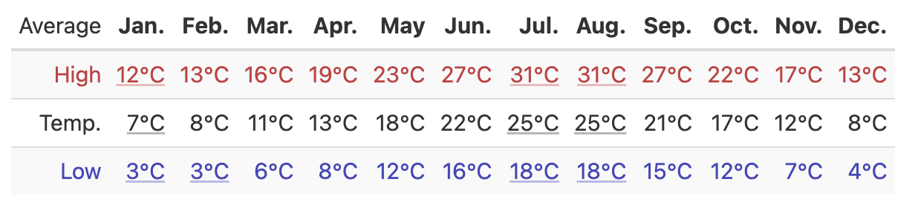
Mean (average) temperature
Part 3: Using the mean temperature data, which two months would be most ideal for travel in your chosen destination?
Month | Average high | Average low
Part 4: For the destination you want to visit, add the mean rainfall by month into ‘sheet 1. destination’ in your Ultimate Trip Planning spreadsheet. Then, use the mean rainfall information to determine which month would be ideal to travel to your chosen destination. Complete the table below.
Month | Average monthly rainfall number of days
Evaluate and reflect: Check and reflect on the mathematical problem-solving processes and outcomes in relation to the real-world context.
Communicate and report: Use a combination of informal and formal mathematical representations to document and report outcomes and results.
Part 5: From your research which month is the most ideal to visit your chosen destinate? Explain why.
Part 6: Add a link to your spreadsheet below.

AoS 8 KS 1 Create tables to collate, organise and input or record common/familiar data information.
Student reflection: How well did you go with this step? (Please tick the box below)
☐Not Submitted | ☐Beginning | ☐Consolidating | ☐Achieving | ☐Excelling
Student comment (optional):
Teacher feedback
☐Not Submitted | ☐Beginning | ☐Consolidating | ☐Achieving | ☐Excelling
Not Submitted: No work has been submitted or attempted for this outcome. | Beginning: You have attempted to answer some of the questions. To bump it up, you need to show that you can transfer researched data into the tables provided. | Consolidating: You have shown a basic ability that you can transfer some researched data from an external source into tables provided and use this information to make a decision. To bump it up, check over your answers and make sure you complete any missing parts. | Achieving: You have shown an ability to transfer some researched data from an external source into the tables provided and use this information to make a decision. You have shown your workings. To bump it up, recheck your answers to make sure your answers are all correct. | Excelling: You have shown an ability to transfer data researched from an external source into tables provided and use this information to make a decision. You have shown all your workings out and all your answers are correct. Great work!
Teacher comment:

AoS 8 KS 5 Adjust variables of inputs to optimise outputs and solutions for common and familiar situations and contexts.
Student reflection: How well did you go with this step? (Please tick the box below)
☐Not Submitted | ☐Beginning | ☐Consolidating | ☐Achieving | ☐Excelling
Student comment (optional):
Teacher feedback
☐Not Submitted | ☐Beginning | ☐Consolidating | ☐Achieving | ☐Excelling
Not Submitted: No work has been submitted or attempted for this outcome. | Beginning: You have attempted to answer some of the questions. To bump it up, you need to show evidence of researching data from a familiar website and entering it into your trip spreadsheet. | Consolidating: You have shown some evidence of researching data from a familiar website and entering data into your trip spreadsheet. To bump it up, include more details of your working out and make sure you have attempted all parts. | Achieving: You have shown evidence of researching data from a familiar website and entering data into your trip spreadsheet. You have shown your workings. To bump it up, recheck your answers to make sure your answers are all correct. | Excelling: You have shown evidence that you can research data from a familiar website and enter relevant data into your trip spreadsheet. You have shown all your workings out and all your answers are correct. Great work!
Teacher comment:

Activity 7.2 Travel arrangements
At the end of this task, you will be able to navigate external tools to generate desired results. You will be able to input data into external market comparison websites and correlate this information to find the best deals.
Identify the mathematics: Recognise, select and interpret the mathematical information embedded in a real-world context and decide what mathematics to use.
Act on and use mathematics: Perform mathematical actions and processes to complete a task – this includes the use and application of a range of technologies.
Part 1: You are on your way to organising your dream trip! You know where you want to go, and you know when the best month to travel there is. Now you need to organise your how! For this trip, you will be travelling for 7 days.
Flights: Select your departure and return dates. Remember they must be in the month you identified as best to travel to your destination. Use the popular flight booking sites below to compare the best options for flights to your destination. Take a screenshot of your top results for each website.
Worked example
Priceline
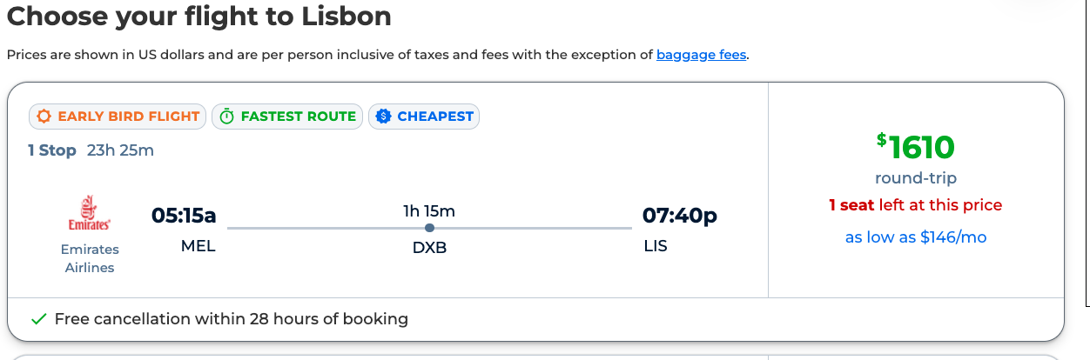
Momondo
Skyscanner
Googleflights
Your own choice:
From the four flight options you have found, which option would you choose? Explain why.
Part 2: Accommodation – Select your dates and use these popular hotel booking sites to compare the best options for accommodation for your trip. Screenshot your top results for each website.
Worked example
Orbitz
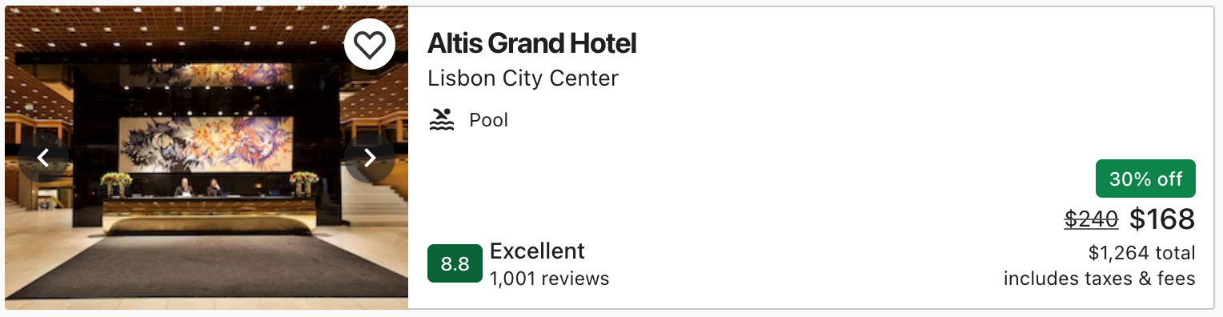
Booking.com
Wotif.com
Hostelworld
Your own choice:
From the four accommodation options you have found which option would you choose? Explain why.
Part 3: Car hire – Select your dates and use these popular car hire booking sites to compare the best options for car rentals for your trip. Screenshot your top results for each website.
Worked example
Avis
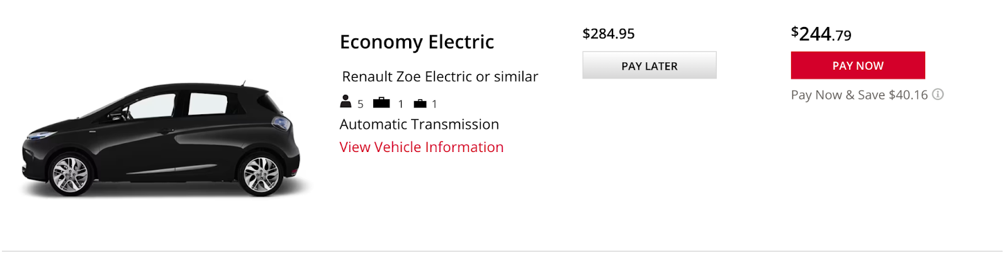
Hertz
Budget
Expedia
Your own choice:
From the four car rental options you have found which option would you choose? Explain why.
Evaluate and reflect: Check and reflect on the mathematical problem-solving processes and outcomes in relation to the real-world context.
Part 4: Fill in the tables below with your chosen information for flights, accommodation and car hire.

Flights
Website | Airline(s) | Trip length | Cost

Accommodation
Website | Hotel / hostel | Stay length | Cost

Car hire
Website | Car type | Rental length | Cost

Communicate and report: Use a combination of informal and formal mathematical representations to document and report outcomes and results.
Part 5: Add the information below to ‘Sheet 2: Summary’ in your Ultimate Trip Planning spreadsheet.
☐ Flight details
☐ Accommodation details
☐ Car hire details
Part 6: Add a link to your spreadsheet below.

AoS 8 KS 4 Read inputs and interpret outputs such as from interactive maps, public transport timetables, online calculators/applications/planners.
Student reflection: How well did you go with this step? (Please tick the box below)
☐Not Submitted | ☐Beginning | ☐Consolidating | ☐Achieving | ☐Excelling
Student comment (optional):
Teacher feedback
☐Not Submitted | ☐Beginning | ☐Consolidating | ☐Achieving | ☐Excelling
Not Submitted: No work has been submitted or attempted for this outcome. | Beginning: You have attempted to answer some of the questions. To bump it up, you need to show that you can input data and analyse data output. | Consolidating: You have shown a basic ability to input some data into your trip spreadsheet and analyse some of the output data. To bump it up, check over your answers and make sure you complete any missing parts. | Achieving: You have shown the ability to input data into your trip spreadsheet and analyse the output data. You have shown your workings. To bump it up, recheck your answers to make sure your answers are all correct. | Excelling: You have shown the ability to input data into your trip spreadsheet and analyse the output data. You have shown all your workings out and all your answers are correct. Great work!
Teacher comment:

Activity 7.3 Activities planning
At the end of this task, you will show that you can research, plan and schedule activities on your trip.
Identify the mathematics: Recognise, select and interpret the mathematical information embedded in a real-world context and decide what mathematics to use.
Part 1: List some important questions below to consider when choosing activities to do while you are away.
For example: Will I physically be able to participate in the activity I want to do?
1.
2.
3.
4.
5.

Act on and use mathematics: Perform mathematical actions and processes to complete a task – this includes the use and application of a range of technologies.
Part 2: It's now time to plan your activity itinerary! This will include daily things you will do. Do your own research or use a website such as Tripadvisor by selecting the ‘Things to Do’ tab for your chosen destination.
Add your activities to ’Sheet 3: Daily’ in your Ultimate Trip Planning spreadsheet. You must include at least three activities per day.
Evaluate and reflect: Check and reflect on the mathematical problem-solving processes and outcomes in relation to the real-world context.
Communicate and report: Use a combination of informal and formal mathematical representations to document and report outcomes and results.
Part 3: List and explain the three top activities you will do on your trip. Include details on why you want to do these activities, and the cost involved.
1.
2.
3.
Part 4: Add a link to your spreadsheet below.

AoS 8 KS 3 Use systems to plan and schedule common and familiar actions.
Student reflection: How well did you go with this step? (Please tick the box below)
☐Not Submitted | ☐Beginning | ☐Consolidating | ☐Achieving | ☐Excelling
Student comment (optional):
Teacher feedback
☐Not Submitted | ☐Beginning | ☐Consolidating | ☐Achieving | ☐Excelling
Not Submitted: No work has been submitted or attempted for this outcome. | Beginning: You have attempted to answer some of the questions. To bump it up, you need to show that you can research, plan and schedule activities. | Consolidating: You have shown a basic ability to research, plan and schedule some activities. To bump it up, check over your answers and make sure you complete any missing parts. | Achieving: You have shown an ability to research, plan and schedule activities. You have provided basic explanations about your decision making. To bump it up, include more information in your explanations. | Excelling: You have shown the ability to research, plan and schedule activities. You have provided detailed explanations about your decision-making and choices. Great work!
Teacher comment:

Activity 7.4 Travel budgets
At the end of this task, you will show that you can budget by inputting data into spreadsheets and understand outputs to make informed decisions.
Identify the mathematics: Recognise, select and interpret the mathematical information embedded in a real-world context and decide what mathematics to use.
Part 1: Budgeting – Adhering to a trip budget is a great way of making sure that you don't run out of money on the trip. Pre-planning a trip budget gives you a rough idea of how much the trip will cost you overall.
Known costs – First you need to list your known costs for the trip. Complete the table below filling out the costs that you already know. See ‘Task 7 The ultimate trip planner Activities 7.2 and 7.3’ for specific details you have already identified.

Flights | Cost:
Accommodation | Cost:
Transport / Car hire | Cost:
Add the information from the table above to ’4: Budget sheet' in your Ultimate Trip planner spreadsheet. See image below.
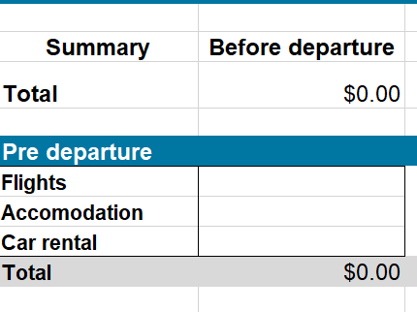
Part 2: Add your known sightseeing, activities and event costs to ’4: Budget sheet’ in your Ultimate Trip planner spreadsheet. See image below.
Act on and use mathematics: Perform mathematical actions and processes to complete a task – this includes the use and application of a range of technologies.
Part 3: What is your total pre-departure cost. Add this to ’4: Budget sheet’ in your Ultimate Trip planner spreadsheet. This can be found in the top right-hand section of your spreadsheet. See image below.
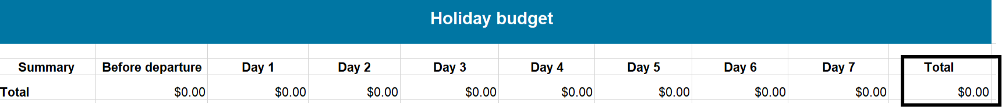
Add your total cost below.
$

Part 4: Anticipated costs – These are the costs that you must estimate as best you can. They include things like extra transport costs, food and drink, shopping and leisure activities. Work through each day of your trip entering your anticipated transport, food and drink, shopping and leisure activities costs. Add this to ’4: Budget sheet’ in your Ultimate Trip planner spreadsheet. See image below.
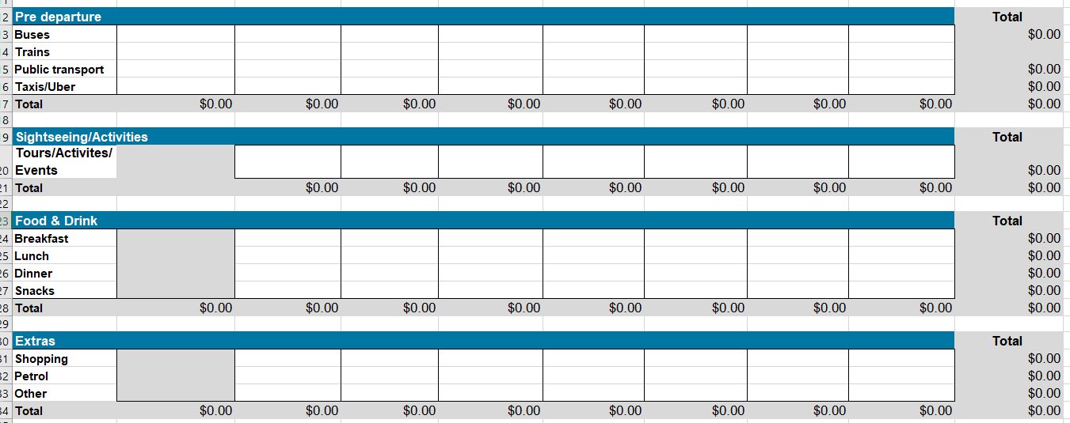
Evaluate and reflect: Check and reflect on the mathematical problem-solving processes and outcomes in relation to the real-world context.
Part 5: Using the data from your ’4: Budget sheet’ in your Ultimate Trip planner spreadsheet fill in the table below.
Item | What is your total cost?
Transport (other than car rental)
Breakfast
Lunch
Dinner
Shopping
Other

Communicate and report: Use a combination of informal and formal mathematical representations to document and report outcomes and results.
Part 6: Using the data from your Ultimate Trip Planner spreadsheet respond to the questions below.
- What is the most expensive day on your trip?
- Total cost of breakfast for your trip?
- The combined total cost of breakfast and lunch?
- The combined total cost of car rental, petrol or any other transport?
- The trip budget total cost?
Part 7: Add a link to your spreadsheet below.

AoS 8 KS 2 Use, arrange and sort simple and familiar data and information.
Student reflection: How well did you go with this step? (Please tick the box below)
☐Not Submitted | ☐Beginning | ☐Consolidating | ☐Achieving | ☐Excelling
Student comment (optional):
Teacher feedback
☐Not Submitted | ☐Beginning | ☐Consolidating | ☐Achieving | ☐Excelling
Not Submitted: No work has been submitted or attempted for this outcome. | Beginning: You have attempted to answer some of the questions. To bump it up, you need to show that you can input data and understand the data output. | Consolidating: You have shown a basic ability to input some data into spreadsheets. You have demonstrated a basic interpretation of the output data. To bump it up, check over your answers and make sure you complete any missing parts of the activity. | Achieving: You have shown an ability to input data into spreadsheets and interpret the output data. To bump it up, you need to include more details in your interpretation of the output data. | Excelling: You have shown an ability to input data into spreadsheets and interpret the output data. You have provided detailed explanations in your interpretation of the output data. Great work!
Teacher comment:

Activity 7.5 Currency conversion
At the end of this task, you will show that you can use different formulas/equations or convert currency.
Identify the mathematics: Recognise, select and interpret the mathematical information embedded in a real-world context and decide what mathematics to use.
Part 1: Currency Conversion – If you are travelling overseas to a country that has a different currency other than Australian Dollars (AUD), it's important to know how much your money is worth in that currency. This will ensure you take enough money with you and that you don't get ripped off. To work this out you will need to understand three things: exchange rate, base currency and foreign currency. Research the definition of each term and take note of the definition in the space provided below.
Exchange rate:
Base currency:
Foreign currency:
Act on and use mathematics: Perform mathematical actions and processes to complete a task – including the use and application of a range of mathematical processes.
Part 2: Review the worked example below and then convert the AUD amounts into their foreign currency equivalents.
Worked example
Mr Dunn wants to travel to America. At the moment, the exchange rate from AUD to USD is 0.65 Mr Dunn has $500 AUD.
To work out how much USD Mr Dunn has:
Base Currency ($500 AUD) x Exchange Rate (0.65) = Foreign Currency (USD)
500 x 0.65 = 325
Mr Dunn has $325 USD to spend.
Convert these AUD amounts into their foreign currency equivalents below.
AUD $300 = amount in Japanese Yen (Exchange Rate 95.74)
Working out
AUD $1,200 = amount in Pound Sterling (Exchange Rate 0.53)
Working out
AUD $645 = amount in Vietnamese Dong (Exchange Rate 15691.88)
Working out
AUD $990 = amount in Euro (Exchange Rate 0.60)
Working out

Evaluate and reflect: Check and reflect on the mathematical problem-solving processes and outcomes in relation to the real-world context.
Part 3: Using the budget you created in Task 7: Activity 7.4 Travel budgets, convert that amount into the foreign currency of the destination you are travelling to. Do not include pre-departure costs as this would be something you have already paid for in AUD before you left.
Budget in AUD: $
Amount in destination country’s currency:
Working out:
Communicate and report: Use a combination of informal and formal mathematical representations to document and report outcomes and results.
Part 4: Add your currency conversion into ‘5: Currency conversions sheet’ in your Ultimate Trip planner spreadsheet.
Worked example
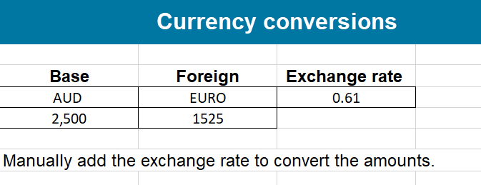
$2,500 AUD = $1,525 Euro

Part 5: Add a link to your spreadsheet below.

Task 7: Feedback and assessment
Peer feedback
Activity 7.1 | Where do I want to go? | Choose an item.
Activity 7.2 | Travel arrangements | Choose an item.
Activity 7.3 | Activities planning | Choose an item.
Activity 7.4 | Travel budgets | Choose an item.
Activity 7.5 | Currency conversion | Choose an item.
Peer comment:
Name of peer:

AoS 8 KS 1 Create tables to collate, organise and input or record common/familiar data information.
Student reflection: How well did you go with this step? (Please tick the box below)
☐Not Submitted | ☐Beginning | ☐Consolidating | ☐Achieving | ☐Excelling
Student comment (optional):
Teacher feedback
☐Not Submitted | ☐Beginning | ☐Consolidating | ☐Achieving | ☐Excelling
Not Submitted: No work has been submitted or attempted for this outcome. | Beginning: You have attempted to answer some of the questions. To bump it up, you need to show that you can convert currency. | Consolidating: You have shown some ability to convert currency. To bump it up, you need to show your workings out and add and link in your Ultimate trip planner spreadsheet. | Achieving: You have shown an ability to convert currency. You have included your basic workings out. To bump it up, link in your Ultimate trip planner spreadsheet. | Excelling: You have shown the ability to convert currency. You have shown all your workings out. You have linked in your Ultimate trip planner spreadsheet. Great work!
Teacher comment:

