VCE Vocational Major

Unit 2: Uniting Communities
Personal Development Skills curriculum support materials

Acknowledgement
The Victorian Curriculum and Assessment Authority proudly acknowledges and pays respect to Victoria’s Aboriginal and Torres Strait Islander communities and their rich and enduring cultures.
We acknowledge Aboriginal and Torres Strait Islander people as Australia’s first peoples and as the Traditional Owners and custodians of the lands and waters on which we rely. We pay respect to Elders past and present of the lands where we conduct our work and recognise their ongoing contributions as the first educators on the land now known as Victoria.
Authorised and published by the Victorian Curriculum and Assessment Authority
Level 7, 200 Victoria Parade
East Melbourne VIC 3002
ISBN: 978-1-923204-71-3
© Victorian Curriculum and Assessment Authority 2025
No part of this publication may be reproduced except as specified under the Copyright Act 1968 or by permission from the VCAA. Excepting third-party elements, schools may use this resource in accordance with the VCAA educational allowance. For more information go to vcaa.vic.edu.au/footer/copyright
The VCAA provides the only official, up-to-date versions of VCAA publications. Details of updates can be found on the VCAA website at vcaa.vic.edu.au
This publication may contain copyright material belonging to a third party. If you believe that material in this publication is an infringement of your copyright, please email the Copyright Officer vcaa.copyright@education.vic.gov.au
Copyright in materials appearing at any sites linked to this document rests with the copyright owner/s of those materials, and is subject to the Copyright Act. The VCAA recommends you refer to copyright statements at linked sites before using such materials.
The VCAA logo is a registered trademark of the Victorian Curriculum and Assessment Authority.

Contact us if you need this information in an accessible format, for example, large print or audio.
Telephone (03) 9032 1629 or email vcaa.publications@education.vic.gov.au

Contents
Contents i
Using this resource ii
Student and teacher actions iii
Personal Development Skills (PDS) activities 4
Task 1: What is community? 4
Activity 1.1 Brainstorm 4
Activity 1.2 How and why are communities formed? 6
Activity 1.3 Community involvement 8
Activity 1.4 Ikigai 9
Have you completed the following activities for PDS Task 1: What is community? 11

Using this resource
- This curriculum resource is an example and shows one way a school could deliver the Victorian Pathways Certificate (VPC) and VCE Vocational Major (VCE VM) through an integrated approach to teaching and learning.
- You will need to make changes to the curriculum resource to best suit your cohort’s needs and abilities by adding or removing scaffolds, and to tailor resources to your school's context. When modifying this curriculum resource, please review the relevant VCAA VCE VM study design and check that the relevant area of study, key skills and key knowledge, and overall learning outcome statement are still being addressed.
- This document is a companion to the suite of curriculum support materials for VCE VM Unit 2: Uniting Communities. Read over the ‘Advice for teacher delivery and assessment summary’ in detail before delivery. Applied learning requires proactive planning and preparation prior to delivery. The curriculum resource does not function like a traditional text or workbook. Pre-work and modifications are required to use this curriculum resource effectively.
- Unit preparation checklists in the ‘Advice for teacher delivery and assessment summary’ highlight key actions to be completed by the teacher prior to the overall unit delivery. It is essential for teachers to review and use the unit checklists prior to implementing or using this curriculum resource.
- This curriculum resource is designed to support your teaching and does not replace you as the teacher. How you deliver the resource and run applied learning activities to support your program is a teacher and school-based decision. Explicit instruction, teacher support and monitoring of student progress is still required.
- In accordance with the Pillars of Applied Learning (POAL) all assessment tasks are flexible and open to negotiation. To support individual students to successfully achieve learning outcomes, modification in collaboration is encouraged.
- This curriculum resource includes links to third party materials as examples for teacher reference only. It is not mandatory to use any of these materials or third party services. Inclusion of links to these materials does not constitute VCAA endorsement of the views or content contained in or linked from these sites. Teachers are advised to use their own judgement in determining what is appropriate for their students and school community. Teachers should ensure that any information or activity complies with their school or organisation’s policies.

Student and teacher actions
Within the student task activities, the following icons indicate these actions:
 | For teacher awareness, advice and information. Should be deleted before providing to students.
 | To be adapted or changed to the relevant educational context.
 | The teacher needs to hyperlink or add in their own documents or links to resources for their students to access the correct information from their own school-based documents.
 | Indicates ‘how to’ IT, document support or general guidance for students. Teachers can decide to leave this in or remove it.
 | Indicates to students which activities can be completed and submitted for assessment as a group.
 | Indicates to students which activities need to be completed and submitted for assessment individually.
 | Indicates to students which activities will be completed with a peer.

Personal Development Skills (PDS) activities

Task 1: What is community?
Task checklist
Students will complete the following for Personal Development Skills Task 1: What is community?
☐ Activity 1.1 Brainstorm
☐ Activity 1.2 How and why are communities formed?
☐ Activity 1.3 Community involvement
☐ Activity 1.4 Ikigai

Key vocabulary
Community: the people living in one particular area or people who are considered as a unit because of their common interests, social group, or nationality.
Involvement: An act or instance of being included, or of including someone or something, in an action, process, group, etc.

Activity 1.1 Brainstorm
Teacher advice: For Part 1 your will need to obtain three large sheets of butchers paper. Title each sheet with one of the titles below:
- Words that come to mind when I hear the phrase ‘Local community’.
- Local community issues.
- Local community organisations I am a part of or know of.
Hang these on your classroom wall where students can access them and add their ideas to each sheet.
Part 1: Local communities brainstorm – On the three titled brainstorm sheets provided by your teacher, use post-it notes to add the following to the relevant brainstorm sheet.
☐ Words, thoughts or ideas that come to mind when you think of the phrase ‘local community’.
☐ Issues that you consider to be local community issues.
☐ Local community organisations or groups that you are part of, or you know of.
Take a picture of the ideas you contributed and add the image in the space provided below.
Add your image here.
Teacher advice: For Part 2 your will need to obtain three large sheets of butcher‘s paper. Title each sheet with one of the titles below:
- Words that come to mind when I hear the word ‘National’.
- National issues.
- National community organisations I am apart of or know of.
Hang these on your classroom wall where students can access them and add their ideas to each sheet.
Part 2: National communities brainstorm – On the three titled brainstorm sheets provided by your teacher, use post-it notes to add the following to the relevant brainstorm sheet.
☐ Words, thoughts or ideas that come to mind when you think of the phrase ‘National’.
☐ Issues that you consider to be national community issues.
☐ National community organisations or groups that you are part of, or you know of.
Take a picture of the ideas you contributed and add the image in the space provided below.
Add your image here.
Teacher advice: For Part 3 your will need to obtain three large sheets of butcher‘s paper. Title each sheet with one of the titles below:
- Words that come to mind when I hear the word ‘Global’.
- Global issues.
- Global community organisations I am apart of or know of.
Hang these on your classroom wall where students can access them and add their ideas to each sheet.
Part 3: Global communities brainstorm – On the three titled brainstorm sheets provided by your teacher, use post-it notes to add the following to the relevant brainstorm sheet.
☐ Words, thoughts or ideas that come to mind when you think of the phrase ‘Global’.
☐ Issues that you consider to be global community issues.
☐ Global community organisations or groups that you are part of, or you know of.
Take a picture of the ideas you contributed and add the image in the space provided below.
Add your image here.

Task 1: Activity 1.1 Brainstorm
Student reflection: How well did you go with this step? (Please tick the box below)
☐Not Submitted | ☐Beginning | ☐Consolidating | ☐Achieving | ☐Excelling
Student comment (optional):
Teacher feedback
☐Not Submitted | ☐Beginning | ☐Consolidating | ☐Achieving | ☐Excelling
Not Submitted: No work has been submitted or attempted for this outcome. | Beginning: You have attempted some aspects of this brainstorm activity. To bump it up, re-read the task requirements and complete all aspects of the task. | Consolidating: You have attempted to brainstorm ideas for the prompts provided. To bump it up, re-read the task instructions and make sure you complete all aspects of this task. | Achieving: You have brainstormed several basic ideas for the prompts provided. To bump it up, include more details in your responses. | Excelling: You have brainstormed a range of detailed ideas for the prompts provided. Excellent work!
Teacher comment:

Activity 1.2 How and why are communities formed?
Part 1: Watch the video about Hello Surf Coast, then complete the analysis table below.

Video source: Times News Group, Hello Surf Coast (youtube.com)

Question | Response
Who is involved in the ‘Hello Surf Coast’ initiative?
What is the purpose of the ‘Hello Surf Coast’ initiative?
Who is the target audience for this program?
How is the ‘Hello Surf Coast’ initiative getting people involved and forming a community?
Part 2: Watch the video about All Abilities Netball, then complete the analysis table below.
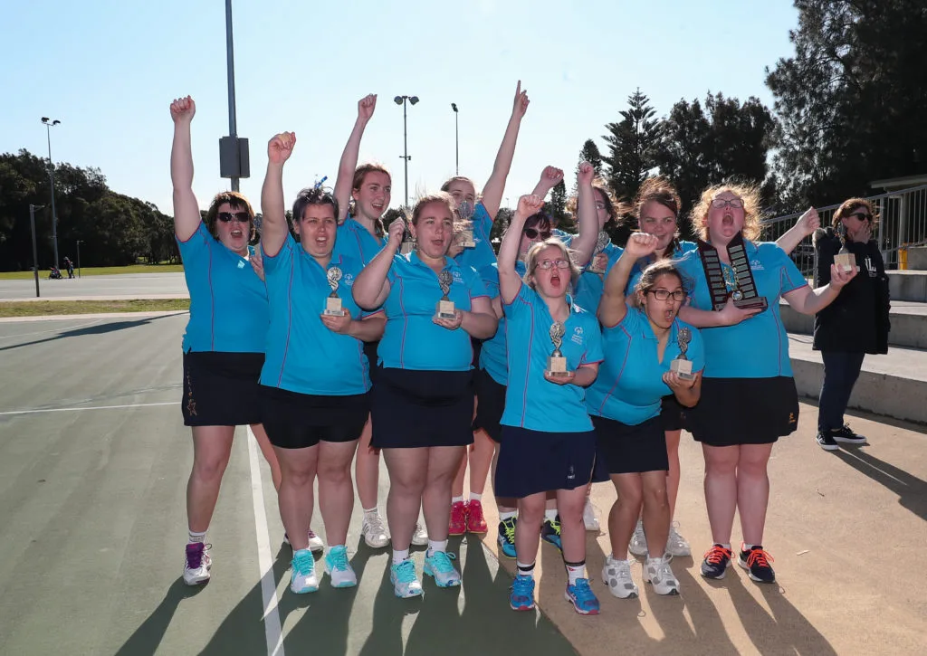
Video source: GippSport, Netball VIC Access for all Abilities Netball Program (youtube.com)
Question | Response
What is the ‘All Abilities’ program?
Characteristics can influence the formation of communities. What similarities do the people within the ‘All Abilities’ program have in common?
Why do individuals want to be part of the ‘All Abilities’ program?
What makes Janet a good leader?
Based on the video, do you think this is a successful community program? Explain your answer.

Task 1: Activity 1.2 How and why are communities formed?
Student reflection: How well did you go with this step? (Please tick the box below)
☐Not Submitted | ☐Beginning | ☐Consolidating | ☐Achieving | ☐Excelling
Student comment (optional):
Teacher feedback
☐Not Submitted | ☐Beginning | ☐Consolidating | ☐Achieving | ☐Excelling
Not Submitted: No work has been submitted or attempted for this outcome. | Beginning: You have attempted to respond to some aspects of this task. To bump it up, re-read over the task requirements and provide a basic response for all required sections. | Consolidating: You have provided basic responses for most aspects of this task. To bump it up, re-read over the task requirements and provide a basic response for all required sections. | Achieving: You have provided detailed responses for most aspects of this task. To bump it up, re-read the task requirements and provide a detailed response for all required sections. | Excelling: You have provided highly detailed responses for all aspects of this task. Great work!
Teacher comment:

Activity 1.3 Community involvement
Part 1: In the table below, put your name in the middle and then around the outside, list the communities that you are a part of or interact with.
Example: VCE VM Community
Your name:
Part 2: Provide examples about how you make a positive impact in at least two of the communities that you are a part of.
Community | Example of your involvement
Example: Surf Coast Secondary College | Example: I contribute positively towards my school community by wearing the correct uniform, respecting my peers, teachers and other members, and acting as a positive role model for younger year levels.

Task 1: Activity 1.3 Community involvement
Student reflection: How well did you go with this step? (Please tick the box below)
☐Not Submitted | ☐Beginning | ☐Consolidating | ☐Achieving | ☐Excelling
Student comment (optional):
Teacher feedback
☐Not Submitted | ☐Beginning | ☐Consolidating | ☐Achieving | ☐Excelling
Not Submitted: No work has been submitted or attempted for this outcome. | Beginning: You have attempted to list how you are involved in your community. To bump it up, you need to make sure that you have responded to all aspects of this task. | Consolidating: You have been able to provide some examples of communities that you are a part of. To bump it up, you need to make sure that you have responded to all aspects of this task. | Achieving: You have been able to list and describe how you are involved within your community and explain how you positively contribute. To bump it up, you could extend your responses by considering future contributions you would like to make to a specific community you are a part of. | Excelling: You have been able to list and describe in detail how you are involved within your community and have explained in detail how you positively contribute. You have included details about how you would like to contribute to a community group you are a part of in the future.
Teacher comment:

Activity 1.4 Ikigai
Part 1: Watch the video link below and view the diagram below about the concept of ‘Ikigai’
Video Link: The Japanese Formula For Happiness - Ikigai
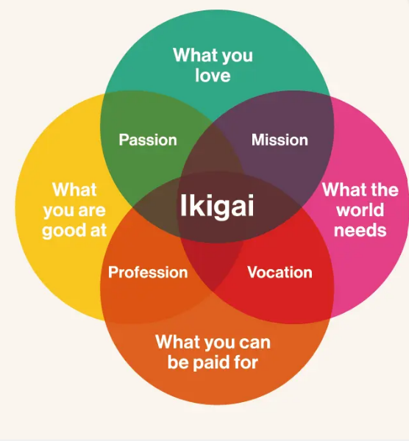
Image source: Ikigai Venn diagram by Marc Winn, from ‘Ikigai: The Japanese Secret to a Joyful Life, Kizuna Magazine Online (Government of Japan)
Part 2: Give a brief summary of what the ‘Ikigai’ concept is.
Part 3: Applying the ‘Ikigai’ concept to yourself, brainstorm how this relates to you in the table below.
What are you good at? | What do you love? | What does the world need? | What can you be paid for?
Part 4: Create your own ‘Ikigai’ infographic, adding your own examples.
You could use:
- Canva
- Ikigai diagram creator
- Ikigai template
- Handwritten
Part 5: Add your ‘Ikigai’ infographic in the space below.
Add your infographic here.

Task 1: Activity 1.4 Ikigai
Student reflection: How well did you go with this step? (Please tick the box below)
☐Not Submitted | ☐Beginning | ☐Consolidating | ☐Achieving | ☐Excelling
Student comment (optional):
Teacher feedback
☐Not Submitted | ☐Beginning | ☐Consolidating | ☐Achieving | ☐Excelling
Not Submitted: No work has been submitted or attempted for this outcome. | Beginning: You have attempted some aspects of this task. To bump it up, you need to provide a basic response for all required sections. | Consolidating: You have provided a basic response to most sections of this task. To bump it up, you need to include more detail in your responses and make sure you include detailed information in your infographic. | Achieving: You have shown that you understand the ‘Ikigai’ concept and can apply this concept to your own life. You have included most of the required information within your ‘Ikigai’ infographic. To bump it up, recheck your infographic and make sure all required information has been included and consider how the infographic looks to a broader audience. | Excelling: You have demonstrated that you understand the ‘Ikigai’ concept and can apply this concept to your own life. You have provided detailed responses to all the required information. This is reflected in your ‘Ikigai’ infographic which is comprehensive and visually appealing to an audience. Great work!
Teacher comment:

Have you completed the following activities for PDS Task 1: What is community?
Task checklist
Students will have completed the following for PDS Task 1: What is community?
☐ Activity 1.1 Brainstorm
☐ Activity 1.2 How and why are communities formed?
☐ Activity 1.3 Community involvement
☐ Activity 1.4 Ikigai

