VCE Vocational Major

VCE VM Unit 2: Uniting Communities
Work Related Skills Curriculum
Support Materials

Acknowledgement
The Victorian Curriculum and Assessment Authority proudly acknowledges and pays respect to Victoria’s Aboriginal and Torres Strait Islander communities and their rich and enduring cultures.
We acknowledge Aboriginal and Torres Strait Islander people as Australia’s first peoples and as the Traditional Owners and custodians of the lands and waters on which we rely. We pay respect to Elders past and present of the lands where we conduct our work and recognise their ongoing contributions as the first educators on the land now known as Victoria.
Authorised and published by the Victorian Curriculum and Assessment Authority
Level 7, 200 Victoria Parade
East Melbourne VIC 3002
ISBN: 978-1-923204-70-6
© Victorian Curriculum and Assessment Authority 2025
No part of this publication may be reproduced except as specified under the Copyright Act 1968 or by permission from the VCAA. Excepting third-party elements, schools may use this resource in accordance with the VCAA educational allowance. For more information go to vcaa.vic.edu.au/footer/copyright
The VCAA provides the only official, up-to-date versions of VCAA publications. Details of updates can be found on the VCAA website at vcaa.vic.edu.au
This publication may contain copyright material belonging to a third party. If you believe that material in this publication is an infringement of your copyright, please email the Copyright Officer vcaa.copyright@education.vic.gov.au
Copyright in materials appearing at any sites linked to this document rests with the copyright owner/s of those materials, and is subject to the Copyright Act. The VCAA recommends you refer to copyright statements at linked sites before using such materials.
The VCAA logo is a registered trademark of the Victorian Curriculum and Assessment Authority.

Contact us if you need this information in an accessible format, for example, large print or audio.
Telephone (03) 9032 1629 or email vcaa.publications@education.vic.gov.au

Contents
Contents ii
Using this resource 1
Student and teacher actions 2
Work Related Skills (WRS) learning activities 3
Task 1: Personal capabilities 3
Activity 1.1 Personal capabilities 3
Activity 1.2 Real-life examples of the personal capabilities 6
Have you completed the following activities for WRS Task 1: Personal capabilities? 8
Task 2: The changing world of work and skills 8
Activity 2.1 The world of work 8
Activity 2.2 My future 11
Have you completed the following activities for WRS Task 2: The changing world of work and skills? 13
Task 3: Technical and employability skills 13
Activity 3.1 Employability skills 14
Activity 3.2 Suggested occupations 16
Have you completed the following activities for WRS Task 3: Technical and employability skills? 18
Task 4: SMARTER capabilities and skills 19
Activity 4.1 Planning for success 19
Activity 4.2 SMARTER goals 20
Activity 4.3 Career Action Plan update 23
Have you completed the following activities for WRS Task 4: SMARTER capabilities and skills? 24
Task 5: Recap on technical and employability skills 24
Activity 5.1 Career map/timeline 25
Activity 5.2 Pathways for education, training and employment 27
Activity 5.3 Technical and employability skills brainstorm and evaluation 28
Activity 5.4 Technical and employability skills debate 30
Have you completed the following activities for WRS Task 5: Recap on technical and employability skills? 32
Task 6: The recruitment process 32
Activity 6.1 Recruitment process steps 32
Activity 6.2 Searching for jobs 34
Activity 6.3 Creating your own job advertisement 36
Have you completed the following activities for WRS Task 6: The recruitment process? 38
Task 7: Preparing, applying and interviewing for a job 38
Activity 7.1 Resume 38
Activity 7.2 Cover letter 42
Activity 7.3 Key selection criteria 45
Activity 7.4 Preparing and participating in an interview 47
Have you completed the following activities for WRS Task 7: Preparing, applying and interviewing for a job? 51

Using this resource
- This curriculum resource is an example and shows one way a school could deliver the Victorian Pathways Certificate (VPC) and VCE Vocational Major (VCE VM) through an integrated approach to teaching and learning.
- You will need to make changes to the curriculum resource to best suit your cohort’s needs and abilities by adding or removing scaffolds, and to tailor resources to your school's context. When modifying this curriculum resource, please review the relevant VCAA VCE VM study design and check that the relevant area of study, key skills and key knowledge, and overall learning outcome statement are still being addressed.
- This document is a companion to the suite of curriculum support materials for VCE VM Unit 2: Uniting Communities. Read over the ‘Advice for teacher delivery and assessment summary’ in detail before delivery. Applied learning requires proactive planning and preparation prior to delivery. The curriculum resource does not function like a traditional text or workbook. Pre-work and modifications are required to use this curriculum resource effectively.
- Unit preparation checklists in the ‘Advice for teacher delivery and assessment summary’ highlight key actions to be completed by the teacher prior to the overall unit delivery. It is essential for teachers to review and use the unit checklists prior to implementing or using this curriculum resource.
- This curriculum resource is designed to support your teaching and does not replace you as the teacher. How you deliver the resource and run applied learning activities to support your program is a teacher and school-based decision. Explicit instruction, teacher support and monitoring of student progress is still required.
- In accordance with the Pillars of Applied Learning (POAL) all assessment tasks are flexible and open to negotiation. To support individual students to successfully achieve learning outcomes, modification in collaboration is encouraged.
- This curriculum resource includes links to third party materials as examples for teacher reference only. It is not mandatory to use any of these materials or third party services. Inclusion of links to these materials does not constitute VCAA endorsement of the views or content contained in or linked from these sites. Teachers are advised to use their own judgement in determining what is appropriate for their students and school community. Teachers should ensure that any information or activity complies with their school or organisation’s policies.

Student and teacher actions
Within the student task activities, the following icons indicate these actions:
 | For teacher awareness, advice and information. Should be deleted before providing to students.
 | To be adapted or changed to the relevant educational context.
 | The teacher needs to hyperlink or add in their own documents or links to resources for their students to access the correct information from their own school-based documents.
 | Indicates ‘how to’ IT, document support or general guidance for students. Teachers can decide to leave this in or remove it.
 | Indicates to students which activities can be completed and submitted for assessment as a group.
 | Indicates to students which activities need to be completed and submitted for assessment individually.
 | Indicates to students which activities will be completed with a peer.

Work Related Skills (WRS) learning activities

Task 1: Personal capabilities
Task checklist
Students will complete the following for Work Related Skills Task 1: Personal capabilities.
☐ Activity 1.1 Personal capabilities
☐ Activity 1.2 Real-life examples of the personal capabilities

Key vocabulary
Skill: The ability to do an activity or a job well.
Capability: The power or ability to do something.
Attribute: A quality or characteristic ascribed to someone or something.
Aptitude: A natural ability to do something/ ability to learn.

Activity 1.1 Personal capabilities
Part 1: Read the statement below.
“One common misconception about ‘Careers or Pathways Education’ is that it’s solely about finding a job or choosing a course. While these aspects are part of careers education, its main purpose is to help you understand yourself better and how you will change over the course of your life. This includes developing your personal capabilities to prepare you for life after school. By adopting a growth mindset, taking opportunities and trying new things during your time at school, you will learn about your strengths, preferences and be able to make informed decisions about what you want to do next.”
Part 2: What do you think about this statement? Do you agree or disagree? Explain why in the space below.
Part 3: Read over the four personal capabilities below.
Hint: If you want more information about the personal capability, you can click on the capability names in the left-hand column for more information.

Growth mindset | ‘Those who hold a growth mindset believe that they can get better at something by dedication of time, effort and energy. Working on one’s flaws, and the process—not the outcome—are the most important components. With time and practice, people with a growth mindset believe they can achieve what they want.’ Professor Carol S Dweck, Mindset: The New Psychology of Success, Ballantine Books (2007).
Work ethic | Work ethic is a personal set of standards for acceptable behaviours in the workplace. Work ethic directly influences how someone approaches their daily tasks, as they are driven by the passion and enjoyment they have for their work.
Self-regulation | Self-regulation is the ability to understand and manage your behaviour and your reactions to feelings and things happening around you.
Conflict resolution | Conflict resolution is the process by which two or more parties reach a peaceful resolution to a dispute.
These capabilities are not only important for the workplace but for our everyday personal lives too.
Part 4: Growth mindset – In the drawing box below highlight or circle the statements that you think are ‘Growth mindset’ statements.
This is too hard.
I will never be able to do this.
I am still learning about…
I need to practice this skill more.
I am trying hard to…
I don’t understand this yet.
I can’t do this.
This time it didn’t work. But next time…
I have faith in myself.
I work hard.
I can’t do anything good.
Part 5: Work ethic scenario – You have just opened a new business. You are looking for new employees to help you get your business going and then to grow. You have read their cover letters and resumes and just called references listed on their resume which are from their previous or current workplaces. You have just found out the following information about each applicant.
Olivia: Works well independently, is very responsible and performs all her duties to a very high standard. Olivia is quiet by nature and can struggle working in a team, especially with others that do not put in the same effort to their work.
Aaron: Is a highly skilled specialist and what he produces is considered the best on the market and worth a high cost. Aaron, however, struggles to meet deadlines and follow specific workplace policies and procedures. At times he can become confrontational when asked accountability questions by his manager.
Tom: Works well in a team and is very respectful and polite. He performs his role and responsibilities to a high standard. However, when under too much pressure, he can become frustrated and respond with a grumpy tone or make negative remarks.
Danny: Great at work and gets through required tasks independently. He shows initiative and goes above and beyond. He gets on with all different types of people and does what needs to be done. However, Danny is often late to work or mixes up which shift he is required for.
Gayle: Is highly dedicated to her work when it interests her. Gayle consistently produces high-quality work, works well independently and in a team. Gayle adds to building a positive work culture and makes others feel valued and included. Gayle can often be noticed on her personal work phone during work hours.
From the five examples above, pick who you would hire. Explain why below.
Who:
Why?
Part 6: Self-Regulation – Tick off below which behaviours you think are healthy ways to self-regulate in the workplace.
☐Going for a quick walk. | ☐Smoke/vape break. | ☐Breathing techniques.
☐Venting with a co-worker on the job. | ☐Grounding techniques (5 things I see, 4 things I hear…). | ☐Asking for a quick break.
☐Telling people what you really think in an aggressive way. | ☐Texting your bestie about how annoyed you are. | ☐Repeating a mantra that has meaning to you.
Part 7: Conflict resolution – Conflict is a normal part of life and will occur at some point in both your personal and working life. What is important is developing the skills needed to work through and repair the relationship after the conflict has occurred. Watch the video below for an example, then respond to the scenario that follows.

Video source: LearnFree.org, Resolving Workplace Conflict (youtube.com)
Scenario: You have had a disagreement at work with a colleague. You both got quite heated and said some things out of frustration that you didn’t mean at the time. Outline below, in steps, how you would work through the conflict.
1.
2.
3.
4.
5.

Task 1: Activity 1.1 Personal capabilities
Student reflection: How well did you go with this step? (Please tick the box below)
☐Not Submitted | ☐Beginning | ☐Consolidating | ☐Achieving | ☐Excelling
Student comment (optional):
Teacher feedback
☐Not Submitted | ☐Beginning | ☐Consolidating | ☐Achieving | ☐Excelling
Not Submitted: No work has been submitted or attempted for this activity. | Beginning: You have attempted some aspects of this task. To bump it up, you need to provide a response for the required parts of this task. | Consolidating: You have responded to most aspects of this task. You have provided basic responses to show your understanding of the four personal capabilities. To bump it up, you need to provide a response for all required parts of this task and add more detail to your responses. | Achieving: You have responded to all aspects of this task. You have provided basic responses to show your understanding of the four personal capabilities. To bump it up, add more detail to your responses. | Excelling: You have responded to all aspects of this task. You have provided detailed responses to show your understanding of the four personal capabilities. Great work!
Teacher comment:

Activity 1.2 Real-life examples of the personal capabilities
Part 1: In the table below, give a personal example of someone you know who demonstrates these personal capabilities. Include a specific example where you have seen this person demonstrate these capabilities.
Capability | Who they are and how you know them? | Example: What did you see them do?
Example: Work ethic | My best friend Bek | My best friend has a very strong work ethic. Bek wants to become a concert pianist. Every afternoon she practices piano from 4-6pm. Bek never misses her sessions and will often miss out on doing fun things.
Growth mindset
Self-regulation
Conflict resolution
Work ethic
Part 2: Thinking about the people and examples you picked above, explain why these examples stood out to you? How could you apply these personal capabilities to your own life and situation?
Growth mindset:
Self-regulation:
Conflict resolution:
Work ethic:
Task 1: Activity 1.2 Real-life examples of the personal capabilities
Student reflection: How well did you go with this step? (Please tick the box below)
☐Not Submitted | ☐Beginning | ☐Consolidating | ☐Achieving | ☐Excelling
Student comment (optional):
Teacher feedback
☐Not Submitted | ☐Beginning | ☐Consolidating | ☐Achieving | ☐Excelling
Not Submitted: No work has been submitted or attempted for this activity. | Beginning: You have attempted some aspects of this task. To bump it up, you need to provide a response for all required parts of this task. | Consolidating: You have provided a basic response to most parts of this task. To bump it up, you need to provide a response for all required parts of this task. | Achieving: You have provided basic responses to all parts of this task. To bump it up, you need to add more detail to your responses. | Excelling: You have provided detailed responses to all parts of this task. You have been able to identify real-life examples of the personal capabilities in action. Great work!
Teacher comment:

Have you completed the following activities for WRS Task 1: Personal capabilities?
Task checklist
Before moving onto Work Related Skills Task 2: The changing world of work and skills, students will have completed the following for Work Related Skills Task 1: Personal capabilities.
☐ Activity 1.1 Personal capabilities
☐ Activity 1.2 Real-life examples of the personal capabilities

Task 2: The changing world of work and skills

Task checklist
Students will complete the following for Work Related Skills Task 2: The changing world of work and skills.
☐ Activity 2.1 The world of work
☐ Activity 2.2 My future

Key vocabulary
Skill: The ability to do an activity or a job well.
Capability: The power or ability to do something.
Attribute: A quality or characteristic ascribed to someone or something.
Aptitude: A natural ability to do something/ ability to learn.
Transferable skills/employability skills: Skills that you possess that are useful to employers across various jobs and industries. Some examples of these would be communication, planning and organising, teamwork, problem solving, self-management, initiative and enterprise, technology and commitment to continuous learning.
Specialist: A person who has a particular skill or knows a lot about a particular subject.
Technical skills: Are specialised knowledge and expertise required to perform specific tasks and use specific tools and programs.

Activity 2.1 The world of work
Part 1: Watch the video, then complete the table below.

Video source: Career Industry Council of Australia, Little Ripples (youtube.com)
List three of your ‘little ripples’.
Little ripple 1 | Worked example: Making beaded jewelry.
Little ripple 2
Little ripple 3
Part 2: Watch the three-video series, then complete the true or false statements table below.
Video 1

Video source: Career Industry Council of Australia, #Work2030 What skills will future careers need most (youtube.com)
Video 2
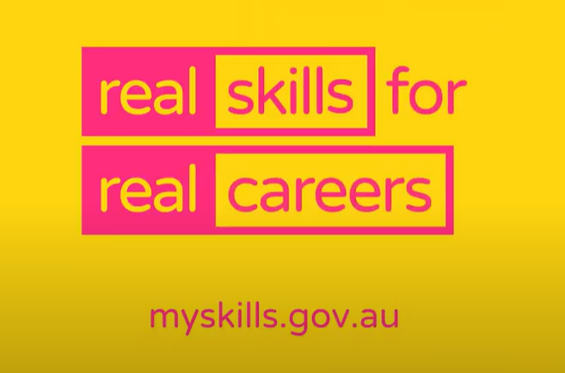
Video source: Career Industry Council of Australia, #Work2030 The days of a job for life are over (youtube.com)
Video 3

Video source: Career Industry Council of Australia, #Work2030 Do we ever really stop learning? (youtube.com)
Statements | True or False?
I will always have the same job. | Add your true or false choice in this column.
Repetitive tasks that can be automated are good for me to practice.
I have choices and options in career interests and aspirations.
Being proactive is not important.
I can develop my experience from a range of jobs, industries and qualifications over time.

Task 2: Activity 2.1 The world of work
Student reflection: How well did you go with this step? (Please tick the box below)
☐Not Submitted | ☐Beginning | ☐Consolidating | ☐Achieving | ☐Excelling
Student comment (optional):
Teacher feedback
☐Not Submitted | ☐Beginning | ☐Consolidating | ☐Achieving | ☐Excelling
Not Submitted: No work has been submitted or attempted for this activity. | Beginning: You have attempted some aspects of this task. To bump it up, you need to provide a response for all required parts of this task. | Consolidating: You have provided basic responses for most parts of this task. To bump it up, check over your task and make sure you have attempted all the required parts of this task. | Achieving: You have provided basic responses for all parts of this task. To bump it up, try to add more details to your responses and check over your true/false statements to make sure they are correct. | Excelling: You have provided detailed responses for all parts of this task. Your responses for the true of false statements are correct. Good work!
Teacher comment:

Activity 2.2 My future
Part 1: For this activity you will undertake a range of online assessments for an overall audit of your current aptitudes, interests, skills and capabilities related to work and industries of interest. Follow the steps outlined below.
Log into your my career portfolio platform where you developed an action plan in WRS Unit 1 via the link here: My Career Portfolio student login. On the home page select the ‘My Future’ square and click ‘GO’.
You will need to have an EDUPASS LOGIN to access this. If you are not sure, check with your teacher.
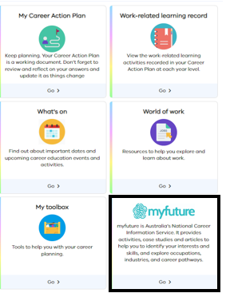

- In Myfuture tab click on the ‘My Career Profile’ tab below. Select the activities tab in the top left-hand corner.
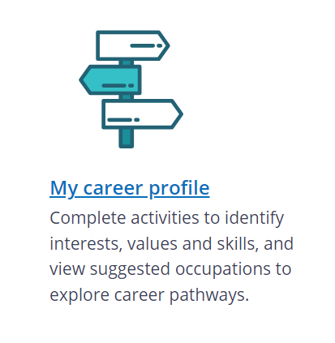
- Take your time to work through each activity and tick them off below as you complete each one. You do not need to do all these activities in one go. Your responses will be saved to the MCP under your login, so that you can log out when you need to, then log back in next time and continue where you finished.
☐ Interests
☐Skills
☐ Education and Training
☐ Study
☐ Work conditions
☐ Values
☐ Career Knowledge
☐ Entrepreneurship
☐ Dream job
Part 2: Once all activities have been completed and checked off above, click on the ‘Results’ tab and either download your results as a PDF or email a copy to yourself. Link or add a copy of your ‘My career profile summary report’ in the space below.
Add your summary report here.
Part 3: Take time to read and review your summary report. Then respond to the questions below.
- What are your current thoughts and feelings about the summary report? Do you think it is accurate?
- What information from the report do you think is inaccurate or not reflective of who you are or your current skill levels?
- What is a follow up question you have about this report?

Task 2: Activity 2.2 My future
Student reflection: How well did you go with this step? (Please tick the box below)
☐Not Submitted | ☐Beginning | ☐Consolidating | ☐Achieving | ☐Excelling
Student comment (optional):
Teacher feedback
☐Not Submitted | ☐Beginning | ☐Consolidating | ☐Achieving | ☐Excelling
Not Submitted: No work has been submitted or attempted for this activity. | Beginning: You have attempted some sections or aspects of these tasks. To bump it up, you need to check over your submission and make sure you have completed the 9x online activities in my future, included your summary report and responded to the reflection questions. | Consolidating: You have completed most aspects of this task. You have provided basic responses for the reflection questions. To bump it up, you need to add more detail to your reflection questions. Try to include specific examples from the summary report and give your opinion on these examples. | Achieving: You have completed all aspects of this task. You have provided basic responses for the reflection questions. To bump it up, you need to add more detail to your reflection questions. Try to challenge your thinking about why some results may have been included that you don’t agree with. Why do you think these showed up in results? | Excelling: You have completed all aspects of this task. You have provided highly detailed responses for the reflection questions. You have thought about and considered your results. You were able to explain why some results were included, even if you didn’t agree with them, and consider this as another opportunity to explore further.
Teacher comment:

Have you completed the following activities for WRS Task 2: The changing world of work and skills?
Task checklist
Before moving onto Work Related Skills Task 3: Technical and employability skills, students will have completed the following for Work Related Skills Task 2: The changing world of work and skills.
☐ Activity 2.1 The world of work
☐ Activity 2.2 My future

Task 3: Technical and employability skills
Task checklist
Students will complete the following for Work Related Skills Task 3: Technical and employability skills.
☐ Activity 3.1 Employability skills
☐ Activity 3.2 Suggested occupations

Key vocabulary
Skill: The ability to do an activity or a job well.
Capability: The power or ability to do something.
Attribute: A quality or characteristic ascribed to someone or something.
Aptitude: A natural ability to do something/ ability to learn.
Transferable skills/employability skills: Skills that you possess that are useful to employers across various jobs and industries. Some examples of these would be communication, planning and organising, teamwork, problem solving, self-management, initiative and enterprise, technology and commitment to continuous learning.
Specialist: A person who has a particular skill or knows a lot about a particular subject.
Technical skills: Are specialised knowledge and expertise required to perform specific tasks and use specific tools and programs.

Activity 3.1 Employability skills
Part 1: Watch the video below.
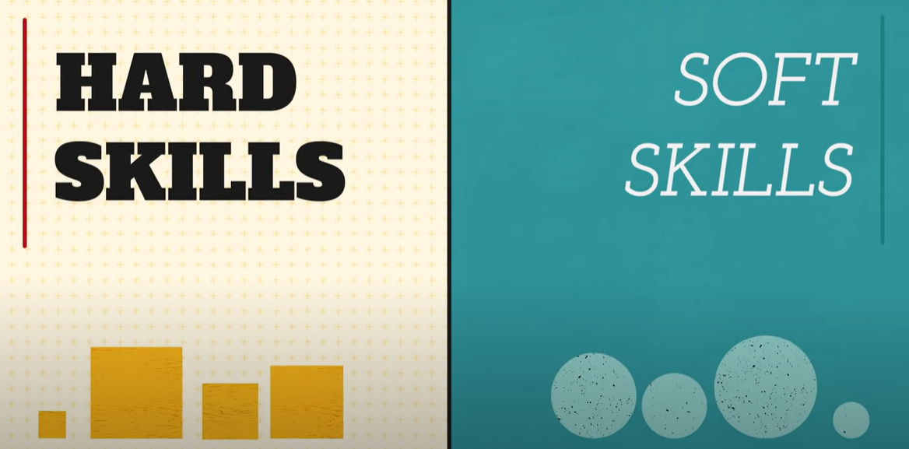
Video source: Learnfree.org, Hard Skills vs Soft Skills (youtube.com)
In the table below, for each employability skill provide an example of how you have shown/demonstrated/carried out this skill preferably in a workplace setting. You can use examples from:
- work experience,
- structured workplace learning
- volunteering
- a part-time/casual job you may have.
If you are just beginning your journey in accessing a workplace, you can use your school-based community participation and project work.
You can choose how you want to present your examples. Some ideas might include written explanations, short videos/short film, pictures, reviews or employer feedback. The choice is yours, but you need one specific example for each skill. You may need to collect this evidence over time.
Hint: If you want more information about the employability skills, you can click on the employability names in the left-hand column to watch a short video.
Employability skill | Your own evidence/example
Communication
Planning and organising
Teamwork
Problem solving
Self-management
Initiative and enterprise
Technology
Commitment to continuous learning

Task 3: Activity 3.1 Employability skills
Student reflection: How well did you go with this step? (Please tick the box below)
☐Not Submitted | ☐Beginning | ☐Consolidating | ☐Achieving | ☐Excelling
Student comment (optional):
Teacher feedback
☐Not Submitted | ☐Beginning | ☐Consolidating | ☐Achieving | ☐Excelling
Not Submitted: No work has been submitted or attempted for this activity. | Beginning: You have attempted some aspects of the tasks. To bump it up, you need to provide an example of how you have demonstrated the employability skills for all eight skills. | Consolidating: You have provided an example for most of the skills in this task. To bump it up, you need to provide an example of how you have demonstrated the employability skills for all eight skills. | Achieving: You have provided an example for all the eight employability skills in this task. Majority of the skills are shown in a workplace context. To bump it up, include details and plans for how you will show these skills in a workplace context in the future. Include specific details about what you need to do between now and then. | Excelling: You have provided an example for all the eight employability skills in this task. You have demonstrated the skills in a workplace context. The examples you have provided are clear demonstrations of the relevant employability skill in action. Well done!
Teacher comment:

Activity 3.2 Suggested occupations
Part 1: For this activity you will explore suggested occupations through the My Career Portfolio and My Future Platform. Follow the steps outlined below.
- Log into your my career portfolio platform where you developed an action plan in WRS Unit 1 via the link here: My Career Portfolio student login. On the home page select the ‘My Future’ square and click ‘GO’.
You will need to have an EDUPASS LOGIN to access this. If you are not sure, check with your teacher.

- In Myfuture tab click on the ‘My Career Profile’ tab below. Then select the third ‘suggested occupations’ tab in the top left-hand corner.
- Select three jobs from the ‘suggested occupations’ that you are most interested in and complete the table for each below.
Occupation 1: Add job name here.
Occupation overview | Technical skills required | Employability skills required
Occupation 2: Add job name here.
Occupation overview | Technical skills required | Employability skills required
Occupation 3: Add job name here.
Occupation overview | Technical skills required | Employability skills required

Task 3: Activity 3.2 Suggested occupations
Student reflection: How well did you go with this step? (Please tick the box below)
☐Not Submitted | ☐Beginning | ☐Consolidating | ☐Achieving | ☐Excelling
Student comment (optional):
Teacher feedback
☐Not Submitted | ☐Beginning | ☐Consolidating | ☐Achieving | ☐Excelling
Not Submitted: No work has been submitted or attempted for this activity. | Beginning: You have attempted some aspects of this task. To bump it up, you need to provide a response for all required parts of this task. | Consolidating: You have included most of the required information for three of your chosen ‘suggested occupations’. To bump it up, you need to include more details about what the job is and the required technical and employability skills to fulfil the role. | Achieving: You have included all the required information for three of your chosen ‘suggested occupations’. To bump it up, you need to expand your responses and add in additional information about what the job is as well as the required technical and employability skills needed to fulfil the role. Include information about how you are suitable for this type of role. | Excelling: You have included all the required information for three of your chosen ‘suggested occupations’. Your responses are highly detailed and include additional information about what the job is and the required technical and employability skills to fulfil the role. You have made connections and included specific information about how you are suitable for this type of role. Excellent work!
Teacher comment:

Have you completed the following activities for WRS Task 3: Technical and employability skills?
Task checklist
Before moving onto Work Related Skills Task 4: SMARTER capabilities and skills, students will have completed the following for Work Related Skills Task 3: Technical and employability skills.
☐ Activity 3.1 Employability skills
☐ Activity 3.2 Suggested occupations

Task 4: SMARTER capabilities and skills
Task checklist
Students will complete the following for Work Related Skills Task 4: SMARTER capabilities and skills.
☐ Activity 4.1 Planning for success
☐ Activity 4.2 SMARTER goals
☐ Activity 4.3 Career Action Plan update

Key vocabulary
Skill: The ability to do an activity or a job well.
Capability: The power or ability to do something.
Attribute: A quality or characteristic ascribed to someone or something.
Aptitude: A natural ability to do something/ ability to learn.
Transferable skills/employability skills: Skills that you possess that are useful to employers across various jobs and industries. Some examples of these would be communication, planning and organising, teamwork, problem solving, self-management, initiative and enterprise, technology and commitment to continuous learning.
Specialist: A person who has a particular skill or knows a lot about a particular subject.
Technical skills: Are specialised knowledge and expertise required to perform specific tasks and use specific tools and programs.

Activity 4.1 Planning for success
Part 1: In a pair, small group or table group, brainstorm different ways to plan for and develop skills and capabilities. You can choose how to do your brainstorm. Examples could be infographic, bubble chart, word dump or format of your own choice.
Add brainstorm here.
Part 2: In your pair, small group or table group discuss which way, method or strategy is best for planning, implementing, monitoring and evaluating a plan, action, goal or skill development. You need to be able to explain and justify your choice.
Add your group response here.
Part 3: Individually, select a rating for how likely you think you are to succeed without a plan compared to succeeding with some type of plan/process/method/structure.
Without | With
- No chance  - Unlikely  - Not likely  - Maybe  - Likely  - Highly likely | - No chance  - Unlikely  - Not likely  - Maybe  - Likely  - Highly likely

Task 4: Activity 4.1 Planning for success
Student reflection: How well did you go with this step? (Please tick the box below)
☐Not Submitted | ☐Beginning | ☐Consolidating | ☐Achieving | ☐Excelling
Student comment (optional):
Teacher feedback
☐Not Submitted | ☐Beginning | ☐Consolidating | ☐Achieving | ☐Excelling
Not Submitted: No work has been submitted or attempted for this activity. | Beginning: You have attempted some aspects of this task. To bump it up, you need to provide a response for all required parts of this task. | Consolidating: You have completed most parts of this task. You have provided a basic brainstorm and group response. To bump it up, you need to add more details to both your brainstorm and group response. | Achieving: You have completed most parts of this task. You have provided a basic brainstorm and group response. To bump it up, you need to add more details to both your brainstorm and group response. | Excelling: You have completed all parts of this task. You have provided a detailed brainstorm and group response. Great work!
Teacher comment:

Activity 4.2 SMARTER goals
Part 1: A key employability skill is the commitment to lifelong learning. Think back and reflect on the tasks you have completed over WRS Unit 2 Tasks 1-3 as you have learned about and explored your current knowledge and skills within the categories of personal capabilities, technical and employability skills.
Part 2: Watch the video below about what a SMARTER goal is.

Video source: Creative Huddle SMARTER goal setting (youtube.com)
Part 3: Set yourself one SMARTER goal for each of the three categories below.
Personal Capabilities options: Work ethic, conflict resolution, self-regulation and lifelong learning.
Goal 1 Personal Capability: Add one of the four options above.
Specific (simple, sensible, significant)
Measurable (meaningful, motivating)
Achievable (agreed, attainable)
Realistic (reasonable, realistic and resourced, results-based)
Timebound (time-based, time limited, time/cost limited, timely, time-sensitive)
Emotional (what does it mean to you?)
Rewarding (what does achieving this mean, feel or look like to you?)
Technical skills options: See Task 3: Activity 3.2 Suggested occupations to support with developing a technical skills goal.
Goal 2 Technical skills: Add occupation name here.
Specific (simple, sensible, significant)
Measurable (meaningful, motivating)
Achievable (agreed, attainable)
Realistic (reasonable, realistic and resourced, results-based)
Timebound (time-based, time limited, time/cost limited, timely, time-sensitive)
Emotional (what does it mean to you?)
Rewarding (what does achieving this mean, feel or look like to you?)
Employability skills options: Communication, panning and organising, teamwork, problem solving, self-management, initiative and enterprise, technology and commitment to continuous learning.
Goal 3 Employability skills: Add one of the eight employability skills options here.
Specific (simple, sensible, significant)
Measurable (meaningful, motivating)
Achievable (agreed, attainable)
Realistic (reasonable, realistic and resourced, results-based)
Timebound (time-based, time limited, time/cost limited, timely, time-sensitive)
Emotional (what does it mean to you?)
Rewarding (what does achieving this mean, feel or look like to you?)

Task 4: Activity 4.2 SMARTER goals
Student reflection: How well did you go with this step? (Please tick the box below)
☐Not Submitted | ☐Beginning | ☐Consolidating | ☐Achieving | ☐Excelling
Student comment (optional):
Teacher feedback
☐Not Submitted | ☐Beginning | ☐Consolidating | ☐Achieving | ☐Excelling
Not Submitted: No work has been submitted or attempted for this activity. | Beginning: You have attempted some aspects of this task. To bump it up, you need to provide a response for all required parts of this task. | Consolidating: You have attempted most parts of this task. You have provided basic responses in setting three SMARTER goals. To bump it up, you need to add more specific information to your goal responses. | Achieving: You have completed all parts of this task. You have provided basic responses in setting three SMARTER goals. To bump it up, you need to add more specific information to your goal responses. | Excelling: You have completed all parts of this task. You have provided detailed responses in setting three SMARTER goals. It is clear what you are working towards and what you want the result to be. Great work!
Teacher comment:

Activity 4.3 Career Action Plan update
Part 1: Update your career action plan through the My career portfolio platform.
Log into the my career portfolio platform to create an action plan via the link here: My Career Portfolio student login. On the home page select the ‘My Career Action Plan’ square and click ‘GO’. You can add your SMARTER goals from Task 4: SMARTER capabilities and skills Activity 4.3 Career Action Plan update.
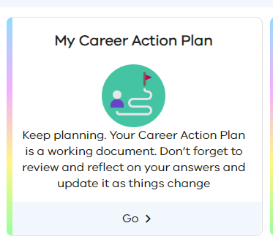
You will need to have an EDUPASS LOGIN to access this. If you are not sure, check with your teacher.
Part 2: Once you have updated your career action plan, add your updated plan into the space below.
Insert/add your career action plan here.

Task 4: Activity 4.3 Career Action Plan update
Student reflection: How well did you go with this step? (Please tick the box below)
☐Not Submitted | ☐Beginning | ☐Consolidating | ☐Achieving | ☐Excelling
Student comment (optional):
Teacher feedback
☐Not Submitted | ☐Beginning | ☐Consolidating | ☐Achieving | ☐Excelling
Not Submitted: No work has been submitted or attempted for this activity. | Beginning: You have attempted some aspects of your career action plan. To bump it up, you need to complete all required sections of your career action plan. | Consolidating: You have provided basic responses for most sections of your career action plan. To bump it up, complete all responses in your action plan and add additional details. | Achieving: You have provided basic responses for all sections of your career action plan. To bump it up, complete all responses in your action plan and add additional details. | Excelling: You have provided detailed responses for all sections of your career action plan. Great work!
Teacher comment:

Have you completed the following activities for WRS Task 4: SMARTER capabilities and skills?
Task checklist
Before moving onto Work Related Skills Task 5: Recap on technical and employability skills, students will have completed the following for Work Related Skills Task 4: SMARTER capabilities and skills.
☐ Activity 4.1 Planning for success
☐ Activity 4.2 SMARTER goals
☐ Activity 4.3 Career Action Plan update

Task 5: Recap on technical and employability skills
Task checklist
Students will complete the following for Work Related Skills Task 5: Recap on technical and employability skills.
☐ Activity 5.1 Career map/timeline
☐ Activity 5.2 Pathways for education, training and employment
☐ Activity 5.3 Technical and employability skills brainstorm and evaluation
☐ Activity 5.4 Technical and employability skills debate

Key vocabulary
Transferable skills/employability skills: Skills that you possess that are useful to employers across various jobs and industries. Some examples of these would be communication, planning and organising, teamwork, problem solving, self-management, initiative and enterprise, technology and commitment to continuous learning.
Specialist: A person who has a particular skill or knows a lot about a particular subject.
Technical skills: Specialised knowledge and expertise required to perform specific tasks and use specific tools and programs.
Educational pathway options: The different education and training options/choices to select from when working towards gaining employment in a specific industry or job.
Tangible skills: Having hard (tangible) skills indicates that you are suitable for a specific job and will need little or no training to get started.
Intangible skills: Your intangible (soft) skills show that you have the potential to move up and benefit the company's culture.

Activity 5.1 Career map/timeline
Part 1: You will develop and create a career timeline/map of someone whose career you admire or a person’s career that you are interested in following yourself. You can interview someone you know personally or research someone’s career journey online. You need to find out the following information and include it in your career timeline/map.
☐ What technical skills and formal qualifications were needed? Was this just one course or have they had to do more?
☐ What employability skills (soft/intangible skills) were required. Did they just learn this once or has it been ongoing?
☐ Timeline journey by year starting in school. Include information like work experience, part-time casual work, volunteering or community participation.
☐ Changes or breaks along the way.
☐ Successes
☐ Failures
☐ Key moment of opportunities/growth/development.
Use the space below to collate your information.
Part 2: Choose an online program such as Canva, Google slide, Prezi to visually present the career map or timeline infographic.
Worked example
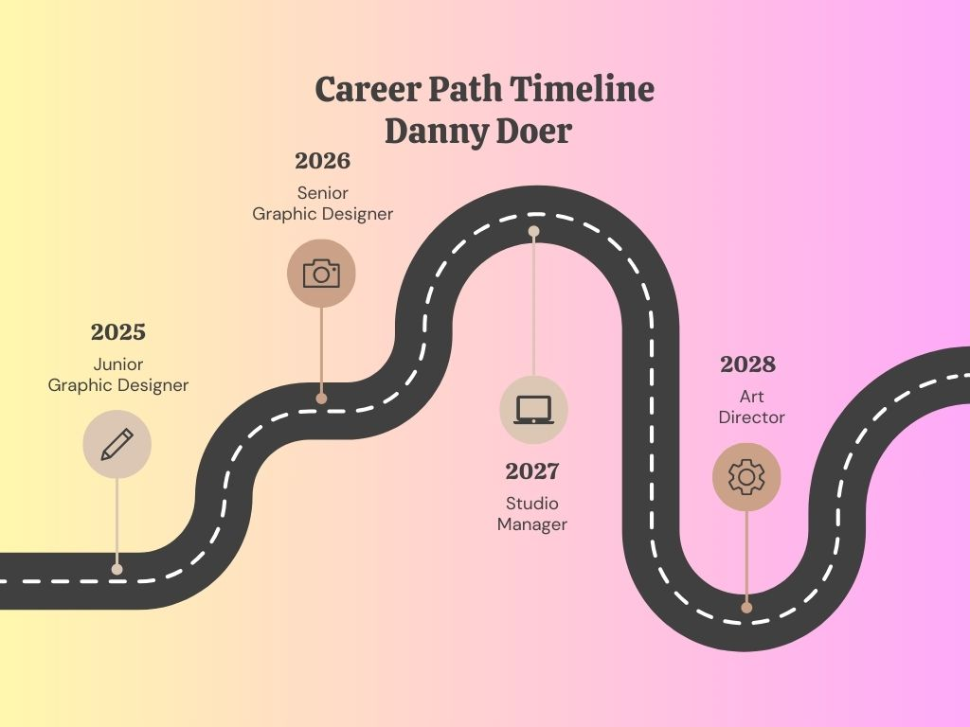
Insert your career map/timeline here.

Task 5: Activity 5.1 Career map/timeline
Student reflection: How well did you go with this step? (Please tick the box below)
☐Not Submitted | ☐Beginning | ☐Consolidating | ☐Achieving | ☐Excelling
Student comment (optional):
Teacher feedback
☐Not Submitted | ☐Beginning | ☐Consolidating | ☐Achieving | ☐Excelling
Not Submitted: No work has been submitted or attempted for this activity. | Beginning: You have attempted some aspects of your career map/timeline. To bump it up, you need to complete all required sections of your career map/timeline. | Consolidating: You have provided a basic career map/timeline of a person whose career journey interests you. Your career map/timeline is presented in a plain format. To bump it up, you need to check over the required information and include more information in your infographic. Use an online program to enhance your career/map timeline presentation. | Achieving: You have provided a detailed career map/timeline of a person whose career journey interests you. Your career map/timeline is presented in a plain format. To bump it up, use an online program to enhance your career/map timeline presentation. | Excelling: You have provided a highly detailed career map/timeline of a person whose career journey interests you. Your career map/timeline is presented in an aesthetically appealing format and easy for the viewer to read and understand. Excellent work!
Teacher comment:

Activity 5.2 Pathways for education, training and employment
Part 1: The role of ongoing training, education and industry experience is an essential part of learning and developing technical skills. Review the image below by following the arrows to explore what options you have in different qualifications to grow your technical skills.
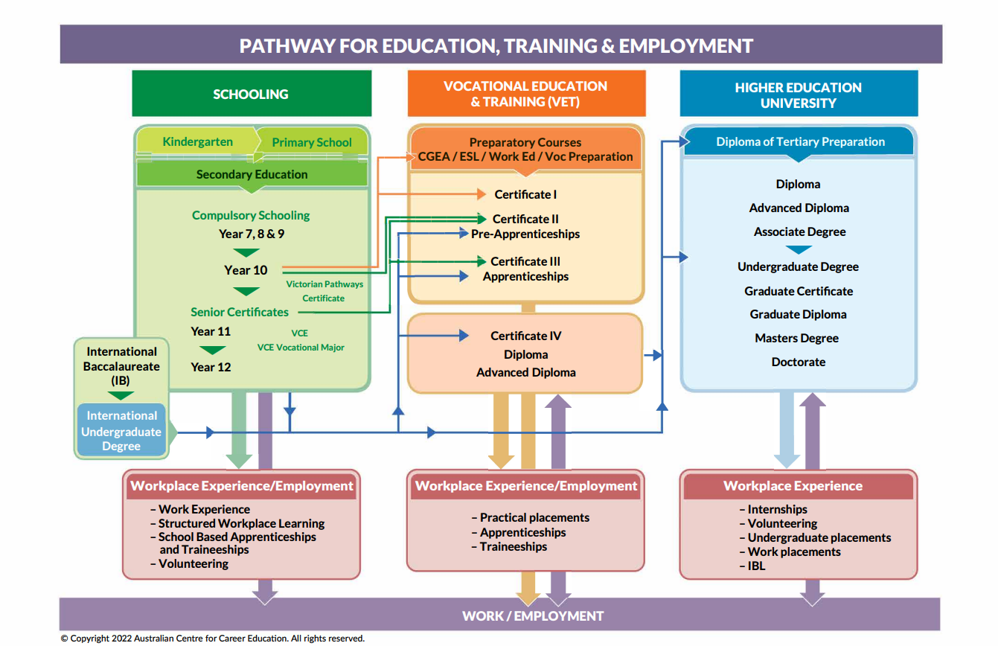
Image source: Australian Centre for Career Education(2022) on Arc website, VCE Lesson Plan 1 Pathways Diagram – What's next for me?
Teachers note: The linked source is only accessible with Edupass account.
Part 2: Using the information from the image in part 1 complete the table below.
Where are you at now in your technical skills journey? | What are some of the education, training and employment experiences you need to work through to develop your technical skills?

Task 5: Activity 5.2 Pathways for education, training and employment
Student reflection: How well did you go with this step? (Please tick the box below)
☐Not Submitted | ☐Beginning | ☐Consolidating | ☐Achieving | ☐Excelling
Student comment (optional):
Teacher feedback
☐Not Submitted | ☐Beginning | ☐Consolidating | ☐Achieving | ☐Excelling
Not Submitted: No work has been submitted or attempted for this activity. | Beginning: You have attempted some aspects of this task. To bump it up, you need to provide a response for all required parts of this task. | Consolidating: You have provided a basic response for where you are currently at in your technical skills. You have included some examples of qualifications you will need in the future. To bump it up, include all relevant technical skill qualifications and training that you will need. | Achieving: You have provided a basic response for where you are currently at in your technical skills. You have included some examples of qualifications you will need in the future. To bump it up, include all relevant technical skill qualifications and training that you will need. | Excelling: You have provided a detailed response for where you are currently at in your technical skills. You have included a range of examples of qualifications you will need into the future. Great work!
Teacher comment:

Activity 5.3 Technical and employability skills brainstorm and evaluation
Teacher advice: Modify task to suit how you want to structure the brainstorm.
Part 1: Add to the group brainstorm different ways you think you can develop both your technical and employability skills.
Hint: think about actions/things you can do.
Once the group brainstorm is complete, take a picture of the group contributions and add into the space provided below.
Technical skills
Add group brainstorm here.

Employability skills
Add group brainstorm here.
Part 2: Read over and review all the contributions from part 1. In both the technical and employability skills table below, you are going to allocate 3 points to your favourite idea, 2 points to your second favourite idea and 1 point to your third favourite idea.
Technical skills | Employability skills
3 points:  2 points:  1 point: | 3 points:  2 points:  1 point:
Part 3: Evaluate the positives and negatives of your 3-point idea from Part 2, for both technical and employability skill development.
Technical skill
Positives | Negatives
Employability skill
Positives | Negatives

Task 5: Activity 5.3 Technical and employability skills brainstorm and evaluation
Student reflection: How well did you go with this step? (Please tick the box below)
☐Not Submitted | ☐Beginning | ☐Consolidating | ☐Achieving | ☐Excelling
Student comment (optional):
Teacher feedback
☐Not Submitted | ☐Beginning | ☐Consolidating | ☐Achieving | ☐Excelling
Not Submitted: No work has been submitted or attempted for this activity. | Beginning: You have attempted some aspects of the task. To bump it up, you must respond to all parts of this activity. | Consolidating: You have provided a basic response for most parts of this task. To bump it up, you need to check over your task and complete all parts. Try to add more details to your responses. | Achieving: You have provided detailed responses for most parts of this activity. To bump it up, you need to complete all parts of this activity with detailed responses. You should include specific information about how this could apply to you. | Excelling: You have provided highly detailed responses to all parts of this activity. You have included how the ideas you have chosen can be applied to your own career growth and development. Great work!
Teacher comment:

Activity 5.4 Technical and employability skills debate
Teacher advice: Modify task to suit how you want to structure the discussion/debate.
Part 1: In consultation with your teacher, you will participate in a small group debate. You will be allocated a position of either technical or employability skills.
You will need to argue why the skill you have been allocated is better than the other skill and explain how these types of skills make you more successful in the workplace.
For your argument you will need to include the following in your prepared notes:
☐ State your position on the topic.
☐ Use evidence and examples to support why your allocated skill/s are more desirable in the workplace.
☐ Attempt to undermine the other skill and why it is not as good as your skill.
Add your preparation notes here.
Part 2: Actively participate and demonstrate respectful listening skills in your group debate.
Add a picture of your group here.
Part 3: After your group debate, write a reflection below about what was discussed. You need to include the following information.
☐ What are some of the best ways to develop your technical or employability skills?
☐ How could you apply these to your own career journey? Be specific.
☐ Is one technical or employability skill better than the other?
☐ Do you think you need both to be successful in the workplace?
☐ Why is ongoing training and learning important in your career journey? What does this skill give you?
Write your response here. Your response should be a minimum of three to five sentences.

Have you completed the following activities for WRS Task 5: Recap on technical and employability skills?
Task checklist
Before moving onto Work Related Skills Task 6: The recruitment process, students will have completed the following for Work Related Skills Task 5: Recap on technical and employability skills.
☐ Activity 5.1 Career map/timeline
☐ Activity 5.2 Pathways for education, training and employment
☐ Activity 5.3 Technical and employability skills brainstorm and evaluation
☐ Activity 5.4 Technical and employability skills debate

Task 6: The recruitment process
Task checklist
Students will complete the following for Work Related Skills Task 6: The recruitment process.
☐ Activity 6.1 Recruitment process steps
☐ Activity 6.2 Searching for jobs
☐ Activity 6.3 Creating your own job advertisement

Key vocabulary
Recruitment process: A recruitment process is a step-by-step approach that companies use to find suitable candidates to fill specific positions. This process varies depending on a company's organisational structure, operations, size and recruitment protocols.
Job design: Job design is a process that companies or businesses use to create a new job or add duties to an existing job.
Job advertisement: is a formal description of a vacant position in a company containing the nature of work, qualification, skill requirements and other important details related to a particular job. The purpose of a job advertisement is to attract employees by describing the benefits of the job.

Activity 6.1 Recruitment process steps
Part 1: The recruitment process is a step-by-step process that a workplace goes through, starting from identifying work that needs to be done through to someone being hired to do that work. Watch the video example below from Australia Post.
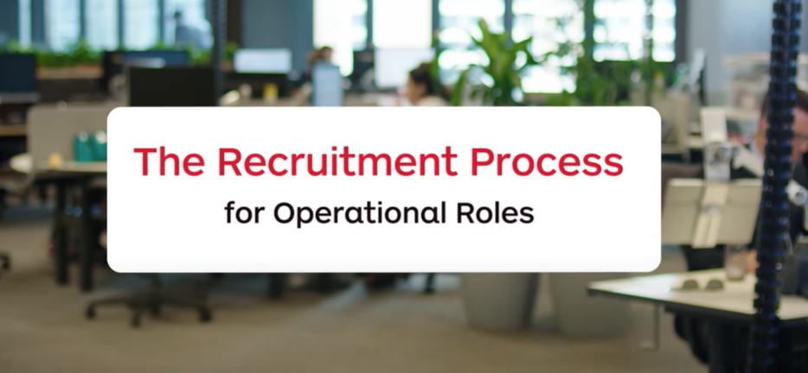
Video source: Australia Post, The Recruitment Process for Operational Roles (youtube.com)
For more information about the recruitment process, check out the following article: What Is a Job Advertisement? Everything You Need to Know
Part 2: Read the statements in the table below. Then, in the blank left-hand column place a number from 1 to 15 in each square that corresponds to the order of the steps taken in the recruitment process.
Teacher advice: Delete the number answers out in the left-hand column before giving this activity to your students.
7 | Review applications, resumes and cover letters and shortlist your top three to five candidates.
2 | Person responsible for recruitment develops a role description of work needed.
10 | Prepare questions for the interview.
5 | Check information for job descriptions and use the Fair Work Job advertisement templates to ensure correct and legal information about the job is advertised.
8 | Decide how you want to conduct the interview – whether in person, on the phone, zoom call. Then contact the person to schedule an interview.
15 | Contact unsuccessful candidates and provide them with feedback if suitable.
12 | Decide on your preferred candidate for the position.
4 | Job description is checked to comply with relevant Fair Work rules.
11 | Interview the candidates.
6 | Select your platform to promote the job opportunity. Allow suitable time for applicants to apply.
1 | Workplace identifies duties or work that needs to be completed.
9 | Decide how you want to conduct the interview in person, on the phone, zoom call and contact the person to schedule an interview.
13 | If they accept the job offer, organise relevant employment offer contract.
3 | Person for recruitment develops a description of the type of person needed to complete the role.
14 | Plan and organise the induction process and start date.

Task 6: Activity 6.1 Recruitment process steps
Student reflection: How well did you go with this step? (Please tick the box below)
☐Not Submitted | ☐Beginning | ☐Consolidating | ☐Achieving | ☐Excelling
Student comment (optional):
Teacher feedback
☐Not Submitted | ☐Beginning | ☐Consolidating | ☐Achieving | ☐Excelling
Not Submitted: No work has been submitted or attempted for this activity. | Beginning: You have attempted to number some of the steps in the recruitment process above. To bump it up, review the information and put an answer for each step in every box 1-15. | Consolidating: You have attempted to number most of the steps in the recruitment process above. To bump it up, review the information and put an answer for each step in every box 1-15. | Achieving: You have numbered all the steps in the recruitment process above. To bump it up, check over your answers to make sure they are in the correct order. | Excelling: You have numbered all the steps in the recruitment process above. You have numbered all 15 steps in the correct order. Well done!
Teacher comment:

Activity 6.2 Searching for jobs
Part 1: Using one of the online job search engines below, search for jobs in your local area. If there is a specific industry you want to know more about, include this in the search criteria.
You are going to collect information about three different jobs currently advertised:
Seek.com
Workforce Australia
Geelong Careers
Careers Victoria
Part 2: Take a screenshot of each job and insert the link to the job advertisement in the table below.
Job 1: Add job name here. | Job 2: | Job 3:
Add image of job advertisements here.
Add link to job advertisement here.
Part 3: Analyse and review the features and the recruitment process outlined for the three job advertisements you have selected. Compare and contrast the similarities and differences for each of the three jobs.
Similarities | Differences
1.  2.  3.  4.  5. | 1.  2.  3.  4.  5.
Part 4: Looking online via a job search site is not the only way to find available jobs. In the space below list as many other different ways you can think of to find out about available jobs.

Task 6: Activity 6.2 Searching for jobs
Student reflection: How well did you go with this step? (Please tick the box below)
☐Not Submitted | ☐Beginning | ☐Consolidating | ☐Achieving | ☐Excelling
Student comment (optional):
Teacher feedback
☐Not Submitted | ☒Beginning | ☐Consolidating | ☐Achieving | ☐Excelling
Not Submitted: No work has been submitted or attempted for this activity. | Beginning: You have attempted some aspects of this task. To bump it up, you need to complete all parts of this activity with basic responses. | Consolidating: You have demonstrated a basic understanding of where to find jobs and the similarities and differences between different job advertisements of your choice. To bump it up, add more details to your list of different ways to find other available jobs. | Achieving: You have demonstrated a basic understanding of where to find jobs and the similarities and differences between different job advertisements of your choice. You have listed two to three other ways to find available jobs in your list. To bump it up, evaluate and make comments on the effectiveness of the job advertisements and add more details to your list of different ways to find other available jobs. | Excelling: You have demonstrated that you understand where to find jobs and the similarities and differences between different job advertisements of your choice. You have listed a range of informal and formal ways to find available jobs in your list. Excellent work!
Teacher comment:

Activity 6.3 Creating your own job advertisement
Part 1: Create your own job advertisement using a digital program of your choice. Your job advertisement should be presented in a formal format that would be ready to publish online. Select an option below by ticking the box for the job advertisement you would like to create.
Options:
☐ Create a job advertisement for your dream job.
☐ You need help for your school community project. Create a job advertisement for an extra person to join your team.
☐ You are the owner of a very successful slime company. Your top slime tester who picks award winning products spilt their coffee and burnt their hands. You need an expert slime product tester to start as soon as possible for 3 months while your top slime tester recovers.
☐ Create your own scenario with your teacher’s approval.
Use the checklist below when creating your job advertisement to make sure you include all the relevant details.
☐ You have used the Fair Work template to develop the information for your job advertisement.
☐ Your job advertisement language is inclusive and non-discriminatory.
☐ You have checked over any spelling or grammar errors.
☐ You have put your job advertisement into a presentable format (such as Canva) to make it stand out compared to others!
Insert your job advertisement here.

Task 6: Activity 6.3 Creating your own job advertisement
Student reflection: How well did you go with this step? (Please tick the box below)
☐Not Submitted | ☐Beginning | ☐Consolidating | ☐Achieving | ☐Excelling
Student comment (optional):
Teacher feedback
☐Not Submitted | ☐Beginning | ☐Consolidating | ☐Achieving | ☐Excelling
Not Submitted: No work has been submitted or attempted for this activity. | Beginning: You have attempted some aspects of the task. To bump it up, you need to check over the requirements for developing a job advertisement. | Consolidating: You have created a basic job advertisement. Most of the required information is included. To bump it up, you need to check over all requirements for developing a job advertisement to see what else you should include. | Achieving: You have created a detailed job advertisement. Most of the required information is included. The presentation of your job advertisement is simple. To bump it up, you need to check over all requirements for developing a job advertisement to see what else you should include. Use an online platform such as Canva to present your job advertisement so that it stands out. | Excelling: You have created a detailed job advertisement. All the relevant information has been included. You have used an online platform to present your job advertisement in a creative way. Well done!
Teacher comment:

Have you completed the following activities for WRS Task 6: The recruitment process?
Task checklist
Before moving onto Work Related Skills Task 7: Preparing, applying and interviewing for a job, students will have completed the following for Work Related Skills Task 6: The recruitment process.
☐ Activity 6.1 Recruitment process steps
☐ Activity 6.2 Searching for jobs
☐ Activity 6.3 Creating your own job advertisement

Task 7: Preparing, applying and interviewing for a job
Task checklist
Students will complete the following for Work Related Skills Task 7: Preparing, applying and interviewing for a job.
☐ Activity 7.1 Resume
☐ Activity 7.2 Cover letter
☐ Activity 7.3 Key selection criteria
☐ Activity 7.4 Preparing and participating in an interview
Key vocabulary
Resume: A resume is one of the documents employers may request you to submit as part of an application package. Resumes allow applicants the opportunity to describe their experience and skills in their own words.
Cover letter: A cover letter is a one-page document you send with your resume that provides additional information about skills and experiences related to the job you're pursuing.
Key selection criteria: This criteria relates to the qualifications, fundamental skills, work experience and industry knowledge required for a role.
Group interview: A group interview is a meeting format with several candidates and one interviewer and is often used when employers are looking to hire for more than one position on a short timeline.
Job interview: A formal interview in which a job applicant must answer questions, especially in a professional manner, to determine whether they are suitable for the job applied for.

Activity 7.1 Resume
Part 1: Using the table below, collate key information about yourself that outlines your current skills, qualifications and experience in preparation to create a resume.
Full name and contact details (email and phone number) | First and last name  Contact number  Email address
Career goal/aim | My aim is to gain casual employment in a reputable business where I can become a valuable member of a team and develop my experience in the workplace.
Personal attributes/interests | Add your own specific information here.
Education | Year Level  Senior Secondary Certificate Name  Subjects you are studying  Any VET programs: Certificate II in…
Work experience | Name of business  Roles/work you did  Timeframe of how long you worked there for
Community participation or volunteering experience | Add your own specific information here.
Employability skills  (choose some that you have a specific example for) | Pick two-three skills to outline:  - Communication – include a specific example.  - Planning and organising – include a specific example.  - Teamwork – include a specific example.  - Problem solving – include a specific example.  - Self-management – include a specific example.  - Initiative and enterprise – include a specific example.  - Technology – include a specific example.  - Commitment to continuous learning – include a specific example.
Technical skills (if any) | Any type of qualification/certificate examples could be:  Food Handler’s certificate  Barista Course  First Aid Certificate
Awards/achievements (any context) | Can be any type of award/recognition you have received.
Availability | List when you are available to work, taking into account your school and own personal life commitments.

Part 2: Using the information from Part 1, log into Canva and create a formal resume. Follow the steps below.
Creating a resume steps:
- Create and log in to your Canva account - Canva Help Centre
- In the search templates section at the top, type in resume template.
- Choose a template that is appropriate for the jobs and positions you may like to apply for.
- In the resume template of your choice, copy and paste the information you have prepared from Part 1.
- Check over your resume for any spelling mistakes or errors.
- In your resume template, click on the ‘Share’ button in the top right-hand corner. Change the settings to ‘Anyone with the link’ and ‘Can Edit’. Select copy link. Then paste the resume link into the space provided below.
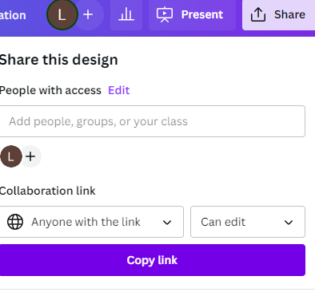
Image source: https://www.canva.com/
Resume Link | Right click and select paste to insert resume link here.
Part 3: Ask a peer to review your resume and complete the feedback table for you below.
Peer feedback
No spelling or grammar mistakes. | Choose an item.
Easy to understand and makes sense. | Choose an item.
Gives you an understanding of who the person is. | Choose an item.
Resume is presented in a formal way. | Choose an item.
Name of Peer:
Date:
Peer comment:
Part 4: Ask your teacher to review your resume and complete the feedback table for you below.
Teacher feedback
No spelling or grammar mistakes. | Choose an item.
Easy to understand and makes sense. | Choose an item.
Gives you an understanding of who the person is. | Choose an item.
Resume is presented in a formal way. | Choose an item.
Name of teacher:
Date:
Teacher comment:
Part 5: Once you have received feedback from both a peer and teacher, make any relevant changes to your resume. Add the final version of your resume in the space provided below.
Add your final resume here.

Task 7: Activity 7.1 Resume
Student reflection: How well did you go with this step? (Please tick the box below)
☐Not Submitted | ☐Beginning | ☐Consolidating | ☐Achieving | ☐Excelling
Student comment (optional):
Teacher feedback
☐Not Submitted | ☐Beginning | ☐Consolidating | ☐Achieving | ☐Excelling
Not Submitted: No work has been submitted or attempted for this activity. | Beginning: You have attempted some aspects of the task. To bump it up, you need to complete all parts of this activity with basic responses. | Consolidating: You have provided basic responses for most parts of this task. You have developed a basic resume. To bump it up, use Canva to make your resume more aesthetically appealing so it stands out to employers. | Achieving: You have provided detailed responses for most parts of this task. You have developed a basic resume in a generic format. To bump it up, use Canva to make your resume more aesthetically appealing so it stands out to employers. | Excelling: You have provided highly detailed responses for all aspects of this task. You have used Canva to make your resume more aesthetically appealing, so it stands out to employers. Your resume is free of spelling and grammar errors. Well done on the professional presentation of your resume.
Teacher comment:

Activity 7.2 Cover letter
Part 1: You are going to create your own cover letter. Your resume is the document that gives a summary of your skills, knowledge and experience. Your cover letter needs to be tailored to the specific job you are applying for. Watch the video below outlining what you need in a cover letter.
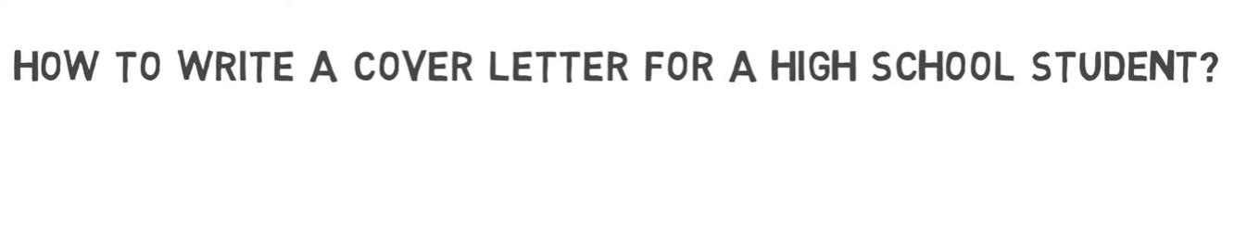
Video source: René Delescen, How To Write A Cover Letter For A High School Student? | Example (youtube.com)
Part 2: Create a base cover letter template that you can modify each time you would like to apply for a specific job. See the worked example below as a guide. Add your own cover letter into the space provided below.
Worked example

Your name
Contact number
Address
Email address

To whom it may concern, (try to find out the person’s name who you need to address the cover letter to, often the job contact name is listed on the advertisement).

I wish to express my interest in the position (job title) currently advertised (where you saw the job advertisement listed).

My name is (your name). I’m (age) years old and I am currently completing Year (enter year level) undertaking the (VCE or VCE Vocational Major) at (Enter school name). In addition to my senior studies, I am currently completing a (Certificate II/III in Cert name) at (Institute name).

I am excited by the opportunity to join the team at (business name). I am a considerate person who is honest and reliable (list employability skills related to you). I have a strong work ethic, work well in a team and take initiative to find jobs that need to be done (include some personal capability examples).

I’d like to thank you for taking the time to review my cover letter and resume attached for the role of (job title).

I look forward to speaking with you shortly to discuss my suitability for the role of (job title)

Yours sincerely,

(Your name)

Add your own cover letter template here.
Part 3: Using the information from Part 2, log into Canva and create a formal cover letter that matches your resume from Task 7 Activity 7.1.
Follow the steps below:
Creating a cover letter steps
- Create and log in to your Canva account - Canva Help Centre
- In the search templates section at the top, type in cover letter template.
- Choose a template that matches your resume template. Aim for the same colour, text and presentation so that the resume and cover letter look like a pair. You can often find this with the resume template you picked previously.
- In the cover letter template, copy and paste the information you have prepared above in Part 2.
- Check over your resume for any spelling mistakes or errors.
- In your cover letter template, click on the ‘Share’ button in the top right-hand corner. Change the settings to ‘Anyone with the link’ and ‘Can Edit’. Select copy link. Then paste the resume link into the space provided below.
Image source: https://www.canva.com/
Cover letter link | Right click and select paste to insert cover letter link here.
Part 4: Ask a peer to review your cover letter and complete the feedback table for you below.
Peer feedback
No spelling or grammar mistakes. | Choose an item.
Easy to understand and makes sense. | Choose an item.
Gives you an understanding of who the person is. | Choose an item.
Cover letter is presented in a formal way. | Choose an item.
Part 5: Ask your teacher to review your cover letter and complete the feedback table for you below.
Teacher feedback
No spelling or grammar mistakes. | Choose an item.
Easy to understand and makes sense. | Choose an item.
Gives you an understanding of who the person is. | Choose an item.
Resume is presented in a formal way. | Choose an item.
Name of teacher:
Date:
Teacher comment:

Part 6: Once you have received feedback from both a peer and teacher, make any relevant changes to your cover letter. Add the final version of your cover letter in the space provided below.
Add your final cover letter here.

Task 7: Activity 7.2 Cover letter
Student reflection: How well did you go with this step? (Please tick the box below)
☐Not Submitted | ☐Beginning | ☐Consolidating | ☐Achieving | ☐Excelling
Student comment (optional):
Teacher feedback
☐Not Submitted | ☐Beginning | ☐Consolidating | ☐Achieving | ☐Excelling
Not Submitted: No work has been submitted or attempted for this activity. | Beginning: You have attempted some aspects of the task. To bump it up, you need to complete all parts of this activity with basic responses. | Consolidating: You have provided basic responses for most parts of this task. You have developed a basic cover letter. To bump it up, check over your cover letter and add more details. | Achieving: You have provided detailed responses for most parts of this task. You have developed a basic cover letter in a generic format. To bump it up, use Canva to make your cover letter more aesthetically appealing so it stands out to employers. | Excelling: You have provided highly detailed responses for all aspects of this task. You have used canva to make your cover letter more aesthetically appealing, so it stands out to employers. Your cover letter is free of spelling and grammar errors. Well done on the professional presentation of your cover letter.
Teacher comment:

Activity 7.3 Key selection criteria
Part 1: Read over the information below regarding key selection criteria for job applications. It is unlikely that a senior secondary school student would apply for jobs that require key selection criteria. Depending on the career pathway you take, at some later stage, it’s likely you will need to write responses to key selection criteria.
Right now, you might be thinking: What is key selection criteria and how do I respond if I apply for a job that has key selection criteria?
According to My future website:
Key selection criteria describe the personal qualities, skills, abilities, knowledge and qualifications a person needs to perform a role effectively. Many employers use key selection criteria to determine which applicants are a good fit for a role. Examining a job's key selection criteria can also be a good way for you to find out whether the role is a good fit for you too.
To address the criteria, you must:
- demonstrate capability by providing evidence of how you meet the selection criteria
- provide specific details of when, where and how you have applied the skill in the past
- where possible, include an indicator of success, such as exceeding key performance indicators.
Part 2: Watch the video below on using the STAR model that helps people structure their written responses to selection criteria.
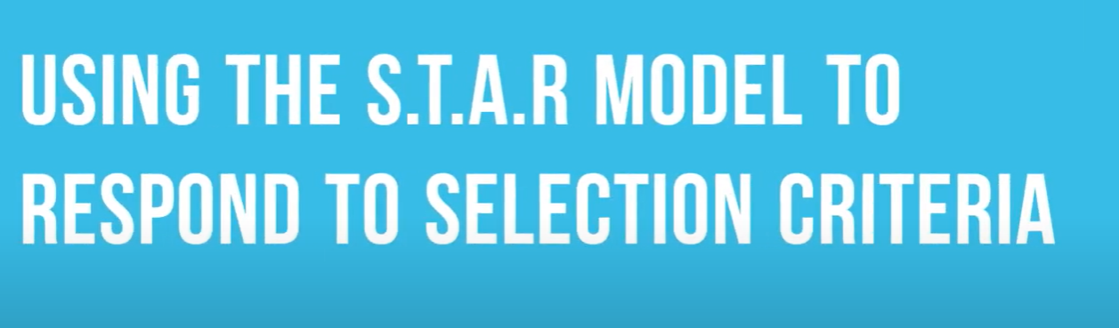
Video source: Workskills, Use the STAR method to write to selection criteria (youtube.com)
STAR stands for:
Situation: Describe your role and responsibility
Task: Describe the task, project or outcome you were required to achieve
Action: Describe what you did and how you did it
Result: Describe the outcomes.
Part 3: Look at the example below of a position description.
Teachers should find an appropriate position description to insert into the document here for the next activity. Be sure to find one that includes information about key selection criteria so that students have material to use for the next activity (Part 4).
INSERT POSITION DESCRIPTION HERE
To apply for this position, you would need a customised cover letter and resume for the role. Then you will need a third document to address the position description selection criteria and capabilities. If you do not address the selection criteria outlined in position descriptions for jobs, you drastically reduce your chances of receiving an opportunity to have a job interview for the role. Reading all the requirements for a job application process is an important skill!
Part 4: From your understanding of key selection criteria, respond to the statements below by selecting TRUE or FALSE.
Statement | Select true or false
Every job I apply for will require me to respond to key selection criteria. | Choose an item.
I will still get an interview if I don’t include key selection criteria. | Choose an item.
There are specific ways to respond to key selection criteria. | Choose an item.
I need to include specific examples in my key selection criteria. | Choose an item.
Key selection criteria details give me more information about what is required within the job’s roles and responsibilities. | Choose an item.

Task 7: Activity 7.3 Key selection criteria
Student reflection: How well did you go with this step? (Please tick the box below)
☐Not Submitted | ☐Beginning | ☐Consolidating | ☐Achieving | ☐Excelling
Student comment (optional):
Teacher feedback
☐Not Submitted | ☐Beginning | ☐Consolidating | ☐Achieving | ☐Excelling
Not Submitted: No work has been submitted or attempted for this activity. | Beginning: You have attempted some aspects of the task. To bump it up, you need to complete all parts of this activity. | Consolidating: You have responded to most of the true or false statements. To bump it up, you need to select a response for all true/false statements. | Achieving: You have responded to all the true or false statements. To bump it up, you need to check over your answers and make sure your responses are correct. | Excelling: You have responded to all the true or false statements. All your responses are correct. Well done!
Teacher comment:

Activity 7.4 Preparing and participating in an interview
Teacher Advice: Add specific information about who the students will be participating in an interview with and how. For example, this could be run in support of your local LLEN team. Modify this task to suit your own context.
Part 1: With a peer, take turns asking and answering the practice job interview questions below. You will swap roles and take turns to be both the interviewer and the interviewee.
Practice interview questions
- Can you tell me a little about yourself?
- Why are you interested in this job?
- What skills or experiences do you have that make you a good fit for this position?
- How do you manage your time between school and other activities?
- Can you describe a challenging situation you faced and how you handled it?
- What are your strengths and weaknesses?
- Where do you see yourself in five years?
- How do you handle working in a team? Can you give an example?
- What motivates you to do your best work?
- Do you have any questions for us about the job or the company/business?
After your practice session complete the peer feedback form below for the person you worked with.
Your name: | What did they do well? | One suggestion for improvement?
Peer name:
Part 2: Job interviews can make us feel nervous and anxious! This is normal! The more we plan and prepare, the smoother our job interview is likely to go. Watch the video below on how to use the STAR method to respond to interview questions. This method is helpful for interview questions where they want an example of what we have done previously. Using this method helps us directly respond to the question.
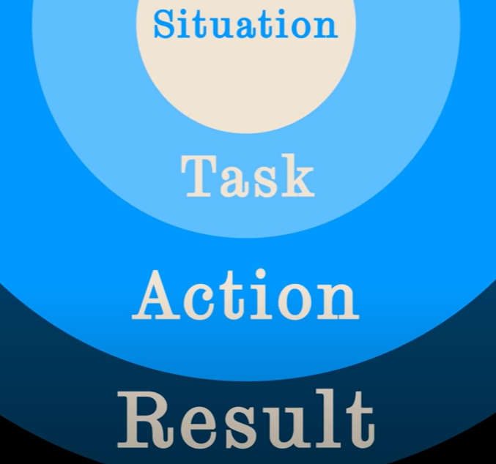
Video source: FutureLearn, Job interview tips: the STAR method (youtube.com)
Prepare some standard responses for potential job interview questions below. For some questions it will be helpful to use the STAR method.
- Can you tell me a little about yourself? This is a very common job interview question but not one for which you would use the STAR method. Plan a brief response in the space provided below.
- Can you describe a challenging situation you faced and how you handled it?
Situation
Task
Action
Result
- How do you handle working in a team? Can you give an example?
Situation
Task
Action
Result
- What are your strengths and weaknesses?
- The sign of a good worker is someone who takes initiative. Can you describe a situation when you have shown initiative?
Situation
Task
Action
Result
Part 3: With a teacher or trusted adult, get them to ask you interview questions. You can use the questions from Parts 1 and 2, but also ask the person you are practicing with to include some that you haven’t planned or prepared for. After you have practiced with your trusted adult, ask them to fill out the feedback table below.
Your name: | What did they do well? | One suggestion for improvement?
Their name:
Part 4: Participate in a practice interview. Treat this interview the same as you would a real interview. You will receive feedback about your performance. For evidence of your participation provide the following below:
☐ A picture with the interviewer
or
☐ Written feedback from the interviewer
Add evidence of your interview participation here.

Task 7: Activity 7.4 Preparing and participating in an interview
Student reflection: How well did you go with this step? (Please tick the box below)
☐Not Submitted | ☐Beginning | ☐Consolidating | ☐Achieving | ☐Excelling
Student comment (optional):
Teacher feedback
☐Not Submitted | ☐Beginning | ☐Consolidating | ☐Achieving | ☐Excelling
Not Submitted: No work has been submitted or attempted for this activity. | Beginning: You have attempted some aspects of the task. To bump it up, you need to complete all parts of this activity. | Consolidating: You have attempted some parts of this activity. To bump it up, you need to spend more time practicing in preparation for your interview. | Achieving: You have participated in all parts of this activity. To bump it up, practice giving more details in your answers to interview questions, reflecting your strengths and initiatives you’ve taken. | Excelling: You have proactively participated in all aspects of this activity. You have taken time to prepare and practice for your interview. You have encouraged your peers and demonstrated that not getting things perfect is an important part of learning. Excellent work!
Teacher comment:

Have you completed the following activities for WRS Task 7: Preparing, applying and interviewing for a job?
Task checklist
Students will have completed the following for Work Related Skills Task 7: Preparing, applying and interviewing for a job.
☐ Activity 7.1 Resume
☐ Activity 7.2 Cover letter
☐ Activity 7.3 Key selection criteria
☐ Activity 7.4 Preparing and participating in an interview

