Victorian Pathways Certificate

Unit 2: Uniting communities


Numeracy curriculum support materials

Acknowledgement
The Victorian Curriculum and Assessment Authority proudly acknowledges and pays respect to Victoria’s Aboriginal and Torres Strait Islander communities and their rich and enduring cultures.
We acknowledge Aboriginal and Torres Strait Islander people as Australia’s first peoples and as the Traditional Owners and custodians of the lands and waters on which we rely. We pay respect to Elders past and present of the lands where we conduct our work and recognise their ongoing contributions as the first educators on the land now known as Victoria.
Authorised and published by the Victorian Curriculum and Assessment Authority
Level 7, 200 Victoria Parade
East Melbourne VIC 3002
ISBN: 978-1-923204-72-0
© Victorian Curriculum and Assessment Authority 2025
No part of this publication may be reproduced except as specified under the Copyright Act 1968 or by permission from the VCAA. Excepting third-party elements, schools may use this resource in accordance with the VCAA educational allowance. For more information go to vcaa.vic.edu.au/footer/copyright
The VCAA provides the only official, up-to-date versions of VCAA publications. Details of updates can be found on the VCAA website at vcaa.vic.edu.au
This publication may contain copyright material belonging to a third party. If you believe that material in this publication is an infringement of your copyright, please email the Copyright Officer vcaa.copyright@education.vic.gov.au
Copyright in materials appearing at any sites linked to this document rests with the copyright owner/s of those materials, and is subject to the Copyright Act. The VCAA recommends you refer to copyright statements at linked sites before using such materials.
The VCAA logo is a registered trademark of the Victorian Curriculum and Assessment Authority.

Contact us if you need this information in an accessible format, for example, large print or audio.
Telephone (03) 9032 1629 or email vcaa.publications@education.vic.gov.au

Contents
Contents i
Using this resource 1
Student and teacher actions 2
Numeracy activities 3
Task 1: Measurement in baking 3
Task 2: Measurement and ordering 7
Task 3: What is the time? 12
Task 4: Shapes 16
Task 5: Data 23
Task 6: Chance 28

Using this resource
- This curriculum resource is an example and shows one way a school could deliver the Victorian Pathways Certificate (VPC) and VCE Vocational Major (VCE VM) through an integrated approach to teaching and learning.
- You will need to make changes to the curriculum resource to best suit your cohort’s needs and abilities by adding or removing scaffolds, and to tailor resources to your school's context. When modifying this curriculum resource, please review the relevant VCAA VPC curriculum design and check that the relevant modules, learning goals, applications and assessment requirements are still being addressed.
- This document is a companion to the suite of curriculum support materials for VPC Unit 2: Uniting Communities. Read over the ‘Advice for teacher delivery and assessment summary’ in detail before delivery. Applied learning requires proactive planning and preparation prior to delivery. The curriculum resource does not function like a traditional text or workbook. Pre-work and modifications are required to use this curriculum resource effectively.
- Unit preparation checklists in the ‘Advice for teacher delivery and assessment summary’ highlight key actions to be completed by the teacher prior to the overall unit delivery. It is essential for teachers to review and use the unit checklists prior to implementing or using this curriculum resource.
- This curriculum resource is designed to support your teaching and does not replace you as the teacher. How you deliver the resource and run applied learning activities to support your program is a teacher and school-based decision. Explicit instruction, teacher support and monitoring of student progress is still required.
- In accordance with the Pillars of Applied Learning (POAL) all assessment tasks are flexible and open to negotiation. To support individual students to successfully achieve learning goals, modification in collaboration is encouraged.
- This curriculum resource includes links to third party materials as examples for teacher reference only. It is not mandatory to use any of these materials or third party services. Inclusion of links to these materials does not constitute VCAA endorsement of the views or content contained in or linked from these sites. Teachers are advised to use their own judgement in determining what is appropriate for their students and school community. Teachers should ensure that any information or activity complies with their school or organisation’s policies.

Student and teacher actions
Within the student task activities, the following icons indicate these actions:
 | For teacher awareness, advice and information. Should be deleted before providing to students.
 | To be adapted or changed to the relevant educational context.
 | The teacher needs to hyperlink or add in their own documents or links to resources for their students to access the correct information from their own school-based documents.
 | Indicates ‘how to’ IT, document support or general guidance for students. Teachers can decide to leave this in or remove it.
 | Indicates to students which activities can be completed and submitted for assessment as a group.
 | Indicates to students which activities need to be completed and submitted for assessment individually.
 | Indicates to students which activities will be completed with a peer.

Numeracy activities

Task 1: Measurement in baking
Learning goals and application
Application:
1.2 Order and compare simple everyday measures and quantities
1.3 Recognise familiar and commonly used units of metric measurement
1.4 Read common and familiar dates and times using digital and analogue clocks

Task checklist
☐ Task 1: Measurement in baking
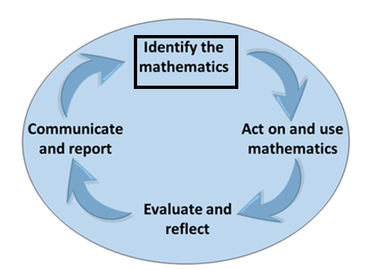
Identify the mathematics: Recognise, select and interpret the mathematical information embedded in a real-world context and decide what mathematics to use.
Part 1: In a small group, think of when you would use the following types of units of measurements in a real-world example.
Unit of measurement: | Real-world example:
Distance: e.g. Centimetres (cm), Metres (m) Kilometres (Km)
Time: e.g. Seconds, Minutes, Hours, Days
Temperature: e.g. Degrees Celsius
Calendar: e.g. Days of the Week, Months of the Year
Weight: e.g. Grams, Kilograms
Teacher advice: In Part 2, have students engage in a practical activity involving cooking. Include a recipe in the table below, based on what you have access to and what students choose to cook. Include all aspects of a recipe needed for students to complete the activity for Part 2.
Part 2: Read through the recipe below. Highlight any terms related to measurement, for example temperature, time, units of measurement etc.
Add recipe here
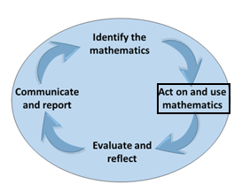
Act on and use mathematics: Perform mathematical actions and processes to complete a task – including the use and application of a range of mathematical processes.
Part 3: Share with the class and highlight any terms that you missed.
Part 4: Baking time – You demonstrate your understanding of quantity and measurement as you work through the recipe. Throughout the task, you use the checklist provided to guide your progress.
Part 5: As you bake once you’re confident with the skill you can tick this off your checklist. The teacher observes and completes the teacher's checklist as you demonstrate each skill.
Skill | Student checklist | Teacher observation checklist
Time  Students demonstrate their understanding by:  - Setting timers.  - Understanding how long it will take to complete the activity.  - Identifying the starting time of the session.  - Identifying the end time of the session. | ☐ | ☒
Temperature  Students demonstrate their understanding by:  - Identifying the temperatures within the recipe.  - Pre-heating the oven to a certain temperature. | ☐ | ☐
Measurement  Students demonstrate their understanding by:  - Using the ‘cup’ and ‘spoon’ measurements.  - Using scales to measure out grams. | ☐ | ☐
Liquid measurement  Students demonstrate their understanding by:  - Demonstrating to the teacher that they can measure out 10 ml, 100 ml and 1 L of liquid. | ☐ | ☐
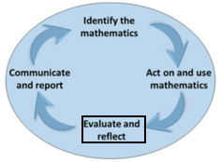
Evaluate and reflect: Check and reflect on the mathematical problem-solving processes and outcomes in relation to the real-world context.
Part 6: Arrange the following grams in order, from the largest to the smallest.
115 grams unsalted butter
90 grams brown sugar
50 grams caster sugar
5 grams vanilla extract
210 grams plain flour
2.5 grams baking soda
1 gram salt
150 grams chocolate chips
Largest: 150 grams of chocolate chips
Smallest: 1 gram of salt
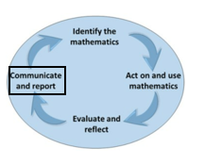
Communicate and report: Use a combination of informal and formal mathematical representations to document and report outcomes and results.
Part 7: Complete the following self-reflection:
Self-reflection
On a scale of 1 to 10 (1 being not confident at all, 10 being extremely confident):  How confident are you to recognise and use different measures and quantities? | Insert rating here.
Explain why you have rated your confidence the way that you have. | Explain your rating here.
Part 8: Complete the table below.
Mathematical tool, formula or concept. | Explain what this tool, formula or concept is. | How/when is this tool, formula or concept needed/used? | What is the accuracy level of this tool, formula or concept? (Low, Medium, High) | How likely are you to use this tool, formula or concept? (Rate 1 to 5) | Do I need to add this tool, formula or concept to my numeracy toolkit? (Tick if yes)
Kitchen scale |  |  |  | Choose a rating | ☐
Timer |  |  |  | Choose a rating | ☐
Grams |  |  |  | Choose a rating | ☐
Litres |  |  |  | Choose a rating | ☐
Degrees |  |  |  | Choose a rating | ☐
(insert more rows if required) |  |  |  | Choose a rating | ☐
Part 9: Swap booklets with a peer and conduct a peer assessment of their work (choose from the drop-down menu: Not Shown, Not Yet Complete or Complete). Make sure that you provide verbal feedback to your peer about what they have done well and what they need to do to improve their responses, as well as writing down your feedback below.
Peer feedback
Parts 1 & 2 | Identify the mathematics | Choose an item.
Parts 3, 4 & 5 | Skill demonstration | Choose an item.
Part 6 | Ordering measurements | Choose an item.
Part 7 | Reflect | Choose an item.
Part 8 | Report table | Choose an item.
Name of Assessor:
Assessor comment:

Task 1: Measurement in baking
Student reflection: How well did you go with this step? (Please tick the box below)
☐Not Submitted | ☐Beginning | ☐Consolidating | ☐Achieving | ☐Excelling
Student comment (optional):
Teacher feedback
☐Not Submitted | ☐Beginning | ☐Consolidating | ☐Achieving | ☐Excelling
Not Submitted: No work has been submitted or attempted for this task. | Beginning: You have attempted some of the activity. To bump it up, you need to attempt all parts of the task. | Consolidating: You have ordered and compared simple everyday measures and quantities. You have used familiar and commonly used units of measurements, with prompting and support. You have recorded times and used time recording devices. To bump it up, consider what you could do to support you next time to need less prompting. | Achieving: You have ordered and compared simple everyday measures and quantities. You have used familiar and commonly used units of measurements. You have recorded times and used time recording devices. To bump it up, check over your responses to make sure the answers you have provided are accurate. | Excelling: You have ordered and compared simple everyday measures and quantities. You have used familiar and unfamiliar units of measurements. You have recorded times and used time recording devices. You have checked over your answers to ensure the information you have provided is accurate. Well done!
Teacher comment:

Task 2: Measurement and ordering
Learning goals and application
Application:
1.1 Estimate lengths of highly familiar objects or items
1.2 Order and compare simple everyday measures and quantities
1.3 Recognise familiar and commonly used units of metric measurement
1.4 Read common and familiar dates and times using digital and analogue clocks

Task checklist
☐ Task 2: Measurement and ordering
Identify the mathematics: Recognise, select and interpret the mathematical information embedded in a real-world context and decide what mathematics to use.
Part 1: Estimate the following listed in the table below:
Familiar object | Estimate
 | Weight: Grams (g) and/or Kilograms (kg)
Classroom chair
Laptop
Mobile phone
 | Height: Centimetres (cm) and/or Metres (m)
Classroom doorway
You
Fridge
Classroom floor to ceiling
Act on and use mathematics: Perform mathematical actions and processes to complete a task – including the use and application of a range of mathematical processes.
Part 2: Use a measuring tape to measure your height in centimetres, and that of three other peers. Record the results in the table below.
Name | Height (cm)
You:
Peer 1 Name:
Peer 2 Name:
Peer 3 Name:
Part 3: Refer to the measurements above and order them from tallest to shortest.
Tallest
Name:
Name:
Name:
Name:
Shortest
Part 4: Use a measuring tape to measure the following in metres and/or centimetres.
Height Width
Measurement: Metres (m) Centimetres (cm)
Height of a classroom doorway
Width of a classroom doorway
Height of a whiteboard
Width of a whiteboard
Part 5: Refer to the measurements above and order them from smallest to largest:
Smallest
Largest

Evaluate and reflect: Check and reflect on the mathematical problem-solving processes and outcomes in relation to the real-world context.
Part 6: After completing this task, using a number between 1 and 5, how confident do you feel with the following?
Statement | Confidence rating  (1 = Not confident at all, 5 = Extremely confident)
I can use a tape measure.

I can accurately record measurements.

I can accurately order numbers.

Communicate and report: Use a combination of informal and formal mathematical representations to document and report outcomes and results.
Part 7: Complete the table below:
Mathematical tool, formula or concept: | Explain what this tool, formula or concept is: | How/when is this tool, formula or concept needed/used? | What is the accuracy level of this tool, formula or concept? (Low, Medium, High) | How likely are you to use this tool, formula or concept? (Rate 1 to 5) | Do I need to add this tool, formula or concept to my numeracy toolkit? (Tick if yes)
Measuring tape |  |  |  | Choose a rating | ☐
Part 8: Swap booklets with a peer and conduct a peer assessment of their work (choose from the drop-down menu: Not Shown, Not Yet Complete or Complete).
Make sure that you provide verbal feedback to your peer about what they have done well and what they need to do to improve their responses, as well as writing down your feedback below.
Peer feedback
Part 1 | Identify the mathematics | Choose an item.
Parts 2, 3 & 4 | Skill demonstration | Choose an item.
Part 5 | Ordering measurements | Choose an item.
Part 6 | Reflect | Choose an item.
Part 7 | Report table | Choose an item.
Name of Assessor:
Assessor comment:

Task 2: Measurement and ordering
Student reflection: How well did you go with this step? (Please tick the box below)
☐Not Submitted | ☐Beginning | ☐Consolidating | ☐Achieving | ☐Excelling
Student comment (optional):
Teacher feedback
☐Not Submitted | ☐Beginning | ☐Consolidating | ☐Achieving | ☐Excelling
Not Submitted: No work has been submitted or attempted for this task. | Beginning: You have attempted some parts of this activity. To bump it up, you need to attempt all parts of this task. | Consolidating: You have ordered and compared simple everyday measures. You have used familiar and commonly used units of measurements, with prompting and support. You have recorded measurements and used some measuring devices. To bump it up, consider what you could do to support you next time to need less promoting. | Achieving: You have ordered and compared simple everyday measures. You have used familiar and commonly used units of measurement. You have recorded times and used time recording devices. To bump it up, check over your responses to make sure the answers you have provided are accurate. | Excelling: You have ordered and compared simple everyday measures. You have used familiar and unfamiliar units of measurements. You have recorded times and used time recording devices. You have checked over your answers to ensure the information you have provided is accurate. Well done!
Teacher comment:

Task 3: What is the time?
Learning goals and application
Application:
1.4 Read common and familiar dates and times using digital and analogue clocks.

Task checklist
☐ Task 3: What is the time?
Identify the mathematics: Recognise, select and interpret the mathematical information embedded in a real-world context and decide what mathematics to use.
Part 1: Brainstorm examples of when you use time in your day-to-day life and why it is important.
Act on and use mathematics: Perform mathematical actions and processes to complete a task – including the use and application of a range of mathematical processes.
Part 2: Read the analogue times provided in the table below. Then fill in the table with what time you think the clock is showing.
Clock | Insert the time
Example:  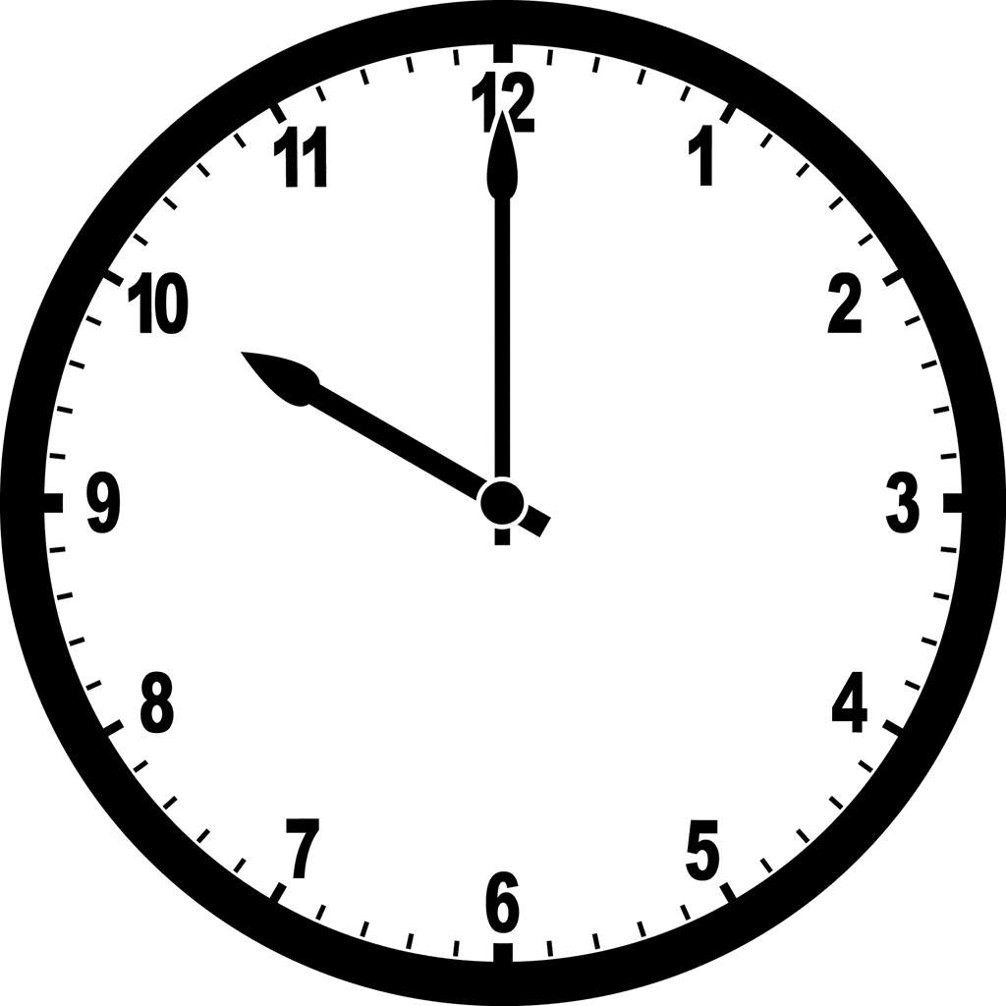 | Example:  10:00
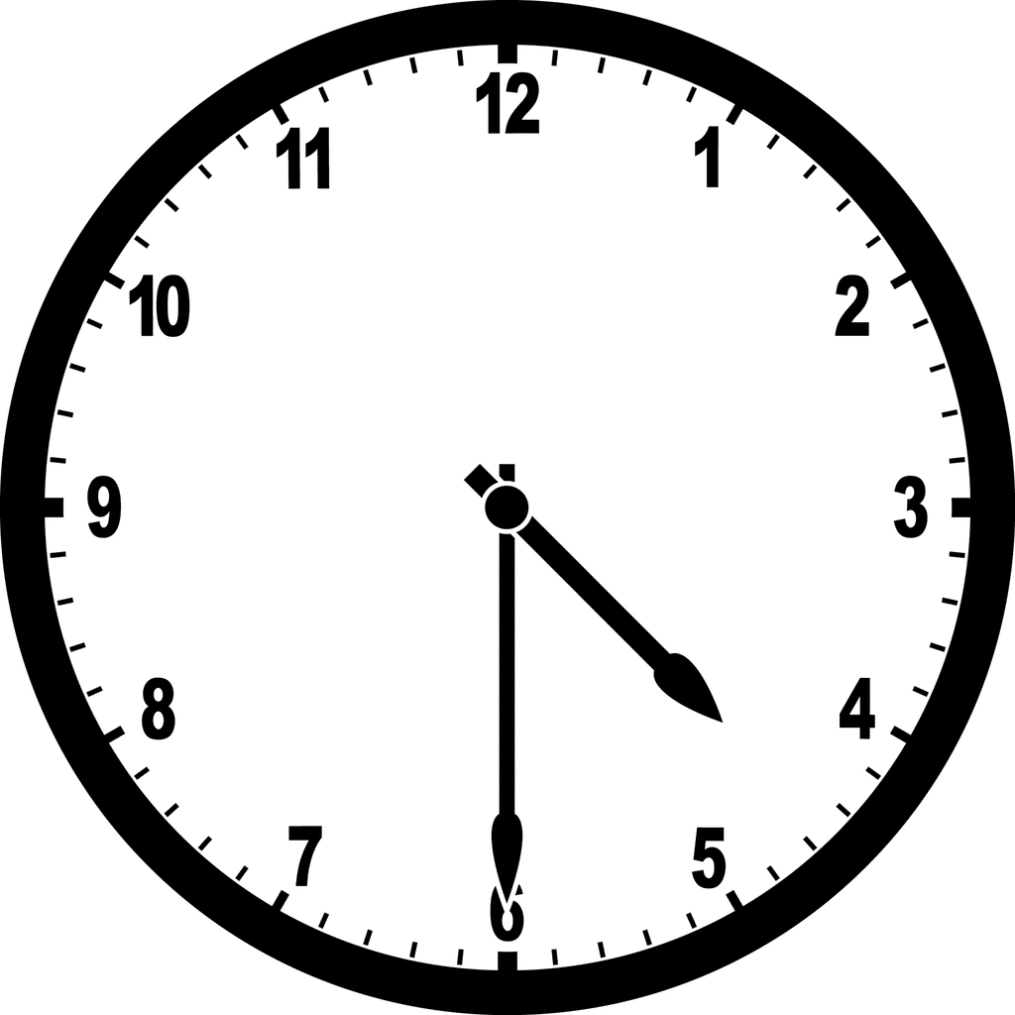

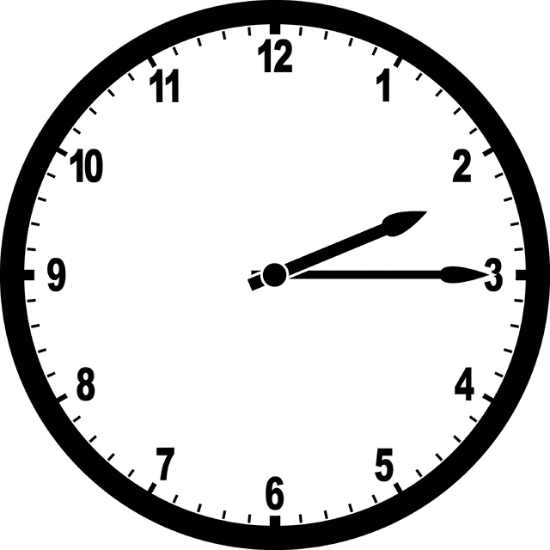

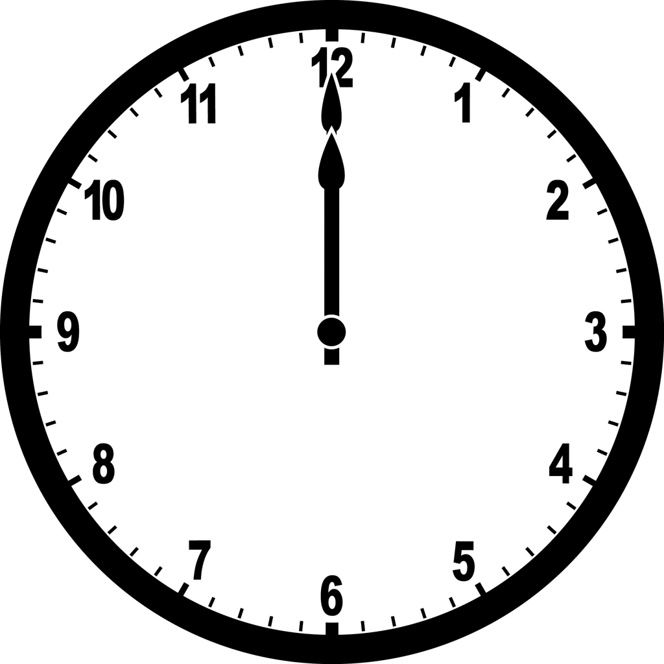

Part 3: With a partner, take it in turns to read out the following times.
Digital time | Read and correct?
02:15 | ☐
07:30 | ☐
12:00 | ☐
06:45 | ☐
Part 4: Convert the data from text to numbers in the table below.
Dates – text | Dates – expressed with numbers
Example:  The twenty-first of October 2024 | Example:  21/10/24
The fourth of March 2022
The fifteenth of July 2015
The seventh of February 2024
Part 5: Pretend that you have a school sports tournament on Wednesday, Thursday and Friday next week …
- What is today’s day and date?
- What days do the dates fall on next week (you may like to use a calendar to help you with this).
Day | Date
Wednesday
Thursday
Friday
- Research and record what the temperature is forecast to be on the dates in the table above.
Day | Temperature (degrees Celsius)
Wednesday
Thursday
Friday
Communicate and report: Use a combination of informal and formal mathematical representations to document and report outcomes and results.
Part 6: After completing this task, using a number between 1 to 5, how confident do you feel with the following?
Statement | Confidence rating  (1 = Not confident at all, 5 = Extremely confident)
I can use and read analogue time.
I can read digital time.
I can express dates as numbers.
Part 7: Complete the table below and add in additional tools you used throughout your road trip planning.
Mathematical tool, formula or concept: | Explain what this tool, formula or concept is: | How/when is this tool, formula or concept needed/used? | What is the accuracy level of this tool, formula or concept? (Low, Medium, High) | How likely are you to use this tool, formula or concept? (Rate 1 to 5) | Do I need to add this tool, formula or concept to my numeracy toolkit? (Tick if yes)
Analogue time |  |  |  | Choose a rating | ☐
Digital time |  |  |  | Choose a rating | ☐
Part 8: Swap booklets with a peer and conduct a peer assessment of their work (choose from the drop-down menu: Not Shown, Not Yet Complete or Complete). Make sure that you provide verbal feedback to your peer about what they have done well and what they need to do to improve their responses, as well as writing down your feedback below.
Peer feedback
Part 1 | Brainstorm | Choose an item.
Part 2 | Identifying time | Choose an item.
Parts 3, 4 & 5 | Application | Choose an item.
Part 6 | Reflecting | Choose an item.
Part 7 | Report table | Choose an item.
Name of Assessor:
Assessor comment:

Task 3: Measuring and ordering
Student reflection: How well did you go with this step? (Please tick the box below)
☐Not Submitted | ☐Beginning | ☐Consolidating | ☐Achieving | ☐Excelling
Student comment (optional):
Teacher feedback
☐Not Submitted | ☐Beginning | ☐Consolidating | ☐Achieving | ☐Excelling
Not Submitted: No work has been submitted or attempted for this task. | Beginning: You have attempted some parts of this activity. To bump it up, ensure all parts of this task are completed. | Consolidating: You have read some analogue and digital times. You have read and understood some dates (including days, dates, months, years). To bump it up, re-check your answers to make sure they are correct. | Achieving: You have read most analogue and digital times. You have read and understood most dates (including days, dates, months, years). All your responses are correct. To bump it up, make sure your respond to all parts of the activity. | Excelling: You have read both analogue and digital times accurately. You have read and understood dates (including days, dates, months, years). The answers you have provided are correct. Well done!
Teacher comment:

Task 4: Shapes
Learning goals and application
Application:
1.1 Recognise common and familiar one- and two-dimensional shapes
1.2 Name common and familiar one- and two-dimensional shapes
1.3 Construct common and familiar two-dimensional shapes
1.4 Categorise similar shapes according to common classifications

Task checklist
☐ Task 4: Shapes
Identify the mathematics: Recognise, select and interpret the mathematical information embedded in a real-world context and decide what mathematics to use.
Part 1: Write and draw (or cut and paste) 3 x two-dimensional (2D) shapes and 3 x three-dimensional (3D) shapes.
Example
Two-dimensional shape: Circle
Three-dimensional shape: Cube
Two Dimensional Shapes (2D)
Name of shape | Picture of shape

Three Dimensional Shapes (3D)
Name of shape | Picture of shape
Act on and use mathematics: Perform mathematical actions and processes to complete a task – including the use and application of a range of mathematical processes.
Part 2: Complete the tables below.
2D shape | Name of shape

3D shape | Name of shape
Part 3: Write the following shapes in the table under the correct category (either a 2D or a 3D shape):
- Square
- Cube
- Circle
- Sphere
- Triangle
- Cylinder
2D Shapes: | 3D Shapes:
Part 4: Take photographs of shapes in and around the classroom. Insert the photographs below and name the shapes.
Add image of 2D/3D shape here. | Add image of 2D/3D shape here. | Add image of 2D/3D shape here. | Add image of 2D/3D shape here.
1. Shape Name: | 2. Shape Name: | 3. Shape Name: | 4. Shape Name:
Part 5: Take three pictures of two different types of recreational settings. This is anything you do for fun! This could include images of the following:
- Sports courts or field
- Gymnasium
- Kitchen
- Garden
- Play centre
- Nature walk
- Camping
- Zoo
- Basketball court
- Any other recreational setting
Insert image one here.

Insert image two here.

Insert image three here.
Part 6: List the shapes that you can see in each of the photographs that you have taken:
Part 7: You are now going to create shapes. Using clay, paper or any other available resources create a 2D shape and a 3D shape. Insert a photograph of your creation and label the shape below.
2D Shapes: | 3D Shapes:
Insert image and label here. | Insert image and label here.
Evaluate and reflect: Check and reflect on the mathematical problem-solving processes and outcomes in relation to the real-world context.
Part 8: After completing this task, using a number between 1 to 5, how confident do you feel with the following?
Statement | Confidence rating  (1 = Not confident at all, 5 = Extremely confident)
I can identify 2D shapes.
I can identify 3D shapes.
I can categorise 2D and 3D shapes.
I can create 2D and 3D models.
Part 9: Share your 2D and 3D models with a peer. Write a summary of your partner’s creation below.
Communicate and report: Use a combination of informal and formal mathematical representations to document and report outcomes and results.
Part 10: Swap booklets with a peer and conduct a peer assessment of their work (choose from the drop-down menu: Not Shown, Not Yet Complete or Complete). Make sure that you provide verbal feedback to your peer about what they have done well and what they need to do to improve their responses, as well as writing down your feedback below.
Peer feedback
Part 1 | Identify shapes | Choose an item.
Parts 2 & 3 | What’s the shape? | Choose an item.
Parts 4, 5 & 6 | Shapes in the real world | Choose an item.
Part 7 | Creating shapes | Choose an item.
Part 8 | Reflecting | Choose an item.
Parts 9 & 10 | Communicate and report | Choose an item.
Name of Assessor:
Assessor comment:

Task 4: Shapes
Student reflection: How well did you go with this step? (Please tick the box below)
☐Not Submitted | ☐Beginning | ☐Consolidating | ☐Achieving | ☐Excelling
Student comment (optional):
Teacher feedback
☐Not Submitted | ☐Beginning | ☐Consolidating | ☐Achieving | ☐Excelling
Not Submitted: No work has been submitted or attempted for this task. | Beginning: You have attempted some parts of this task. To bump it up, ensure all parts of the task are completed. | Consolidating: You have recognised and named familiar one- and two-dimensional shapes. You have categorised shapes according to common classifications. You have also created shapes (2D and 3D). To bump it up, add more information and re-check your answers. | Achieving: You have accurately recognised and named one- and two-dimensional shapes. You have categorised shapes according to classifications. You have also created shapes (2D and 3D). To bump it up, add more specific details to your answers. | Excelling: You have accurately recognised and named one- and two-dimensional shapes. You have categorised shapes according to classifications. You have also created shapes (2D and 3D). Your answers are clear and specific. Well done!
Teacher comment:

Task 5: Data
Learning goals and application

Application:
1.1 Collect and display simple data
1.2 Read simple graphs such as bar or pie graphs
1.3 Read simple tables
1.4 Identify and locate key facts from simple data.

Task checklist
☐ Task 5: Data
Identify the mathematics: Recognise, select and interpret the mathematical information embedded in a real-world context and decide what mathematics to use.
Part 1: Write your own definition of data and provide two examples below:
Act on and use mathematics: Perform mathematical actions and proceVPsses to complete a task – including the use and application of a range of mathematical processes.
Part 2: Conduct a survey of your class to collect data on the modes of transport your peers use to get to school each day. Record the responses in the table below.
Mode of transport: | Name of students who use this mode:
Bus
Car
Walk
Ride a bike
Ride a scooter
Other
Part 3: Complete the following frequency table, summarising the information from Part 1.
Mode of transport: | Frequency (number):
Bus
Car
Walk
Ride a bike
Ride a scooter
Other
Part 4: Using the data from the frequency table above, create either a bar graph or a pie chart to represent your data.
Insert your graph here.
Part 5: Answer the following questions:
- What is the most popular mode of transport among your peers?
- What is the least popular mode of transport among your peers?
Part 6: Look at the infographic below displaying the issues of greatest personal concern to young people aged 15–25 years old in the Surf Coast Shire in 2021.
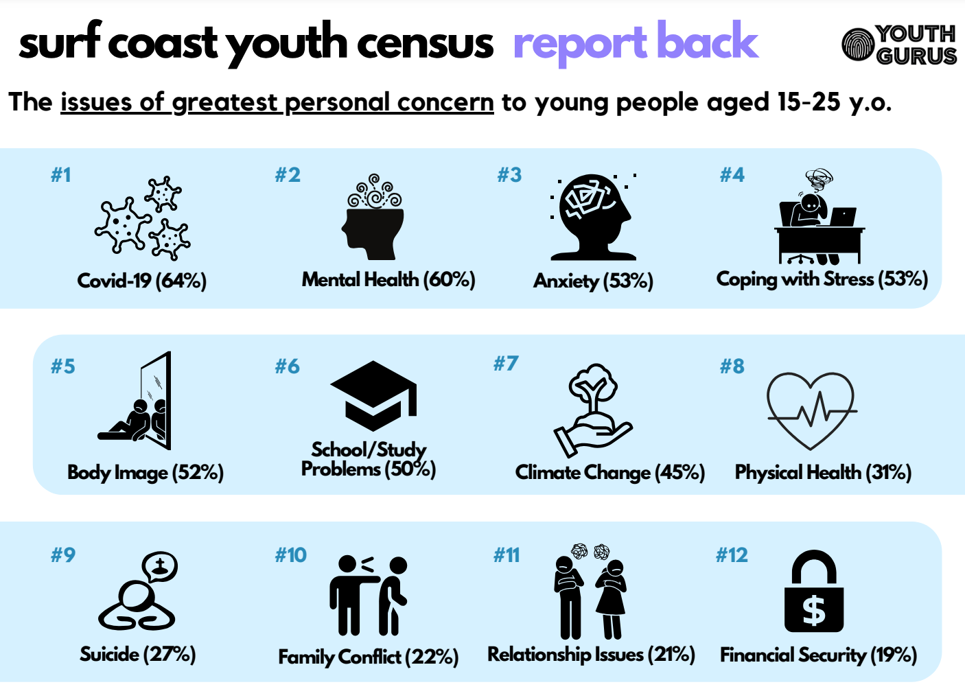
Image source: Youth Gurus, Surf Coast Youth Census-Final Report (2021)
Part 7: Using the infographic above, add the percentages to the following table.
Issue | Percentage
Covid 19
Mental Health
Anxiety
Coping with stress
Body image
School / study problems
Climate change
Physical Health
Suicide
Family conflict
Relationship issues
Financial issues
Part 8: Answer the following questions:
- What was the issue of greatest personal concern for youth in the Surf Coast Shire?
- What percentage of Surf Coast youth identified family conflict as an issue of greatest personal concern?
- What percentage of Surf Coast youth identified anxiety as an issue of greatest personal concern?
Evaluate and reflect: Check and reflect on the mathematical problem-solving processes and outcomes in relation to the real-world context.
Part 9: Using a number between 1 to 5, how confident do you feel with the following?
Statement | Confidence rating  (1 = Not confident at all, 5 = Extremely confident)
I can collect data.

I can display data in a frequency table.

I can display data in simple graphs.

I can read and interpret simple data set.

Communicate and report: Use a combination of informal and formal mathematical representations to document and report outcomes and results.
Part 10: Complete the table below.
Mathematical tool, formula or concept: | Explain what this tool, formula or concept is: | How/when is this tool, formula or concept needed/used? | What is the accuracy level of this tool, formula or concept? (Low, Medium, High) | How likely are you to use this tool, formula or concept? (Rate 1 to 5) | Do I need to add this tool, formula or concept to my numeracy toolkit? (Tick if yes)
Frequency table |  |  |  | Choose a rating | ☐
Pie graph |  |  |  | Choose a rating | ☐
Bar graph |  |  |  | Choose a rating | ☐
Part 11: Swap booklets with a peer and conduct a peer assessment of their work (choose from the drop-down menu: Not Shown, Not Yet Complete or Complete). Make sure that you provide verbal feedback to your peer about what they have done well and what they need to do to improve their responses, as well as writing down your feedback below.
Peer feedback
Part 1 | Define | Choose an item.
Parts 2, 3 & 4 | Collecting and displaying data | Choose an item.
Part 6 | Youth census data | Choose an item.
Part 9 | Reflecting | Choose an item.
Part 10 | Report table | Choose an item.
Name of Assessor:
Assessor comment:

Task 5: Data
Student reflection: How well did you go with this step? (Please tick the box below)
☐Not Submitted | ☐Beginning | ☐Consolidating | ☐Achieving | ☐Excelling
Student comment (optional):
Teacher feedback
☐Not Submitted | ☐Beginning | ☐Consolidating | ☐Achieving | ☐Excelling
Not Submitted: No work has been submitted or attempted for this task. | Beginning: You have attempted parts of the task. To bump it up, complete a response for all parts of the task. | Consolidating: You have collected some data. You have understood some of what you have collected. You have put most of the required information into a graph. To bump it up, you need to provide a response for all parts of this task. | Achieving: You have collected data and interpreted information from the data you have collected. You have displayed the data in several simple graphs. To bump it up, make sure that you re-check all your answers are correct. | Excelling: You have collected data, interpreted it and displayed it in a number of different graphs and charts. The information you have provided is correct. Well done!
Teacher comment:

Task 6: Chance
Learning goals and application
Application:
1.1 Recognise and use the everyday language of chance and likelihood
1.2 Use everyday language to compare and order different and simple magnitudes of chance.

Task checklist
☐ Task 6: Chance
Identify the mathematics: Recognise, select and interpret the mathematical information embedded in a real-world context and decide what mathematics to use.
Part 1: Brainstorm examples in your everyday life where you would use chance or likelihood. For example, checking the weather in the morning to see the likelihood of rain.
Act on and use mathematics: Perform mathematical actions and processes to complete a task – including the use and application of a range of mathematical processes.
Part 2: Read each situation below. Tick the word or phrase that best describes the likelihood of each event happening.
- The chance of it raining tomorrow.
☐ Very likely
☐ Likely
☐ Unlikely
☐ Very unlikely
- The chance of you catching a cold this week.
☐ Very likely
☐ Likely
☐ Unlikely
☐ Very unlikely
- The chance of winning a prize in a school raffle.
☐ Very likely
☐ Likely
☐ Unlikely
☐ Very unlikely
- The chance of a team winning a game after losing the first half.
☐ Very likely
☐ Likely
☐ Unlikely
☐ Very unlikely
Part 3: Use the words below to order the following events from most likely to least likely.
- A sunny day in summer.
- A snowstorm in the middle of summer.
- Getting an A on an exam when you’ve studied hard.
- Catching the flu in the summer months.
Most likely
1. Very likely
2 Likely
3. Unlikely
4. Very unlikely
Least likely
Teacher advice: Add a weather forecast image below for your local area for the next 7 days. Modify the questions in Part 4 to suit the image you have added.
Part 4: Answer the following questions using the image below.
Teacher advice: Add the image here.
Teacher advice: Example questions only. Modify to suit the image you have added above.
- What is the likelihood of the maximum temperature being above 20 degrees Celsius for each of the 10 days on the forecast:
☐ Very likely
☐ Likely
☐ Unlikely
☐ Very unlikely
- What day is it most likely to rain?
- What is the likelihood of the maximum temperature being 10 degrees Celsius or below for each of the 10 days?
☐ Very likely
☐ Likely
☐ Unlikely
☐ Very unlikely
Evaluate and reflect: Check and reflect on the mathematical problem-solving processes and outcomes in relation to the real-world context.
Part 5: Respond to the following questions below.
- Why is it important to understand the likelihood of everyday events such as weather or health risks?
- How can knowing the chance of an event happening affect your decisions (e.g. should you bring an umbrella tomorrow if there’s a likely chance of rain)?
Communicate and report: Use a combination of informal and formal mathematical representations to document and report outcomes and results.
Part 6: Complete the table below and add in additional tools you used throughout your road trip planning.
Mathematical tool, formula or concept: | Explain what this tool, formula or concept is: | How/when is this tool, formula or concept needed/used? | What is the accuracy level of this tool, formula or concept? (Low, Medium, High) | How likely are you to use this tool, formula or concept? (Rate 1 to 5) | Do I need to add this tool, formula or concept to my numeracy toolkit? (Tick if yes)
Probability |  |  |  | Choose a rating | ☐
Weather app |  |  |  | Choose a rating | ☐
Part 7: Swap booklets with a peer and conduct a peer assessment of their work (choose from the drop-down menu: Not Shown, Not Yet Complete or Complete). Make sure that you provide verbal feedback to your peer about what they have done well and what they need to do to improve their responses, as well as writing down your feedback below.
Peer feedback
Part 1 | Brainstorm | Choose an item.
Parts 2, 3, 4 | What’s the chance? | Choose an item.
Part 5 | Reflecting | Choose an item.
Parts 6 & 7 | Report table | Choose an item.
Name of assessor:
Assessor comment:

Task 6: Chance
Student reflection: How well did you go with this step? (Please tick the box below)
☐Not Submitted | ☐Beginning | ☐Consolidating | ☐Achieving | ☐Excelling
Student comment (optional):
Teacher feedback
☐Not Submitted | ☐Beginning | ☐Consolidating | ☐Achieving | ☐Excelling
Not Submitted: No work has been submitted or attempted for this task. | Beginning: You have attempted some parts of this task. To bump it up, you need to provide a response for all parts of this task. | Consolidating: You have recognised and used some everyday language of chance and likelihood. You have attempted to compare and order different magnitudes of chance. To bump it up, you need to attempt all parts of this task. | Achieving: You have recognised and used everyday language of chance and likelihood. You have compared and ordered different magnitudes of chance. To bump it up, you need to re-check your answers to see if the information you have provided is correct. | Excelling: You have recognised and used language (simple and complex) of chance and likelihood. You have accurately compared and ordered different magnitudes of chance. Well done!
Teacher comment:

