Victorian Pathways Certificate

Unit 2: Uniting communities


Personal Development Skills curriculum support material

Acknowledgement
The Victorian Curriculum and Assessment Authority proudly acknowledges and pays respect to Victoria’s Aboriginal and Torres Strait Islander communities and their rich and enduring cultures.
We acknowledge Aboriginal and Torres Strait Islander people as Australia’s first peoples and as the Traditional Owners and custodians of the lands and waters on which we rely. We pay respect to Elders past and present of the lands where we conduct our work and recognise their ongoing contributions as the first educators on the land now known as Victoria.
Authorised and published by the Victorian Curriculum and Assessment Authority
Level 7, 200 Victoria Parade
East Melbourne VIC 3002
ISBN: 978-1-923204-71-3
© Victorian Curriculum and Assessment Authority 2025
No part of this publication may be reproduced except as specified under the Copyright Act 1968 or by permission from the VCAA. Excepting third-party elements, schools may use this resource in accordance with the VCAA educational allowance. For more information go to vcaa.vic.edu.au/footer/copyright
The VCAA provides the only official, up-to-date versions of VCAA publications. Details of updates can be found on the VCAA website at vcaa.vic.edu.au
This publication may contain copyright material belonging to a third party. If you believe that material in this publication is an infringement of your copyright, please email the Copyright Officer vcaa.copyright@education.vic.gov.au
Copyright in materials appearing at any sites linked to this document rests with the copyright owner/s of those materials, and is subject to the Copyright Act. The VCAA recommends you refer to copyright statements at linked sites before using such materials.
The VCAA logo is a registered trademark of the Victorian Curriculum and Assessment Authority.

Contact us if you need this information in an accessible format, for example, large print or audio.
Telephone (03) 9032 1629 or email vcaa.publications@education.vic.gov.au

Contents
Contents i
Using this resource 1
Student and teacher actions 2
Personal Development Skills activities 3
Task 1: What is community? 3
Activity 1.1 Brainstorm 3
Activity 1.2 Community groups and benefits 5
Activity 1.3 Community involvement 7
Activity 1.4 Support systems 8

Using this resource
- This curriculum resource is an example and shows one way a school could deliver the Victorian Pathways Certificate (VPC) and VCE Vocational Major (VCE VM) through an integrated approach to teaching and learning.
- You will need to make changes to the curriculum resource to best suit your cohort’s needs and abilities by adding or removing scaffolds, and to tailor resources to your school's context. When modifying this curriculum resource, please review the relevant VCAA VPC curriculum design and check that the relevant modules, learning goals, applications and assessment requirements are still being addressed.
- This document is a companion to the suite of curriculum support materials for VPC Unit 2: Uniting Communities. Read over the ‘Advice for teacher delivery and assessment summary’ in detail before delivery. Applied learning requires proactive planning and preparation prior to delivery. The curriculum resource does not function like a traditional text or workbook. Pre-work and modifications are required to use this curriculum resource effectively.
- Unit preparation checklists in the ‘Advice for teacher delivery and assessment summary’ highlight key actions to be completed by the teacher prior to the overall unit delivery. It is essential for teachers to review and use the unit checklists prior to implementing or using this curriculum resource.
- This curriculum resource is designed to support your teaching and does not replace you as the teacher. How you deliver the resource and run applied learning activities to support your program is a teacher and school-based decision. Explicit instruction, teacher support and monitoring of student progress is still required.
- In accordance with the Pillars of Applied Learning (POAL) all assessment tasks are flexible and open to negotiation. To support individual students to successfully achieve learning goals, modification in collaboration is encouraged.
- This curriculum resource includes links to third party materials as examples for teacher reference only. It is not mandatory to use any of these materials or third party services. Inclusion of links to these materials does not constitute VCAA endorsement of the views or content contained in or linked from these sites. Teachers are advised to use their own judgement in determining what is appropriate for their students and school community. Teachers should ensure that any information or activity complies with their school or organisation’s policies.

Student and teacher actions
Within the student task activities, the following icons indicate these actions:
 | For teacher awareness, advice and information. Should be deleted before providing to students.
 | To be adapted or changed to the relevant educational context.
 | The teacher needs to hyperlink or add in their own documents or links to resources for their students to access the correct information from their own school-based documents.
 | Indicates ‘how to’ IT, document support or general guidance for students. Teachers can decide to leave this in or remove it.
 | Indicates to students which activities can be completed and submitted for assessment as a group.
 | Indicates to students which activities need to be completed and submitted for assessment individually.
 | Indicates to students which activities will be completed with a peer.

Personal Development Skills activities

Task 1: What is community?
Task checklist
Students will complete the following for PDS Task 1: What is community?
☐ Activity 1.1 Brainstorm
☐ Activity 1.2 Community groups and benefits
☐ Activity 1.3 Community involvement
☐ Activity 1.4 Support systems

Key vocabulary
Community: a social, religious, occupational or other group sharing common characteristics or interests and perceived or perceiving itself as distinct in some respect from the larger society within which it exists: the business community.
Involvement: an act or instance of being included, or of including someone or something, in an action, process, group, etc.

Activity 1.1 Brainstorm
Teacher advice: For Part 1 your will need to organise two large sheets of butcher’s paper. Title each sheet with one of the titles below:
- Words that come to mind when I hear the phrase ‘local community’.
- Local community organisations I am a part of or know of.
Hang these on your classroom wall where students can access them and add their ideas to each sheet.
Part 1: Local communities brainstorm: On the two titled brainstorm sheets provided by your teacher, use post-it notes to add the following to the correct brainstorm sheet.
☐ Words, thoughts or ideas that come to mind when I think of the phrase ‘local community’
☐ Local community organisations or groups that I am a part of or that I know of.
Take a picture of your class’s ideas and add the image in the space provided below:
Add your image here.
Teacher advice: For Part 2 your will need to organise two large sheets of butchers paper. Title each sheet with one of the titles below:
- Words that come to mind when I hear the word ‘global’.
- Global community organisations I am a part of or that I know of.
Hang these on your classroom wall where students can access them and add their ideas to each sheet.
Part 2: Global communities brainstorm: On the two titled brainstorm sheets provided by your teacher, use post-it notes to add the following to the correct brainstorm sheet.
☐ Words, thoughts or ideas that come to mind when you think of the word ‘global’.
☐ Global community organisations or groups that you are a part of or that you know of.
Take a picture of your class’s ideas and add the image in the space provided below:
Add your image here.

Task 1: Activity 1.1 Brainstorm
Student reflection: How well did you go with this step? (Please tick the box below)
☐Not Submitted | ☐Beginning | ☐Consolidating | ☐Achieving | ☐Excelling
Student comment (optional):
Teacher feedback
☐Not Submitted | ☐Beginning | ☐Consolidating | ☐Achieving | ☐Excelling
Not Submitted: No work has been submitted or attempted for this activity. | Beginning: I can attempt some aspects of this brainstorm activity. To bump it up, re-read the task requirements and complete all parts of the task. | Consolidating: I can contribute to the brainstorm ideas for the prompts provided. To bump it up, re-read the task instructions and complete all parts of this task. | Achieving: I can contribute several ideas for the prompts provided to the brainstorm. To bump it up, include more details. | Excelling: I can brainstorm a range of detailed ideas for the prompts provided. Excellent work!
Teacher comment:

Activity 1.2 Community groups and benefits
Part 1: Watch the video (refer link below) about Hello Surf Coast and then respond to the questions in the table below.

Video source: Times News Group, Hello Surf Coast (youtube.com)
Question | Response
What is Hello Surf Coast?
How does the program benefit the community?
Part 2: Watch the video about all abilities netball (refer link below), and then respond to the questions in the table below.
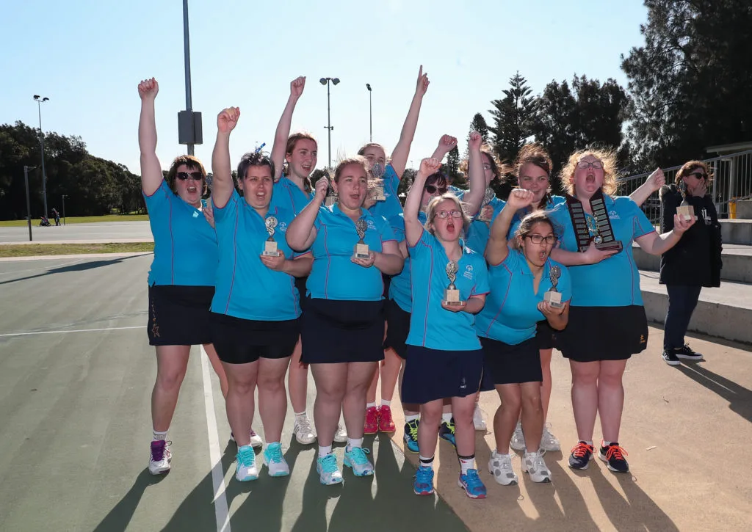
Video source: GippSport, Netball VIC Access for all Abilities Netball Program (youtube.com)
Question | Response
What is the ‘All Abilities’ program?
How does the program benefit the community?
What makes Janet a good leader?

Task 1: Activity 1.2 Community groups and benefits
Student reflection: How well did you go with this step? (Please tick the box below)
☐Not Submitted | ☐Beginning | ☐Consolidating | ☐Achieving | ☐Excelling
Student comment (optional):
Teacher feedback
☐Not Submitted | ☐Beginning | ☐Consolidating | ☐Achieving | ☐Excelling
Not Submitted: No work has been submitted or attempted for this activity. | Beginning: I can attempt to respond to some parts of this task. To bump it up, re-read over the task requirements and provide a basic response for all required parts. | Consolidating: I can provide basic responses for most parts of this task. To bump it up, re-read over the task requirements and provide a basic response for all required sections. | Achieving: I can provide detailed responses for most aspects of this task. To bump it up, re-read over the task requirements and provide a detailed response for all required sections. | Excelling: I can provide highly detailed responses for all aspects of this task. Great work!
Teacher comment:

Activity 1.3 Community involvement
Part 1: In the table below, put your name in the middle box. Then around the outside boxes, list each of the communities that you are a part of or interact with.
Example: VPC School Community
Name:
Part 2: Provide examples about how you make a positive impact in a community that you are a part of.
Community | Example of your involvement
Example: My school community | Example: I contribute positively towards my school community by wearing the correct uniform, respecting my peers, teachers and other members of the community, and I act as a positive role model for younger year levels.

Task 1: Activity 1.3 Community involvement
Student reflection: How well did you go with this step? (Please tick the box below)
☐Not Submitted | ☐Beginning | ☐Consolidating | ☐Achieving | ☐Excelling
Student comment (optional):
Teacher feedback
☐Not Submitted | ☐Beginning | ☐Consolidating | ☐Achieving | ☐Excelling
Not Submitted: No work has been submitted or attempted for this activity. | Beginning: I can attempt to list how I am involved in my community. To bump it up, you need to provide a basic response for all parts of the activity. | Consolidating: I can provide some examples of communities that I am a part of. To bump it up, complete all parts of this task and check spelling and punctuation is correct. | Achieving: I can list and describe how I am involved in my community. I can explain how I positively contribute. To bump it up, extend the responses by considering future contributions that could be made to the specific community you are a part of. | Excelling: I can list and describe how I am involved within my community and have explained in detail how I positively contribute. I have included details about how I would like to contribute to a community group I am part of in the future.  Great work!
Teacher comment:

Activity 1.4 Support systems
Part 1: Brainstorm some of the support systems in your life that you can rely on in times of need (e.g. family, friends, school, community). Capture your response below:
Part 2: You are now going to research community support systems or organisations that contribute to wellbeing.
Below are some examples that you can use, but it would be great if you could research systems or organisations that are local to you:
Surf Coast Youth
Feed Me
Torquay Community House
Ocean Mind
Art of The Minds
Local community support system | Supports they offer | Resources, links, how to access the support
Example:  DIIGG Wellbeing | Example:  Monthly Sunday evening sessions at different venues across the Surf Coast.  Aim to create a supportive space, so guys can feel safe to share their stories.  DIIGG connect, mentor and coach younger men.  Tribe of mentors – at Surf Coast Secondary College. A range of mentors come in weekly and run sessions for Years 11 and 12 VCE-VM students. | Example:  info@diiggwellbeing.com.au  Bringing Blokes Together  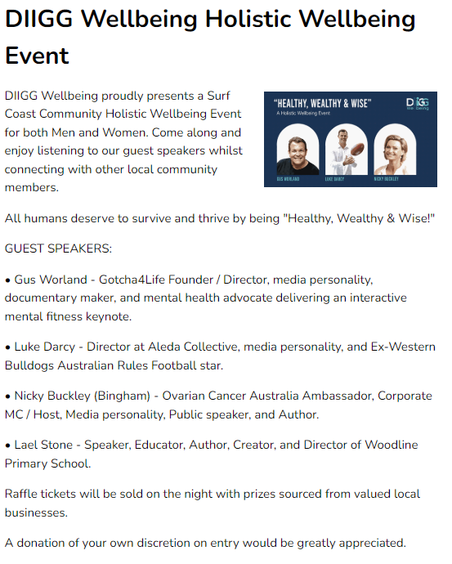  Image source: DIIGG Wellbeing Holistic Wellbeing Event

Task 1: Activity 1.4 Support systems
Student reflection: How well did you go with this step? (Please tick the box below)
☐Not Submitted | ☐Beginning | ☐Consolidating | ☐Achieving | ☐Excelling
Student comment (optional):
Teacher feedback
☐Not Submitted | ☐Beginning | ☐Consolidating | ☐Achieving | ☐Excelling
Not Submitted: No work has been submitted or attempted for this activity. | Beginning: I can attempt some parts of this task. To bump it up, you need to provide more information. | Consolidating: I can provide basic responses for each of the required parts. To bump it up, include more detailed information for each response. | Achieving: I can provide detailed responses for all required parts of this activity. I can research and select the important information to include in the table. To bump it up, you need to include more local examples. | Excelling: I can provide detailed responses for all required parts of this activity. I can research a variety of different local community supports and identify the key information to summarise into the table. Great work!
Teacher comment:

