2025 VCE Product Design and Technologies external assessment report
This report provides sample answers, or an indication of what answers may have been included. Unless otherwise stated, these are not intended to be exemplary or complete responses.
The statistics in this report may be subject to rounding, resulting in a total of more or less than 100 per cent.
Student responses reproduced in this report have not been corrected for grammar, spelling or factual information.

Question 1a.
Marks | 0 | 1 | Average
% | 43 | 57 | 0.6
Students were asked to identify the type of data collected in the user trial.
Over half of students answered this correctly by identifying the data as quantitative.

Question 1b.
Marks | 0 | 1 | 2 | Average
% | 71 | 20 | 8 | 0.4
Students were asked to identify two ethical research methods.
Although many students demonstrated some understanding of research methods, most responses did not fully meet the requirements of the question.
A significant number of students could identify a relevant research method; however, they did not explain what made the method ethical. In other cases, students referred to an ethical issue but failed to link it to a specific research method. As a result, responses often addressed only one aspect of the question rather than demonstrating the required connection between ethical practice and research methodology.
High-scoring responses successfully paired an ethical consideration with an appropriate method of gathering research material, clearly showing how the chosen method addressed ethical concerns.
The following is from a high-scoring student response:
One ethical research method is surveying end users, ensuring that their information is private. Another is researching reviews from existing products and acknowledging intellectual property.

Question 1c.
Marks | 0 | 1 | Average
% | 11 | 89 | 0.4
Students were required to interpret whether the feature of fabric or style was rated more highly in Graph 2.
Most students correctly identified fabric as the higher-rated feature.

Question 1d.
Marks | 0 | 1 | 2 | 3 | Average
% | 5 | 13 | 37 | 46 | 2.2
Students were required to synthesise information from both graphs and summarise the findings.
Students were not able to obtain full marks if they described each graph separately without forming an overarching conclusion.
High-scoring responses combined results and made a clear judgement.
The following is from a high-scoring student response:
Overall, it seemed that majority of the participants didn't like the style of the chair, 19 participants giving the style a 2 out of five and half of the participants were unlikely to purchase the chair as shown in Graph 1. However, overall, the fabric of the chair was looked upon favourably by participants.

Question 2a.
Marks | 0 | 1 | 2 | Average
% | 7 | 39 | 53 | 1.5
Students had to identify two areas for design improvement based on the end user feedback in the graphs.
Some students referenced other features not shown in the graph and therefore could not receive full marks.
High-scoring responses appropriately referenced style, fabric or overall design aesthetics.
The following is from a high-scoring student response:
One area of improvement could be the style of the chair. An area to be enhanced further could be the fabric of the chair.

Question 2b.
Marks | 0 | 1 | 2 | 3 | Average
% | 14 | 20 | 40 | 26 | 1.8
Students were required to justify one identified improvement using data from both graphs.
High-scoring responses explicitly used evidence from Graph 1 and Graph 2 to inform their decision.
The following is from a high-scoring student response:
Style: evident in graph 2 the most frequently occurring response for style was to 2/5 as ‘fair’. This is likely to influence graph one’s results that half of the participants were unlikely to choose the home office chair.

Question 3
Marks | 0 | 1 | 2 | 3 | Average
% | 17 | 13 | 24 | 45 | 2.0
Students needed to add three annotations directly connecting features of the chairs to end user needs.
Common issues included listing generic product features without explaining their relevance or referencing features unrelated to the end user.
High-scoring responses reflected the ‘End user ‒ Factors that influence product design’ section from page 18 of the Study Design and explained how these needs were addressed.
Sample annotations:
- Padded seat and back insures comfort during extended periods of use.
- Easy-to-use lever quickly adjusts seat height making it ergonomically personalised.
- Wide sturdy base with wheels ensures stability while not sacrificing mobility around the home office.

Question 4
Marks | 0 | 1 | 2 | 3 | 4 | Average
% | 6 | 10 | 45 | 20 | 20 | 2.4
Students were asked to analyse how ethical considerations were addressed in a pram design.
Some students analysed only one ethical consideration and therefore did not receive full marks.
High-scoring responses examined two considerations and explored the significance of their relationship to the design of the pram.
The following is from a high-scoring student response:
The ethical consideration of sustainability has been addressed in this pram through the use of recycled materials such as recycled polypropylene plastic. This eliminates the need to make new plastic and reduces used plastic ending in landfill and chemical leaking into soil and waterways. The Greentom Pram has also considered Australian ISO standards by ensuring the products is of high quality and is reliable and is safe for children to use by having consistent performance.

Question 5
Marks | 0 | 1 | 2 | 3 | 4 | Average
% | 3 | 6 | 32 | 39 | 21 | 2.7
Students needed to compare and critique the environmental impacts of repurposed versus virgin plastics.
Most students did this well and referenced the stimulus material.
High-scoring responses compared similarities and differences between the environmental impacts and explained the significance of these similarities and differences. They critiqued both positive and negative environmental impacts to form an overall judgement.
The following is from a high-scoring student response:
Manufacturing repurposed plastics involves sorting, shredding and then either melting them slightly to stick the plastic together. However this is not very strong and can only be done a few times before it doesn't work anymore, or melting it at a very high temperature to get the molecules to bind together and form a new shape. However, this releases toxic gases into the air and can be more damaging than using virgin plastics. Virgin plastics are made using petroleum and oil where there is also a lot of pollution.
In comparison both repurposed and virgin plastics pollute the environment however repurposed plastics don't use a new finite resource but does use fossil fuels, so the best method is to use the less damaging method of reforming plastic back together but it is not a long-term or very viable solution.

Question 6
Marks | 0 | 1 | 2 | 3 | 4 | 5 | 6 | 7 | 8 | Average
% | 5 | 3 | 9 | 40 | 24 | 9 | 5 | 3 | 1 | 3.5
Students were asked to critique the pram in relation to Rethink, Reduce and Recycle.
Many students only addressed positives and did not include a judgement.
High-scoring responses identified positives and negatives for each of the three Rs and provided an overall judgement.
The following is from a high-scoring student response:
Greentom pram uses the idea of ‘rethink’ to rethink the traditional pram design. Not only does the pram adjust easily to suit the age stage of the child, but is made with different materials to a regular pram. The adjustability of the pram is unique and innovative and increases sustainability by reducing the amount of prams parents will have to buy for their child thus reducing waste.
Therefore we also see an element of ‘reduce’ in the prams multifunctional design. The reduce principle also plays a role in the chosen material for the pram, along with ‘recycle’, as the product utilizes recycled plastics to construct the Frame and fabric. This means the amount of plastic that ends up in landfill is reduced, helping to slow pollution. The ‘recycle’ concept is also seen as the prams material can be recycled and reused at the end of its use.
However, the materials are still plastic, which it's not biodegradable, and will ultimately end up as rubbish once it loses quality, presenting a limit to the full application of reducing waste.
Overall in terms of sustainability the Greentom pram applies reduce, rethink and recycle fairly well, but at the end of the materials life, it will still become plastic waste.

Question 7
Marks | 0 | 1 | 2 | 3 | 4 | Average
% | 49 | 16 | 18 | 9 | 8 | 1.09
Students were asked to discuss the importance of research and development (R&D) when creating the pram, referring to two areas of research.
Many students referenced only market research and did not identify the scientific or technical nature of R&D relating to materials and processes.
High-scoring responses successfully identified two areas of R&D and discussed their relevance to the pram.
Sample response:
Research and Development is important scientific investigations into new materials, tools and processes. In regard to the pram, it would have been important to research the properties of different materials, such as plastic, wood or metal to determine which would be most suitable to the product. Additionally, Research and Development would have been vital to determine how to process the recycled plastic into a sturdy usable material.

Question 8
Marks | 0 | 1 | 2 | 3 | Average
% | 11 | 24 | 40 | 25 | 1.8
Students were asked to state how designers gather information from a prototype and describe how this informed decision-making.
Many responses provided information gained from a prototype but did not describe how it informed decisions.
High-scoring responses could state the method of gathering and described how this would inform decision-making.
Methods of obtaining information:
- end user trials
- online feedback
- collecting and comparing results
- conducting a survey
- focus group
- field research.
Information obtained:
- physicality of product concepts
- suitability of materials
- function and safety
- iterative development
- testing aesthetics
- popularity/opinions of end users / qualitative feedback
- gauging interest in the market.

How it informs decision making:
- risk reduction
- cost efficiency
- legal compliance
- aesthetic decisions
- changes needed before mass production.
Note: Students needed to describe how the information was used.
The following is from a high-scoring student response:
The designers could gain information from prototypes by testing it to see if the design functions as intended and the materials hold up, or by asking for feedback from an end user or people in the target market. This information would then inform decision-making as it could help refine a product concept into the final product concept and changes could be made to make it appeal to the target market or function in a more useful way.

Question 9a.
Marks | 0 | 1 | 2 | 3 | Average
% | 23 | 25 | 28 | 24 | 1.5
Students were asked to justify why low-volume production was appropriate for the pram and use reasoning based on data or other information.
High-scoring responses focused on niche market size, flexibility and cost-efficiency.
The following is from a high-scoring student response:
Low volume production would be appropriate as the company is yet to establish a broad consumer base, meaning they may only sell smaller numbers of the product rendering High volume production unnecessary. Low volume production also allows the company to remain more flexible in the design and manufacturing process, which is important in today's fluctuating market.

Question 9b.
Marks | 0 | 1 | 2 | 3 | 4 | 5 | 6 | Average
% | 17 | 6 | 19 | 18 | 24 | 12 | 5 | 2.78
Students were required to compare two technologies and discuss how both would increase productivity.
Although many students attempted to justify the use of low-volume production, most responses did not relate their reasoning to factors that were specific to low-volume manufacturing. Instead, answers often relied on general statements about production or manufacturing without using data or contextual information to support the justification.
High-scoring responses clearly linked low-volume production to the size of a niche market, the need for flexibility, and cost-efficiency at smaller scales, often supported by data or other relevant information.
Where these specific links were absent, responses did not fully address the requirements of the question, which contributed to a high proportion of incorrect or lower-level answers.

Answers needed to reference two technologies that could apply to the manufacturing of the product in a low-volume scale, such as:
- CAD – used in the design to enable sharing to CAM; a more efficient production and quality control
- rapid 3D prototyping – creates parts of the pram; reduces mistakes in production
- AI – aids automation and quality control; a more efficient production process
- automation – streamlines the production line
- laser – cuts fabrics with accuracy and efficiency
- robotics – fast, safe and efficient labour
- CNC – efficiently makes parts for the pram.
Note: New technology should have referenced manufacturing, not the design of the pram.
The following is from a high-scoring student response:
A technology that could have been used is Computer Aided Design. CAD would allow GreenTom to create a virtual prototype of the PRAM and see what it would look like in real life. Using CAD is efficient and reduces wastage of materials it takes to create a physical model. The use of rapid 3D prototyping could also benefit the Producer by creating a physical model to get feedback from end users. However, CAD is more efficient as there is no need to wait for models to be made. Both of the technologies would be useful in low volume setting as they are cheaper than other technology and allow for quick prototypes. CAD however is more suitable as it is quicker and can connect directly to the computer aided manufacturing, increasing productivity.

Question 10
Marks | 0 | 1 | 2 | Average
% | 44 | 21 | 35 | 0.9
Students were required to discuss how new or emerging technologies addressed an ethical consideration.
High-scoring responses presented a clear and balanced response that highlighted the issues and presented strengths, weaknesses and differing viewpoints.
The following is from a high-scoring student response:
The use of new technologies like AI and automation allows for a faster manufacturing process, while also eliminating hazards for human workers in areas like cutting materials, ensuring a safe workplace for humans without risk of injury.

Question 11
Marks | 0 | 1 | 2 | 3 | 4 | Average
% | 14 | 10 | 20 | 26 | 29 | 2.5
Students were required to identify one benefit and one issue of planned obsolescence for the consumer and the producer.
Many students identified a benefit and issue for the producer but found it challenging to identify an aspect of obsolescence relevant to the consumer.
High-performing responses identified one benefit and one issue for both consumer and producer.
Consumer benefit:
- can purchase a new pram with potentially better features
- can purchase a new pram with improved materials
- can recycle the pram
- can repair the pram.
Consumer issue:
- may not repair the pram and instead throw it out and contribute to landfill
- will need to buy a new pram
- may need to pay to dispose of the pram
- could be inconvenienced having a broken pram
- repair could cost more than replacement
- short life span, pram may not last more than one child.
Producer benefit:
- encourages innovation with designing new prams
- could increase sales
- a more efficient way of manufacturing could be found
- faults in the pram could be improved with the next model
- make a profit on spare parts.
Producer issue:
- may impact reputation
- may impact future sales
- may end up with stock wastage if the pram does not sell.
Note: All types of planned obsolescence (style, technical and functional) could be referred to in this question.
The following is from a high-scoring student response:
Consumer
Benefit: consumers can get the latest Styles and technology quality
Issue: replacing products more often becomes more expensive
Producer
Benefit: encourage Innovation and design cycles to continue to keep up to date products to attract customers
Issue: damage to brand reputation

Question 12
Marks | 0 | 1 | 2 | 3 | 4 | Average
% | 27 | 14 | 32 | 12 | 14 | 1.7
Students were required to describe two methods that use digital technologies to investigate market needs.
While many students demonstrated some awareness of market research methods, many responses did not gain any marks because they referred only to non-digital methods, or simply listed methods without providing a description.
High-performing responses clearly identified two appropriate digital methods and described how each could be used to investigate market needs.
The following is from a high-scoring student response:
Online questionnaires which allow users to answer a series of questions which provide designers with potential gaps in the market and unfavourable products to ensure that they don't include similar features.
An online survey that can be sent to a group of individuals with a tested interest who can give products already on the market a ranking out 5 for certain categories, shape, material, styles, style, which helps designers meet the needs of consumers.

Question 13a.
Marks | 0 | 1 | 2 | 3 | 4 | 5 | 6 | Average
% | 39 | 9 | 16 | 10 | 15 | 8 | 4 | 1.9
Students were asked to identify a design element and principle and critique their application to the dumbbells.
Many students failed to choose a correct element or principle.
High-scoring responses correctly reflected the ‘End user ‒ Factors that influence product design’ section from page 18 of the Study Design and provided a critique, including an evaluation and a reasoned opinion.
The following is from a high-scoring student response:
Design element – shape
Design principle – symmetry
The designer has used shape in their design of the weights, using organic shapes to create a unique and modern design. This along with the use of symmetry and balance make the product stand out yet fit in looking like an art piece. These designs however, may not fit many other aesthetic environments.

Question 13b.
Marks | 0 | 1 | 2 | 3 | Average
% | 8 | 15 | 33 | 43 | 2.1
Students needed to make a judgement about positive impacts of the dumbbell’s aesthetics on the end user.
Most students could justify that the aesthetics encouraged use, by using reasoning and evidence based on the given data and/or other information.
The following is from a high-scoring student response:
The aesthetically pleasing look of the dumbbell means it can be left out in the home. This means less strain on the body and more motivation to work out. Moreover, it serves a secondary purpose as a decoration, making less of a need for the end user to buy new home decor.

Question 14
Marks | 0 | 1 | 2 | Average
% | 11 | 24 | 65 | 1.5
Students were asked to explain one purpose of visualisations.
Many correctly identified that visualisations encourage divergent thinking; however, only some students showed the relationship between visualisations and the information they communicate.
The following is from a high-scoring student response:
Visualizations are a Divergent technique through producing many ideas and product concepts which can be critiqued and improved on as new iterations follow. It allows designers to view ideas conceptually to help then Express their ideas.

Question 15a.
Marks | 0 | 1 | 2 | 3 | 4 | 5 | 6 | 7 | 8 | Average
% | 2 | 3 | 11 | 14 | 27 | 19 | 14 | 6 | 3 | 4.3
Students were required to draw and annotate two visualisations.
Most students drew and annotated two visualisations inspired by the organic leaf shapes.
High-scoring responses demonstrated creativity and functional innovation, with meaningful annotations and clear inspiration from two of the organic leaf shapes.

The following examples are from high-scoring student responses:
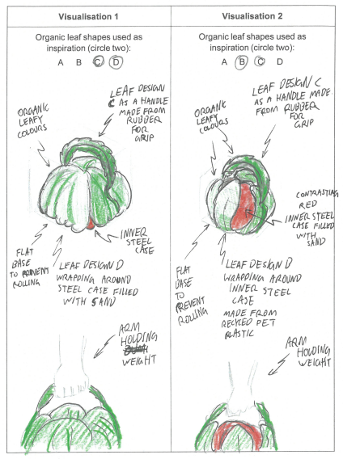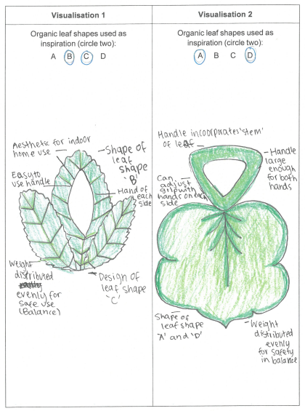
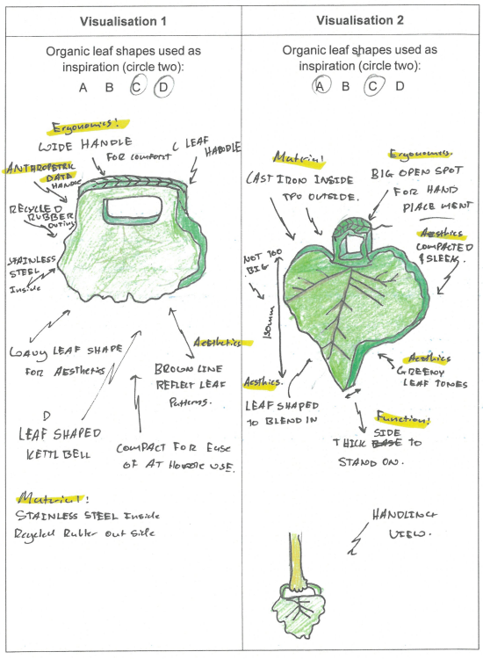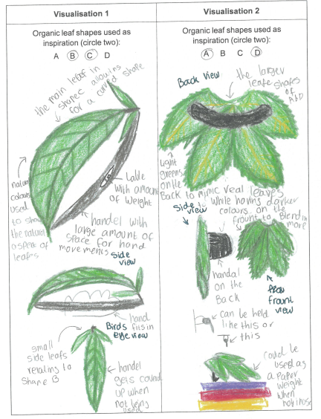
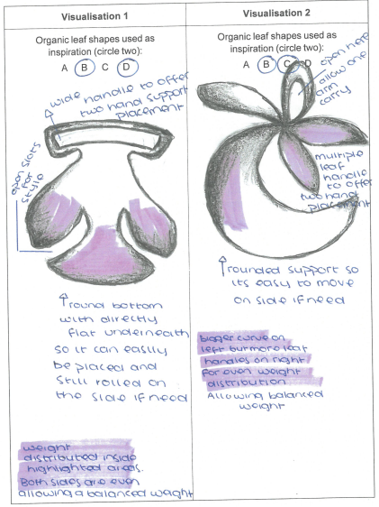

Question 15b.
Marks | 0 | 1 | 2 | Average
% | 19 | 14 | 67 | 1.5
Students were asked to describe a design consideration linked to their visualisation.
Students answered this question well, clearly providing features of a design consideration to ensure the kettle bell design was functional.
The following is from a high-scoring student response:
I included a rubber handle for grip on both visualisations to ensure a comfortable grip for end users when using the weight.

Question 16a.
Marks | 0 | 1 | 2 | 3 | 4 | 5 | 6 | Average
% | 20 | 14 | 24 | 15 | 17 | 6 | 4 | 2.3
Students were required to discuss social and economic considerations relating to material selection.
While many responses identified relevant considerations, these were often stated in isolation and not clearly linked to the chosen material.
High-scoring responses provided a balanced discussion that directly connected material choice to its social and economic impacts. Students explained how sourcing materials overseas could reduce employment opportunities for local people and raised concerns about unknown working conditions, whereas locally sourced materials were often associated with better-regulated labour practices and greater social responsibility. Social impacts were also effectively discussed where students considered the potential harm of toxic or hazardous materials on workers, end users or local communities; for example, through poor air quality or contaminated water affecting public health.
Economically, high-scoring answers linked material choice to cost, sustainability and the wider economy. Examples included recognising that materials such as cast iron may increase production costs, that using multiple materials could raise manufacturing expenses, or that cheaper materials may be more economically sustainable in the long term. High-scoring responses also highlighted that sourcing materials locally can support local industry, keep money within the local economy, and enhance the reputation of the designer or producer, potentially increasing sales and long-term profitability.
Overall, full-mark responses consistently linked material selection to clear social or economic consequences, whether at the stage of production or in relation to the end user, rather than simply listing considerations without explanation.

Question 16b.
Marks | 0 | 1 | 2 | 3 | 4 | 5 | 6 | Average
% | 17 | 11 | 29 | 19 | 16 | 4 | 3 | 2.3
Students were asked to critique two impacts of artificial intelligence in kettlebell production.
Many students listed only positive aspects and did not provide an evaluation or reasoned opinion.
High-scoring responses presented positives, negatives and a judgement for each impact, and related this to production.
The following is from a high-scoring student response:
AI would streamline manufacturing and automate machinery and Technologies which speeds up manufacturing. This allows for cheaper and faster manufacturing. However, the use of AI would potentially lower quality as it will take longer to identify inconsistencies and defects.
AI also reduces human interaction and therefore any hazards they may face. However it would reduce the jobs needed in factories, and therefore less job opportunities in the local economy.
Overall, AI would be helpful as long as quality checks are insured and jobs are offered in different areas.

