2025 VCE Systems Engineering external assessment report
Note: Student responses reproduced in this report have not been corrected for grammar, spelling or factual information.
This report provides sample answers, or an indication of what answers may have included. Unless otherwise stated, these are not intended to be exemplary or complete responses.
The statistics in this report may be subject to rounding resulting in a total more or less than 100 per cent.

Section A – Multiple-choice questions
The table indicates the percentage of students who chose each option. Grey shading indicates the correct response. The statistics in this report may be subject to rounding, resulting in a total of more or less than 100 per cent.
Question | Correct answer | % A | % B | % C | % D | Comments
1 | B | 1 | 93 | 4 | 2
2 | D | 27 | 11 | 11 | 51 | LCD stands for ‘liquid crystal display’.
3 | C | 2 | 0 | 96 | 2
4 | A | 71 | 7 | 13 | 9
5 | A | 55 | 9 | 24 | 13
6 | B | 24 | 53 | 1 | 21
7 | C | 7 | 23 | 55 | 15 | New and emerging technologies are predominantly driven by discoveries and new materials.
8 | D | 2 | 3 | 3 | 92
9 | B | 23 | 61 | 9 | 7
10 | A | 57 | 18 | 18 | 6
11 | C | 4 | 54 | 40 | 2 | A potentiometer is illustrated as being the reference for the voltmeter.
12 | B | 31 | 66 | 2 | 1 | Geothermal power plants convert thermal energy to electrical energy using mechanical turbines.
13 | A | 67 | 11 | 14 | 8
14 | D | 21 | 5 | 14 | 60
15 | C | 58 | 7 | 28 | 7 | As solar panels only produce DC and batteries can only be charged using DC, storage must come before conversion.
16 | B | 12 | 67 | 10 | 10
17 | D | 14 | 29 | 19 | 38 | Biomass energy is energy derived from organic materials; wood is an organic material that produces heat when it is burnt.
18 | B | 0 | 98 | 2 | 0
19 | C | 6 | 3 | 83 | 9
20 | D | 1 | 0 | 10 | 88

Section B

Question 1
Mark | 0 | 1 | 2 | 3 | Average
% | 6 | 21 | 11 | 62 | 2.3
Students needed to demonstrate an understanding of a simple gear train with a mechanical advantage of 5. To achieve a mechanical advantage of 5, the middle gear (10 teeth) is the driver gear (input) and the 50-tooth gear is the driven gear (output). While this is not a conventional gear train, it is acceptable for the middle gear to be the driver, because the driver can be positioned anywhere in a gear train as long as it transmits motion effectively to the other gears. Marks were still awarded for calculating a mechanical advantage of 2, where the 50-tooth gear was the driver gear and the 100-tooth gear was the driven gear.
The following is an example of a possible response:
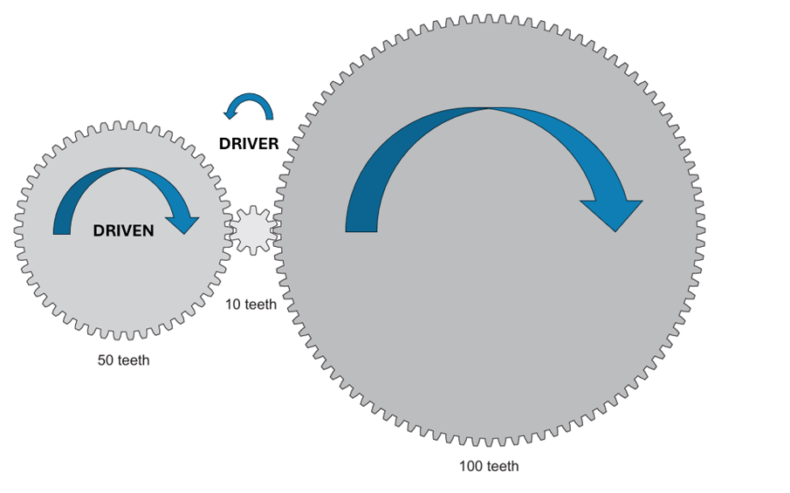

The following is an example of a high-scoring response:
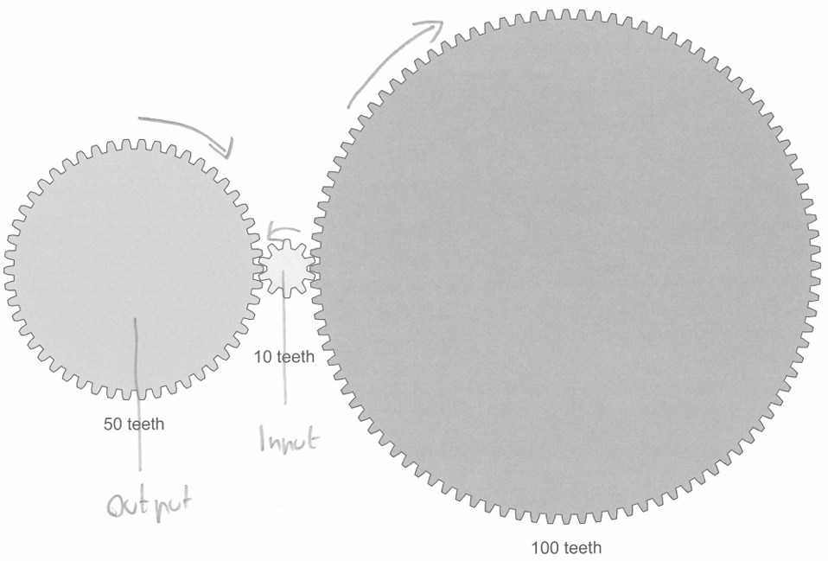

Question 2a.
Mark | 0 | 1 | 2 | 3 | Average
% | 25 | 13 | 24 | 38 | 1.8
Any illustration that included a third-class lever connected to both the fulcrum and the hydraulic piston was accepted. Alternatively, it was acceptable to depict a third-class lever that wasn’t connected to the hydraulic piston but included a spring mechanism attached to it to allow it to retract after being activated.
Full marks were awarded for an appropriately drawn lever with both the effort and load labelled correctly.
The following are examples of possible responses:
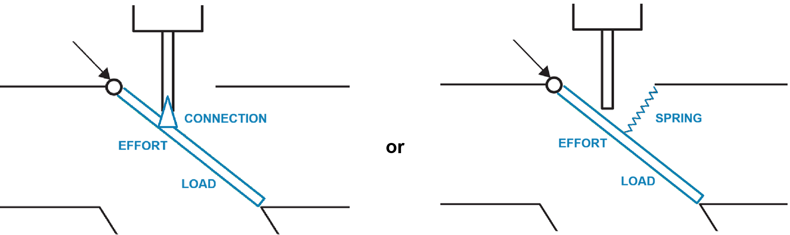

The following is an example of a high-scoring response:
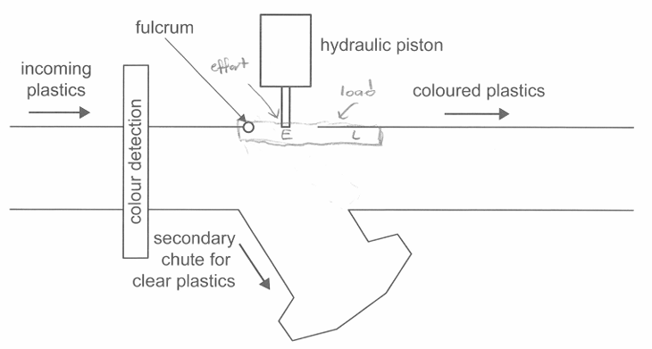

Question 2b.
Mark | 0 | 1 | Average
% | 45 | 55 | 0.6
The class of lever was third-class.

Question 2c.
Mark | 0 | 1 | 2 | 3 | Average
% | 27 | 20 | 27 | 26 | 1.5
Full marks were awarded for an input-process-output (IPO) diagram showing colour detection by an appropriate sensor as the input, activation of the hydraulic piston as the process and the diversion of plastic as the output.

Question 2d.
Mark | 0 | 1 | 2 | 3 | Average
% | 25 | 20 | 5 | 50 | 1.8
The output force of the hydraulic piston could be determined by calculating the pressure within the system and using this value to obtain the force being exerted on the corresponding piston. Another possible response was the use of a ratio-based approach to reach the same solution.
Marks were awarded for an accurate formula with appropriate values substituted in to determine the pressure of the hydraulic system and subsequently the correct response, which needed to include appropriate units.
The following are examples of possible responses:

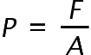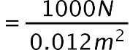



Or

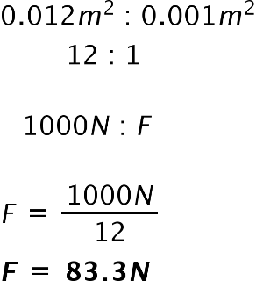

Question 2e.
Mark | 0 | 1 | 2 | 3 | Average
% | 35 | 5 | 6 | 54 | 1.8
The power of the hydraulic system was determined by calculating the work done on the piston, which was subsequently used to find the power. Full marks were awarded for appropriate calculations using previous solutions for force values determined in question 2d.
The following is an example of a possible response:
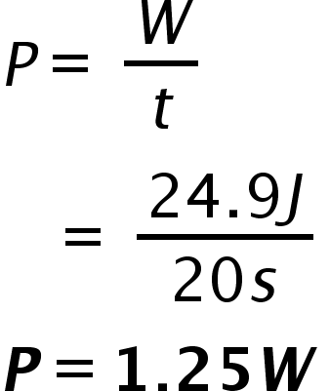
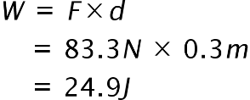

Question 2fi.
Mark | 0 | 1 | 2 | 3 | Average
% | 12 | 20 | 25 | 43 | 2.0
Students were required to refer explicitly to friction in their response, which was associated with either the friction of the chute itself or the friction resulting from the size of the plastics moving through it.
Full marks were awarded if any one of Newton’s laws were used to describe how the motion of the plastic was affected when redirected through the secondary chute.

Question 2fii.
Mark | 0 | 1 | Average
% | 24 | 76 | 0.8
Full marks were awarded for any method that reduced friction or provided an alternative to improving the movement of plastic through the secondary chute.
Possible responses included:
- widening or polishing the chute
- making the chute from an alternate material
- applying a lubricant.
The following is an example of a high-scoring response:
As is said in Newton’s first law, ‘an object in motion will stay in motion unless acted upon by another force’. Here, the clear plastics being directed down the secondary chute have friction as a force acting on them, preventing them from moving. The surface friction of the materials it is moving across may stop it, meaning it must be pushed along manually.

Question 3a.
Mark | 0 | 1 | 2 | Average
% | 23 | 36 | 41 | 1.2
The two components were a light-emitting diode (LED) and phototransistor or light-dependent transistor. Most students were familiar with the circuit symbol for an LED but not all were able to identify the phototransistor.

Question 3b.
Mark | 0 | 1 | 2 | Average
% | 50 | 25 | 25 | 0.8
Component A is a polarised or electrolytic capacitor; its role in the circuit is to filter out noise and smooth the signal sent to the speaker. A small number of students were able to accurately describe the function of the component.

Question 3c.
Mark | 0 | 1 | 2 | Average
% | 46 | 18 | 37 | 0.9
A variety of responses were accepted, but all responses needed an explanation of how the system could be modified with reference to causes, effects, continuity, change, reasons or mechanisms; and make the relationships between things evident to obtain full marks.
Possible responses included:
- adjusting the phototransistor using the potentiometers to make the signal more or less sensitive
- using a brighter LED, focusing the LED or replacing the LED with a laser to give a stronger signal
- adding some shading over the phototransistor so the sunlight doesn’t interfere with its functionality
- redesigning the circuit using an alternative sensor that is not sensitive to light, such as an ultrasonic
- using an infrared receiver instead of the phototransistor and LED so that it is not as sensitive to light.
The following is an example of a high-scoring response:
The coach could adjust the values of the potentiometers to lower the sensitivity of the system so that the speaker only triggers when the signal from the transistors is sent. The potentiometers control the thresholds.

Question 3d.
Mark | 0 | 1 | 2 | 3 | Average
% | 32 | 1 | 1 | 65 | 2.0
Full marks were awarded for any resistor network, either series or parallel, using a combination of the given resistors, as the question did not specify quantities of each type.
The following is an example of a high-scoring response:
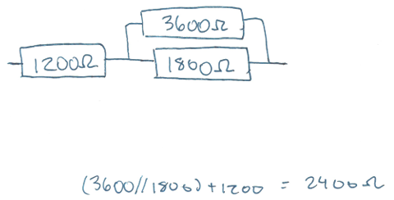

Question 4a.
Mark | 0 | 1 | 2 | Average
% | 49 | 16 | 35 | 0.9
Full marks were awarded for an appropriate approach and accurate description of the way in which it improves the efficiency of the power plant.
Possible responses included:
- carbon capture; reusing carbon for other purposes throughout the plant
- addition of enzymes to speed up the reaction rate
- adding oxygen to speed up the reaction rate
- capturing heat, which can be recycled back into the system rather than wasted
- Brayton-Rankine cycles; recycling heat back into the system
- crushing the coal; larger surface areas increase reaction rates
- upgrading the plant’s facilities as better designed generators have less friction and energy losses.
The following is an example of a high-scoring response:
The efficiency of the generators within a coal-fired power plant could be improved by reducing their internal friction through regular lubrication of their bearings. This reduces the energy loss as heat when they spin and as such increases the overall efficiency.

Question 4b.
Mark | 0 | 1 | 2 | 3 | 4 | Average
% | 1 | 2 | 10 | 24 | 63 | 3.5
Full marks were awarded for a completed table showing one advantage and one disadvantage for both solar and wind energy.
Possible responses included:
 | Solar | Wind
Advantage | - more predictable than wind as sunlight generally follows reliable daily and seasonable cycles so output is more easily forecastable  - easy to install  - reliable  - expandable  - clean form of energy | - can be placed off-shore  - can produce power all the time  - produces more power per unit area than solar  - clean form of energy
Disadvantage | - large amount of space required  - seasonal  - no production during the night  - requires maintenance; unclean panels affect energy production | - requires a windy location  - noisy  - impact on some wildlife (e.g. birds flying into turbines)  - expensive to set up

Question 4c(i).
Mark | 0 | 1 | 2 | Average
% | 5 | 2 | 94 | 1.9
The efficiency of the battery system is determined by dividing the energy being delivered to the medical equipment by the batteries’ capacity. Full marks were awarded for accurate workings and a correct solution represented as a percentage.
The following is an example of a possible response:
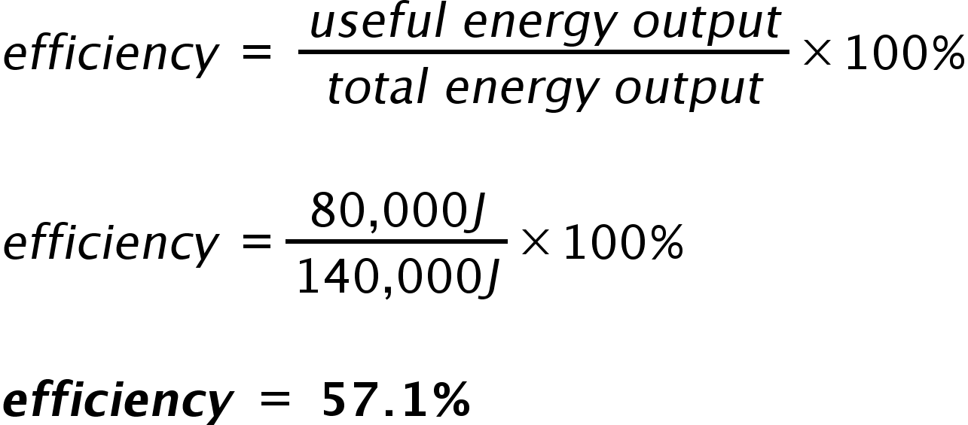

Question 4cii.
Mark | 0 | 1 | 2 | Average
% | 20 | 37 | 43 | 1.3
Students needed to refer to the type of energy being lost or to the process by which energy is lost in the transfer of energy from the battery to the medical equipment.
Possible responses included:
- sound energy, through operation of equipment
- heat energy, lost to resistance in transmission lines/cables
- energy losses due to discharge within the battery itself.
The following is an example of a high-scoring response:
Some energy would be lost due to the wires themselves that connect the battery to the medical equipment. This is because the wires do have a resistance, one which is impacted by the material resistivity of the wire and its length, therefore explaining the energy loss.

Question 5a.
Mark | 0 | 1 | 2 | Average
% | 30 | 29 | 41 | 1.1
To obtain full marks, students needed to determine the period of the alternating current (AC) waveform signal and then use this value to determine the frequency. Full marks were awarded for both the correct period and frequency. One mark was awarded for frequencies that were derived using an incorrect period.
The following is an example of a possible response:

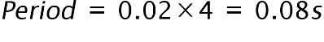
$f$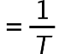 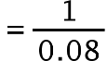

$f$

Question 5b.
Mark | 0 | 1 | 2 | 3 | 4 | Average
% | 29 | 8 | 25 | 8 | 30 | 2.0
Any two components within the AC to direct current (DC) adaptor were accepted. Marks were awarded for identifying an appropriate component and outlining the purpose it serves with the adaptor itself.
Possible responses included:
- a transformer to step down the voltage to 12V
- a voltage rectifier to convert AC to DC
- a capacitor to smooth the rectified signal
- a voltage regulator to help aid in the delivery of constant voltage.

The following is an example of a high-scoring response:
Component 1: transformer
A transformer’s purpose is to alter the amount of voltage from the AC mains to the rest of the system, in this case reducing the 220v to the required 12v.
Component 2: bridge rectifier
A bridge rectifier is needed to change the AC voltage received from the secondary side of the transducer, and make it a DC voltage, as the laptop will require.

Question 6a.
Mark | 0 | 1 | 2 | Average
% | 45 | 27 | 27 | 0.8
Students were required to justify the selection of either a dynamo or generator for use in an LED lighting system. Justification of the type of power source chosen was required to achieve full marks.
A dynamo or DC generator would be the preferred option to power the LED lighting system as it would provide a continuous flow of current for constant illumination of the LED. However, if the student wanted the LED light to flicker, then a generator would be the preferred option.
The potential for full marks was available for either selection, as long as the student used reasoning and evidence to show a sound understanding of how the power supply operates.

Question 6b.
Mark | 0 | 1 | 2 | Average
% | 27 | 41 | 33 | 1.1
An accurate description of the operational system of the power source chosen in Question 6a. was required to obtain full marks. This included a description of the energy conversion from mechanical to electrical energy, along with details pertaining to the inner workings of either a dynamo or generator. To achieve full marks, students needed to refer to an induced current generated by a magnet rotating within a coil of wire.
The following is an example of a high-scoring response:
The rotating of the pedals would spin the armature coil of the dynamo in a magnetic field. This creates an alternating current that is converted to DC by a split ring commutator. This current is then connected to the LED to power it.

Question 6c.
Mark | 0 | 1 | 2 | 3 | Average
% | 5 | 7 | 20 | 69 | 2.5
Students were required to draw an appropriate lighting system circuit, which included a power source attached to a rotational part of the bicycle, such as the crank, wheel axles or connected to the frame near to where the tyre rotates. An electrical connection consisting of a pair of wires or single cable connecting the power source to an LED positioned at an appropriate section on the bicycle scored highly.

The following is an example of a high-scoring response:
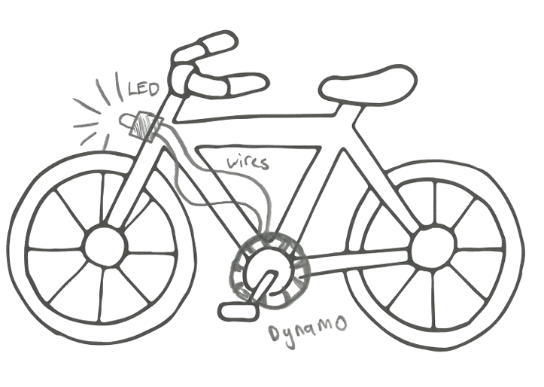

Question 6d.
Mark | 0 | 1 | 2 | 3 | 4 | Average
% | 19 | 11 | 38 | 9 | 24 | 2.1
Two evaluation criteria used to evaluate the efficiency of the bicycle lighting system could be:
- the brightness of the LED
- the power output of the dynamo or generator.
High-scoring responses made a clear connection between energy input and energy output.
The following is an example of a possible response:
Does the dynamo provide enough power to supply the LED light with the required energy it needs to operate effectively and be seen by other road users?
The following is an example of a high-scoring response:
Criterion 1: The length of time pedalled compared to the length of time the LED is on should be equal. This is important in evaluating the efficiency as the energy generated should be transmitted effectively in a manner that converts the energy into electricity for the LED.
Criterion 2: The LED light’s brightness is important in evaluation as all the energy loss from the light system will reduce the brightness of the light and the useful output energy, consequently impacting the efficiency of the system.

Question 6e.
Mark | 0 | 1 | 2 | 3 | 4 | 5 | Average
% | 19 | 14 | 15 | 22 | 9 | 21 | 2.5
An appropriate test procedure that outlined the setup and referred to the way voltage and current are measured scored highly.

The following is an example of a possible response:
- Setup: Connect a multimeter to the output terminals of the dynamo or generator.
- Testing procedure – voltage: Set up the bicycle to allow the wheels to spin freely. Connect a multimeter in parallel across the LED and begin to rotate the wheels in order to spin the dynamo or generator. Measure the voltage being output and record the results.
- Testing procedure – current: Set up the bicycle in the same way as per the voltage testing procedure to allow the wheels to spin freely. Connect a multimeter in series with the LED and begin to rotate the wheels in order to spin the dynamo or generator. Measure the current that is being delivered to the LED to ensure it isn’t overlading it.
The following is an example of a high-scoring response:
Set-up
For voltage set up, multimeter should be placed in parallel across the LED. For current set up, multimeter should be placed in series anywhere on circuit.
Testing procedure – voltage
1. Start at stationary and record initial voltage
2. Use speedometer to pedal to specific speed and record voltage at that velocity
3. Increase velocity interval by consistent amount and repeat step 2 to generate a voltage/velocity relationship
Testing procedure – current
1. Start at stationary and record initial current
2. Use speedometer to pedal to a specific speed and record current at that point
3. Increase velocity interval by consistent amount and repeat step 2 to generate a current/velocity relationship

Question 7
Mark | 0 | 1 | 2 | 3 | 4 | 5 | Average
% | 5 | 5 | 22 | 22 | 33 | 12 | 3.1
Students were required to discuss the application of artificial intelligence (AI) within the operation and maintenance of wind energy systems. The discussion needed to present a clear, considered and balanced argument that outlined operational benefits such as the ability of AI to analyse large data sets and make predictions on weather patterns, helping to identify periods of low energy yield. It also needed to include reference to any potential benefits provided to the maintenance of the wind energy system such as the ability of AI to track the operation patterns of the system and alert operators when anomalies occur, allowing issues to be addressed more promptly.
A discussion outlining both the strengths and weaknesses associated with the use of AI in the operation and maintenance of wind energy systems scored highly.
Possible responses included:
- Strengths:
- higher efficiency
- improved energy forecasting
- better grid stability

- Weaknesses:
- high implementation costs
- reliance on data quality
- poses cybersecurity risks.
The following is an example of a high-scoring response:
AI can be used to analyse daily wind patterns as well as users’ energy usage throughout the day. It can then determine when to focus on supplying user energy through wind or instead send the wind energy into the electrical mains. Additionally, AI can analyse the frequency of rotation of all turbines in a farm and determine the frequency they should all match to create constructive interference to improve efficiency of output. With this determination, it can limit the input of faster turbines to phase it into the slower ones. Furthermore, AI can monitor the voltage and current outputs of the internal generator and formulate a relationship based on data monitored over time. If the data does not meet the relationship to a significant degree, it can signal to humans that there may be a fault that requires maintenance.

Question 8
Mark | 0 | 1 | 2 | 3 | 4 | Average
% | 15 | 5 | 24 | 16 | 40 | 2.6
Students were required to discuss the positive and negative effects of using open-source software in the development of an electronic locking system. High-scoring responses presented a clear, considered and balanced argument that identified at least one positive and one negative effect of the use of open-source software on the development of the system.
Possible responses included:
Positive effects – As it is a free resource, using an open-source software model would allow students to use aspects of existing code or computer-aided design (CAD) designs that are freely available and assist in the development of an efficient end product.
Negative effects – There is a risk of security issues both during and following development, as using existing code or CAD designs without necessary security adjustments and checks may cause security issues with the system.
The following is an example of a high-scoring response:
Open-source software means software that can be easily obtained and modified by the general public. A possible positive effect of this is that widescale contributions may result in an optimised and efficient software as collective minds work to modify the software. However, a negative side effect could be that the software could be more susceptible to online attacks as the public has access to the inner workings of the software. This poses a security risk, as strangers can control one’s lock remotely for malicious use.

Question 9
Mark | 0 | 1 | 2 | 3 | 4 | 5 | 6 | Average
% | 19 | 4 | 9 | 5 | 13 | 6 | 44 | 3.8
This question centred around students’ understanding of production processes. Responses needed to relate each production process to the manufacture of the lamp and include a description of how the process should be undertaken safely. Marks were awarded for an accurate process along with a description regarding appropriate safety concerns that needed to be addressed.

Possible responses included:
- soldering: avoid touching the hot parts; keep the soldering iron in its stand when not in use
- cutting: follow safe work practices; use the correct tool for the right job
- sanding: follow safe work practices; if using a belt sander, avoid touching the belt when in operation
- drilling holes: clamp materials down and wear safety glasses
- assembly: use suitable tools to prevent any injury due to incorrect application and use.
The following is an example of a high-scoring response:
1. Metal work in the cutting of the metal parts to fit the lamp. During cutting, safety glasses should be worn to minimise the risk of metal shards getting in the eye, and the sharp edges of the metal and tools should not be touched.
2. Wood work using a saw to cut the wooden arms. The user should wear safety glasses to minimise debris getting in the eye, a proper clamp should be used, and the saw should always be used cutting away from the individual to minimise the risk of cuts/injury.
3. Sanding of wooden/metal parts would be performed, which would smooth sharp edges on the lamp. This would need to be performed with safety glasses, and the user should not touch the grain side of the sandpaper as this may cause grazes.

Question 10
Mark | 0 | 1 | 2 | 3 | 4 | Average
% | 18 | 3 | 18 | 8 | 52 | 2.7
Students were required to identify two subsystems that would commonly be used in the operation of a weather station and outline a maintenance procedure that would ensure the effective operation of each.
Possible responses included:
- subsystem: power supply
- maintenance: regularly check batteries, wires and outlet connections to ensure operation
- subsystem: barometer
- maintenance: calibration, cleaning
- subsystem: thermometer
- maintenance: calibration, cleaning.
The following is an example of a high-scoring response:
Subsystem 1: Light detection for sunny or cloudy days
Maintenance procedure: dust needs to be cleaned off sensors regularly to ensure maximum exposure to light
Subsystem 2: Rain detector
Maintenance procedure: the sensor must be cleaned and dried after rain stops to prevent false rain readings.

