2025 VCE Visual Communication Design external assessment report
Note: Student responses reproduced in this report have not been corrected for grammar, spelling or factual information.
This report provides sample answers or an indication of what answers may have included. Unless otherwise stated, these are not intended to be exemplary or complete responses.
The statistics in this report may be subject to rounding resulting in a total of more or less than 100 per cent.

Section A

Question 1
Marks | 0 | 1 | 2 | 3 | 4 | Average
% | 19 | 9 | 17 | 35 | 19 | 2.3
In this question, students were required to identify a Gestalt principle of visual perception and discuss how it was used in their selected design example.
High-scoring responses:
- correctly identified a relevant Gestalt principle in relation to their selected design example
- discussed how the principle was used in the selected design example.
Most students were able to identify an appropriate Gestalt principle (from those listed on page 16 of the study design), effectively discussing how the principle was used in reference to the examples. Common Gestalt principles discussed include ‘continuity’, ‘similarity’, ‘focal point’, ‘figure-ground’ and ‘proximity’, mostly within the DesignHer+ or the SmartGym App examples. Students who selected the vitaPACK or Magney House examples often found it more challenging to link the Gestalt principle to the design example.
Lower-scoring responses that did not sufficiently discuss the selected Gestalt principle often drifted off topic. For example, students often identified continuity as their Gestalt principle but their discussion focused on ‘similarity’. Other students focused on design principles such as ‘hierarchy’ or ‘contrast’ but did not align their response with the initial Gestalt principle identified. Some students merely stated the phrase ‘Gestalt principle of visual perception’ without selecting a specific principle, resulting in answers that could not be awarded marks.
In lower-scoring responses, students:
- were unable to identify a relevant Gestalt principle
- incorrectly discussed a design element or design principle instead of a Gestalt principle
- did not discuss the Gestalt principle identified.
Students should ensure that they can accurately distinguish between Gestalt principles and design elements and principles. Definitions of the design elements, design principles and Gestalt principles of visual perception are in the specifications on page 16 of the study design. Students must apply the principle directly to their selected example and clearly discuss how it is used.
The following are examples of high-scoring responses:
SmartGym app
Similarity – The Gestalt principle of similarity has been used in the SmartGym app to help the user to identify the app they are using as they work though each of the app’s functions and screens. The same consistent elements of type and the colour combination of green and white on a black background are used to ensure that each face/screen is easily recognisable as part of the SmartGym app and highlights the connections between each screen/face.
DesignHer+
Continuity – Continuity has been used to guide the viewers attention through the use of a thick multi-coloured line which travels in a vertical direction. The line travels from the top to the bottom and guides the viewer from the large title to the smaller info informative text. This use of continuity extends onto all panels maintaining viewer attention and creating a fluid reading experience from one section of information to the other, effectively organising it.

Question 2
Marks | 0 | 1 | 2 | 3 | 4 | Average
% | 13 | 14 | 42 | 26 | 5 | 2
In this question, students were required to explain the legal obligations a designer may have needed to consider in the development of their design, using evidence from the selected example to support their explanation.
High-scoring responses:
- correctly identified multiple legal obligations relevant to the selected field of design practice
- explained these obligations with accuracy, using correct terminology
- linked the legal obligation directly to the features or requirements of the selected design example
- maintained a clear distinction between ethical considerations and legal requirements.
Many students were able to identify at least one appropriate legal obligation. Common obligations discussed included copyright and trademark (particularly in the AFL Indigenous Round example), safety regulations and building codes (such as those relevant to the Northcote Aquatic Centre), and patents and design registration (relevant to the Pure Advanced Flex scooter). Students who had a strong grasp of these terms were able to identify the most appropriate ones relevant to the selected example and successfully explained how these obligations were considered in the development of the design example.
However, many students mentioned obligations (such as copyright) but described them inaccurately or as part of a broad, overarching statement, without any reference to the design example. For example, they stated that copyright must be applied for or that trademark or patent protection is automatic. Students should understand that copyright is automatically assigned when the work is created, whereas trademarks and patents must be formally registered. There is information about Intellectual property and copyright on page 18 of the study design. Further clarification is provided in the 2025 Visual Communication Design FAQs.
Additionally, a significant number of students demonstrated confusion between ethical considerations and legal obligations. In responses discussing examples involving Aboriginal and Torres Strait Islander perspectives or cultural references, many students referred to the Indigenous Design Charter or Indigenous Cultural and Intellectual Property (ICIP). While these frameworks are important and relevant to ethical practice, they are not legal documents and therefore could not be identified as legal obligations in this context. Students often struggled to shift their focus from ethical considerations (such as attribution, consultation or respectful representation) to the legal obligations required by the question.
In lower-scoring responses, students typically:
- identified only one obligation
- listed obligations without explanation or evidence
- discussed ethical considerations instead of legal obligations
- made factually incorrect statements about intellectual property
- provided generic statements without linking them to the selected design example.
Students should ensure that they are familiar with the specific legal obligations relevant to different fields of design practice, as outlined in the study design and support materials, and that they can clearly distinguish them from ethical responsibilities. There is further information about Aboriginal and Torres Strait Islander histories and cultures in design practice on page 17 of the study design. Students must be able to apply these obligations directly to the selected design example.
The following are examples of high-scoring responses:
Northcote Aquatic Centre
Legal obligations that the designer may need to consider in the Northcote Aquatic Centre are safety and accessibility. As the design is an aquatic water park for children, the designer must ensure that safety measures are met. For example, the slide must have barriers on the sides that are high enough so that children do not fall out over the top when sliding down. Similarly, the designer should consider accessibility for all people. For example, building the water play on a flat surface so those in wheelchairs can play and engage too.
AFLW Indigenous Round Guernsey Poster
In creating the AFLW Indigenous Round guernsey poster, the designer needed permission from the First Nations artist to use the Indigenous artwork, meeting copyright requirements and ensuring any changes like cropping for the poster were allowed under the licence agreement. The designer also had to follow trademark and brand-guideline obligations when using logos such as those for Telstra, Cotton On, BHP, NAB and the West Coast Eagles, making sure each logo was approved or used correctly in line with brand rules for colour, size and placement.

Question 3
Marks | 0 | 1 | 2 | 3 | 4 | 5 | 6 | Average
% | 9 | 10 | 17 | 35 | 18 | 8 | 3 | 2.8
In this question, students were required to evaluate the application of methods, media and materials used in the design solution.
High-scoring responses:
- correctly identified methods, media and materials evident in the design solution
- used accurate terminology consistent with the study design
- provided clear evidence from the figures to support their evaluation
- evaluated how effectively the chosen methods, media and materials were applied.
Many students demonstrated a general understanding of methods, media and materials and could link them directly to the design solution. Commonly selected design examples included Tronicwaste (typically with links to printing, cardboard and ink), and the Christian Jenkins Pavilion (often with links to drawing, vector-based application and wood). Stronger responses explicitly stated, for example, that ‘The method of printing was used…’ before evaluating its application in terms of clarity, appropriateness, effectiveness, and so on. While categorising the materials, methods and media was not necessary, it often helped students to enhance the clarity and accuracy of their response.
There was occasional confusion regarding the categorisation of the three terms. Students often mislabelled specific digital tools such as Adobe Illustrator as methods, or incorrectly identified materials used in manufacturing rather than the materials evident in the communication. While most students could recognise at least one material accurately, many struggled to distinguish between digital and manual methods. Some responses relied on broad terms such as ‘digital process’ or ‘manual techniques’, which did not meet the requirement to specify the methods listed in the study design specifications on page 15. There is additional advice about methods in the Planning section of the VCE Visual Communication Design Study Design webpage under ‘Visual communication practices.’
A common error was discussing methods, media and materials used earlier in the design process rather than those visible in the final design solution. Students frequently referred to methods such as sketching, ideation or prototyping, which were not relevant to the question. The question required an evaluation of what was present in the resolved solution, not what may have occurred during development. This led many responses to remain speculative, generic or disconnected from the design examples. The use of methods is provided in the definitions of documentation drawings and presentation drawings in the specifications on page 15 of the study design.
Additionally, evaluations were often superficial, with students stating what was used rather than evaluating its application. For example, students stated that ‘digital software was used’ without explaining how this enhanced precision, clarity, colour quality or user engagement.
While some students referred to examples such as the Tronicwaste design with thoughtful detail, many responses lacked clear, specific evidence drawn from the final solution.
Lower-scoring responses:
- misidentified or conflated methods, media and materials
- provided description without an evaluation
- failed to reference evidence from the design solution
- used terminology that was inconsistent with the study design.
Students should ensure that they can accurately define and distinguish methods, media and materials and apply these terms specifically to the features evident in the design solution, as required by the question. Further information about these terms can be found in the Planning section of the VCE Visual Communication Design Study Design webpage under ‘Visual communication practices.’
The following are examples of high-scoring responses:
Tronicwaste Electronic Waste Information Kit
The methods used to create the electronic waste information kit mainly consist of digital drawing and collaging. The designer would arrange different compartments of the design, such as the images of appliances and the typography, outlining environmental statistics using a computer. The media used could either be a vector-based program like Adobe Illustrator or a raster-based application such as Photoshop, which has allowed the designer to successfully create the modern look appropriate to the environmental purposes of the design. The materials used include card and paper in images 10, 11, and 12, which neatly display a book and effective fold-out pamphlet. The material of cardboard is used in image 9, where a cardboard box is used to store different parts of the kit.
Christian Jenkins Pavilion
The designer has successfully used the method of digital drawing in an app such as Procreate or Illustrator (media) to create a digital drawing of the pavilion design solution in Image 19. They used this media to effectively apply colour and texture of different parts of the design to convey this to the client, who has then had the design built using materials such as timber. The use of timber was likely decided upon given its sustainable qualities, in addition to it suiting the garden-based context.

Question 4
Marks | 0 | 1 | 2 | 3 | 4 | 5 | 6 | Average
% | 3 | 3 | 12 | 15 | 30 | 27 | 11 | 3.9
In this question, students were required to analyse how one design element and one design principle were used in the selected example to support aesthetic decisions.
High-scoring responses:
- clearly identified one appropriate design element and one appropriate design principle
- described how each was used in the selected design example
- linked their analysis directly to how aesthetic decisions were supported.
Many students identified relevant design elements and principles, with colour, type, contrast and hierarchy being the most commonly selected. The responses discussing Tronicwaste were generally the strongest, with many students noting the use of green to communicate an environmentally themed aesthetic and the use of red or orange to reinforce warnings or environmental harm. Similarly, responses referencing the Melbourne Aquarium example often demonstrated an understanding of how colour supported an underwater or oceanic aesthetic.
Students who began their response with a clear topic sentence that named both the element and principle, and stated the aesthetic they supported, were often the most successful. This approach ensured that all parts of the question were addressed and prevented students from drifting into description without analysis. They could also discuss the way that design elements, design principles, Gestalt principles, methods, media and materials work together to communicate ideas and information. There is further information about aesthetic impacts, considerations and decisions and their definition on page 3 of the 2025 Visual Communication Design FAQs.
However, while many students mentioned ‘aesthetic’ in their responses, a common limitation was not articulating what aesthetic was being supported. Statements such as ‘colour supports the aesthetic’ or ‘this enhances the overall aesthetic’ did not meet the analytical requirements of the question. Stronger responses specified the nature of the aesthetic, such as natural, environmental, technological, calming or vibrant, and explained how the decisions around the design elements and principles used contributed to this.
There was recurring confusion between shape and form, particularly in examples where three-dimensional objects were depicted. Students who referenced shape in the Soufflé Sofa example were sometimes inaccurate, unless referring strictly to the flat, two-dimensional components featured in Image 16. There was also some uncertainty around principles such as scale and proportion (for example, responses identifying scale but discussing proportion).
Many students attempted to bring in multiple design principles, such as discussing contrast and then hierarchy, without providing sufficient depth for either. A common shortfall was not adequately discussing the hierarchy of design elements. For example, many students correctly identified the most dominant feature in the design but did not extend their discussion to include secondary or tertiary elements. These responses did not explain how layers of hierarchy were created or how the viewer’s visual pathway was shaped across the design.
Lower-scoring responses typically:
- listed elements and principles without linking them to aesthetic decisions
- identified ‘aesthetic’ but did not describe its qualities
- described the design rather than analysing how visual choices supported an aesthetic intention
- selected an element or principle that was not relevant or incorrectly categorised.
Students should ensure that they can identify an aesthetic quality and explain how both the chosen design element and design principle contribute to achieving that effect within the visual communication.
The following are examples of high-scoring responses:
Melbourne Aquarium
They have used blue as the main consistent colour across all of the screens of the JellyLab interface, reflecting an underwater aesthetic. They have used a strong blue image on the home page with contrasting pops to orange and red to invite interest while the use of white text creates a strong contrast to the background making it easy for the user to navigate to the screens that interest them. The use of a monochromatic blue jellyfish photo as a background for the white life cycle graphic also creates a strong contrast allowing the viewer to easily see both the drawings and text. A dark blue is used for the experts screen ensuring the focus is the expert videos. Lighter blue bubbles tie each of the screens together and further the ocean-like aesthetic.
Tronicwaste Electronic Waste Information Kit
In the Tronicwaste kit, the designer has used the element of colour to support the organic and environmentally focused aesthetic. They have chosen earthy tones commonly associated with sustainability, such as shades of forest green, muted green and a light beige background. Using these green tones as the dominant colours reinforces the environmental imagery and creates a cohesive aesthetic that suits the design’s purpose. The design principle of contrast is also used to highlight the focus on the environment through both type and imagery. Vibrant greens and oranges contrast with the light beige background, and this variation between light and dark places stronger emphasis on the imagery and type, further supporting the environmental aesthetic.

Question 5
Marks | 0 | 1 | 2 | 3 | 4 | Average
% | 22 | 8 | 27 | 30 | 13 | 2.1
For this question, students were required to explain how one factor influenced the designer of the selected design example.
High-scoring responses:
- selected one of the five prescribed factors from the study design using correct terminology
- explained how the factor influenced the designer – usually in terms of specific design decisions, such as material choice, layout, colours, form, functionality or communication style
- referred directly to visual or functional evidence in the selected example
- remained focused on the influence on the designer, rather than on the need for or purpose of the design solution.
Students who had clearly learned the five factors (as stated in Unit 3 Outcome 1 and 2 on page 33 of the VCE Visual Communication Design study design) were able to select the most appropriate one and explain it accurately in relation to their chosen example. Environmental factors were commonly discussed in relation to Tronicwaste and the Christian Jenkins Pavilion, where students linked the designer’s choices (such as colour palette, imagery or materials) to environmental themes. Social factors were explained effectively in examples such as the Soufflé Sofa, where comfort, inclusivity or contemporary living needs were used as evidence. Finally, technological factors were applied clearly in the Jelly Lab example, where digital fabrication and scientific technologies influenced the choice of visual and functional qualities.
However, confusion around terminology persisted. Many students provided reasonable explanations of how influences shaped the design but did not articulate these using study design terminology. Responses that simply referred to ‘sustainability’ instead of environmental factors or ‘budget’ instead of economic factors lacked specificity.
Another recurring issue involved students explaining how a factor influenced the creation or need for the design, rather than how it influenced the designer and their decisions. For example, in Tronicwaste, some students stated that environmental issues created a need for awareness-raising, without explaining how the designer’s choices around colour, imagery or composition were shaped by environmental factors.
Some responses relied on generic statements or discussed factors unrelated to their chosen example, limiting the specificity required for full marks.
Lower-scoring responses:
- did not use the correct terminology for factors
- focused on the problem or need instead of the design
- provided no evidence from the example
- selected a factor that did not align with the chosen design.
Students should ensure that they use the exact terminology of the five factors from the study design and apply them directly to designer decisions that were evident in the design example selected. Further information regarding factors is available under ‘Planning’ on the VCE Visual Communication Design study design webpage.
The following are examples of high-scoring responses:
Soufflé Modular Sofa
Social factors, which relate to how people interact, gather and use shared spaces, may have influenced the designer of the Soufflé modular sofa. This likely shaped its overall form, allowing the sofa to be split into multiple parts and arranged in different layouts depending on the social situation. The design supports users who want to sit closer together or further apart, and it can be adapted for large groups or more private seating. It also considers the direction people may want to face, ultimately prioritising user comfort and seating preferences in a variety of social contexts.
Christian Jenkins Pavilion
The designer of the pavilion would have been influenced by environmental factors, such as the context and location of the site. Being within the Melbourne International Garden Show, the designer would have aligned the pavilion, and included skylights, strategically in response to the location’s solar path. This would help to maximise natural light, cutting back on artificial lighting, saving energy and money. Additionally, to blend in with the surrounding garden, the designer used natural timbers for both the canopy and flooring.

Question 6a.
Marks | 0 | 1 | 2 | 3 | 4 | Average
% | 8 | 27 | 23 | 32 | 10 | 2.1
In this question, students were required to describe how the purpose of their selected design example reflects conceptions of good design.
High-scoring responses:
- clearly identified the purpose of the design
- selected appropriate conceptions of good design
- described how the specific purpose of the design aligned with or was supported by these conceptions
- used evidence from the selected example to support their claims.
While many students opted to identify familiar purposes such as to inform or to depict, which were potentially relevant, other students were able to confidently branch out to discuss more tailored purposes, for example, ‘The purpose of the Souffle Sofa is to provide a comfortable, yet flexible, seating option…’. These responses usually contained clearer and more focused descriptions; however, many responses included vague or implied references to purpose without clearly stating what the purpose was. Statements such as ‘The purpose reflects the good design conception…’ lacked specificity and made it difficult to determine whether students understood the design’s purpose.
Most students were also able to identify relevant conceptions of good design, with many confidently drawing upon Dieter Rams’s Ten Principles of Good Design. Common options included ‘Good design is functional’, ‘Good design is innovative’ and ‘Good design is environmentally friendly’.
Some students had difficulty linking the purpose of the design with the conceptions of good design chosen. Often these two aspects of the response were described independently of one another.
Lower-scoring responses:
- did not state the purpose of the design
- referenced good design concepts without evidence, relying on assumptions (for example, suggesting durability for a design where longevity could not be confirmed)
- did not link the purpose to the selected conception(s) of good design.
Students are encouraged to begin with a clear sentence outlining the design’s purpose and then to link this directly to specific conceptions of good design evidenced in the selected design example. There is specific information about good design in the terms used in the study on page 19 of the VCE Visual Communication Design study design. It is important to note that these terms, along with the study specifications, are examinable as they reference key terms in the key knowledge and skills in Units 3 and 4.
The following are examples of high-scoring responses:
Melbourne Aquarium
The JellyLab interactive experience intends to inform and teach children about jellyfish. The designer would have considered this while planning this experience ensuring that good design was used to make sure that it was ‘easy to understand’ and access. The use of an interactive touch screen is ‘accessible’ to most as touch screens are found everywhere in daily life. The imagery is easily identifiable though includes the required detail. The choice of type is simple and clear with easily recognisable hyperlinks that could be used to navigate the program, conveying the required information.

Tronicwaste Electronic Waste Information Kit
Conceptions of good design such as being ‘environmentally friendly’, occurs in Image 9 where the designer has used a cardboard box for the packaging of the kit. This is a more sustainable choice than other materials, which reflects the ideals of the company, whose purpose is to educate and inform consumers of e-waste and its impact. It continues to convey this message through a powerful and sustainable ‘aesthetic’ (another Dieter Rams principle) through the strategic and bold choices of colour, type and imagery.

Question 6b.
Marks | 0 | 1 | 2 | 3 | 4 | Average
% | 23 | 36 | 17 | 19 | 5 | 1.5
In this question, students were required to evaluate how the context of their selected design example reflects conceptions of good design.
High-scoring responses:
- accurately described the context of the selected design example
- selected relevant conceptions of good design and linked them directly to aspects of the context
- used evidence from the design example to support their evaluation.
In responses where context was correctly identified – for example, as an exhibition environment, a domestic space, a public venue or an outdoor installation – students were better able to make meaningful links to conceptions of good design such as usefulness, unobtrusiveness, innovation or sustainability. These stronger responses evaluated how the context influenced the designer’s decisions and how the design’s intended setting reinforced specific principles of good design.
A number of student responses demonstrated uncertainty around what constitutes context, with students often offering vague or unrelated descriptions. A common misunderstanding involved describing the presentation format instead of the setting or circumstances in which the design is intended to be used. For example, some students referred to the Tronicwaste design being ‘on a kit’ rather than discussing the educational or environmental context in which the kit might be accessed.
Additionally, many students struggled to connect their chosen conception of good design to the context. Some responses listed concepts such as sustainability, aesthetic appeal or ‘as little design as possible’ without explaining how the design’s context made these qualities advantageous, necessary or more effective. Others misapplied terminology, for example, by using the phrase ‘as little design as possible’ for designs that were quite detailed.
Lower-scoring responses:
- did not identify an appropriate context
- listed conceptions of good design without evaluation
- relied on assumptions that could not be supported by evidence from the design example
- provided statements that were too general to demonstrate an understanding of context.
Students should ensure that they can accurately identify the context of a design example and understand that context refers to the environment or circumstances in which a design is created, used or viewed. They should then evaluate how this context supports or enhances relevant conceptions of good design, using clear and direct evidence from the design example.
The following are examples of high-scoring responses:
Soufflé Modular Sofa
In terms of Ram’s principle ‘good design is innovative’, the Soufflé sofa is a very flexible design that is suitable for a range of contexts, such as office spaces, foyers/waiting rooms, schools and libraries. The couch’s modular features help define individual spaces while still encouraging group interaction, offering both privacy and connection at the same time. This furthers the idea that ‘good design makes a product useful’, as in places like a library, it can create cozy, personal areas for individuals who wish to enjoy reading, while still allowing for multiple users to share the same piece of furniture. As seen in image 12, the couch can be rearranged into various configurations to adapt to the needs of each context, making it an innovative and useful design.
Christian Jenkins Pavilion
The pavilion is in Melbourne as part of the Melbourne International Garden Show and is positioned outdoors. In response to this context, the designer has selected modern, minimalistic lighting, such as LED strip lighting placed along the wooden beams. This choice reflects Dieter Rams’ idea that good design is aesthetic, as the lighting enhances the visual form of the pavilion and creates a refined, contemporary atmosphere. At the same time, because the pavilion sits outdoors, the design features a canopy for shelter and shade, which reflects the good design principle of being functional.

Question 7
Marks | 0 | 1 | 2 | 3 | 4 | 5 | 6 | 7 | 8 | Average
% | 30 | 6 | 9 | 11 | 15 | 12 | 11 | 4 | 1 | 2.8
In this question, students were required to compare how two contemporary designers they had studied engaged a specialist when resolving design problems. Students were expected to identify the designer, the project and the specialist, and then compare the ways the specialist contributed to each designer’s practice.
High-scoring responses:
- clearly identified two contemporary designers (working from 2000 onwards)
- named a specific design example for each designer
- accurately identified an appropriate specialist relevant to that project
- provided a direct comparison, outlining similarities and differences in how specialists contributed to design development.
Many students were familiar with the designers they had studied during the year, but fewer were able to clearly identify an appropriate specialist. Stronger responses selected specialists such as engineers, typographers, manufacturers and exhibition designers – essentially any professionals who contributed specific knowledge or expertise to help resolve aspects of the design. They were then able to clearly compare how these specialists may work with the designer to resolve design problems in similar or different ways. For example, such responses described how a print specialist (working with a graphic designer) and a materials specialist (working with an architect) may have similarities in terms of how they create sustainable designs.
However, many students demonstrated misunderstanding of the concept of a specialist. Some referred to clients, target audiences, stakeholders or the general public as specialists, which did not meet the requirements of the question. Others incorrectly identified celebrities, sportspeople or other designers as specialists. Students should understand that specialists contribute specialist knowledge, rather than providing approval, inspiration or general feedback.
A significant proportion of responses did not fulfil the comparative component of the question. Many students discussed each designer separately and then added a brief linking sentence, rather than making sustained, analytical comparisons. Some students provided detailed descriptions of designers’ practices but did not mention specialists at all, suggesting that memorised responses were used rather than tailoring the response to the question. Other students discussed differences between the specialists based on the fact that they both undertake very different roles.
There were also instances of students selecting designers who were not contemporary as defined in the 2025 Visual Communication Design FAQs, leading to answers that could not be awarded full marks. Others referred to ‘designers’ who were actually artists, photographers or craftspeople working outside the field of visual communication design.
Lower-scoring responses typically:
- did not name specialists or identified inappropriate ones
- conflated designers with specialists (for example, describing a graphic designer assisting another graphic designer)
- selected projects without explaining the specialist’s contribution
- omitted comparison and treated the designers separately
- referred to tradespeople such as builders as specialists, despite their primary role being construction rather than design resolution.
Students should ensure that they revise the expectations of Unit 3, Outcome 1, including the definitions of ‘contemporary designers’, ‘context’ and ‘specialist engagement’. Thorough understanding of these key knowledge areas will enable students to identify appropriate examples and make meaningful comparisons in their responses.
The following is an example of a high-scoring response:
Designer 1: Bjarke Ingels Designer 2: Cas Holman
Design example: Lego House Design example: Geemo
Specialist: Exhibition designer Specialist: Manufacturer
Both Bjarke Ingels in the design of Lego House and Cas Holman in the design of Geemo collaborated with specialists to address design problems at different scales. Ingels, architect of Lego House in Denmark, worked with exhibition designers to create dynamic and accessible spaces that reflected Lego’s creative spirit. Their expertise helped position building stations at suitable heights for children and adults, and design interactive zones that encouraged participation and play.
Similarly, Cas Holman, designer of the Geemo magnetic toy, collaborated with manufacturers to ensure the product was functional, safe, and suitable for children. Through their specialist knowledge of materials and production, Holman could make informed, user-centred design decisions.
A key difference between the two is scale: Ingels’ collaboration with specialists focused on large-scale spatial and experiential design, while Holman’s centred on detailed product functionality and safety. Both demonstrate how engaging relevant specialists supports effective problem-solving and enhances the user experience.

Section B

Question 1a.
Marks | 0 | 1 | 2 | 3 | Average
% | 17 | 23 | 36 | 24 | 1.7
In this question, students were required to discuss additional characteristics of the 18–30-year-old audience/user that were relevant to the design problem.
High-scoring responses:
- clearly discussed specific audience characteristics, using demographic and psychographic descriptors
- avoided vague or universal descriptions
- linked the characteristics directly to the design problem
- demonstrated an understanding of the difference between audience characteristics, audience needs and constraints.
Most students were able to identify at least one relevant characteristic of the target audience, with interests related to fashion, sustainability and technology being common. Higher-scoring responses discussed the audience using precise terms, such as lifestyle preferences, values, purchasing behaviours or cultural affiliations within the 18–30 age range. These responses articulated how such characteristics were relevant to the design problem, rather than simply noting them.
However, many students confused audience characteristics with audience needs, often describing what the audience ‘wanted to see in the design’ instead of who they were. This resulted in responses centred on the desired features of the communication rather than on the demographic or psychographic profile of the audience.
A significant number of students provided characteristics that were too broad or generic. References such as ‘all genders’, ‘any cultural background’ or ‘people who live anywhere in Australia’ did not demonstrate meaningful insight into the target audience. Similarly, some students used vague categories such as ‘young adults’ without providing further detail, which meant the response lacked the precision required in the discussion of the audience.
Lower-scoring responses typically:
- listed characteristics without discussion
- did not link characteristics to the design problem
- used overly broad descriptors
- confused characteristics with needs or constraints
- provided irrelevant or incorrect audience information.
Students should be encouraged to discuss audiences using both demographic descriptors (age, income, education, location) and psychographic descriptors (values, interests, behaviours, motivations), ensuring that these are relevant to the design problem and clearly distinguishable from audience needs or design constraints.
The following is an example of a high-scoring response:
The audience may also be people who live in urban areas where fast fashion is a growing issue, they may value reusing clothes and often find themselves going thrifting or using DIY methods to repurpose their clothes. These people may be primarily female with an interest in fashion items and styling. They are also likely to value the preservation of the environment and ensuring that minimal waste ends up in landfill, leading to them recycling and reusing in their everyday lives.

Question 1b.
Marks | 0 | 1 | 2 | 3 | Average
% | 29 | 31 | 26 | 14 | 1.2
This question required students to identify their field of design practice and discuss constraints relevant to the design problem.
High-scoring responses:
- discussed constraints as limitations or expectations
- referred to constraints that were realistic and relevant to the selected field of design practice
- avoided repeating design criteria.
Strong responses were able to clearly discuss limitations or expectations relevant to the specific communication need outlined in the design criteria for their selected field of design practice. References to constraints such as ‘Symbols need to be universally recognised without type’ or ‘Screens should include a clear and easy to understand map’ were examples of extending on the design criteria, not simply repeating it.
Some students confused constraints with design criteria, repeating statements such as ‘must attract 18- to 30-year-olds’ or ‘must reflect sustainable practices’, which are requirements, not constraints. Others listed speculative ‘threats’ to success (for example, ‘people may not choose to wear second-hand clothing’) rather than describing limitations.
Lower-scoring responses:
- repeated design criteria or the brief verbatim
- provided constraints unrelated to the field of practice
- confused constraints with audience characteristics
- lacked clarity and specificity.
Students should refer to the constraints they developed in their school-assessed task, ensuring that they describe true expectations or limitations such as those related to materials, projected cost, aesthetic qualities, functional features, legal requirements or technological restrictions.
The following are examples of high-scoring responses:
Messages – The four symbols included need to be clear and universally understood. Therefore, they should not rely on type to explain or identify but rather be simple icons that are distinguishable from each other and reflect the article of clothing. The signage should consider using lightweight, yet durable materials that would be suitable for a pop-up store.
Objects – One constraint for the display furniture would be that it should include features that allow it to be easily transported once dismantled, such as wheels or a handle. This will allow for the functionality of the furniture to be optimised. Another constraint is that the furniture should be able to display a range of different types of clothing, from t-shirts to dresses and even shoes. Having this flexibility will allow them to display different types of clothing regardless of what stock they have available.
Interactive experiences – The constraints for the app screens would be that they are clear to read and accessible for people with vision impairments, this may lead to a larger text style, clear hierarchy and contrast. The app would also need to contain a navigation bar on the menu to easily navigate the functions of the app in locating the nearest pop-up event.
Environments – Adaptability is a key constraint for environments because the Swap Shop is a pop-up clothing event, so the entrance structure should be easy to assemble, dismantle and transport, and able to fit into different spaces. Sustainability is another important constraint, as the event aims to reduce the impact of fast fashion on the planet. This means the design should be environmentally responsible, which could be addressed through careful material selection and choosing options with a lower environmental footprint.

Question 2
Marks | 0 | 1 | 2 | 3 | 4 | 5 | 6 | Average
% | 2 | 6 | 16 | 30 | 24 | 17 | 5 | 3.4
In this question, students were required to generate at least three diverse ideas using development drawings that responded to the selected field of design practice identified in Question 1b.
High-scoring responses:
- produced three or more distinctly different ideas
- explored different directions rather than repeating similar designs
- aligned their drawings clearly with the chosen field of design practice
- used drawing as the primary method of idea generation, rather than relying on written annotations.
Most students responded well to this question and provided a range of drawings, with many demonstrating confidence in generating ideas appropriate to their selected field. Students generally remained within the scope of the identified field, and there were few instances of designs crossing multiple fields.
However, a common issue was a lack of diversity across ideas. Some students produced three drawings that were effectively minor variations of the same concept rather than distinct ideas. These responses showed limited exploration and did not demonstrate a breadth of thinking.
A small number of students included brainstorms or mind maps in place of drawings. While brainstorming can be a useful thinking strategy, it does not meet the requirement for developmental drawings and therefore limited the marks that could be awarded in these cases. Students should carefully check whether drawing questions require annotations, evaluations or written strategies, and use the reading time to clarify these expectations. There is information about development drawings on page 15 of the study design.
A small number of students misinterpreted the design problem by drawing logos for the Swap Shop instead of symbol-based signage. In many responses that used the messages field, signage was completely ignored and used more as an afterthought in responses to later questions.
Lower-scoring responses:
- showed little or no variation between ideas
- relied heavily on annotations rather than drawing
- presented unclear or incomplete drawings
- ignored the selected field of design practice
- included thinking strategies (for example, brainstorms) instead of developmental drawings.
Students should practise generating multiple distinct ideas and ensure that the drawings demonstrate genuine exploration within the expectations of their chosen field.
The following are examples of high-scoring responses:
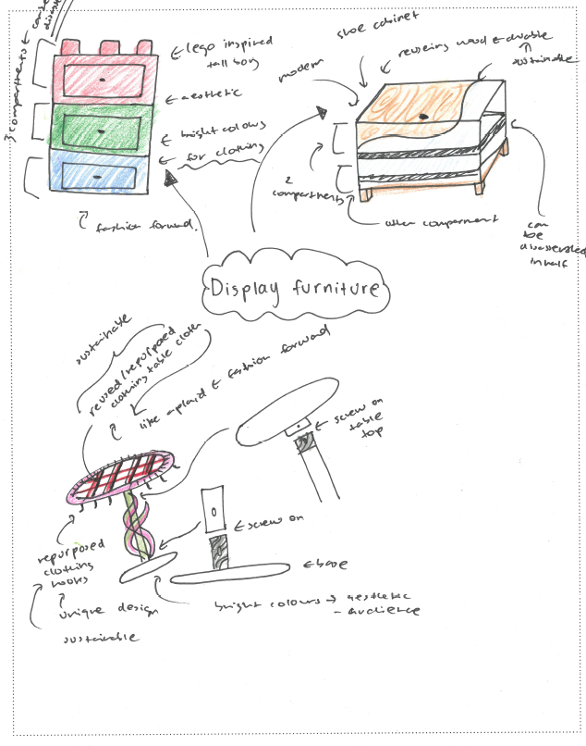
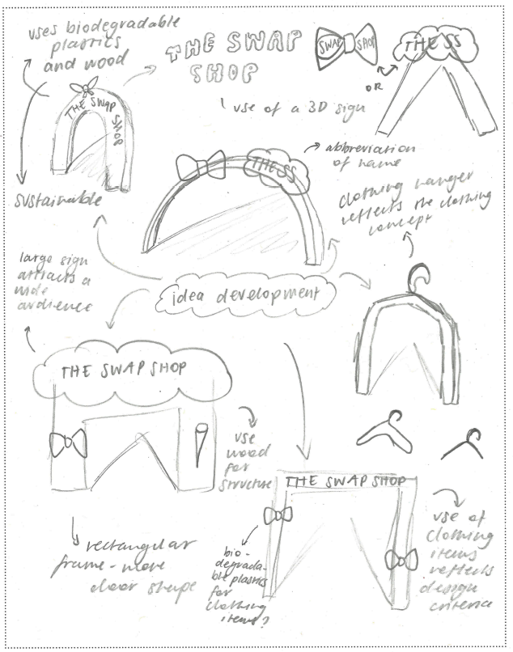

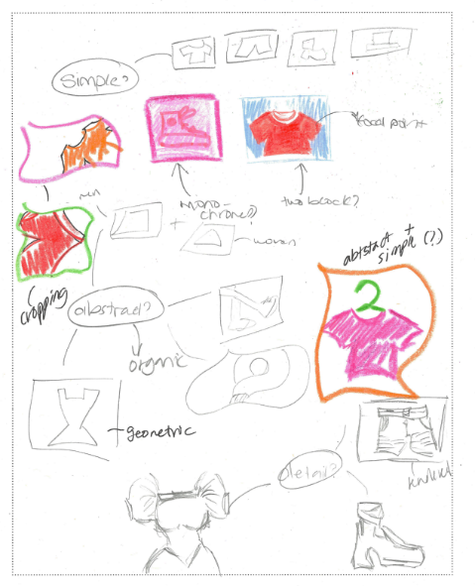
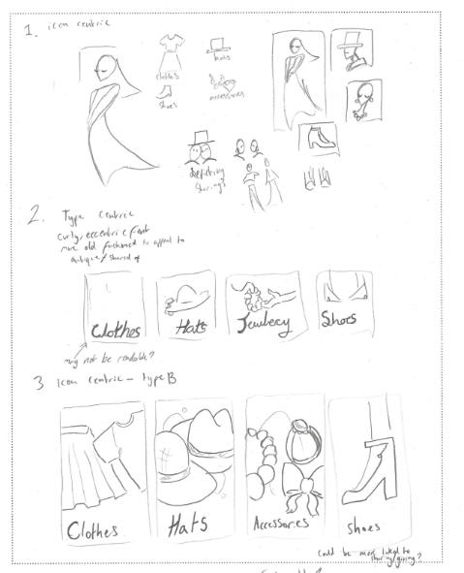
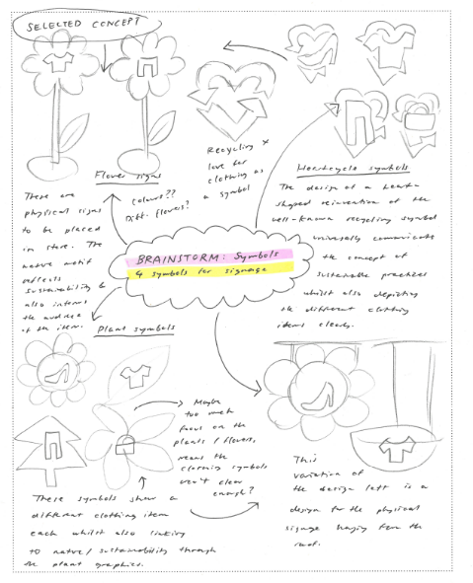

Question 3
Marks | 0 | 1 | 2 | 3 | 4 | 5 | 6 | 7 | 8 | 9 | 10 | 11 | 12 | Average
% | 3 | 2 | 5 | 11 | 21 | 21 | 16 | 10 | 6 | 2 | 1 | 0.4 | 0.2 | 4.9
In this question, students were required to select one idea from Question 2 and develop it into two distinct concepts, using annotations to explain how the design elements and design principles were applied in each concept.
High-scoring responses:
- selected a single idea from Question 2 and showed clear development and variation of two concepts
- produced drawings that were relevant to the selected field of design practice
- used annotations that correctly identified and explained design elements and design principles.
Most students were able to produce two drawings and maintain a connection to the idea that they selected in Question 2. In many cases, the transition from idea to concept was evident, and students showed an understanding of how to advance an idea through development. Stronger responses illustrated deliberate choices around shape, colour, scale, hierarchy or form, and used annotations to explain how these contributed to the communication needs of the design problem.
However, a significant number of students misunderstood the requirement to develop one idea. Many students took two different ideas from Question 2 and presented them as concepts and therefore did not address the question.
The level of visual development in drawings varied considerably. In many responses, the drawings were simplistic or lacked enough detail to show the deliberate application of design elements and principles. Some responses included minimal adjustments between the two concepts, such as small changes like colour swaps or repositioning of components, resulting in limited development.
While annotations around design elements and principles were mostly in line with the requirements of the question, some students annotated design criteria, restated the brief or used terms relating to Gestalt principles. In these cases, the annotations did not address the requirements of the question.
Lower-scoring responses typically:
- used two separate ideas from Question 2 rather than developing one idea
- produced concepts that were not related to the selected design field
- provided annotations that were not related to design elements or design principles
- showed minimal or no development between the two concepts
- presented drawings lacking detail or clarity.
Students should be supported in understanding how ideas progress into concepts, and how annotations should be used to communicate the purposeful application of design elements and design principles.

The following are examples of high-scoring responses:
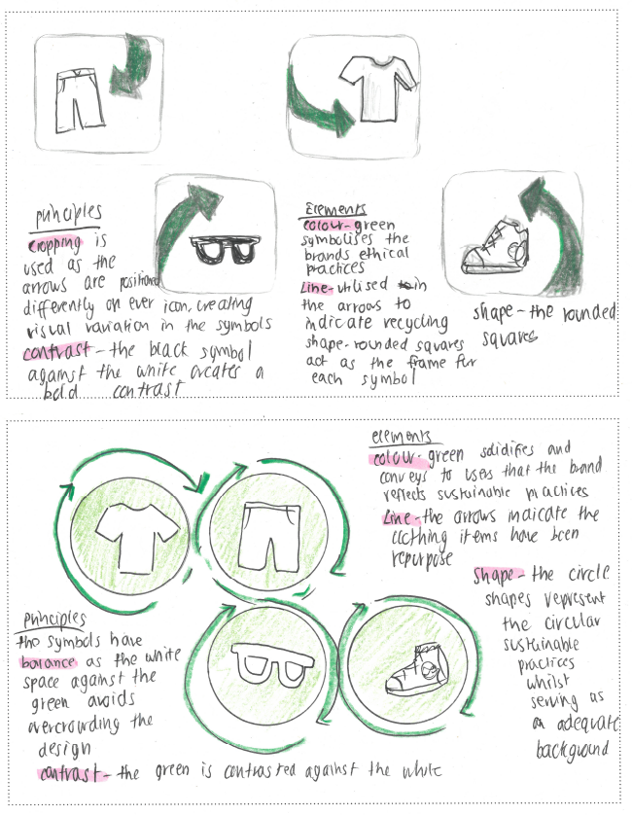
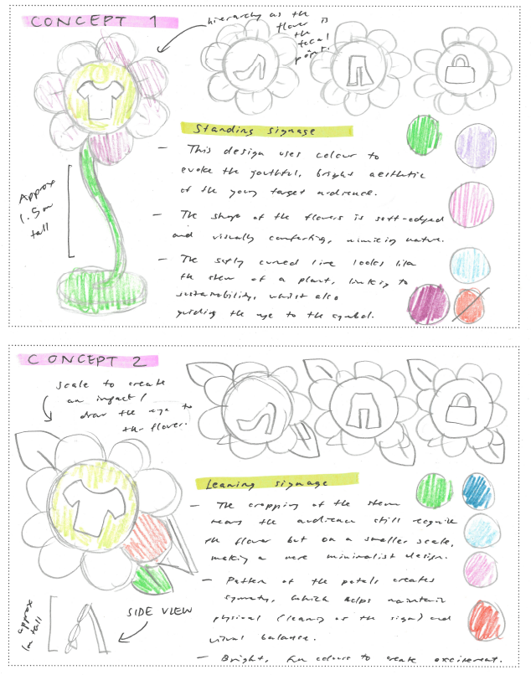

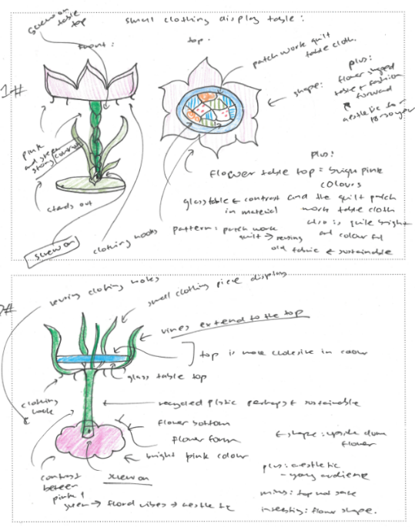
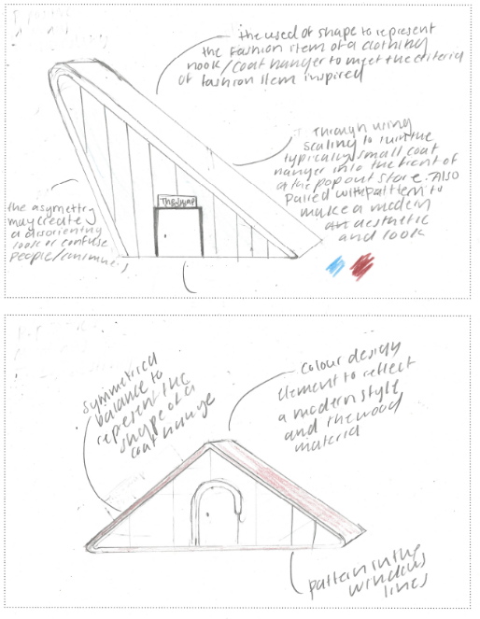

Question 4
Marks | 0 | 1 | 2 | 3 | 4 | 5 | 6 | 7 | 8 | 9 | 10 | 11 | 12 | Average
% | 12 | 5 | 9 | 13 | 15 | 15 | 12 | 8 | 6 | 3 | 1 | 0.7 | 0.2 | 4.2
In this question, students were required to select and resolve one concept from Question 3 and present it as a resolved design to the client. They were also required to use a convergent thinking strategy to evaluate how their resolved concept was informed by the design criteria.
High-scoring responses:
- clearly selected one concept and developed it into a resolved design
- demonstrated progression from the concept drawings in Question 3
- used an appropriate drawing method for the selected field of design practice (for example, isometric for display furniture, perspective for entrance structures, appropriately sized screens for digital interfaces)
- used a convergent thinking strategy (for example, Plus, Minus, Interesting [PMI] or Strengths, Weaknesses, Opportunities, Threats [SWOT]) to explicitly evaluate how the resolved concept met the design criteria.
Most students responded to this question well, showing continuity from earlier drawings and maintaining alignment with their chosen design field. Students most commonly designed within the messages field of design, frequently incorporating symbols inspired by shorts, pants, shirts and shoes. Other students working in the objects and environments fields demonstrated appropriate use of drawing methods such as isometric, orthogonal and perspective. Those who undertook interactive experience designs often included colour, icons and screens sized proportionally to the intended device.
However, only a few responses demonstrated a fully resolved concept. Many drawings resembled the concepts in Question 3 without further development as a presentation suitable for a client. Some students had partially completed drawings or minimal resolution beyond Question 3.
Responses demonstrated mixed understanding of convergent thinking strategies. While many students attempted a PMI or SWOT, these were frequently generalised or descriptive rather than evaluative. In some cases, students relied on annotations rather than applying a clear convergent thinking method as instructed. Higher-scoring responses explicitly linked points in their PMI or SWOT to the design criteria, explaining how specific features of the resolved concept satisfied these requirements.
Lower-scoring responses typically:
- included rushed drawings that were either unfinished or unresolved
- did not clearly fulfil the design criteria (for example, did not use four symbols or address the signage)
- had annotations that repeated design criteria rather than evaluating how the concept addressed them.
Overall, while students generally understood the intent of the question, stronger responses demonstrated clearly resolved designs that used convergent thinking to evaluate how the resolved concept addressed the design criteria.

The following are examples of high-scoring responses:
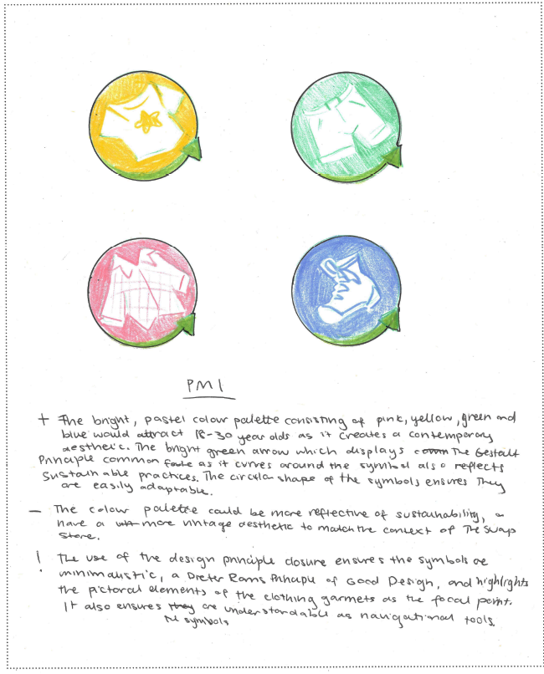
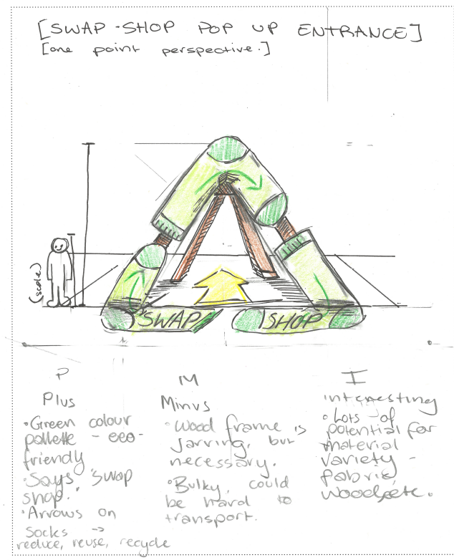

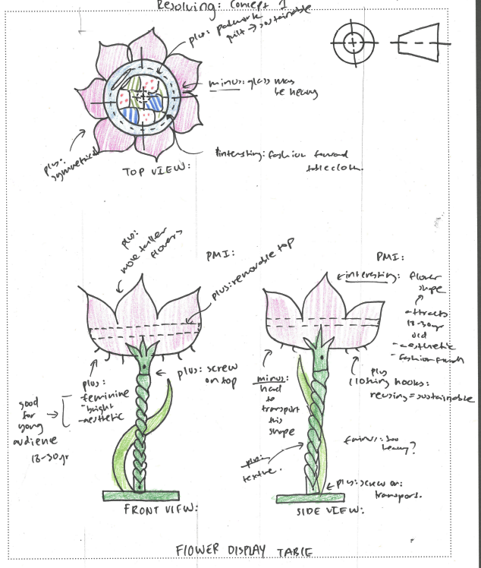
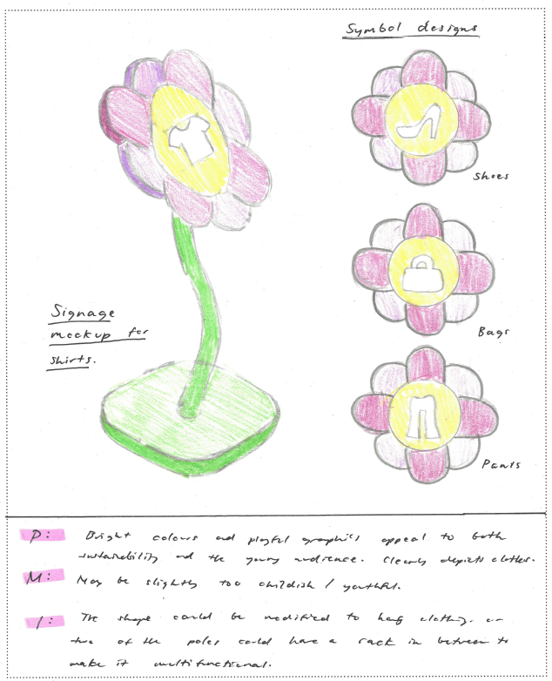

Question 5
Marks | 0 | 1 | 2 | 3 | 4 | Average
% | 60 | 15 | 13 | 9 | 4 | 0.8
In this question, students were required to discuss one or more relevant conventions that would need to be considered when presenting their design concept to the client.
High-scoring responses:
- selected conventions appropriate to the field of design practice used in Question 4
- discussed conventions accurately using the terminology of the study design
- explained how the convention would support clear communication of the resolved concept to the client
- linked the chosen convention directly to their own design solution.
Students who completed display furniture or entrance structure concepts often referred to technical drawing conventions, such as dimensioning, scale, line types and structural detail, explaining how these conventions assist the client in understanding measurements and spatial relationships. Students who developed screen-based or signage solutions commonly discussed layout, type and grid conventions, as well as symbol construction grids for clarity and consistency. These responses demonstrated an understanding that the selection of conventions depends on the nature of the design and the communication needs of the client.
Some responses were appropriate and thoughtful; however, a significant number of students were unable to accurately identify presentation conventions. These students tended to describe what they had created, pitch the idea to the client, or discuss materials and production methods rather than conventions of visual communication. In other cases, students named a convention but did not explain its relevance to presenting their concept.
Some students provided conventions that did not relate to their chosen field of design practice; others discussed hypothetical tools or processes (for example, ‘I would show them different colours I could use’) rather than established conventions used to support communication.
Lower-scoring responses typically:
- did not identify relevant conventions to the design field
- were unable to discuss how the conventions would be considered when presenting to the client
- merely described their designs or ‘pitched’ their idea to the client.
Students should ensure that they understand a range of conventions across drawing types within particular fields of design practice and select conventions that are relevant to their own resolved concept. They must also be able to articulate how these conventions support professional communication with a client. Further information regarding the conventions of each field of design practice is provided in the 2025 Visual Communication Design FAQs.
The following is an example of a high-scoring response:
When presenting the final messages design to the client, consideration of layout conventions is required. Using a grid system and guides ensures each part of the design presented follows the same mapping and alignment. Colour conventions should be considered and communicated to the client, whether CMYK or RGB has been used, as it alters the printing process and on-screen perception of each colour.

