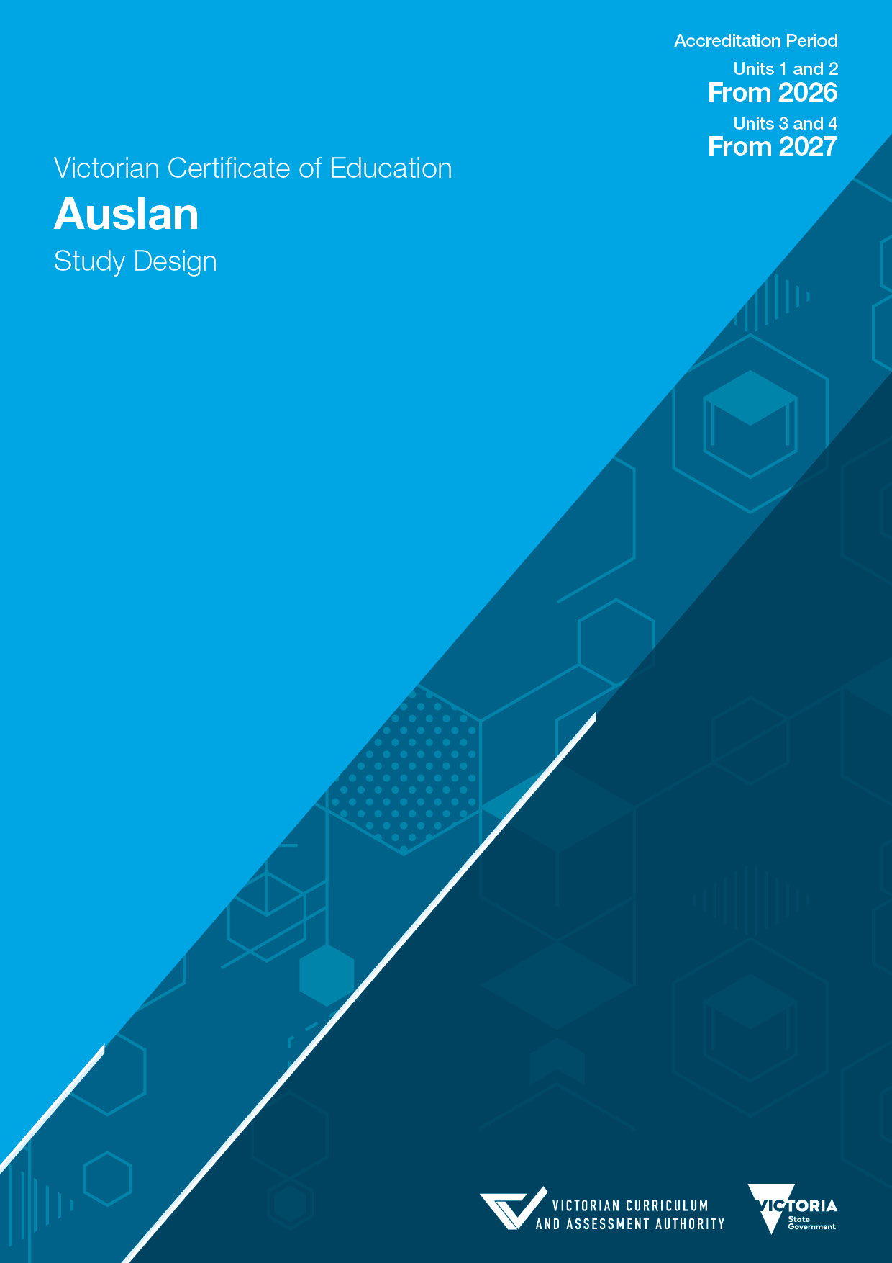

Acknowledgement
The Victorian Curriculum and Assessment Authority proudly acknowledges and pays respect to Victoria’s Aboriginal and Torres Strait Islander communities and their rich and enduring cultures.
We acknowledge Aboriginal and Torres Strait Islander people as Australia’s first peoples and as the Traditional Owners and custodians of the lands and waters on which we rely. We pay respect to Elders past and present of the lands where we conduct our work and recognise their ongoing contributions as the first educators on the land now known as Victoria.
Authorised and published by the Victorian Curriculum and Assessment Authority
Level 7, 200 Victoria Parade
East Melbourne VIC 3002
ISBN: 978-1-923204-86-7
© Victorian Curriculum and Assessment Authority 2025
No part of this publication may be reproduced except as specified under the Copyright Act 1968 or by permission from the VCAA. Excepting third-party elements, schools may use this resource in accordance with the VCAA educational allowance. For more information go to vcaa.vic.edu.au/footer/copyright
The VCAA provides the only official, up-to-date versions of VCAA publications. Details of updates can be found on the VCAA website at vcaa.vic.edu.au
This publication may contain copyright material belonging to a third party. If you believe that material in this publication is an infringement of your copyright, please email the Copyright Officer vcaa.copyright@education.vic.gov.au
Copyright in materials appearing at any sites linked to this document rests with the copyright owner/s of those materials, and is subject to the Copyright Act. The VCAA recommends you refer to copyright statements at linked sites before using such materials.
The VCAA logo is a registered trademark of the Victorian Curriculum and Assessment Authority.

Contact us if you need this information in an accessible format, for example, large print or audio.
Telephone (03) 9032 1629 or email vcaa.publications@education.vic.gov.au

Contents
Important information 3
Accreditation period 3
Other sources of information 3
VCE providers 3
Copyright 3
Purposes of the CCAFL Framework 4
Introduction 5
Scope of study 5
Language 5
Conventions used in this study design 5
Rationale 6
Aims 6
Protocols 6
Objectives 7
Structure 7
Entry 7
Duration 8
Changes to the study design 8
Monitoring for quality 8
Safety and wellbeing 8
Employability skills 8
Legislative compliance 8
Child Safe Standards 8
Assessment and reporting 9
Satisfactory completion 9
Levels of achievement 9
Authentication 10
Study specifications 11
Learning language 11
Communication skills 11
Interacting in Auslan 12
Analysing Auslan 12
Creating meaning in Auslan 12
Language and culture 12
Language as a system 13
Vocabulary 13
Grammar 13
Language functions 13
Language structures 14
Auslan grammar 14
Grammatical categories in Auslan 17
Text types 19
Styles of signing 20
Dictionaries 20
Using language 21
Content 21
Concepts 21
Tasks 26
Task design 27
Terms used in this study 28
Unit 1 30
Area of Study 1 30
Area of Study 2 31
Area of Study 3 32
Assessment 33
Unit 2 34
Area of Study 1 34
Area of Study 2 35
Area of Study 3 36
Assessment 37
Unit 3 38
Area of Study 1 38
Area of Study 2 39
Area of Study 3 40
School-based assessment 41
External assessment 42
Unit 4 43
Area of Study 1 43
Area of Study 2 44
Area of Study 3 45
School-based assessment 46
External assessment 47

Important information

Accreditation period
Units 1 and 2: from 2026
Units 3 and 4: from 2027

Other sources of information
The VCAA Bulletin is the only official source of changes to regulations and accredited studies. The Bulletin also regularly includes advice on VCE studies. It is the responsibility of each VCE teacher to refer to each issue of the Bulletin. The Bulletin is available as an e-newsletter via free subscription on the VCAA website.
To assist teachers in developing courses, the VCAA publishes online Support materials (incorporating the content previously supplied in the Advice for teachers).
The current VCE Administrative Handbook contains essential information on assessment processes and other procedures.

VCE providers
Throughout this study design the term ‘school’ is intended to include both schools and other VCE providers.

Copyright
Schools may use this VCE study design in accordance with the VCAA educational allowance, including making copies for students and use within the school’s secure online teaching and learning environment.
For details, access the full VCAA copyright policy on the VCAA website.

Purposes of the CCAFL Framework
The study of Auslan at senior secondary level is based on a common framework developed within the Collaborative Curriculum and Assessment Framework for Languages (CCAFL). The CCAFL Framework (2021) has been designed to:
- provide high quality, equitable and inclusive language curriculum and assessment for all students
- value prior language learning
- provide challenges and opportunities through learning and using new language
- emphasise effective communication and intercultural competence.
To achieve these purposes, the CCAFL Framework has the following organising features:
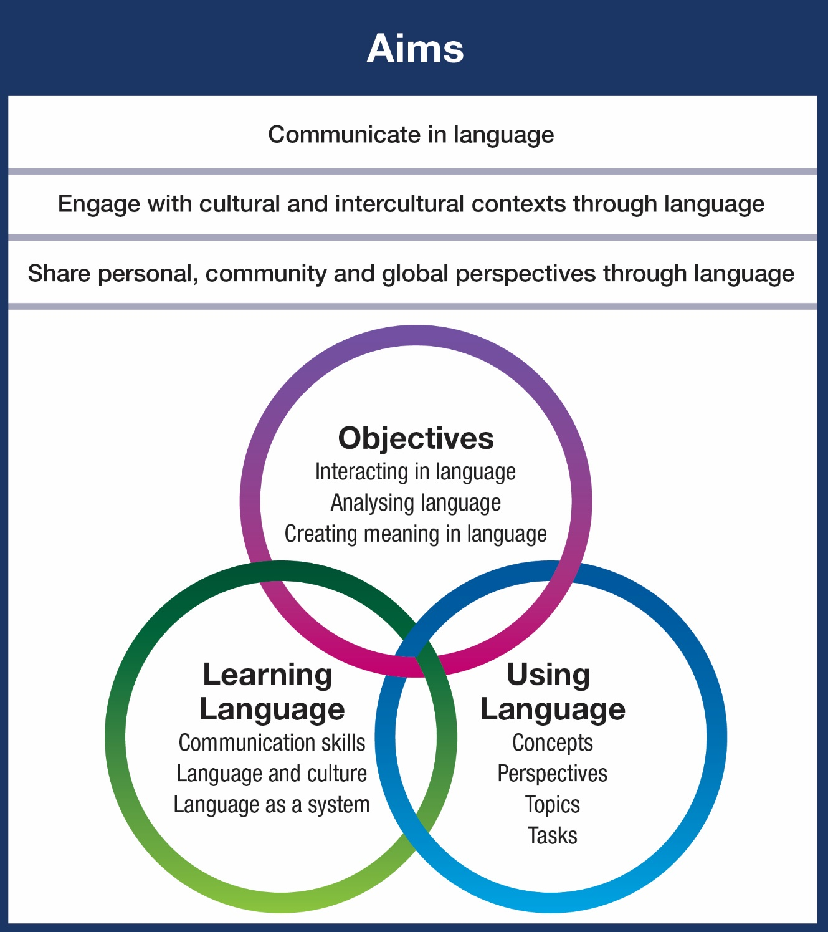

Introduction

Scope of study
VCE Auslan focuses on student participation in learning language and using language to interact with others, analyse language and create meaning in language. Learning language and using language require students to engage with the range of perspectives and topics related to the concepts that are a feature of the CCAFL Framework.
Students develop and extend skills in signing and viewing in Auslan in a range of contexts. They develop cultural and intercultural understanding, including skills to mediate between Auslan communities and the Australian social context.
Students develop their understanding of the relationships between language and culture in new contexts and consider how these relationships shape communities. Throughout the study students are given opportunities to make connections and comparisons based on personal reflections about the role of language and culture in communication and in personal identity.

Language
The language to be studied and assessed is Auslan, the sign language used by the Australian Deaf community. Auslan involves using manual signs and bodily actions, unlike spoken languages which involve using speech and sound. Students make use of manual signs, movements of the head and body, facial expressions, mouth patterns and the signing space. There are many variations in signs and register used by Auslan signers across Australia. Students should be familiar with formal and informal language as prescribed in this document.
There is a long history of sign language use in Australia, including sign languages used by First Australians, convicts and early European settlers. Auslan, which evolved from BSL (British Sign Language), belongs to the BANZSL sign language family, an acronym representing: British, Australian and New Zealand Sign Languages.
Auslan has its own lexicon and grammar, as do all human languages. All language and grammar samples in Auslan are presented in context to allow them to be interpreted accurately as intended.

Conventions used in this study design
In the past, the preference has been to write ‘Deaf’ with a capital ‘D’ when referring to members of the signing deaf community. However, recent works from deaf academics view this distinction as one that differentiates between those deemed 'fluent' signers and those who are not.
This study design uses d/Deaf, d/Deafblind and hard of hearing communities, to be inclusive of all users of Auslan. This approach celebrates the diversity within the Deaf communities, and acknowledges that many different d/Deaf people use Auslan.

Rationale
The study of Auslan provides access to the culture of the Deaf communities of Australia who use Auslan. It promotes understanding of different attitudes and values within the wider Australian community and the global community. By studying and learning Auslan, students develop the ability to understand and communicate in a sign language, acknowledging that plurilingualism and multiculturalism have an integral place in Australian society.
Communicating through language is a complex and rich human activity. Learning a language contributes meaningful dimensions to each student’s overall education and their understanding of the world. Students who study a language at senior secondary level build on a diverse range of linguistic and intercultural skills, knowledge and understanding gained through previous experiences at school and in the community. Knowledge of Auslan enhances each student’s repertoire of skills for the 21st century and expands opportunities in all areas of human endeavour.
Through the study of Auslan, students extend their intercultural competence, adaptability and empathy. They further develop an understanding of the role of language and culture in communication and explore various perspectives and ideas about belonging and inclusion to foster mutual respect. Students develop an awareness of world views and extend their understanding of their own heritage, values, culture and identity. Knowledge of more than one language assists students to become effective communicators in a global environment and to extend their ability to reflect on experience.
Students are able to make significant social, cultural and economic contributions in the Australian context through their knowledge of Auslan and interest in Deaf communities. Students are encouraged to develop individual, community and global perspectives through the study of Auslan.
The CCAFL Framework draws on prior learning and/or key ideas from the Australian Curriculum: Languages.

Aims
The study of Auslan based on the CCAFL Framework (adapted for Auslan) develops student capacity to successfully:
- communicate in Australian Sign Language (Auslan)
- engage with d/Deaf people in various cultural and intercultural contexts using Auslan
- share personal, community and global perspectives in Auslan.

Protocols
In order to deliver the study of VCE Auslan in contextually, culturally, sensitive and appropriate ways, it is recommended that schools consider:
- engagement and consultation with local, regional or state d/Deaf community groups, as available to the school
- steps taken for staff to undertake professional development in Auslan language, linguistics and culture
- the availability of appropriate school staff and community members, and resources, for developing and teaching Auslan
- the proportion of students in the school identifying directly with Auslan.

Objectives
The areas of study in each unit align to the three objectives of the CCAFL Framework (adapted for Auslan): Interacting in language (Objective 1), Analysing language (Objective 2) and Creating meaning in language (Objective 3).
Meeting the objectives involves development of key skills, knowledge and understanding used in signing and understanding when communicating.

Area of Study 1

Interacting in Auslan
Exchange information, opinions, ideas and experiences in Auslan and reflect on knowledge and understanding of the relationship between language and culture.

Area of Study 2

Analysing Auslan
Evaluate, synthesise, reflect on and respond to texts presented in Auslan, and mediate between languages and cultures.

Area of Study 3

Creating meaning in Auslan
Express ideas and perspectives in Auslan, demonstrating knowledge and understanding of language as a system and the relationship between language and culture.

Structure
The study is made up of four units. Each unit deals with specific content that is contained in areas of study and designed to enable students to achieve a set of outcomes for that unit. Each outcome is described in terms of key knowledge and key skills.

Entry
The CCAFL Framework (adapted for Auslan) is designed for students who typically have studied Auslan for at least 200 hours prior to undertaking the study of the language at senior secondary level. Some students with equivalent experience may also be able to successfully meet the requirements.
There are no prerequisites for entry to Units 1, 2 and 3. Students must undertake Unit 3 and Unit 4 as a sequence.

Duration
Each unit involves at least 50 hours of scheduled classroom instruction.

Changes to the study design
During its period of accreditation minor changes to the study will be announced in the VCAA Bulletin. The Bulletin is the only source of changes to regulations and accredited studies. It is the responsibility of each VCE teacher to monitor changes or advice about VCE studies published in the Bulletin.

Monitoring for quality
As part of ongoing monitoring and quality assurance, the VCAA will periodically undertake an audit of VCE Auslan to ensure the study is being taught and assessed as accredited. The details of the audit procedures and requirements are published annually in the VCE Administrative Handbook. Schools will be notified if they are required to submit material to be audited.

Safety and wellbeing
It is the responsibility of the school to ensure that duty of care is exercised in relation to the health and safety of all students undertaking the study.

Employability skills
This study offers a number of opportunities for students to develop employability skills. The Support materials provide specific examples of how students can develop employability skills during learning activities and assessment tasks.

Legislative compliance
When collecting and using information, the provisions of privacy and copyright legislation, such as the Victorian Privacy and Data Protection Act 2014 and Health Records Act 2001, and the federal Privacy Act 1988 and Copyright Act 1968, must be met.

Child Safe Standards
Schools and education and training providers are required to comply with the Child Safe Standards made under the Victorian Child Wellbeing and Safety Act 2005. Registered schools are required to comply with Ministerial Order No. 1359 Implementing the Child Safe Standards – Managing the Risk of Child Abuse in Schools and School Boarding Premises. For further information, consult the websites of the Victorian Registration and Qualifications Authority, the Commission for Children and Young People and the Department of Education.

Assessment and reporting

Satisfactory completion
The award of satisfactory completion for a unit is based on the teacher’s decision that the student has demonstrated achievement of the set of outcomes specified for the unit. Demonstration of achievement of outcomes and satisfactory completion of a unit are determined by evidence gained through the assessment of a range of learning activities and tasks.
Teachers must develop courses that provide appropriate opportunities for students to demonstrate satisfactory achievement of outcomes.
The decision about satisfactory completion of a unit is distinct from the assessment of levels of achievement. Schools will report a student’s result for each unit to the VCAA as S (satisfactory) or N (not satisfactory).

Levels of achievement

Units 1 and 2
Procedures for the assessment of levels of achievement in Units 1 and 2 are a matter for school decision. Assessment of levels of achievement for these units will not be reported to the VCAA. Schools may choose to report levels of achievement using grades, descriptive statements or other indicators.

Units 3 and 4
The VCAA specifies the assessment procedures for students undertaking scored assessment in Units 3 and 4. Designated assessment tasks are provided in the details for each unit in VCE study designs.
The student’s level of achievement in Units 3 and 4 will be determined by School-assessed Coursework (SAC) as specified in the VCE study design, and external assessment.
The VCAA will report the student’s level of achievement on each assessment component as a grade from A+ to E or UG (ungraded). To receive a study score the student must achieve two or more graded assessments in the study and receive an S for both Units 3 and 4. The study score is reported on a scale of 0–50; it is a measure of how well the student performed in relation to all others who completed the study. Teachers should refer to the current VCE Administrative Handbook for details on graded assessment and calculation of the study score.
Percentage contributions to the study score in VCE Auslan are as follows:
- Unit 3 School-assessed Coursework: 25 per cent
- Unit 4 School-assessed Coursework: 25 per cent
- end-of-year examination* (Auslan Interactive and Auslan Comprehension and Production examinations): 50 per cent.
Details of the assessment program are described in the sections on Units 3 and 4 in this study design.
*A single grade is awarded.

Authentication
Work related to the outcomes of each unit will be accepted only if the teacher can attest that, to the best of their knowledge, all unacknowledged work is the student’s own. Teachers need to refer to the current VCE Administrative Handbook for authentication rules and strategies.

Study specifications
For the purposes of this study the following specifications apply across all units. Details of the scope of each specification are provided in the unit overviews and in the introduction to the relevant areas of study.
This study is designed for students who are learning and communicating in Auslan in the Australian context. It focuses on learning Auslan signs, communicating, using culturally contextualised signs and gestures, and mediating between d/Deaf signing people and communities. It balances the cognitive demands of learning and using Auslan in a range of contexts.
The content of this study is organised through the concepts of Identity, Legacy, Responsibility and Sustainability. Students are expected to encounter content related to the concepts through the eight prescribed topics, with two for each concept. All topics are to be studied in the two years of the senior secondary study of Auslan. The topics allow personal, community and global perspectives to be explored in Auslan and within the Australian context for language learning.
The prescribed topics for Auslan are designed to be flexible and can focus on a range of perspectives, depending on cultural considerations, student interests and available resources. The topics are taught through subtopics chosen by the teacher. It is recommended that students study between eight and 12 subtopics over the two years of the course. Some subtopics may require greater depth of treatment than others.
Students are expected to engage with a wide variety of common contemporary text types. Across Units 1–4 students will be provided with opportunities to produce descriptive, evaluative, imaginative, informative, personal, persuasive and reflective styles of signed texts, individually or in combination.
In each unit the areas of study align to the objectives of the CCAFL Framework.

Learning language
Learning Auslan involves an investigation of language as a dynamic system and of the way it works to create meaning. Students extend their skills, knowledge and understanding of the interrelationship between language and culture to communicate effectively with others in formal and informal contexts. They develop metalinguistic and metacognitive awareness to enable them to employ critical and creative thinking skills, employ intercultural competence and reflect on how they engage in their language learning.

Communication skills
Students engage with texts and create their own signing for a range of purposes and audiences. Students practise skills in various contexts and combinations through tasks requiring interpersonal language use, analysis of language and creating meaning in Auslan.
Students should be provided with a range of authentic learning experiences and school-based assessment tasks that provide opportunities to achieve the objectives represented in the areas of study. This requires balanced exposure to all language skills, links between language and culture, and investigation of language as a system throughout their study.

Interacting in Auslan
By exchanging, sharing and reflecting on information, opinions, ideas and experiences in Auslan, students interact and mediate meaning with other Auslan signers. This requires students to demonstrate intercultural competence and use receptive and productive language skills as they respond to the input of others.

Analysing Auslan
Through evaluating, synthesising, reflecting on and responding to texts presented in Auslan, students extract, process, interpret and compare information, opinions, ideas and aspects of Auslan texts. This requires awareness of cultural and intercultural considerations when seeking and relaying meaning, and an understanding that Auslan is a highly contextualised language that does not have a written form.

Creating meaning in Auslan
When interacting and developing texts in Auslan, students create meaning, express and present ideas, experiences, opinions and arguments, and communicate knowledge for a specified context, purpose and audience. This requires students to demonstrate an awareness of language as a system and to consider cultural factors that influence meaning and strategies for effective communication and self-representation through Auslan.

Language and culture
(Students) come to understand how personal, group and national identities are shaped, and the variable and changing nature of culture. Intercultural understanding involves students learning about and engaging with diverse cultures in ways that recognise commonalities and differences, create connections with others and cultivate mutual respect.
Australian Curriculum – General Capabilities Intercultural understanding
The study of Auslan explores the interrelationship between language and culture. It acknowledges the richness of cultural understanding required for students to successfully communicate in Auslan, engage with cultural and intercultural contexts and share personal, community and global perspectives through Auslan. Students recognise the importance of the link between culture and effective communication.
By learning an additional language, students actively engage with the culture expressed by that language. Students learn to appreciate the dynamic nature of language and culture, and how these are linked in time and place. Students develop an awareness of how culture influences language, behaviours, and personal and community identities.
Students develop the capacity for ongoing reflection about languages and cultures, including their own and those of others. They build on their shared interests and similarities to negotiate or mediate difference. Students discover new ways of thinking about language and culture and the world in which they live.
Through communicating in Auslan, students gain a deeper insight into their own values, beliefs, language and culture, as well as an appreciation for those of others. Students recognise the importance of the need to take responsibility for, evaluate and adjust their actions and reactions for effective communication.

Language as a system
Students develop their understanding of language as a system and reflect on how language is used in different contexts may vary between different individuals or groups. Students expand their cognitive horizons through exposure to different systems of language.
Students understand that there are particular language features that are specific to Auslan. They draw on this knowledge when they understand or communicate meaning through interacting with others, analysing meaning in Auslan or creating meaning themselves in Auslan.
Students recognise and apply features of Auslan. They understand the systematic nature of lexical forms and use elements of grammar to refine their expression of complex ideas. They analyse the effects of linguistic and structural features in texts, explaining their interrelationship with context, purpose and audience. Students are aware that some language features may change over time or vary in different places according to the needs of different people.
Students make comparisons with their own and other languages and are able to use and adapt understandings about language. In doing so, they accelerate their learning of Auslan, identify differences in the contexts of language use and develop effective communication skills. They reflect on an expanding knowledge of the linguistic features of Auslan and an understanding of language as a system.

Vocabulary
There is no prescribed vocabulary; however, students should be familiar with a range of vocabulary that enables them to engage in interpersonal interactions, analyse information in Auslan, and create meaning in Auslan on the prescribed topics.

Grammar
Grammar can be described as the organisation of the structural elements needed to communicate in a language. Knowledge of grammar is essential for understanding language as a system.
Students extend their understanding of the function of grammar in Auslan gained through prior study or personal experience. Students build on their awareness of the system of structures that underlies Auslan, as well as their ability to apply and adapt this knowledge.

Language functions
Students are expected to recognise and use Auslan to perform the functions listed below. These functions align with the three objectives of the CCAFL Framework (adapted for Auslan): interact in, analyse and create meaning in language. They also align with the areas of study in each unit of this study.
- exchanging information, ideas, opinions and experiences (Objective 1 and Area of Study 1)
- analysing, evaluating and synthesising (Objective 2 and Area of Study 2)
- expressing ideas and perspectives (Objective 3 and Area of Study 3)
These functions are provided to assist teachers to recognise key aspects of the CCAFL Framework (adapted for Auslan) within this study design. Examples of how students may perform these functions are provided with the language structures as demonstrated in the video support resources accessible under the ‘Teaching and learning’ section of the VCE Auslan study page on the VCAA website.

Language structures
Students are expected to recognise and use the following language structures to meet the objectives represented in the areas of study, perform the language functions listed above and to communicate effectively in Auslan.
The language structures provided below include a possible function associated with a sub-element, where this is appropriate.
Grammar that students should be familiar with from prior learning is not included in the list that follows.

Auslan grammar
The Auslan grammar that the student is expected to recognise and use (listed below) is described, using examples, in the video support resources accessible under the ‘Teaching and learning’ section of the VCE Auslan study page on the VCAA website.
Students should be encouraged to extend their control of linguistic elements in simple and more complex structures. They are expected to recognise and use the following grammatical items.

Types of manual signs
Different types of signs
- conventional (can understand out of context)
- lexical signs
- fingerspelling
- mouthing
- some mouth gestures
- partly conventional (can understand some parts out of context but need context to fully understand)
- pointing
- indicating verbs
- depicting signs
- mouth gestures
- non-conventional (need context to fully understand)
- enactments/constructed action/role shift

Constructed action/dialogue
Using body and face to quote actions and dialogue
- framing constructed action
- constructed action with conventional signs
- constructed action without conventional signs
- constructed action with dialogue

Phonology of manual signs
Parameters of manual signs that can be changed to mean something else
Concept of minimal pairs
- handshape
- orientation
- location
- movement
- expression/non-manual features (NMF)

Morphology of manual signs
Modification of manual signs to add meaning
- modifying signs to show direction
- modifying to show reference
- modifying signs to show aspect
- modifying to show manner

Fingerspelling
Fingerspelling words from English and/or other languages
- using fingerspelling
- initialised signs
- why use fingerspelling
- fingerspelling rhythms

Mouthing
The use of mouthing of words from English and/or other languages
- mouthing

Pointing
The use of finger pointing actions and/or eye gaze direction to refer to people, animals, things, events and concepts in the signing space
- pronominal
- locative
- determiner
- possessive
- buoy

Indicating verbs
The use of manual lexical signs to indicate (i.e. point) where someone or something is in the signing space

Depicting signs
The use of depicting signs to show what something looked like and/or how and where it moved
- size and shape
- entity
- handling shapes
- touch handshape
- instrumental handshape

Mouth gestures
The use of mouth gestures with/without manual signs

Timelines
The use of spatial timelines to show a particular time or era spatially
- past spatial timeline
- present spatial timeline
- future spatial timeline

Time signs
The use of lexical signs adverbially to state a particular time or era
- past adverbial
- present adverbial
- future adverbial

Aspect
The modification of verb signs to show how something was done over time
- single movement
- repetition
- speed
  - fast
  - slow

Space
The use of space in front of the body to show people, things and events, and also to refer to these things without having to fully repeat the first mention again
- real space
- blended space

Grammatical categories in Auslan

Verbs*
The use of different types of verb signs
- plain verbs
- indicating/directional verbs
- depicting verbs
* Sometimes depicting signs can function both as a noun and a verb at the same time.

Nouns*
The use of different types of noun signs
- plain nouns
- depicting nouns
* Sometimes depicting signs can function both as a noun and a verb at the same time.

Negation
Negating signs and sentences
- signs
- sentences
- negative inflection
- constituent negation
- clause negation
- non-manual features

Questions
Asking questions
- polar questions
- content questions

Sentences
The use of different sentence structures
- simple
- sequential
- simultaneous
- carrier attribute
- complex
- subordinate
- topicalised
- rhetorical

Statements
The use of different statements
- declarative
- imperative
- conditional

Text types
Students should be familiar with a wide variety of common contemporary Auslan text types. They learn to identify, understand and apply the different characteristics of personal and public texts used for communication in Auslan.
Auslan texts are broadly categorised as informal when referring to spontaneous communication, such as face-to-face conversations with a friend, and formal when describing prepared communication, such as a filmed video explaining a new government service.
A variety of Auslan text types may be used for developing, teaching or assessing the skills of signing and viewing in the language. In coursework and school-based assessment tasks, students should be provided with a range of signed texts for interacting in Auslan, analysing Auslan and creating meaning in Auslan.
The text types that the student is expected to recognise and use (listed below) are described, using examples, in the Auslan text types support resource videos, which may be accessed via the ‘Teaching and learning’ section of the VCE Auslan study page on the VCAA website.
In the end-of-year Auslan Comprehension and Production examination, a range of texts will be included in questions requiring a student response in Auslan. However, students will only be expected to produce the following text types in Auslan in the examination:
- advice
- analysis
- announcement
- biography
- commentary
- conversation
- critique
- debate
- description
- explanation
- instruction
- interview
- itinerary
- narrative
- presentation
- report
- review
- story
- vlog post

Styles of signing
Students should be familiar with the characteristics of different styles of Auslan signing. Auslan texts require different styles of signing depending on their context, purpose and audience. Students may be asked to recognise or produce Auslan texts that are personal, informative, descriptive, evaluative, reflective, persuasive and imaginative, individually or in combination.

Dictionaries
Students are encouraged to use Auslan dictionaries. Use of dictionaries is part of a range of strategies that students can apply when:
- mediating between languages
- reflecting on language use
- understanding the context for language use
- understanding language as a system
- understanding the limitations of resources and technologies.
Successful use of dictionaries and translation technologies requires students to understand the characteristics of vocabulary in Auslan and how signs are presented in Auslan texts. Effective dictionary use assists students to develop critical thinking skills, strategies for accurately confirming meaning and creating interest to engage an audience. It is expected that teachers will help students develop the necessary skills and confidence to use dictionaries effectively.
Information on the use of dictionaries in examinations is provided in the examination specifications.
The Support materials provide further information on suitable dictionaries and other resources.

Using language

Content
The study of Auslan provides learning that extends student knowledge of the world in which they live. It allows them to apply the Auslan language they have learnt in new contexts. Students apply language skills, knowledge and understanding to content organised through interrelated concepts, perspectives and topics. The topics are drawn from the concepts and students are encouraged to consider them from different perspectives.

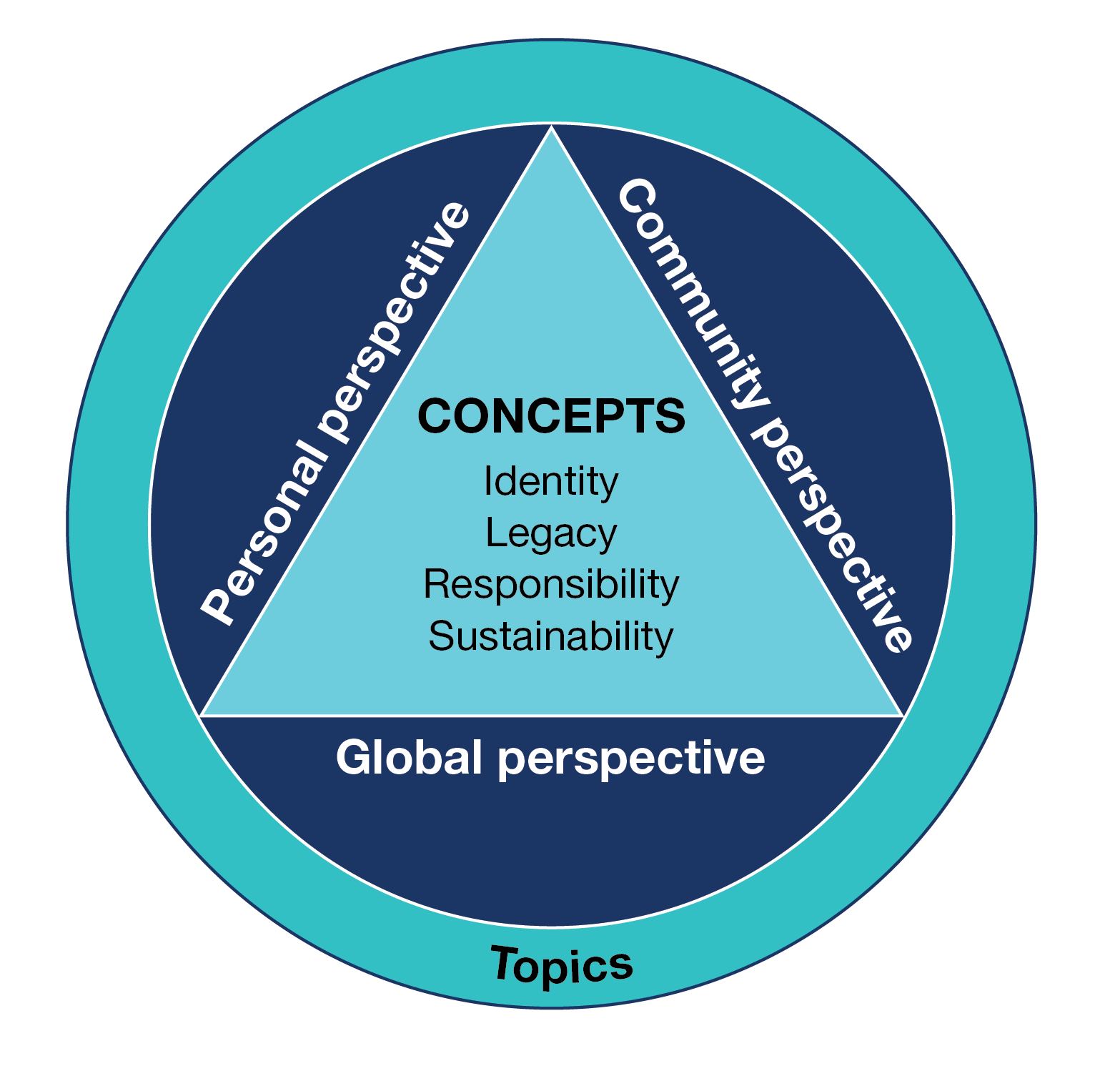

Concepts
The concepts provide the content that students are expected to encounter through the prescribed topics. The concepts are: Identity, Legacy, Responsibility and Sustainability. They allow personal, community and global perspectives to be explored in Auslan and within the Australian context for Auslan language learning.
All concepts are to be studied over the two years of the senior secondary study of Auslan.

Identity
Studying the concept of Identity enables students to explore topics related to their personal world; for example, a sense of self, personal values, opinions, ideas, aspirations and relationships with others. It provides opportunities to reflect on personal identity, individuality and group affiliation in another language and cultural context. It enables students to explore and communicate aspects of Australian society in culturally and linguistically appropriate ways.

Legacy
Studying the concept of Legacy allows students to consider how people and events influence change, and how people respond to opportunities and challenges. They investigate topics related to the contributions, achievements and influence of Auslan-signing individuals and communities throughout history to the present day. Students consider the impact and enduring nature of achievements on Auslan users, Deaf communities and beyond.

Responsibility
Studying the concept of Responsibility enables students to investigate how people manage social responsibilities and influence decisions that affect individuals or groups within society. The topics associated with this concept allow students to consider issues of particular relevance to young people and other groups within Auslan signing Deaf communities in Australia, and to make comparisons with their own experiences.

Sustainability
Studying the concept of Sustainability provides students with the opportunity to explore topics with a focus on an aspect of sustainability, including present and future lifestyles, the environment and how language and culture can be sustained.

Perspectives
Students engage with the concepts through a range of prescribed topics that allow them to recognise, exchange and share ideas viewed from different personal, community and global perspectives.
All three perspectives are to be addressed through a range of topics over the two years of the study of Auslan at senior secondary level.

Topics
There are eight prescribed topics which relate to the concepts and may be studied from a personal, community or global perspective. All topics are to be studied during the two years of the senior secondary study of Auslan. The topics provide the content focus for teaching, learning and assessment. The topics are taught through subtopics chosen by the teacher. Subtopics are not prescribed and allow flexibility in the way topics are taught and studied.
Through topics and tasks, students are provided with opportunities to apply key language skills, knowledge and understanding in authentic contexts, and engage with content that reflects their interests and the requirements of the senior secondary study of Auslan.

Topics for Auslan for each concept

Identity
- Inclusivity, diversity and belonging
- Living in Australia

Legacy
- Innovation
- The culture of Auslan signing communities

Responsibility
- Society
- Work

Sustainability
- Sustaining language and culture
- Global trends

Selecting subtopics
The prescribed topics are designed to be flexible and can focus on a range of perspectives, depending on the language, culture, student interests and available resources. The topics are taught through subtopics chosen by the teacher. When selecting subtopics over the two years of study, the teacher should ensure that students are provided with opportunities to engage with:
- each of the eight topics for the language
- personal, community and global perspectives
- content that has an Australian focus.
It is recommended that students study between eight and 12 subtopics over the two years of the course, and some subtopics may require greater depth of treatment than others.
The following example shows how aspects of one of the prescribed topics may be developed for teaching and learning and may address different perspectives.
Concept: Identity
Topic: Inclusivity, diversity and belonging
Example subtopic and perspective:
- Diversity of deafness (hearing aids and cochlear implants) (personal perspective)
OR
- Children of deaf adults (CODAs) and allies (community perspective)
OR
- Deaf mobilities and immigration – a global phenomenon (global perspective)

The following prescribed topics relate to the four concepts. Example subtopics are also provided for each topic. A subtopic may be taught through any one of the three perspectives: personal, community or global.

Concept | Topic | An example of a suggested subtopic related to this topic
Identity | Inclusivity, diversity  and belonging | Family, friends, community and belonging  Festivals and celebratory events in the Deaf community such as National week of deaf people (NWDP), Auslan Day, Australian Deaf Games  Impact of diverse voices in the community  CODAs and allies  DeafBlind community  Diversity in the Deaf community (d/Deaf, d/DeafBlind, hard of hearing, people who describe it differently)  Going beyond access  Organisations that exist within the Deaf community and Deaf-led expression  Deaf mobilities and immigration – a global phenomenon  Inclusive classrooms for d/Deaf or hard of hearing children
Identity | Living in Australia | The social lives of Deaf people: clubs, sports and gatherings  Changes in cultural values and experiences over time  The value of Deaf and hearing sporting groups, teams and organisations  d/Deaf Australian leaders in art, literature, music, research or technology  Deaf history in Australia and beyond  Support groups and programs for families with d/Deaf and hard of hearing children  Acceptance of interpreters on TV
Legacy | Innovation | Innovations I can’t live without  The impact of technology on Deaf communities (pros and cons)  Evolution of technology and its impacts on access – Fax, teletypewriter (TTY), texting, online messaging, video calls  Access to services and technology such as captions in movies, voice recognition apps  Artificial Intelligence and Auslan – opportunities and limitations  Breakthroughs in education, medicine, science and engineering – automatic caption glasses, video remote interpreting (VRI) and other innovations  Captioning, interpreters and the need for equal access
Legacy | The culture of Auslan signing communities | Arts in the Deaf community – legacy of d/Deaf artist(s)  Famous Auslan artists and storytellers  Worldwide competitions for Auslan storytelling  Changes in cultural values and experiences over time  The influence of culture and language on identity  The impact of world travel on sign languages  The emergence and use of International Sign  Influential d/Deaf role models, both past and present  Cultural appropriation of Auslan  Voices of the 21st century – influential people
Responsibility | Society | Portrayal and representation of d/Deaf people in TV and the movies  The evolution of Auslan and its importance  Language deprivation and d/Deaf children  The impact of increased Auslan awareness and use in schools  Changing roles in society for men and women  Access and inclusion in society  Exploring concepts of Audism, Ableism, and Deaf Gain  Access to communication  Staying connected through social media  The role and impact of interpreters in education
Responsibility | Work | Part-time work, work experience and volunteering  The role of interpreters  The interpreter demand/supply disparity on the Deaf community  Access to education and career opportunities  Disappearing, evolving and new occupations  Jobs of the future  Realising a personal ambition  Deaf role models at work  Robots are changing the nature of work
Sustainability | Sustaining language and culture | Sign language acquisition and sign language teaching  Bilingual education approach  Government-funded community language programs  Raising awareness of language preservation and cultural responsibility  Deaf community events supporting language and culture  Comparing rural and metropolitan Deaf, DeafBlind and hard of hearing communities  Celebrating, preserving and sharing language and culture  Strength in the face of discrimination and adversity  Online Auslan dictionaries and resources – evolution of dictionaries in an online world
Sustainability | Global trends | The impact of globalisation on Deaf worlds  Sign language rights as human rights  Deaf communities around the world: similarities and differences  The role of the World Federation of the Deaf in advocacy and policy  Sociolinguistic variation in sign language  Loss of regional dialects due to increased travel and social media influence  Standardisation of signs – global influence and the impact of social media terminology on language  Social media and digital activism in the Deaf community  Using online platforms to amplify grassroots advocacy

Tasks
Tasks are broadly defined as opportunities for the meaningful use of language and are designed to allow students to develop and demonstrate key skills, knowledge and understanding in Auslan at increasingly complex levels. They relate to the areas of study, which are based on the objectives of the CCAFL Framework (adapted for Auslan) – interacting in language, analysing language and creating meaning in language.
Three elements are to be specified for each task: context, purpose and audience.

Context
The context for communication requires students to consider suitable language for a particular situation. The context may be real, simulated or imaginary. Knowledge of the language as a system and the relationship between language and culture will inform the language used in any given context.

Purpose
The purpose indicates the reason for undertaking the task and the aims for communication in a particular context. Students demonstrate key skills, knowledge and understanding, and control of Auslan they have learned, by selecting and using appropriate and relevant language within the scope of the task.

Audience
The audience is the intended group of viewers for the task. Students adjust their language to suit the audience for the task by considering aspects of language and culture that impact on developing shared meaning appropriate to that audience.

Task design
Students will be provided with information about the context, purpose and audience for each school-based assessment task. In the Auslan Comprehension and Production examination, appropriate information will be provided for all productive tasks that require students to produce original language.

Terms used in this study

Authentic
Authentic is used to refer to contexts and learning experiences that allow students to use appropriate language for a given real-life situation.

CCAFL
The Collaborative Curriculum and Assessment Framework for Languages (CCAFL) project is an initiative of the Australasian Curriculum, Assessment and Certification Authorities (ACACA). It is a long-running national collaborative curriculum and assessment model that supports the provision of high-quality languages education at the senior secondary level. It provides a common framework for the development of language curriculum and external assessment that ensures the ongoing provision of languages that might otherwise be unsustainable due to small candidatures.

CCAFL Framework (2021)
The CCAFL Framework provides the structure and elements that are common to all Australian CCAFL Languages developed at this level. It represents the foundation for the development of language-specific materials and state-based curriculum and assessment for these CCAFL Languages.

Contexts for creating meaning in Auslan
Contexts for creating meaning in Auslan refers to both the level of formality and type of interaction required in the production of Auslan for communication in a particular situation.
Auslan texts or signed texts are broadly categorised as informal when referring to spontaneous communication, and formal when describing a prepared communication act.

Creating meaning in Auslan
Creating meaning in Auslan refers to any text that students generate themselves in Auslan. When creating meaning in Auslan, students present information, experiences, opinions and ideas through a range of interactions, text types, styles of signing and media. Creating meaning in Auslan is not limited to particular contexts, purposes or audiences, and includes language for all student products.

Intercultural competence
Intercultural competence is the ability to think, behave and create meaning to communicate effectively with people across cultures and communities.

Mediating
Mediating between languages refers to an understanding of what is required to take meaning expressed in one language and create similar meaning in another language. Students need to consider aspects of language and culture that help or deflect shared understanding, and account for these in effective communication.

Self-representation
Self-representation refers to how students present themselves to others when using Auslan.

Visual images
For the purposes of this study, visual images are defined as viewed texts that do not rely on any signed or written means to convey meaning.
Visual images may include a wide range of texts, such as films, cartoons, photographs, posters, artworks, maps and many more. Care must be taken when selecting visual images for school-based assessment tasks to ensure that the information required in the student response is primarily located in the visual aspects of the image. Maps, charts and graphs with extensive written information may not be suitable as visual images in this context.

Unit 1
Across Units 1 to 4 students will study topics related to all the concepts of the study – Identity, Legacy, Responsibility and Sustainability – through the subtopics selected for each unit.
Students develop the knowledge, skills and understanding to use language through subtopics that allow them to consider aspects of the topics from personal, community and global perspectives. Language learning supports language use associated with this focus.
The study specifications common to Units 1–4 are detailed in the Study specifications section of this study design.

Area of Study 1

Interacting in Auslan
This area of study enables students to demonstrate their knowledge and skills in using Auslan in culturally and linguistically appropriate ways.
Students exchange information, opinions, ideas and/or experiences in an informal, personal signed interaction in Auslan, reflecting an aspect of the subtopic for this area of study.

Outcome 1
On completion of this unit the student should be able to exchange meaning in an informal personal signed interaction in Auslan.
To achieve this outcome the student will draw on key knowledge and key skills outlined in Area of Study 1.

Key knowledge
- information and ideas related to the subtopic studied
- relevant formulaic structures in Auslan to exchange information, ideas, opinions and experience
- awareness of culturally appropriate greetings and farewells, and conversational openers
- awareness of cultural and intercultural considerations in Auslan interactions, such as turn-taking strategies, politeness conventions, and Deaf community norms
- strategies for recognition of signing style, based on familiarity with audiences such as peers, teachers or elders
- language features such as non-manual features and multi-channel signs appropriate to the subtopic

Key skills
- set up referents in space and maintain location consistency
- use directional verbs appropriately such as GIVE-you vs GIVE-me
- use eye gaze and body shifting to show interactions between people
- use fillers, affirming phrases and formulaic expressions to link and sequence ideas
- incorporate constructed action to enhance anecdotal retelling where appropriate
- self-correct and/or rephrase to maintain communication
- recognise and respond to conventions for everyday interactions, such as turn-taking, active watching, non-manual features and back-channelling, such as nodding, shaking head, or brief responses like OH-I-SEE
- ask for repetition or clarification of unfamiliar vocabulary or structures

Area of Study 2

Analysing Auslan
This area of study enables students to demonstrate the skills and knowledge to extract information from texts and compare or reorganise the information.
Students identify relevant content and interpret information, opinions or ideas from two texts related to different aspects of one subtopic. Students compare and reorganise information and ideas when responding. They consider the features of the texts and cultural and intercultural considerations when comprehending meaning.

Outcome 2
On completion of this unit the student should be able to analyse two signed texts and respond in Auslan to compare or reorganise information.
To achieve this outcome the student will apply key knowledge and key skills outlined in Area of Study 2.

Key knowledge
- information and ideas related to the subtopic studied
- a range of Auslan vocabulary to present information and ideas relevant to the texts
- understanding of a range of language structures to compare and reorganise information
- language conventions such as role-shifting, constructed action, depicting signs, and appropriate non-manual features to convey intent and emotion
- language for classifying, comparing and reorganising information and ideas

Key skills
- clarify and confirm understanding by asking for repetition or rephrasing
- identify specific details from texts such as numbers, locations or actions
- summarise or sequence events from texts
- compare, reorganise and analyse information from signed texts
- use a range of language structures to compare and reorganise information
- adjust signing style and register based on context, audience and formality
- use self-correcting language where appropriate

Area of Study 3

Creating meaning in Auslan
This area of study enables students to respond personally to real or imaginary experiences relating to everyday situations by creating an informal Auslan text in response to a signed prompt.
The response is related to the subtopic that has been studied in class. The students create their response using language suited to context, purpose, audience and text type. They demonstrate an awareness of language as a system, cultural factors that influence meaning and using strategies for effective communication and self-representation.

Outcome 3
On completion of this unit the student should be able to create an informal Auslan text that relates to personal experience.
To achieve this outcome the student will apply key knowledge and key skills outlined in Area of Study 3.

Key knowledge
- ideas and concepts related to the subtopic studied
- vocabulary and grammar appropriate for expressing and sharing personal experiences
- Auslan language structures for explaining, describing, comparing and commenting on past, present and future events
- cultural and intercultural considerations relevant to the subtopic
- conventions of text types and signing styles, such as informal register, organisation of content and summarising events
- recognition of manual signs relevant to the context and audience

Key skills
- use appropriate Auslan language conventions to create informal personal, informative or narrative texts
- use connectives to logically link and sequence ideas and information such as ALSO, BEFORE, AND THEN, BECAUSE
- summarise, explain, compare and contrast experiences, opinions, ideas, feelings and reactions
- use grammatical features such as informal register, constructed action, depicting signs and fingerspelling to engage the audience
- use non-manual features to enhance meaning, set the tone and support storytelling
- use anecdotal storytelling techniques, such as structured sequencing and engaging signing styles
- use time markers to clearly reference when events occurred

Assessment
The award of satisfactory completion for a unit is based on whether the student has demonstrated the set of outcomes specified for the unit. Teachers should use a variety of learning activities and assessment tasks that provide a range of opportunities for students to demonstrate the key knowledge and key skills in the outcomes.
The areas of study, including the key knowledge and key skills listed for the outcomes, should be used for course design and the development of learning activities and assessment tasks. Assessment must be a part of the regular teaching and learning program and should be completed mainly in class and within a limited timeframe.
All assessments in Units 1 and 2 are school-based. Procedures for assessment of levels of achievement in Units 1 and 2 are a matter for school decision.
For this unit students are required to demonstrate three outcomes. As a set these outcomes encompass the areas of study in the unit.
One task for each area of study is to be set for assessment in this unit. Suitable tasks for assessment in this unit may be selected from the following:

Outcome 1
- participate in a role-play or informal interview related to the subtopic using appropriate Auslan signs and conversational strategies
- participate in an informal conversation to share personal information, asking and answering questions in relation to personal recounts related to the subtopic

Outcome 2
- view two signed texts on the subtopic studied and summarise and sequence the events in response to short answer questions
- view two signed texts on subtopics studied, such as deaf education, and reorganise the information in response to short answer questions

Outcome 3
- create a personal signed presentation about a past, present, future event or experience
- sign an announcement or explanation
- an informal recount of a real or imagined experience in Auslan that relates to the subtopic studied

It is expected that students will respond in Auslan to all assessment tasks.
All tasks should be digitally recorded.
Where teachers allow students to choose between tasks, they must ensure that the tasks they set are of comparable scope and demand.

Unit 2
Across Units 1 to 4 students will study topics related to all the concepts of the study – Identity, Legacy, Responsibility and Sustainability – through the subtopics selected for each unit.
Students develop the knowledge, skills and understanding to use language through subtopics that allow them to consider aspects of the topics from personal, community and global perspectives. Language learning will support language use associated with this focus.

Area of Study 1

Interacting in Auslan
This area of study enables students to demonstrate their knowledge and skill in Auslan and their understanding of the influence of culture on language. Students participate in formal signed exchanges related to negotiating and reaching agreement in social situations.
Students develop the knowledge and skills to negotiate an outcome in a formal signed exchange related to a selected subtopic. They consider the interplay between cultural perspectives associated with acknowledging others’ points of view and negotiating and persuading in culturally appropriate ways.

Outcome 1
On completion of this unit the student should be able to participate in a formal signed exchange to negotiate and reach agreement in social situations.
To achieve this outcome the student will apply key knowledge and key skills outlined in Area of Study 1.

Key knowledge
- information and ideas related to the subtopic studied
- vocabulary and grammar required to understand and express information on the subtopic in a formal context
- conventions of relevant signed text types and contexts appropriate to register
- contextually appropriate greetings, farewells and conversational openers
- modification of signs to show direction, reference, aspect and manner
- different types of manual signs and how they can be applied in texts
- understanding how to convey tone, intonation, emotions and attitudes using appropriate non-manual features
- understanding of how to effectively initiate, maintain and close a signed exchange using non-manual features

Key skills
- use repetition and non-manual features to enhance meaning, set tone, emphasise key points, and strengthen persuasive arguments
- use list buoys to structure and clarify examples, justifications and reasoning, support arguments, facilitate agreement, and aid decision-making
- adapt signing style to suit the formal context, purpose and audience, using appropriate register, maintaining eye contact, and using respectful signing space
- use explicit topicalisation to signpost new ideas
- establish visual reference points in signing space for different topics or arguments, such as placing one topic on the left and another on the right

Area of Study 2

Analysing Auslan
This area of study enables students to demonstrate skills and knowledge to analyse and respond to Auslan texts.
Students extract and interpret main ideas and supporting details from signed texts related to the subtopic studied. They consider the features of the texts, aspects of language, and cultural and intercultural factors when locating meaning and expressing themselves in Auslan. Students extract and analyse information and respond to a series of short answer questions in Auslan.

Outcome 2
On completion of this unit the student should be able to extract and analyse information from two signed texts and respond to questions in Auslan.
To achieve this outcome the student will apply key knowledge and key skills outlined in Area of Study 2.

Key knowledge
- information and ideas related to the subtopic studied
- language for understanding and responding to signed texts, including different types of manual signs
- strategies to recognise and analyse conventions in Auslan, such as multi-channel signs, depicting signs, constructed action, and non-manual features
- understanding of how to identify main ideas and supporting details in Auslan texts
- metalanguage related to linguistic and cultural aspects of Auslan
- awareness of cultural and intercultural understanding in context
- understanding of how common grammatical markers convey meaning such as non-manual features

Key skills
- identify and interpret common grammatical markers such as non-manual features
- extract specific details from a text such as numbers, locations or actions
- compare and analyse information from signed texts
- express and justify opinions, using features such as non-manual features, multi-channel signs, depicting signs and constructed action
- develop a response to signed questions using appropriate language conventions
- recognise and interpret a range of signing styles, registers and perspectives related to context, purpose and audience

Area of Study 3

Creating meaning in Auslan
This area of study enables students to demonstrate the knowledge and skill to create an informative Auslan text for a specific context, purpose and audience. A visual image may be provided as stimulus.
Students demonstrate an awareness of cultural factors that influence meaning to accurately express general and detailed aspects of the subtopic in a way that is meaningful to people who use Auslan. Students use language suited to context, purpose, audience and text type. They use strategies for effective communication, for positive self-representation and to create interest for the audience.

Outcome 3
On completion of this unit the student should be able to create an informative Auslan text in response to a prompt.
To achieve this outcome the student will apply key knowledge and key skills outlined in Area of Study 3.

Key knowledge
- information, ideas and expressions appropriate to the subtopic studied
- a range of vocabulary, types of manual signs, and grammar appropriate for expressing information in Auslan
- understanding of how to appropriately extend, translate and share information in Auslan
- understanding of how to modify signs to show direction, reference, aspect and manner
- understanding of the function of grammar in Auslan
- cultural and intercultural considerations relating to the subtopic studied
- Auslan language conventions appropriate to informative signing styles

Key skills
- explain an aspect of the subtopic through an informative Auslan text
- apply knowledge of systems of Auslan structures and language conventions
- use the conventions of relevant signed text types
- use space, depicting signs and constructed action to express information visually and spatially
- use a suitable level of formality for the task and audience
- vary language for audience, context and purpose
- structure signed responses to sequence main ideas and/or events and develop ideas logically
- analyse and extract information from visual images
- revise, self-correct and edit recorded drafts

Assessment
The award of satisfactory completion for a unit is based on whether the student has demonstrated the set of outcomes specified for the unit. Teachers should use a variety of learning activities and assessment tasks that provide a range of opportunities for students to demonstrate the key knowledge and key skills in the outcomes.
The areas of study, including the key knowledge and key skills listed for the outcomes, should be used for course design and the development of learning activities and assessment tasks. Assessment must be a part of the regular teaching and learning program and should be completed mainly in class and within a limited timeframe.
All assessments at Units 1 and 2 are school-based. Procedures for assessment of levels of achievement in Units 1 and 2 are a matter for school decision.
For this unit students are required to demonstrate three outcomes. As a set these outcomes encompass the areas of study in the unit.
One task for each area of study is to be selected for assessment in this unit. The following are examples of suitable tasks.

Outcome 1
- formal conversation in a social situation to negotiate an outcome or reach agreement; real or simulated
- suggest a possible course of action, give advice or negotiate solutions for improvements in accessibility for the Deaf community, leading to an agreement in a formal context

Outcome 2
- view a signed news report and an announcement, and respond in Auslan to a series of short-answer questions that require a summary of the main ideas, the identification of key details or important figures involved
- analyse two signed interviews or opinion pieces on a Deaf community issue and respond in Auslan to a series of short answer questions

Outcome 3
- develop an informative text to explain an aspect of the subtopic studied, such as a newspaper report or a vlog post for the Deaf community about Auslan Day
- view an image that depicts a Deaf community event and create an informative Auslan text to describe it
- sign a biography of a prominent Auslan artist or performer
It is expected that students will respond in Auslan to all assessment tasks that are selected.
All tasks should be digitally recorded.
Where teachers allow students to choose between tasks, they must ensure that the tasks they set are of comparable scope and demand.

Unit 3
Across Units 1 to 4 students will study topics related to all the concepts of the study – Identity, Legacy, Responsibility and Sustainability – through the subtopics selected for each unit.
This unit focuses on language use related to three or more subtopics, each of which is chosen to allow students to consider aspects of the prescribed topics. The subtopics studied may focus on one or more perspectives and will engage students with personal, community and global perspectives across Units 3 and 4.

Area of Study 1

Interacting in Auslan
This area of study enables students to develop their knowledge and skills in Auslan by participating in an informal signed exchange to explain and justify opinions. They reflect on the relationship between language and culture.
Students exchange information, opinions, ideas and/or experiences in an informal signed Auslan interaction related to the subtopic studied. They take into consideration aspects of language and culture that influence meaning and convey opinions, attitudes and perspectives.

Outcome 1
On completion of this unit the student should be able to participate in an informal signed exchange to explain and justify opinions in Auslan.
To achieve this outcome the student will apply key knowledge and key skills outlined in Area of Study 1.

Key knowledge
- information and ideas related to the subtopic studied
- understanding of how to express and sign information, ideas and opinions relevant to the subtopic studied
- awareness of culturally appropriate greetings and farewells in informal settings, relevant to audience and context
- appropriate Auslan structures to explain or justify views, attitudes or opinions in informal contexts, to support sequencing of information
- awareness of language features such as non-manual features and multi-channel signs appropriate to the subtopic

Key skills
- use culturally appropriate conventions to open and close an informal Auslan exchange, adapting to audience and context
- follow appropriate Auslan structure to explain or justify an opinion, ensuring clarity and coherence
- apply culturally appropriate attention-gaining strategies, conversational openers, and techniques for concluding opinions or arguments
- transition between topics and maintaining a natural conversational flow
- use turn-taking strategies relevant to the informal setting
- use appropriate language, non-manual features, and multi-channel signs to convey opinions, attitudes and perspectives effectively
- use opinions to support examples, explanations or comparisons, to ensure responses are relevant to context

Area of Study 2

Analysing Auslan
This area of study enables students to develop skills and knowledge to analyse Auslan texts, and to develop a formal response in Auslan for a specified context, purpose and audience.
Students identify relevant ideas and interpret information and/or opinions from Auslan texts related to different aspects of the subtopic studied. They extract and synthesise information to develop their response. Students consider the features of the texts and cultural and intercultural considerations when seeking and relaying meaning in Auslan.

Outcome 2
On completion of this unit the student should be able to analyse and use information from signed texts related to different aspects of the subtopic studied to develop a formal signed response.
To achieve this outcome the student will apply key knowledge and key skills outlined in Area of Study 2.

Key knowledge
- information and ideas related to the subtopic studied
- language to identify key themes, main ideas, and supporting details in formal signed texts
- understanding of how to recognise and evaluate different perspectives and arguments
- strategies to identify and understand key ideas and detailed information from texts
- strategies to extract, analyse and synthesise complex information relevant to the subtopic
- conventions of formal signed texts
- characteristics of formal discourse, such as clear topic and purpose, use of list buoys, imperative verbs, use of space and clear structure
- signed language to effectively signpost, transition and sequence to enhance logical flow
- appropriate language and types of manual signs suitable to the formal context and audience

Key skills
- identify and apply the conventions of formal signed texts
- recognise and interpret points of view, opinions and ideas, attitudes and emotions from linguistic and contextual features
- identify similarities and differences between texts
- identify aspects of culture, language or context critical to meaning in the texts
- identify relationships between key ideas and perspectives expressed in texts
- present an extended response relevant to the purpose, context and audience of the task
- locate evidence to support particular views or interpretations of information from the texts
- summarise, explain and analyse ideas and information from different signed texts
- respond to texts using suitable stylistic features for the purpose, context, audience and text type
- review drafts and self-correct language, where appropriate

Area of Study 3

Creating meaning in Auslan
This area of study enables students to develop the knowledge and skills to create an informal Auslan text for a specific context, purpose and audience. The signed text will be descriptive, reflective, imaginative, or a combination of these styles, and will be related to the subtopic studied. A visual image may be provided as a stimulus.
Students demonstrate an awareness of language as a system and cultural factors that influence meaning, in addition to using strategies for effective communication and self-representation.

Outcome 3
On completion of this unit the student should be able to create an informal descriptive, reflective or imaginative Auslan text for a specific context, purpose and audience.
To achieve this outcome the student will apply key knowledge and key skills outlined in Area of Study 3.

Key knowledge
- ideas and concepts related to the subtopic studied
- information, ideas and expressions related to the subtopic studied
- understanding of how the audience and setting influence the style and delivery of a signed text
- awareness of linguistic choices and language features used for text type selected
- understanding of effectiveness in using language features such as non-manual features, depicting signs and constructed action to enhance a story, or emphasise an idea or emotion
- understanding of how to adjust tone, formality and linguistic choices according to the text type
- awareness of spatial references in storytelling
- cultural and intercultural considerations relating to the subtopic studied
- features of descriptive, reflective and imaginative signing styles
- appropriate structures and expressions for the context, purpose and audience
- strategies to review, correct and refine signing skills

Key skills
- sequence ideas appropriately in a range of text types
- use stylistic features, conventions and other elements appropriate to text type and to descriptive, reflective and imaginative signing styles
- demonstrate fluency and cohesiveness throughout the signed presentation
- use structures to explain, compare and connect past, present and future ideas, events and experiences, real or imagined, such as signposting and spatial references
- use stylistic devices and manual signs to create effect, such as repetition, mouthing, indicating verbs and pointing signs
- create text through use of depicting signs, non-manual features, and constructed action to engage the audience
- modify verbs through changes in movement, speed and repetition to show aspect and manner
- analyse and extract information from visual images

School-based assessment

Satisfactory completion
The award of satisfactory completion for a unit is based on whether the student has demonstrated the set of outcomes specified for the unit. Teachers should use a variety of learning activities and assessment tasks to provide a range of opportunities for students to demonstrate the key knowledge and key skills in the outcomes.
The areas of study and key knowledge and key skills listed for the outcomes should be used for course design and the development of learning activities and assessment tasks.

Assessment of levels of achievement

School-assessment Coursework
The student’s level of achievement in Unit 3 will be determined by School-assessed Coursework. School-assessed Coursework tasks must be a part of the regular teaching and learning program and must not unduly add to the workload associated with that program. They must be completed mainly in class and within a limited timeframe.
Where teachers provide a range of options for the same School-assessed Coursework task, they should ensure that the options are of comparable scope and demand.
The types and range of forms of School-assessed Coursework for the outcomes are prescribed within the study design. The VCAA publishes Support materials for this study, which include advice on the design of assessment tasks and the assessment of student work for a level of achievement.
Teachers will provide to the VCAA a numerical score representing an assessment of the student’s level of achievement. The score must be based on the teacher’s assessment of the performance of each student on the tasks set out in the following table.

Contribution to final assessment
School-assessed Coursework for Unit 3 will contribute 25 per cent to the study score.

Outcomes | Marks allocated | Assessment tasks
Outcome 1  Participate in an informal signed exchange to explain and justify opinions in Auslan. | 20 | Participate in a three- to four-minute informal conversation in Auslan, explaining and justifying opinions.
Outcome 2  Analyse and use information from signed texts related to different aspects of the subtopic studied to develop a formal signed response. | 15 | A two- to three-minute formal signed response to two or more signed texts for a specific context, purpose and audience.
Outcome 3  Create an informal descriptive, reflective or imaginative Auslan text for a specific context, purpose and audience. | 15 | Create a two- to three-minute descriptive, reflective or imaginative informal Auslan text for a specific context, purpose and audience. A visual image may be included as a stimulus.
Total marks | 50

External assessment
The level of achievement for Units 3 and 4 is also assessed by two end-of-year examinations (see page 47), which will contribute 50 per cent to the study score.

Unit 4
Across Units 1 to 4 students will study topics related to all the concepts of the study – Identity, Legacy, Responsibility and Sustainability – through the subtopics selected for each unit.
This unit focuses on language use related to three or more subtopics, each of which is chosen to allow students to consider aspects of the prescribed topics. The subtopics studied may focus on one or more perspectives and will engage students with personal, community and global perspectives across Units 3 and 4.

Area of Study 1

Interacting in Auslan
This area of study enables students to present information, opinions and ideas in Auslan and discuss aspects of the subtopic studied.
Students present information ideas and opinions in a formal signed Auslan presentation, and then participate in a signed exchange in which they explain their point of view and justify their position. Students consider aspects of language, culture and appropriateness of content when using Auslan, and use strategies for effective communication and positive self-representation.

Outcome 1
On completion of this unit the student should be able to present information in a formal signed presentation and then explain and justify opinions.
To achieve this outcome the student will apply key knowledge and key skills outlined in Area of Study 1.

Key knowledge
- relevant information, ideas and opinions about the subtopic studied
- grammatical conventions and structures required for formal Auslan discourse
- understanding of how the role of space and directional verbs in Auslan are used to clarify meaning and show relationships between objects or actions
- the significance of non-manual features in conveying emphasis, stance and conviction, for example facial expressions, head movements, body posture, in conveying emphasis, stance and conviction
- understanding of the use of conditional phrases in Auslan to express hypothetical situations and justify opinions, or to show cause and effect
- conventions of topicalisation such as using explicit topic markers to signpost new ideas or arguments
- understanding of how to use spatial organisation in signing space to maintain clarity and ensure logical flow in a conversation

Key skills
- recognise and respond to cues for turn-taking, maintaining, directing and closing formal exchanges appropriately
- review and correct language during a formal exchange, using appropriate structure with accuracy
- use appropriate Auslan grammar to formulate and present formal responses
- use a wide range of Auslan vocabulary appropriate to context, register and audience
- use non-manual features (NMFs) to show stance on a particular subtopic or emphasise a point of view, such as raised eyebrow to challenge arguments, closed mouth for conviction
- use conditional phrases and imperatives to express justification of opinions, such as IF… MUST/SHOULD/CAN…

Area of Study 2

Analysing Auslan
This area of study enables students to analyse Auslan texts and develop an extended informal response. Students identify relevant content and interpret information, opinions and/or ideas from two or more texts related to different aspects of the subtopic studied. Students extract, analyse and synthesise information from the texts to develop an original informal signed response.

Outcome 2
On completion of this unit the student should be able to analyse and synthesise information from two or more signed texts related to different aspects of the subtopic studied, to develop an informal response in Auslan.
To achieve this outcome the student will apply key knowledge and key skills outlined in Area of Study 2.

Key knowledge
- information and ideas related to the subtopic studied
- understanding of how to recognise different perspectives and viewpoints expressed in texts, such as analysing a signed narrative and identifying how the signer uses constructed action to represent different perspectives
- conventions of informal signed texts
- the role of non-manual features in conveying emotions, emphasis and tone
- vocabulary structures and grammar suitable for analysing and comparing ideas in Auslan
- text type and signing style suited to the context and audience
- characteristics of informal discourse, including conversational structures, relaxed pacing and interactive elements

Key skills
- identify and apply the conventions of informal discourse
- use main characteristics for analysis, such as list buoys, non-manual features, use of space, constructed action and role shifting
- recognise and understand different perspectives and viewpoints expressed in the texts
- summarise, explain and analyse ideas and information from a range of signed texts
- extract, classify and synthesise information relevant to the subtopic
- interpret and convey meaning from texts and develop an original response that uses relevant information
- understand and apply knowledge of appropriate grammatical and cultural conventions when responding
- review drafts and self-correct language as appropriate

Area of Study 3

Creating meaning in Auslan
This area of study enables students to develop the knowledge and skills to create a formal signed Auslan text for a specific context, purpose and audience. Students will identify relevant information to formulate a position on an issue related to the subtopic studied in class. Students will select and use language appropriate for a formal register to develop an evaluative or persuasive argument in a signed presentation.

Outcome 3
On completion of this unit the student should be able to create a formal persuasive or evaluative Auslan presentation on an issue related to the subtopic studied.
To achieve this outcome the student will apply key knowledge and key skills outlined in Area of Study 3.

Key knowledge
- information, ideas and expressions relevant to the subtopic studied
- appropriate vocabulary and grammar for signed texts
- textual conventions and stylistic features suited to the signing style and audience
- effective use of delivery, style and register to match the audience and purpose
- understanding of how to select and use language appropriate for a formal register and persuasive texts, including modal verbs such as MUST, CAN, SHOULD
- understanding of the impact of non-manual features in conveying emphasis, tone and emotion

Key skills
- use depicting signs and constructed action to illustrate or highlight examples, ideas or arguments
- use constructed action and non-manual features to present different perspectives
- use signposts, gestures, and transitional phrases for logical progression such as SO, BUT, ALSO
- use spatial references to organise perspectives and deliver an argument to persuade an audience
- evaluate an issue and identify relevant information to support a position, using a range of Auslan language features
- sequence ideas logically to support an evaluative or persuasive presentation, and use list buoys to organise information
- use appropriate grammatical and cultural conventions in Auslan

School-based assessment

Satisfactory completion
The award of satisfactory completion for a unit is based on whether the student has demonstrated the set of outcomes specified for the unit. Teachers should use a variety of learning activities and assessment tasks to provide a range of opportunities for students to demonstrate the key knowledge and key skills in the outcomes.
The areas of study and key knowledge and key skills listed for the outcomes should be used for course design and the development of learning activities and assessment tasks.

Assessment of levels of achievement

School-assessed Coursework
The student’s level of achievement in Unit 4 will be determined by School-assessed. School-assessed Coursework tasks must be a part of the regular teaching and learning program and must not unduly add to the workload associated with that program. They must be completed mainly in class and within a limited timeframe.
Where teachers provide a range of options for the same School-assessed Coursework task, they should ensure that the options are of comparable scope and demand.
The types and range of forms of School-assessed Coursework for the outcomes are prescribed within the study design. The VCAA publishes Support materials for this study, which include advice on the design of assessment tasks and the assessment of student work for a level of achievement.
Teachers will provide to the VCAA a numerical score representing an assessment of the student’s level of achievement. The score must be based on the teacher’s assessment of the performance of each student on the tasks set out in the following table.

Contribution to final assessment
School-assessed Coursework for Unit 4 will contribute 25 per cent to the study score.

Outcomes | Marks allocated | Assessment tasks
Outcome 1  Present information in a formal signed presentation and then explain and justify opinions. | 20 | Give a formal presentation of up to 90 seconds and then participate in a three- to four-minute exchange to explain and justify opinions.
Outcome 2  Analyse and synthesise information from two or more signed texts related to different aspects of the subtopic studied, to develop an informal response in Auslan. | 15 | Present a two- to three-minute informal response to texts for a specific context, purpose and audience.
Outcome 3  Create a formal persuasive or evaluative Auslan presentation on an issue related to the subtopic studied. | 15 | Present a three- to four-minute evaluative or persuasive formal Auslan text on an issue for a specific context, purpose and audience.
Total marks | 50

External assessment
The level of achievement for Units 3 and 4 is also assessed by an end-of-year examination.

End-of-year examination

Contribution to final assessment
The examination will contribute 50 per cent to the study score.

Description
- Auslan Interactive examination
- Auslan Comprehension and Production examination
All the key knowledge and key skills that underpin the outcomes in Units 3 and 4 are examinable.
The Auslan Comprehension and Production examination will be set by a panel appointed by the agency that produces the examination.

Conditions
The examination will be completed under the following conditions:
- Duration: 2 hours plus 10 minutes reading/viewing time.
- Date: end-of-year, on a date to be published annually by the VCAA.
- VCAA examination rules will apply. Details of these rules are published annually in the VCE Administrative Handbook.
- The examination will be marked by assessors appointed by the VCAA.

Further advice
The VCAA publishes specifications for all VCE examinations on the VCAA website. Examination specifications include details about the sections of the examination, their weighting, the question format(s) and any other essential information. The specifications are published in the first year of implementation of the revised Unit 3 and 4 sequence together with any sample material.

