School-based Assessment Report

VCE Chemistry
Accreditation period commencing 2024

Introduction
Schools must deliver the Victorian Certificate of Education (VCE) to the standards and requirements established by the VCAA. Study-specific standards and requirements are stated in the relevant VCE study design. The School-based Assessment Audit checks that the standards and requirements set out in study designs are being followed and that assessment is being carried out in line with the VCE assessment principles.
This report reflects the first year of implementation of this study design and is based on the findings of the 2024 School-based Assessment Audit.
All official communications regarding VCE study designs are provided in the Senior Secondary update and Notices to Schools. It is recommended that teachers subscribe to the Senior Secondary update and the VCAA Bulletin to receive updated information regarding the study. Important administrative dates and assessment schedules are published on the School administration page of the VCAA website.

General comments
Responses to the School-based Assessment Audit for VCE Chemistry indicated that schools experienced some issues in adjusting to the requirements of the 2024 VCE Chemistry Study Design, particularly in terms of the scope and focus of assessment, and the use of appropriate command terms. The School-assessed Coursework (SAC) tasks are narrower in scope than in previous study designs and reflect a growing emphasis on transferable skills such as communication, problem-solving and critical thinking.
Further advice about the requirements of the SAC tasks can be found in the VCE Chemistry Support Materials.
The use of commercially produced assessment materials and other publicly available resources as the basis for school-based assessment remains quite widespread. Schools are reminded that commercial materials, textbook practical activities, past examination questions and materials sourced from universities and specialist science centres may have been seen by students prior to their assessment and their use could therefore provide an unfair advantage. Any publicly available materials used to develop school-based assessment must be significantly modified to ensure the assessment is unique to the school.

Assessment planning
Schools must provide an assessment timetable to students at the beginning of the school year.
Prior to each SAC task, students should be given a clear and accurate statement of:
- the outcome being assessed
- the selected task type
- the requirements and conditions of the task
- the contribution of the task to the final study score.
Most schools used marking schemes to assess student SAC tasks, although performance descriptors and marking rubrics continued to be used for the student-designed practical investigation for Unit 4 Area of Study 3. New assessment tasks are generally structured as scaffolded tasks, allowing the marking guide to provide valid and differentiated assessment.

Task development
Schools employed a variety of approaches when constructing SAC tasks, most commonly drawing on classroom practical experiences and learning activities, together with relevant contemporary resources. In addition, SAC tasks were informed by study design requirements and command terms, data sets, simulations and virtual laboratories, case studies and real-world contexts, demonstrations, modelling activities, and adapted examination-style questions.
Teachers should take care to ensure only the content from the current study design is assessed. There were examples of SAC tasks that included questions involving Maxwell-Boltzmann distribution curves, acid-base titrations and bomb calorimetry. Teachers must also ensure that only content from the nominated Area of Study being assessed is included in SAC tasks. For example, the ‘comparison’ task type should not involve comparing galvanic cells (Unit 3, Area of Study 1 content) with electrolytic cells (Unit 3, Area of Study 2 content).
When using publicly available assessment resources, such as commercially published materials or resources obtained through teacher ne2rks, schools should ensure that these materials accurately reflect the intended assessment task types and provide appropriate opportunities for students to demonstrate both the relevant key science skills and the selected key knowledge. Schools are also reminded that resources available in the public domain must be adapted extensively to reduce the risk of authentication concerns. In this context, extensive modification means that the task has been altered sufficiently so that prior familiarity would not provide an advantage to any student, and that tasks are significantly changed each year. Re-using SAC tasks without substantial modification not only presents an authentication issue but also prevents students from accessing the tasks for meaningful feedback and revision purposes. In practice, this requires more than superficial changes, as minor alterations such as reordering questions or changing formula values rarely result in substantively different student responses. Similarly, assessment tasks developed collaboratively across schools must be adapted so that each school administers a task that is clearly distinct and locally specific.
Where the extent of modifications to publicly available resources or the uniqueness of collaboratively developed tasks was unclear, schools were requested to submit both the original materials and their adapted SAC tasks as additional evidence. Schools should note that simply altering tasks from previous years may not be sufficient to guarantee authentication, particularly if the original context is too specific to allow for meaningful alternative questions. One approach to adapting publicly available tasks is to map the key knowledge and key science skills from the original task and then use other knowledge or skills as the basis for developing new, original questions.
Across schools, SAC tasks covered a broad spectrum of key knowledge from the reaccredited study design and required students to apply the relevant key science skills. Many schools reported deliberately designing tasks to include higher-order and more complex questions, ensuring these were appropriately weighted. Tasks incorporated a variety of question styles, ranging from simple recall to analysis, evaluation, synthesis, and application in unfamiliar contexts, aligned with cognitive frameworks such as Bloom’s revised taxonomy, SOLO taxonomy, and Webb’s Depth of Knowledge. Teachers also employed multiple-choice items, diagram-based questions, scaffolded and open-ended questions, as well as tasks involving the design of chemical pathways or multi-step problem solving to differentiate student performance. Mathematical skills were assessed through graph construction and interpretation, data analysis, and evaluation, including explanation of discrepancies in provided results.
A common issue identified during the audit was over-assessment. While students must demonstrate achievement of all outcomes in each Area of Study to be awarded an ‘S’ for a unit, SAC tasks only need to address a representative sample of the outcomes. In many cases, assessment tasks were excessively long or attempted to cover the entirety of the key knowledge and key science skills within a single task. Where tasks are conducted over multiple sessions for scaffolding purposes, the total assessment time should not exceed the recommended time allocation of 50–70 minutes.
All SAC tasks were conducted under supervised conditions, with resources available to students varying between schools. In some cases, students were permitted to consult their logbooks to access data they had generated earlier, while in other cases SAC tasks were based on new data sets or stimulus materials that students had not previously encountered. Most schools expected students to use the VCAA Chemistry Data Book, supporting alignment with external examination conditions and promoting consistent application of reference data. Access to other materials during SAC tasks generally reflected the conditions of the external examination and included pens, pencils, highlighters, erasers, sharpeners and a scientific calculator. Where required, schools also specified items that were not permitted, most commonly blank paper and mobile phones.
Schools are advised to refer to the VCE Chemistry Support Materials for information about different approaches to assessment tasks. These materials also include advice about developing School-assessed Coursework tasks, the nature of scientific inquiry, sample teaching and learning activities and programs, and elaborations of assessment tasks.

Authentication
Schools must be aware of the authentication requirements set out in the VCE Administrative Handbook. Any work set over an extended period should include a process for authentication of student work. Most schools provided details about the procedure used to authenticate student work that included how logbooks were used by students and monitored by the teacher. It is recommended that attention is paid to authentication for Unit 4 Outcome 3 and that as much work as possible is observed, completed in class, initialled and dated by the teacher on a regular basis.
All schools audited indicated that SAC tasks were completed under teacher supervision, making authentication of student work less problematic. Where SAC tasks involved preparatory data generation and/or laboratory work (such as ‘analysis and evaluation of data’ or ‘comparison and evaluation of at least 2 practical activities’), students were often required to keep their logbooks at school, ensuring their work could be authenticated.
Schools with multiple classes and more than one teacher indicated marking consistency was achieved by using a prepared answer sheet, discussion and/or cross-marking. For schools with only one Chemistry class, marking validation was often achieved by working with another Chemistry teacher, either within the school or at a different school, to mark a sample of ‘top’, middle’ and ‘low’ student work. These practices are important to ensure an accurate student rank order is attained.
Most audited schools had in place thorough and appropriate processes related to the authentication of student work and student redemption of an ‘N’ outcome. It is important to note that students should not be limited to one supplementary task but should be provided every opportunity to demonstrate achievement of the outcome up to the date results are due to be entered into VASS. This may be documented through their workbook or logbook, or through a series of smaller tasks.

Practical work
Practical work is an important part of the VCE Chemistry Study Design and was undertaken regularly in all audited schools, mostly weekly in a ‘double lesson’ and sometimes fortnightly. It is generally managed in conjunction with laboratory staff, adhering to risk registers for chemical use and applicable safety data sheets. Teachers are reminded that there is a minimum requirement of 10 hours across Outcomes 1 and 2 in each of Units 3 and 4, and an additional 10 hours in undertaking the student-designed scientific investigation and communicating findings.
Almost all schools met the practical work requirements. Most schools allocated approximately equal times to practical work in each Area of Study, although some schools placed greater emphasis on practical work in a particular Area of Study. Most schools incorporated between 5 and 6 hours for each Area of Study into their teaching schedules. The graph below shows practical work hours allocated to each Area of Study in Units 3 and 4:
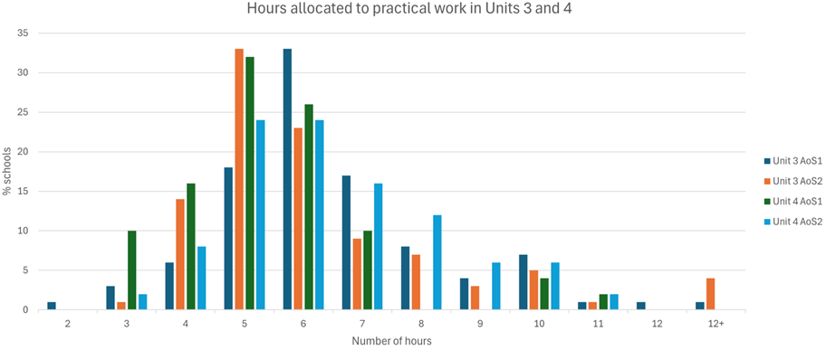
Practical work was conducted through laboratory experiments, modelling activities, simulations, the use of virtual laboratories, and teacher demonstrations. Students worked individually, in pairs or small groups. Logbooks were used extensively to record practical work. Many experiments were familiar to teachers from the previous study design and were adapted as the basis for some assessment tasks. Schools must take care to ensure that practical work adheres to Unit 3 and 4 content, for example, paper chromatography and acid-base titrations relate to Units 1 and 2.
Examples of innovative practical activities involving the scientific methodologies specified in the study design on page 13 are shown below:
Unit | Area of Study 1 | Area of Study 2
3 | Design and construction: Creation of a mud fuel cell  Construction and testing: Sponge fuel cells  Video: Biofuel from cooking oil  Experiment: Flame colour and completeness of combustion  Modelling: Carbon emissions  Experiment: Optimising fermentation conditions  Experiment (demonstration in a fume cupboard): Chemical oven, showing highly exothermic reaction that produces a rapid and significant temperature increase  Simulation: Virtual interactive calorimetry  Experiment: Calorimetry of household items (cotton balls, paper, pringles, marshmallows)  Product, process or system development: Design your own solution calorimeter | Design and construction: Alka-Seltzer rockets  Experiment: Recovery of silver using competing equilibria  Experiment: Hydrolysis of urea as an equilibrium reaction  Experiment (photo essay): Effect of concentration and temperature on equilibrium yields  Simulation (virtual laboratory): How can the formation of sulfuric acid be optimised?  Student simulation: What factors affect the Haber process?  Experiment (demonstration): Catalysed chemical rainbow experiment  Experiment: Turning rust back into iron  Experiment: Electroplating art
4 | Experiment: Comparison of oxidation rates of primary, secondary, and tertiary alcohols under controlled conditions; vary one factor (e.g., concentration, temperature) at a time  Product, process or system development: Synthesis of simple esters and combination to create a “signature fragrance” or flavour, recording yield and purity and including peer evaluation for sensory appeal  Experiment: Volumetric analysis of Vitamin C content of natural vs processed fruit juices  Case study: Analysis and comparison of petrochemical and biomass-derived production pathways for the same compound using selected green chemistry principles  Simulation: Comparison of alternative organic reaction pathways for producing the same compound, evaluating the sustainability of each pathway | Classification and identification: Spot tests to identify alcohols, aldehydes, ketones, carboxylic acids, amines, and esters; classification of unknown mixtures in a problem-solving laboratory challenge  Case study: Chemical detective challenge; spectra are provided for unknown organic compounds; students identify functional groups, molecular formula, and possible structures  Product, process, or system development: Hydrodistillation of essential oils  Modelling: Construction of enzyme active sites and substrate specificity with pipe cleaners or paper, and visually exploring competitive inhibition
Some schools gave students preparatory reading including questions prior to undertaking practical activity, which served as formative assessment prior to the SAC task being undertaken.

Fieldwork
Schools identified a range of fieldwork opportunities that supported student learning in Units 3 and 4. In Unit 3, visits to energy facilities and manufacturing sites helped students explore chemical energy changes in fuels, reaction rates and equilibrium. In Unit 4, fieldwork focused on analytical chemistry, synthesis, and medicinal chemistry, with students observing instrumentation and analysis of purity and yield in university, commercial, or government laboratories. Victorian science and mathematics specialist centres and tech schools provided a number of relevant programs. Where physical visits were limited, virtual tours and authentic datasets were used to support learning.

Specific information
Schools are required to allocate 4 nominated SAC tasks to Outcomes 1 and 2 in Units 3 and 4, with an additional SAC task involving a student-designed investigation undertaken in Unit 4 Outcome 3. These tasks should include a representative sampling of key knowledge and key science skills.
To support this process, a mapping tool (Appendix 1) can assist schools in aligning key science skills with each assessment task, helping to maintain a balanced across Units 3 and 4. In addition, a checklist for developing compliant SAC tasks (Appendix 2) provides guidance on the distinct features of each SAC task type, enabling schools to design tasks that meet study design requirements.
Analysis of task selection shows differences across Units 3 and 4 and between Areas of Study:
Task type | Unit 3 |  | Unit 4
Task type | Area of Study 1  (% selection) | Area of Study 2  (% selection) | Area of Study 1  (% selection) | Area of Study 2  (% selection)
Comparison | 42 | 36 | 8 | 12
Data analysis | 14 | 24 | 14 | 64
Problem-solving | 16 | 21 | 28 | 18
Innovation | 28 | 19 | 50 | 6
In Unit 3, comparison tasks were the most selected, particularly in Area of Study 1, while data analysis tasks were more frequently used in Area of Study 2. In Unit 4, there was a strong shift towards data analysis tasks in Area of Study 2, whereas innovation tasks were most prevalent in Area of Study 1. Problem-solving tasks were used more evenly across areas and units.
The new SAC tasks are more specific than those in previous study designs, emphasising critical and creative thinking, problem-solving, and clear communication in a chemistry context. Many schools developed assessment tasks that did not fully reflect the requirements of the selected task type. With the updated Chemistry study design introducing a set of clearly defined task types, it is important that SACs align closely with their intended features. Schools are encouraged to consult the guidance for each task type provided below and the support materials available on the VCAA Chemistry page.
To illustrate the distinct focus of each SAC task type, schools should note that the same scientific context can be used across multiple tasks or adapted across different academic years, provided that each task targets a different focus and set of skills. For example, in a context related to the production, analysis and sustainability of esters used as artificial fragrances, a comparison and evaluation task may require students to directly compare 2 ester synthesis practical activities and evaluate their effectiveness, safety and sustainability. A data analysis task using the same context may instead provide students with unfamiliar data sets related to ester yield or reaction conditions, requiring interpretation and explanation of trends and anomalies. In a problem-solving task, students could be asked to recommend an appropriate ester production pathway for a specific purpose, justifying their decision using chemical principles and evidence. An innovation task may then require students to evaluate and select from a limited set of teacher-provided modifications (such as changes to catalyst type, temperature range, or purification method) and justify how these choices could improve efficiency or sustainability.
Overall, the most common issue for all SAC task types was the tendency to attempt assessment of the entire content of an Area of Study within a single task. In some cases, this was addressed by adding extra questions at the end of tasks, which often reduced opportunities for students to engage in meaningful analysis and application of chemistry concepts. Such an approach is not necessary and is generally impractical for most task types. To support deeper learning, schools are encouraged to first select a relevant context or setting for each SAC task and then identify the associated key knowledge and key science skills. While students are required to demonstrate achievement of all elements of each outcome to receive an ‘S’, a considered selection of content provides a sufficient basis for SAC task development. Students should also participate in additional learning activities to receive ongoing feedback and consolidate understanding across all key knowledge and science skills. This approach allows SAC tasks to assess learning in greater depth than is possible in the external examination, where a representative sample of knowledge and skills from all outcomes in Unit 3 and Unit 4 is assessed.
Schools should ensure that the selected assessment task type appears on the front page of a written SAC task. For example, a SAC task described as ‘Analysis of primary data’ required reference to the selected assessment task type, specifically, ‘Analysis and evaluation of primary data, including data limitations, and conclusions.’ It is not necessary to include the outcome statement from the study design.

Sustainability
Schools are required to include reference to sustainability in at least one of the 4 tasks for Outcomes 1 and 2 across Units 3 and 4. All audited schools assessed sustainability through clearly identifiable questions that were integrated into the SAC task context and drew on one or more of the 3 perspectives listed on pages 20–22 of the VCE Chemistry Study Design: sustainable development, green chemistry principles and/or the transition to a circular economy.
Appropriate examples of sustainability-related questions submitted by schools included:
- evaluating a given chemical process or reaction pathway using relevant green chemistry principles (such as waste reduction, safer reagents, or energy efficiency)
- analysing how sustainable development considerations influence the selection of reactants, reaction conditions, or industrial processes
- comparing linear and circular economy approaches to the production, use, and disposal of a given chemical product or material.
All 4 task types enable reference to sustainability, with many schools including it in more than one task, as shown by uptake across the 4 task types in the graph below:
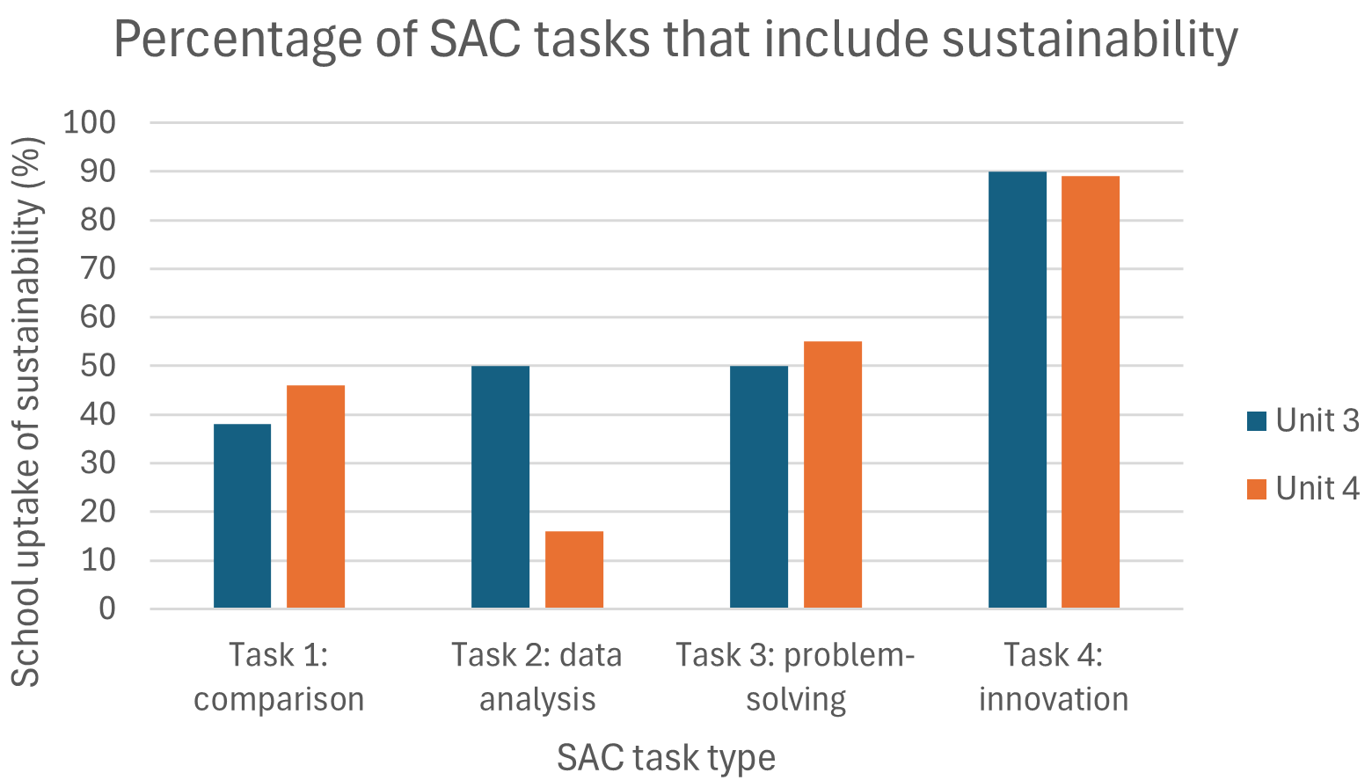
Not surprisingly, almost all of the tasks related to SAC Task type 4 (analysis and evaluation of a chemical innovation, research study, case study, socio-scientific issue, or media communication) included questions involving sustainability.
Inclusion of sustainability is relevant to all 4 Unit 3 and 4 Areas of Study, as shown by school uptake in SAC tasks developed for each Area of Study in the graph below:
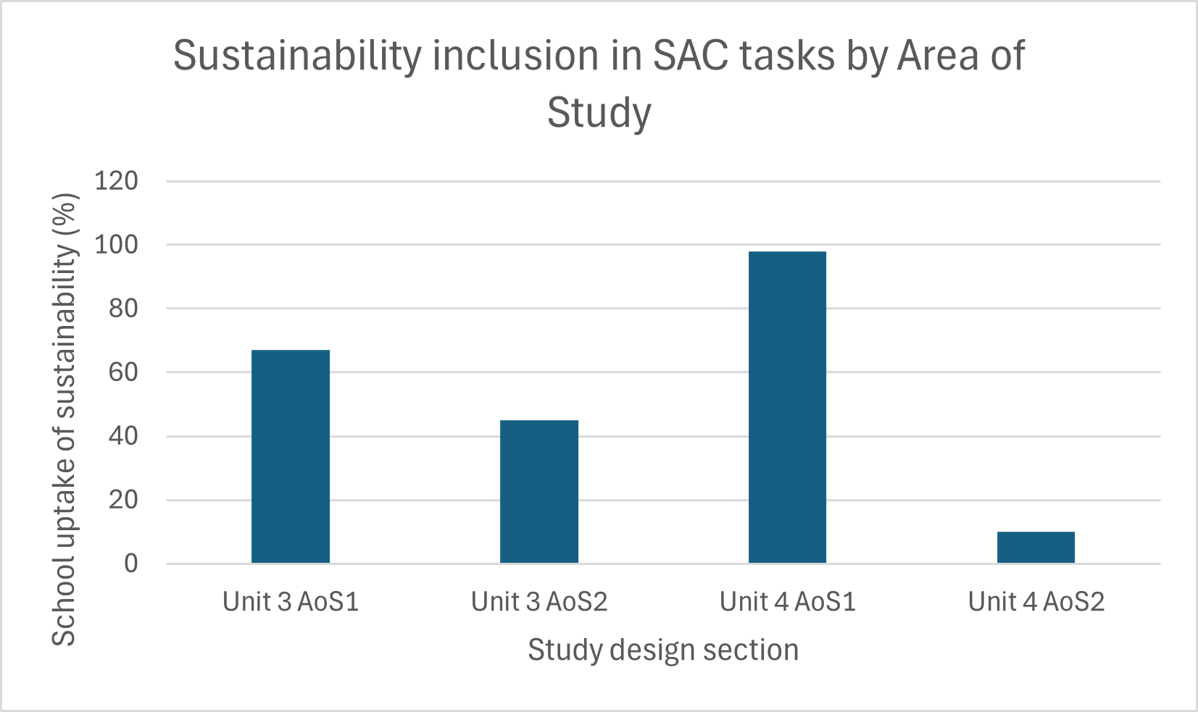
Unit 4 Area of Study 1 tasks often included assessment of atom economy, percentage yield and green chemistry principles.
Where sustainability is assessed in more than one assessment task type, schools are advised to ensure that the sustainability focus differs in each SAC task so that students are not assessed more than once on the same sustainability concept. In all cases, sustainability questions should be directly aligned with the scenario specified in the SAC task.

Use of Assessment Task Types

1. Comparison and evaluation of chemical concepts, methodologies and methods, and findings from at least 2 practical activities
This assessment task type emphasises critical comparison of multiple practical activities. Students examine experimental approaches, procedures, and outcomes to identify similarities and differences, assess the quality and validity of data, and justify conclusions using chemical reasoning. There are many practical activities that can be performed easily and safely within a secondary school laboratory that are well suited to this task type, and schools that ran excursions or completed activities involving instrumental analysis in Unit 4 were also able to apply these experiences effectively. The emphasis is on drawing comparative conclusions across activities, rather than conducting separate analyses of each activity in isolation. The bulk of the task should be focused on direct comparisons, and practical activities must be selected from the same Area of Study.
As shown in the graph below, this task was most commonly assessed by schools in Unit 3.
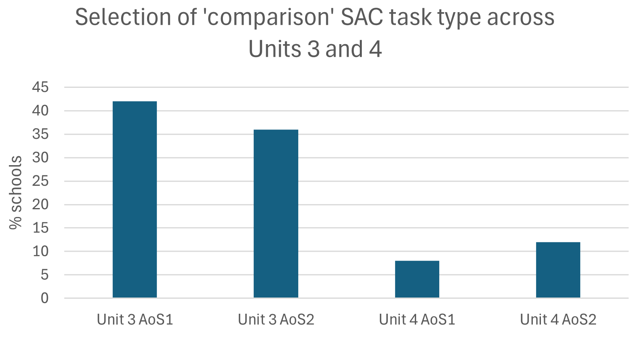
This was similar to a task in the previous study design; however, it caused confusion for some schools because the current task focuses on comparison across practical activities, whereas the previous task emphasised providing annotations for each activity separately. Over 50% of audited schools undertook little or no comparison between experiments. Where comparisons were attempted, they were often limited to results, with fewer schools comparing methodologies or the usefulness of observations, and almost none evaluating the practical activities themselves.
Most audited schools based the SAC on 2 practical activities, where the overall methodology was usually consistent, but the specific methods or procedures differed. Students were required to compare both the methods and the resulting outcomes, including observations, and to apply chemical reasoning to interpret the results. Many schools found it challenging to emphasise the comparative evaluation aspect and sometimes structured the task as separate analyses of each activity. Selecting or designing practical activities with clear points of comparison is important to allow meaningful assessment of similarities and differences. Students should be guided to integrate their comparison effectively, using observations as evidence to support evaluation rather than as an end in themselves. Successful tasks were often scaffolded using a 3-column table, helping students organise their responses and make comparisons across specified criteria.
Clear identification of comparison criteria supports students in integrating their responses across activities, for example when comparing equilibrium systems under different conditions or alternative methods for determining concentration. Designing prompts that require students to synthesise similarities and differences into comparative judgements helps maintain focus on evaluation rather than description. Scaffolding strategies, such as comparison tables, Venn diagrams or guided criteria, can assist students in organising their thinking while still requiring chemical reasoning to support conclusions.
Task design is strengthened when schools clearly identify what students are expected to compare and why, such as comparing 2 methods for determining concentration, 2 equilibrium systems under different conditions, or 2 approaches to investigating reaction rate. Establishing comparison criteria in advance (for example, method, observations, data trends, or conclusions) helps students integrate their responses across activities. Prompts that require students to synthesise similarities and differences into comparative judgements support evaluation rather than description. Scaffolding strategies, such as a structured comparison table or aligned response prompts, can assist students in organising their thinking while still requiring chemical reasoning to justify conclusions.
Suitable contexts used by schools for this assessment task type included the following:

Unit 3 Area of Study 1: What are the options for energy production?
Most audited schools based the comparison SAC on 2 practical activities. Common examples included comparing exothermic and endothermic reactions, including analysis of energy profiles and calculations of energy changes, comparing the production of ethanol from ethene or the anaerobic fermentation of glucose, and investigating variations in galvanic or fuel cell design, such as changes in electrode materials or cell configuration, to compare voltage, current, or energy output. Students were required to interpret the underlying chemical principles, link observations to energy transformations or redox reactions, and integrate their comparisons to draw evaluative conclusions. While some schools initially structured the task as separate analyses of each activity, effective tasks prompted students to synthesise their findings across the activities, using evidence to justify differences in performance. An interesting task submitted by one school involved the potential of green, red and brown seaweeds as biofuels.

Unit 3 Area of Study 2: How can the rate and yield of chemical reactions be optimised?
Schools commonly selected practical activities that investigated equilibrium systems or reaction rates, varying factors such as temperature, concentration, or the presence of a catalyst. Students were required to compare how these changes influenced reaction outcomes, including product formation or time to reach equilibrium. In some cases, SAC tasks focused too heavily on procedural or calculation-based comparisons; stronger examples guided students to evaluate trends and differences using chemical reasoning.

Unit 4 Area of Study 1: How are organic compounds categorised and synthesised?
While this was not a commonly selected Area of Study for this assessment task type, the schools that did implement it typically structured the SAC task around comparisons of different synthetic pathways for a single organic compound, such as the production of an ester or an active pharmaceutical ingredient. Students compared yields, reaction conditions, waste production, and efficiency, linking observations to underlying chemical principles such as reaction conditions and functional groups. Successful tasks scaffolded the comparison, ensuring students drew integrated conclusions rather than analysing each pathway in isolation. In most cases, students were presented with an unfamiliar pathway to compare alongside a more familiar one, promoting critical reasoning and application of chemical knowledge.

Unit 4 Area of Study 2: How are organic compounds analysed and used?
Tasks were often based on 2 investigations conducted in the laboratory, for example, enzyme activity under different conditions or redox titration of ethanol using acidified KMnO4 solution compared with Vitamin C in orange juice using iodine solution, Secondary data from techniques such as IR, HPLC, or NMR, was also common, for example considering how 1H-NMR and 13C-NMR can contribute to confirming the purity of a biodiesel sample. Students compared the outcomes and methodological differences, including factors that could affect results, such as sample preparation or experimental conditions. While some tasks separated the analysis of each activity, more effective examples required students to make comparisons across the activities, using observations and data as evidence to evaluate the effectiveness, limitations, and validity of the methods.

2. Analysis and evaluation of primary and/or secondary data, including identified assumptions or data limitations, and conclusions
This assessment task type emphasises critical interpretation and evaluation of chemical data. The task is deliberately open in design: students may perform their own experiments to generate primary data, or schools may provide printed or electronic data sets for analysis. Many audited schools successfully used spectral or other instrumental data in this task. Students analyse trends, consider assumptions and limitations, and draw evidence-based conclusions using chemical reasoning.
As shown below, this task was most commonly assessed in Unit 4 Area of Study 2:
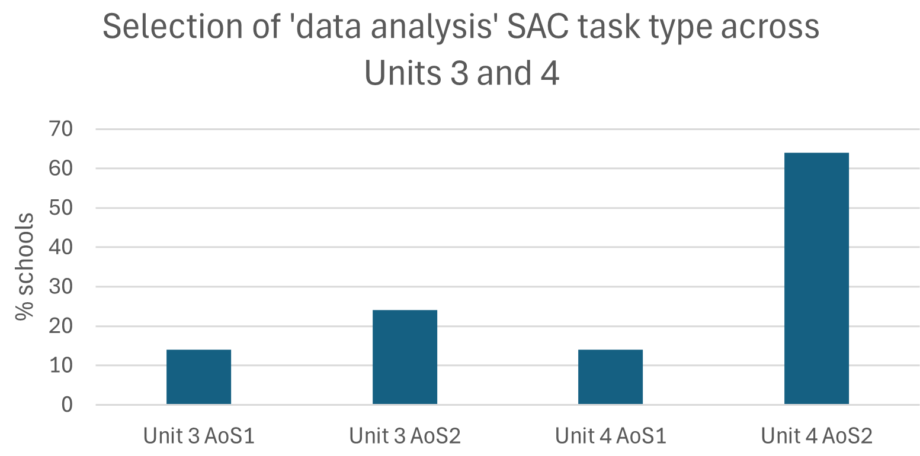
A key challenge for schools was selecting or designing a data set that was meaningful, valid, and sufficient for analysis. In some cases, schools provided data in which much of the analysis had already been completed, such as pre-graphed calibration curves or fully processed and corrected spectra, with students asked only to read values from graphs or respond to short, examination-style questions. These tasks typically emphasised calculations and interpretation of provided outputs, but did not require students to consider assumptions, limitations, or the quality of the data. As a result, many tasks consisted of multiple discrete data scenarios rather than an in-depth analysis of a single data set. Schools are advised that a single well-chosen data set is sufficient to support deeper analysis and evaluation. Where second-hand instrumentation data was used, effective tasks required students to interpret chemical features and trends while also considering method-specific limitations, such as resolution, peak overlap, or sample purity. Where relevant, tasks should provide opportunities for students to evaluate the quality of data using measurement concepts such as accuracy, precision, repeatability, reproducibility, resolution, outliers, and errors. Schools should also make clear decisions about when and how students are expected to represent data graphically to support their analysis.
Effective SAC tasks are supported by the deliberate selection of a single, well-targeted dataset that enables sustained analysis, such as data from a titration, reaction rate investigation, or spectroscopy results. Providing raw data and requiring students to construct their own graphs or standard curves encourages decision-making about line of best fit and supports discussion of assumptions, uncertainties, and conclusions. Where spectroscopy data are used, effective tasks prompt students to consider what additional information would be required before drawing firm conclusions, rather than treating a single technique (such as IR, NMR, or mass spectrometry) as sufficient in isolation. Explicitly planning where students will identify assumptions, consider limitations, and draw conclusions helps ensure these elements are addressed. Where appropriate, incorporating graphical representation and targeted measurement concepts can further support students in organising their reasoning and communicating conclusions clearly.
Suitable contexts used by schools for this assessment task type included the following:

Unit 3 Area of Study 1: What are the options for energy production?
Most SAC tasks were based on primary laboratory investigations, particularly solution calorimetry experiments and applications of Faraday’s Laws. These contexts provided accessible and appropriate datasets for students to perform calculations, construct and interpret graphs (such as energy changes over time or charge versus mass relationships), identify trends, and evaluate uncertainty and limitations in experimental methods. In some cases, schools also used prepared representations, for example, energy profile diagrams to support interpretation of reaction energetics. However, primary experimental data alone was sufficient to assess students’ capacity to analyse and evaluate data in this Area of Study.

Unit 3 Area of Study 2: How can the rate and yield of chemical reactions be optimised?
Most audited schools based this SAC task type on practical work conducted in the school laboratory, particularly investigations related to equilibrium and factors affecting reaction rates, such as temperature, concentration, or catalysts. These tasks commonly drew on student-generated primary data, and in some cases included multiple datasets from repeated trials or differing experimental conditions. While this approach supported accessibility, it sometimes resulted in tasks that were overly procedural or calculation-focused, rather than emphasising analysis and evaluation, including consideration of data quality and limitations. In most cases, students analysed quantitative data by plotting and interpreting graphs (such as concentration–time or rate–condition graphs) to identify trends and relationships and considered how experimental design and conditions influenced the interpretation of results.

Unit 4 Area of Study 1: How are organic compounds categorised and synthesised?
Contexts for this SAC task type often involved several short scenarios and centred on data from organic synthesis, such as reaction rates for an active pharmaceutical ingredient, efficiency of a greener organic pathway, or yields from a modified industrial or commercial reaction. Students analysed trends in the data, considered limitations in experimental design or reporting, and drew evidence-based conclusions using chemical reasoning, including evaluation of effectiveness, waste reduction, or sustainability. Overly focusing on writing chemical reactions, although an important aspect of this Area of Study, is not intended to be a focus of this assessment task type and could render the task invalid if included.

Unit 4 Area of Study 2: How are organic compounds analysed and used?
This Area of Study was frequently chosen for this SAC task type, possibly because schools were familiar with using this content for data analysis from previous study designs. In practice, schools generally selected familiar and manageable contexts, enabling students to work with primary laboratory investigations such as enzyme activity or redox titrations, or secondary instrumentation results (HPLC, NMR, IR), for example, to differentiate between 2 isomers. There was very little uptake of newer content, including solvent extraction, distillation, or measurement of the degree of unsaturation of compounds. Some schools included acid–base titrations, which are no longer part of Units 3 and 4, with these often conducted outside the prescribed redox context. Distillation and other less commonly used practical techniques were rarely incorporated, representing a clear opportunity for future tasks to broaden both the chemical content and the types of data students engage with.

3. Problem-solving, including calculations, using chemistry concepts and skills applied to real-world contexts
This assessment task type develops students’ ability to apply chemistry knowledge and quantitative reasoning to authentic problems that require making a justified choice or decision. Students are expected to interpret data, perform relevant calculations, and evaluate possible solutions using chemical principles, before selecting and justifying the most appropriate course of action. The task emphasises multi-step reasoning and the application of chemistry concepts in real-world contexts, such as industrial processes, energy production, or chemical synthesis, where students must consider alternatives and support their recommendations with evidence. Generally, a single context should be used as the basis for this task to allow depth of reasoning, rather than structuring the assessment as a series of short, calculation-focused questions. All questions in the SAC task must relate to the chosen context or scenario to ensure task validity.
As shown in the graph below, this assessment task type was used relatively evenly across all Areas of Study in Units 3 and 4:
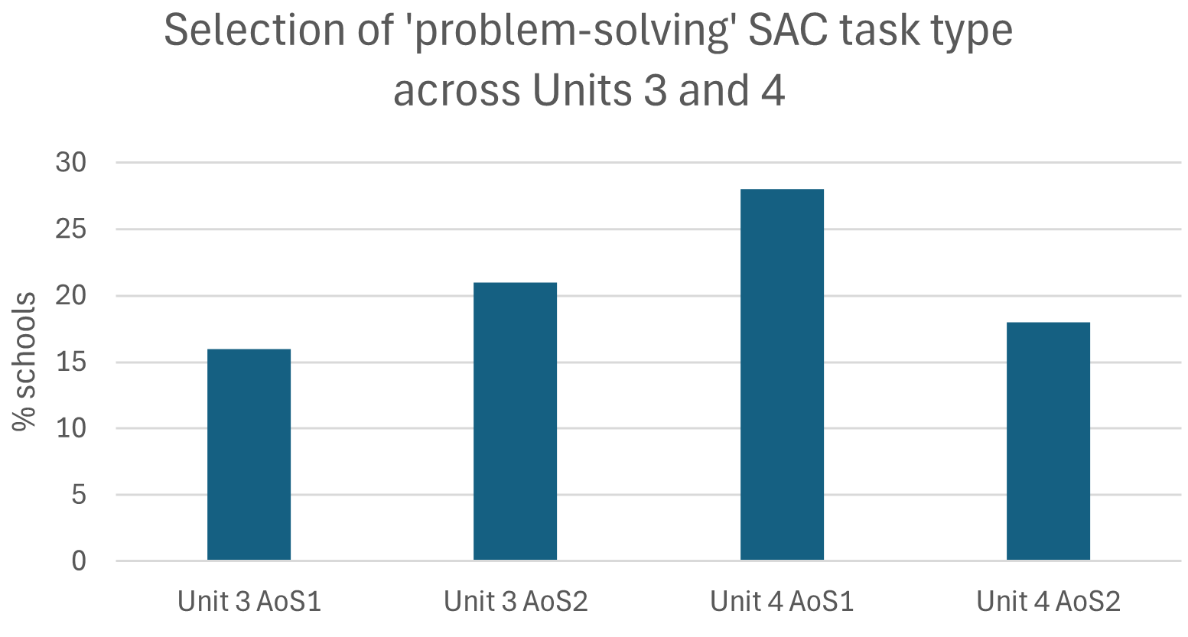
Some schools found it challenging to design scenarios that genuinely required students to make and justify decisions. In some cases, tasks were framed with a brief contextual stem that led into a sequence of examination-style questions, with students asked to perform calculations or recall definitions without needing to decide how their findings should be applied to the stated real-world context. These tasks closely resembled questions from the external examination and, in some instances, drew directly on past examination items or unmodified publicly available materials, which compromised both the intent of the task and equity across schools.
A compliant problem-solving SAC task must present a clearly defined chemical problem and provide sufficient context and data for students to analyse and compare alternative approaches or solutions. Typically, students should be required to evaluate options or justify a preferred solution using chemical concepts and/or calculations, interpreting information and applying chemical reasoning in alignment with the key knowledge and key science skills. Schools are advised to avoid tasks that assess only procedural calculations and instead ensure that calculations, where used, support higher-order reasoning and evidence-based decision-making. Selecting a single, well-scoped scenario supports deeper student engagement and enables students to justify their conclusions meaningfully.
Task design is strengthened when schools clearly identify the decision or judgement students are expected to make before developing supporting questions, such as selecting optimal reaction conditions, choosing between alternative materials, or evaluating competing industrial processes. Framing the task around evaluating alternatives or constraints helps students link calculations to meaningful conclusions. Structured prompts can support students in justifying their decisions using chemical principles, while careful calibration of data quantity and complexity enables multi-step reasoning without overloading students. Suitable contexts used by schools for this assessment task type included the following:

Unit 3 Area of Study 1: What are the options for energy production?
Compliant tasks were commonly structured around a single energy-related scenario that required students to make a justified decision. Examples included selecting the most suitable fuel mixture for a specific application, such as use in a camp oven, balancing energy output, emissions, and efficiency, or comparing different fuel cell types for a particular purpose, such as stationary versus portable energy generation. An imaginative task was built as a scenario around the energy needs of a post-apocalyptic world. Students were required to interpret provided data, perform relevant energy or redox-based calculations, and evaluate trade-offs between alternatives before recommending a solution. Stronger tasks required students to justify their choice using chemical reasoning linked to energy transformations and redox processes, rather than relying on isolated calculations.

Unit 3 Area of Study 2: How can the rate and yield of chemical reactions be optimised?
In this Area of Study, schools often presented a scenario involving the optimisation of a chemical reaction, such as adjusting temperature, concentration, or catalyst use to achieve a desired rate or equilibrium yield. Students analysed quantitative data, applied relevant calculations, and evaluated alternative reaction conditions before recommending the most appropriate set of conditions for a specified purpose, such as efficiency or safety. Another appropriate context was to decide which of 3 methods of producing green hydrogen was recommended to fuel ‘hydrogen-powered buses. Effective tasks required students to balance multiple factors and justify their decision using chemical principles, rather than simply identifying the condition that produced the highest numerical result.
In this Area of Study, schools often presented a scenario involving the optimisation of a chemical reaction, such as adjusting temperature, concentration, or catalyst use to achieve a desired rate or equilibrium yield. Other schools structured tasks around batteries or electrolytic cells, where students compared different system options or operating conditions, such as cell type, applied voltage, or electrolyte choice, to achieve a specified outcome related to efficiency, energy output, or safety. In both contexts, students analysed quantitative data, applied relevant calculations, and evaluated alternative options before recommending the most appropriate choice for a stated purpose. Effective tasks required students to balance multiple factors and justify their decision using chemical principles, rather than simply identifying the option that produced the highest numerical result.

Unit 4 Area of Study 1: How are organic compounds categorised and synthesised?
Problem-solving tasks in this Area of Study were typically based on selecting or optimising an organic synthesis pathway for a specific purpose, such as maximising yield or reducing waste. Students compared alternative reaction sequences, reagents, or conditions, using calculations related to yield or atom economy where appropriate, and evaluated the implications of each option. Tasks that were most effective required students to recommend a pathway and justify their decision by linking quantitative results to reaction conditions, functional groups, and green chemistry considerations.

Unit 4 Area of Study 2: How are organic compounds analysed and used?
Schools applying this task type in Unit 4 Area of Study 2 often framed the problem around choosing an appropriate analytical technique or experimental approach to address a specific chemical question. Scenarios included selecting the most suitable method to identify an unknown compound or to assess product purity under given constraints. Students interpreted provided data, considered the strengths and limitations of each option, and justified their choice using chemical reasoning related to the principles of the techniques involved. Strong tasks emphasised decision-making informed by evidence, rather than separate calculations or descriptions of each method. Another common approach, often described as a “chemical detective” scenario, involved students being presented with a series of unlabelled clear liquids. They were required to plan and justify a sequence of tests, interpret observations using chemical principles, and make evidence-based conclusions for each substance. This scenario also emphasised multi-step reasoning and decision-making, allowing students to demonstrate practical application of chemistry knowledge while linking observations to theoretical concepts.

4. Analysis and evaluation of a chemical innovation, research study, case study, socio-scientific issue, or media communication
This assessment task type develops students’ ability to identify the underlying chemistry in novel or practical situations outside the school laboratory and to understand how chemical theory can lead to practical innovations and improvements for society. Students are expected to analyse data or claims, consider assumptions and limitations, and reflect on broader impacts, considering ethical, environmental, economic, or societal implications where relevant. The task emphasises critical thinking and reasoned evaluation, using chemical knowledge to interpret the significance and potential impacts of the innovation or issue. Only a single context should be selected to allow sufficient depth of treatment.
Innovations, case studies and media communications are readily available for all Areas of Study. This assessment task type is also particularly well-suited to incorporating a sustainability perspective, as many recent innovations focus on improving atom economy, reducing energy requirements, and minimising wastes. This assessment task type was a popular choice for Area of Study 1 in Unit 4, as shown in the graph below:
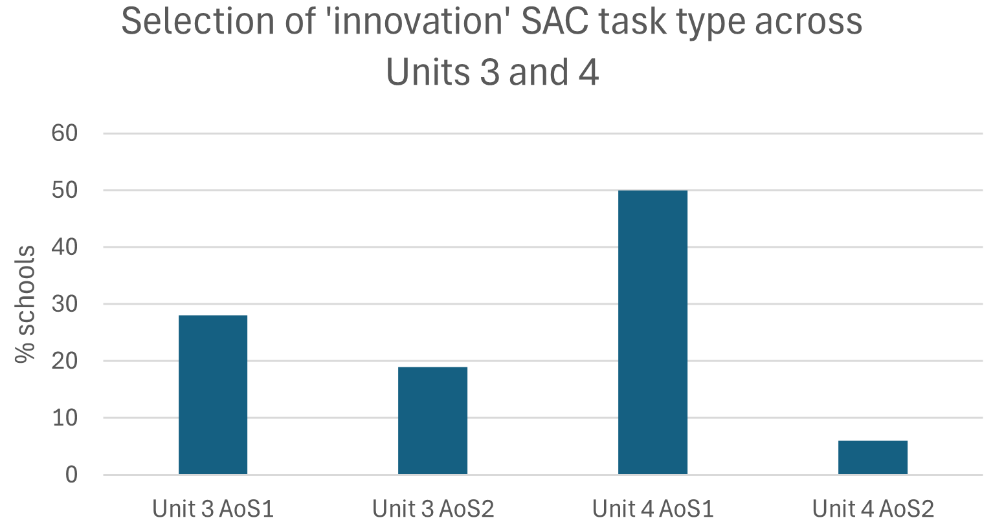
Schools sometimes selected contexts that were either too narrow or not directly linked to chemistry, limiting opportunities for students to demonstrate analysis and evaluation. Many tasks were based on a single innovation or study, which is sufficient to allow depth of evaluation. Schools are advised to ensure tasks enable students to identify the chemistry underlying the scenario, consider broader impacts, and draw reasoned, evidence-based conclusions, rather than simply summarising the case study or innovation. Selecting a relevant context and specifying key knowledge and skills in advance helps ensure alignment with task requirements.
In some submitted tasks, questions referred to content that was not included in the context or scenario. This was the most common reason tasks were determined to be invalid. Schools should ensure that all questions are clearly related to the stimulus material.
Selecting appropriate contexts, such as a new industrial process, an alternative energy technology, or an improved material, provides an opportunity for schools to engage students with current and relevant chemistry applications. These contexts should be credible and appropriately complex. In cases where source materials are lengthy, schools may consider shortening them, selecting excerpts, editing them to reduce overly technical language, or providing the materials to students beforehand. Readability score tests, such as Flesch Reading Ease test, can assist schools in determining the readability of selected stimulus materials. Maintaining a clear focus on assessable chemistry can be supported by explicitly identifying the key chemical concepts to be addressed during task design, particularly in socio-scientific contexts. Open-ended tasks may produce a range of student responses, but structured scaffolds can support consistent assessment. Schools can further strengthen student performance by explicitly teaching skills related to evaluating data, sources, and claims. The use of clearly defined assessment criteria or mark allocations can assist schools in assessing ethical or societal considerations while maintaining a focus on the quality of chemical reasoning. Suitable contexts used by schools for this assessment task type included the following:

Unit 3 Area of Study 1: What are the options for energy production?
A number of schools selected contexts focused on the evaluation of an alternative energy technology, such as a new fuel mixture, innovations in fuel cell design, and contemporary developments in bioethanol production via glucose fermentation. Students analysed the chemical principles underpinning the chosen technology, including energy transformations, redox reactions, and efficiency, and evaluated claims related to its sustainability, emissions reduction, and feasibility. This involved interpreting the chemical rationale behind observed outcomes or reported processes and considering any assumptions or limitations in the information provided.

Unit 3 Area of Study 2: How can the rate and yield of chemical reactions be optimised?
Contexts for this SAC task type were commonly drawn from an innovation or case study related to reaction rates, equilibrium systems, or electrolytic processes. Examples used by schools included improvements to the Haber process, innovations in sulfuric acid production, and the operation of a new battery technology. Students were expected to explain the chemistry underpinning the scenario, using principles such as collision theory, Le Châtelier’s principle, or Faraday’s laws and stoichiometry. This involved interpreting the chemical rationale behind observed outcomes or reported processes, and considering any assumptions or limitations in the information provided.

Unit 4 Area of Study 1: How are organic compounds categorised and synthesised?
Schools often selected contexts based on an organic chemistry innovation, such as a new synthetic pathway to produce an active pharmaceutical ingredient, a greener route to a biopolymer for packaging purposes, or a modified synthesis of an industrially important organic molecule. In these cases, students examined reaction mechanisms, functional groups, and reaction pathways, and evaluated claims regarding efficiency, waste reduction, and alignment with green chemistry principles. Other schools focused on a specific green chemistry innovation, such as an alternative solvent, a biodegradable polymer, or a catalyst than can convert carbon dioxide to ethanoic acid, where students considered the underlying chemical concepts alongside environmental and societal impacts, and assessed claims about sustainability, emissions, and feasibility. A media article about the possible expansion of insect farming or lab-grown meat as the best way of meeting UN Sustainable Development Goals was used by one school to explicitly assess sustainability in this Area of Study.

Unit 4 Area of Study 2: How are organic compounds analysed and used?
Some schools focused on an analytical or instrumentation-based innovation, such as the use of HPLC to characterise plant-derived compounds, a novel enzyme for biocatalysis, or an improved distillation technique for natural product extraction. Students analysed the chemical principles underpinning the innovation, considered practical applications, and evaluated claims about effectiveness, accuracy of identification, and broader environmental or societal impacts.

5. Communication of the design, analysis and findings of a student-designed and student-conducted scientific investigation through a structured scientific poster and logbook entries
All audited schools implemented this task with a high level of familiarity, as its structure remains largely unchanged from the previous study design, apart from the introduction of a 600-word limit for the scientific poster.
Students must be evaluated on their own ability to plan, carry out, and communicate the findings of an investigation. As part of this, students should explain the significance of their proposed investigation in the ‘introduction’ section of their scientific poster. In schools with multiple classes or large student numbers, it may not be practical for every student to undertake a fully independent investigation. In these cases, students may work in groups to generate data, provided they have already been assessed on their individual capacity to design an investigation.
All proposed investigations require teacher approval before they begin, as some plans may be unsuitable due to safety concerns, limited equipment, time constraints, or the challenges of supervising large student cohorts. In situations where students have proposed investigations that are not practicable, or safe, to conduct, they may be directed to investigate an alternative investigation question, and subsequent assessment will be based on the alternative investigation. However, the original assessment of experimental design will stand.
Schools should provide guidance to students before they conduct any experiment in which the variables have not been adequately controlled. For example, a question such as ‘What is the optimum time to electroplate a nail?’ might serve as a general class question, but it is unlikely to be answered meaningfully by an individual student within the time allocated to this area of study.
Investigations may be limited to one area of study or may integrate content across multiple areas of study and/or units. For example, the investigation question “How does temperature affect the rate of esterification between different alcohols and carboxylic acids, and what does this indicate about the efficiency of industrial ester production?” draws on reaction rates from Unit 3 Area of Study 2 and organic synthesis from Unit 4 Area of Study 1.
The distribution of SAC tasks by unit content, shown in the graph below, shows that over a third of tasks were based solely on Unit 3, with fewer drawn from Unit 4 only. A number of tasks allowed choice of Unit 3 or 4 content, or combined content from both units, reflecting flexibility or integration across units. This provides scope for investigating more complex questions.
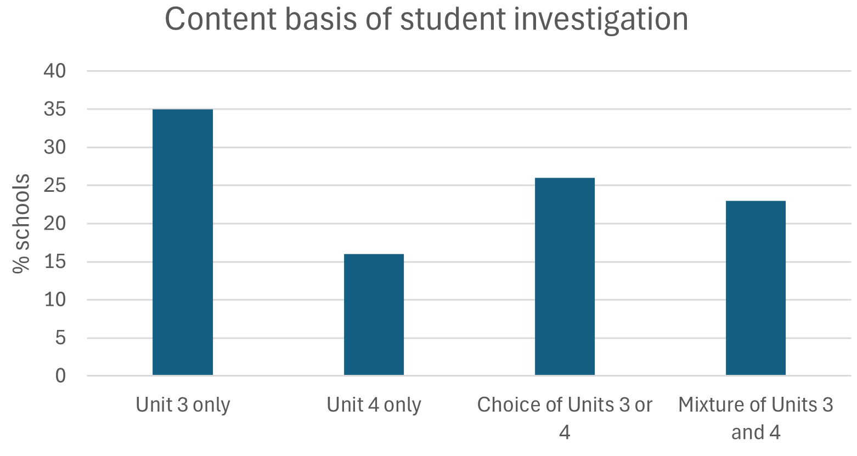
The investigation can be undertaken at any time across Units 3 and/or 4. Most schools chose a timeframe during Unit 4 as shown the following graph:
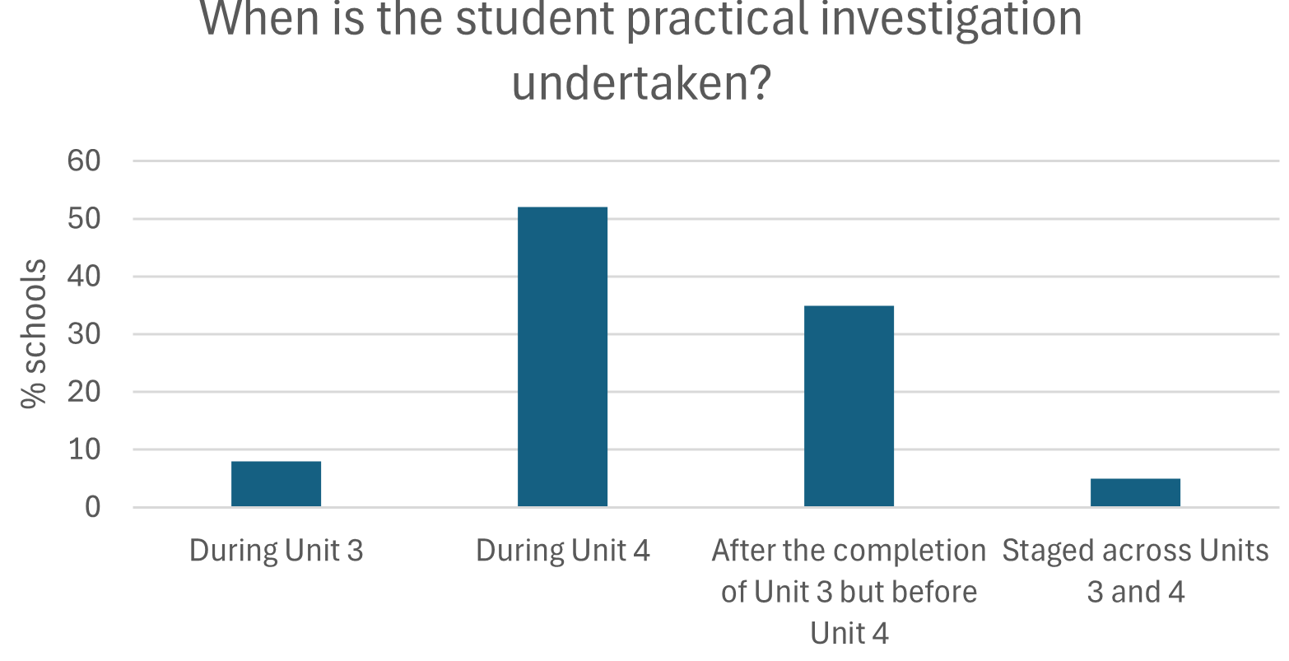
To manage large or multiple classes, or to accommodate limited resources, schools often restricted student choice to a small number of topics; for example, several schools limited investigations to catalytic activity. Other schools provided a broad guiding question for students to refine into specific, investigable questions. For example, one school nominated electrolysis as an area of focus, with class time allocated to discussing industry considerations, followed by students then developing their research question.
When using a restricted-topic approach, schools should ensure sufficient scope for investigations to go beyond simple confirmation tasks. Investigable questions should explore relationships rather than yes/no outcomes and avoid answers that are easily predicted. For this reason, an investigation such as examining how effectively copper plates onto different metals is more appropriate than tasks that simply confirm expected results.
The student investigation is expected to run for a minimum of 10 hours, a guideline that most audited schools followed. In many cases, the investigation took the form of a ‘coupled investigation’, building directly on a shared laboratory activity. To support this approach, some schools allocated part of a day as an incursion specifically for completing the required preparatory laboratory work.
All audited schools established suitable timelines covering each stage of the investigation, from planning and data analysis to evaluation and presentation in a scientific poster. Most schools supported students with a scaffolded booklet alongside the logbook to guide investigation planning and progress. A common assessment rubric was used for all students, regardless of investigation topic, to ensure consistent scope and challenge; therefore, schools must ensure investigation questions are comparable, so all students have the opportunity to achieve at the highest performance levels.
Audit concerns for this assessment task included:
- investigation titles that were not phrased as a question
- investigation questions that could be answered by undertaking research or using secondary data
- investigation questions that had obvious answers that could be predicted by using chemical relationships and equations, particularly Faraday’s Laws
- students who were provided with a topic and possible variables, and therefore did not have an authentic opportunity to work independently to design their own investigations
- investigation questions that could not be investigated in the allocated timeframe
- investigation questions that could simply be answered with ‘yes’ or ‘no’
- lack of opportunity for students to investigate their own topics of interest
- schools that accepted submission of multiple drafts.
Schools may provide data to students in situations where, after designing and running their own investigation, students do not generate a viable set of data that can be analysed.
Ideally, investigation questions should not be chosen if the outcome is already well established, or it can be readily determined using a search engine. For example, the question “How does the enthalpy of combustion change with increasing hydrocarbon chain length?’ can be answered without investigation, as students learn that enthalpy of combustion becomes more exothermic with increasing chain length due to a greater number of C–H and C–C bonds releasing energy during combustion. A more suitable alternative investigation question might be: “How do different alcohols affect the measured enthalpy of combustion under controlled experimental conditions?”, allowing students to demonstrate experimental design, control of variables, and evaluation of data quality without safety risks or reliance on readily available information.
Most submitted student investigation questions related to content that was common to the previous and the current study designs. Schools are encouraged to broaden opportunities for supporting students to develop questions which are of interest to them. The new content in the study design provides many opportunities, for example:
- Unit 3 Area of Study 1: How does the energy content of biofuels change when using different plant oils?
- Unit 3 Area of Study 2: How is the reaction rate of a ‘green’ iodine clock experiment affected by changing temperature?
- Unit 4 Area of Study 1: How does the presence of water affect the hydrolysis of sucrose into glucose and fructose?
- Unit 4 Area of Study 2: How does the presence of impurities in a liquid affect the distillation process and the purity of the distillate?
Most student investigations described by audited schools involved controlled experiments. Schools are advised that other scientific methodologies listed on page 13 of the study design may also be used. For example, students may use experimental data to construct and evaluate a model that explains the behaviour of a chemical system or use a simulation to make predictions that are then tested through practical experimentation. Investigations may involve using experimental tests to classify and identify unknown substances, collecting chemical data from a local environment to explore the influence of environmental conditions, or designing, testing and refining a chemical product, process or system to improve performance. In all cases, the investigation should be sufficiently open-ended so that outcomes depend on student decisions, experimental conditions and collected data, rather than being predictable or discoverable through external sources. The VCE Chemistry Support Materials include an extensive list of possible topics.

Appendix 1

VCE Chemistry Units 3 and 4: Key Science Skills Mapping Grid
A set of key science skills apply across Units 1 to 4. The table below provides a planning template for schools to map how the contextualised key science skills on pages 11 and 12 of the VCE Chemistry Study Design will be developed by students across Units 3 and 4.
Key science skill | VCE Chemistry contextualised  skills for Units 1–4 | Unit 3 |  | Unit 4
Key science skill | VCE Chemistry contextualised  skills for Units 1–4 | AoS1 | AoS2 | AoS1 | AoS2 | AoS3
Develop aims and questions, formulate hypotheses and make predictions. | Identify, research and construct aims and questions for investigation.
 | Identify independent, dependent, and controlled variables in experiments.
 | Formulate hypotheses to focus investigations.
 | Predict possible outcomes of investigations.
Plan and conduct investigations. | Determine appropriate investigation methodology (case study; classification and identification; controlled experiment; correlational study; fieldwork; literature review; modelling; product, process, or system development; simulation).
Plan and conduct investigations. | Design and conduct investigations; select and use methods appropriate to the selected investigation methodology, including consideration of sampling technique and size, equipment, and procedures, considering potential sources of error and causes of uncertainty; determine the type and amount of qualitative and/or quantitative data to be generated or collated.
Plan and conduct investigations. | Work independently and collaboratively as appropriate and within identified research constraints, adapting or extending processes as required and recording such modifications in a logbook.
Comply with safety and ethical guidelines. | Demonstrate safe laboratory practices when planning and conducting investigations by using risk assessments that are informed by safety data sheets (SDS), and accounting for risks.
Comply with safety and ethical guidelines. | Apply relevant occupational health and safety guidelines while undertaking practical investigations.
Comply with safety and ethical guidelines. | Demonstrate ethical conduct when undertaking and reporting investigations.
Generate, collate, and record data. | Systematically generate and record primary data, and collate secondary data, appropriate to the investigation, including use of databases and reputable online data sources.
Generate, collate, and record data. | Record and summarise both qualitative and quantitative data, including use of a logbook as an authentication of generated or collated data.
Generate, collate, and record data. | Organise and present data in useful and meaningful ways, including schematic diagrams, flow charts, tables, bar charts and line graphs.
Analyse and evaluate data and investigation methods. | Process quantitative data using appropriate mathematical relationships and units, including calculations of ratios, percentages, percentage change and mean.
Analyse and evaluate data and investigation methods. | Use appropriate numbers of significant figures in calculations.
Analyse and evaluate data and investigation methods. | Plot graphs involving 2 variables that show linear and non-linear relationships.
Analyse and evaluate data and investigation methods. | Identify and analyse experimental data qualitatively handling, where appropriate, concepts of accuracy, precision, repeatability, reproducibility, resolution, and validity of measurements; and errors (random and systematic).
Analyse and evaluate data and investigation methods. | Identify outliers, and contradictory, provisional, or incomplete data.
Analyse and evaluate data and investigation methods. | Repeat experiments to evaluate the precision of data.
Analyse and evaluate data and investigation methods. | Evaluate investigation methods and suggest ways to improve precision, and to reduce the likelihood of errors.
Construct evidence-based arguments and draw conclusions. | Distinguish between opinion and evidence, and between scientific and non-scientific ideas.
Construct evidence-based arguments and draw conclusions. | Evaluate data to determine the degree to which the evidence supports the aim of the investigation, and make recommendations, as appropriate, for modifying or extending the investigation.
Construct evidence-based arguments and draw conclusions. | Evaluate data to determine the degree to which the evidence supports or refutes the initial prediction or hypothesis.
Construct evidence-based arguments and draw conclusions. | Use reasoning to construct scientific arguments, and to draw and justify conclusions consistent with evidence and relevant to the question under investigation.
Construct evidence-based arguments and draw conclusions. | Identify, describe, and explain the limitations of conclusions, including identification of further evidence required.
Construct evidence-based arguments and draw conclusions. | Discuss the implications of research findings.
Analyse, evaluate and communicate scientific ideas. | Use appropriate chemical terminology, representations, and conventions, including standard abbreviations, graphing conventions, algebraic equations, units of measurement and significant figures.
Analyse, evaluate and communicate scientific ideas. | Discuss relevant chemical information, ideas, concepts, theories and models and the connections between them.
Analyse, evaluate and communicate scientific ideas. | Analyse and explain how models and theories are used to organise and understand observed phenomena and concepts related to chemistry, identifying limitations of selected models/theories.
Analyse, evaluate and communicate scientific ideas. | Critically evaluate and interpret a range of scientific and media texts (including journal articles, mass media communications and opinions in the public domain), processes, claims and conclusions related to chemistry by considering the quality of available evidence.
Analyse, evaluate and communicate scientific ideas. | Apply sustainability concepts (green chemistry principles, development goals and the transition from a linear towards a circular economy) to analyse and evaluate responses to chemistry-based scenarios, case studies, issues, and challenges.
Analyse, evaluate and communicate scientific ideas. | Identify and explain when judgements or decisions associated with chemistry-related issues may be based on sociocultural, economic, political, legal, and/or ethical factors and not solely on scientific evidence.
Analyse, evaluate and communicate scientific ideas. | Use clear, coherent, and concise expression to communicate to specific audiences and for specific purposes in appropriate scientific genres, including scientific reports and posters.
Analyse, evaluate and communicate scientific ideas. | Acknowledge sources of information and assistance and use standard scientific referencing conventions.

Appendix 2

VCE Chemistry School-assessed Coursework Task Design Checklist
Assessment principle | Does the task meet the requirements of the VCE assessment principles and the VCE Chemistry Study Design (From 2024)? | Check
Valid  Task type is in line with the VCE Chemistry Study Design. | Is the task a true reflection of the selected task type listed on pages 43 or 49 of the VCE Chemistry Study Design?  Note: Refer to further information for each task type on the next page.
Does the task identify the specific key knowledge from the outcome and the key science skills that will be assessed?
Note: Although all key science skills and key knowledge points related to an outcome must be met by students to be awarded an ‘S’ for the unit, only part of an outcome is sufficient as the basis of a SAC task. The Key Science Skills assessment checklist (Appendix 1) may be useful as a planning tool.
 | Does at least one of the tasks include a reference to sustainability?
 | Have sources of diagrams, articles, spectra, etc. used in the task been cited?
 | Are all the questions in the task within the single Area of Study being assessed?
 | Does the task language match that of the study design?
 | Are clear processes in place to authenticate permitted task notes/resources?
Equitable  Task is run under fair conditions and is equally accessible to all students - access to past tasks or commercial sites should not advantage any student. | Have students been provided with clear information/instructions before the task and on the task itself?  Note: Prior notification of the task to students and the SAC task itself should include the following information: unit, relevant part of the outcome to be assessed, SAC task type, key science skills and key knowledge to be assessed, date and duration of the task, pre-task requirements, task conditions, resources permitted, materials allowed, how the task will be marked, and contribution to the final study score.
 | Is the task original to the school and cohort?
 | If materials available in the public domain have been used, have they been carefully checked against the study design and selected task type for alignment?
 | If a past task and/or materials available in the public domain have been used, have they been sufficiently modified to make the task unique to the school and cohort?
Has the task been checked to make sure that there is no bias?
Note: Consider gender, culture, linguistic background, physical disability, socioeconomic status and geographical background.
 | Are suitable conditions in place to ensure that no student is disadvantaged?
If students are given access to stimulus materials before the task, are processes in place to authenticate any annotations?
Note: Annotations of the materials may be made inside or outside of class, but these materials should be handed in with the SAC task. Student work for assessment undertaken outside class must be accompanied by a School-assessed Coursework Authentication Form, available on VASS.
 | Does the task enable feedback to be provided to students?
Balanced  Task provides access for the weakest to the strongest in the student cohort. | Does the task provide a range of question types, and questions with varying cognitive demands, to ensure student performance can be differentiated?  Note: Consider the ‘25:50:25 rule’, where a quarter of the task or questions are concrete, half require medium-level analysis, and a quarter require higher-order synthesis – enabling access to all students. Tools such as Bloom’s or SOLO taxonomies may be useful.
 | Has an appropriate mark scheme or rubric been developed?
Efficient  Task should not generate undue stress. | Is the time allowed for the task in line with the guidelines on pages 43 or 49 of the VCE Chemistry Study Design?
Efficient  Task should not generate undue stress. | Can the task be reasonably completed in the time frame allocated?
Efficient  Task should not generate undue stress. | Is the complexity and volume of the reading load reasonable within the time frame allocated?

Task Type | Does the task meet the requirements of the VCE assessment principles and the VCE Chemistry Study Design 2024–2027? | Check
Comparison and evaluation of chemical concepts, methodologies and methods, and findings from at least 2 practical activities. | Is the task based on practical activities undertaken by students?
Does the task include a direct comparison of the selected activities?
- Chemical concepts
- Methodologies and/or methods
- Findings (e.g., qualitative vs quantitative, safety procedures, theoretical versus actual results, conclusions, equations, data)
Note: The use of a table that lists what will be compared for each of the selected practical activities may assist in ensuring task validity.
 | Does the task include evaluation questions?
 | Do all questions in the task relate specifically to the selected practical activities?
Analysis and evaluation of primary and/or secondary data, including identified assumptions or data limitations, and conclusions. | If using secondary data or spectra, are sources appropriately cited?
 | Does the task require students to manipulate the data, such as graphing, calculating or merging information from multiple sources?
 | Does the task require students to find information/draw conclusions from the data?
Does the task require students to reflect on the type or quality of the data?
Note: Measurement terms such as accuracy, precision, repeatability, reproducibility, resolution, validity, errors, outliers, and contradictory, provisional or incomplete data should be included in the task.
 | Are assumptions or data limitations explored?
Problem-solving, including calculations, using chemistry concepts and skills applied to real-world contexts. | Is there a single real-world scenario that forms the task stimulus?
Is there an actual problem or dilemma to be solved, or a preferred option to be presented?
Note: This may involve, for example, presenting a set of chemical operating options from which students justify a preferred choice, or setting a scene where the student is placed within an industry.
 | Does the task provide opportunities for students to use their calculations to evaluate options or justify a preferred solution?
 | Does the task provide opportunities for students to use their chemical knowledge to evaluate options or justify a preferred solution?
Analysis and evaluation of a chemical innovation, research study, case study, socio-scientific issue, or media communication. | Is there a single chemical innovation, research study, case study, socio-scientific issue or media communication?
Is the reading load reasonable?
Note: Consider using excerpts to replace extended articles, providing the stimulus prior to the task and/or discussing the materials in class.
 | Are all the task questions linked to the chemistry in the stimulus material?
 | Does the scenario provide sufficient information for students to analyse the relevant scientific concepts and skills?
 | Is there an evaluation of the information?
Communication of the design, analysis and findings of a student-designed and student-conducted scientific investigation through a structured scientific poster and logbook entries. | Have students been advised of the task timelines?
 | Do students have input into question development?
 | Is there sufficient opportunity for student experimental design?
 | Is there a separate provision to assess students’ capacity to design an investigation?
 | Are the student questions of similar complexity?
 | Can the work of individual students be suitably authenticated?
 | Does the logbook form a significant component of the overall marks?
 | Are procedures in place for logbook entry authentication?
 | Have students been provided with information about how they will construct their scientific poster?

