School-based Assessment Report

VCE Physics
Accreditation period commencing 2024

Introduction
Schools must deliver the Victorian Certificate of Education (VCE) to the standards and requirements established by the VCAA. Study-specific standards and requirements are stated in the relevant VCE study design.
This report reflects the first year of implementation of this study design and is based on the findings of the 2024 School-based Assessment Audit. The School-based Assessment Audit checks that the standards and requirements set out in study designs are being followed and that assessment is being carried out in line with the VCE assessment principles.
All official communications regarding VCE study designs are provided in the Senior Secondary update and Notices to Schools. It is recommended that schools subscribe to the Senior Secondary update and the VCAA Bulletin to receive updated information regarding the study. Important administrative dates and assessment schedules are published on the School administration page of the VCAA website.

General comments
The responses to the School-based Assessment Audit for VCE Physics indicated that schools experienced some issues in adjusting to the requirements of the 2024 VCE Physics Study Design, particularly in terms of the revised scope and focus of the School-assessed Coursework (SAC) tasks.

Assessment planning
Schools must provide an assessment timetable to students at the beginning of the school year.
Prior to each SAC task, students should be given a clear and accurate statement of:
- the outcome being assessed
- the selected task type
- the requirements and conditions of the task
- the contribution of the task to the final study score.
Most schools used marking schemes to assess student SAC tasks, although performance descriptors and marking rubrics continued to be used for the student-designed practical investigation for Unit 4 Area of Study 2. Most assessment tasks are now developed by schools as scaffolded activities, allowing marking guides to support valid judgments and clearly differentiate between levels of student achievement. Some schools appeared to use both a marking scheme and a rubric for a single task; schools are advised that this is not required and may result in conflicting student rank orders.

Task development
Schools used a range of approaches to develop SAC tasks, often building on practical classroom experiences, contemporary learning activities, and resources such as datasets, virtual simulations, laboratories, case studies, demonstrations, modelling exercises, and modified exam-style questions. Schools meeting VCAA expectations designed SAC tasks that aligned closely with the study design, used the list of verbs in the study design and the VCAA command terms, included a variety of question formats, and required students to demonstrate both key knowledge and key science skills.
When using publicly available resources, including commercial materials, teacher-shared tasks and past VCAA examination questions, questions should be significantly adapted to reduce authentication risks and ensure students are not advantaged by familiarity. Schools are expected to confirm that these tasks are unique to the school, reflect the intended type and allow students to demonstrate relevant skills. Providing both original and adapted materials is requested in the audit to confirm that sufficient modification has been made. Similarly, collaboratively developed tasks should be tailored so each school delivers a version that is locally specific.
SAC tasks across schools sampled a wide range of key knowledge and required students to apply relevant key science skills. Effective SAC tasks included higher-order questions, using formats such as multiple-choice items, diagrams, scaffolded and open-ended responses, and multi-step problem-solving. Questions ranged from simple recall to analysis, evaluation, synthesis, and application in unfamiliar contexts, often aligned with cognitive frameworks like Bloom’s revised taxonomy and the SOLO taxonomy. Mathematical skills were assessed through calculations, graphing, data analysis, and evaluation, including explaining discrepancies in results.
The most common issue was over-assessment. While students must demonstrate all outcomes to receive an ‘S’ for a unit, individual SAC tasks need only address a representative sample of the key knowledge and key skills. Some tasks were excessively long or attempted to assess all key knowledge and skills in one task. For scaffolded tasks spanning multiple sessions, the total assessment time should not exceed the recommended 50–70 minutes.
All SAC tasks were completed under supervision, with resources varying between schools. Students sometimes used their logbooks to access previously generated data, while other tasks involved new data or stimulus materials. Many tasks included the use of a formula sheet to align with external examination conditions, alongside standard stationery, and a scientific calculator. Items commonly prohibited included blank paper and mobile phones.
Schools are encouraged to consult the online VCE Physics Advice for Schools for further guidance on developing SAC tasks and ensuring alignment with the study design and assessment principles.

Use of commercially produced assessment materials
The use of commercially produced assessment materials and other publicly available resources as the basis for school-based assessment remains quite widespread. Schools are reminded that commercial materials, textbook practical activities, past examination questions and materials sourced from universities and specialist science centres may have been seen by students prior to their assessment and their use could therefore provide an unfair advantage. Any publicly available materials used to develop school-based assessment must be significantly modified to ensure the assessment is unique to the school.

Authentication
All audited schools reported that SAC tasks were completed under teacher supervision, reducing authentication concerns. Where tasks involved preparatory or extended practical work, such as data generation or investigations, schools regularly sighted student work and required logbooks to be kept at school. Most work was completed in class and was initialled and dated by schools, supporting effective authentication, particularly for Unit 4 Area of Study 2. Schools are reminded to follow the authentication requirements outlined in the VCE Administrative Handbook for any work completed over an extended period.
Marking consistency was addressed through prepared marking guides, professional discussion, and cross-marking in schools with multiple classes and schools. In single-class schools, validation was often achieved by collaborating with another teacher within the school or at a different school to review samples of high, middle, and low student work. These practices support accurate ranking.

Practical work
Practical work is an important part of the VCE Physics Study Design and provides opportunities for students to engage with the new methodologies listed on page 13. Schools are reminded that a minimum of 15 hours should be allocated to practical work in Unit 3 and at least 5 hours should be allocated to practical work in Unit 4 Area of Study 1.
The recommended hours of practical work stated in the study design was not fully achieved In some schools, while in other schools a comprehensive suite of practical activities, allowing students to engage with a broad range of key knowledge and science skills, as shown in the graph below:
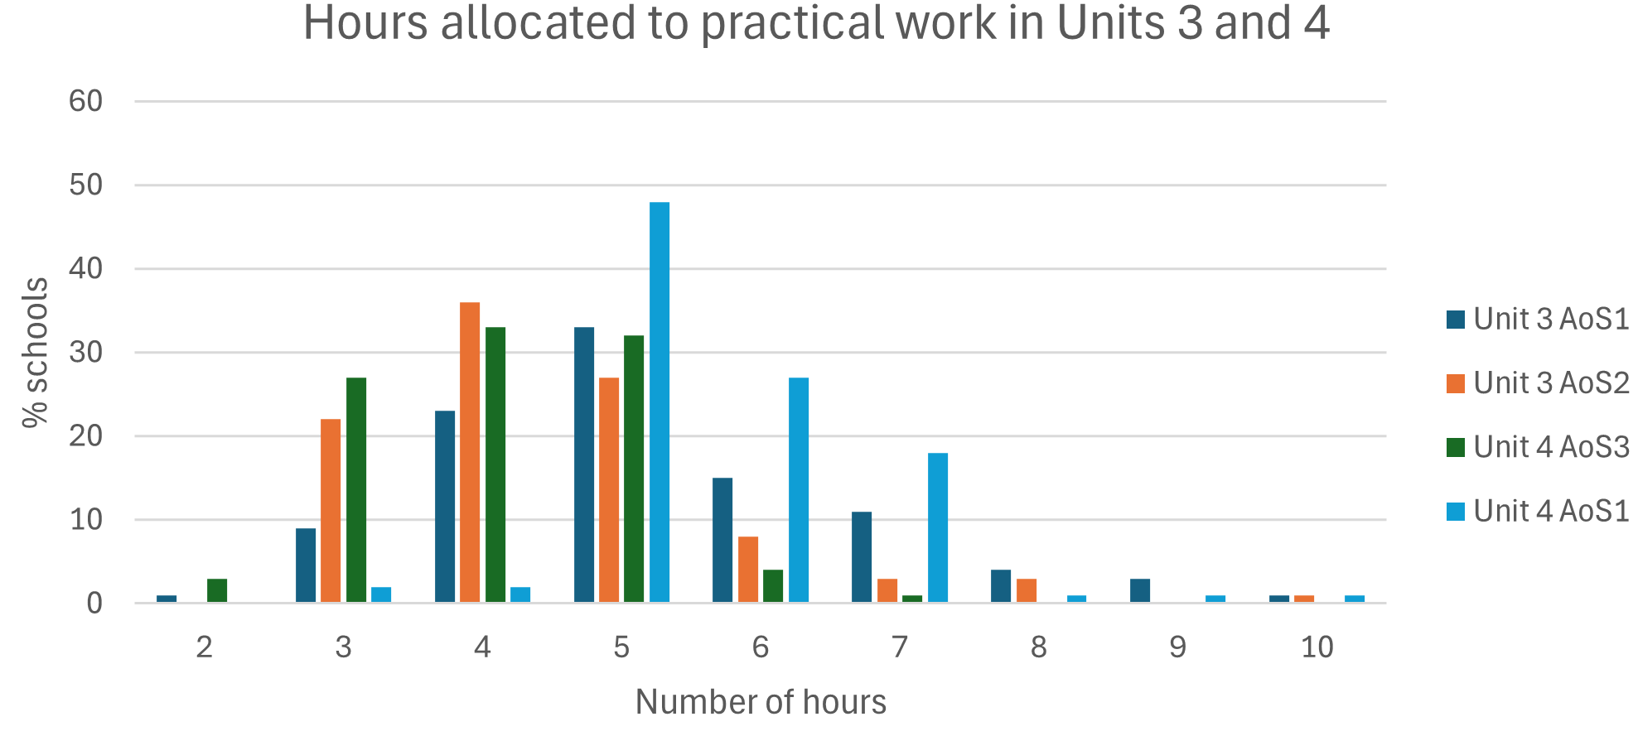
Practical work was conducted through laboratory experiments, modelling activities, simulations, the use of virtual laboratories, and teacher demonstrations. Students worked individually, in pairs or small groups. Students used logbooks extensively across all Areas of Study to document procedures, observations, and reflections, supporting both learning and assessment. Many experiments were familiar to schools from the previous study design and were adapted as the basis for some assessment tasks. There are numerous examples of appropriate activities for schools to select from in the VCE Physics Support Materials on the VCAA website.
Where access to equipment or facilities is limited, schools are advised to use simulations, virtual experiments, or pre-prepared datasets to give students practical experience. Schools that devoted only a small amount of time to the student-designed investigation in Unit 4 Area of Study 3 were encouraged to review their scheduling, ensuring that teaching of the relevant key knowledge and skills and opportunities for student feedback are explicitly incorporated in future planning.
Specific electrical safety instructions should be provided to students for practical work and to students developing investigations related to electricity for their independently designed investigation in Unit 4 Area of Study 2.
Below are examples of practical activities involving the methodologies specified in the study design:

Unit | AoS | Methodologies and activities
3 | 1 | Case study: Analysing motion in sport (AFL, cricket, soccer) – motion tracking technology measuring 2D player movement, ball trajectories, and forces; Galileo’s cannonball experiments  Experiment: Launching balls or marshmallows from catapults or slingshots to hit targets, and measuring horizontal/vertical distances and times  Fieldwork: Visiting local recreational sites with rides or skate parks to record real-world motion data  Modelling: Building small-scale rollercoaster or catapult models to predict motion mathematically  Product/process/system development: Designing and testing a small braking system, launcher, or energy-absorbing mechanism  Simulation: Using PhET or Tracker to simulate projectile motion, rollercoasters, or free-fall experiments
3 | 2 | Case study: analysing orbital data for Starlink satellites to predict future positions and evaluate collision risk; Cavendish experiment measuring gravity  Classification/identification: Identifying types of forces acting at a distance in simple demonstrations (magnetic, electric, gravitational)  Fieldwork: Visit local renewable energy sites (solar/wind/hydro) or observe simple generator demos at school  Modelling: Product/process/system development: Building a small maglev or levitation track with magnets or magnets under a table
3 | 3 | Case study: Snowy Hydro Scheme – analysis of water flow and calculation of electrical output from turbines  Classification/identification: Identifying electric/magnetic field effects in simple classroom setups  Modelling: Using PhET or Crocodile Clips to model generators, coils, and transformers  Product/process/system development: Constructing and analysing a model high voltage power line
4 | 1 | Case study: James Webb Space Telescope - using spectroscopy to determine composition of exoplanets  Experiment: Using lasers and diffraction gratings or CDs to observe interference and spectra  Fieldwork: Visiting labs/universities/science centres to see quantum/optical devices (photon detection, wave-particle demonstrations, emission spectra)  Simulation: Simulating photon behaviour, interference, and time dilation using online quantum/relativity simulations

Fieldwork
Audit feedback indicated that fieldwork in VCE Physics Units 3 and 4 was largely confined to activities at local recreational sites with rides, where students investigated motion, forces, and energy transfers. A few schools reported engaging with Victorian energy, transport, research, or specialist facilities to support student learning. Where physical excursions were not possible, schools made use of virtual tours, simulations, and authentic datasets to provide alternative contexts for applied learning and exploration of the assumptions and limitations of simplified physics models.

Task-specific comments
Schools are required to allocate 4 nominated SAC tasks across Outcomes 1, 2 and 3 in Unit 3 and Outcome 1 in Unit 4, with an additional SAC task involving a student-designed investigation undertaken in Unit 4 Outcome 2. When designing these tasks, schools should ensure that a representative sampling of key knowledge and key science skills is assessed.
To support this process, a mapping tool (Appendix 1) can assist schools in aligning key science skills with each assessment task, helping to maintain a balance across Units 3 and 4. In addition, a checklist for developing compliant SAC tasks (Appendix 2) provides guidance on the distinct features of each SAC task type, enabling schools to design tasks that meet study design requirements.
Analysis of SAC task selection shows clear differences across Units 3 and 4 and between Areas of Study, as shown in the table below:
Task type | Unit 3 |  |  | Unit 4
Task type | AoS 1  (% selection) | AoS 2  (% selection) | AoS 3  (% selection) | AoS 1  (% selection)
Explanation | 11 | 44 | 32 | 10
Data analysis | 34 | 34 | 16 | 26
Problem-solving | 50 | 19 | 22 | 9
Comparison | 5 | 3 | 30 | 55

Different task types were commonly used for particular Areas of Study. The ‘explanation’ format was most often used in Unit 3 Areas of Study 2 and 3, ‘problem-solving’ tasks were frequently applied in Unit 3 Area of Study 1, and the ‘comparison’ format was regularly implemented in Unit 4 Area of Study 1. Data analysis tasks were used across all Areas of Study.
The revised SAC tasks are more clearly defined than in previous study designs, with a focus on fostering critical and creative thinking, problem-solving, and effective communication within a physics context. Many schools, however, developed assessment tasks that did not fully align with the expectations of the selected task type. With the updated Physics study design providing a set of distinct task types, it is essential that SACs are closely matched to their intended features. Schools are advised to refer to the guidance for each task type below, as well as the supporting resources available on the VCAA Physics page.
The SAC task types have been developed so that they can be used in any of the Areas of Study. Schools can design 4 distinct SAC tasks from a single scientific context – whether a practical experiment, case study, simulation, or dataset – by ensuring that each task targets a different assessment focus and skill demand. For example, a context such as launching a ball from a ramp to investigate 2D projectile motion can be adapted into 4 separate 50-minute SAC tasks aligned to the VCE Physics assessment types. An explanation task may require students to justify how horizontal and vertical components combine to produce the observed trajectory, supported by diagrams and real-world applications. A data analysis and evaluation task may involve working with collected or provided data to calculate quantities, construct graphs, identify trends, and assess reliability. In a problem-solving task, students apply kinematic equations to determine the conditions required for the ball to reach a target, justifying each step, and considering practical constraints. A comparison and evaluation task may require students to investigate 2 ramp designs or launch methods, analyse outcomes, and evaluate which approach is more accurate or consistent using evidence. This approach demonstrates how a single context can support multiple skill sets while producing distinct SAC tasks of appropriate depth and duration.
Across all SAC task types, a common issue was the tendency to cover the entire content of an Area of Study within a single task. In some cases, this coverage was attempted by adding extra questions at the end of tasks, which often limited opportunities for students to engage in meaningful analysis and application of physics concepts. Such an approach is unnecessary and impractical for most task types. To promote deeper learning, schools are advised to begin by selecting a relevant context or scenario for each SAC task and then identify the associated key knowledge and science skills. While students must demonstrate achievement of all elements of each outcome to receive an ‘S,’ a carefully chosen subset of content provides a sufficient basis for SAC development. Students should also engage in additional learning activities to receive ongoing feedback and consolidate understanding across all key knowledge and skills. This approach allows SAC tasks to assess learning in greater depth than is possible in the external examination, which evaluates a representative sample of knowledge and skills across Unit 3 and Unit 4 outcomes.
Schools should ensure that the selected assessment task type appears on the front page of a written SAC task. For example, a SAC task described as ‘Analysis of primary data’ required reference to the selected assessment task type, specifically, ‘Analysis and evaluation of primary data, including data plotting, identified assumptions or data limitations, and conclusions.’ It is not necessary to include the outcome statement from the study design.

Use of assessment task types

Application of physics concepts to explain a model, theory, device, design, or innovation
This assessment task type focuses on students communicating their understanding of how a physical system, device, or phenomenon operates, using physics concepts in a clear and coherent way suited to a peer audience. Responses should prioritise explanatory reasoning supported by appropriate representations such as diagrams, graphs, or annotated equations, rather than extended calculation. Calculations may be included where they assist in clarifying how a system behaves or why an outcome occurs, but they should support, not dominate, the explanation. For example, students might explain how electromagnetic induction produces an alternating current in a generator, using a labelled diagram and a brief calculation to show how changes in rotational speed influence the induced voltage. Schools may choose to have students present their explanation as an oral or multimodal presentation, supported by a scaffolded set of presentation slides.
Unit 3 Areas of Study 2 and 3 were the most common Areas of Study used for this assessment task type, as seen in the graph below:
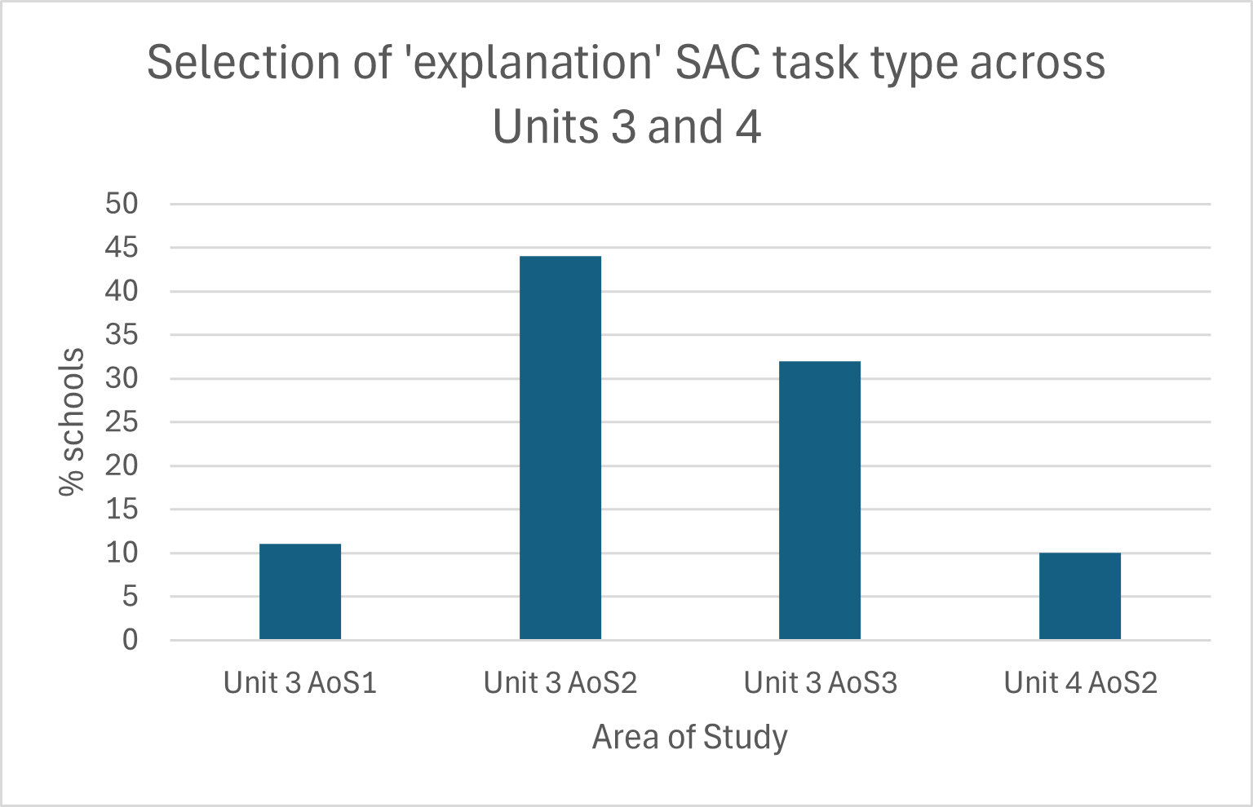
Compliant tasks often encouraged students to consider the question, ‘How does it work?’ Many schools structured this task in ways that made it difficult for students to focus on explaining the operation of a selected artifact. A common issue was the inclusion of questions – often calculations – that were not directly linked to the explanation or the underlying physics principles. In some cases, schools asked students to consider multiple artifacts, which limited opportunities for deeper analysis. Effective explanations benefit from prompts that encourage students to explore questions such as, ‘What happens if one component is not functioning?’ ‘How can the performance be improved?’ ‘Why does this behaviour occur?’ and ‘How do the underlying physics principles determine the observed outcome?’
Effective support for this task type is characterised by clear alignment between questions and explanatory reasoning, ensuring that every question directly reinforces the focus on understanding how a system, device, or phenomenon works. Scaffolding strategies, such as concept maps, sentence starters, and guiding questions, provide structure to student responses, enabling them to organise their reasoning clearly and communicate their understanding effectively. The task may be preceded by modelling high-quality explanations and explicitly demonstrating connections between physics concepts and real-world examples, helping students understand expectations and standards.
Suitable contexts used by schools for this assessment task type included the following:
Unit 3 Area of Study 1: How do physicists explain motion in 2 dimensions?
In this Area of Study, schools often presented tasks where students explained the principles underlying 2-dimensional motion. Contexts included sports activities, rollercoaster dynamics, or lunar module landings, with emphasis on how horizontal and vertical motion components interact and how trajectories can be predicted. Engineering setups such as ramps or catapults, as well as modern technologies like drone delivery systems, were commonly used as contexts for this task.
Unit 3 Area of Study 2: How do things move without contact?
Schools frequently selected contexts in which forces act at a distance to facilitate understanding of motion without contact. Examples included maglev trains, wireless charging devices, and satellite orbits. Historical investigations, such as Cavendish’s measurement of gravitational forces, were also used to illustrate how magnetic, electric, or gravitational interactions enable movement.
Unit 3 Area of Study 3: How are fields used in electricity generation?
In this Area of Study, tasks often focused on explaining how mechanical motion is converted into electrical energy. Students used examples such as hydroelectric turbines and wind farms to illustrate electromagnetic induction. Emerging technologies, including Tesla Megapack energy storage systems or wave energy devices, were also employed to show the application of these principles in modern energy generation.
Unit 4 Area of Study 2: How has understanding about the physical world changed?
Schools commonly asked students to explore contexts where models of light and matter explain observable phenomena. Typical examples included wave-particle duality in LEDs or lasers, photon behaviour in the photoelectric effect, and the role of relativistic effects in GPS satellite corrections.

Analysis and evaluation of primary and/or secondary data, including data plotting, identified assumptions or data limitations, and conclusions
This assessment task type focuses on the critical analysis and evaluation of data. Tasks are deliberately open-ended: students may generate and record their own primary data through experiments, or schools may provide pre-collected datasets in printed or digital form. Schools often used motion, electrical, or energy data, including measurements from sensors, simulations, or instrumentation. Students are expected to identify trends, assess assumptions and sources of error and uncertainty, and draw evidence-based conclusions using appropriate physics reasoning.
Unit 3 Areas of Study 1 and 2 were commonly used as the basis for this assessment task type, as shown in the graph below:
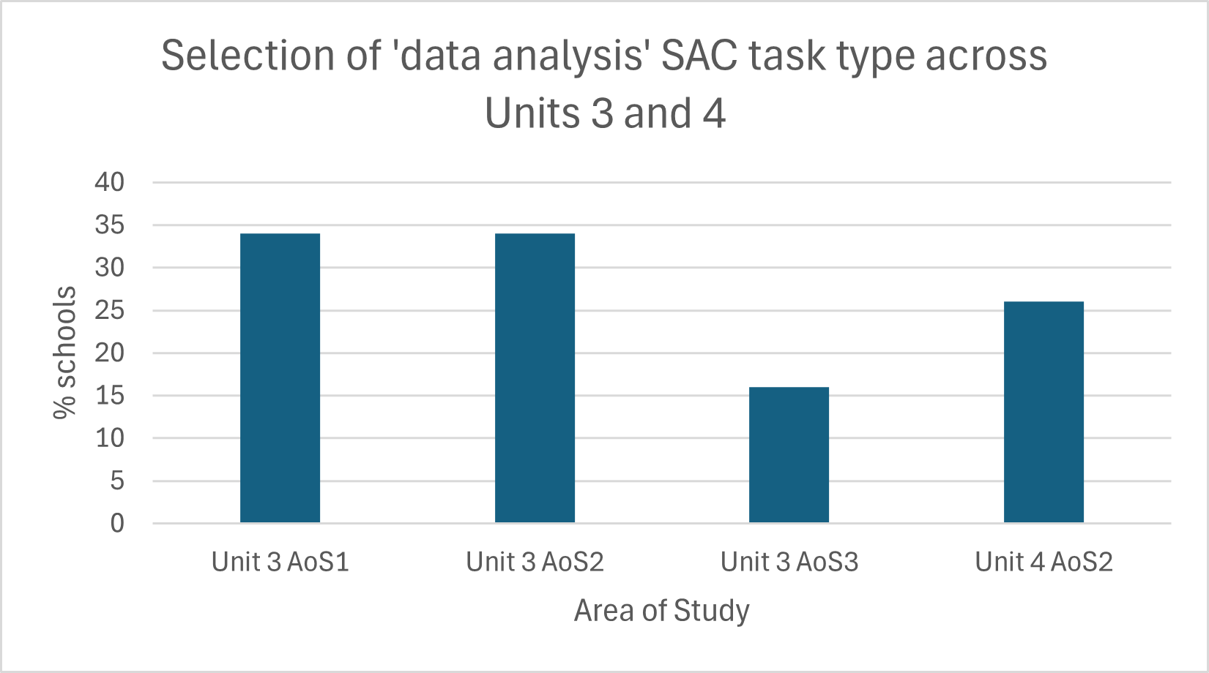
A common challenge for schools in developing this assessment task type was selecting or designing a dataset that was meaningful, valid, and sufficient for in-depth analysis. In some cases, schools provided data that had already been heavily processed, such as pre-plotted motion graphs, velocity-time curves, or fully calculated electrical measurements, with students asked only to read values or respond to brief, exam-style questions. These approaches tended to emphasise calculations and interpretation of provided outputs, without requiring students to consider underlying assumptions, limitations, or the quality of the data. As a result, tasks often involved multiple short data scenarios rather than a sustained analysis of a single dataset. Effective tasks used a single, well-chosen dataset to enable deeper evaluation, allowing students to assess trends, make predictions, and critically consider the reliability of their results.
High-quality SAC tasks provided raw or partially processed data, encouraging students to construct graphs and make decisions about lines of best fit, variable relationships, and relevant assumptions. Students should be prompted to evaluate the quality of the data using measurement concepts such as accuracy, precision, repeatability, reproducibility, resolution, validity, outliers, and errors, as well as consider experimental limitations. Where instrumentation or sensor data is used, students could be asked to interpret trends and features while explicitly addressing potential sources of uncertainty. Incorporating graphical representation and explicit discussion of assumptions, limitations, and uncertainties ensures students engage fully with reasoning, enabling evidence-based conclusions to be communicated clearly.
Schools are reminded that students are no longer required to calculate uncertainties, but they should be able to represent given uncertainties graphically by plotting error bars on data points when numerical values are provided.
Suitable contexts used by schools for this assessment task type included the following:
Unit 3 Area of Study 1: How do physicists explain motion in 2 dimensions?
Schools submitting compliant tasks commonly structured the SAC task around the analysis of trajectory or motion data from experiments, simulations, or published research. Contexts included projectile motion in sport, rollercoaster rides, drone flight paths, or lunar lander trajectories. Students evaluated accuracy, precision, resolution, repeatability, reproducibility, outliers, and sources of error, and considered relationships between variables to support evidence-based explanations and predictions.
Unit 3 Area of Study 2: How do things move without contact?
Data analysis tasks commonly focused on forces acting at a distance, using datasets from satellite orbital tracking, measurements of charged particle motion, or demonstrations of electrical forces in circuits. Students interpreted the data to assess the magnitude and direction of forces, while explicitly considering uncertainties, assumptions, and potential sources of error in their analyses.
Unit 3 Area of Study 3: How are fields used in electricity generation?
SAC tasks frequently involved the analysis of electricity generation or energy conversion data from small-scale laboratory generators, wind turbines, hydroelectric setups, or wave energy devices. Datasets could include voltage, current, power output, or energy efficiency, providing opportunities for students to evaluate accuracy, precision, resolution, repeatability, reproducibility, outliers, and measurement errors, as well as the effect of varying experimental conditions on system performance.
Unit 4 Area of Study 2: How has understanding about the physical world changed?
In this Area of Study, tasks were often structured around evaluation of data related to models of light and matter. Contexts included emission spectra from spectral lamps (e.g., hydrogen or mercury), measurements of photon interactions in the photoelectric effect, and timing data for relativistic corrections in GPS satellites. Students used the data to test and compare wave and particle models of light, assess assumptions and limitations of the measurements, and explain how physics models account for observed phenomena.

Problem-solving, applying physics concepts and skills to real-world problems
This assessment task type develops students’ ability to apply physics knowledge and quantitative reasoning to authentic problems that require making a reasoned decision or selecting an optimal solution. Students are expected to interpret data, perform relevant calculations, and evaluate approaches using physics principles, before justifying their chosen course of action. The task emphasises multi-step reasoning and the application of physics concepts in real-world contexts, such as engineering designs, energy generation, or motion systems, where students must weigh alternatives and support conclusions with evidence. Typically, a single context or scenario is used to provide sufficient depth for analysis, rather than presenting a series of short, calculation-focused questions. All questions in the SAC should relate to the chosen scenario to maintain task validity and coherence.
Unit 3 Area of Study 1 was the most frequently used context for this assessment task, as illustrated in the graph below. Tasks often drew on amusement park scenarios to explore concepts such as 2-dimensional motion and projectile trajectories.
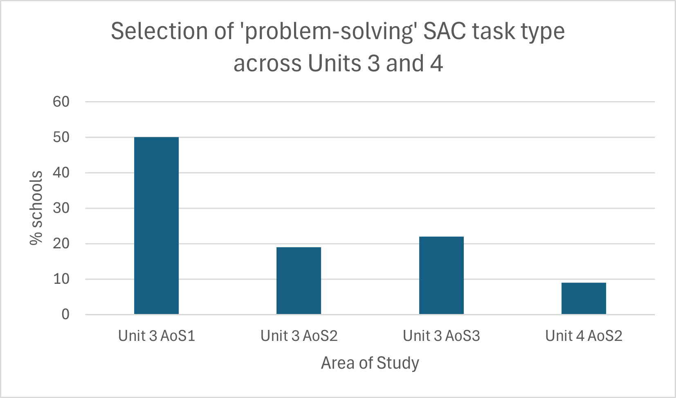
Audited schools sometimes had difficulty in designing scenarios that genuinely required students to make and justify decisions in a physics context. In several cases, tasks were presented with a brief contextual stem that led into a sequence of examination-style questions, where students performed calculations or recalled definitions without needing to consider how their findings applied to the stated real-world scenario. Such tasks often resembled questions from the external examination or drew directly on past examination items or unmodified publicly available materials, which reduced the authenticity of the task and, in some cases, raised equity concerns.
A compliant problem-solving SAC task in physics should present a clearly defined problem and provide sufficient context and data for students to analyse and compare alternative approaches or solutions. Typically, students are required to evaluate options or justify a preferred solution using physics principles and calculations, interpreting information, and applying reasoning in line with the relevant key knowledge and key science skills. Tasks should avoid assessing only procedural calculations; any calculations included should support higher-order thinking and evidence-based decision-making. Using a single, well-scoped scenario encourages deeper engagement and provides students with the opportunity to meaningfully justify their conclusions.
While theoretical scenarios provide valid contexts, this assessment task type lends itself particularly well to the ‘product, process, or system development’ methodology, and some schools made the most of this by designing engaging, hands-on tasks. Examples included building simple ramps to optimise the distance of a rolling ball, designing small catapults to achieve a target range, adjusting the angle or mass of a pendulum to reach a desired period, or configuring basic circuits to maximise LED brightness. These tasks allowed students to apply physics principles, make decisions about design choices, test alternatives, and justify their solutions based on observed outcomes.
Suitable contexts used by schools for this assessment task type included the following:
Unit 3 Area of Study 1: How do physicists explain motion in 2 dimensions?
Problem-solving tasks in this Area of Study often required students to predict projectile paths or design ramps and launch systems. Contexts included theoretical analyses of sports trajectories, drone delivery simulations, or lunar lander motion, alongside hands-on investigations using ramps, rolling balls, or mini catapults. Students applied physics reasoning and calculations to select launch angles, velocities, or ramp designs that achieved desired outcomes, considering constraints such as range, height, or safety.
Unit 3 Area of Study 2: How do things move without contact?
Schools submitting compliant SAC tasks frequently used scenarios involving forces acting at a distance. Theoretical examples included calculating satellite orbital adjustments or modelling charged particle trajectories, while practical tasks involved moving magnets along tracks or testing small-scale magnetic interactions. Students calculated forces, accelerations, or trajectories to decide on optimal configurations or timings that achieved a functional goal.
Unit 3 Area of Study 3: How are fields used in electricity generation?
Problem-solving tasks in this Area of Study typically involved energy conversion or electricity generation. Students worked with theoretical models of wind or hydroelectric output, or analysed small-scale hands-on setups such as lab generators, turbine blade arrangements, or wave energy devices. Calculations of voltage, current, or power output guided decisions about design parameters or operational strategies to maximise efficiency or achieve target outcomes.
Unit 4 Area of Study 2: How has understanding about the physical world changed?
Schools submitting compliant SAC tasks structured problems around models of light and matter, including wave-particle duality and relativistic effects. Theoretical contexts included predicting photon paths, calculating relativistic time corrections for GPS satellites, or modelling wave interference patterns, complemented by practical investigations using LEDs, low-power laser pointers, or filtered white-light sources. Students could use these setups to explore the photoelectric effect, interference, diffraction, or refraction, applying physics principles to select experimental arrangements or configurations that produced desired effects or optimised performance.

Comparison and evaluation of 2 solutions to a problem, 2 explanations of a physics phenomenon or concept, or 2 methods and/or findings from practical activities
This assessment task type focuses on supporting students to engage with multiple approaches within the same Area of Study, drawing comparisons that highlight strengths, limitations, assumptions, and contextual relevance. Hands-on experiments, such as projectile motion trials, pendulum or spring oscillations, or small-scale electricity generation, can be compared with alternative approaches or theoretical models to assess deeper understanding. The emphasis is on direct, evidence-based comparisons rather than analysing each method in isolation. Example comparisons include hydroelectric versus wind energy, Newtonian versus relativistic models, or results from 2 experimental procedures.
Unit 4 Area of Study 1 was the most frequently used context for this assessment task type, as shown in the graph below. Tasks commonly focused on comparing the wave and particle models of light to explore how physics models explain observable phenomena.
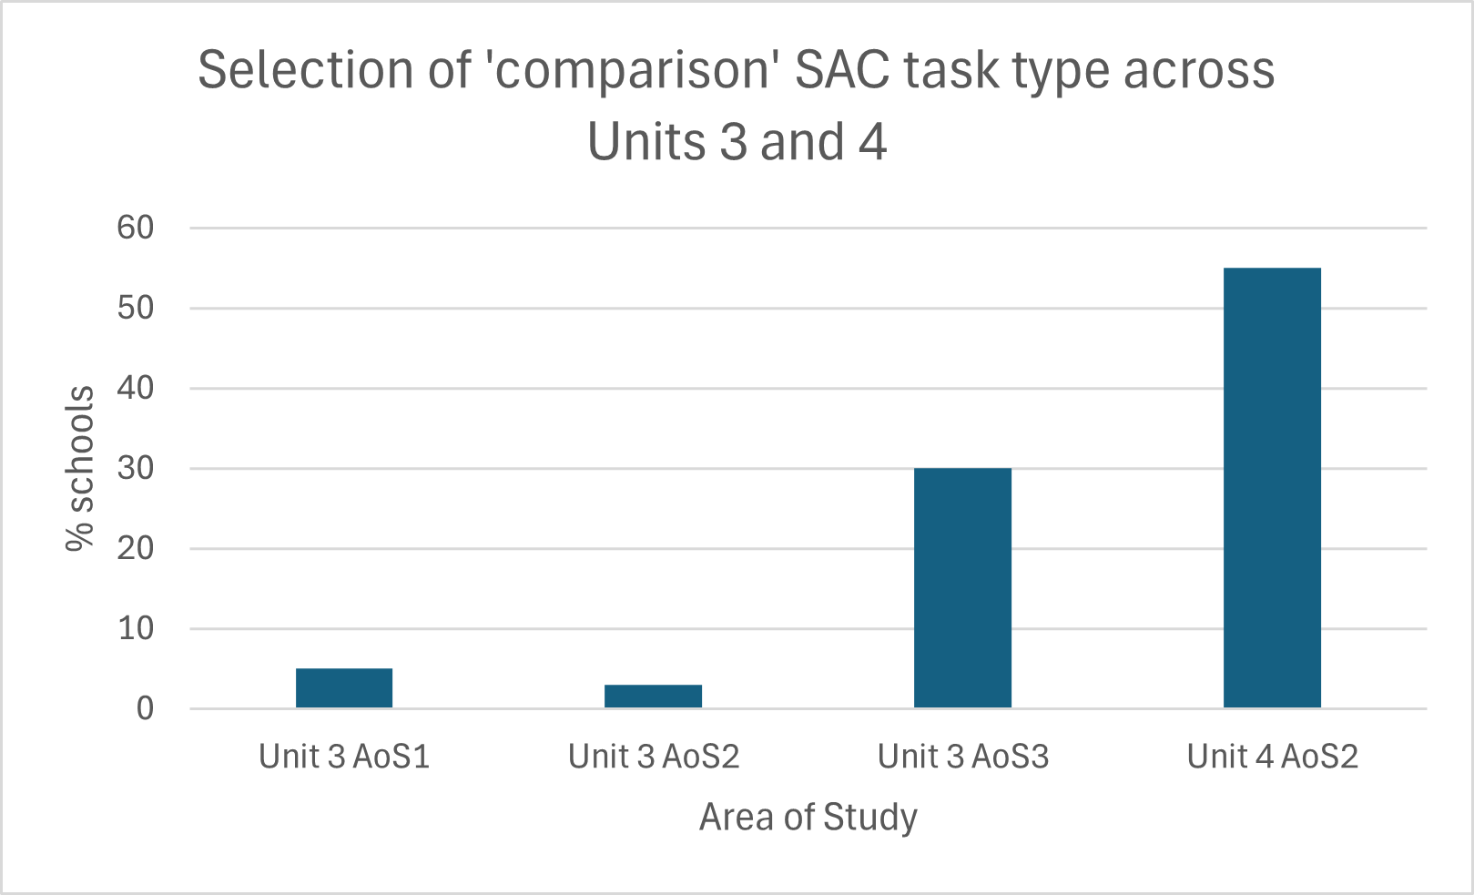
Many schools were challenged in emphasising the comparative evaluation element of this task, with some structuring it as separate analyses rather than directly comparing 2 solutions, methods, or approaches to the same physics problem. Selecting or designing paired activities with clear points of comparison is essential to enable meaningful evaluation of similarities and differences. Students should be guided to use observations and data from both approaches as evidence to support their judgements, rather than treating each method in isolation. Successful tasks often included scaffolding, such as a 2- or 3-column comparison table, to help students organise thinking and draw integrated conclusions across the 2 approaches.
Clearly defining comparison criteria reinforces the focus on evaluating 2 solutions to a single problem. For example, students might compare projectile motion under 2 launch angles, 2 methods for measuring acceleration, or 2 approaches to converting motion into electricity in small-scale generators. Prompts should require students to synthesise similarities and differences into comparative judgements, highlighting which method is more efficient, accurate, or practical and why. Scaffolding strategies, including structured comparison tables, Venn diagrams, or guided criteria, can support organisation while ensuring students apply physics reasoning to justify their conclusions.
Suitable contexts used by schools for this assessment task type included the following:
Unit 3 Area of Study 1: How do physicists explain motion in 2 dimensions?
Most SAC tasks were based on comparing 2 explanations of projectile motion, such as idealised versus real-world trajectories including air resistance, or contrasting 2 experimental methods for measuring 2D motion. Contexts included hands-on activities like amusement park ride experiments or analysing sports trajectories, allowing students to evaluate which approach provided more accurate or applicable results.
Unit 3 Area of Study 2: How do things move without contact?
SAC tasks commonly required students to compare 2 solutions for forces at a distance. Examples included contrasting different satellite orbital adjustments, or 2 ways of moving small objects using magnetic or electric forces in a laboratory setup. Students assessed which approach achieved the desired effect more efficiently, accurately, or practically, considering constraints such as force magnitude, distance, or timing.
Unit 3 Area of Study 3: How are fields used in electricity generation?
In many tasks, students compared 2 methods of generating or converting energy, such as wind versus hydroelectric power, early AC versus DC generators (Tesla vs Edison), alternative coil designs for small-scale generators, or laboratory versus field-based measurements of electricity generation. Evaluations focused on efficiency, practical limitations, cost, and achievable output under specific conditions.
Unit 4 Area of Study 2: How has understanding about the physical world changed?
Most SAC tasks focused on comparing the wave and particle models of light. Students evaluated how each model explains phenomena such as the photoelectric effect, Young’s double slit experiment or emission spectra, considering assumptions, limitations, and applicability. Contexts included simple optical devices, photon energy measurements, or theoretical predictions that highlight the differences between wave and particle descriptions.

Communication of the design, analysis, and findings of a student-designed and student-conducted scientific investigation through a structured scientific poster and logbook entries
All audited schools implemented this task with a high level of familiarity, as its structure remains largely unchanged from the previous study design. Key differences include the requirement to investigate only one continuous independent variable and the introduction of a 600-word limit for the scientific poster.
Assessment must be based on each student’s individual capacity to design an investigation, generate primary data, and communicate outcomes effectively. Students are expected to outline the purpose and relevance of their investigation in the introduction section of the scientific poster. In schools with large cohorts or multiple classes, fully independent data collection may not be feasible for all students. In such cases, collaborative data generation is acceptable, provided students have previously demonstrated their own ability to plan and design the investigation independently.
Schools are required to review and approve all investigation proposals prior to commencement, as some plans may be impractical due to safety considerations, equipment availability, time limitations, or supervision requirements for large cohorts. Where a proposed investigation cannot be undertaken safely or feasibly, students may be redirected to an alternative investigation question, with subsequent assessment based on that revised investigation. Assessment of the student’s original experimental design, however, should still be retained.
The distribution of SAC tasks by unit content, shown in the graph below, indicates that over 50% of schools provided students with the option to select topics within a specific unit. Approximately 15% of schools allowed students full freedom in choosing their topic, providing increased opportunities for student engagement and the pursuit of individual interests.
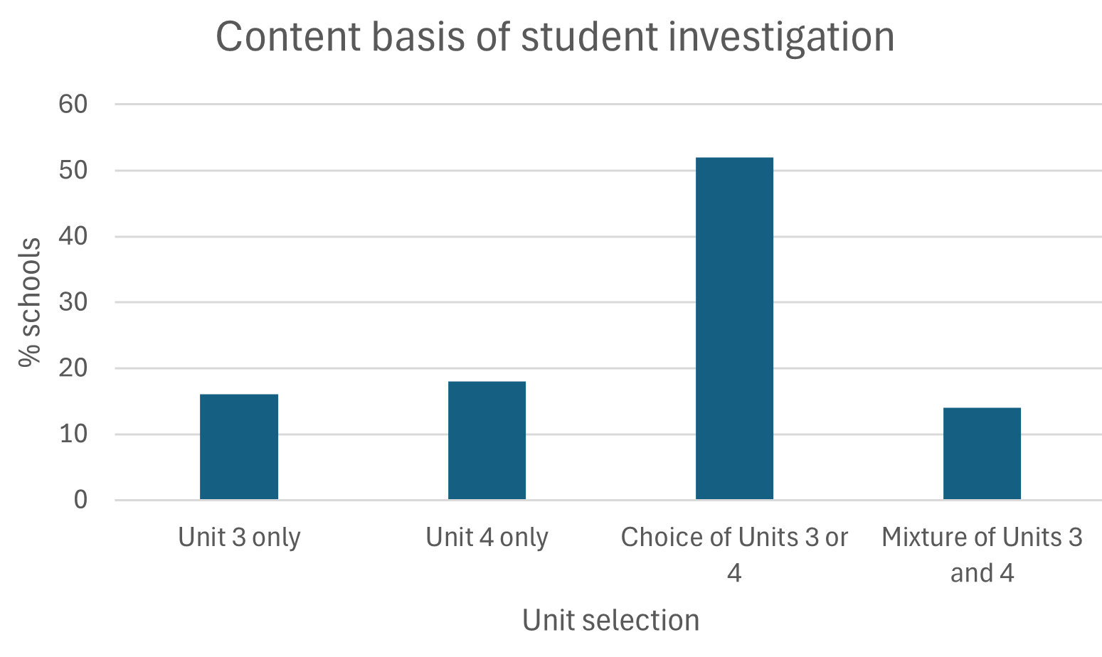
The investigation can be undertaken at any time across Units 3 and/or 4. Most schools chose a timeframe during Unit 4 as shown the following graph:
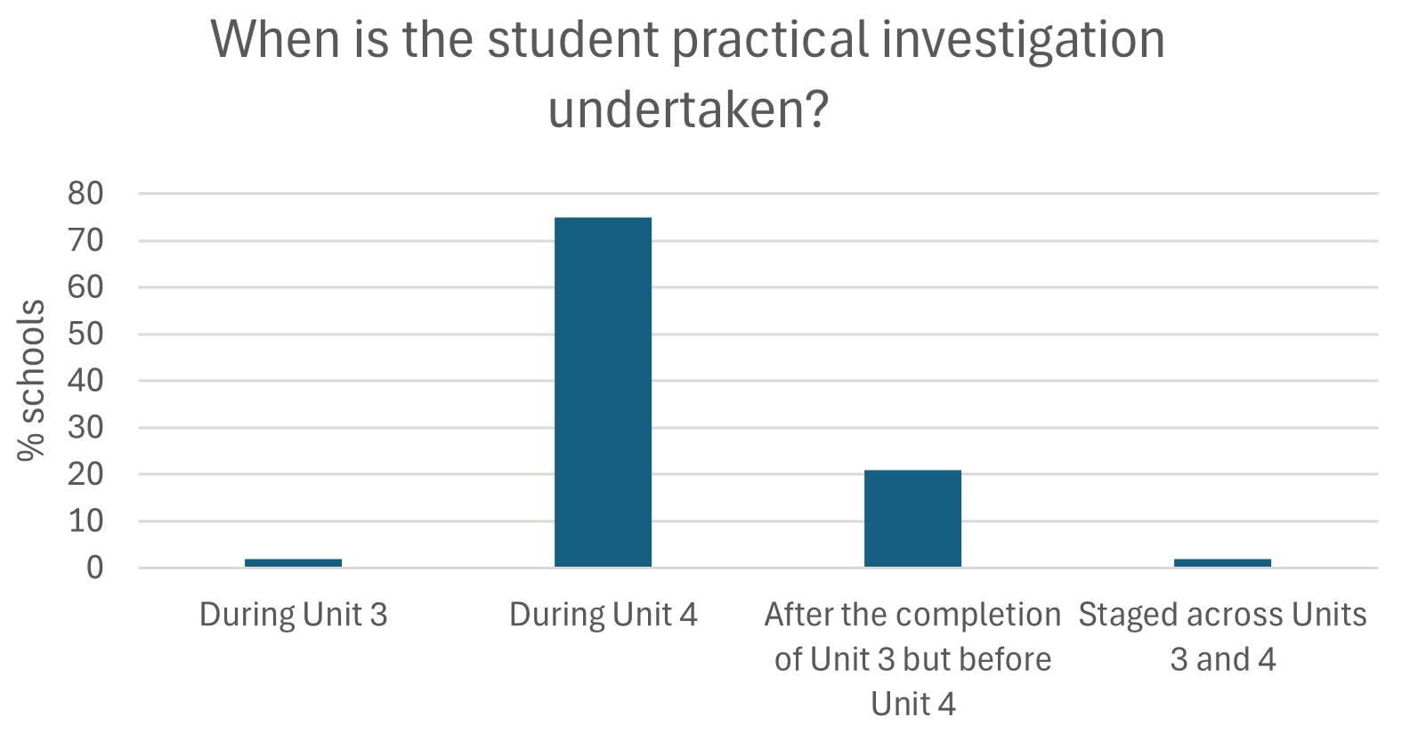
Different approaches were used to support students in developing their own investigation questions. A number of schools, particularly those with large cohorts or limited resources, set a general question, for example: ‘What factors affect how objects move along a slope?’ Students then refined this question to investigate a single continuous independent variable, such as slope angle or object mass, while measuring outcomes like speed, acceleration, or distance travelled. This approach encouraged students to make decisions about experimental design, data collection, and analysis, fostering deeper engagement and ownership of the investigation.
Students typically worked in pairs, with each student collecting data on a different variable associated with the same experiment. For example, an investigation into ‘How do coil geometry and magnet configuration influence voltage output in a small-scale generator?’ enabled one student to vary the coil shape (circular, solenoid, or flat spiral) while the other adjusted the number or arrangement of magnets, with both measuring induced voltage under controlled rotation speeds.
Most audited schools followed the guideline that the student investigation should involve a minimum of 10 hours of work. Many investigations began with a shared laboratory activity, giving students a common starting point while enabling independent decisions about variables, methods, and data collection. Some schools allocated part of a day for an extended laboratory session or incursion, allowing students time to conduct preparatory experiments and make informed choices about their investigation design. This structure promoted critical thinking, deeper engagement, and ownership of the investigative process.
Schools that used a restricted-topic approach ensured sufficient scope for investigations to go beyond simple confirmation tasks. Investigable questions generally explored relationships rather than yes/no outcomes and avoided predictable answers. For example, an investigation examining how the spacing of fringes changes with slit width in a single-slit diffraction experiment provided a strong foundation. From this starting point, students extended the experiment to design investigations exploring the effect of wavelength, distance to the screen, or multiple slits, applying the same principles in novel ways.
A number of schools encouraged students to develop their own investigation topics. Strategies included presenting students with a set of equipment and asking them to brainstorm ideas for investigation, organising student into groups by Area of Study to consider how activities completed in class could be extended, and asking questions such as ‘Do your hobbies, sporting activities or musical interests have aspects you would like to investigate?’ and ‘Are there particular topics from this year’s course that sparked your interest?’.
All audited schools implemented clear timelines that covered every stage of the investigation, from initial planning and data collection to analysis, evaluation, and presentation in a scientific poster. Many schools provided students with a scaffolded guide or booklet, used alongside the logbook, to support planning and monitor progress. A single assessment rubric was typically applied to all students, regardless of their chosen investigation topic, to maintain consistent expectations and challenge. Consequently, schools need to ensure that investigation questions are comparable so that every student has an equal opportunity to demonstrate the highest levels of achievement.
Audit concerns for this assessment task included:
- investigation titles that were not phrased as a question
- investigation of 2, rather than one, independent variables
- investigation questions that involved discrete rather than continuous variables, such as testing how the number of coils in a solenoid affects the induced voltage when only 2–3 coil numbers are examined, limiting the opportunity to analyse trends
- investigation questions that had obvious answers that could be predicted using standard physics formulas or relationships, such as calculating the range of a projectile using kinematic equations without requiring experimental investigation
- investigation questions that could not be investigated in the allocated timeframe
- investigations based on topics in the previous study design for example, ‘How can we determine the refractive index of gelatin?’
- student questions that could simply be answered with ‘yes’ or ‘no.’
Most submitted student investigation questions focused on content that was common to both the previous and current study designs. Schools are encouraged to broaden opportunities for students to develop questions that genuinely interest them
The majority of investigations reported by audited schools were experimental in nature; however, the study design allows for a variety of scientific methodologies. Examples submitted included using experimental data to develop and evaluate models of physical systems, testing predictions generated from simulations, collecting data from local environments to investigate the effect of physical conditions, and designing, testing, and refining devices, processes, or systems to optimise performance.
Schools are advised to check the VCE Physics Support Materials for a list of possible topics. However, schools are reminded that since these resources are available in the public domain, they must be modified prior to use as an assessment task.

Appendix 1

VCE Physics Units 3 and 4 key science skills mapping grid
A set of key science skills apply across Units 1 to 4. The table below provides a planning template for teachers to map how the contextualised key science skills on pages 11 and 12 of the VCE Physics Study Design will be developed by students across Units 3 and 4.

Key science skill | Contextualised skills for Units 1–4 | Unit 3 |  |  | Unit 4
Key science skill | Contextualised skills for Units 1–4 | AoS1 | AoS2 | AoS3 | AoS1 | AoS2
Develop aims and questions, formulate hypotheses and make predictions | Identify, research and construct aims and questions for investigation
 | Identify independent, dependent and controlled variables in controlled experiments
 | Formulate hypotheses to focus investigations
 | Predict possible outcomes of investigations
Plan and conduct investigations | Determine appropriate investigation methodology: case study; classification and identification; experiment; fieldwork; literature review; modelling; product, process, or system development; simulation
Plan and conduct investigations | Design and conduct investigations: select and use methods appropriate to the selected investigation methodology, including consideration of equipment and procedures, considering potential sources of error and causes of uncertainty; determine the type and amount of qualitative and/or quantitative data to be generated or collated
Plan and conduct investigations | Work independently and collaboratively as appropriate and within identified research constraints, adapting or extending processes as required and recording such modifications in a logbook
Comply with safety and ethical guidelines | Demonstrate safe laboratory practices when planning and conducting investigations by using risk assessments that are informed by safety data sheets (SDS), and accounting for risks
Comply with safety and ethical guidelines | Apply relevant occupational health and safety guidelines while undertaking practical investigations
Comply with safety and ethical guidelines | Demonstrate ethical conduct when undertaking and reporting investigations
Generate, collate, and record data | Systematically generate and record primary data, and collate secondary data, appropriate to the investigation, including use of databases and reputable online data sources
Generate, collate, and record data | Record and summarise both qualitative and quantitative data, including use of a logbook as an authentication of generated or collated data
Generate, collate, and record data | Organise and present data in useful and meaningful ways, including tables and graphs
Analyse and evaluate data and investigation methods | Process quantitative data using appropriate mathematical relationships and units
Analyse and evaluate data and investigation methods | Use appropriate numbers of significant figures in calculations
Analyse and evaluate data and investigation methods | Construct graphs that show the relationship between variables
Analyse and evaluate data and investigation methods | Extrapolate to determine graph intercepts of significance
Analyse and evaluate data and investigation methods | Construct linearised graphs and identify the significance of the gradient (using relationships relevant to the key knowledge outlined in the areas of study)
Analyse and evaluate data and investigation methods | Identify and analyse experimental data qualitatively, handling, where appropriate, concepts of accuracy, precision, repeatability, reproducibility, resolution, and validity of measurements; and errors (random and systematic)
Analyse and evaluate data and investigation methods | Identify outliers, and contradictory, provisional, or incomplete data
Analyse and evaluate data and investigation methods | Repeat experiments to evaluate the precision of data
Analyse and evaluate data and investigation methods | Evaluate investigation methods and possible causes of error and uncertainty, and suggest how precision can be improved, and how uncertainty can be reduced
Construct evidence-based arguments and draw conclusions | Distinguish between opinion and evidence, and between scientific and non-scientific ideas
Construct evidence-based arguments and draw conclusions | Evaluate data to determine the degree to which the evidence supports the aim of the investigation, and make recommendations, as appropriate, for modifying or extending the investigation
Construct evidence-based arguments and draw conclusions | Evaluate data to determine the degree to which the evidence supports or refutes the initial prediction or hypothesis
Construct evidence-based arguments and draw conclusions | Use reasoning to construct scientific arguments, and to draw and justify conclusions consistent with evidence and relevant to the question under investigation
Construct evidence-based arguments and draw conclusions | Identify, describe, and explain the limitations of conclusions, including identification of further evidence required
Construct evidence-based arguments and draw conclusions | Discuss the implications of research findings
Analyse, evaluate and communicate scientific ideas | Use appropriate physics terminology, representations, and conventions, including standard abbreviations, graphing conventions, vector diagrams, algebraic equations, significant figures, uncertainty bars and units of measurement
Analyse, evaluate and communicate scientific ideas | Discuss relevant physics information, ideas, concepts, theories and models and the connections between them
Analyse, evaluate and communicate scientific ideas | Analyse and explain how models and theories are used to organise and understand observed phenomena and concepts related to physics, identifying limitations of selected models/theories
Analyse, evaluate and communicate scientific ideas | Critically evaluate and interpret a range of scientific and media texts (including journal articles, mass media communications and opinions in the public domain), processes, claims and conclusions related to physics by considering the quality of available evidence
Analyse, evaluate and communicate scientific ideas | Analyse and evaluate physics-related societal issues taking into account the influence of social, economic, legal, and political factors relevant to the selected issue
Analyse, evaluate and communicate scientific ideas | Use clear, coherent, and concise expression to communicate to specific audiences and for specific purposes in appropriate scientific genres, including scientific reports and posters
Analyse, evaluate and communicate scientific ideas | Acknowledge sources of information and assistance, and use standard scientific referencing conventions

Appendix 2

VCE Physics SAC Task Design Checklist
Assessment principle | Does the task meet the requirements of the VCE assessment principles and the VCE Physics Study Design? | Check
Valid  Task type is in line with the VCE Physics Study Design | Is the task a true reflection of the selected task type listed on pages 55 or 61 of the VCE Physics Study Design?  Note: Refer to further information for each task type on the next page.
Does the task identify the specific key knowledge from the outcome and the key science skills that will be assessed?
Note: Although all key science skills and key knowledge points related to an outcome must be met by students to be awarded an ‘S’ for the unit, only part of an outcome is sufficient as the basis of a SAC task. The Key Science Skills assessment checklist (Appendix 1) may be useful as a planning tool.
 | Have sources of diagrams, articles, spectra, etc. used in the task been cited?
 | Are all the questions in the task within the single Area of Study being assessed?
 | Does the task language match that of the study design?
 | Are clear processes in place to authenticate permitted task notes/resources?
Equitable  Task is run under fair conditions and is equally accessible to all students - access to past tasks or commercial sites should not advantage any student. | Have students been provided with clear information/instructions before the task and on the task itself?  Note: Prior notification of the task to students and the SAC task itself should include the following information: unit, relevant part of the outcome to be assessed, SAC task type, key science skills and key knowledge to be assessed, date and duration of the task, pre-task requirements, task conditions, resources permitted, materials allowed, how the task will be marked, and contribution to the final study score.
 | Is the task original to the school and cohort?
 | If materials available in the public domain have been used, have they been carefully checked against the study design and selected task type for alignment?
 | If a past task and/or materials available in the public domain have been used, have they been sufficiently modified to make the task unique to the school and cohort?
Has the task been checked to make sure that there is no bias?
Note: Consider gender, culture, linguistic background, physical disability, socioeconomic status, and geographical background.
 | Are suitable conditions in place to ensure that no student is disadvantaged?
If students are given access to stimulus materials before the task, are processes in place to authenticate any annotations?
Note: Annotations of the materials may be made inside or outside of class, but these materials should be handed in with the SAC task. Student work for assessment undertaken outside class must be accompanied by a School-assessed Coursework Authentication Form, available on VASS.
 | Does the task enable feedback to be provided to students?
Balanced  Task provides access for the weakest to the strongest in the student cohort | Does the task provide a range of question types, and questions with varying cognitive demands, to ensure student performance can be differentiated?  Note: Consider the ‘25:50:25 rule,’ where a quarter of the task or questions are concrete, half require medium-level analysis, and a quarter require higher-order synthesis – enabling access to all students. Tools such as Bloom’s or SOLO taxonomies may be useful.
 | Has an appropriate mark scheme or rubric been developed?
Efficient  Task should not generate undue stress | Is the time allowed for the task in line with the guidelines on pages 55 or 61 of the VCE Physics Study Design?
Efficient  Task should not generate undue stress | Can the task be reasonably completed in the time allocated?
Efficient  Task should not generate undue stress | Is the complexity and volume of the reading load reasonable within the time allocated?

Task Type | Does the task meet the requirements of the VCE assessment principles and the VCE Physics Study Design from 2024? | Check
Application of physics concepts to explain a model, theory, device, design, or innovation | Does the task involve students explaining their chosen subject?
 | If students have selected different topics, are the topics comparable in complexity?
 | Do the questions in the task relate solely to an explanation of a selected topic?
 | Is the task mainly focused on qualitative rather than quantitative explanations?
 | Does the task enable students to explain the importance and the limitations/issues associated with their selected topic?
Analysis and evaluation of primary and/or secondary data, including data plotting, identified assumptions or data limitations, and conclusions | Does the task require students to plot a graph?
Does the task require students to manipulate the data?
Note: This could involve students performing tasks such as calculating means, linearising data, determining gradients, or using extrapolation and interpolation.
Does the task require students to reflect on the type or quality of the data?
Note: Measurement terms such as accuracy, precision, repeatability, reproducibility, resolution, validity, errors, outliers, and contrary, provisional, or incomplete data should be included in the task.
 | Does the task require students to evaluate causes of error and uncertainty?
 | Are assumptions or data limitations explored?
 | Do students have an opportunity to write a conclusion?
Problem-solving, applying physics concepts and skills to real-world contexts | Is there a single real-world scenario that forms the task stimulus?
Is there an actual problem or dilemma to be solved, or a preferred option to be presented?
Note: This may involve, for example, presenting a set of options from which students justify a preferred choice, or setting a scene where the student is placed within an industry.
 | Does the task provide opportunities for students to use their calculations to evaluate options or justify a preferred solution?
 | Does the task provide opportunities for students to use their physics knowledge to evaluate options or justify a preferred solution?
Comparison and evaluation of 2 solutions to a problem, 2 explanations of a physics phenomenon or concept, or 2 methods and/or findings from practical activities | Does the task include a direct comparison of the 2 parameters?  Note: The use of a table that lists what will be compared for each of the selected parameters may assist in ensuring task validity.
 | Are all the task questions linked to the physics in the stimulus material?
 | Does the scenario provide sufficient information for students to analyse the relevant scientific concepts and skills?
 | Is there an evaluation of the information?
Communication of the design, analysis, and findings of a student-designed and student-conducted scientific investigation through a structured scientific poster and logbook entries. | Have students been advised of the task timelines?
 | Do students have input into question development?
 | Is there sufficient opportunity for student experimental design?
 | Is there a separate provision to assess students’ capacity to design an investigation?
 | Do the investigation questions include a continuous, independent variable?
 | Are the student questions of similar complexity?
 | Can the work of individual students be suitably authenticated?
 | Does the logbook form a significant component of the overall marks?
 | Are procedures in place for logbook entry authentication?
 | Have students been provided with information about how they will construct their scientific poster?

