2026 VCE General Mathematics Examination 2 (NHT) external assessment report
This report provides sample answers, or an indication of what answers may have included. Unless otherwise stated, these are not intended to be exemplary or complete responses.

Data analysis

Question 1a.
Nominal variable

Question 1b.
Minimum | Q1 | Median | Q3 | Maximum
2.5 | 4.3 | 35 | 100 | 250

Question 1c.
Positively skewed
When describing shape, it is not necessary to include the outlier.

Question 1d.
Due to data being skewed and/or the presence of an outlier.

Question 1e.
Upper fence = 100 + 1.5 × (100 – 4.3) = 243.55
As 240 < 243.55, it is not an outlier.
Students needed to take particular care to include all the working for the upper fence.

Question 2a.
life expectancy | = | 8.07 | + | 0.0876 | × | brain weight
Significant figures were handled very well with only a few students confusing this with decimal rounding.

Question 2b.
0.943

Question 2c.
Positive

Question 2d.
Yes, as the residual plot shows a random distribution of points with no clear pattern.

Question 2e.
Underpredicted, as the residual has a positive value indicating that the actual value is greater than the predicted value.
Students who used the residual plot as suggested in the question were mostly successful.

Question 3a.
Body weight

Question 3b.
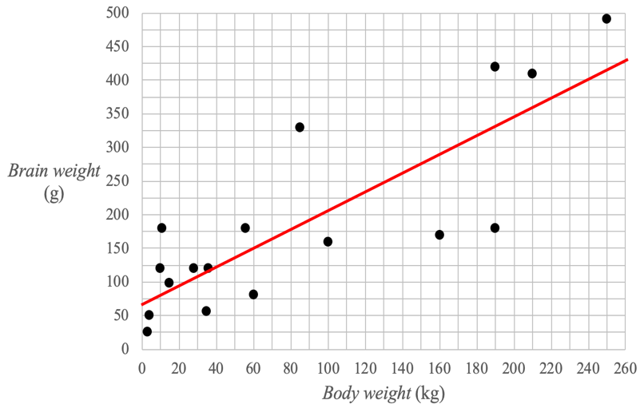

Question 3c.
68% of the variation in the brain weight can be explained by the variation in the body weight.

Question 3d.
13.9 | increase
Students needed to carefully read that a 10 kg change was referenced.

Question 3e.
Predicted brain weight = 69.6 + 1.39 × 210 = 361.5
Residual = 410 – 361.5 = 48.5, therefore 49 grams rounded

Question 4a.
Decreasing trend
Cycles are not referenced in the current study design.

Question 4bi.
197.7

Question 4bii.
196.1

Question 4c.
Time period = 36 years = 432 months
Number of points = 432 – (2 × 6)
= 420
This question was correctly answered by a small number of students.

Recursion and financial modelling

Question 5a.
$4215.93

Question 5b.
V1 = 1.0048 × 600 000 – 4215.93

Question 5c.
5.76%

Question 5d.
Finance solver entries
N =  I% =  PV =  PMT =  FV =  P/Y & C/Y = | 239.9996…  5.76  600 000  – 4215.93  0  12
N =  I% =  PV =  PMT =  FV =  P/Y & C/Y = | 239  5.76  600 000  – 4215.93  – 4194.4908…  12
Last payment = 4194.49 × 1.0048 = 4214.623… , which rounds to $4215.

Question 6a.
$42 500

Question 6b.
V0 = 60 000, Vn+1 = Vn – 8750

Question 6c.
Wn = 60 000 – 0.35n

Question 7
Payment ($) | Interest ($) | Principal reduction ($) | Balance ($)
12 222.56 | 12 222.56 | 0 | 252 011.45

Question 8ai.
Interest rate = (1.0025 – 1) × 1200 = 3.0%
Find annuity duration:
N =  I% =  PV =  PMT =  FV =  P/Y & C/Y = | 144 months  3.0  225 000  –1862.52  0  12
12 years
Students needed to answer in years, as required by the question.

Question 8aii.
Find annuity balance after 12th payment:
N =  I% =  PV =  PMT =  FV =  P/Y & C/Y = | 12  3.0  225 000  –1862.52  209 183.3374…  12
225 000 – 12 × 1862.52 + Interest = 209 183.34
Int = 209 183.34 – 225 000 + 12 × 1862.53
= 6533.70

Question 8b.
Find principal for new investment:
N =  I% =  PV =  PMT =  FV =  P/Y & C/Y = | 40  3.2  259 279.5394…  –7600  0  4
Interest factor = 1 + 3.2/400 = 1.008
V0 = 259 279.54, Vn+1 = 1.008Vn – 7600

Matrices

Question 9a.
3 | × | 7

Question 9b.
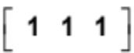

Question 10a.
MQ is not defined because the number of columns in M (1) is not equal to the number of rows in Q (3).
Students needed to clearly reference the number of columns and rows.

Question 10b.
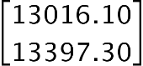

Question 10c.
0.88

Question 11a.
Females are expected to have:
- 0 offspring in their first year of life
- 2 offspring in their second year of life
- 1 offspring in their third year of life.
Many students did not demonstrate an understanding of the language used with Leslie matrices.

Question 11b.
0.35 × 0.22 = 0.077
= 7.7%

Question 11c.
Number projected in Year 10 = 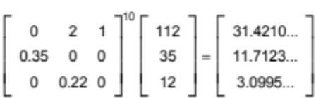
2022 total population = 112 + 35 + 12 = 159
2032 total population = 31.4 + 11.7 + 3.1 = 46
Population reduction = 159 – 46 = 113
Percentage reduction = 113/159 × 100 ≈ 71%
Endangered

Question 12a.
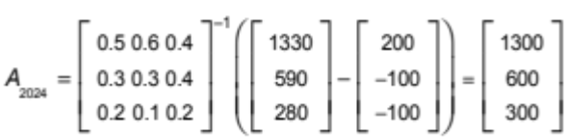
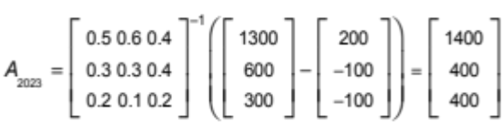

1400
This question was not well done, with students unable to use the inverse matrix correctly.

Question 12b.
1330 + 590 + 280 = 2200
Since the elements of matrix B added to 0, the expected number of sugar gliders always remains the same from one year to the next.

Networks and decision mathematics

Question 13a.
3
Connects to P, PO and F

Question 13bi.
F – PO – S – P – C – A – H – SC – E

Question 13bii.
Hamiltonian path

Question 13c.
Cafe, police station, shopping centre

Question 14a.
18 + 32 + 17 + 37
104

Question 14b.
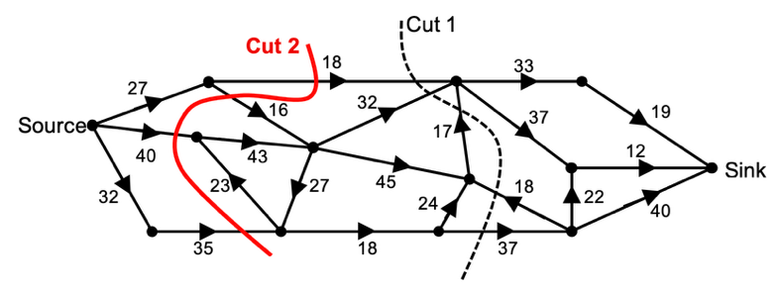
Some students identified a cut with a capacity of 109 that included five edges, not four as stated in the question.

Question 14c.
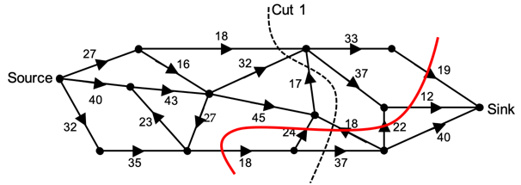
Cut through 19 – 12 – 22 – 18 – 24 – 18, with 22, 18 and 24 not counted (wrong way)
19 + 12 + 18 = 49

Question 15a.
A – C – E – J – M – N

Question 15b.
25 – 4 – 4 – 5 = 12

Question 15c.
B, D, F, G, K

Question 15d.
On A – C – E – J – M – N, reduce A and M each by 2 minutes (now 21 minutes).
On A – C – E – H – L – N, reduce H by 1 minute (now 21 minutes).
ALL other paths are, at longest, 21 minutes.
5 × $20 = $100
New minimum completion time: 21
Minimum associated cost: $100
The highest-performing candidates were able to obtain full marks.

