1. Purpose
The purpose of this guide is to outline the occupational health and safety (OHS) requirements for the management of potentially hazardous manual handing tasks that increase the risk of causing a Work-Related Musculoskeletal Disorder.

2. Scope
This guide applies to all VCAA workplaces including central offices and assessment venues.

3. Guidelines

3.1 What is manual handling?
Manual handling is any activity requiring the use of force, exerted by a person to lift, lower, push, pull, carry or otherwise move, hold or restrain an object, person or animal.

3.2 Where can manual handling occur?
Manual handling tasks can occur anywhere within VCAA workplaces, including:
- office environments
- assessing venues
- warehouses
- archive rooms

3.3 Example manual handling tasks undertaken in VCAA workplaces
Examples of manual handling tasks may include:
- carrying large number of books / materials
- lifting or carrying a student
- pushing a full trolley from a vehicle to point of destination
- lifting and moving equipment
- storing and retrieving archive boxes above or below shoulder height
- moving furniture
- typing at an incorrectly set-up workstation
- hanging posters
- bending over for extended periods of time to be at the same level as students

3.4 What are the risks of manual handling?
Manual handling injuries make up approximately 10% of total injuries occurring in VCAA workplaces.
According to WorkSafe Victoria the most common injuries associated with manual handling for the education sector are:
Shoulder:  Muscular stress/strain from assisting students, moving furniture, or lifting/carrying equipment or materials.  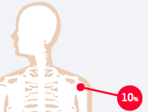 | Forearm/ Wrist:  Muscular stress/ strain from repetitive movements (e.g. computer use).  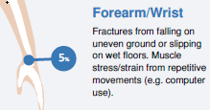
Back:  Muscular stress/strain from lifting, assisting or restraining students, bending down, moving furniture or boxes.  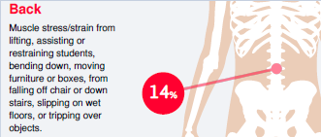 | Hand / Fingers:  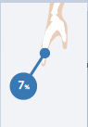  Fractures and traumatic joint/muscle injury during physical activity or practical classes
The above injures are referred to as Work-Related Musculoskeletal Disorders (WMSD) and can occur as a result from repeated damage or strain, or, in some instances, from a single case of overburdening.
Other common injuries associated with manual handling include:
- injuries to muscles, ligaments, intervertebral disc and other structures in the back
- injuries to soft tissues such as nerves, ligaments and tendons in the wrist, arms, shoulders, neck or legs
- abdominal hernias
- chronic pain.

3.5 What makes manual handling hazardous?
Four key risk factors that can make manual handling tasks hazardous include:
- Task
- Individual
- Load
- Environment
These risk factors can be easily remembered as ‘TILE’:
Task
Sub-Factors | Description | Image
Task is too strenuous | - Tasks undertaken too frequently with insufficient rest breaks  - Tasks undertaken for long periods of time / long distance  - Imposed working speed process unable to be altered | 
Awkward postures or movements | - Bending backwards, forwards or sideways  - Twisting the back  - Raised arms above shoulder height  - Working with bent wrists  - Looking down for long periods of time  - Looking to the side for long periods of time  - Squatting or kneeling for long periods of time. | 

Individual
Sub- Factors | Description | Images
Work familiarity / experience | - Undertaking a task where you are not familiar with the movements, expectations and muscular effort required | 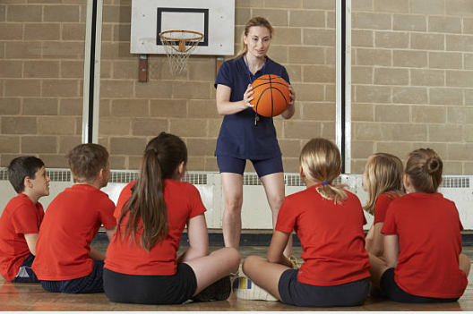
Training / supervision | - Training received prior to undertaking the task  - Management / peer expert supervision
Individual Physical capacity | - Strength of individual  - Age of individual etc. | 
Previous known injuries | - Previous and/or existing injuries | 

Load
Sub-Factors | Description | Image
Too large | - Loads that are unable to be held close to the body (e.g. arms outstretched more than 30cm from body). This increase the potential for overexertion and muscle fatigue. | 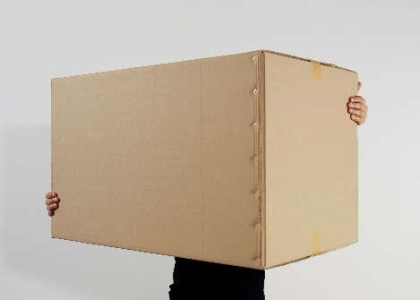
Too heavy | - There is no legislative weight limit that is considered ‘safe’ for manual handling and/or lifting. Individuals have different capabilities that must be considered when taking into account when lifting and moving a load | 
Difficult to grasp | - Loads may be slippery  - Use of personal protective equipment e.g. gloves may make gripping the load difficult  - Unsuitable handles or broken handles  - Surface textures  - Load is too small (e.g. having to pinch to pick something up) | 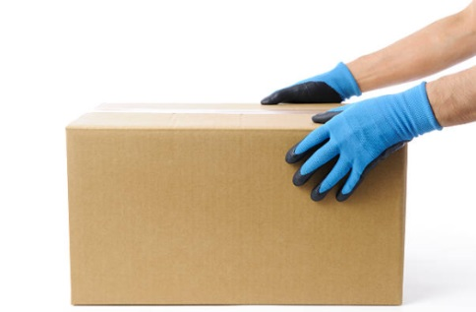
Unstable  unbalanced or contents can move | - Moving water/chemical container  - Moving half-filled box  - Having to lift a person or animal | 
Difficult to reach. | - Loads that are stored above shoulder height  - Loads that are stored below knee height | 

Environment
Sub- Factors | Description | Images
Available space | - Having enough space to manoeuvre items or stand straight  - Walkways and entry/exit points are free from obstacles  - Enough clearance under desks to ensure workstation is set-up correctly | 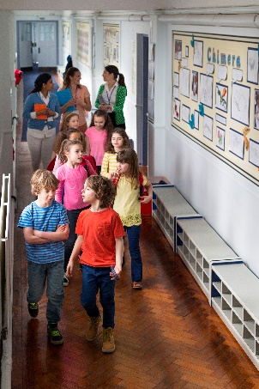
Floor surface | - Working in areas where there are changes in levels e.g. navigating stairs  - Undertaking a task where there may be surface cracks, dips or holes  - Working where there is the potential to have a slippery floor e.g. spilt water or working outside | 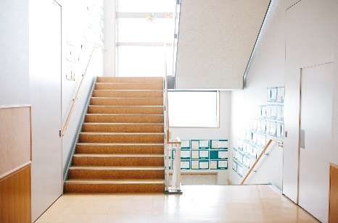
Climate (heat, cold, ventilation, humidity) | - Working in hot conditions  - Undertaking tasks where there may be exposure to radiant heat e.g. welding  - Working in cold conditions  - Working in humid conditions  - Working in areas with a lack of ventilation | 
Vibration | - Undertaking tasks using plant or equipment e.g. use of a power tool | 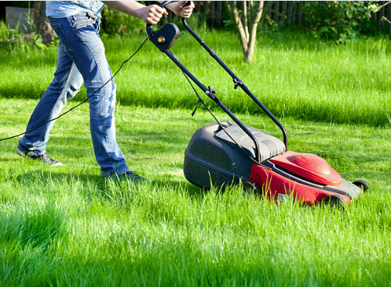
Lighting | - Adequate lighting to enable employees to see without squinting or leaning forward to see | 

3.6 Risk Assessment
The health and safety risks associated with manual handling tasks that are potentially hazardous are to be assessed by the VCAA manager, considering:
- If an individual is likely to be injured while carrying out the task?
- What preventative measures have already been put in place and are they adequately managing the risk?
- What is the level of risk associated with undertaking the task?

3.7 Risk Controls
Control | Description
Do not undertake the tasks | - Communicate to employees that they are not to perform the task  - Re-design the task so that manual handling can be avoided
Change the environment (workspace) | - Change the layout of the area e.g. create a clear pathway to the door  - Store items close to where they are to be used  - Adequate and accessible storage solutions (e.g. weight rated shelves, shelves are built fit for purpose, items can be stored between knee and shoulder height)  - Lower the height of storage shelves to reduce the need to use a ladder or lift above shoulder height  - Undertake the task in more suitable temperature conditions (Compliance Code for Workplace Amenities states that for sedentary work 20°C - 26°C depending on the time of year and clothing worn)  - Allow enough space to conduct the task  - Keep items to be used at the same level to reduce the need for lifting or lowering  - Provide enough lighting
Change the nature of the work | - Arrange for deliveries to be placed near area of use  - Team lifting  - Break down the task e.g. reduce the weight of object  - Determine working position e.g. sitting or standing  - Set realistic work rates/timeframes  - Rotate tasks
Modify the load | - Reduce the weight of the load to be carried e.g. take objects out of box to be moved  - Place items in smaller tub  - Purchase items in smaller containers instead of bulk
Use mechanical aids | - Use of slings/straps  - Backpacks  - Tool belts  - Hoists  - Trolleys
Administrative aids | - Develop, display and communicate safe work procedures  - Provide adequate supervision  - Provide manual handling training  - Display safety signage indicating the weight of the load is visible

3.8 Manual Handling Techniques

3.8.1 What is the maximum weight employees are allowed to lift?
There is no legislated weight limit that is considered ‘safe’ for manual handling. Individuals have different physical capabilities, which must be considered when taking into account any manual handling task. The weight of an object is not necessarily the only thing that makes a task hazardous.

3.8.2 What techniques can I use to help prevent an injury?
- S.M.A.R.T Lifting Technique
- Team Lifting
- Pushing or Pulling Techniques when using mechanical aids

3.8.3 SMART Lifting
S

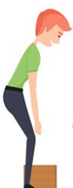
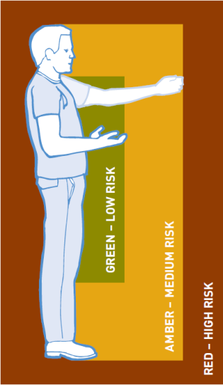
Size up that load
- Assess the load (shape, size and weight)
- Determine where the load needs to be moved and placed
- Determine whether you can carry the load or whether a mechanical aid should be used
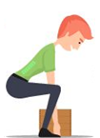
M
Move the load as close to the body as possible
- Carry the load as close to the body as possible
- Secure your grip

A
Always bend your knees
- Keep feet apart in a comfortable position (usually in line with hips)
- Minimise lower back bending
- Bend knees (squat or semi-squat position)
R

Raise the load with your legs
- Lift the load with your legs, not your back, in a smooth motion (avoid twisting or jerky movements)
- Maintain normal curvature of the spine

T
Turn your feet in the direction you want to move
- Change direction by pointing your feet and not twisting your back
- To set the load down, squat down, keep your head up and allow your legs to carry the weight.

The SMART Lifting Poster that can be displayed throughout your workplace.

3.8.4 Team Lifting
Team lifting can be an effective way of moving objects however; it is important to consider:
- Whether there are enough people?
- Does anyone have a known pre-existing injury?
- Who will be coordinating the lift?
- Whether a lifting plan has been established and communicated to those involved?
- Whether all persons of the same size with similar strength?

3.8.5 Lifting of persons
A ‘no lift policy’ is best. If a student is required to be lifted, employees should use available equipment (e.g. hoist, wheelchair etc.) and the students own ability, to avoid unnecessary manual handling. Where it has been identified that a student will be required to be lifted guidance should be sought from the Central Office.
Where there are behaviours of concern, a Behaviour Support Plan should be developed in consultation with Student Support Services, parents or carers or specialist.

3.8.6 Pushing and pulling techniques when using mechanical aids
Use of mechanical aids can assist in eliminating or reducing the need to lift, carry items/objects/persons in the workplace; however, it is important to consider:
- when pushing, lean forward
- when pulling, lean backwards (pushing is preferable as it involves less work by the lower back muscles and allows for maximum use of body weight). It allows employees to adopt a forward facing posture, providing clearer vision in the direction of travel
- ensuring you have a good grip
- avoiding twisting and turning
- checking that the handle height is between shoulder and waist height
- checking that the handles or grips are in good condition
- checking that the wheels on trolleys are in good condition
- checking that the floors are free from obstacle and rubbish
Example mechanical aids include:
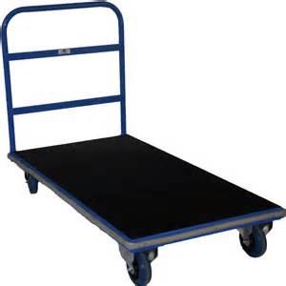  Flatbed Trolleys | Upright trolley  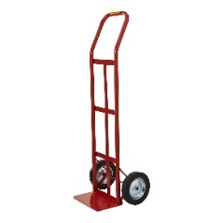 | 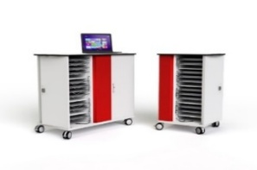  Laptop charging trolley | Gym mat trolley  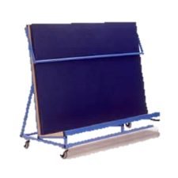
Shelf trolley  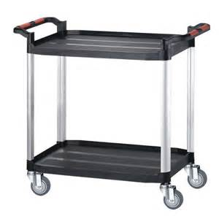 | Wheelchair  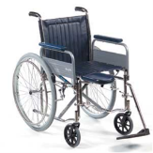 | Chair trolley  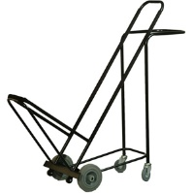 | Sports equipment trolley  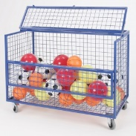
Wheelie bin trolley  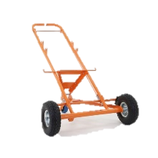 | Clax Trolley  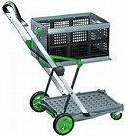 | Library book trolley  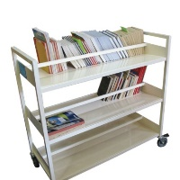 | Mobile hoist  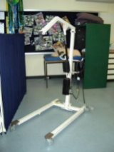

3.9 Safe storage and house keeping
Items should be stored safely with work areas are kept free from obstacles and debris. This can be done by:
- storing frequently used and heavy items between waist and shoulder height
- storing smaller, lightweight or infrequently used items in lower or higher areas
- removing all obstacles and/or obstructions in pathways or in front of storage areas
- knowing shelving weight limits (see label)
- having access to a step-ladder to raise the employee to the best working zone
- testing the weight of the object before picking it up
- conducting quarterly workplace inspections using the relevant Workplace Inspection Checklist or equivalent.

3.10 Training
The VCAA has also made available a manual handling presentation that can be used during a meeting or other forum, to assist in building capability and raising awareness of manual handling tasks that are potentially hazardous.

