1. Purpose
The purpose of this guide is to give you tips to help create a safe and healthy working from home environment.

2. Guidelines
When required to work remotely, we need to ensure we look after our health and safety the best we can. Unfortunately, we don't all have the ideal work from home set-up.
Many of us may be trying to work and be productive while also working in the same space as our family, instead of sitting or standing at a dedicated workspace and workstation with readily available ergonomic equipment.
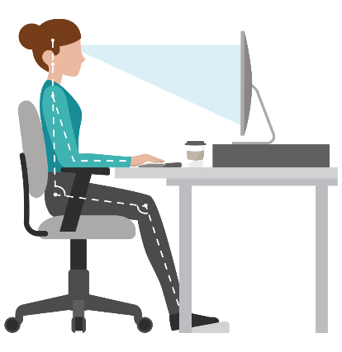 | 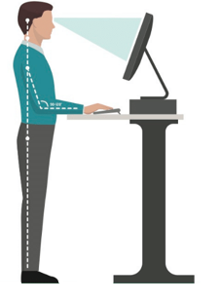 | 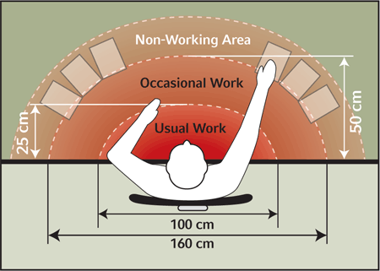
A kitchen benchtop or a dining room table may be our workspace and a combination of long hours on a laptop on the kitchen table can be both physically and psychologically stressful over the long haul.

It is important we consider how to make our work environment function best in order to protect our physical and mental wellbeing.
Here are some tips to help keep us safe and healthy while working from our home office, however this may look.

Ergonomic Setup
Work with what’s available
Laptop | - If you have a laptop and a separate keyboard and mouse, consider how you might build a sitting or standing workstation around it.  - If you don’t have a laptop stand, raise the height of the laptop on some books or boxes to get it to the right height to prevent being hunched over and to optimise working posture.  - The screen should also be positioned about an arm's length away to help minimise eye strain and fatigue.  - A laptop is likely to have a screen much smaller than we are used to, which can be an issue for some people.  - Where possible, ensure a separate monitor is connected. If it is not possible to have a separate screen, an option may be to use a small television screen if one is available or try increasing the font size on the laptop to make it easier to read. | 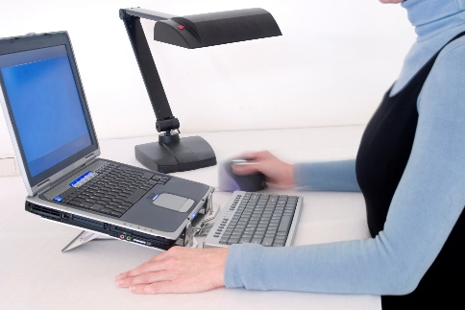  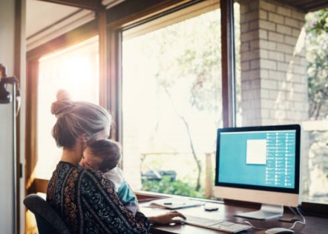
Chair | - Having an adjustable chair is a good idea. This can help make sure we are working at a good height and our back is supported.  - However, if an adjustable chair is not available, use the tallest chair available, a comfortable chair with a backrest (avoid using a stool as this does not support the spine) and put something on it so you're sitting at the right working height.  - You should also move more frequently to help reduce the possibility of discomfort. | 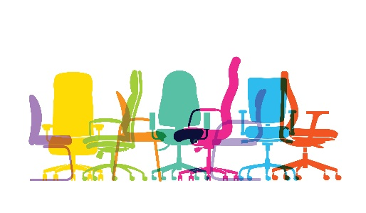
Footrest | - Ideally your feet should be flat and in contact with the floor or a footrest when sitting to support your posture, if this is not possible consider improvising, find something like a box, books, or whatever that can fill in that gap between your feet and the floor. | 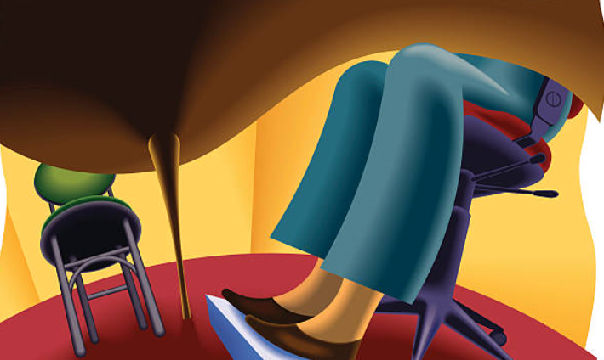
Mouse | Use the mouse  - Try to avoid using the mousepad on the laptop for long periods. Having fingers and hands scrolling around a laptop’s mousepad for extended periods of time can lead to discomfort that we want to avoid.  - Try alternating the mouse between the left and right hand – this will reduce any potential for strain over time. Be patient as it will take time for the non-dominant hand to be as effective, but it will be beneficial in evening out the load on your hands. To help make this transition easier you can change the settings of your mouse to be left or right-handed through the settings functions on your computer.  - Consider an external mouse your best ally and look after each other. | 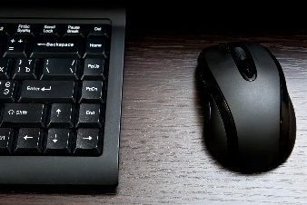  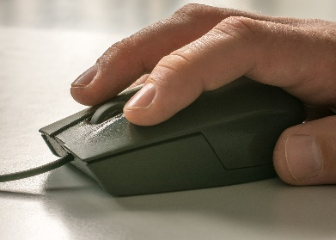
Headset | - Optimise the use of a headset or the laptops speakers for calls.  - Using a headset, earphones or internal speakers for calls can enable us to get up and move, even if it’s just to stretch or walk around for a period of time.  - Where you can, take telephone calls standing up and work sitting down, the use of a headset or internal speakers can provide some flexibility of movement when working from home. | 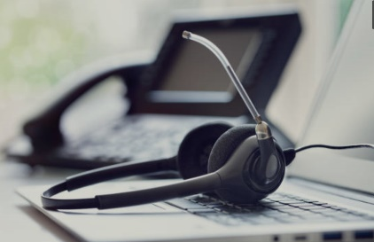  
Virtual meetings | - When in virtual meetings consider alternating between sitting and standing.  - Remember it’s the prolonged static awkward postures we want to eliminate where possible or reduce and limit as much as possible to reduce discomfort. | 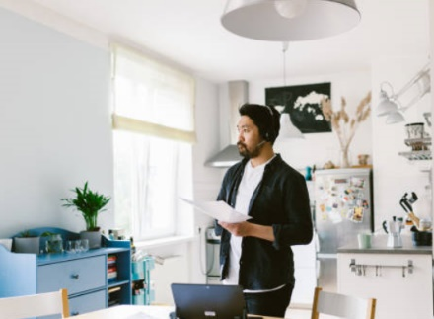

Individual
Changing position | - Most importantly we should ensure that we take every opportunity to move  - We should be changing our position as often as we can when the opportunities arise.  - Both sitting and standing for extended periods of time is problematic, it’s the prolonged static and awkward postures we want to eliminate, reduce and limit as much as we can. This is what can lead to discomfort and injury.  - Changing position is more important when we don’t have a proper office or ergonomic chair. A makeshift office seat/chair can’t be adjusted and therefore we are more likely to in a less than optimal posture while working from home.  - Ideally, we should alternate between sitting and standing and even walking around our home or outside, where practicable | 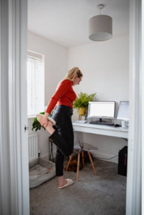  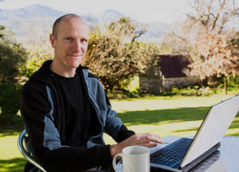  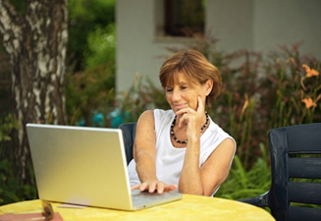
Take regular breaks | - Put triggers in place as a prompt to move and break up the day. This is important for everyone, but particularly when working at a far-from-ideal workstation.  - Some alternatives may include using a device such as our phone, computer or watch to set alarms or getting up on the hour to move and do something different.  - Getting up and moving away from the laptop or computer every 20-30 minutes, means we’re changing position and also gives our eyes a break from the screen to reduce eye fatigue. |   
Physical wellbeing | - Drink plenty of water, not only does it look after our physical health by ensuring we remain hydrated, if we use a glass or a cup, we will need to refill it regularly which means moving away from our laptop or computer regularly throughout the day. | 

Environment
Lighting | Position  - A workstation should be positioned to reduce glare and reflections.  - Place the screen in a position to maximise lighting over the desk or workspace and avoid reflections on the screen. | 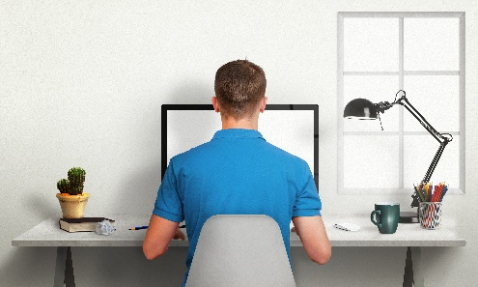
Available space | - Having enough space to manoeuvre items or stand straight  - Enough clearance under desks to ensure workstation is set-up correctly | 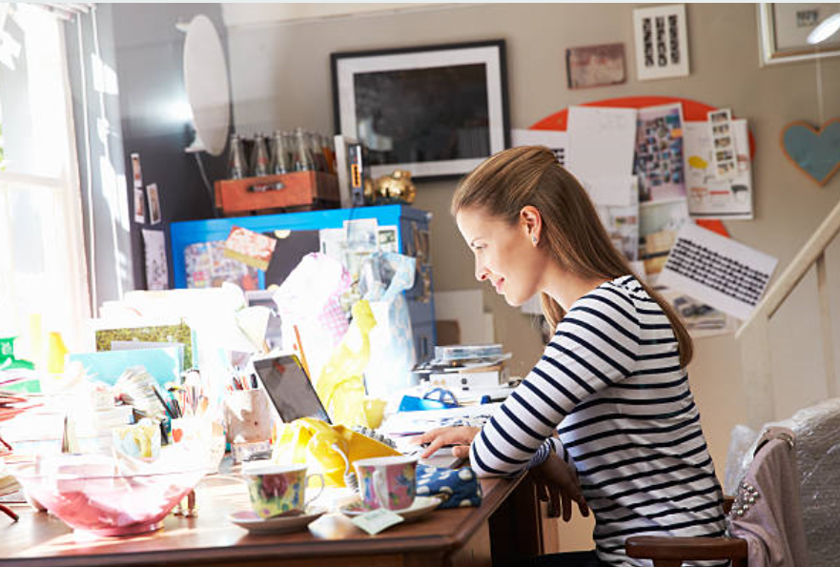
Noise, Temperature and Airflow | Other elements to the working environment such as, noise, temperature and airflow should also be considered. | 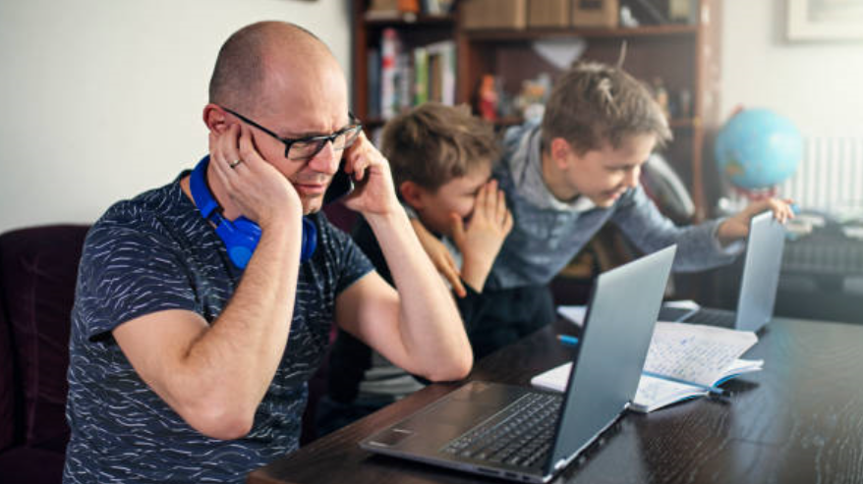  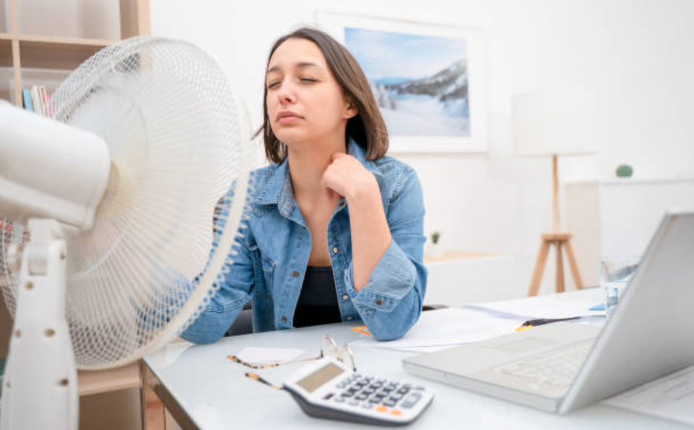

3. Support and Advice
Please consider these are general tips and may not work for everyone, if you need specific advice, or ergonomic support, get in contact with your VCAA Manager or contact VCAA HR at vcaa.hr@education.vic.gov.au or call 1800 718 320 (option 2).

