A well designed workstation can reduce the risk of injury. The following checklist is provided to assist in setting up and assessing your own workstation. The outcomes of this assessment should be discussed with your VCAA manager and/or management representative. The VCAA manager and/or management representative should be notified if there is pain or discomfort.
For further information contact the VCAA HR team at vcaa.hr@education.vic.gov.au or call 1800 718 320 (option 2).
Assessment Details
Employee name:
VCAA Manager or VCAA Representative name:
Location of workstation:
Date of assessment:

1. Hazard Identification - Nature of tasks undertaken on a daily basis
List your main daily tasks:

Do you change your posture (e.g. move away from your workstation, stretching) at least every 30 minutes? | ☐ Yes | ☐ No
Are rest breaks and micro pauses taken regularly? | ☐ Yes | ☐ No
Do you vary and rotate the types of tasks you undertake? | ☐ Yes | ☐ No
Do you look away from the screen every 20 minutes for at least 20 seconds? | ☐ Yes | ☐ No
Current issues/comments

2. Chair - Refer to manufacturer’s instructions that are provided with the chair.
Can you adjust your chair height so that your feet are flat on the floor and thighs are horizontal? | ☐ Yes | ☐ No
Can you adjust the seat tilt to be horizontal or slightly forward, to your own preference? Refer to dotted lines on diagram? | ☐ Yes | ☐ No
Can you raise the backrest until the lumbar support fits with the curve of your lower back?  N.B Whilst seated adjust the forward/backward lever on the chair until the position of the backrest exerts a comfortable pressure on the lower back | ☐ Yes | ☐ No
Is there a 2-3 finger-width gap between the front of the seat and the back of your knee? | ☐ Yes | ☐ No
Can you place your chair at a comfortable typing or viewing distance from the screen?  N.B Chair armrests should be positioned to fit under the desk. | ☐ Yes | ☐ No
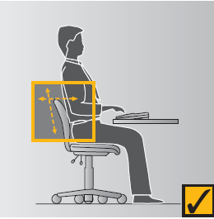
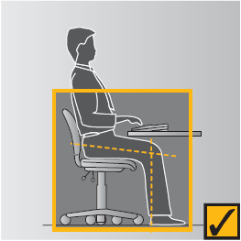
Comments:

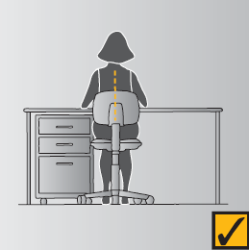
3. Desk
Do you have an adjustable keyboard shelf, if yes, is it elevated to the desk height to ensure a level work surface? | ☐ Yes | ☐ No
Is your desk at an appropriate height whereby your shoulders are relaxed and elbows are slightly above the level of the desk, bent at 90 degrees?  If the desk is too high and cannot be adjusted  Adjust the height of the chair and make use of a footrest, if required.  If the desk is too low  Consult with your workplace manager about modification or replacement if your desk is too high/too low. | ☐ Yes | ☐ No
Is there adequate clearance under your desk to accommodate your chair and legs? | ☐ Yes | ☐ No
Are objects such as rubbish bins, storage boxes, and bags stored under the desk? If yes, remove the objects to ensure you are positioned directly in front of your monitor to avoid twisting or awkward posture of the spine. | ☐ Yes | ☐ No
Are the frequently used items on the desk stored no more than an arm’s length away? | ☐ Yes | ☐ No
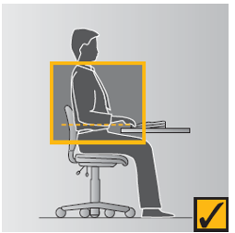
Comments:

4. Footrest
Can you comfortably place your feet flat on the floor after adjusting your chair, If no, you may require a footrest. | ☐ Yes | ☐ No | - N/A
Can you adjust the footrest? | ☐ Yes | ☐ No | - N/A
Is the footrest stable when your feet are resting on it? | ☐ Yes | ☐ No | - N/A
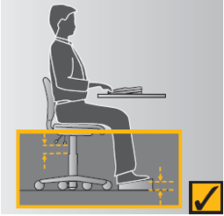
Comments:

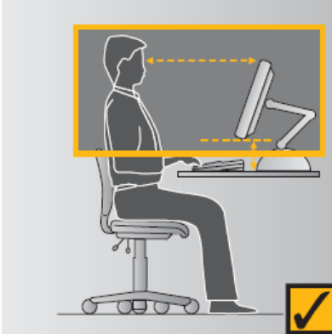
5. Single Monitor Set-Up
Is the top of the monitor (including laptops positioned so that it is level with your eyes?  N.B: If you wear bi or trifocals, the monitors will usually be positioned lower so that you do not have to tilt your head up to view the screens. | ☐ Yes | ☐ No
Are you able to adjust your monitor to the correct height? If no, a monitor stand may be required. | ☐ Yes | ☐ No
Is your monitor approximately arm’s length away from your seated position? | ☐ Yes | ☐ No
When looking at the screen, is your head upright (not bent forward or backward)? | ☐ Yes | ☐ No
Is the screen set to an appropriate brightness, size, colour, and contrast? | ☐ Yes | ☐ No
Comments:

6. Dual Monitor Set-Up
Are both monitors the same size and height? | ☐ Yes | ☐ No
Are both monitors adjusted to the correct height, see section 5. | ☐ Yes | ☐ No
Can both monitors be placed at approximately arm’s length away from your seated position? | ☐ Yes | ☐ No
Are both monitors set to the same resolution to minimise eyestrain? | ☐ Yes | ☐ No
Do you use both monitors for an equal amount of time?  If yes, set the monitors next to each other. The monitors should be positioned directly in front of the user in a slight outward “V” shape. Refer to diagram 1 | ☐ Yes | ☐ No | - N/A
Do you use one monitor as the primary monitor?  If yes, position it directly in front of you and place the secondary monitor to the right or the left at about a 30-degree angle to the primary monitor. Refer to Diagram 2 | ☐ Yes | ☐ No | - N/A
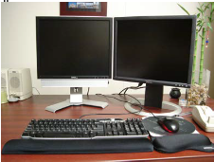
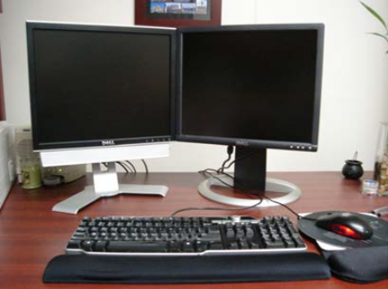
Comments:
Diagram 1
Diagram 2

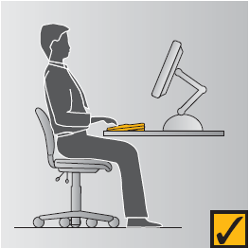
7. Keyboard
Is your keyboard aligned with the monitor and placed directly in front of you near the front edge of the desk? | ☐ Yes | ☐ No
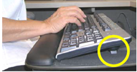  Are the feet of the keyboard lowered to reduce the height and angle of the keyboard to prevent bending of the wrists?  X | ☐ Yes | ☐ No
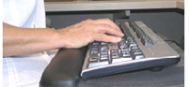
Comments:

8. Mouse
Is your mouse and keyboard on the same level and used as close to you as possible? | ☐ Yes | ☐ No
Do you use keys on the keyboard to reduce mouse use? | ☐ Yes | ☐ No
When using the mouse do you keep your wrist as straight as possible? | ☐ Yes | ☐ No
Is your mouse and keyboard close to one another? | ☐ Yes | ☐ No
Do you alternate between hands to reduce time spent using your dominant hand? | ☐ Yes | ☐ No
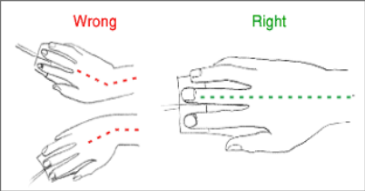
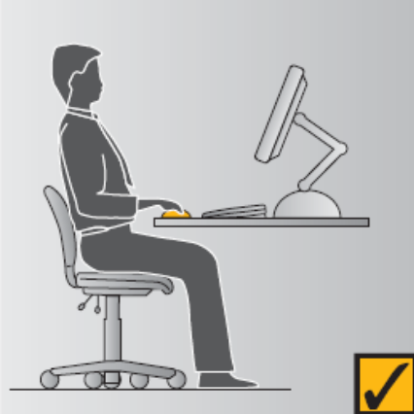
Comments:

9. Referencing documents
Do you regularly reference documents?  If yes, you may require a document holder or should try to place the document directly between the keyboard and the computer monitor to reduce neck and back twisting. | ☐ Yes | ☐ No
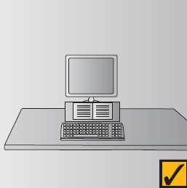
Comments:

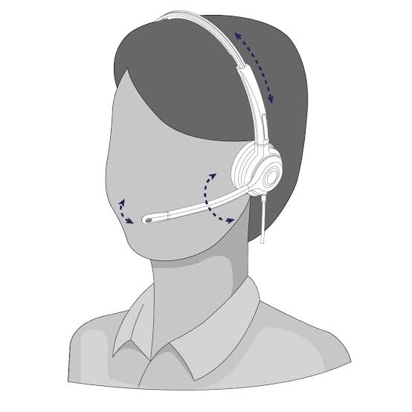
10. Headset
Does the headset fit securely without being excessively tight or causing pressure on the ears, head, or temples?  Adjust headset or headphones so they sit comfortably. If necessary, consider using the laptop's built-in speakers and microphone for shorter calls. | ☐ Yes | ☐ No
Does the headset allow you to maintain a neutral, upright head and neck position while working?  Ensure you are not tilting or turning your head to hear the caller. | ☐ Yes | ☐ No
Can the microphone be positioned close enough to the mouth that you do not need to lean or turn your head toward it? | ☐ Yes | ☐ No
Is the headset volume set at a comfortable level that allows conversations to be heard clearly without excessive volume? | ☐ Yes | ☐ No
Comments:

11. Standing Workstation
Is the height of the desk just below elbow height?  N.B: Your shoulders should be relaxed and your elbows bent at approximately 90 degrees. | ☐ Yes | - No
Is the top of monitor just below or at eye level? | ☐ Yes | - No
When standing, are the head, neck, torso and legs should be in line | ☐ Yes | - No
Is the keyboard and mouse on the same level? | ☐ Yes | - No
Are alternated postures adopted (e.g. standing and sitting?  N.B: To minimise leg fatigue, alternate between standing and sitting approximately every 20-30 minutes, or as needed and utilise an anti-fatigue mat. | ☐ Yes | - No
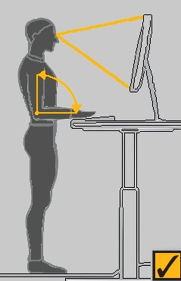
Comments:

12. Notebook or Laptop Computers
Can your laptop be placed on an adjustable stand or attached to a docking station? | ☐ Yes | ☐ No
Do you have an external monitor, keyboard and mouse? | ☐ Yes | ☐ No
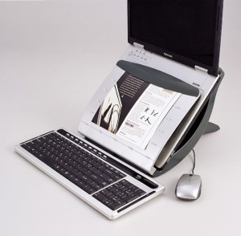

Comments:

13. Workstation Environment
Is your computer monitor in a position so as to maximise light cast over your desk and to avoid reflections on the screen or glare behind the screen. | ☐ Yes | - No
Is your working environment too loud?  Please provide comments below. | ☐ Yes | - No
Is your working environment too hot / cold?  Please provide comments below. | ☐ Yes | - No
Does your working environment have adequate ventilation?  Please provide comments below. | ☐ Yes | - No
Is the electrical equipment in your working environment in good condition -no frayed cords, no double adaptors, adequate electrical equipment ventilation?  Please provide comments below. | ☐ Yes | - No
Is there a Residual Current Device (RCD) installed at the workplace?  Please provide comments below. | ☐ Yes | - No
Is there a smoke alarm installed and fire extinguisher available?  Please provide comments below. | ☐ Yes | - No
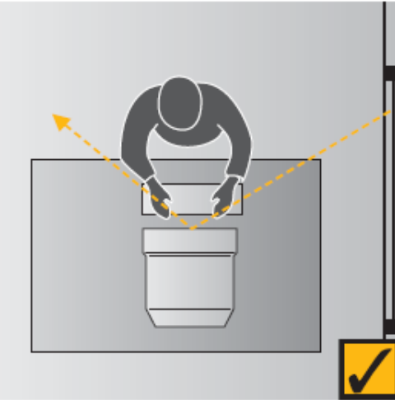
Comments:

The following section is to be completed by the VCAA manager or management representative in consultation with the employee.
The controls implemented should be trialled for a week and if discomfort persists, please contact the VCAA HR team at vcaa.hr@education.vic.gov.au or call 1800 718 320 (option 2) to arrange an Ergonomic Assessment. Please see risk matrix below for further guidance on conducting the risk assessment.
Risk Assessment & Controls
Hazard Identification (use references from previous sections) | C | L | Risk Level | Controls | Date Implemented | Date Reviewed

Review controls in consultation with employee
Verification in consultation with employee and VCAA manager and/or management representative that controls are effective.
VCAA Manager and/or Management Representative
☐ Effective ☐ Not effective Name: Signature: Date: / /
Employee
☐ Effective ☐ Not effective Name: Signature: Date: / /

Using the Matrix
- Evaluate the consequences of a risk occurring according to the ratings in the top row.
- Evaluate the likelihood of an incident occurring according to the ratings in the left hand column.
- Calculate the level of risk by finding the intersection between the likelihood and the consequences.

Consequence
Descriptor | Level | Definition
Insignificant | 1 | No injury
Minor | 2 | Injury/ ill health requiring first aid
Moderate | 3 | Injury/ill health requiring medical attention
Major | 4 | Injury/ill health requiring hospital admission
Severe | 5 | Fatality

Likelihood
Descriptor | Level | Definition
Rare | 1 | May occur somewhere, sometime (“Once in a life time / once in a hundred years”)
Unlikely | 2 | May occur somewhere within the VCAA over an extended period of time
Possible | 3 | May occur several times across the VCAA over a period of time
Likely | 4 | May be anticipated multiple times over a period of time.  May occur once every few repetitions of the activity or event
Almost Certain | 5 | Prone to occur regularly  It is anticipated for each repetition of the activity of event

Risk level
Likelihood | Consequence
Likelihood | Insignificant | Minor | Moderate | Major | Severe
Almost Certain | Medium | High | Extreme | Extreme | Extreme
Likely | Medium | Medium | High | Extreme | Extreme
Possible | Low | Medium | Medium | High | Extreme
Unlikely | Low | Low | Medium | Medium | High
Rare | Low | Low | Low | Medium | Medium

Key
Descriptor | Definition
Extreme: | Notify Workplace Manager and/or Management Representative immediately. Corrective actions should be taken immediately. Cease associated activity.
High: | Notify Workplace Manager and/or Management Representative immediately. Corrective actions should be taken within 48 hours of notification
Medium: | Notify Nominated employee, HSR / Health and Safety Committee (HSC). Nominated employee, HSR / HSC is to follow up that corrective action is taken within 7 days.
Low: | Notify Nominated employee, HSR / Health and Safety Committee (HSC). Nominated employee, HSR / HSC is to follow up that corrective action is taken within a reasonable time.

