Victorian Pathways Certificate

Unit 1
Striving Individuals
Numeracy Curriculum
Support Materials

Authorised and published by the Victorian Curriculum and Assessment Authority
Level 7, 2 Lonsdale Street
Melbourne VIC 3000
ISBN: 978-1-xxxxxx-xx-x [email vcaa.media.publications@edumail.vic.gov.au for ISBN requests]
© Victorian Curriculum and Assessment Authority [year]

No part of this publication may be reproduced except as specified under the Copyright Act 1968 or by permission from the VCAA. Excepting third-party elements, schools may use this resource in accordance with the VCAA educational allowance. For more information go to https://www.vcaa.vic.edu.au/Footer/Pages/Copyright.aspx.
The VCAA provides the only official, up-to-date versions of VCAA publications. Details of updates can be found on the VCAA website at www.vcaa.vic.edu.au.
This publication may contain copyright material belonging to a third party. Every effort has been made to contact all copyright owners. If you believe that material in this publication is an infringement of your copyright, please email the Copyright Officer vcaa.copyright@edumail.vic.gov.au
Copyright in materials appearing at any sites linked to this document rests with the copyright owner/s of those materials, subject to the Copyright Act. The VCAA recommends you refer to copyright statements at linked sites before using such materials.
The VCAA logo is a registered trademark of the Victorian Curriculum and Assessment Authority.

Contact us if you need this information in an accessible format - for example, large print or audio.
Telephone (03) 9032 1635 or email vcaa.media.publications@edumail.vic.gov.au

Contents
Contents
Numeracy activities 4
Task 1-Maps 4
Task 2- Obstacle course directions 8
Task 3- Holiday Planning 11
Task 4- Flights and accommodation 14
Task 5- Memberships 19
Task 6- Moving Out & discounts 23
Task 7- Patterns & Shapes 27

Numeracy activities

Task 1-Maps

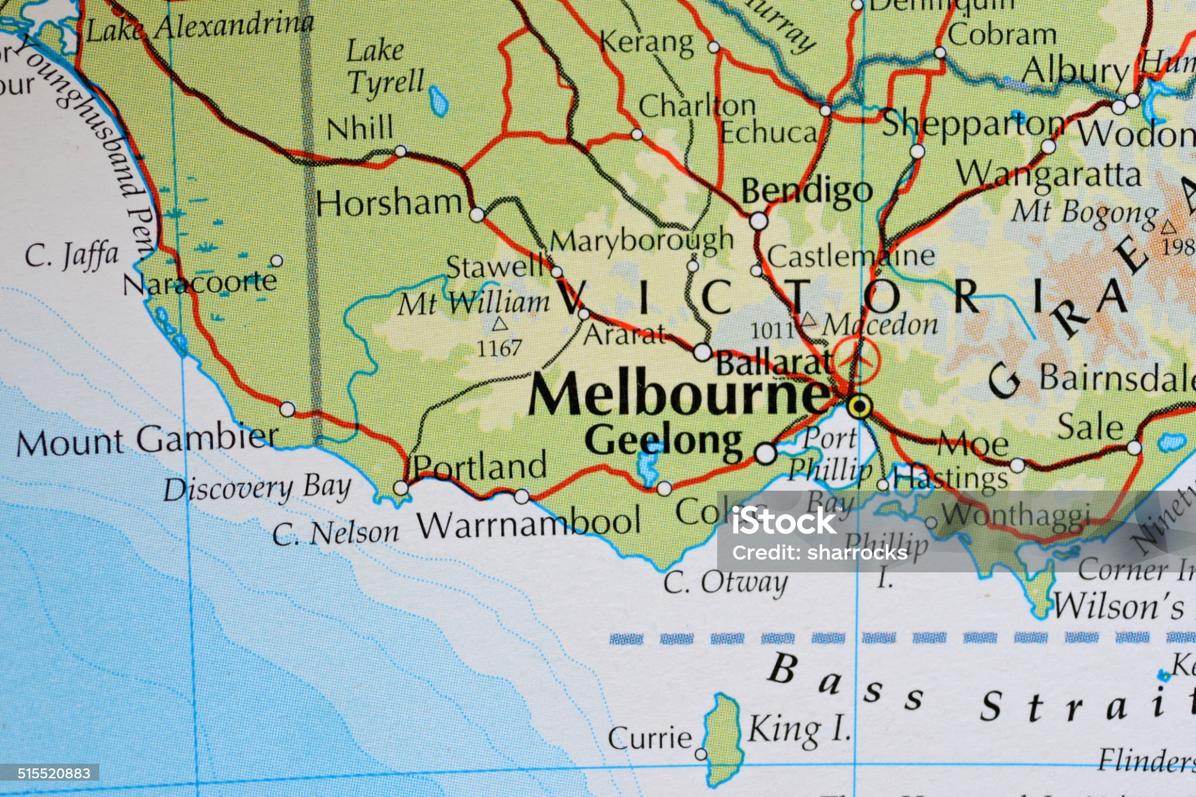
Learning goals & application
Learning Goal:
1.1 - Find location and direction in relation to everyday, familiar places within a vicinity.
1.2 - Find location and direction with everyday, simple and familiar maps and technologies.
Application:
1.2 - Use interactive and paper maps to locate highly familiar places and objects.

Task Checklist
Students will complete the following for Numeracy Task 1 Focus Area: Location
☐ Task 1-Maps

 Part 1: Your Tuesday fitness activities will involve attending a local facility to engage in your program. Select what you will base your response on:
☐ F45
☐ Body Sculpt
☐ Bone Yards

Part 2: Go to Google Maps. Find the directions from Surf Coast Secondary College to your selected gym. Take a screenshot of the map that shows directions from your school to your
Gym and add into the space provided below.

Add screenshot of map here.

Part 2: From Google Maps, answer the following questions below.

- What is the distance between your school and the gym?

- How long does Google Maps predict it would take to complete the following from your school to your selected gym?
Walk:
Ride a bike:
Drive a car:

- Take a screenshot or copy and paste the written instructions on how to get from your school to your selected gym.

Part 3: Use this map to answer the questions in the table below.

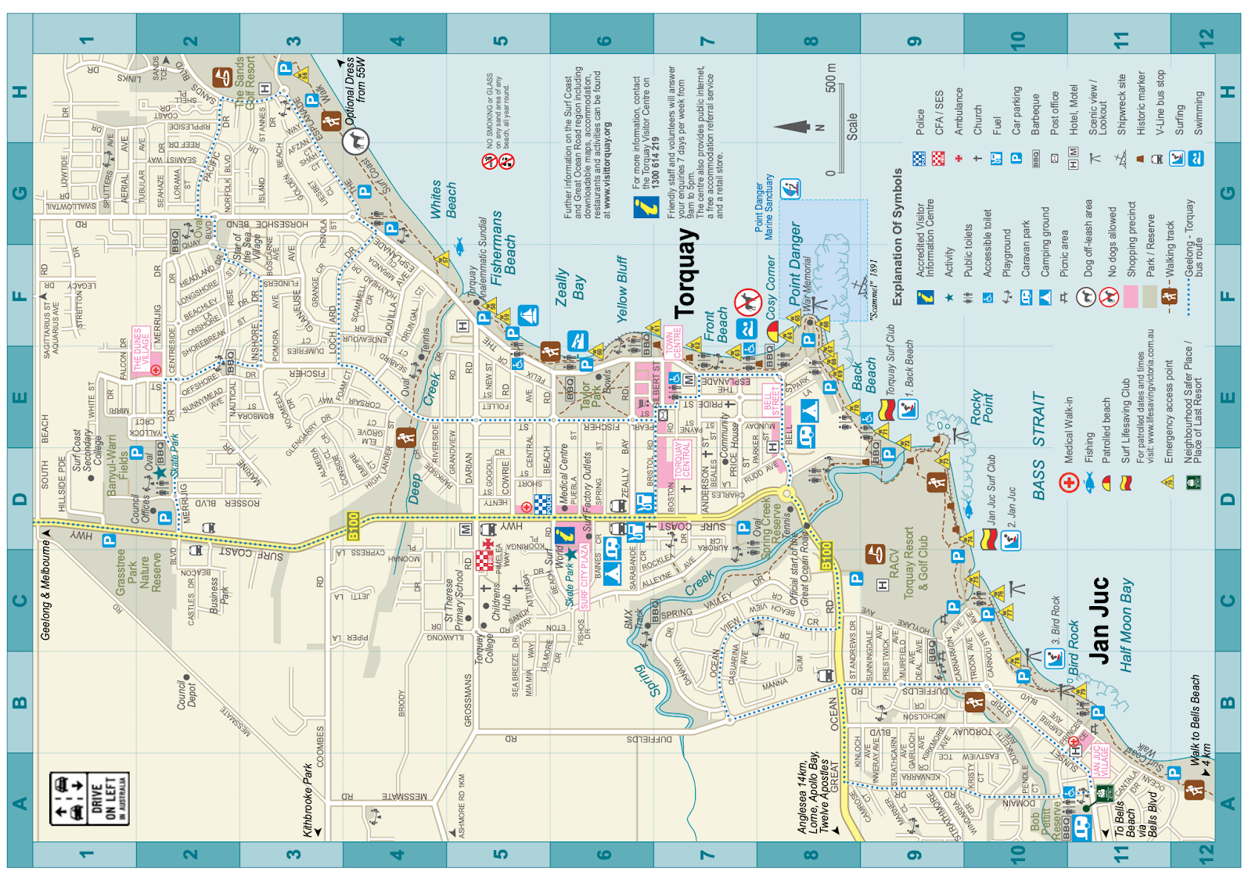

- What symbol would you look for on the map, when you want to find the following?

Location / site / facility | What symbol (image) represents this?
Example:  Playground | Seesaw  
Shopping Precinct
Hotel / Motel
Picnic Area
Activity
Barbeque

- Grid Locations- Use the Grid coordinates and clues to find the landmark.

Grid Reference | Landmark
C9 (Worked Example) | RACV Golf Course (Course)
A10 | (Reserve)
D8 | (Reserve)
F5 | (Beach)
H2 | (Resort)

Task 1 –Maps
Student Reflection - How well did you go with this step? (Please check the box below)
☐Not Submitted | ☐Beginning | ☐Consolidating | ☐Achieving | ☐Excelling
Student Comment (Optional):
Teacher Feedback
☐Not Submitted | ☐Beginning | ☐Consolidating | ☐Achieving | ☐Excelling
Not Submitted: No work has been submitted or attempted for this activity. | Beginning: I can attempt some aspects of this task.  To bump it up, you need to complete all sections of this task with basic responses. | Consolidating: I can provide basic responses to most sections of this task.  To bump it up, you need to recheck your answers and include more detail. | Achieving: I can provide detailed responses to most aspects of this task.  To bump it up you need to add additional details with specific information to your responses. | Excelling: I can provide highly detailed responses with correct information to all sections of this task.
Teacher Comment:

Task 2- Obstacle course directions

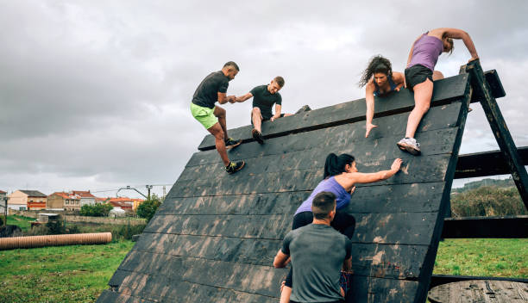
Learning goals & application
Learning Goal:
1.3 Use everyday oral directions using informal language such as left/right, up/down, front/back, under/beside/over.
Application:
1.1 Orally describe a location of familiar, local places.
1.3 Give and follow simple oral directions to highly familiar objects.

Task Checklist
Students will complete the following for Numeracy Focus Area: Location
☐ Task 2- Obstacle course directions

Part 1: Think of a route you regularly take, such as:
- From your house to your school
- From your classroom to the canteen
- From your house to the local supermarket
Write down the directions for this route, describing how you would get from the starting point to the destination.

Part 2: Read out or explain these directions to your teacher. Asked them to fill in the table below.
Criteria | Yes/No | Teacher comment
Student can describe a location that is familiar and local.

Part 3: You must set up an obstacle course for a partner to get through blindfolded. You can do this either in the classroom or outside. Within the obstacle course you need to include ‘obstacles’ that allow the following terms within your instructions:
- Left/Right
- Up/Down
- Front/Back
- Under/Beside/Over
Add an image of the obstacle course you have created below. Label the start point and end point in your image.
Add labelled image of obstacle course here.

Part 4: Get your partner to complete the obstacle course. You need to give your partner specific and clear instructions. Take a photo of your partner going through your obstacle course blindfolded and insert photo evidence below.
Add picture of your partner completing the obstacle course here.

Part 5: After completing the obstacle course, reflect on the instructions you gave your partner. Write three sentences you used when giving instructions that included any of the following:
- Left/Right
- Up/Down
- Front/Back
- Under/Beside/Over
Example- ‘Take three steps forward, then crouch down and crawl under the table’.

Part 6: Feedback - Get your partner to fill out the following table about your ability to give effective instructions.
Their name:
Your name:
Criteria | Yes/No | Feedback comments
Clear and specific directions were given to you.
My partner used terms such as:
Left/Right
Up/Down
Front/Back
Under/Beside/Over
You were able to successfully complete the challenge because of the instructions you were provided with were clear from your partner.

Task 2 –Obstacle course directions
Student Reflection - How well did you go with this step? (Please check the box below)
☐Not Submitted | ☐Beginning | ☐Consolidating | ☐Achieving | ☐Excelling
Student Comment (Optional):
Teacher Feedback
☐Not Submitted | ☐Beginning | ☐Consolidating | ☐Achieving | ☐Excelling
Not Submitted: No work has been submitted or attempted for this activity. | Beginning: I can attempt some aspects of this task.  To bump it up, you need to complete all sections of this task with basic responses. | Consolidating: I can provide basic responses to most sections of this task.  To bump it up, you need to recheck your answers and include more detail. | Achieving: I can provide detailed responses to most aspects of this task.  To bump it up, you need to add additional details with specific information to your responses. | Excelling: I can provide highly detailed responses with correct information to all sections of this task.
Teacher Comment:

Task 3- Holiday Planning


Learning goals & application
Learning Goal
1.1 Find common and familiar information and data inputs.
1.2 Read data outputs
1.3 Summarise information
Application
1.1 Input simple data into familiar apps
1.2 Read simple output data
1.3 Interpret simple output data

Task Checklist
Students will complete the following for Numeracy Focus area: Systematics
☐ Task 3- Holiday Planning

Part 1: You are going to plan a holiday. Respond to the questions below.

- Where are you going to go? What Country/City would you like to visit in the future? Brainstorm a list in the space provided below. This could be within Australia or Overseas.

- Choose one holiday location from your brainstorm.

Part 2: When is the best time to visit your holiday location? Use the Weather Spark website to locate the mean average temperatures for your destination and identify two months that would be the most ideal for you to take your trip in.
 https://weatherspark.com/

Worked example
Mean (Average) Temperature
ROME:
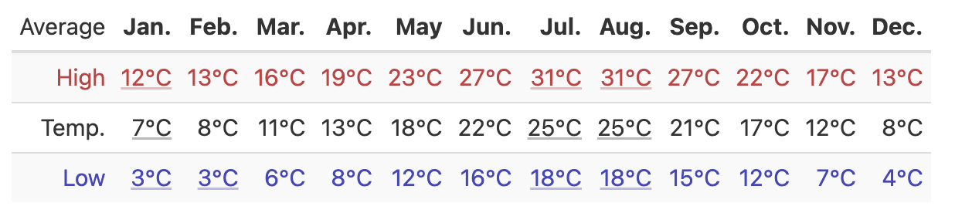
Mean ( Average)
Temperature

Insert your mean temperature data for your chosen destination in the space below.
.

Part 3: From the Weather Spark website add the following information for your chosen destination into the table below.

Monthly Temperatures:
Chosen destination: (Insert your chosen destination).
Weather Spark
 | Jan | Feb | Mar | Apr | May | Jun | Jul | Aug | Sep | Oct | Nov | Dec
High
Temp (average)
Low

Part 4: Using the mean temperature data in the table above, which two months would be most ideal for travel? Complete your answers in the table below.
Month | Average High | Average Low

Part 5: When are you going to travel? Based on the information you have collected, what month will you choose to travel to your chosen destination?
I have chosen (insert month) to travel to (insert your destination).

Task 3 –Holiday planning
Student Reflection - How well did you go with this step? (Please check the box below)
☐Not Submitted | ☐Beginning | ☐Consolidating | ☐Achieving | ☐Excelling
Student Comment (Optional):
Teacher Feedback
☐Not Submitted | ☐Beginning | ☐Consolidating | ☐Achieving | ☐Excelling
Not Submitted: No work has been submitted or attempted for this activity. | Beginning: I can attempt some aspects of this task.  To bump it up, you need to complete all sections of this task with basic responses. | Consolidating: I can provide basic responses to most sections of this task.  To bump it up, you need to recheck your answers and include more detail. | Achieving: I can provide detailed responses to most aspects of this task.  To bump it up, you need to add additional details with specific information to your responses. | Excelling: I can provide highly detailed responses with correct information to all sections of this task.
Teacher Comment:

Task 4- Flights and accommodation

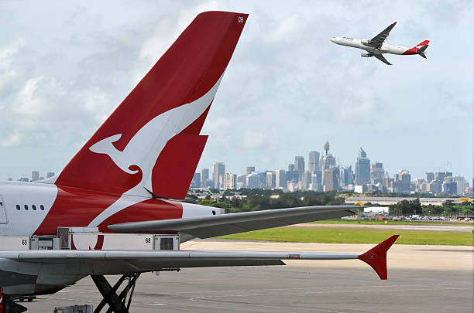

Learning goals & application
Learning Goal
1.1 Find common and familiar information and data inputs.
1.2 Read data outputs
1.3 Summarise information

Application
1.1 Input simple data into familiar apps
1.2 Read simple output data
1.3 Interpret simple output data

Task Checklist
Students will complete the following for Numeracy Focus Area: Systematics
☐ Task 4- Flights and accommodation

Part 1: In Task 3- Holiday planning you identified a location you wanted to travel to and what month would be best for the travel. Complete the questions below.

- What was your chosen destination?
- What month was the best month to travel?

Part 2: Flight research- Select your departure and return dates (Remember the dates must be in the month you identified as best to travel to your destination).
Use these popular flight booking sites in the tables below to compare the best options for flights to your destination. Screenshot your top results for each website.

Worked Example PRICELINE:
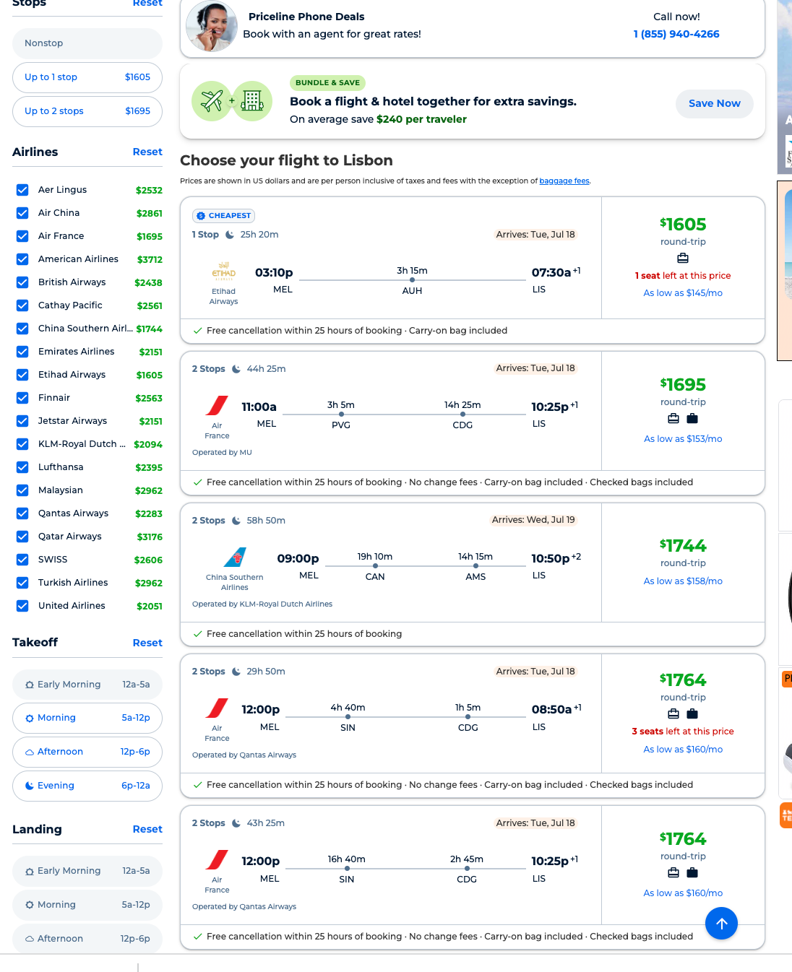
 Add your screenshot here.

Momondo

Add your screenshot here.

Skyscanner
Add your screenshot here.

Part 3: Based on the information you have gained above, select the best departure and return flight for you and fill in the details in the table below.
Hint- Take into consideration the following:
- Overall cost
- Trip duration
- Stopovers
- Airline Company

Departure Flight
Insert a screenshot of the selected flight here.

Airline
Departure airport | Melbourne International Airport
Departure date/time
Arrival date/time
Arrival destination

Return Flight
Insert a screenshot of the selected flight here.

Airline
Departure airport | Melbourne International Airport
Departure date/time
Arrival date/time
Arrival destination

Part 4: What is the total expense of your return flights?

Part 5: Select your travel dates and use these popular hotel booking sites to compare the best options for accommodation for your trip. Screenshot your top results for each website.
Worked example
ORBITZ
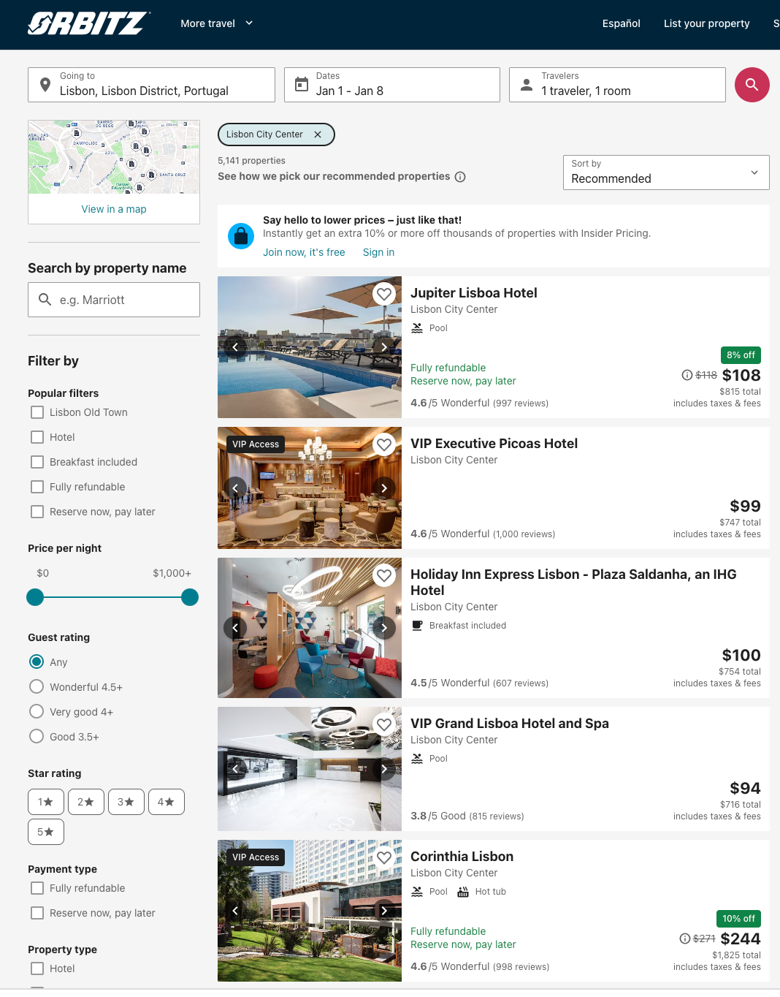

Booking.com
Add your screenshot here.

Your own choice (Air BnB, Expedia, Hostelworld)
Add your screenshot here.

Part 6: Think about the pros and cons of each accommodation. Select one and complete the table below.

Chosen accommodation name
Location
Check-in date
Check-out date
Cost

Part 7: Often on a holiday, most expenses come from both flights and accommodation. From the information you have collected above, calculate the total cost of the flights and accommodation.

Cost of flights | $_______
Cost of accommodation | $_______
Total = (flights + accommodation) | $_______

Task 4–Flights and Accommodation
Student Reflection - How well did you go with this step? (Please check the box below)
☐Not Submitted | ☐Beginning | ☐Consolidating | ☐Achieving | ☐Excelling
Student Comment (Optional):
Teacher Feedback
☐Not Submitted | ☐Beginning | ☐Consolidating | ☐Achieving | ☐Excelling
Not Submitted: No work has been submitted or attempted for this activity. | Beginning: I can attempt some aspects of this task.  To bump it up, you need to complete all sections of this task with basic responses. | Consolidating: I can provide basic responses to most sections of this task.  To bump it up, you need to recheck your answers and include more detail. | Achieving: I can provide detailed responses to most aspects of this task.  To bump it up, you need to add additional details with specific information to your responses. | Excelling: I can provide highly detailed responses with correct information to all sections of this task.
Teacher Comment:

Task 5- Memberships

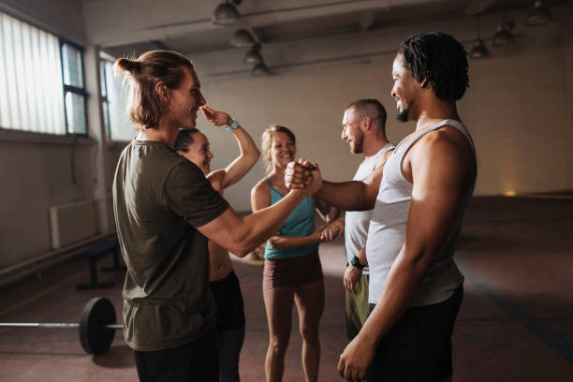

Learning goals & application
Learning Goal
1.1 place value and numbers up to 1000
1.2 whole number and monetary amounts up to 1000
1.3 addition and subtraction of whole numbers and familiar monetary amounts into the 100’s
1.4 common, simple unit fractions such as 1/2, 1/4 and 1/10.
Learning Application
1.1 identify place value and read whole numbers up to 1000
1.2 perform calculations of addition and subtraction with simple whole number amounts and familiar monetary amounts (into the 100s)
1.3 recognise and understand very common simple unit fractions, decimals and percentages

Task Checklist
Students will complete the following for Numeracy Focus Area: Number
☐ Task 5- Memberships

Part 1: Identify place value and read whole numbers and respond to the questions below.
Example
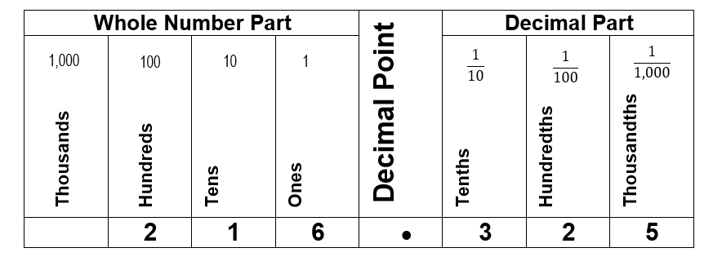
- Look at the number 582.74. What digit is in the ones place?

- What digit is in the hundredths place?

- What digit is in the hundreds place?

- What digit is in the tens place?

- What digit is in the tenths place?

- Write the number 582.74 in words.

Part 2: Understanding decimals, percentages, and fractions- Fill in the blank spots in the table with the correct decimal, percentage or fraction.
Decimal | Percentage | Fraction
Example:  0.25 | 25% | $$1/4$$
 | 75 %
 |  | $$1/2$$

Part 3: The local gym has three different types of memberships. The membership options are listed below. Use this information to complete the following questions.
Fun Membership  $10 per week | Active Membership  $20 per week | Power Membership  $30 per week

- In a week of operation, the local gym sells the following memberships. 50 Fun memberships, 30 Active memberships and 20 Power Memberships were sold. How many gym memberships were sold in total for the week?

Show your workings out.

- The gym sales for the week were as follows. $500 was from ‘Fun Memberships’, $600 from ‘Active Memberships’, and $700 from ‘Power Memberships’. How much did the gym earn on memberships in the week?

Show your workings out.

- Outgoings - The gym has the following expenses each week:
- Rent: $300
- Bills: $200
- Wages: $200
What is the total amount of the expenses each week?

Show your workings out.

- Profit - How much profit would the gym earn within the week?
The equation to use:
Profit = Sales - Outgoings

Show your workings out.

- Change in membership sales- The following week, the sales for the memberships changed slightly. The ‘Fun Membership’ increased by 14, the ‘Active Membership’ decreased by 2 and the ‘Power Membership’ increased by 8. Using the information from questions 1, how many of each type of gym memberships were sold in the second week?

Show your workings out.

Fun Membership:

Active Membership:

Power Membership:

- Total- Based on the information above, how many gym memberships were sold in total for the second week?

Show your workings out.

- Increase or decrease? From week 1 to week 2.
Using the information above did the total number of memberships sold in week 2 increase or decrease? How much did the membership increase or decrease?

Show your workings out.

Task 5–Memberships
Student Reflection - How well did you go with this step? (Please check the box below)
☐Not Submitted | ☐Beginning | ☐Consolidating | ☐Achieving | ☐Excelling
Student Comment (Optional):
Teacher Feedback
☐Not Submitted | ☐Beginning | ☐Consolidating | ☐Achieving | ☐Excelling
Not Submitted: No work has been submitted or attempted for this activity. | Beginning: I can attempt some aspects of this task.  To bump it up, you need to complete all sections of this task with basic responses. | Consolidating: I can provide basic responses to most sections of this task.  To bump it up, you need to recheck your answers and include more detail. | Achieving: I can provide detailed responses to most aspects of this task.  To bump it up, you need to add additional details with specific information to your responses. | Excelling: I can provide highly detailed responses with correct information to all sections of this task.
Teacher Comment:

Task 6- Moving Out & discounts


Learning goals & application
Learning Goal
1.3 changes and number matching with simple numbers. For example, prices increasing or decreasing, matching corresponding numbers.
Learning Application
1.1 recognise changes in numerical values such as prices increasing or decreasing with a common fixed price discount
1.2 number matching and comparison of simple numbers in context such as matching prices from receipts to on-the-shelf items

Task Checklist
Students will complete the following for Numeracy Focus Area: Change
☐ Task 6- Moving out

Part 1: You are moving out of home and renting a house with a friend. What items will you need to move out into a new place? Make a list with one other person you are house sharing with.

Part 2: You and your partner are to find the cheapest price for each of your items on the list above. Complete for a minimum of 5 items in the table below.
Hint- For furniture, think Fantastic Furniture, Kmart, Amart, furniture, eBay, gumtree, op shop, Facebook marketplace.

Add more rows to your table if needed.

Item | Cost 1 | Cost 2 | Price difference  (largest price) - (smallest price) | Comparative sentence  The (*insert the cheaper product) is cheaper than the (*insert more expensive product) by (insert price difference).
Example- Couch | Fantastic Furniture - $629  Add image of your choice of product in this column. | Kmart - $319  Add image of your choice of product in this column. | 629 - 319  = $310 | The K-Mart couch is cheaper than the Fantastic Furniture couch by $310.

Part 2: Discounts – Review the formula and example below for how to work out a discounted price. Then complete questions below for the different discount scenarios.
Formula steps and worked example
1.Convert the percentage discount to a decimal.

25.00%= 0.25

2.Multiple the original price by the decimal.

  - X 0.25 = 17.49

3.Subtract the discount from the original price.

69.95 – 17.49 = 52.46

Liam wants to buy some new noise cancelling headphones which are $449.95. They see that there is a sale now with 15% off. Liam used the following steps to work out how much the headphones will end up costing.
- 15%= 0.15
- 449.95 x .15 = 67.49
- 449.95 – 67.49 = 382.46
If Liam wants to buy the headphones, he will need to pay $382.46

- Sam went to the uniform shop to buy a shirt. The original cost of the shirt was $45. The shirt was on sale and was a further 10% off the original price.
Convert the percentage into a decimal-

Multiply the original price by the decimal-

Subtract the discounted price from the original price-

- Milla’s favourite shop is having a 50% off sale. Milla finds a pair of jeans that she loves and wants to buy. The original price of the jeans is $125.
Convert the percentage into a decimal-

Multiply the original price by the decimal-

Subtract the discounted price from the original price-

- Tom plans on buying a car. The original cost of the car is $7,500. The man selling the car will offer a 15% discount if Tom pays in cash.
Convert the percentage into a decimal-

Multiply the original price by the decimal-

Subtract the discounted price from the original price-

Task 6–Moving out
Student Reflection - How well did you go with this step? (Please check the box below)
☐Not Submitted | ☐Beginning | ☐Consolidating | ☐Achieving | ☐Excelling
Student Comment (Optional):
Teacher Feedback
☐Not Submitted | ☐Beginning | ☐Consolidating | ☐Achieving | ☐Excelling
Not Submitted: No work has been submitted or attempted for this activity. | Beginning: I can attempt some aspects of this task.  To bump it up, you need to complete all sections of this task with basic responses. | Consolidating: I can provide basic responses to most sections of this task.  To bump it up, you need to respond to all parts of the task. | Achieving: I can provide detailed responses to most aspects of this task.  To bump it up, you need to respond to all parts of the task with the required information. | Excelling: I can provide highly detailed responses with correct information to all sections of this task.
Teacher Comment:

Task 7- Patterns & Shapes



Learning goals & application
Learning Goal
1.1 pattern prediction with shapes
1.2 repeating patterns with one element
Learning Application
1.3 predict pattern continuation with shapes. For example, triangle, square repeating pattern
1.4 demonstrates repeating patterns with one element.

Task Checklist
Students will complete the following for Numeracy Focus Area: Change
☐ Task 7- Patterns & Shapes

Part 1: Complete the following patterns.

Triangle, Square, Triangle, Square, ___________
Circle, Triangle, Square, Circle, Triangle, ___________
Square, Square, Triangle, Triangle, Square, Square, ___________
Triangle, Circle, Square, Triangle, Circle, ___________
Circle, Circle, Triangle, Square, Circle, Circle, ________

Part 2: Complete the questions below on patterns.
- Tim plans on saving $2 more than the following week, every week for 6 weeks. Complete the pattern below for weeks 3, 4, 5, and 6.

Week 1 | Week 2 | Week 3 | Week 4 | Week 5 | Week 6
$2 | $4 | $_____ | $_____ | $_____ | $_____
- After the 6 weeks, how much would Tim have saved? Hint- add week 1, 2, 3, 4, 5, 6 together to get your total number.

- Fill in the gaps with the following to complete the pattern.

Week 1 | Week 2 | Week 3 | Week 4 | Week 5 | Week 6
$15 | $30 | $45 | $_____ | $_____ | $_____

- What is the pattern that you identified above? Include - increasing or decreasing and the amount by.
- Fill in the gaps with the following to complete the pattern.
Week 1 | Week 2 | Week 3 | Week 4 | Week 5 | Week 6
$100 | $80 | $60 | $_____ | $_____ | $_____
- What is the pattern that you identified above? Include - increasing or decreasing and the amount by.

- Fill in the gaps with the following to complete the pattern.
Week 1 | Week 2 | Week 3 | Week 4 | Week 5 | Week 6
$3 | $6 | $9 | $_____ | $_____ | $_____
- What is the pattern that you identified above? Include - increasing or decreasing and the amount by.
- Fill in the gaps with the following to complete the pattern.
Week 1 | Week 2 | Week 3 | Week 4 | Week 5 | Week 6
$3 | $6 | $9 | $_____ | $_____ | $_____

- What is the pattern that you identified above?

Part 3: In the classroom, find objects that you can use to create patterns. Create three different patterns using different objects. Take a photo and insert the images of these patterns you created below. Underneath each photo, write in words what the pattern is.
EXAMPLE
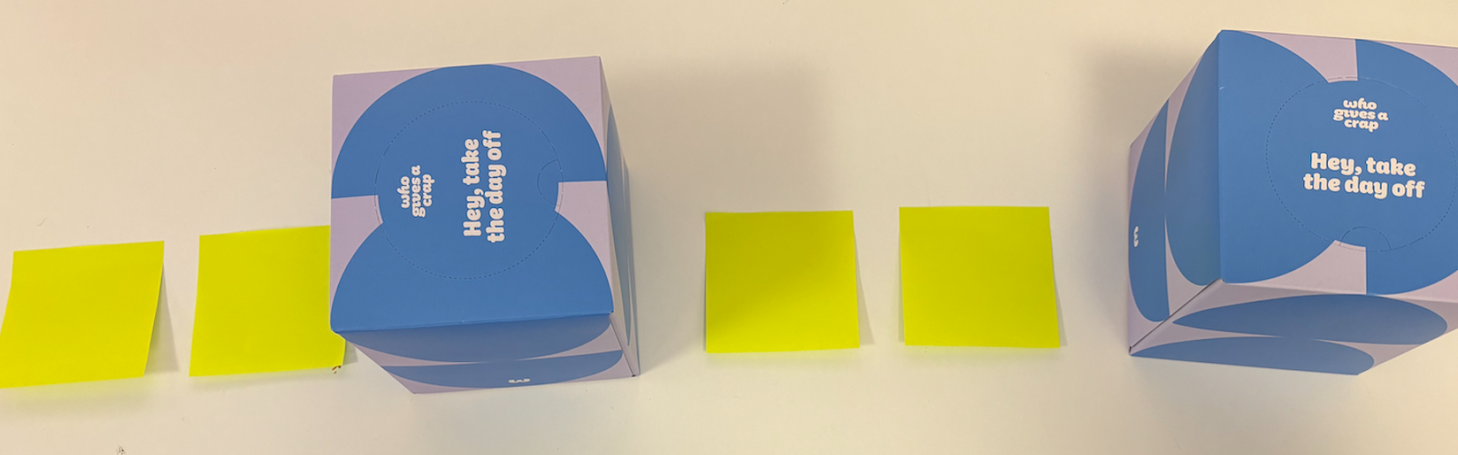

Photo 1:

Add photo here.

Written pattern-

Photo 2:

Add photo here.

Written pattern-

Photo 3:

Add photo here.

Written pattern-

Task 7–Patterns and shapes
Student Reflection - How well did you go with this step? (Please check the box below)
☐Not Submitted | ☐Beginning | ☐Consolidating | ☐Achieving | ☐Excelling
Student Comment (Optional):
Teacher Feedback
☐Not Submitted | ☐Beginning | ☐Consolidating | ☐Achieving | ☐Excelling
Not Submitted: No work has been submitted or attempted for this activity. | Beginning: I can attempt some aspects of this task.  To bump it up, you need to complete all sections of this task with basic responses. | Consolidating: I can provide basic responses to most sections of this task.  To bump it up, you need to respond to all parts of the task. | Achieving: I can provide detailed responses to most aspects of this task.  To bump it up, you need to respond to all parts of the task with the required information. | Excelling: I can provide highly detailed responses with correct information to all sections of this task.
Teacher Comment:

