2023 VCE Further Mathematics 1 (NHT) external assessment report

Specific information
This report provides sample answers or an indication of what answers may have included. Unless otherwise stated, these are not intended to be exemplary or complete responses.

Section A – Core
In 2023, the Core section comprised two components: Data analysis (Questions 1–16) and Recursion and financial modelling (Questions 17–24).
Question | Correct answer
1 | B
2 | E
3 | A
4 | C
5 | D
6 | A
7 | B
8 | D
9 | E
10 | C
11 | B
12 | C
13 | E
14 | E
15 | E
16 | B
17 | B
18 | B
19 | E
20 | A
21 | E
22 | C
23 | C
24 | A

Data analysis
Students generally answered the questions in the Data analysis section very well.

Question 9
 | Level of exposure
Symptoms | None | Limited | High | Total
Yes | 17 | 33 | 185 | 235
No | 72 | 73 | 120 | 265
Total | 89 | 106 | 305 | 500
As the level of exposure increases from none to limited to high, the number of workers with symptoms (yes) increased from 17 to 33 to 185 respectively. When these are converted to percentages, 19.1% of workers showed symptoms following no exposure, 31.1% of workers showed symptoms following limited exposure and 60.7% of workers showed symptoms following high exposure. The correct answer was E.
A number of students incorrectly chose D, which gives the percentage of workers with symptoms in each exposure level.

Recursion and financial modelling

Question 24
Three steps are required, as follows.
Step 1: Determine initial monthly repayment.
Use Finance Solver.
N = 15 × 12
I% = 3.64
PV = –440 000
PMT = SOLVE = 3175.82
FV = 0
P/Y = 12
C/Y = 12

Step 2: Determine the number of repayments required with the new monthly repayment
Use Finance Solver.
N = SOLVE = 159.99
I% = 3.64
PV = –440 000
PMT = 3175.82 + 299.52
FV = 0
P/Y = 12
C/Y = 12

Step 3: Determine the difference between the total amounts paid with each payment
3 175.82 x 160 – 3 475.34 x 160 = 571 647.60 – 556 054.40 = 15 593.20

Module 1 – Matrices
Question | Correct answer
1 | A
2 | D
3 | C
4 | E
5 | D
6 | B
7 | D
8 | C

Question 5
Write down all the possible routes between towns Y and V.
Single step: Y – V
Multiple steps via X: Y – X – W – V and Y – X – W – Z – V
Multiple steps via Z: Y – Z – V
There are four ways in total.

Question 8
Consider the following five statements.
- The highest number will always be at K. FALSE: in S₂ J=149 and K=145.
- All four numbers in matrix S₀ are equal. TRUE: all elements equal 100.
- 30% of workers at L one week will remain at L the following week. TRUE: t₃ ₃ = 0.3.
- Of those workers who started at J, 20 will still be at J two weeks later. FALSE: only 4 will still be at J two weeks later.
- In the long term, the number at K to the nearest whole number will be 152. TRUE.
Three statements are correct.

Module 2 – Networks and decision mathematics
Question | Correct answer
1 | E
2 | C
3 | C
4 | D
5 | B
6 | A
7 | D
8 | D

Question 8
A directed network diagram can help with this question.
From the directed network diagram, it can be seen that activities F, G, J and K all have two immediate predecessors.
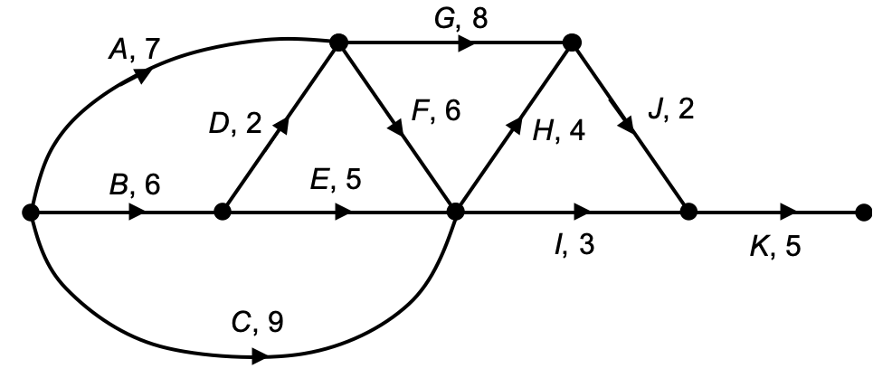

Module 3 – Geometry and measurement
Question | Correct answer
1 | C
2 | C
3 | E
4 | B
5 | B
6 | C
7 | D
8 | C
Students answered the questions in the Geometry and measurement module very well.

Module 4 – Graphs and relations
Question | Correct answer
1 | B
2 | E
3 | A
4 | D
5 | D
6 | E
7 | C
8 | C

Question 6
The four inequalities are:
$y-x≤0$
$x≤30$
$y+x≥40$
$4y+3x≤154$

Question 7
The objective function has a negative gradient. The maximum value could be any value along the line BC, including at the point B or C.

Question 8
Three steps are required:
Step 1: Determine the value of b and c.
When t=5, 2t =10, 10=3t+b, b=$-$5
When t=9, 3t$-$5 =22, 22=4t+c, c=$-$14

Step 2: Determine the total distance and time travelled.
Distance travelled away from burrow = 4a $-$14, time travelled = a
Distance travelled returning to burrow = 4a $-$14, time travelled = $\frac{4a-14}{5}$

Step 3: Determine the value of a.
Solving $53=a+\frac{4a-14}{5}, a=31$

