2023 VCE Specialist Mathematics 1 (NHT) external assessment report

Specific information

This report provides sample answers or an indication of what answers may have included. Unless otherwise stated, these are not intended to be exemplary or complete responses.

Question 1

Since , . Consider the triangle:

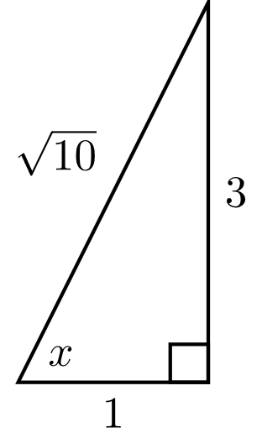

Since ,  and .

Then:



Alternative approaches can be used.

Question 2a.



Question 2b.



Question 2c.



Question 3ai.



Question 3aii.



Also,



The coordinates of the point of inflection are . This point is labelled on the graph.shown in 3b.

Question 3b.

Since



the stationary point occurs when



and



The coordinates of the stationary point are . The equation of the vertical asymptote is .

The stationary point and the vertical asymptote are shown on the graph.

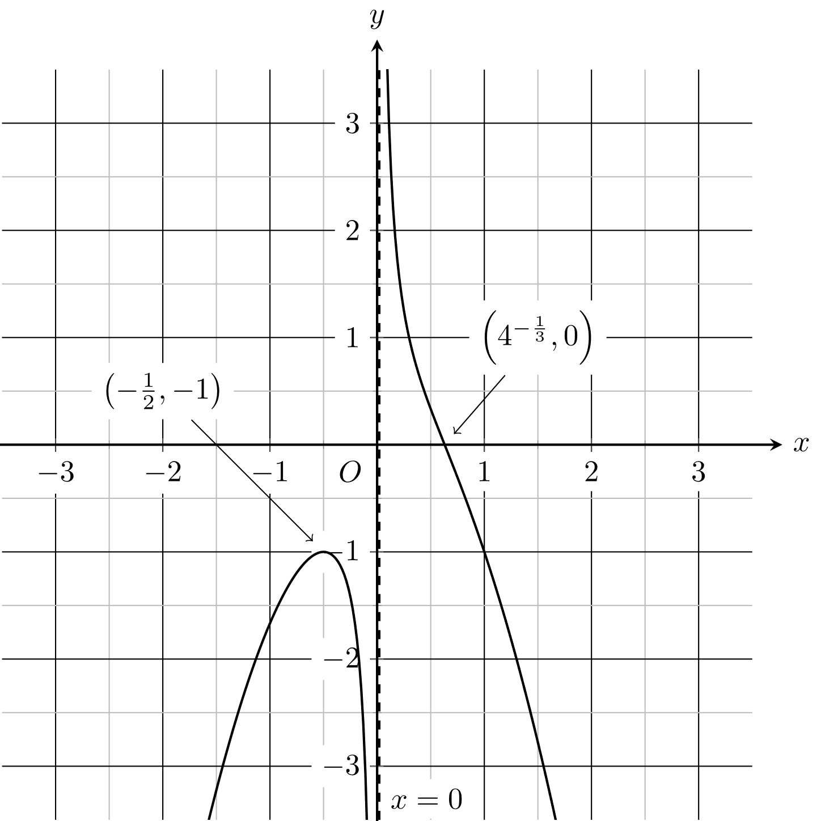

Question 4a.

The forces to be labelled on the diagram are the tension forces in the cables and the weight force:

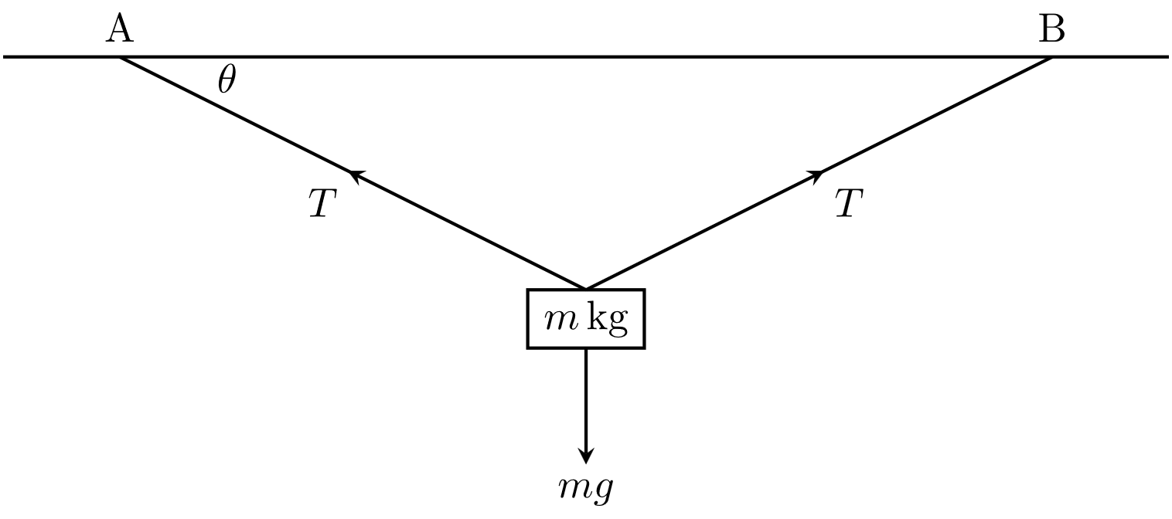

Question 4b.

 and so . Therefore,



Question 5a.



Alternatively, a geometric argument could be used. Knowing that  is a solution of  and that the other solutions lie on a circle of radius of  centred at the origin and separated by an angle of , the remaining solutions can be located.

Question 5b.

Consider the distance between any two points. For example,  and .

Distance is .

Alternative approaches (using, for example, the cosine rule) were acceptable.

Question 5c.



Question 6

. The length of the curve is





Question 7a.



When , 



Question 7b.

Terminal (limiting) velocity occurs when . Therefore, .

Alternatively, .

Question 8a.



Other approaches may also be used.

Question 8b.



Question 9a.



and so



Distance between starting positions is :



Question 9b.

Integrate to find :

.



As cyclists  and  meet, they must meet when



Then



and so



Question 10

There are two reasonable approaches:

Let . Then . When ,  and when , . Then



Or

Let . Then . When ,  and when , . Then



Now let  and so . When ,  and when , . Then

