2020 VCE Music Performance written examination report

General comments
In 2020 the Victorian Curriculum and Assessment Authority produced an examination based on the VCE Music Performance Adjusted Study Design for 2020 only. The examination consisted of three sections: Sections A, B and C. The large majority of students attempted all questions.
Section A – Listening and interpretation required consistent practice in listening to works and writing about them. This should commence from the very beginning of the school year and not be attempted as an intense unit of work. Following frequent, regular sessions discussing performances of works, teachers should introduce students over time to activities that require responding to works with time constraints as per examination conditions. Students need to read the question carefully to ensure that they are addressing the issues raised in the question: for example, taking note whether the question relates to the accompaniment. Some students highlighted the key terms in the questions to assist with this. Higher-scoring responses in Section A demonstrated a good understanding of the elements and the appropriate terminology. These responses were able to link the elements of music to the expressive outcome. Students need to ensure that the link between the expressive outcome and the element of music is logical. For example, it does not necessarily stand to reason that the accompaniment using guitars creates a relaxed mood. There may well be other factors that can be included to build the case. For example, the quality of the tone may contribute to the expressive outcome. Overall, students were able to highlight the expressive outcome quite successfully, but attention needs to be drawn to how the elements of music contribute to the expressive outcome. Students should become familiar with vocal and instrumental techniques and be able to use terminology appropriately.
Many students used a sharp pencil for Sections B and C, which is strongly advisable. Students should check the basics of music notation conventions and ensure there is no ambiguity in the pitch when writing notes on the staff. They should also check that any accidentals are written level with and before the note to which they apply. When an interval or chord is written and accidentals collide, it is customary to move the accidental slightly to the left to ensure accidentals do not overlap. Stems in scales proved problematic for some students. Stems are written up on the right side of the note, and down on the left side of the note. Generally, notes that are above the middle line of the staff are written with the stem going down, while notes that are written below the middle line of the staff are written with the stem going up.
When undertaking transcription questions, students are advised to complete their rough work on the blank manuscript paper provided and then transfer a neat, legible copy of their final response to the space provided for the answer.
Where possible, students should have access to appropriate aural training software and a computer music sequencer, especially to program rhythms, chords and chord progressions for aural practice. Class singing of melodies and performance of rhythms regularly is highly recommended to develop an understanding of the connection between the sound and the musical notation.

Specific information
This report provides sample answers or an indication of what answers may have included. Unless otherwise stated, these are not intended to be exemplary or complete responses.
The statistics in this report may be subject to rounding resulting in a total more or less than 100 per cent.

Section A – Listening and interpretation

Question 1
Marks | 0 | 1 | 2 | 3 | 4 | 5 | 6 | 7 | 8 | Average
% | 0 | 1 | 2 | 5 | 14 | 29 | 27 | 16 | 6 | 5.5
This question was broad, allowing students to draw on one or more of the elements of music listed. The highest-scoring responses referred to the changes of mood during the excerpt and how the elements of music were used to achieve this. Articulation proved problematic for some students. Students need practice in writing to develop their application of appropriate musical terminology. For example, a more appropriate word for a short sound might be ‘crisp’ rather than ‘sharp’, which has a different musical connotation. Students are encouraged to look at the full title of the work, as this may give a clue as to its character. Some students were able to link the clearly articulated triplets in the percussion to a sense of forward motion and urgency, like a horse race. Higher-scoring responses referred to the change to a foreboding mood created by the harmonics on the strings over a low pedal note and the cessation of the triplet pattern.

Question 2a.
Marks | 0 | 1 | 2 | 3 | 4 | Average
% | 1 | 7 | 31 | 47 | 15 | 2.7
This question required students to describe how the accompaniment contributed to the expressive outcomes. Students were required to refer to both the instrumental and vocal parts in the accompaniment.
Some students did not read the question carefully, focusing instead on the lead vocal part, which was not required, and referred only minimally to the instrumental accompaniment. Students must read the questions carefully to ensure they are addressing the requirements of the question. The highest-scoring responses were able to describe how the accompaniment, both instrumental and vocal, contributed to the expressive outcomes, referring to elements such as the heavily accented staccato bowing on the repeated string notes, the heavily accented bass drum sound giving rhythmic drive and the ‘ooh’, ‘ah’ and snatches of lyrics of accompanying vocal parts. The effect of silence, when the accompaniment dropped away leaving just the bass drum to accompany the voices, was noted by some students.

Question 2b.
Marks | 0 | 1 | 2 | 3 | 4 | Average
% | 2 | 12 | 39 | 37 | 10 | 2.4
Many students struggled with this question, which required a description of the vocalists’ use of articulation and improvisation/embellishment/ornamentation. This could include both the soloist and the backing singers. Many students did not have the terminology to describe the articulation and improvisation/embellishment/ornamentation. Regular listening with class discussions of appropriate terminology for these elements is required so that students can build up a vocabulary of terms that can relate to these elements of music. Detailed discussions of short excerpts enable students to focus on details and how to describe the treatment of the elements of music. Although onset can relate to articulation in general terms, students should develop an understanding of more specific techniques that can be used, such as use of runs, melisma, grace notes, slides, vocal fry and vibrato.
Higher-scoring responses were able to identify the semi-spoken rap style of the first voice as opposed to the more lyrical, legato articulation of the second voice providing the ‘ooh’ accompaniment at the beginning of the excerpt. High-scoring responses were able to note the changes at specific points in the excerpt of both the soloist and the backing vocalists: for example, in the chorus, the backing vocals using staccato articulation and the extensive use of melisma of the soloist.

Question 3
Marks | 0 | 1 | 2 | 3 | 4 | 5 | 6 | 7 | 8 | 9 | 10 | 11 | 12 | Average
% | 0 | 1 | 1 | 3 | 7 | 9 | 16 | 17 | 17 | 10 | 10 | 5 | 3 | 7.2
In their responses to this question, students had to refer to three of the following: tone colour, articulation, phrasing, ornamentation/embellishment/improvisation and balance of musical lines. This question required students to compare the ways in which the two interpretations created different expressive outcomes through these elements of music.
Responses presented comparisons in a range of formats. Some listed points evident in each interpretation. Others used a two-column format, aligning the descriptions of the specific features of each interpretation. The highest-scoring responses made a clear comparison between the two interpretations, linking the treatment of the three elements of music to the expressive outcomes.
Students are reminded to check the terminology associated with each of the elements of music to develop a clear understanding of what the elements of music mean.
The following are examples of possible relevant points.

Tone colour
Interpretation A:
- The acoustic guitar with single picked notes and bass guitar with light backing vocals create a relaxed mood.
- The bright tone colour of the vocals, accompanied by the high notes of the guitar in the chorus, create an uplifting mood.
- After the chorus, the solo guitar and occasional triangle notes create an uplifting mood.
Interpretation B:
- The female vocals use a much darker tone colour, with a gospel-style backing chorus to create a more soulful interpretation.
- When the female soloist uses her upper register, her tone increases in brightness, becoming quite piercing, adding to the intensity of the interpretation.
- The backing vocals use a warm, round vocal tone to add to the intensity.
- The full, round tone of the piano accompaniment adds to the soulful interpretation.
- At the end of the excerpt, the soloist uses a warmer tone colour in the singer’s lower register to create a more relaxed feel.

Articulation
Interpretation A:
- The male vocals are lyrical in style, but the phrases are short and not extended.
- The acoustic guitar in the instrumental section is clearly articulated in a finger picking of the melodic motif.
- The male vocal soloist often uses slides at the ends of short phrases to highlight the relaxed feel. The slides are both ascending and descending.
- The staccato notes of the guitar solo with detached notes in the accompanying parts add to the relaxed feel.
Interpretation B:
- The female soloist’s vowels are stretched for maximum melismatic effect, creating an improvisatory feel.
- The backing vocals use staccato to punctuate the solo line as well as legato ‘ahs’ to add to the intensity of the interpretation.

Phrasing
Interpretation A:
- The male vocals use short phrases that follow the regular eight-bar patterns in verse, chorus, etc., contributing to the relaxed feel. The short phrases, which include repetition of melodic material, add to the almost speech-like quality, reinforcing the relaxed feel.
Interpretation B:
- The female solo vocalist uses longer phrases, which adds to the intensity.
- The solo vocalist’s changing length of phrases contributes to the improvisatory, exploratory feel.
- The backing vocals using short declamatory phrases in a call and response add to the intensity by highlighting certain words.

Ornamentation/embellishment/improvisation
Interpretation A:
- Little vocal embellishment is used except for slides at the ends of the short phrases.
- Guitar provides some improvisatory material over the strumming guitar and bass, centred initially on one note before moving on to improvisation on the main melody.
- Backing vocals use phrases from the main melody on ‘ah’ to add to the relaxed feel.
Interpretation B:
- Extensive ornamentation is used by the solo vocalist to add to the intensity of the interpretation.
- The melodic line is altered, using upward inflection and improvisation in the higher register, using a belting tone.
- The final chorus and coda are heavily improvised and decorated in soul style.
- The piano improvisation towards the end of the excerpt creates a more relaxed mood.

Balance of musical lines
Interpretation A:
- The vocals are always clear, with harmonies balanced, sounding almost distant.
- The lead guitar takes centre stage in the introduction and instrumental interludes with the finger picked riff melody.
Interpretation B:
- The female soloist is always at the forefront, which adds to the intensity of the song.
- The backing vocals sing with or are complementary to the soloist, but very much in a secondary role. The backing vocals often highlight certain words, such as ‘weather’.
- The piano sounds independent of the vocals but supports the performers harmonically.
- The piano has a brooding character in the outro as it plays on its own.

Section B – Music language (aural)

Question 4
Marks | 0 | 1 | 2 | 3 | 4 | Average
% | 9 | 21 | 23 | 22 | 25 | 2.4
- The first interval was a perfect fifth.
- The second interval was a minor third.
- The third interval was a major third.
- The fourth interval was a minor sixth.
Many responses identified the first and last intervals correctly; however, the second and third intervals sometimes proved problematic. The second interval was played descending, then harmonically, then descending. The third interval was presented harmonically.
Students are reminded to practise hearing and identifying intervals that are presented harmonically, as well as to practise hearing intervals that are presented descending as well as ascending. To obtain full marks, both quality and quantity needed to be correct.
Students must avoid using ‘M’ or ‘m’ to indicate intervals, as this is unclear. If the interval was not clearly identified, it was deemed incorrect.

Question 5
Marks | 0 | 1 | 2 | 3 | 4 | Average
% | 3 | 14 | 24 | 26 | 33 | 2.7
- The first was a major scale.
- The second was a natural minor scale or aeolian mode.
- The third was major pentatonic scale.
- The fourth was dorian mode.
Many students were able to identify the major and major pentatonic scales. Students had to identify the major pentatonic rather than pentatonic on its own, as there needs to be a distinction between a major pentatonic scale and a minor pentatonic scale.
Some students experienced difficulty identifying the natural minor, confusing it with the mixolydian mode. The natural minor contains a minor third from the bottom note, whereas the mixolydian mode contains a major third from the bottom note. For full marks, the response had to identify the specific minor form (natural minor) so it could not be confused with harmonic minor and melodic minor scales. Identification of this scale as minor was marked as incorrect.
Many students were unable to identify the final question as a dorian mode, instead identifying it as a harmonic minor scale. Singing and writing of scales and modes should reinforce the main differences between the dorian mode and the harmonic minor scale. Compared to the harmonic minor scale, the dorian mode contains a raised sixth and a lowered seventh.

Question 6a.
Marks | 0 | 1 | 2 | 3 | Average
% | 15 | 23 | 23 | 38 | 1.9
- The first interval was a minor third.
- The second interval was a minor second.
- The third interval was a perfect fifth.
The interval in the middle of the melody sometimes proved problematic. Memorisation of the melody so that students can replay the melody silently in their head during the silent working time can assist in breaking the melody into sections to identify intervals. Identifying intervals in short melodies and then increasing the length of melodies could also assist. Students were required to identify both the quality and number of the interval to be awarded full marks.

Question 6b.
Marks | 0 | 1 | Average
% | 37 | 63 | 0.7
Many responses correctly identified the tonality of the melody as harmonic minor. Identification as minor was marked as incorrect, as the response did not identify the type of minor scale.

Question 7
Marks | 0 | 1 | 2 | 3 | 4 | Average
% | 16 | 22 | 24 | 22 | 16 | 2.0
- The quality of the first triad/chord was minor.
- The quality of the second triad/chord was dominant seventh.
- The quality of the third triad/chord was major seventh.
- The quality of the fourth triad/chord was half diminished seventh.
Responses generally showed a good command of chords.
Students need to practise recognising the quality of chords that are presented melodically as well as harmonically. Practise singing the individual notes when hearing a chord played harmonically to develop the skills to break the chord down into its individual notes and then analyse the intervals that are involved in each chord.
The third chord was sometimes identified as an augmented seventh chord. This chord is not included in the study design. Although this may have been incorrectly interpreted as an augmented seventh because the quality of the seventh is raised, as opposed to the minor seventh of the dominant seventh, it is a major seventh.
The recognition of the half diminished seventh chord that was presented melodically and harmonically proved challenging for many students. Some students confused the full diminished seventh chord with the half diminished seventh chord. The half diminished seventh chord has a minor seventh above the root, whereas the full diminished seventh chord has a diminished seventh above the root.
Writing of chords followed by singing of chords when learning them, focusing on the differences, should assist.
Again, ‘M’ or ‘m’ could not be accepted as a correct identification of major seventh or minor.

Question 8
Marks | 0 | 1 | 2 | 3 | 4 | Average
% | 19 | 18 | 21 | 18 | 24 | 2.1

Bass note | G | A
Quality | minor | major
The instructions in the question indicated that the final chords required formed a common cadence. The ability to hear that the piece sounded unfinished with the dominant note in the bass indicated an imperfect cadence, meaning it ended on the dominant or dominant seventh chord.
Although many students were able to hear that the second-last chord was minor in quality, some did not hear that the G bass note was the same note in chord 3. Students should practise following chord progressions, including the chords that are given in the question, following the bass line progression. The first chords are given as an aid. In the final two chords, the bass line ascended by step from G to A in the bass. Some students incorrectly identified the final chord as an A seventh chord. Students need to practise hearing whether a chord is based on a triad or is a seventh chord.

Question 9
Marks | 0 | 1 | 2 | 3 | 4 | 5 | 6 | 7 | 8 | Average
% | 4 | 8 | 15 | 20 | 16 | 14 | 10 | 6 | 7 | 3.9

Bass note | Bb | A | D | G
Quality | major | minor 7th | minor | minor 7
This progression proved to be quite difficult for some students. The first chord to be recognised had the bass line rising by a step from the given bass note, so it had to be a chord based on Bb. The bass line then went down by a step from the Bb, so it had to be an A bass line. Some students wrote B in the bass note instead of Bb for the first bass note to be identified, failing to remember that in the key of F major, it would be Bb as the chord progression will be diatonic, without any chromatic notes. Some students identified the quality of the chords incorrectly. A knowledge of chords in a key, for example, would identify as a chord based on D in the key of F major, to be a DFA chord, and therefore, minor in quality. Sometimes poor handwriting made it very difficult to differentiate between C and G. Many students did not identify the final chord as a minor seventh. Practising hearing whether seventh chords are used or not is vital, as is learning the quality of sevenths in both major and minor keys.

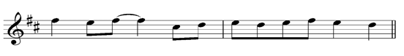
Question 10
Marks | 0 | 1 | 2 | 3 | 4 | 5 | 6 | 7 | 8 | Average
% | 18 | 13 | 9 | 10 | 9 | 9 | 4 | 6 | 23 | 3.9
Students need to look at the music to work out which type of scale the music is based on. In this case, it was the key of D major. This melody was quite easy to remember, so students are reminded that memorising the melody when it is played assists, as when the music is not being played, students can ‘replay’ the melody in their heads during the silent working time, slowing it down to work out intervals, etc. The melody progressed by ascending step from the last given note of E to F sharp. The only leap in the required transcription was from the F sharp descending to C sharp. The five bar flute melody started and ended on the same note, the tonic of D major. Some students did not recognise this when transcribing the last two bars.
When the rhythm is given, it is important to write notes that correspond to the given rhythm. For example, in the first bar requiring notation, the F sharp was tied to another F sharp. Some students did not check the rhythm above and wrote the rhythm incorrectly, ignoring the tied note.
Students need to ensure that stems follow the conventions of music notation. Using the correct pitch, in this case, stems needed to be going down on the left side of the notes.
Regular sight singing of melodies as well as completion of many examples of melodic transcription assists with the development of the skills required for this question type.

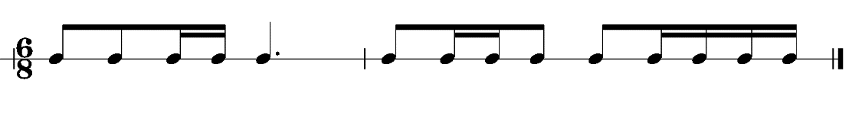
Question 11
Marks | 0 | 1 | 2 | 3 | 4 | Average
% | 28 | 17 | 12 | 15 | 28 | 2.0
Very few students were able to answer this correctly. Although 6/8 is compound duple time, with two dotted crotchet beats per bar, it can be useful to count six quaver pulses per bar, particularly when semiquavers are used. Many students incorrectly identified where the semiquavers occurred.
Students should check that their grouping of notes reflects the value of the beat. In this case, the notes should have been grouped to show the dotted crotchet beat.

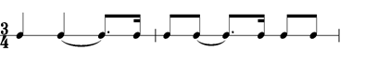
Question 12
Marks | 0 | 1 | 2 | 3 | 4 | 5 | 6 | Average
% | 12 | 23 | 33 | 12 | 7 | 3 | 10 | 2.3
This transcription task proved problematic for many students. Although most students were able to correctly identify the first two beats of the first bar to be transcribed (bar two of the rhythm), many did not hear that there was no sound on beat three with a semiquaver at the end of the bar. This should have been written as a tie or a rest to the crotchet of bar two. Beat three should have included a tied dotted quaver followed by a semiquaver. The second bar of the transcription proved more difficult; many students again did not hear that although there were two quavers at the beginning of the second bar to be transcribed, there was no sound on beat two, with the same pattern as in the first transcription bar.
Students are advised to practise clapping rhythms that include various groupings of semiquavers and quavers in complex patterns, including examples of syncopation, to prepare for this type of question.

Section C – Music language (written)

Question 13
Marks | 0 | 1 | 2 | 3 | Average
% | 6 | 8 | 20 | 66 | 2.5
- The first interval was a major seventh.
- The second interval was a minor third.
- The third interval was a minor seventh.
Most students were able to identify the first interval correctly as a major seventh. The following intervals proved problematic for many students. When working out intervals, it can be useful to work out the number of the interval first, then think of the major key of the bottom note, and then work out if the top note belongs to the bottom note major scale (in which case it will be named as major or perfect) and if not, how the note has been altered. For example, the Ab to Cb: Ab to C is a third; Ab major contains the note C, so the note Cb had lowered the C by a semitone, thus it is a minor third.

Question 14
Marks | 0 | 1 | 2 | 3 | Average
% | 16 | 16 | 22 | 46 | 2.0
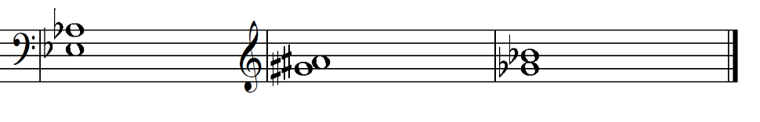
This question was handled reasonably well.
Students need to read the instructions carefully. The question required students to write the intervals using semibreves. Some students chose to colour in the notes, thus making their answer incorrect. There was also some confusion of clefs. Before writing notes on the staff, students should always check whether it is using a treble or bass clef.
Many students omitted the relevant accidentals. For example, the first question required students to write a perfect fourth below Ab. Writing A without the flat rendered the response incorrect. Many students had difficulty writing a major third below Bb, leaving the answer as G. G to Bb is a minor third, so to make it a major third below Bb, Gb needed to be written.
Writing of accidentals was difficult for some students, particularly the major second above G sharp, which required an A sharp. If notes are next to each other on the staff, it is customary to write the second note just after the first, rather than directly on top. This allows the accidentals to be written without overlapping each other. Clarity of notation is important. Accidentals should be level with the note to which they apply. So, if a note is written on the second line, for example, the accidental needs to be written on the second line also. Accidentals need to be written before the note to which they apply, not after.

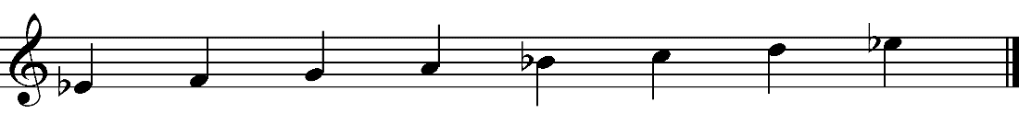
Question 15a.
Marks | 0 | 1 | 2 | 3 | Average
% | 15 | 22 | 11 | 53 | 2.0
or
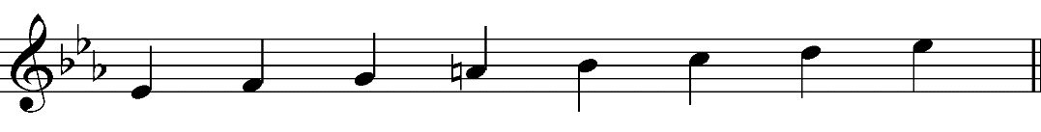
This question was generally handled well. Two marks were awarded for correct notes and one mark for correct stems and direction of scale. Correct accidentals or appropriate key signatures were accepted.
Some students wrote in a key signature – for example, Eb major – and then omitted to raise the fourth degree of the scale. With the key signature of Bb, Eb and Ab, an A natural was required to cancel out the Ab in the key signature. When writing natural signs, students need to ensure that they are distinct from sharps. Use of the Bb major key signature was acceptable, as the Lydian mode of Eb can be thought of as the scale of Bb major starting on the subdominant. In this latter case, no accidentals were required.
Students are reminded to adhere to the conventions of musical notation, including appropriate stem direction.

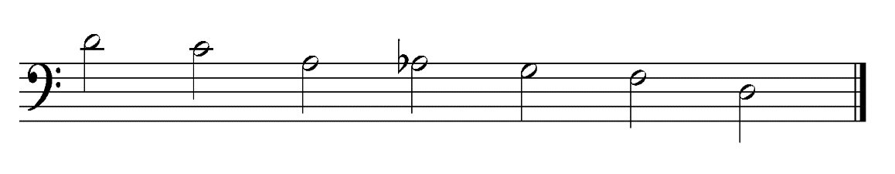
Question 15b.
Marks | 0 | 1 | 2 | 3 | Average
% | 17 | 41 | 2 | 40 | 1.7
or
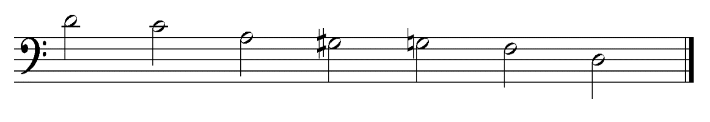
The descending blues scale starting on D proved problematic for many students. If students learn scales in ascending form, it can be useful to write it out on the working paper ascending to the top D, then write it backwards, from the top D, so it forms the descending form. Two forms were accepted: A – Ab , or A followed by G sharp and G natural.
Two marks were awarded for correct notes and one mark for correct stems and direction of scale.

Question 15c.
Marks | 0 | 1 | 2 | 3 | Average
% | 16 | 16 | 11 | 57 | 2.1
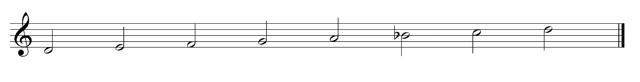
or
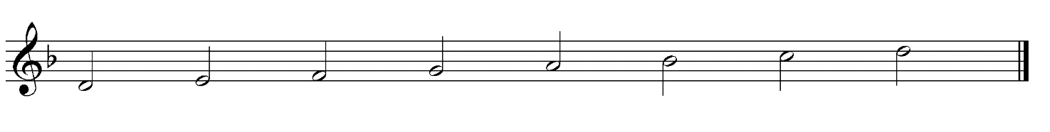
Some students had difficulty writing the natural minor scale starting on D. The natural minor can be thought of as a harmonic minor scale without the raised seventh. Some students chose to write the key signature of Bb, which was correct, as the relative major of D minor is F major. In this case, no accidentals were required.
Two marks were awarded for correct notes and one mark for correct stems and direction of scale.

Question 16
Marks | 0 | 1 | 2 | 3 | Average
% | 41 | 23 | 24 | 12 | 1.1

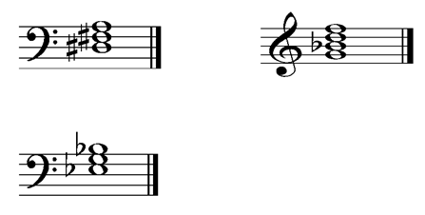
Students were required to write chords in given keys.
The first chord was a triad built on VII in the key of E minor, which happens to be diminished in quality. Many students wrote a seventh chord. The identification of the chords to be written explains the quality of each chord. The second example required a seventh chord based on II of F major. This happens to be a minor seventh chord. Some students were confused by the additional information given. Students need to work out the chord based on the degree of the scale that is stipulated, checking if a triad or seventh chord is required. Students then need to insert the appropriate accidentals that belong to the stipulated key. Many students did not remember that Bb major contains Bb and Eb, so any chord built on Eb would be Eb, G and Bb, not EGB. The appropriate key signature saves students from writing accidentals.

Question 17
Marks | 0 | 1 | 2 | 3 | 4 | Average
% | 23 | 7 | 12 | 20 | 27 | 2.2

Diatonic function | Submediant  (or VI or 6) | Leading note  (or VII or 7)
Quality | major seventh | full diminished seventh
Responses had to identify the diatonic function in the key of G minor of two chords as well as whether they were a triad or seventh chord and the quality of the triad or seventh chord.
Many students were able to identify the diatonic function of each chord. The identification of the quality of the chords was problematic for many students. Students are encouraged to work out the intervals that are contained in each chord when analysing written chords. For example, the first chord contained Eb, G, Bb and D. This is a major chord with a major seventh, so it is called a major seventh chord. Many students did not take note of the key signature and interpreted the first chord as EGBD, therefore giving the answer as minor seventh. Students must check the key signature if it is used and it applies to any of the notes of the chords.
Although roman numerals or numbers are accepted as identifying the diatonic function of a chord, when using technical names (for example, submediant or subdominant), students need to check that they have a sound knowledge of the names. Subtonic is not acceptable as a response.

Question 18a.
Marks | 0 | 1 | Average
% | 27 | 73 | 0.8
Most students were able to identify the time signature as 6/8, as they noted that the rhythms were grouped to show two dotted crotchet beats per bar.

Question 18b.
Marks | 0 | 1 | Average
% | 33 | 67 | 0.7
Students were required to select the scale or mode that was used in the excerpt. The G sharp and A sharp ascending, followed by the A natural and G natural (that is, the raised sixth and seventh, followed by the lowered sixth and seventh) was an indication of B melodic minor scale.

Question 18c.
Marks | 0 | 1 | Average
% | 67 | 33 | 0.4
Identification of the chord in bar four indicated by the box required students to work out the names of the notes. In this case, they were G, B, D and F sharp. Although some students identified the chord as major seventh, the full naming of the chord was G major seventh, as it includes the name of the note upon which the chord is built.

Question 18d.
Marks | 0 | 1 | Average
% | 40 | 60 | 0.6
The interval in the trumpet part indicated by a bracket was a D descending to B. Many students were unable to identify the interval as a minor third. Even if an interval is descending, the interval is always worked out by taking the bottom note and working up (that is, B up to D is a minor third regardless of which of the two notes are played first).

