NAPLAN Online 2021 conventions of language – new test design
The below information has been taken from the 2021 NAPLAN Online Test Administration handbook and supplemented by a screen snippet and additional messaging.

Composition
This test is composed of two parts (or ‘sections’): grammar and punctuation followed by spelling.

The spelling test will only be available to students after they have completed the grammar and punctuation test. Students will not be able to return to the grammar and punctuation questions once they have moved on to the spelling questions. A message screen (see below) at the end of the grammar and punctuation test will remind them of this. Students will need to be reminded to check they have completed all grammar and punctuation questions before moving on to spelling. Monitor students as they move from one section of the test to the other.

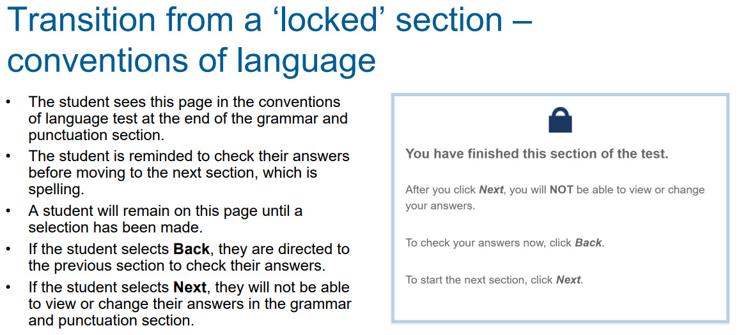

Timing
There are 52 questions in the test: 27 questions in the first part and 25 questions in the second. Students will have 45 minutes to complete all the questions. Some students will need more time on grammar and punctuation as there is more to read in that section than in the spelling section. Teachers should provide guidance based on knowledge of their students’ abilities.

There is a timer in the top left-hand corner of the student’s screen. When the timer says 25 minutes, students should be close to finishing the first section, which finishes at question 27, and be getting ready to move onto the second section.

For further information
Please see Test administration: conventions of language (page 30) of the Years 3 & 5 NAPLAN Online test administration handbook 2021. Also, the NAP website https://nap.edu.au and the PDF NAPLAN Online branching messages

