Levels 9 and 10: Continuity and Change – Student Handout

Activity 1
- What do you think continuity means?
- What do you think change means?
- Examine the following photographs carefully. Can you identify examples of continuity and change between the two photos?
- Image 1 is a photograph of a living room from c.1907.
- Image 2 is a photograph of a living room in 2020.
Hint: Draw two columns, with one column headed ‘Continuities’ and the other ‘Changes’, to allow you to set out your observations clearly.
Image 1
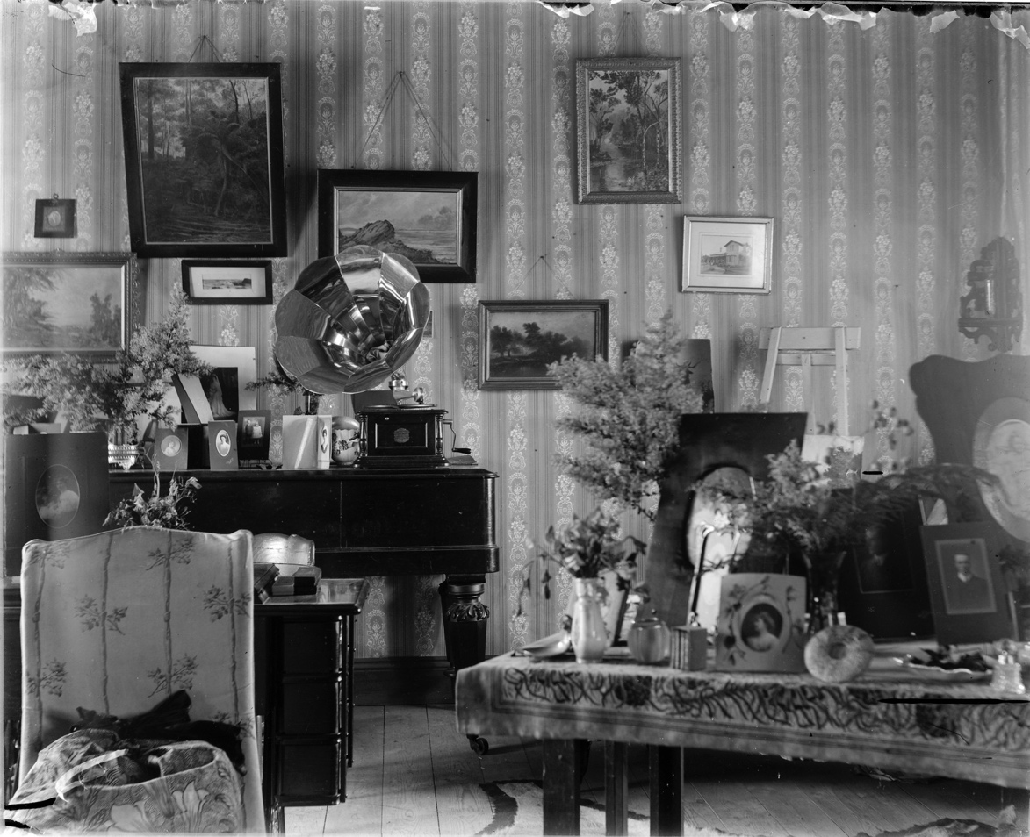

Image 2
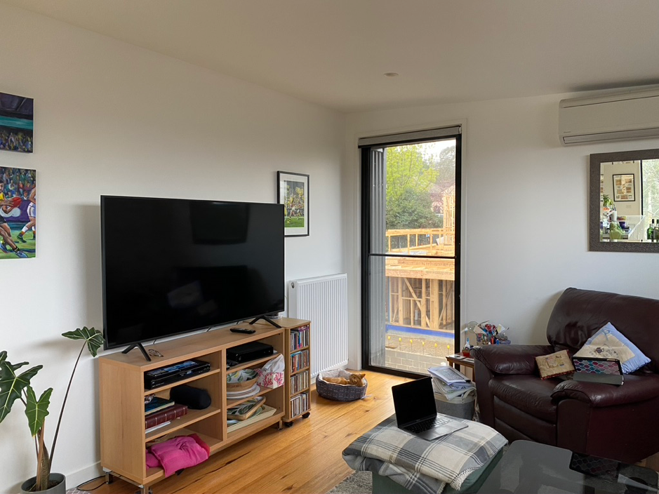

Activity 2
To complete this activity, download the PDF document ‘4102 – Australian Social Trends’ from the Australian Bureau of Statistics website.
With a partner, examine the section called ‘20th Century: beginning and end: Population Characteristics’ on pages 6 to 10 and answer the following questions:
- Identify three to five aspects of Australian society in 1900.
- Evaluate each of these aspects by comparing them in 1900 and in 2000.
- Create a table that outlines how these aspects of Australian society have stayed the same (continuity) and/or have changed.
- What do you think were the causes of the changes?
- What do you think were the reasons that some things remained the same?
Note: the document is focused mostly on change, but by reading closely you will recognise that some things can also be said to have ‘stayed the same’ (e.g. the majority of Australians still declare an affiliation with the Christian religion).

