Level 3 – Number and Algebra

Overview
Task name What is my place?
Learning intention To read, order and represent numbers up to 10 000
Duration 30 minutes

Links to Victorian Curriculum
These work samples are linked to Level 3 of the Mathematics curriculum.

Extract from achievement standard
Students count and order numbers to and from 10 000 … They classify numbers as either odd or even, continue number patterns involving addition or subtraction, and explore simple number sequences based on multiples.

Relevant content descriptions
- Investigate the conditions required for a number to be odd or even and identify odd and even numbers (VCMNA129)
- Recognise, model, represent and order numbers to at least 10 000 (VCMNA130)
- Apply place value to partition, rearrange and regroup numbers to at least 10 000 to assist calculations and solve problems (VCMNA131)
- Describe, continue, and create number patterns resulting from performing addition or subtraction (VCMNA138)

Links to NAPLAN

Minimum standards – numeracy
Year 3: Number – Whole numbers
Students read, recognise and count with whole numbers up to three digits. For example, students can generally:
- recognise three-digit numbers in words and symbols
- recognise odd and even numbers
- make given numbers larger or smaller by 1, by 10 or by 100
- count forwards and backwards by 1s, 2s, 5s and 10s
- skip count by 2s, 5s and 10s.
Students compare and order whole two-digit numbers. They use place value knowledge up to the hundreds to interpret different representations of whole numbers. For example, students can generally:
- compare and order two-digit numbers
- partition one- and two-digit numbers in different ways
- recognise different standard representations of numbers in hundreds, tens and ones.

Student work samples − Number patterns
These work samples were created by students working at
Level 3. Evidence of student achievement has been annotated.

Victorian Curriculum link
Describe, continue, and create number patterns resulting from performing addition or subtraction (VCMNA138)

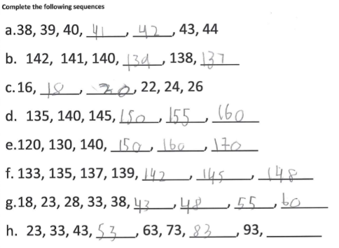
Complete the following sequences.

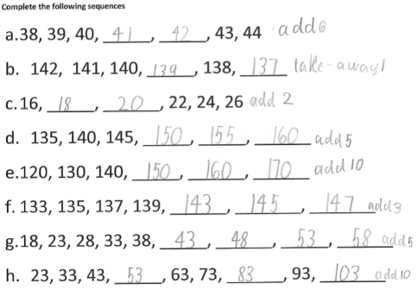
Complete the following sequences.

Continues counting pattern, increasing by 1
Identifies the numbers before and after counting by 1 up to 1000
Continues skip counting pattern by 2, 5 and 10 from a non-zero starting point
Skip counts by 2, 5 and 10 in
a pattern from a non-zero starting point

Skip counts by 10, from 23 up to 93

Identifies pattern operations

Skip counts by 10 from a non-zero starting point up to 1000

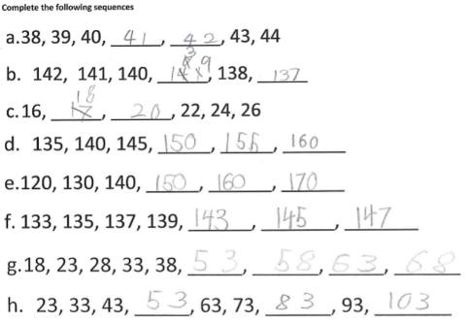
Complete the following sequences.

Begins counting forward, then self-corrects to decrease by 1

Counts forward by 1, then self-corrects and identifies pattern as counting forward by 2
Skip counts by 2, using 143 as the starting point

Skip counts by 5, although does not continue from 38

Student work samples − Place value
These work samples were created by students working at
Level 3. Evidence of student achievement has been annotated.

Victorian Curriculum links
Apply place value to partition, rearrange and regroup numbers to at least 10 000 to assist calculations and solve problems (VCMNA131)
Recognise, model, represent and order numbers to at least 10 000 (VCMNA130)

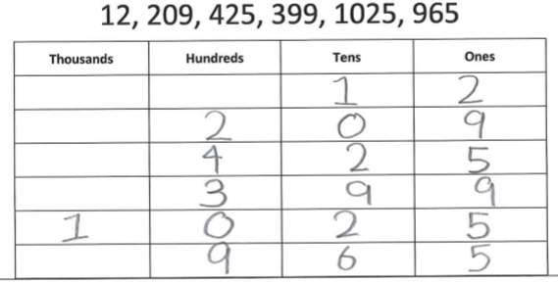
Write the following numbers in their correct place.

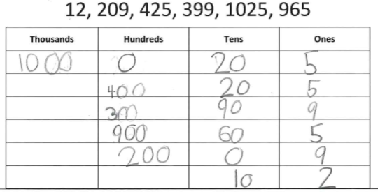
Write the following numbers in their correct place.

Partitions numbers using place value

Identifies in the numbers 209 and 1025 that zero is used hold place value

Expands numbers by listing components instead of partitioning

Write the following numbers in their correct place.
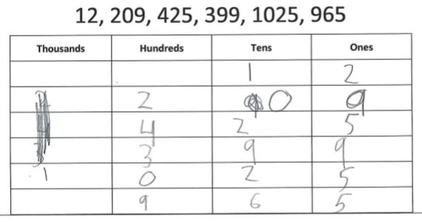

Write the following numbers in their correct place.
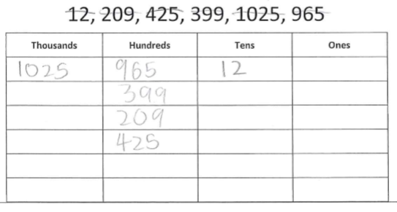

Orders numbers from left to right starting in the thousands column then corrects

Sorts numbers into columns according to largest place value instead of partitioning

Order these numbers from smallest to largest.
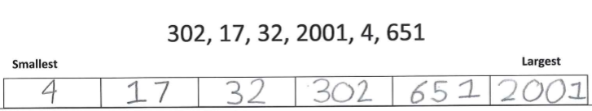

Order these numbers from smallest to largest.
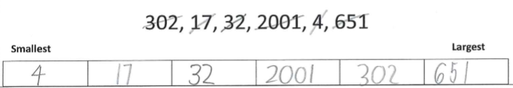

Orders numbers in ascending order to at least 10 000

Identifies and orders numbers to 999 but then misplaces 2001 between 32 and 302, identifying 2001 as 201

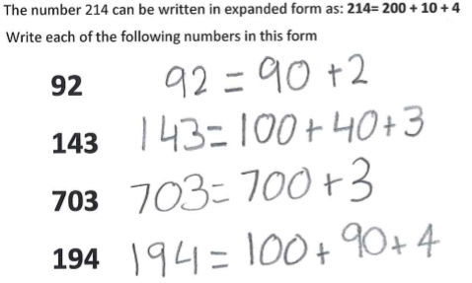

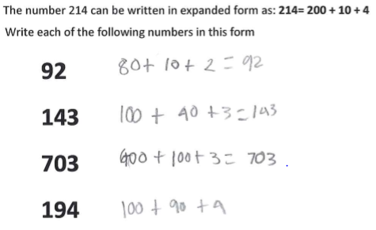

Records numbers in expanded form, identifying correct place value up to 1000

Identifies that there is a zero in the tens column for 703

Records some numbers in expanded form, identifying correct place value to 1000, but partitions some numbers by adding up to the required number

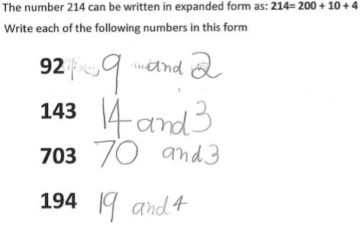

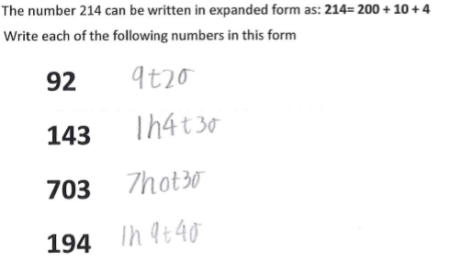

Partitions whole numbers into distinct groups to create separate numbers, instead of recording numbers in expanded form

Uses the word ‘and’ instead of the operations

Correctly expands numbers using ‘h’, ‘t’, ‘o’ (hundreds, tens, ones) abbreviations

The number thirty-two can be written using numerals as: 32
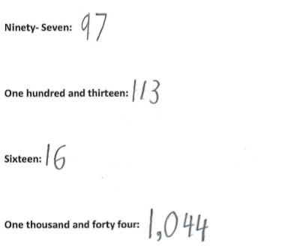
Write each of the following numbers using numerals.

The number thirty-two can be written using numerals as: 32
Write each of the following numbers using numerals.

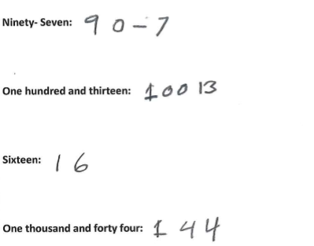

Provides numerical representations of a number in words up to thousands

Writes ‘teen’ numbers in the correct order

Identifies the place value of a zero in a word representation

Provides numerical representations of a number in words up to hundreds

Misrepresents numbers expressed in words containing ‘and’

The number thirty-two can be written using numerals as: 32
Write each of the following numbers using numerals
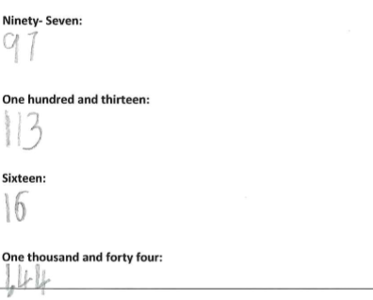

The number thirty-two can be written using numerals as: 32
Write each of the following numbers using numerals
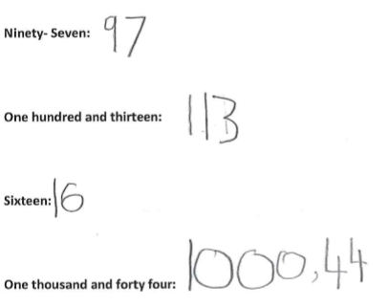

Reproduces numbers in words using their numerical representations up to 999

Does not count ‘zero’ as a place holder for 100

Reproduces numbers in words using their numerical representations up to 999

Represents as two separate numbers without attention to place value

The number thirty-two can be written using numerals as: 32
Write each of the following numbers using numerals.
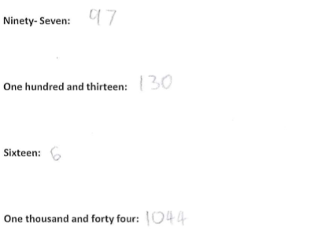

Does not relate number value to ‘teen’

Identifies the place value of a zero in a word representation

Student work samples − Odd or even
These work samples were created by students working at
Level 3. Evidence of student achievement have been annotated.

Victorian Curriculum link
Investigate the conditions required for a number to be odd or even and identify odd and even numbers (VCMNA129)

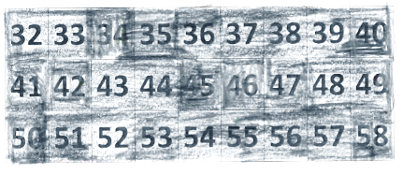
Colour in the odd numbers.

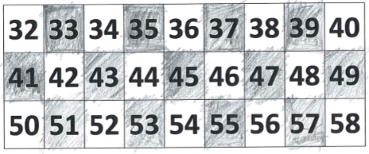
Colour in the odd numbers.

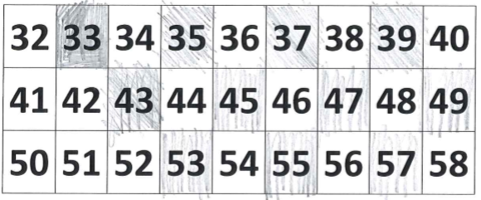
Colour in the odd numbers.

Colours in all numbers without distinguishing between odd and even numbers

Correctly colours in all odd numbers

Colours most of the odd numbers, leaving out the 1s (41, 51)

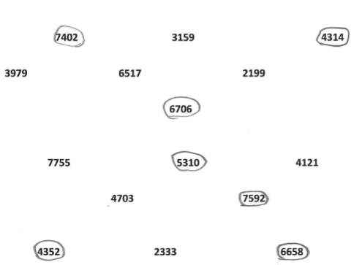
Circle all of the even numbers.

Circle all of the even numbers.
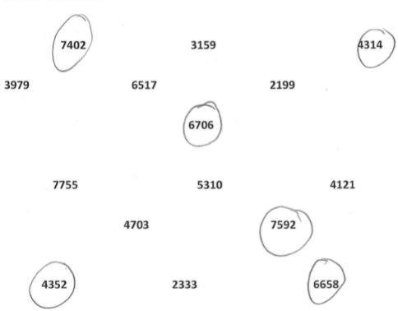

Identifies all even numbers from a random selection up to 10 000

Identifies the final digit as the influencing factor

Identifies a number ending in zero as even

Identifies all even numbers except the number ending in zero

Circle all of the even numbers.
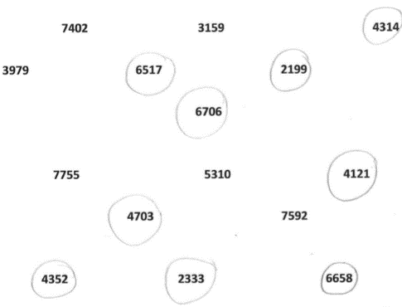

Circles a selection of odd and even numbers

Where to next for the teacher?
When the task on which these annotated student work samples is based has been used as a classroom activity, there is opportunity to gather data on student achievement to help inform further teaching.
An analysis of student responses, on an individual, group or whole class basis, can be used to develop and direct student learning with respect to the following content.

For students needing to review underpinning knowledge and skills at Level 2
- Investigate number sequences, initially those increasing and decreasing by twos, threes, fives and ten from any starting point, then moving to other sequences (VCMNA103)
- Recognise, model, represent and order numbers to at least 1000 (VCMNA104)
- Group, partition and rearrange collections up to 1000 in hundreds, tens and ones to facilitate more efficient counting (VCMNA105)
- Describe patterns with numbers and identify missing elements (VCMNA112)

For students consolidating knowledge and skills at Level 3
- Apply place value to partition, rearrange and regroup numbers to at least 10 000 to assist calculations and solve problems (VCMNA131)
- Describe, continue, and create number patterns resulting from performing addition or subtraction (VCMNA138)

For students moving on to new knowledge and skills at Level 4
- Investigate and use the properties of odd and even numbers (VCMNA151)
- Recognise, represent and order numbers to at least tens of thousands (VCMNA152)
- Apply place value to partition, rearrange and regroup numbers to at least tens of thousands to assist calculations and solve problems (VCMNA153)
- Recognise that the place value system can be extended to tenths and hundredths. Make connections between fractions and decimal notation (VCMNA159)

Resources
- Numeracy Learning Progressions, Victorian Curriculum and Assessment Authority (VCAA) –The Numeracy Learning Progressions amplify, extend and build on the numeracy skills in the Victorian Curriculum F–10: Mathematics and support the application of numeracy learning within other learning areas.
- FUSE, Victorian Department of Education and Training (DET) – The FUSE website provides access to digital resources that support the implementation of the Victorian Curriculum F–10, including an extensive range of activities and other resources for Primary Mathematics and Secondary Mathematics.
- Mathematics Curriculum Companion, Victorian Department of Education and Training (DET)
- Aligned Australian Curriculum Resources (Mathematics), Australian Curriculum, Assessment and Reporting Authority (ACARA)

