Level 5 – Number and Algebra

Overview
Task name What is missing?
Learning intention To find unknown quantities in a sentence
Duration 30 minutes

Links to Victorian Curriculum
These work samples are linked to Level 5 of the Mathematics curriculum.

Extract from achievement standard
Students solve simple problems involving the four operations using a range of strategies including digital technology. They estimate to check the reasonableness of answers and approximate answers by rounding … They find unknown quantities in number sentences …

Relevant content descriptions
- Use estimation and rounding to check the reasonableness of answers to calculations (VCMNA182)
- Solve problems involving multiplication of large numbers by one- or two-digit numbers using efficient mental, written strategies and appropriate digital technologies (VCMNA183)
- Solve problems involving division by a one digit number, including those that result in a remainder (VCMNA184)
- Use efficient mental and written strategies and apply appropriate digital technologies to solve problems (VCMNA185)
- Use equivalent number sentences involving multiplication and division to find unknown quantities (VCMNA193)

Links to NAPLAN

Minimum standards – numeracy
Year 5: Algebra, function and pattern
Equivalence
Students solve simple number sentences arising from familiar situations. For example, students can generally:
- recognise the number sentence that matches a familiar situation
- recognise equivalence in familiar contexts (e.g. balance scales)
- solve one-step number sentences involving simple calculations.

Relationships
Students make links between arithmetic operations based on familiar properties. For example, students can generally:
- make links between routine multiplication and division facts
- use known facts to work out related calculations
- make changes to computations that maintain equivalence.

Year 5: Number
Calculating
Students recall addition and subtraction facts with one- and two-digit numbers and link to routine multiplication and related division facts. They add and subtract whole numbers to hundreds and decimal fractions with the same number of decimal places, and multiply one-digit numbers. For example, students can generally:
- recall addition and subtraction facts of small numbers
- identify and use known number facts to assist calculations
- multiply small whole numbers …

Student work samples – Unknown quantities
These work samples were created by students working at
Level 5. Evidence of student achievement has been annotated.

Victorian Curriculum links
Solve problems involving multiplication of large numbers by one- or two-digit numbers using efficient mental, written strategies and appropriate digital technologies (VCMNA183)
Solve problems involving division by a one digit number, including those that result in a remainder (VCMNA184)
Use efficient mental and written strategies and apply appropriate digital technologies to solve problems (VCMNA185)
Use equivalent number sentences involving multiplication and division to find unknown quantities (VCMNA193)

Find the missing numbers in the following number sentences. Explain and show your thinking in the space below.
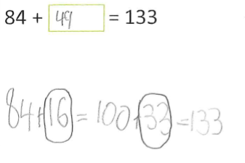
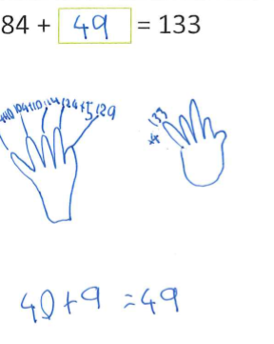

Partitions numbers to calculate answer

Adds 16 to get from 84 to 100, then adds 33 to get to 133

Identifies 16 and 33 as numbers to be added, which gives the answer 49

Uses a diagram to show skip counting as an efficient mental strategy, skip counting by 10
to 124

Continues by adding 5 to make 129, then 4 to make the required amount of 133

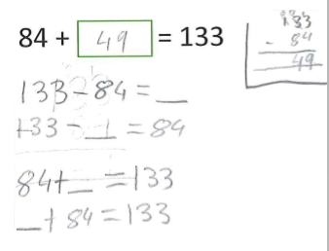

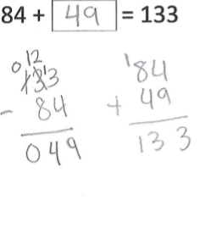

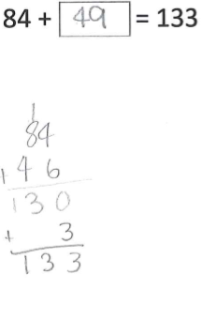

Uses vertical subtraction with regrouping, and then erases and rewrites equation demonstrating calculation

States inverse operations with addition and subtraction

Uses vertical subtraction algorithm with regrouping in the hundreds, tens and ones columns to calculate the missing number

Checks reasonableness of
the answer using inverse operation

Uses vertical addition algorithm with regrouping to add number to 130

Adds 3 more to reach 133

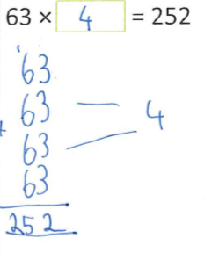
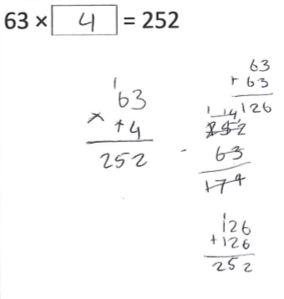
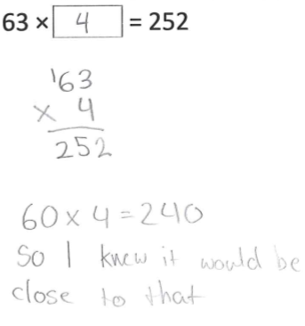

Uses repeated addition in a vertical algorithm with regrouping to count 4 × 63 to make 252

Connects repeated addition and doubling to multiplication

Uses vertical algorithm to double, then double again

Transitions from additive to multiplicative thinking

Uses a vertical algorithm with regrouping to multiply

Estimates to check reasonableness of the calculation

Explains reasoning for calculation

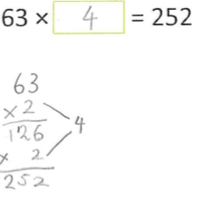

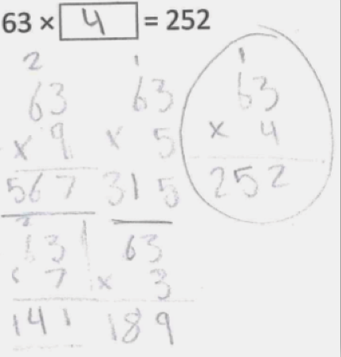
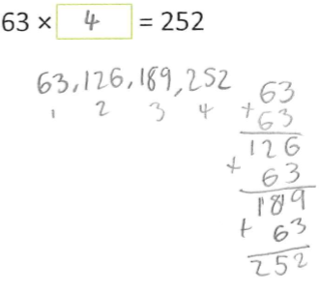

Doubles 63 using vertical algorithm

States how many times the number was multiplied to reach the answer as ‘× 2’ twice

Continues calculation through doubling again from the intermediate answer

Obtains the answer following guess, check and refine process using vertical multiplication algorithm

Applies trial and error and identifies ‘× 9’ as too great, so reduces value and recalculates ‘× 7’, ‘× 5’ and
‘× 3’ to reach the answer of
‘× 4’

Skip counts by 63 and records the number of skip counts to determine missing value

Calculates using repeated addition to check the reasonableness of the answer

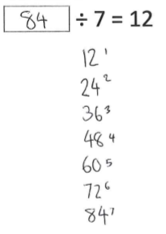

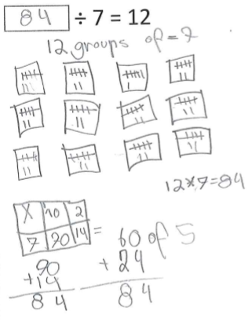

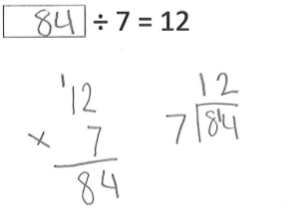

Skip counts by 12 until reaching 7 skips

Records 84 as the missing number

Creates 12 groups

Adds 7 to each group using a tally count (|||| and ||)

Adds total of twelve 5s (60) and twelve 2s (24) using vertical algorithm to identify the missing number

Identifies split strategy and multiplication facts to identify the missing number

Uses inverse operation to identify missing number

Calculates multi-digit equation using vertical multiplication by one digit with regrouping

Calculates division with regrouping

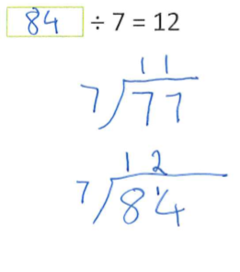
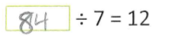

Uses multiplication and division facts to identify 7 × 11 as 77, so one more group of 7 is 84

Uses division with regrouping to check accuracy of the answer

Records numbers vertically to calculate using repeated addition

Uses vertical algorithm with regrouping to calculate the answer

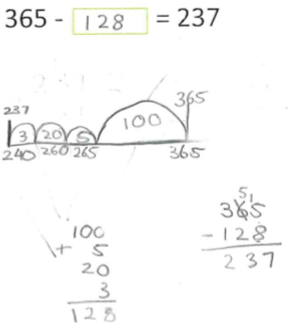

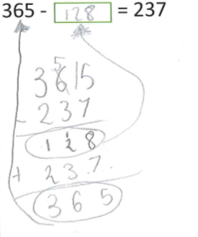

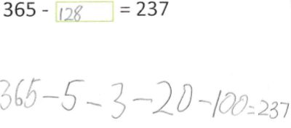

Uses a number line to solve the problem

Partitions on the number line (237 + 3 = 240, + 20 = 260, + 5 = 265, and + 100 = 365)

Checks reasonableness of answer using vertical algorithm with regrouping

Adds ‘jumps’ vertically to identify the missing number

Rearranges the expression

Calculates using vertical addition and subtraction algorithm with regrouping

Identifies addition as the inverse operation to subtraction

Uses step by step repeated subtraction

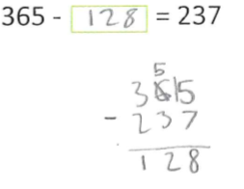

Aligns numbers vertically and calculates using vertical subtraction algorithm with regrouping

Student work samples – Demonstrating strategies
These work samples were created by students working at
Level 5. Evidence of student achievement has been annotated.
Victorian Curriculum link
Use efficient mental and written strategies and apply appropriate digital technologies to solve problems (VCMNA185)

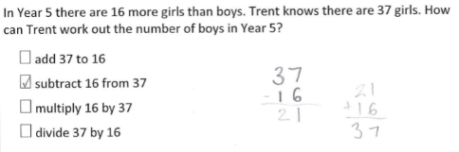

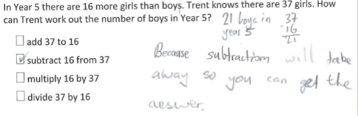

Identifies the inverse operation from a worded problem

Uses vertical algorithm for addition and subtraction
to check the reasonableness
of the answer

Calculates the number of
boys first using
vertical subtraction

Explains the use of subtraction

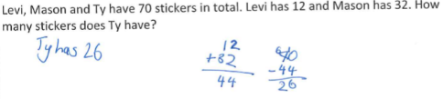

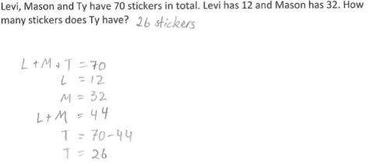

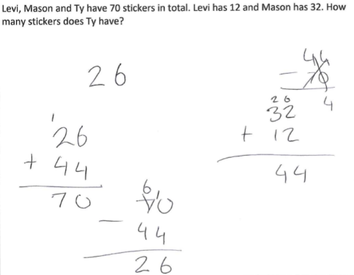

Identifies the steps in a worded problem to calculate the answer

Adds 12 + 32 vertically and then subtracts 44 from the total amount to identify the answer as 26

Correctly calculates using a combination of symbols to represent value and assist with the calculation

Identifies the correct
steps to calculate the
worded problem through
trial and error

Uses vertical algorithm for addition and subtraction to identify the answer

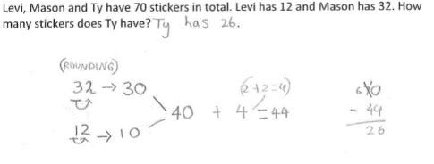

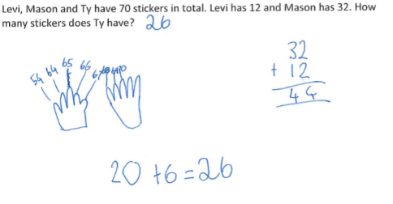

Rounds numbers to the nearest ten to assist with calculation

Checks the reasonableness of the answer using a vertical algorithm with regrouping

Uses an efficient mental strategy (compensation strategy) to calculate answer

Adds 32 + 12 to determine total

Counts on by 10s to 64 then continues by 1s until reaching the total given (70)

Adds the amount counted (10 + 10 + 6 = 26) to identify the answer

Where to next for the teacher?
When the task on which these annotated student work samples is based has been used as a classroom activity, there is opportunity to gather data on student achievement to help inform further teaching.
An analysis of student responses, on an individual, group or whole class basis, can be used to develop and direct student learning with respect to the following content.

For students needing to review underpinning knowledge and skills at Level 4
- Apply place value to partition, rearrange and regroup numbers to at least tens of thousands to assist calculations and solve problems (VCMNA153)
- Investigate number sequences involving multiples of 3, 4, 6, 7, 8, and 9 (VCMNA154)
- Recall multiplication facts up to 10 × 10 and related division facts (VCMNA155)
- Develop efficient mental and written strategies and use appropriate digital technologies for multiplication and for division where there is no remainder (VCMNA156)
- Solve word problems by using number sentences involving multiplication or division where there is no remainder (VCMNA162)
- Use equivalent number sentences involving addition and subtraction to find unknown quantities (VCMNA163)

For students consolidating knowledge and skills at Level 5
- Identify and describe factors and multiples of whole numbers and use them to solve problems (VCMNA181)
- Investigate strategies to solve problems involving addition and subtraction of fractions with the same denominator (VCMNA188)

For students moving on to new knowledge and skills at Level 6
- Solve problems involving addition and subtraction of fractions with the same or related denominators (VCMNA212)
- Add and subtract decimals, with and without digital technologies, and use estimation and rounding to check the reasonableness of answers (VCMNA214)
- Multiply and divide decimals by powers of 10 (VCMNA216)
- Explore the use of brackets and order of operations to write number sentences (VCMNA220)
Resources
- Numeracy Learning Progressions, Victorian Curriculum and Assessment Authority (VCAA) –The Numeracy Learning Progressions amplify, extend and build on the numeracy skills in the Victorian Curriculum F–10: Mathematics and support the application of numeracy learning within other learning areas.
- FUSE, Victorian Department of Education and Training (DET) – The FUSE website provides access to digital resources that support the implementation of the Victorian Curriculum F–10, including an extensive range of activities and other resources for Primary Mathematics and Secondary Mathematics.
- Mathematics Curriculum Companion, Victorian Department of Education and Training (DET)
- Aligned Australian Curriculum Resources (Mathematics), Australian Curriculum, Assessment and Reporting Authority (ACARA)

