Level 3 – Measurement and Geometry

Overview
Task name What time is it?
Learning intention To record time on a digital and analogue clock to the nearest minute
Duration 40 minutes

Links to Victorian Curriculum
These work samples are linked to Level 3 of the Mathematics curriculum.

Extract from achievement standard
They tell time to the nearest minute.

Relevant content description
- Tell time to the minute and investigate the relationship between units of time (VCMMG141)

Links to NAPLAN

Minimum standards – numeracy
Year 3: Measurement, chance and data – Measures
Students read times and dates using clocks and calendars. For example, students can generally:
- read half and quarter hour times on analogue clocks
- read time on digital clocks in hours and minutes
- recognise the time half an hour before or after a given time.

Student work samples − Telling the time to the nearest minute
These work samples were created by students working at
Level 3. Evidence of student achievement has been annotated.
Victorian Curriculum link
Tell time to the minute and investigate the relationship between units of time (VCMMG141)

Student sample 1
Write the time on a digital clock to show when you get home from school to the nearest minute.
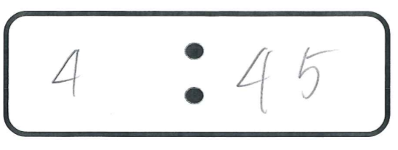

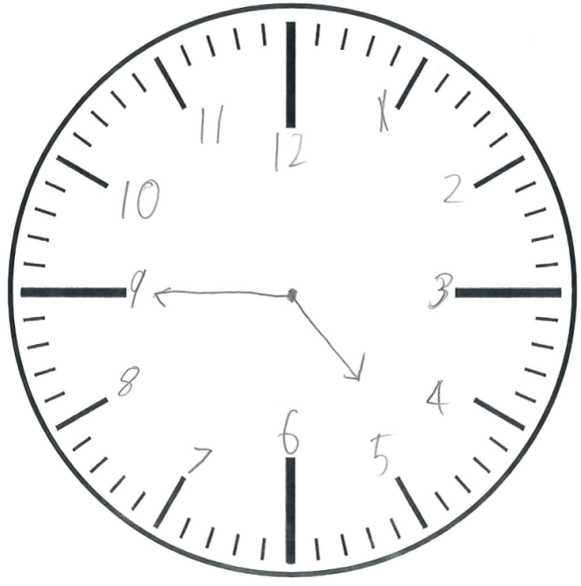
Draw the hands and write the numbers on the clock face to show when you get home from school to the nearest minute.

Identifies digital time for 12- hour format without ‘am’ or ‘pm’ notation

Connects the same time in digital and analogue representations

Shows the minute hand to the nearest minute
Presents hour and minute hands in relative sizes

Correctly places numbers for hours on the clock face

Places the hour hand in the position before the hour

Student sample 2
Write the time on a digital clock to show when you get home from school to the nearest minute.
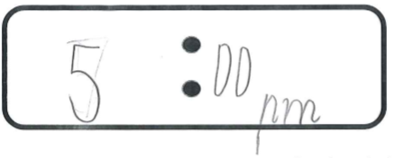

Draw the hands and write the numbers on the clock face to show when you get home from school to the nearest minute.
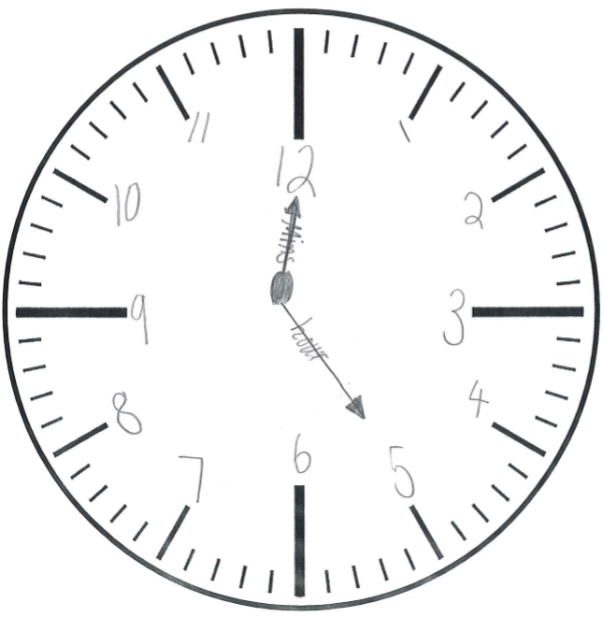

Includes ‘pm’ notation with digital representation

Correctly places numbers for hours on the clock face

Reverses hour and minute hand size but labels correctly with respect to time

Student sample 3
Write the time on a digital clock to show when you get home from school to the nearest minute.
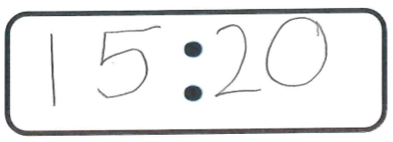

Draw the hands and write the numbers on the clock face to show when you get home from school to the nearest minute.
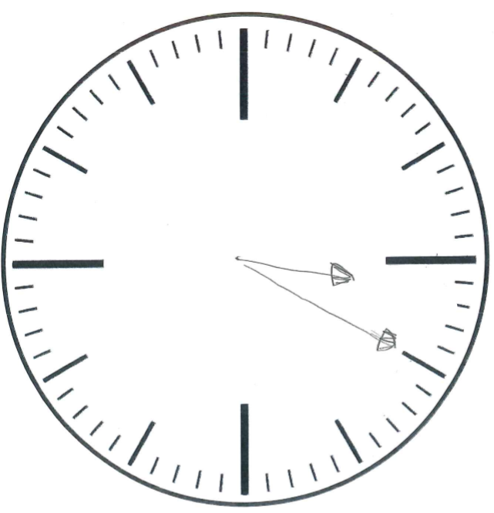

Records time in 24-hour time system

Connects the same time in digital and analogue representations

Presents hour and minute hands in relative sizes

Locates hour and minute hands accurately, without labelling hours with numbers

Student sample 4
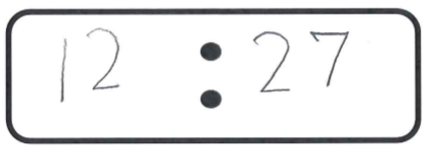
Write the time on a digital clock to show when you get home from school to the nearest minute.*

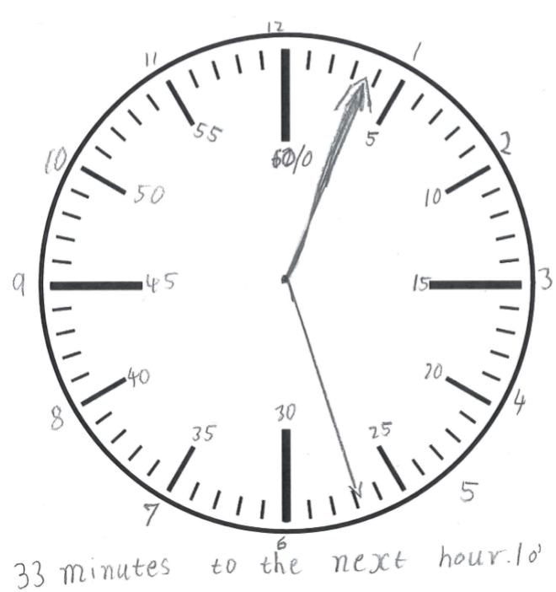
Draw the hands and write the numbers on the clock face to show when you get home from school to the nearest minute.

Identifies digital time without ‘am’ or ‘pm’ notation

Connects time same time in digital and analogue representations

Presents hour hand inaccurately, as the same size as the minute hand

Locates minute hand accurately

Places numbers for
hours accurately
on the clock face

Records minutes on clock face in 5-minute intervals from 0
to 60
Explains 33 minutes ‘to’
the next hour

Identifies 1 o’clock as
the next hour

Student sample 5
Write the time on a digital clock to show when you get home from school to the nearest minute.*
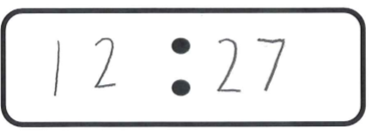

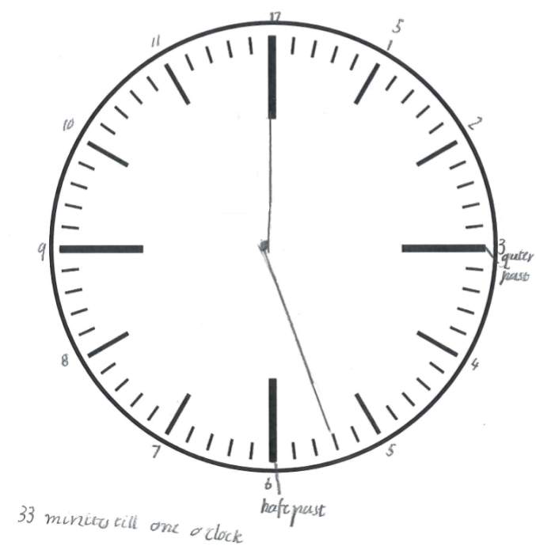
Draw the hands and write the numbers on the clock face to show when you get home from school to the nearest minute.

Identifies correct digital time without ‘am’ or ‘pm’ notation

Connects the same time in digital and analogue representations
Identifies location of clock face digits

Records the hour hand directly on the hour rather than indicating progression
beyond the hour

Identifies ‘quarter past’ and ‘half past’ locations
on the clock
Explains 33 minutes ‘to’ the next hour
Identifies 1 o’clock as the next hour

Where to next for the teacher?
When the task on which these annotated student work samples is based has been used as a classroom activity, there is opportunity to gather data on student achievement to help inform further teaching.
An analysis of student responses, on an individual, group or whole class basis, can be used to develop and direct student learning with respect to the following content.

For students needing to review underpinning knowledge and skills at Level 2
- Tell time to the quarter-hour, using the language of ‘past’ and ‘to’ (VCMMG117)

For students moving on to new knowledge and skills at Level 4
- Convert between units of time (VCMMG167)
- Use am and pm notation and solve simple time problems (VCMMG168)

Resources
- Mathematics Sample Programs, Victorian Curriculum and Assessment Authority (VCAA) – This set of sample programs covering the Victorian Curriculum Mathematics: F–10 were developed as examples to illustrate how the Mathematics curriculum could be organised into yearly teaching and learning programs.
- Numeracy Learning Progressions, Victorian Curriculum and Assessment Authority (VCAA) – The Numeracy Learning Progressions amplify, extend and build on the numeracy skills in the Victorian Curriculum Mathematics F–10 and support the application of numeracy learning within other learning areas.
- FUSE, Victorian Department of Education and Training (DET) – The FUSE website provides access to digital resources that support the implementation of the Victorian Curriculum F–10, including an extensive range of activities and other resources for Primary Mathematics and Secondary Mathematics.
- Mathematics Teaching Toolkit, Victorian Department of Education and Training (DET)
- Mathematics Curriculum Companion, Victorian Department of Education and Training (DET)
- Victorian Numeracy Portal, Victorian Department of Education and Training (DET)
- Aligned Australian Curriculum Resources (Mathematics), Australian Curriculum, Assessment and Reporting Authority (ACARA)

