Level 7 – Measurement and Geometry

Overview
Activity name Finding areas
Learning intention To calculate and make comparisons between the area of regular shapes
Duration 40 minutes

Links to Victorian Curriculum
These work samples are linked to Level 7 of the Mathematics curriculum.

Extract from Mathematics Level 7 achievement standard
Students use formulas for the area and perimeter of rectangles.

Relevant content description
Establish the formulas for areas of rectangles, triangles and parallelograms and use these in problem solving (VCMMG258)

Links to NAPLAN

Minimum standards – numeracy
Year 7: Measurement, chance and data
In measurement, chance and data, students at the minimum standard at Year 7 use both formal and informal methods to measure and compare lengths, areas, volumes or angles.
Measures
Students measure and compare lengths, areas, volumes and angles.

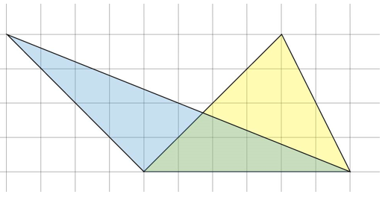
Note: the image below has been used to form the Part 3 responses.

Student work samples –
Part 1: Finding the area of a triangle
These work samples were created by students working at
Level 7. Evidence of student achievement has been annotated.

Victorian Curriculum link
Establish the formulas for areas of rectangles, triangles and parallelograms and use these in problem solving (VMMG258)

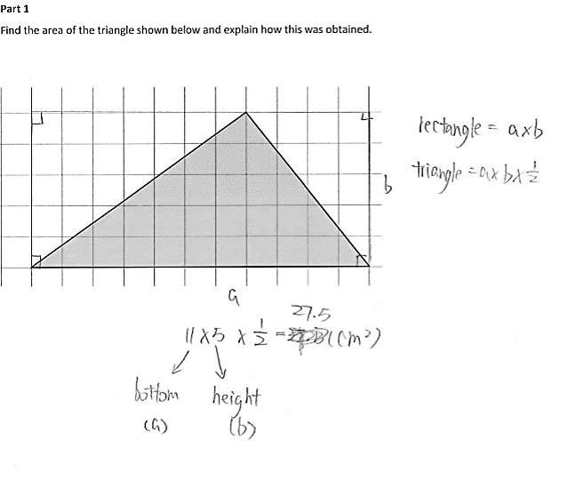

Draws a rectangle identifying right angle corners
Writes the formula for calculating the area of a rectangle

Writes the formula for calculating the area of a triangle

Labels the length and height on horizontal and vertical axes with variables shown in the formula

Uses cm² as unit of measurement

Substitutes values for variables in the formula and calculates area

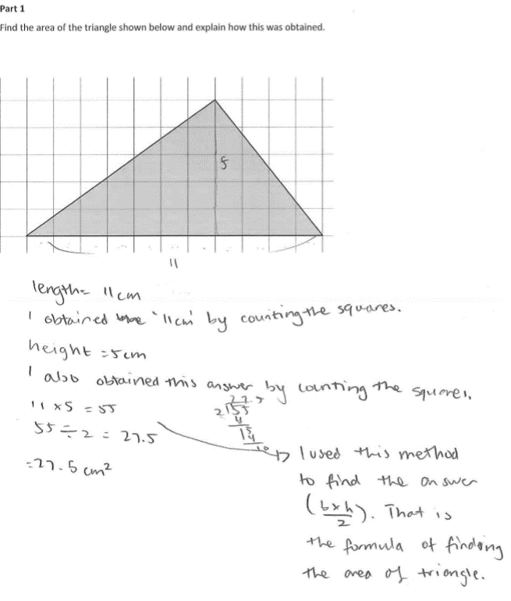

Specifies length of base and height

Includes working for division calculation

Applies algorithm for calculating the area of a triangle and justifies answer

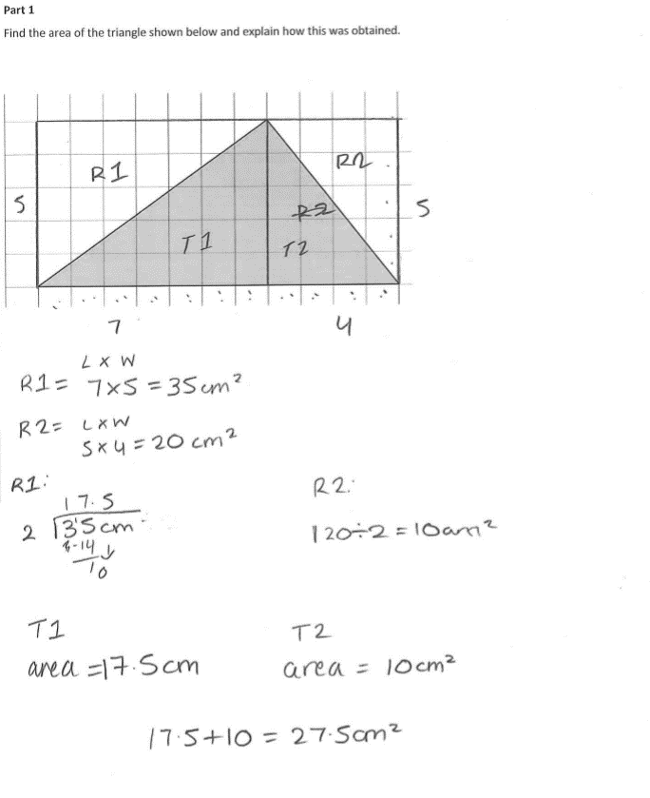

Decomposes the triangle into two rectangles

Labels the length and width of each rectangle

Calculates the area of each rectangle

Decomposes the area of each rectangle by two to calculate the area of each triangle

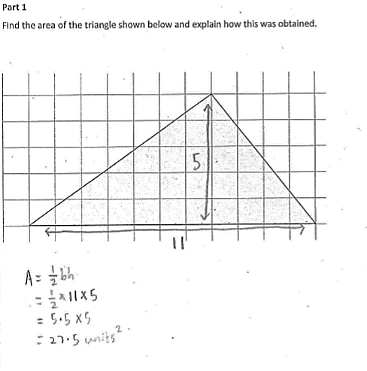

Labels the base and the height of the triangle

States the formula for calculating the area of a triangle

Completes calculation and includes unit of measurement in answer (units²)

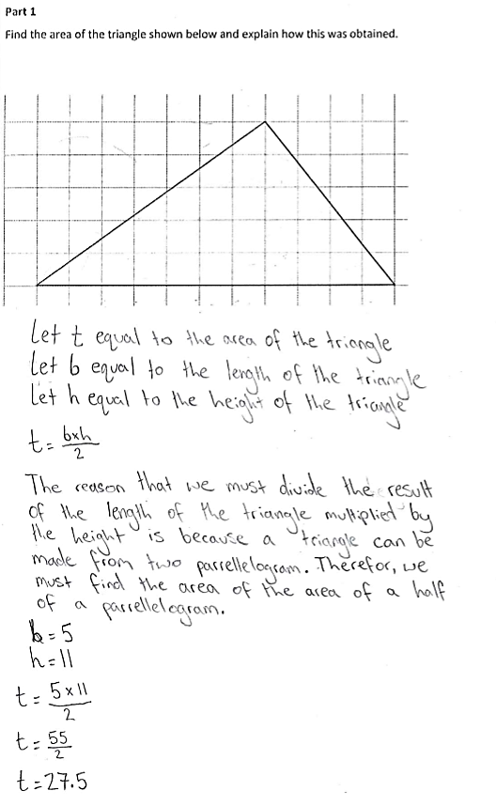

Justifies the
formula and explains
what the letters stand for within the formula

Completes the calculation using the algorithm; although the base and height have been incorrectly labelled, this doesn’t affect the calculation

Student work samples –
Part 2: Finding the area of a parallelogram
These work samples were created by students working at
Level 7. Evidence of student achievement has been annotated.
Victorian Curriculum link
Establish the formulas for areas of rectangles, triangles and parallelograms and use these in problem solving (VMMG258)

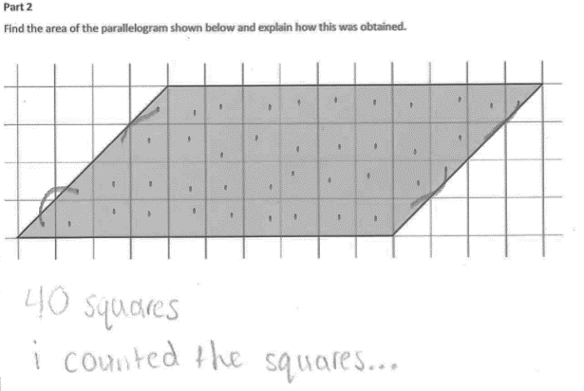

Counts individual squares and triangles to calculate the area and indicates some combinations of two half squares to make a whole

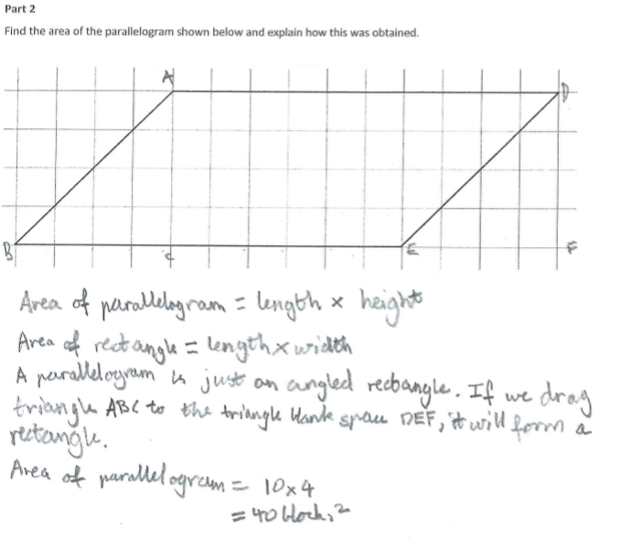

Labels components of the parallelogram

Explains the formula to calculate the area of a parallelogram

Justifies using the same formula for a parallelogram and a rectangle

Substitutes numbers into the formula for calculating the area

Calculates the area of a parallelogram using units²

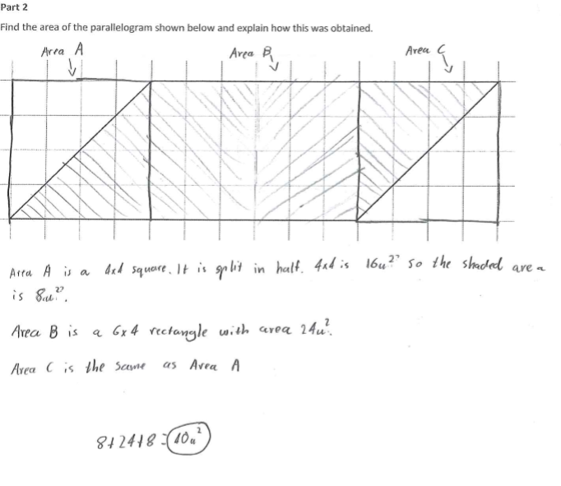

Decomposes and labels the parallelogram as three separate shapes

Calculates the area of each shape

Adds the area of each shape to calculate the total area for the parallelogram

Calculates the area of a parallelogram using units²

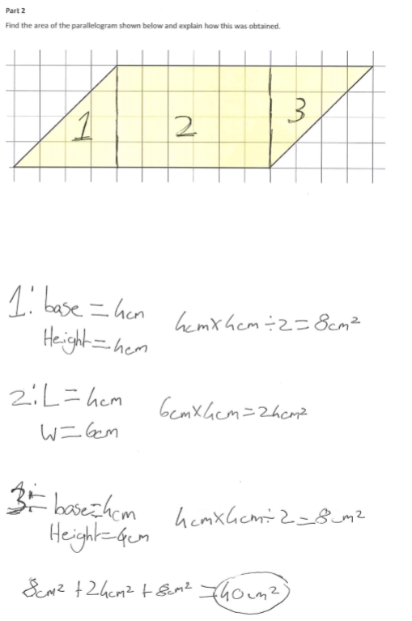

Decomposes and labels the parallelogram as three separate shapes

Records the base and height measurement of each shape

Calculates the area for Shape 1 including cm²

Calculates the area for Shape 2 including cm²

Calculates the area for Shape 3 including cm²
Calculates the total parallelogram area by adding the area of the three separate shapes using cm²

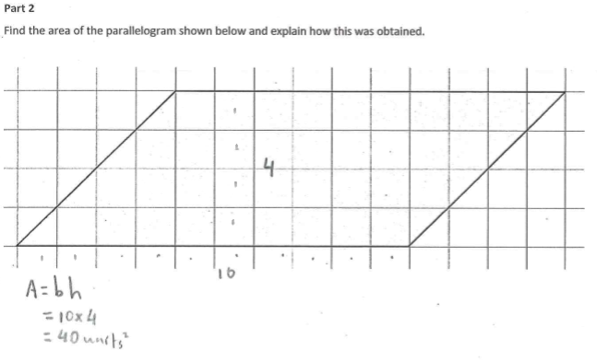

Counts the number of units in the base and height

States the formula to calculate the area of a parallelogram

Applies the formula to calculate the area in units²

Student work samples –
Part 3: Comparing triangles
These work samples were created by students working at
Level 7. Evidence of student achievement has been annotated.
Victorian Curriculum link
Establish the formulas for areas of rectangles, triangles and parallelograms and use these in problem solving (VMMG258)
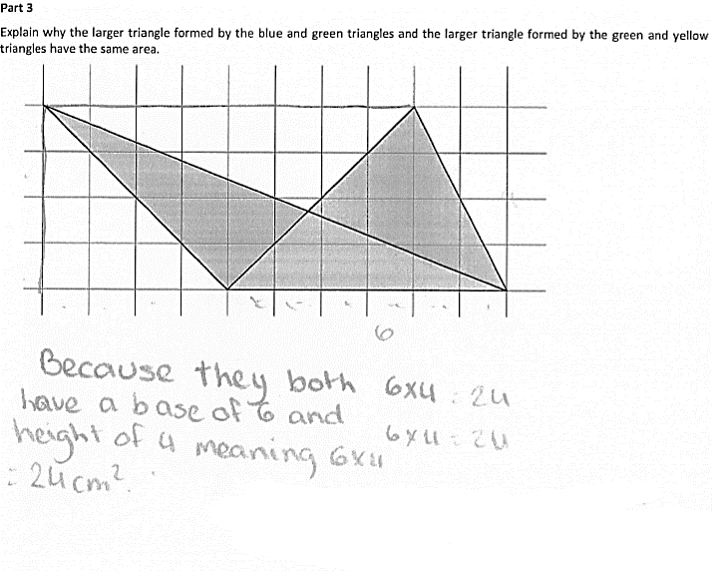

Identifies the base and the height of each shape

Identifies that the triangles have the same base and height, therefore they will have the same area

Calculates the base × height but does not halve the result

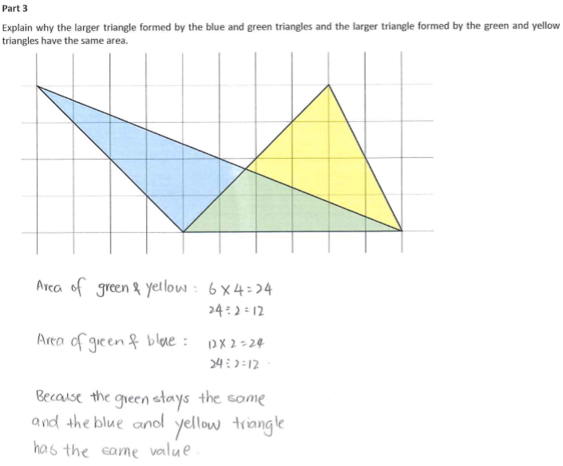

Applies formula to calculate the area of each triangle

Identifies that the base and the height of each triangle are the same

Explains that each of the triangles have the same value, as the green triangle is common

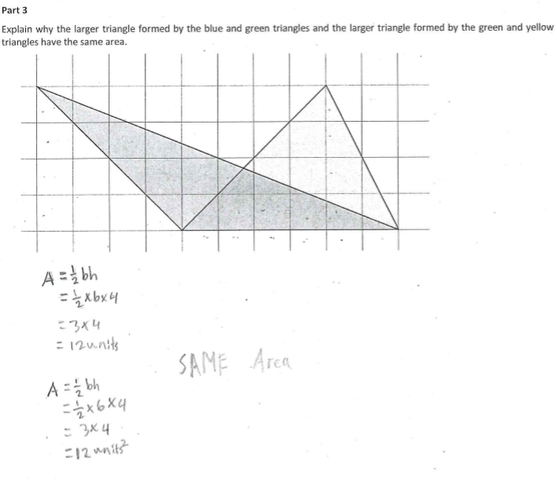

Records the formula for calculating the area of a triangle

Calculates the area of each triangle

Identifies each triangle as having the same area

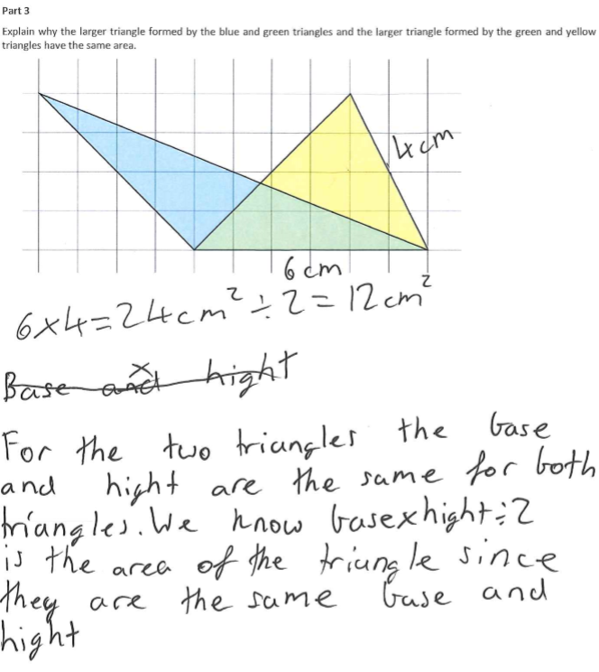

Records base and height
of triangles

Calculates triangle area using the correct formula

Describes the formula used to calculate the area of each triangle, and justifies their explanation

Where to next for the teacher?
When the task on which these annotated student work samples is based has been used as a classroom activity, there is opportunity to gather data on student achievement and to help inform further teaching.
An analysis of student responses, on an individual, group or whole class basis, can be used to develop and direct student learning with respect to the following content.

For students needing to review underpinning knowledge and skills at Level 6
- Convert between common metric units of length, mass and capacity (VCMMG223)
- Solve problems involving the comparison of lengths and areas using appropriate units (VCMMG224)

For students consolidating knowledge and skills at Level 7
- Establish the formulas for areas of rectangles, triangles and parallelograms and use these in problem solving (VCMMG258)

For students moving on to new knowledge and skills at Level 8
- Choose appropriate units of measurement for area and volume and convert from one unit to another (VCMMG286)
- Find perimeters and areas of parallelograms, trapeziums, rhombuses and kites (VCMMG287)
- Investigate the relationship between features of circles such as circumference, area, radius and diameter. Use formulas to solve problems involving determining radius, diameter, circumference and area from each other (VCMMG288)

Resources
- Mathematics Sample Programs, Victorian Curriculum and Assessment Authority (VCAA) – This set of sample programs covering the Victorian Curriculum Mathematics: F–10 were developed as examples to illustrate how the Mathematics curriculum could be organised into yearly teaching and learning programs.
- Numeracy Learning Progressions, Victorian Curriculum and Assessment Authority (VCAA) – The Numeracy Learning Progressions amplify, extend and build on the numeracy skills in the Victorian Curriculum Mathematics F–10 and support the application of numeracy learning within other learning areas.
- FUSE, Victorian Department of Education and Training (DET) – The FUSE website provides access to digital resources that support the implementation of the Victorian Curriculum F–10, including an extensive range of activities and other resources for Primary Mathematics and Secondary Mathematics.
- Mathematics Teaching Toolkit, Victorian Department of Education and Training (DET)
- Mathematics Curriculum Companion, Victorian Department of Education and Training (DET)
- Victorian Numeracy Portal, Victorian Department of Education and Training (DET)
- Aligned Australian Curriculum Resources (Mathematics), Australian Curriculum, Assessment and Reporting Authority (ACARA)

